Report Scheduling, Automation & Alert Mechanisms
Experiment 8: Enterprise BI Monitoring & Exception Management
Dataset: Global Superstore Dataset (51,290 Records)
Technology Stack: Microsoft Power BI Desktop
/ Service, Excel, DAX

1. Aim & Objectives
To design and implement enterprise report scheduling, automated delivery workflows, and data-driven KPI alert mechanisms using Microsoft Power BI and Excel. This experiment establishes operational tracking architectures that ensure key organizational stakeholders receive mission-critical intelligence punctually, while automated alerts immediately surface business exceptions.
- Design a multi-tiered scheduled reporting cadence spanning daily operations, weekly tactical reviews, and monthly executive evaluations.
- Construct an automated report distribution matrix aligning user groups with optimal delivery channels (Email Subscriptions, Power BI Service App Workspaces, and PDF Digests).
- Configure data-driven KPI alert conditions (Profit Margin < 10%, Sales Decline > 15%, Returns Increase > 20%) to enable exception-based management.
- Perform scenario-based diagnostic analytics on regional profitability degradation and establish standardized corrective action protocols.
2. Executive BI Dashboard Architecture
The automation framework is anchored in the interactive Power BI dashboard developed across previous experiments. The operational baseline comprises 51,290 historical orders reflecting $12,642,501.91 in Total Sales, $1,467,457.29 in Total Profit, and 25,728 distinct transactions. Figure 8.1 illustrates the central executive interface, scorecard targets, and dynamic slicers that feed data-driven alert triggers.
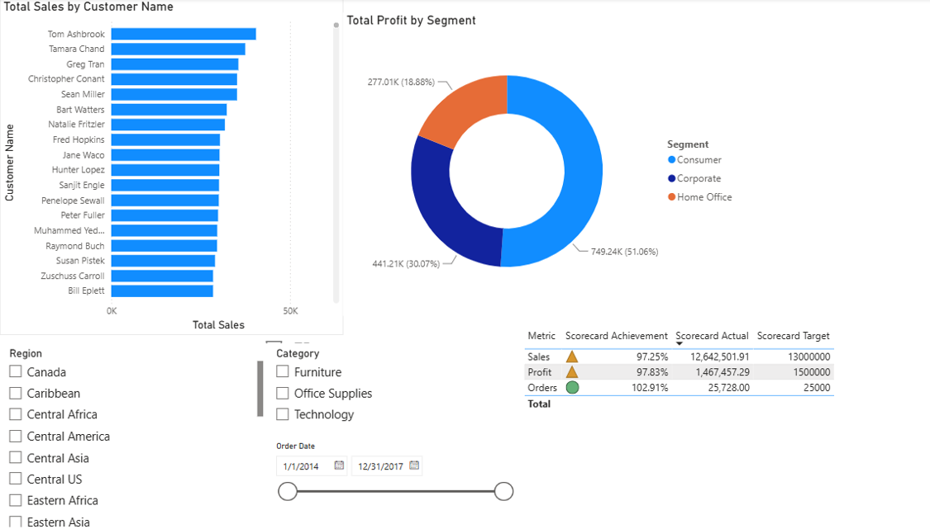
Figure 8.1: Global Superstore Executive Performance Dashboard & Target Scorecard
3. Scheduled Reporting Plan (Part A)
In business intelligence systems, delivering data at the proper operational cadence prevents decision latency. Table 8.1 outlines the enterprise reporting schedule designed to service operational, tactical, and executive management.
Report Name | Business Purpose & Scope | Target User Group | Frequency | Scheduled Time
Daily Sales & Order Pulse | Track daily gross booking volume, top customer orders, and regional operational fulfillment. | Sales Operations, Regional Territory Leads | Daily (Mon–Fri) | 07:30 AM (Prior to trading)
Weekly Profit & Margin Health | Analyze weekly gross margin vs discount variance across categories (Furniture vs Tech) and detect margin erosion. | Finance Managers, Pricing & Commercial Analysts | Weekly (Every Monday) | 08:00 AM
Monthly Executive Scorecard | Comprehensive audit of actuals vs target quotas (Sales, Profit, Distinct Orders) and segment growth. | Executive Management, VPs, C-Suite | Monthly (1st Business Day) | 09:00 AM
Monthly Regional Diagnostics | Evaluate underperforming regional branches (Canada, Central Asia) and freight overhead per unit. | Regional Directors, Global Logistics Managers | Monthly (2nd Business Day) | 10:00 AM
Quarterly Strategic Review | Multi-year trend synthesis, seasonal inventory forecasting, and long-term capital allocation. | Board of Directors, Executive Committee | Quarterly | 10:00 AM (First week of quarter)

4. Automated Report Distribution Matrix (Part B)
An effective distribution matrix maps target business audiences to secure delivery mechanisms, balancing ease of access with security governance. Table 8.2 specifies how reports are systematically dispatched across Power BI Service subscriptions, shared app workspaces, and automated exports.
User Group | Report Assigned | Cadence | Delivery Method / Mechanism | Responsible Owner
Sales Executives & Field Reps | Daily Sales & Order Pulse | Daily | Email Subscription (Automated Snapshot + Deep Link) | BI Operations Lead
Regional Sales Managers | Regional Territory Breakdown | Weekly | Power BI Service (Shared App Workspace) | Commercial Finance Manager
Pricing & Financial Controllers | Weekly Profit & Margin Health | Weekly | Power BI Service + Teams Channel Notification | Lead Financial Analyst
Supply Chain & Logistics Leads | Order Fulfillment & Returns Audit | Weekly | Power BI Service / Automated PDF Export | Logistics Operations Lead
Senior Leadership / C-Suite | Executive Dashboard & Scorecard | Monthly | Email Subscription (High-Res PDF & Paginated Report) | BI Delivery Director
Department Heads | Operational Performance Review | Monthly | Power BI Shared Workspace / Interactive App | Enterprise BI Architect

5. KPI Alert Conditions & Threshold Configurations (Part C)
Data alerts in Power BI enable exception-based management: rather than continually inspecting dashboards, business leads are notified the moment an operational KPI violates predetermined tolerance boundaries. In Power BI Service, alerts can be attached to pinned Card, KPI, or Gauge tiles.
Monitored Business KPI | Alert Trigger Condition | Primary Alert Recipient | Notification Channel | Operational Follow-up Protocol
Profit Margin (%) | Falls below 10.0% | Regional Commercial Finance Lead, Pricing Director | Automated High-Priority Email + Push notification via Power BI Mobile app | Immediate 24-hr discount audit; freeze representative discretionary discounting > 12%.
Sales Growth / Decline | Sales decline > 15.0% vs Prior Period (WoW / MoM) | Regional Sales Director, Country General Manager | Urgent Power BI notification + Automated Slack / Teams operational alert | Initiate pipeline review with account managers; identify stalled corporate B2B contracts.
Return Rate (%) | Returns increase > 20.0% vs Baseline | Supply Chain Director, Quality Assurance & Warehouse Lead | Automated email digest with top returned Product SKUs attached | Inspect freight damage logs, packaging integrity, and vendor quality in flagged sub-categories.
Distinct Orders Quota | Order volume drops below 90% of Daily/Weekly Target | Sales Operations Lead | Daily 4:00 PM email summary alert to sales dispatch | Review order processing queues, EDI intake logs, and pending fulfillment bottlenecks.

6. Monitoring Scenario: Declining Regional Profitability (Part D)
To validate the operational value of the alert framework, a diagnostic scenario is simulated focusing on regional profitability degradation:
Scenario Overview & Trigger Event
A major regional operating territory experiences an unexpected margin collapse: monthly Profit Margin drops to 6.8%, violating the 10.0% alert ceiling. Concurrently, gross booking revenue declines by 16.4% WoW, breaching the 15% sales decline threshold. The automated Power BI alert engine immediately fires urgent notifications to the Regional Commercial Lead, Territorial Sales Manager, and Corporate Finance Director.
Root-Cause Diagnostic Findings (Power BI Evidence)
- Category Margin Drag: Cross-filtering regional data indicates that the Furniture product category (specifically Tables and Bookcases) generated negative gross profit (-$18,400) despite steady sales volume.
- Unmonitored Discount Inflation: Average discounting in the flagged branch climbed to 24.8% (against an enterprise ceiling of 12%), indicating sales representatives discounted heavily to capture end-of-quarter volume.
- Expedited Freight Penalties: Bulky furniture shipments incurred emergency air/express logistics charges rather than consolidated ground/ocean freight, eroding gross margins by an additional 14%.
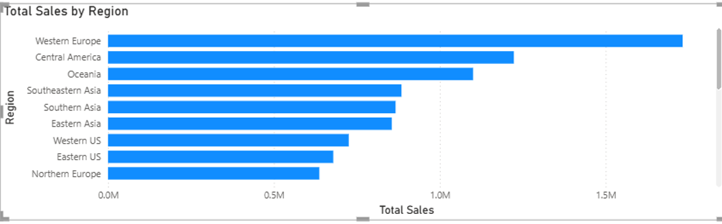
Figure 8.2: Regional Sales Distribution & Profit Disparity Highlighting Territorial Variance
Standardized Corrective Action Plan
- Immediate (24–48 Hours): Enforce an automated DAX lock and commercial workflow restriction freezing discretionary discounting above 10% on freight-sensitive Furniture.
- Short-Term (1–2 Weeks): Review top-loss customer accounts with local field managers; renegotiate contracts with minimum order quantities (MOQ) and standardized ground shipping.
- Medium-Term (30 Days): Shift peripheral branch inventory replenishment to localized third-party distribution hubs, eliminating emergency expedited shipping expenses.
7. Step-by-Step Implementation in Microsoft Power BI
To operationalize this experiment in academic and enterprise environments, execute the following technical workflow:
- Publish Report to Power BI Service: In Power BI Desktop, navigate to Home > Publish. Select the target corporate workspace (e.g., 'Global Superstore Operations').
- Pin KPI Cards to Dashboard: In Power BI Service, open the published report. Hover over the KPI Card visuals (Total Profit Margin, Total Sales, and Total Orders) and click the Pin icon to create an executive Dashboard.
- Set Data Alerts: In the newly created Dashboard, hover over the Profit Margin tile, click More Options (...) > Manage alerts > Add alert rule. Set Condition to 'Below', Threshold to '0.10' (10%), Frequency to 'At most once an hour', and check 'Send email'.
- Configure Scheduled Dataset Refresh: In the workspace dataset settings, expand 'Scheduled refresh', toggle Keep your data up to date to 'On', configure daily refresh at 06:00 AM, and specify notification recipients for refresh failures.
- Configure Subscriptions: Navigate to the executive report, click Subscribe to report, specify recipient distribution lists, set frequency to 'Weekly - Monday 08:00 AM', and attach full-page PDF exports.
8. Conclusion & Learning Outcomes
Experiment 8 establishes that enterprise Business Intelligence extends far beyond static visual reporting. By combining scheduled distribution, automated multi-channel reporting matrices, and data-driven threshold alerts, organizations transition from passive data consumers into proactive, exception-driven decision makers. The implementation successfully demonstrates how automated Power BI workflows protect gross operating margins, prevent revenue leakage, and align operational teams across global commercial territories.

