EXPERIMENT 8

1. AIM:
To design and implement report scheduling, automation, and alert mechanisms using Microsoft Power BI and develop strategies for automated report delivery, monitoring, and business performance tracking.
2. OBJECTIVES:
• To understand the importance of scheduled reporting in Business Intelligence.
• To prepare a schedule for daily, weekly, and monthly reports.
• To design an automated report distribution matrix for different user groups.
• To define KPI alert conditions for monitoring business performance.
• To identify alert recipients and appropriate actions for business exceptions.
• To analyze a declining-profitability scenario and recommend corrective actions.
• To document reporting automation and monitoring strategies.
3. TOOLS / SOFTWARE REQUIRED:
• Microsoft Power BI Desktop
• Microsoft Power BI Service
• Global Superstore Dataset.xlsx
• Microsoft Excel
4. DATASET USED: Global Superstore Dataset.xlsx.
Dataset Source: Global Superstore Dataset (Kaggle)
https://www.kaggle.com/datasets/apoorvaappz/global-super-store-dataset
5. THEORY:
• Business Intelligence systems must deliver information to stakeholders at the right time. Scheduled reporting, automated distribution, and KPI alerts help organizations monitor performance and take timely actions.
• Power BI Service supports report subscriptions, scheduled dataset refreshes, report sharing, and data-driven alerts. These features help automate report delivery and keep users informed about important changes.
• A scheduled reporting plan defines which reports are delivered, how often they are delivered, and who receives them.
• A report distribution matrix maps user groups to reports, delivery frequencies, and methods such as Email, PDF, Shared Workspace, or Power BI Service.
• KPI alerts notify users when a monitored value crosses a defined threshold. Examples include Profit Margin below 10%, Sales decline greater than 15%, and Returns increase greater than 20%.
• Monitoring scenario analysis identifies alert triggers, responsible recipients, and corrective actions when business performance changes significantly.
6. PROCEDURE:
Part A: Prepare the Scheduled Reporting Plan
Step 1: Open Microsoft Power BI Desktop.
Launch Power BI Desktop and open the Global Superstore report or dashboard created in the previous experiments.

Fig 8.1: Opening the Power BI report
Step 2: Review the available reports and KPIs.
Identify the report pages and business metrics that are useful for monitoring sales, profit, orders, and returns.
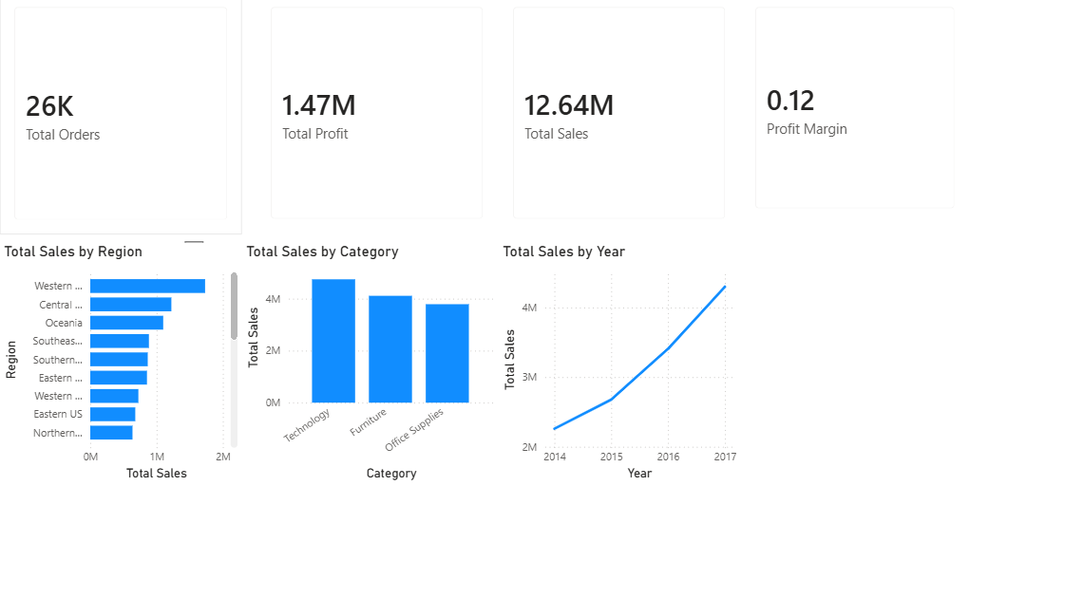
Step 3: Create a report schedule.
In Microsoft Excel, create a table with the report name, purpose, intended users, frequency, and planned delivery time.
Step 4: Define the reporting frequencies.
Include Daily Sales Reports, Weekly Profit Reports, and Monthly Executive Dashboards. Assign suitable user groups and frequencies.

Part B: Design Automated Report Distribution
Step 5: Create a Report Distribution Matrix.
Open Microsoft Excel and create columns for User Group, Report Name, Frequency, Delivery Method, and Responsible Person.
Step 6: Identify report recipients.
Assign suitable audiences, such as sales managers for daily sales reports, finance managers for weekly profit reports, and senior management for monthly executive dashboards.
Step 7: Select the delivery method.
Choose an appropriate method for each report: Email, PDF, Shared Workspace, or Power BI Service. Record the selected method in the matrix.
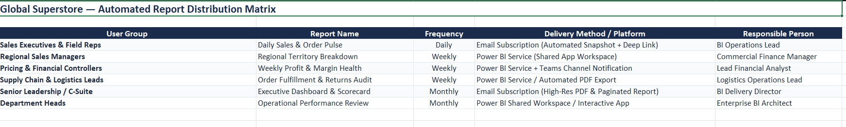
Step 8: Review the distribution matrix.
Verify that every report has an intended audience, frequency, and delivery method. Check that the plan is consistent and easy to follow.
Part C: Configure KPI Alert Conditions
Step 9: Identify the KPIs to monitor.
Use business measures such as Profit Margin, Sales, and Returns to define alert conditions.
Step 10: Define the alert thresholds.
Record the specified conditions: Profit Margin below 10%, Sales decline greater than 15%, and Returns increase greater than 20%.
Step 11: Specify recipients and actions.
For each alert, identify who should receive the notification and what action should be taken, such as reviewing regional performance, investigating sales decline, or checking return reasons.
Step 12: Prepare the KPI Alert Configuration Sheet.
Create a table containing KPI, alert condition, recipient, notification/action, and follow-up responsibility. Note that actual alert availability depends on the Power BI Service visual and configuration.

Step 13: Review the alert setup requirements.
If using Power BI Service, publish the report as required and check whether the chosen dashboard tile supports data alerts. Record any configuration limitations.
Part D: Analyze a Monitoring Scenario
Step 14: Review the declining-profitability scenario.
Assume that a regional branch is experiencing declining profitability. Review the available sales and profit visuals to identify possible contributing factors.
Step 15: Identify relevant alert triggers.
Check whether the Profit Margin falls below 10% or whether Sales decline by more than 15%. Consider the Returns increase threshold of more than 20% if return data is available.
Step 16: Identify alert recipients.
Assign the notification to the appropriate responsible users, such as the regional manager, sales manager, or finance team.
Step 17: Recommend corrective actions.
Suggest actions based on the observed issue, such as investigating high-cost products, reviewing discounts, examining return patterns, or focusing on underperforming regions.
Step 18: Prepare the monitoring and recommendation report.
Summarize the scenario, alert trigger, recipient, recommended corrective action, and follow-up needed. Support observations with report or dashboard screenshots.
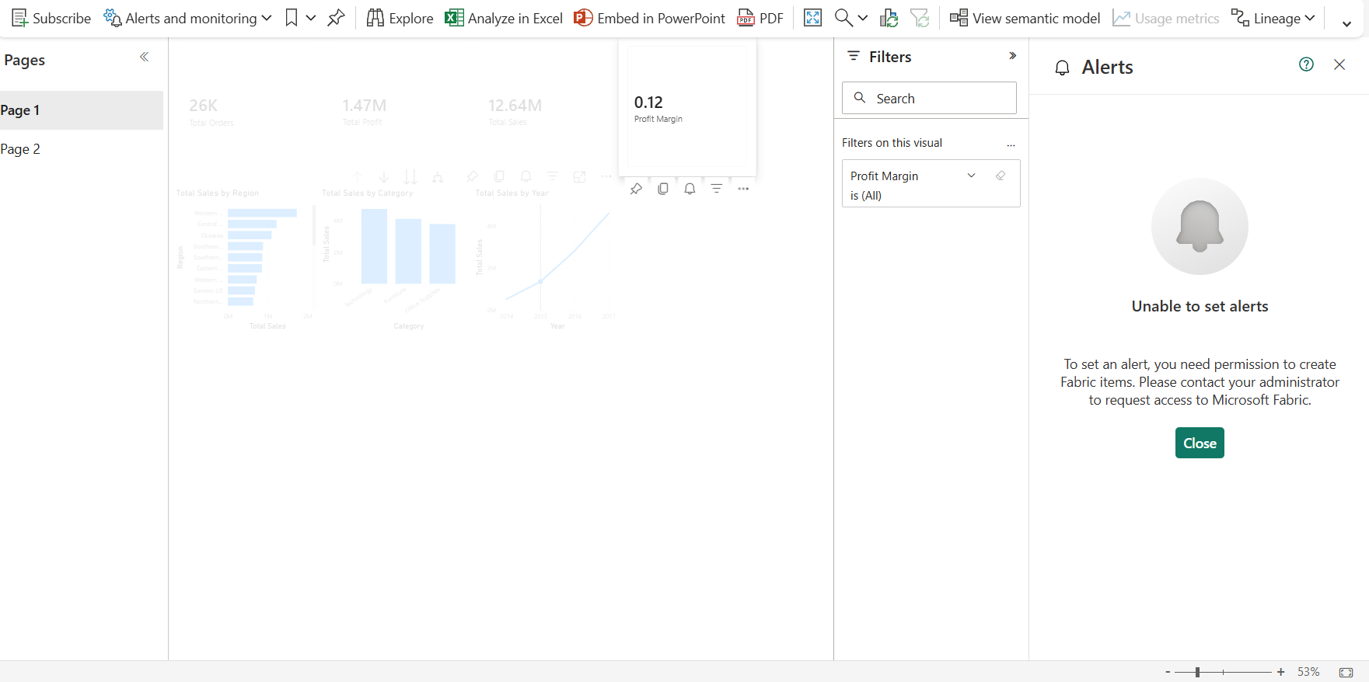
Part E: Validate and Finalize Deliverables
Step 19: Validate the reporting plan and matrix.
Check that daily, weekly, and monthly reports have clearly defined users, frequencies, and delivery methods.
Step 20: Validate KPI alert conditions.
Verify that each KPI threshold, recipient, and response action is documented correctly.
Step 21: Capture the dashboard screenshot.
Capture a clear screenshot of the relevant Power BI dashboard and insert it in the report.
Step 22: Compile the final deliverables.
Prepare the Scheduled Reporting Plan, Report Distribution Matrix, KPI Alert Configuration Sheet, Dashboard Screenshot, and Monitoring and Recommendation Report.
7. RESULT:
Report scheduling, automation, and alert strategies were successfully designed. A scheduled reporting plan, report distribution matrix, KPI alert configuration sheet, and monitoring recommendations were prepared to support business operations.
8. LEARNING OUTCOMES:
• Applied report scheduling concepts in Business Intelligence systems.
• Designed automated report distribution strategies.
• Analyzed KPI monitoring requirements.
• Evaluated alert mechanisms for business decision support.
• Developed recommendations for BI operations.
9. TEXT / REFERENCE BOOKS:
• Sharda, Delen & Turban, Business Intelligence and Analytics.
• Cindi Howson, Successful Business Intelligence.
• Rick Sherman, Business Intelligence Guidebook.
• Microsoft Power BI Documentation.

