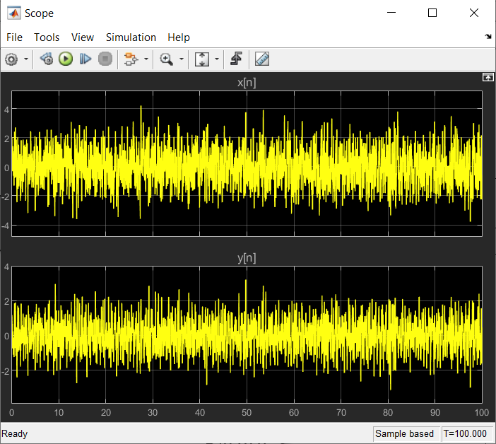

FREQUENCY: 700 rad/sec

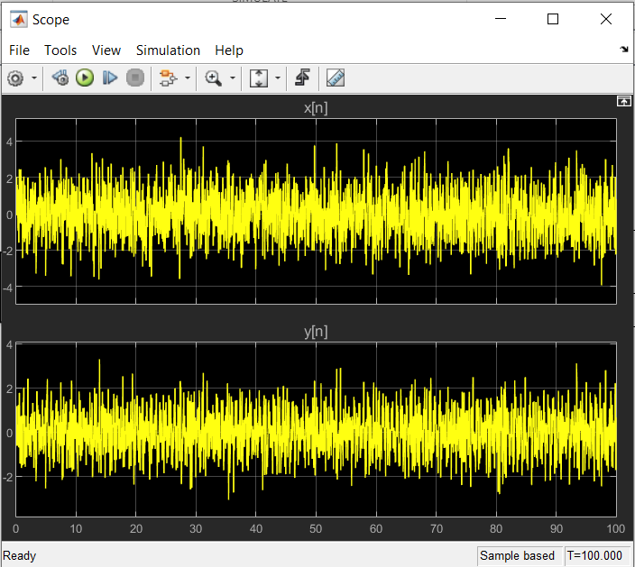

FREQUENCY: 1500 rad/sec

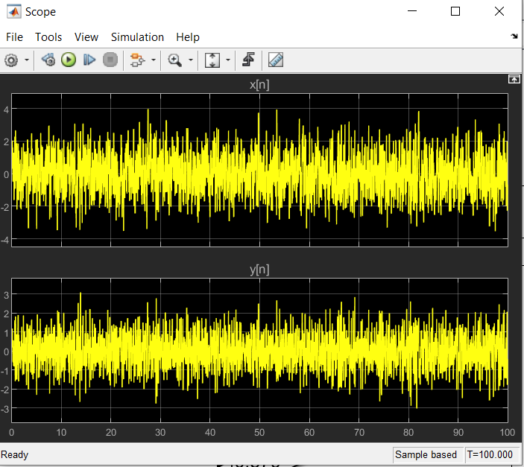

FREQUENCY: 4500 rad/sec

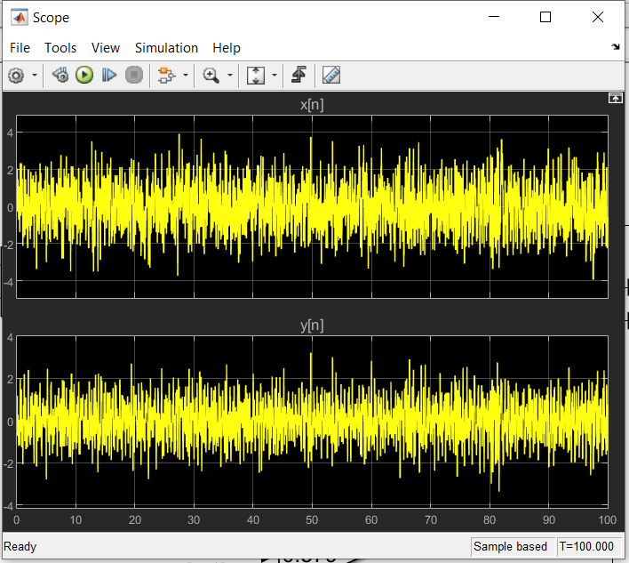

FREQUENCY: 10000 rad/sec

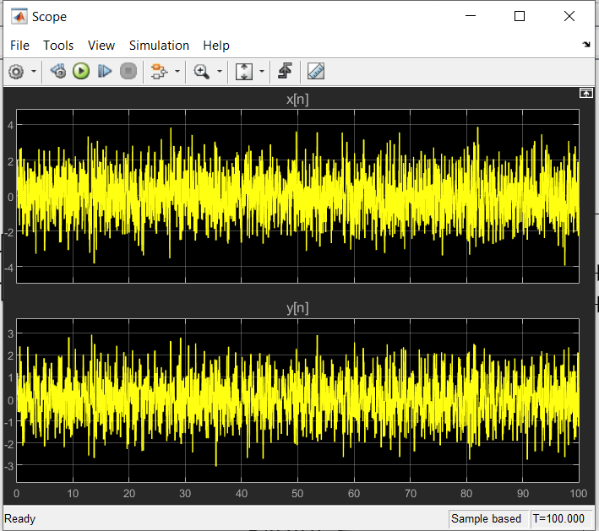

FREQUENCY: 60000 rad/sec