Customer Purchase Behaviour and Revenue Analysis
Executive Summary
This project analyzes customer purchase data to better understand spending behavior, key revenue drivers, and factors that influence customer purchasing decisions. The goal of the analysis is to identify patterns in customer transactions and translate them into insights that can support more informed business decisions.
The analysis shows that clothing is the company’s strongest performing product category, generating the highest revenue across all seasons. Sales also display clear seasonal patterns, with fall producing the highest revenue and summer the lowest. Additionally, the majority of revenue comes from mid-range purchases between $40 and $80, indicating that this price range is particularly important to the business.
Customer segmentation revealed that non-subscribers spend more than subscribers, and only 26.28% of high-spending customers are subscribed. Notably, the dataset shows no female subscribers, suggesting a potential gap in how the subscription program is positioned or marketed.
Overall, the findings highlight opportunities to strengthen high-performing product categories, improve subscription adoption, and align marketing strategies with seasonal demand patterns.
Business Problem Statement
The business seeks to better understand the factors that influence customer purchasing behavior and revenue performance. However, limited visibility into customer spending patterns, product performance, and the effectiveness of the subscription program makes it difficult to identify opportunities for growth.
In particular, the business needs to understand which product categories and customer segments drive the most revenue, how purchasing behavior changes across seasons, and whether operational factors such as discounts, shipping options, and payment methods influence customer spending.
This analysis examines historical transaction data to identify key trends and insights that can support more informed decisions related to product strategy, customer engagement, and revenue optimization.
Key Questions Addressed by the Analysis
- Revenue distribution among different demographic groups
- Categorical revenue distribution
- Seasonal change in revenue
- Impact of discounts on sales
- Effectiveness of subscription model in attracting high-value customers
- Effect of review ratings on customers’ spending
- Most used payment methods used by customers
Project Scope
In Scope
This project focuses on analyzing historical transaction data to identify patterns in customer behavior and revenue generation. The analysis includes:
- Examining customer spending across demographic groups
- Identifying top-performing product categories
- Analyzing seasonal revenue patterns
- Comparing subscribers and non-subscribers
- Evaluating the impact of discounts on transaction value
- Understanding shipping method preferences
- Analyzing payment method usage among different customer segments
- Developing a Power BI dashboard to visualize key insights
The goal is to generate clear, actionable insights that could support marketing, pricing, and customer engagement strategies.
Out of Scope
The following areas were not included in this analysis:
- Predictive modeling or machine learning
- Customer lifetime value (CLV) analysis
- Marketing campaign performance
- Customer acquisition analysis
- Supply chain or inventory optimization
- External market or competitor data analysis
The insights presented are therefore based only on the available transactional dataset.
Assumptions
- Each record represents a valid customer transaction.
- Purchase amount reflects gross transaction value.
- Review ratings are measured on a standardized 1–5 scale.
- Subscription status reflects active enrollment at time of transaction.
- Discount indicators reflect transaction-level promotional application.

Dataset Overview
Data Preparation
The dataset was reviewed and cleaning was performed to ensure the data is suitable for analysis. This included:
- Overview of columns and their data type
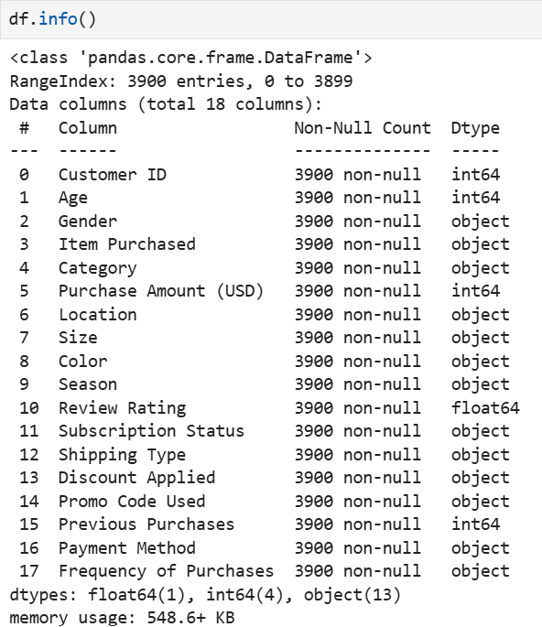

- Checked for missing values
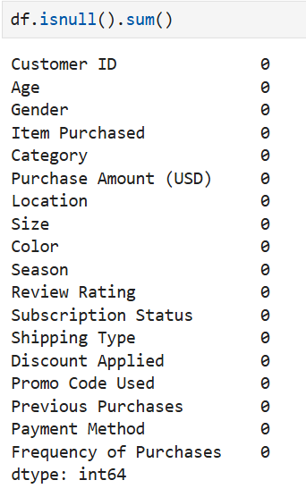

- Changed the column names to lowercase for uniformity. Renamed purchase_ amount_(usd) to purchase_amount for better readability.
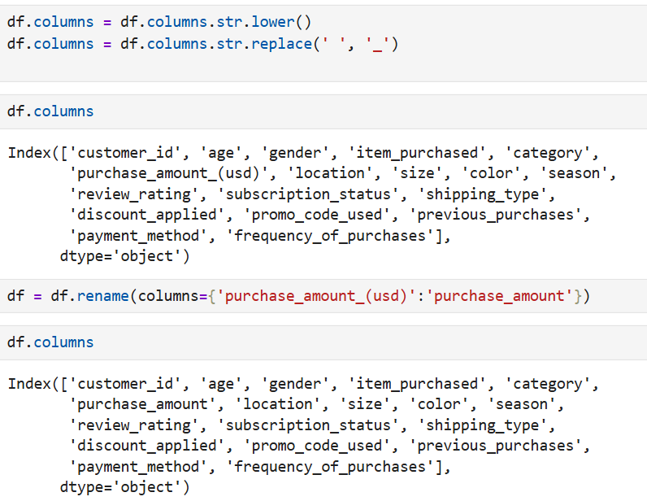
- Finding outliers in purchase amounts
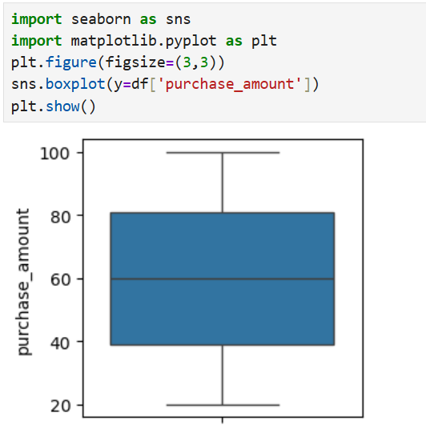
- Compared distribution of purchase_amount data for discount_applied, subscription_status.
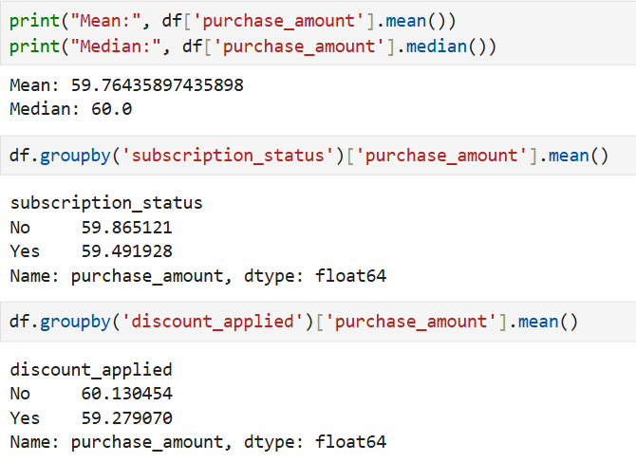
Since the mean and median was found to be similar for all the assessed variables, the data distribution is found to be normal. No skewness of data found.

- Identifying any existing correlations between the variables
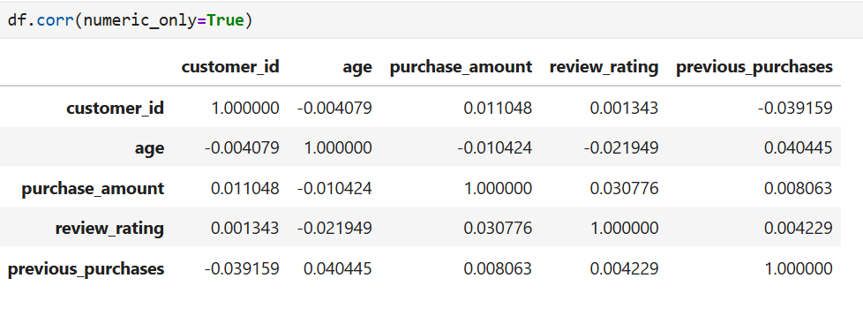
- Created age groups for analysis
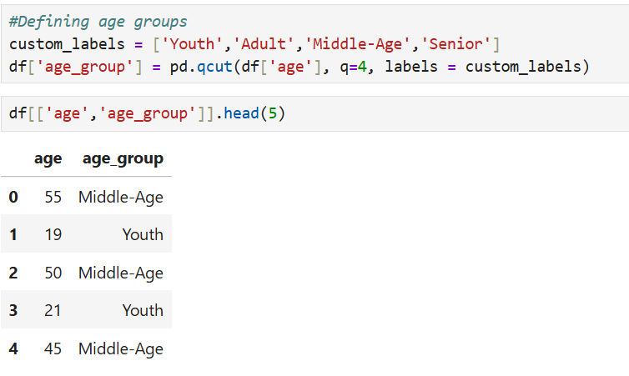
- Created a frequency map to convert alphabetic frequency data to numeric for analysis
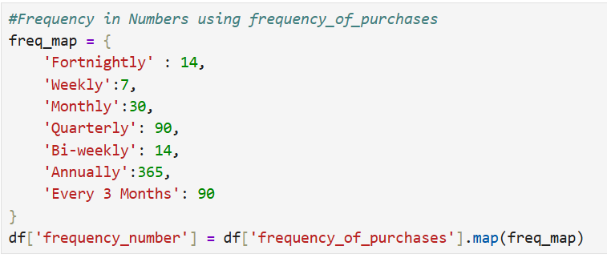
- Identified discount and promo code columns were redundant hence removed promo code column.
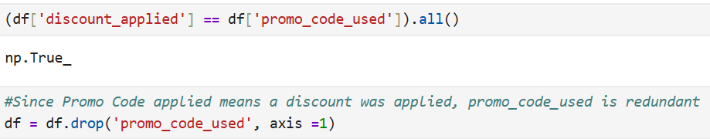
- Established a path between jupyter notebook and SQL Workbench to transfer the cleaned dataset from Python to SQL for analysis
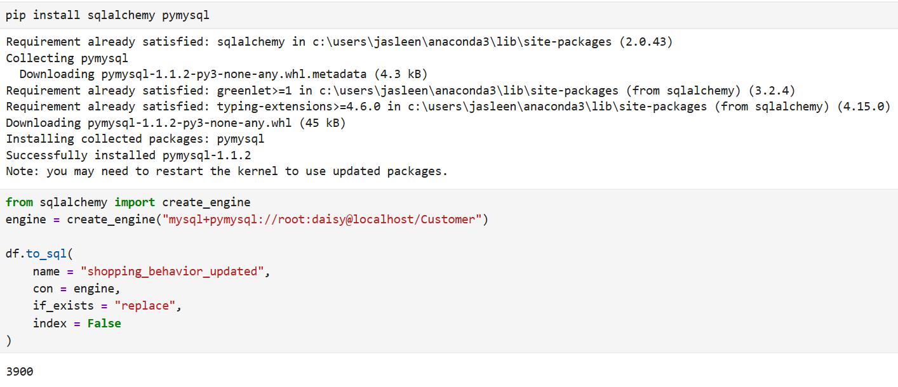
Data Analysis
SQL queries were used to aggregate and analyze the data in order to answer the defined business questions. Metrics such as average purchase value, revenue by category, and revenue by customer segment were calculated.
- Revenue and Profitability
  - Average purchase value across different demographic groups
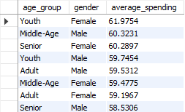

The average spending across different age groups for different genders does not differ by a lot, ranging from $58.5 to $61.9

  - Which product categories generate the highest revenue
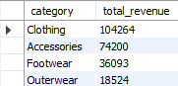

Clothing generates the most revenue.
Increasing variety could increase revenue, accessories could be bundled with clothing to increase cart value, outwear could be a potential seasonal product.

  - Which customer segments contribute the highest revenue
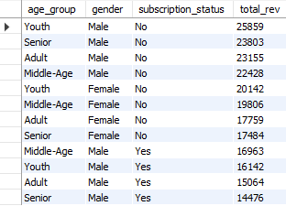

Men were found to be the highest paying segment without subscription. None of the females were found to have active subscription.

  - How does revenue vary by season
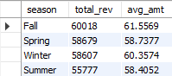

Revenue is the highest for fall and lowest for summer.

  - How do category sales vary by season (Helps in inventory management)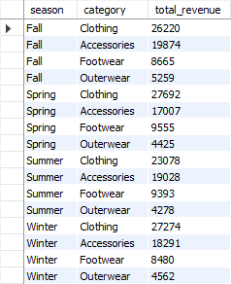
Clothing is the highest performing category for all seasons.
- Customer Value
  - can customers be segmented on spending levels?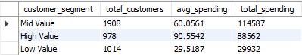
Customers who spend between $40-$80 get the highest revenue.
  - Is there a relationship between review ratings and spending?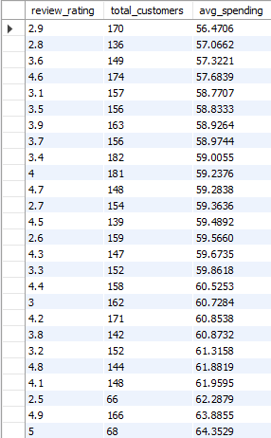
Spending does not depend on review ratings.
- Subscription Effectiveness
  - Do subscribers spend more than non-subscribers?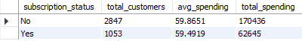
Non-subscribers were found to spend more than subscribers.
  - what % of high values customers are subscribed
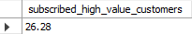
Only 26.28 % of the high spending customers are subscribed.
- Discount and Promotion Impact
  - Do discounts increase transaction value?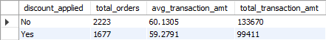
Discounts don’t increase transaction value which means company does not heavily rely on discounts to gain revenue

  - Is the company over-reliant on discount to drive sales?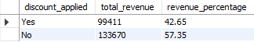
No, as the revenue percentage is more from the sales that were not discounted.

  - Do discounts impact spending behaviors across different age groups?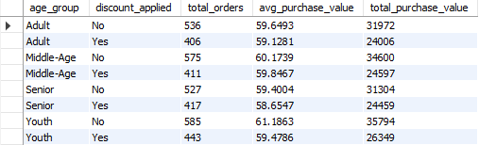
No, most people buy full-priced items.

  - How do different categories perform with and without discounts?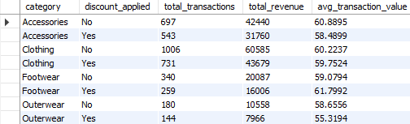
All categories sales amount for non-discounted items was higher in general.

- Operational analysis
  - Which shipping methods are most used?
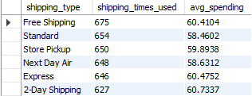
Most customers opt for free shipping method. Express and 2-day shipping are least used.

  - What payment methods are most preferred by high-value customers and regular customers?
High-value customers
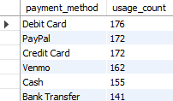
Regular customers
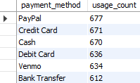
High-value customers prefer to use debit card and paypal whereas the regular customers prefer to use paypal and credit card.

Data Visualization
To make the insights easier to interpret, a Power BI dashboard was created. The dashboard allows users to quickly explore trends in customer spending, product performance, and operational factors such as shipping and discounts.
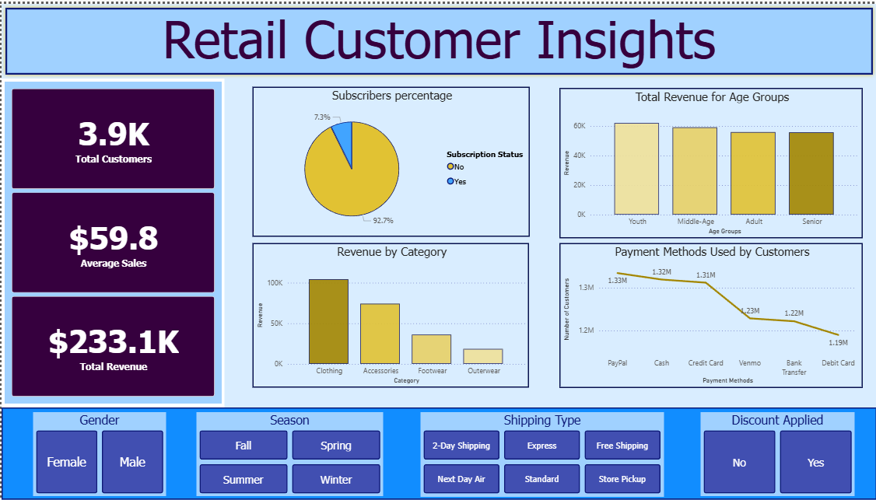
Key Insights
- Customer spending is relatively consistent across demographic groups.
  - Average purchase value across age groups and genders ranges between $58.5 and $61.9, showing very little variation.
- Clothing is the company’s primary revenue driver.
  - Clothing generates the highest total revenue and performs strongly throughout the year.
- Subscription program currently has limited adoption among customers.
  - Non-subscribers spend more than subscribers
  - Only 26.28% of high-spending customers are subscribed
  - Men without subscriptions represent the highest spending segment
  - No female customers in the dataset are subscribed
- Customer demand appears to follow seasonal trends
  - Fall generates the highest revenue while Summer generates the least revenue.
- Mid-range transactions are the most important contributors to sales.
  - Customers spending between $40 and $80 account for the largest share of total revenue.
- Business does not appear to rely heavily on discount-driven sales.
  - Most purchases occur at full price, and discounts do not significantly increase purchase value.
- Customers generally prioritize cost savings over faster delivery options.
  - Free-shipping is the most frequently selected option while express and 2-day shipping are least used.
- Payment methods differ for different sections of customers.
  - High-value customers tend to use debit cards and Paypal more as compared to regular customers who prefer using Paypal and Credit Cards.
Business Recommendations
- Strengthen High-performing categories
  - Since clothing generates the highest revenue, expanding product offerings and focusing marketing efforts on this category may help drive additional growth.
- Improve subscription program
  - The low adoption rate among high-value customers suggests that the subscription program may need stronger incentives or clearer benefits to increase participation.
- Increase engagement with female customers
  - The absence of female subscribers indicates a potential opportunity to review how the subscription program is positioned and marketed to ensure it appeals to a broader customer base.
- Align marketing with seasonal demand
  - Since revenue peaks in the fall, marketing campaigns and product launches could be timed to maximize demand during this period while introducing strategies to boost summer sales.
- Focus on mid-range purchase value customers
  - Given that most revenue comes from purchases between $40 and $80, product bundles or pricing strategies within this range may help increase overall sales.
- Maintain strategic pricing
  - As most purchases occur at full price, the business appears to maintain strong pricing power and may not need to rely heavily on discounts.
- Continue offering free shipping
  - Free shipping clearly aligns with customer preferences and should remain a key component of the purchasing experience.
Conclusion
This analysis provides a clearer understanding of customer purchasing behavior and the factors driving revenue. Clothing stands out as the company’s most important product category, while seasonal demand peaks during the fall. The findings also highlight the importance of mid-range transactions and reveal opportunities to strengthen the subscription program.
By leveraging these insights, the business can make more informed decisions around product strategy, customer engagement, and marketing initiatives, ultimately supporting sustainable revenue growth.

