**# Multiple-Year-Stock-Analysis**

Date # 15 Jan 2024

**Overview of Project**

In this project, I used macro and VBA scripts to pull and process thousands of rows in multiple worksheets and output summary columns of stocks. The raw data file was provided by the University of Toronto as a part of the Module 2 assignment.

**Requirements of the project –**

* Creating a Ticker symbol
* Volume of stock
* Open price
* Close price
* Performing conditional formatting
* Greatest increase
* Greatest decrease
* Greatest total volume

**Results**

Screenshot of analysis of the year 2018

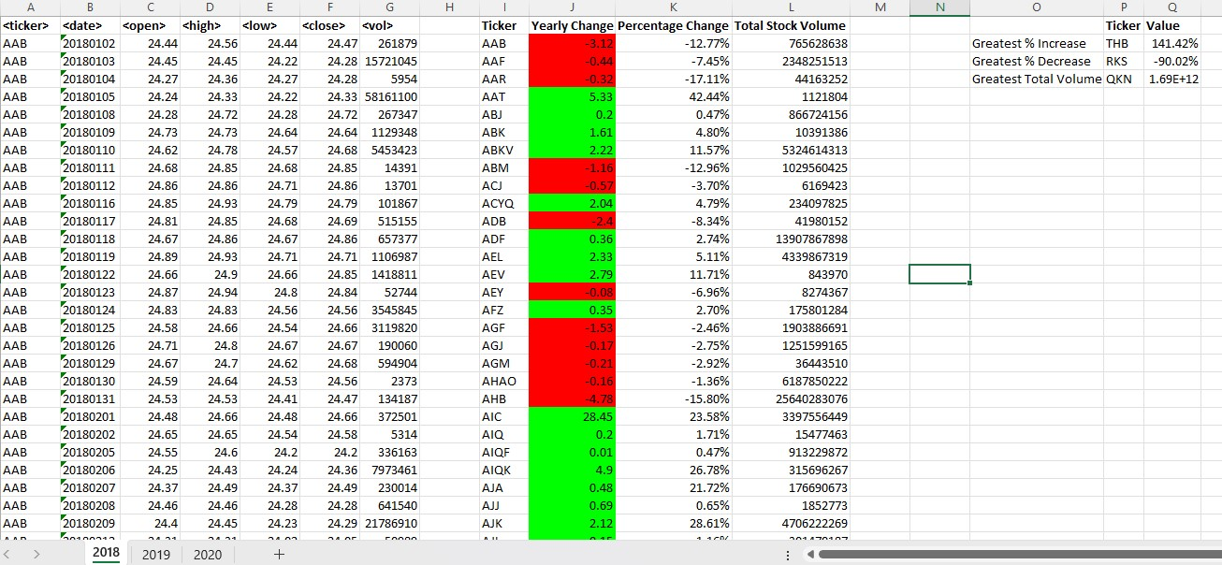

Screenshot of analysis of the year 2019

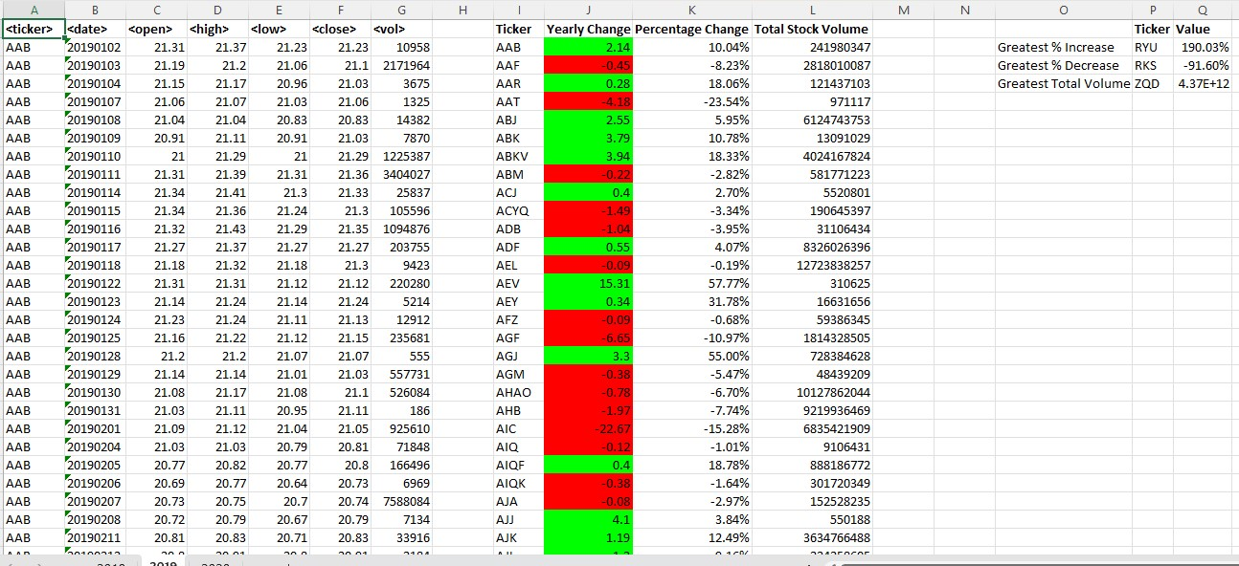

Screenshot of analysis of the year 2020

