FARMPLAN

UI/UX Design & Build Brief
Implementation-ready specification for Antigravity
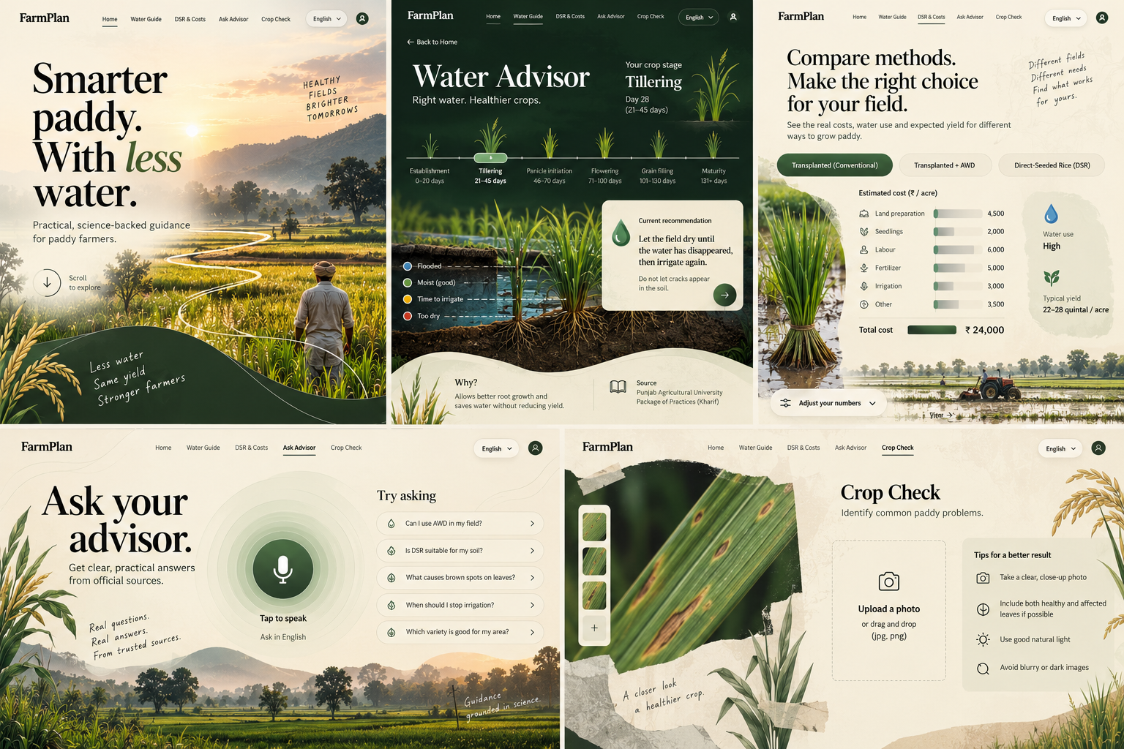
Visual reference: overall art direction and page compositions. Recreate the design as a functional responsive website; do not use this collage as a single page image.

1. Build objective
Build FarmPlan, a polished, responsive, English-language web app for small paddy farmers. Its purpose is to provide practical water-saving guidance, compare rice cultivation methods and costs, answer paddy-related questions from trusted official sources, and optionally help users inspect common crop problems.
The design must feel distinctive and art-directed—not like a generic SaaS dashboard. Use an editorial field-guide aesthetic: immersive paddy photography, oversized typography, asymmetrical compositions, flowing organic shapes, subtle paper texture, botanical illustrations, thin field-contour lines, and carefully composed data visualizations.

Primary design rule
Avoid a card-grid interface. Do not build every feature as a rounded rectangle. Prefer full-width sections, open layouts, inline comparisons, editorial text, image-led panels, thin separators, and purposeful negative space. Use contained surfaces only when they improve comprehension, such as the current irrigation recommendation or a photo-upload drop zone.

2. Product context and feature priorities
Build in this priority order:
- Tier 1 — Water-saving advisor: crop-stage AWD guidance, DSR suitability checklist, and cost comparison calculator.
- Tier 2 — Grounded AI advisor: text/voice questions answered from curated official documents, with visible citations and a safe fallback.
- Tier 3 — Crop photo checker: optional and narrowly scoped; show confidence and refuse to guess when uncertain.
Product constraints: software-only; mobile-first; low-bandwidth friendly; no unnecessary diary/logging; minimal data entry; do not base high-cost irrigation decisions on uncertain weather forecasts; show what is known, the source, and when it was verified.

3. Design system

Palette
Token | Hex | Usage
Warm ivory | #F5F2E9 | Main page background
Soft sage | #DCE4D2 | Quiet highlights and selected states
Muted olive | #6D8563 | Secondary actions and plant details
Forest ink | #203A2C | Primary text, dark surfaces, main buttons
Terracotta | #C18161 | Rare caution/warm accent
Water blue | #6D9BA6 | Water-level and irrigation visuals
Soft gold | #C8A85B | Small details, harvest illustrations

Typography
- Display headings: Fraunces or a comparable editorial serif. Use large, confident headlines with controlled line breaks.
- Interface/body: DM Sans or Manrope. Keep body copy readable and concise.
- Use consistent type hierarchy, restrained weights, and enough line-height for accessibility.
- English is the only language to implement in this pass. Keep localization architecture possible, but do not mix Punjabi and English on the same page.

Shape, imagery and motion
- Use flowing, irregular curves inspired by field boundaries and irrigation channels—not identical pill-shaped cards everywhere.
- Use real-looking paddy fields, soil layers, rice plants, leaves and water as visual storytelling elements.
- Use hand-drawn annotations sparingly, only where they support explanation.
- Subtle transitions: fade/slide content, timeline selection, water ripple or waveform animation. Avoid heavy parallax, distracting animation, and performance-costly effects.
- Icons should be consistent line icons; avoid emoji icons and generic AI-looking illustrations.
- Maintain accessible contrast, visible focus states, keyboard navigation, reduced-motion support, and large touch targets.

4. Shared site structure
Use a slim, elegant navigation system with the FarmPlan wordmark on the left and links to Home, Water Guide, DSR & Costs, Ask Advisor, and Crop Check. Keep the English language selector visible as a control, but English is the only active language in this build. Add a restrained profile/settings icon only if it has a real purpose.
On mobile, convert navigation to a compact menu or bottom navigation with clear labels. Never shrink the desktop navigation until it becomes unreadable. Keep the visual identity consistent, but make each page composition distinct.

5. Page-by-page specification

Page A — Home: “The Living Field”
Visual concept: an immersive, image-led editorial landing page.
- Hero occupies most of the first viewport. Use a high-quality paddy landscape image with an asymmetrical organic mask or flowing edge.
- Headline: “Smarter paddy. With less water.” Supporting copy: “Practical, science-backed guidance for paddy farmers.”
- Primary CTA: “Ask your advisor” routes to Ask Advisor. Secondary action: “Explore water guide” routes to Water Advisor.
- Add a small, elegant three-part value statement: less water; informed choices; trusted guidance.
- Below the hero, introduce the three core jobs as full-width editorial sections or typographic links—not a 3/4-card dashboard grid.
- Use a small hand-drawn contour/irrigation line to lead the eye through the page.
- Mobile: stack headline and image cleanly; preserve legibility and avoid text over busy image areas.

Page B — Water Advisor: “The Water Atlas”
Visual concept: a more immersive dark forest-green page with a living field and soil/water cross-section.
- Use a dark forest-green canvas with bright but restrained plant greens and water-blue accents.
- At the top, show the computed crop stage and day range derived from the provided sowing date and variety duration. Do not ask users to manually update crop stage every day.
- Create a horizontal crop-stage timeline: Establishment, Tillering, Panicle initiation, Flowering, Grain filling, Maturity. Make the active stage visually obvious.
- Main illustration: rice plants above ground, roots and soil layers below, and a clear water-level visualization. Use labels for flooded, moist, time to irrigate, and too dry/avoid cracks where applicable.
- Show one short current recommendation in a prominent editorial panel, with a clear next/detail affordance.
- Place the official source and its verification date close to the recommendation—not hidden in settings.
- Guardrails: saline soil/water must trigger a warning and referral; flowering must never recommend a dry period; unknown inputs default to the safer rule and explain uncertainty.
- Do not claim guaranteed savings. Any water-saving range must be verified against an official source before it is displayed.
- If no verified rules are available, show an explicit setup/demo state instead of inventing irrigation instructions.

Page C — DSR & Costs: “The Field Ledger”
Visual concept: warm paper, field photography, editorial typography, and precise comparison graphics.
- Lead with the heading: “Compare methods. Make the right choice for your field.”
- Offer three selectable methods: Transplanted (Conventional), Transplanted + AWD, and Direct-Seeded Rice (DSR).
- Use a wide comparison table or editorial columns rather than separate feature cards. Include estimated cost per acre, water-use category, expected yield range, and relevant caveats.
- Inputs: sowing method, sowing/transplanting date, soil type, previous crop, variety or “don’t know”, field levelling status, and salinity status. Collect the minimum required information and explain why it is needed.
- DSR checklist: previous crop, levelling, seed-drill access, ability to apply the required weed-control treatment within the recommended time, weed history, and salinity. Return Go / Go with caution / Not recommended with plain-language reasons.
- Always include the alternative: AWD on transplanted paddy may be worth considering and does not require a DSR seed drill or DSR herbicide program.
- Cost calculator should expose editable inputs for seed, labour, nursery, herbicide, machine, levelling, irrigation, and applicable incentive. Show a clear per-acre total.
- Add a user-editable expected yield-difference slider and calculate break-even yield difference. Explain that DSR yield may be lower if weeds are not controlled.
- Store defaults with source and “last verified” date. Never hard-code old prices or incentives as current facts.
- Use illustrative placeholder values only in a clearly labelled demo state; do not present mock numbers as verified advice.

Page D — Ask Advisor: “The Listening Room”
Visual concept: spacious, quiet, voice-first, and intentionally unlike a standard chatbot.
- Use a warm ivory background with subtle topographic contour lines and minimal botanical details.
- Make a large microphone/soundwave the central interaction. Add a clear “Tap to speak” label and a text input fallback.
- Show suggested questions as a simple, elegant list of rows with separators—not chat bubbles or a card grid.
- Support English in/out for this build. Structure the interface so Punjabi/Hindi can be added later without mixing languages in one view.
- Answers should be short and farmer-friendly, with a visible official source title, document date/page or section where available, and optional audio playback.
- The model must answer only from retrieved curated passages. If sources do not cover the question or retrieval confidence is low, show: “I don’t have a reliable answer for this. Please contact your local agriculture office.”
- Never provide chemical doses unless explicitly present in a retrieved official source; even then cite it and tell the user to check the product label.
- For spraying, disease, or costly decisions, show a recommendation to confirm with a local agriculture officer.
- Show loading, listening, transcription, answer, error, and no-source states as part of the design.

Page E — Crop Check: “The Field Journal”
Visual concept: botanical specimen page, macro leaf photography, restrained annotations, and a clear upload area.
- Use one large leaf/photo composition with an organic edge and a few subtle diagnostic markers.
- Provide a clear drag-and-drop/photo upload area with a camera option on mobile. Explain how to take a useful photo: close-up, natural light, include healthy and affected leaves where possible.
- Keep scope to 5–8 locally relevant, visually distinguishable paddy problems only after local validation.
- Results must show: most likely issue or “unclear”; confidence High/Medium/Low; signs to check; relevant official guidance and source; next step.
- Low confidence must not guess. Ask for a better photo or refer to an agriculture officer.
- Never output chemical names or doses unless they come directly from retrieved official guidance. Always encourage confirmation before spraying.
- Clearly label this feature as experimental until validated on real field photos.

6. Functional behaviour and technical expectations
- Build a real multi-page or route-based application, not a static screenshot. Every nav link and CTA must work.
- Use reusable components for navigation, typography, source attribution, input controls, buttons, alerts and loading/error states—but do not force all pages into the same layout template.
- Mobile-first and responsive from small Android screens through desktop. Optimize images and avoid large unnecessary bundles.
- Tier 1 rules and cost calculations should be possible in the frontend using a versioned JSON data file. Each rule/default should include source and verification date.
- Tier 2 may use a backend for document ingestion, retrieval and answer generation. Keep secrets in environment variables; never expose API keys in client code.
- Use a curated official document set (for example, state agricultural university guidance, ICAR, state agriculture department and KVK materials), with usage/licensing terms recorded.
- Add accessible form validation, keyboard support, semantic headings, descriptive labels and meaningful empty/error states.
- Do not add unrelated features such as price forecasting, machine marketplace, diary logging, satellite flood claims or yield-learning loops.

7. Trust, safety and data integrity
- Never invent official recommendations, source names, dates, cost defaults, incentive status, yield ranges or water-saving claims.
- If source content is not yet configured, clearly show “Guidance not configured yet” in development mode.
- Separate demo/sample data from verified guidance in code and UI.
- Show uncertainty honestly and refer to a human agriculture officer when needed.
- Weather forecasts may only provide a cautious nudge if implemented and locally validated; they must never independently trigger irrigation skipping, especially during flowering.
- Do not imply that FarmPlan verifies seed quality or replaces agriculture officers.

8. Acceptance checklist
- ☐ All five pages are implemented and navigable.
- ☐ Each page has a distinct layout/composition while sharing a coherent design system.
- ☐ No repetitive grid of feature cards; the interface uses editorial layouts, imagery, open space and purposeful data visualization.
- ☐ English-only interface throughout this build, including all states and controls.
- ☐ Responsive on mobile and desktop, with accessible contrast and touch targets.
- ☐ Water guidance is stage-based, sourced, dated, and protected by salinity/flowering/unknown-input guardrails.
- ☐ DSR suitability explains each warning; cost calculations use editable, sourced defaults and clearly labelled assumptions.
- ☐ Advisor answers display source evidence or decline safely.
- ☐ Crop checker reports confidence and refuses to guess when uncertain.
- ☐ All displayed sample numbers are labelled illustrative until verified.
- ☐ No broken buttons, placeholder navigation, fake upload success, or decorative controls that do nothing.

9. Instructions to Antigravity
Read this document completely before coding. Inspect the existing project and preserve working functionality. Implement the design as a real, responsive application rather than reproducing the reference image as a single background. Start with the design system and shared navigation, then build Home, Water Advisor, DSR & Costs, Ask Advisor, and Crop Check. Prioritize Tier 1 first, then the grounded advisor, and leave crop diagnosis as a clearly marked optional/experimental tier if validation is not available. Use thoughtful placeholder states wherever verified agronomic content or API credentials are missing. After implementation, run the app, inspect every page at mobile and desktop sizes, fix layout issues, and report what is functional versus still mocked.

10. Project source of truth
The FarmPlan v2 build specification defines the product scope and agronomic guardrails. This brief defines the English UI direction and page compositions. If a visual design choice conflicts with a safety rule or verified official guidance, the safety rule and source-backed guidance take precedence.

