GURU NANAK DEV ENGINEERING COLLEGE
DEPARTMENT OF
INFORMATION TECHNOLOGY

MINOR PROJECT
Advanced Web Technologies
(5th Semester 2021-2025 Batch)
JULY-DECEMBER,2023


Submitted to: Submitted by:
(Prof).Akshay Girdhar Jasmeen Kaur Gill
URN:2104390
CRN:2121138

MINOR PROJECT
PROJECT NAME: Attendance Management System in CodeIgniter
ABOUT: It is a fully functional web-based system. It is built on the CodeIgniter Web Framework and uses PHP as its programming language.
This Employee Attendance Management System It comes with a number of features that allow users to keep track of their employees’ attendance. It helps to keep track of how many hours your employees work for you each week or each month. It is the way you keep track of how long your employees work and how long they take off. It is true.
It was created with HTML, CSS, Bootstrap, JavaScript, Ajax, JQUERY, and Modal, as well as the PHP Programming Language, Codeigniter Framework, and MySQL database.
Language Used: PHP (Codeigniter Framework)
PHP Version: 7.4
Database: MySQL
Type of Project: Website, Web Application
STEPS TO RUN THE PROJECT:
- Step 1: Open Wamp
Next, open Xampp and start the Apache and MySQL.
- Step 2 : Create Database
Next, click any browser and type to the URL localhost/phpmyadmin and create database.
- Step 3 : Write codes for files
Now write code for conteoller, modal , views.
- Step 4: Import Database
Type on cmd to start the project php spark serve
- Step 5 : Execute Project
Final, type to the URL “localhost:8080”.
CODE
- FILE: app/Config/Database.php
$db['default'] = array(
'dsn' => '',
'hostname' => 'localhost',
'username' => 'root',
'password' => '',
'database' => 'seams_ci',
'dbdriver' => 'mysqli',
'dbprefix' => '',
'pconnect' => FALSE,
'db_debug' => (ENVIRONMENT !== 'production'),
'cache_on' => FALSE,
'cachedir' => '',
'char_set' => 'utf8',
'dbcollat' => 'utf8_general_ci',
'swap_pre' => '',
'encrypt' => FALSE,
'compress' => FALSE,
'stricton' => FALSE,
'failover' => array(),
'save_queries' => TRUE
);

- FILE: app/Controllers/ProfileController.php
<?php
class Employee extends CI_Controller
{
public function dashboard()
{
if (!$this->session->userdata("username")) {
redirect("user/login");
} else {
$employees = $this->Employee_model->dashboard();

$this->load->view("inc/header");
$this->load->view("employee/dashboard", [ "employees" => $employees ]);
$this->load->view("inc/footer");
}
}
public function empadd()
{
$this->load->view("inc/header");
$this->load->view("employee/empadd");
$this->load->view("inc/footer");
}
public function empinsert()
{
$this->form_validation->set_rules($rules);

if ($this->form_validation->run() == false) {
$this->empadd();
} else {
$data = $this->Employee_model->empinsert();
if ($data) {
$this->session->set_flashdata("empinsert", "Employee added successfully.");
} else {
$this->session->set_flashdata("empinsertnot", "Employee does not add.");
}
redirect("employee/empadd");
}
}

public function empedit($emp_id)
{
$employee = $this->Employee_model->empsearch($emp_id);

$this->load->view("inc/header");
$this->load->view("employee/empedit", [ "employee" => $employee ]);
$this->load->view("inc/footer");
}
public function empdelete($emp_id)
{
$employee = $this->Employee_model->empsearch($emp_id);

$this->load->view("inc/header");
$this->load->view("employee/empdelete", [ "employee" => $employee ]);
$this->load->view("inc/footer");
}

public function empremove()
{
$data = $this->Employee_model->empremove();
if ($data) {
$this->session->set_flashdata("empremove", "Employee deleted successfully.");
redirect("employee/dashboard");
} else {
$this->session->set_flashdata("empremovenot", "Employee does not deleted.");
redirect("employee/empdelete");
}
}

public function attsearch()
{
$emp_id = $this->uri->segment(3);
$year = $this->uri->segment(4);
$month = $this->uri->segment(5);

$employee = $this->Employee_model->empsearch($emp_id);
$attendances = $this->Employee_model->attsearch();

$this->load->view("inc/header");
redirect("employee/attadd/$emp_id/$year/$month", [ "year" => $year, "month" => $month, "employee" => $employee, "attendances" => $attendances ]);
$this->load->view("inc/footer");
}

public function attadd()
{
$emp_id = $this->uri->segment(3);
$year = $this->uri->segment(4);
$month = $this->uri->segment(5);

$employee = $this->Employee_model->empsearch($emp_id);
$attendances = $this->Employee_model->attsearch();

$this->load->view("inc/header");
$this->load->view("employee/attadd", [ "year" => $year, "month" => $month, "employee" => $employee, "attendances" => $attendances ]);
$this->load->view("inc/footer");
}

public function attupdate()
{
$emp_id = $this->input->post("empid");
$year = $this->input->post("year");
$month = $this->input->post("month");

$employee = $this->Employee_model->empsearch($emp_id);
$data = $this->Employee_model->attupdate();
$attendances = $this->Employee_model->attsearch();

$this->load->view("inc/header");
redirect("employee/attadd/$emp_id/$year/$month", [ "year" => $year, "month" => $month, "employee" => $employee, "attendances" => $attendances ]);
$this->load->view("inc/footer");
}
}

- FILE: app/Controllers/Users.php
<?php
defined('BASEPATH') OR exit('No direct script access allowed');
class User extends CI_Controller
{
public function login()
{
$this->load->view("inc/header");
$this->load->view("user/login");
$this->load->view("inc/footer");
}
public function signin()
{
$this->form_validation->set_rules("username", "Username", "required|trim");
$this->form_validation->set_rules("password", "Password", "required|trim");

if ($this->form_validation->run() == false) {
$this->login();
} else {
$userdata = $this->User_model->signin();

if ($userdata) {
$userdataSession = [
"userid" => $userdata->id,
"username" => $userdata->username,
];

$this->session->set_userdata($userdataSession);
redirect("employee/dashboard");
} else {
$this->session->set_flashdata('userlogin', 'User login failed.');
redirect("user/login");
}
}
}
public function adminImage()
{
echo "Image";
}
public function adminSettings()
{
echo "Settings";
}
public function logout()
{
$this->session->sess_destroy();
redirect("home/index");
}
}

- FILE: app/Controllers/Employee_model.php
<?php
class Employee_model extends CI_Model
{
public function empinsert()
{
$data = [
"name" => $this->input->post("name"),
"address" => $this->input->post("address"),
"email" => $this->input->post("email"),
"mobile" => $this->input->post("mobile"),
"dob" => $this->input->post("dob"),
"doj" => $this->input->post("doj"),
"status" => $this->input->post("status") == '1' ? '1' : '0',
];

return $this->db->insert("employees", $data);
}

public function dashboard()
{
$this->db->from("employees");
$this->db->order_by("name");
$query = $this->db->get();
return $query->result();
}

public function empsearch($emp_id)
{
$query = $this->db->get_where("employees", [ "id" => $emp_id ]);
return $query->row();
}

public function empupdate()
{
$id = $this->input->post("id");
$data = [
"name" => $this->input->post("name"),
"address" => $this->input->post("address"),
"email" => $this->input->post("email"),
"mobile" => $this->input->post("mobile"),
"dob" => $this->input->post("dob"),
"doj" => $this->input->post("doj"),
"status" => $this->input->post("status") == '1' ? '1' : '0',
];

$this->db->where("id", $id);
return $this->db->update("employees", $data);
}

public function empremove()
{
$id = $this->input->post("id");
$this->db->where("id", $id);
return $this->db->delete("employees");
}

public function attendance()
{
$emp_id = $this->input->post("empid");
$year = $this->input->post("year");
$year = $year != "" ? $year : date("Y");
$month = $this->input->post("month");
$month = $month != "" ? $month : date("m");
$like_date = $year . "-" . $month . "-";
$empid = [];
$name = [];
$present = [];
$absent = [];
$holiday = [];

$this->db->select("id, name, mobile, email");
$this->db->where("status", "1");
$this->db->from("employees");
$this->db->order_by("name");
$query = $this->db->get();
$result = $query->result();

for ($i = 0; $i < count($result); $i++) {
$this->db->select("attdate, attstatus");
$this->db->where([ "empid" => $result[$i]->id, "attstatus" => "P" ]);
$this->db->like([ "attdate" => $like_date ]);
$this->db->from("attendance");
$query2 = $this->db->get();
$result2 = $query2->result();
$this->db->select("attdate, attstatus");
$this->db->where([ "empid" => $result[$i]->id, "attstatus" => "A" ]);
$this->db->like([ "attdate" => $like_date ]);
$this->db->from("attendance");
$query3 = $this->db->get();
$result3 = $query3->result();
$this->db->select("attdate, attstatus");
$this->db->where([ "empid" => $result[$i]->id, "attstatus" => "H" ]);
$this->db->like([ "attdate" => $like_date ]);
$this->db->from("attendance");
$query4 = $this->db->get();
$result4 = $query4->result();
$empid[] = $result[$i]->id;
$name[] = $result[$i]->name;
$present[] = count($result2);
$absent[] = count($result3);
$holiday[] = count($result4);
}

$data = [ $empid, $name, $present, $absent, $holiday ];
return $data;
}

public function attsearch()
{
$emp_id = $this->uri->segment(3);
$year = $this->uri->segment(4);
$month = $this->uri->segment(5);
$this->db->like([ "attdate" => $year . "-" . $month . "-" ]);
$this->db->where("empid", $emp_id);
$this->db->from("attendance");
$this->db->order_by("attdate");
$query = $this->db->get();
return $query->result();
}

public function attupdate()
{
$empid = $this->input->post("empid");
$year = $this->input->post("year");
$month = $this->input->post("month");
$attstatus = $this->input->post("attstatus");
$save = $this->input->post("save")[0];

$attdate = $attstatus[$save - 1];
$attdate = $year . "-" . $month . "-" . $save;

$attstatus = $attstatus[$save - 1];
}
}
- FILE: app/Controllers/Users_model.php
<?php
class User_model extends CI_Model
{
public function signin()
{
$username = $this->input->post("username");
$password = sha1($this->input->post("password"));
$user = $this->db->where(["username" => $username, "password" => $password, "active" => "1"])->get("users");
return $user->row();
}

public function adminImage(){}
public function adminSettings(){}
}

- FILE: app/View/employee/attadd.php
<div class="container mt-4">
<div class="row justify-content-start">
<h4 class="pr-2" style="color:#656565"><?php echo $employee->name; ?>'s attendance for </h4>
<?php echo form_open("employee/attendance/1"); ?>
<div class="form-row">
<div class="col">
<input type="text" name="year" class="form-control" placeholder="YYYY" size="10" value="<?php echo $year != '' ? $year : date('Y'); ?>">
</div>
<div class="col">
<input type="text" name="month" class="form-control" placeholder="MM" size="10" value="<?php echo $month != '' ? $month : date('m'); ?>">
</div>
<div class="col-6">
<input type="hidden" name="empid" value="<?php echo $employee->id; ?>">
<button type="submit" class="btn btn-primary" style="border-radius:0%;">Submit</button>
<a href="<?php echo base_url(); ?>employee/attendance" class="btn btn-dark" style="border-radius:0%;">Go Back</a>
</div>
</div>
<?php echo form_close(); ?>
</div>
<div class="row table-responsive mt-4 mb-4">
<table class="table table-striped">
<thead>
<tr>
<th scope="col">Date</th>
<th scope="col">Weekday</th>
<th scope="col">Status</th>
<th scope="col">Action</th>
</tr>
</thead>
<tbody>
<?php echo form_open("employee/attupdate"); ?>
<?php
$days = cal_days_in_month(CAL_GREGORIAN, $month, $year);
$arrIndex = 0;
for ($i = 1; $i <= $days; $i++) {
$weekday = date("l", strtotime(date($year . "-" . $month . "-" . $i)));
$date_current = $year . "-" . $month . "-" . ( strlen($i) == 1 ? "0" . $i : $i );
?>
<tr <?php echo $weekday == "Sunday" ? "class='text-danger'" : ""; ?>>
<th scope="row"><?php echo $i; ?></th>
<td><?php echo $weekday; ?></td>
<td>
<?php if (strcmp($date_current, @$attendances[$arrIndex]->attdate) == 0) { ?>
<select name="attstatus[]" class="custom-select <?php echo $weekday == 'Sunday' ? 'text-danger' : ''; ?>" id="inlineFormCustomSelectPref">
<option value="">Select</option>
<option value="P" <?php if (@$attendances[$arrIndex]->attstatus == "P") echo "selected"; ?>>Present</option>
<option value="A" <?php if (@$attendances[$arrIndex]->attstatus == "A") echo "selected"; ?>>Absent</option>
<option value="H" <?php if (@$attendances[$arrIndex]->attstatus == "H") echo "selected"; ?>>Holiday</option>
</select>
<?php
$arrIndex++;
} else {
?>
<select name="attstatus[]" class="custom-select <?php echo $weekday == 'Sunday' ? 'text-danger' : ''; ?>" id="inlineFormCustomSelectPref">
<option value="">Select...</option>
<option value="P">Present</option>
<option value="A">Absent</option>
<option value="H" <?php echo $weekday == "Sunday" ? "selected" : ""; ?>>Holiday</option>
</select>
<?php } ?>
</td>
<td>
<button type="submit" name="save[]" value="<?php echo strlen($i) == 1 ? "0" . $i : $i; ?>" class="btn btn-success" style="border-radius:70px;"><i class="fas fa-check"></i></button>
</td>
</tr>
<?php } ?>
<input type="hidden" name="empid" value="<?php echo $employee->id; ?>">
<input type="hidden" name="year" value="<?php echo $year; ?>">
<input type="hidden" name="month" value="<?php echo $month; ?>">
<?php echo form_close(); ?>
</tbody>
</table>
</div>
</div>

- FILE: app/View/employee/attendance.php
<div class="container mt-4">
<div class="row d-flex mb-2">
<div class="col-12 col-sm-12 col-md-8 col-lg-8 col-xl-8">
<h3 style="color:#656565">Employee Attendance</h3>
</div>
<div class="col-12 col-sm-12 col-md-4 col-lg-4 col-xl-4">
<?php echo form_open("employee/attendance"); ?>
<div class="form-row">
<div class="col">
<input type="text" name="year" class="form-control" placeholder="YYYY" value="<?php echo $year != '' ? $year : date('Y'); ?>">
</div>
<div class="col">
<input type="text" name="month" class="form-control" placeholder="MM" value="<?php echo $month != '' ? $month : date('m'); ?>">
</div>
<div class="col-5">
<button type="submit" class="btn btn-success" style="border-radius:0%;"><i class="fas fa-sort"></i> Filter Date</button>
</div>
</div>
<?php echo form_close(); ?>
</div>
</div>
<div class="row table-responsive">
<div class="col-12">
<table class="table table-striped table-hover">
<thead>
<tr>
<th scope="col">#</th>
<th scope="col">Name</th>
<th scope="col">Present</th>
<th scope="col">Absent</th>
<th scope="col">Holiday</th>
<th scope="col">Attendance</th>
</tr>
</thead>
<tbody>
<?php
$count = 0;
for ($i = 0; $i < count($data[0]); $i++) {
?>
<tr>
<th scope="row"><?php echo ++$count; ?></th>
<td><?php echo $data[1][$i]; ?></td>
<td><?php echo $data[2][$i]; ?></td>
<td><?php echo $data[3][$i]; ?></td>
<td><?php echo $data[4][$i]; ?></td>
<td><a href="<?php echo base_url(); ?>employee/attadd/<?php echo $data[0][$i]; ?>/<?php echo $year; ?>/<?php echo $month; ?>"><button class="btn btn-warning btn-sm" style="border-radius:0%;">Manage</button></a></td>
</tr>
<?php } ?>
</tbody>
</table>
</div>
</div>
</div>

- FILE: app/View/employee/dashboard.php
<div class="container mt-4">
<div class="row d-flex">
<div class="col-12 col-sm-12 col-md-8 col-lg-8 col-xl-8 text-left">
<h3 lass="text-center" style="color:#656565">Employee Section</h3>
</div>
<div class="col-12 col-sm-12 col-md-4 col-lg-4 col-xl-4 text-right">
<a href="<?php echo base_url(); ?>employee/empadd"><h3><button class="btn btn-success" style="border-radius:0%;"><i class="fas fa-plus-square"></i> Add Employee Records</button></h3></a>
</div>
</div>
<div class="row table-responsive">
<div class="col-12">
<table class="table table-striped table-hover">
<thead>
<tr>
<th scope="col" class="text-center">#</th>
<th scope="col" class="text-center">Fullname <i class="fa fa-user"></i></th>
<th scope="col" class="text-center">Email <i class="fa fa-at"></i></th>
<th scope="col" class="text-center" >Contact <i class="fas fa-phone-square-alt"></i></th>
<th scope="col" class="text-center" >Address <i class="fas fa-map-marker-alt"></i></th>
<th scope="col" class="text-center">Joined <i class="fas fa-calendar-alt"></i></th>
<th scope="col" class="text-center">Actions</th>

</tr>
</thead>
<tbody>
<?php
$count = 0;
foreach ($employees as $emp) {
?>
<tr>
<th scope="row" class="text-center"><?php echo ++$count; ?></th>
<td class="text-center"><?php echo $emp->name; ?></td>
<td class="text-center"><?php echo $emp->email; ?></td>
<td class="text-center"><?php echo $emp->mobile; ?></td>
<td class="text-center"><?php echo $emp->address; ?></td>
<td class="text-center"><?php echo $emp->doj; ?></td>
<td class="text-center"><a href="<?php echo base_url(); ?>employee/empedit/<?php echo $emp->id; ?>"><button class="btn btn-success" style="border-radius:60px;"><i class="fas fa-pencil-alt"></i></button></a>
<a href="<?php echo base_url(); ?>employee/empdelete/<?php echo $emp->id; ?>"><button class="btn btn-danger" style="border-radius:60px;"><i class="fas fa-trash"></i></button></a></td>
</tr>
<?php } ?>
</tbody>
</table>
</div>
</div>
</div>

- FILE: app/View/employee/empadd.php
<div class="container mt-4">
<div class="row d-flex ml-2">
<div class="col"></div>

<div class="col-6">
<h2 class="text-center" style="color:#656565">Employee Registration</h2>
</div>

<div class="col"></div>
</div>
<?php if ($this->session->flashdata("empinsert")) { ?>
<div class="row d-flex mt-4 ml-2 alert alert-success">
<?php echo $this->session->flashdata("empinsert"); ?>
</div>
<?php } ?>
<?php if ($this->session->flashdata("empinsertnot")) { ?>
<div class="row d-flex mt-4 ml-2 alert alert-danger">
<?php echo $this->session->flashdata("empinsertnot"); ?>
</div>
<?php } ?>
<?php if (validation_errors()) { ?>
<div class="row d-flex mt-4 ml-2 alert alert-danger">
<?php echo validation_errors(); ?>
</div>
<?php } ?>
<div class="row d-flex mt-4 ml-2">
<div class="col"></div>

<div class="col-6">
<?php echo form_open_multipart("employee/empinsert"); ?>
<div class="form-group">
<input type="text" class="form-control" name="name" placeholder="Name" value="<?php echo set_value('name'); ?>">
</div>
<div class="form-group">
<input type="text" class="form-control" name="address" placeholder="Address" value="<?php echo set_value('address'); ?>">
</div>
<div class="form-group">
<input type="email" class="form-control" name="email" placeholder="Email Address" value="<?php echo set_value('email'); ?>">
</div>
<div class="form-group">
<input type="number" class="form-control" name="mobile" placeholder="Mobile Number" value="<?php echo set_value('mobile'); ?>">
</div>
<div class="form-group">
<input type="date" class="form-control float-left" name="dob" placeholder="DOB::DD.MM.YYYY" value="<?php echo set_value('dob'); ?>"><label>Date of Birth</label>
</div>
<div class="form-group">
<input type="date" class="form-control" name="doj" placeholder="DOB::DD.MM.YYYY" value="<?php echo set_value('doj'); ?>"><span>Date of Joining</span>
</div>
<div class="custom-control custom-checkbox mb-3">
<input type="checkbox" class="custom-control-input" id="customCheck" name="status" value="1" checked>
<label class="custom-control-label" for="customCheck">Set As Active</label>
</div>
<div class="form-group text-center">
<button type="submit" class="btn btn-success" style="border-radius:0%;">Submit</button>
<a href="dashboard" class="btn btn-dark" style="border-radius:0%;">Go Back</a>
</div>
<?php echo form_close(); ?>
</div>

<div class="col"></div>
</div>
</div>

- FILE: app/View/employee/empdelete.php
<div class="container mt-4">
<div class="row d-flex ml-2 text-center">
<div class="col"></div>

<div class="col-6">
<h3 style="color:#656565">Remove Employee's Record</h3>
<br>
<h5 style="color:red;">Are you sure you want to remove this data?</h5>
</div>

<div class="col"></div>
</div>
<?php if ($this->session->flashdata("empdelete")) { ?>
<div class="row d-flex mt-4 ml-2 alert alert-success">
<?php echo $this->session->flashdata("empdelete"); ?>
</div>
<?php } ?>
<?php if ($this->session->flashdata("empdeletenot")) { ?>
<div class="row d-flex mt-4 ml-2 alert alert-danger">
<?php echo $this->session->flashdata("empdeletenot"); ?>
</div>
<?php } ?>
<div class="row d-flex mt-4 ml-2">
<div class="col"></div>

<div class="col-6">
<?php echo form_open_multipart("employee/empremove"); ?>
<div class="form-group text-center">
<b>Name:</b>&nbsp;&nbsp;<?php echo $employee->name; ?>
</div>
<div class="form-group text-center">
<b>Address:</b>&nbsp;&nbsp;<?php echo $employee->address; ?>
</div>
<div class="form-group text-center">
<b>Email:</b>&nbsp;&nbsp;<?php echo $employee->email; ?>
</div>
<div class="form-group text-center">
<b>Mobile:</b>&nbsp;&nbsp;<?php echo $employee->mobile; ?>
</div>
<div class="form-group text-center">
<b>Date of Birth:</b>&nbsp;&nbsp;<?php echo $employee->dob; ?>
</div>
<div class="form-group text-center">
<b>Date of Joining:</b>&nbsp;&nbsp;<?php echo $employee->doj; ?>
</div>
<div class="form-group text-center">
<b>Status:</b>&nbsp;&nbsp;<?php echo $employee->status == '1' ? 'Active' : 'Not Active'; ?>
</div>
<div class="form-group text-center">
<input type="hidden" name="id" value="<?php echo $employee->id; ?>">
<button type="submit" class="btn btn-danger" style="border-radius: 0%;">Confirm</button>
<a href="<?php echo base_url(); ?>employee/dashboard" class="btn btn-dark" style="border-radius: 0%;">Go Back</a>
</div>
<?php echo form_close(); ?>
</div>

<div class="col"></div>
</div>
</div>

- FILE: app/View/employee/empedit.php
<div class="container mt-4">
<div class="row d-flex ml-2">
<div class="col"></div>

<div class="col-6">
<h3 class="text-center" style="color:#656565">Update Employee</h3>
</div>

<div class="col"></div>
</div>
<?php if ($this->session->flashdata("empupdate")) { ?>
<div class="row d-flex mt-4 ml-2 alert alert-success">
<?php echo $this->session->flashdata("empupdate"); ?>
</div>
<?php } ?>
<?php if ($this->session->flashdata("empupdatenot")) { ?>
<div class="row d-flex mt-4 ml-2 alert alert-danger">
<?php echo $this->session->flashdata("empupdatenot"); ?>
</div>
<?php } ?>
<?php if (validation_errors()) { ?>
<div class="row d-flex mt-4 ml-2 alert alert-danger">
<?php echo validation_errors(); ?>
</div>
<?php } ?>
<div class="row d-flex mt-4 ml-2">
<div class="col"></div>

<div class="col-6">
<?php echo form_open_multipart("employee/empupdate"); ?>
<div class="form-group">
<input type="text" class="form-control" name="name" placeholder="Name" value="<?php echo $employee->name; ?>">
</div>
<div class="form-group">
<input type="text" class="form-control" name="address" placeholder="Address" value="<?php echo $employee->address; ?>">
</div>
<div class="form-group">
<input type="email" class="form-control" name="email" placeholder="Email" value="<?php echo $employee->email; ?>">
</div>
<div class="form-group">
<input type="number" class="form-control" name="mobile" placeholder="mobile" value="<?php echo $employee->mobile; ?>">
</div>
<div class="form-group">
<input type="date" class="form-control float-left" name="dob" placeholder="DOB::DD.MM.YYYY" value="<?php echo $employee->dob; ?>"><label>Date of Birth</label>
</div>
<div class="form-group">
<input type="date" class="form-control" name="doj" placeholder="DOB::DD.MM.YYYY" value="<?php echo $employee->doj; ?>"><span>Date of Joining</span>
</div>
<div class="custom-control custom-checkbox mb-3">
<input type="checkbox" class="custom-control-input" id="customCheck" name="status" value="1" <?php echo $employee->status == '1' ? 'checked' : ''; ?>>
<label class="custom-control-label" for="customCheck">Set As Active</label>
</div>
<div class="form-group text-center">
<input type="hidden" name="id" value="<?php echo $employee->id; ?>">
<button type="submit" class="btn btn-success" style="border-radius:0%;">Submit</button>
<a href="<?php echo base_url(); ?>employee/dashboard" class="btn btn-dark" style="border-radius:0%;">Go Back</a>
</div>
<?php echo form_close(); ?>
</div>

<div class="col"></div>
</div>
</div>

- FILE: app/View/user/index.php
<div class="container">
EMS Users
</div>

- FILE: app/View/user/login.php
<h2 class="mt-2 text-center" style="color:#656565">Login To Continue...</h2>
<div class="container">
<?php if ($this->session->flashdata("userlogin")) { ?>
<div class="row justify-content-center alert alert-success">
<?php echo $this->session->flashdata("userlogin"); ?>
</div>
<?php } ?>
<?php if (validation_errors()) { ?>
<div class="row justify-content-center alert alert-danger">
<?php echo validation_errors(); ?>
</div>
<?php } ?>
<div class="row justify-content-center d-flex mt-4">
<div class="col"></div>

<div class="col-4">
<?php echo form_open('user/signin'); ?>
<div class="form-froup">
<label for="">Username</label>
<input type="text" name="username" value="<?php echo set_value('username'); ?>" class="form-control" placeholder="Enter Username">
</div>
<div class="form-froup mt-2">
<label for="">Password</label>
<input type="password" name="password" value="<?php echo set_value('password'); ?>" class="form-control" placeholder="Enter Password">
</div>
<div class="form-froup text-center mt-4">
<button type="submit" class="btn btn-dark btn-block" style="border-radius:0%;">Login</button>
</div>
<?php echo form_close(); ?>
</div>

<div class="col"></div>
</div>
</div>

- FILE: app/Config/Routes.php
<?php
defined('BASEPATH') OR exit('No direct script access allowed');
$route['default_controller'] = 'home';
$route['404_override'] = '';
$route['translate_uri_dashes'] = FALSE;

OUTPUTS

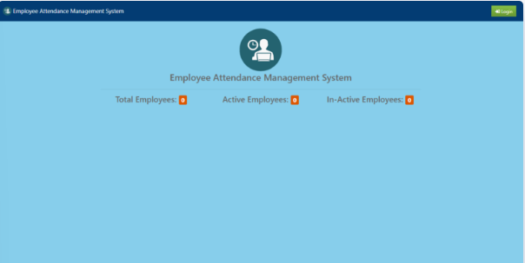
Employee Attendance Management System Home Page
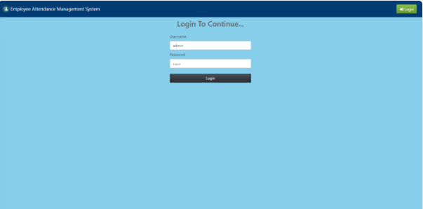
Employee Attendance Management System Login Page
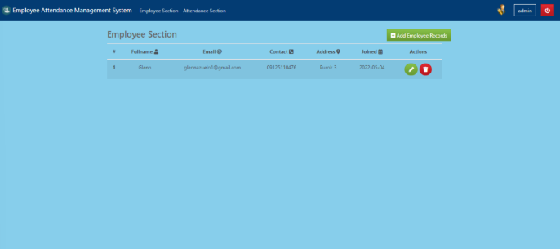
Employee Attendance Management System Dashboard
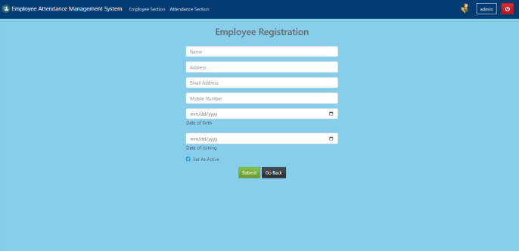
Employee Attendance Management System Employee Registration
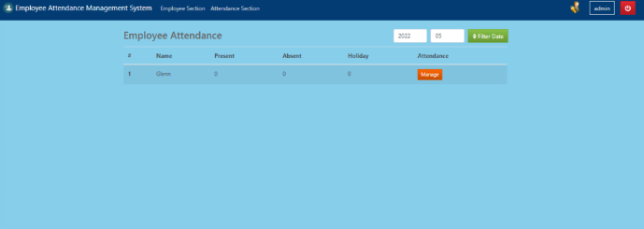
Employee Attendance Management System Employee Attendance

