**DBMS Project Report**

**Organ Donation Management System**

**Fourth-Semester**

**Submitted by:**

**Jatin Thakur 102116096**

**Loveneet Kaur 102116111**

**Jasmeet Kaur 102116124**

**BE Second Year, CSE**

**Submitted To:**

**Dr. Manisha Kaushal**



**Computer Science and Engineering Department**

**Thapar Institute of Engineering and Technology, Patiala**

**APRIL 2023**

**Table of Contents:**

1. Introduction
2. ER-Diagram
3. ER to Tables
4. Normalization
5. SQL and PL/SQL
6. Conclusion
7. References
8. **Introduction: -**

Organ Donation Organizations are pivotal in today’s medical institutions. Such organizations are responsible for evaluating and procuring for organ transplantation. These organizations have direct contact with the hospital and a donor’s family. The work of such organizations includes identifying the best candidates for the available organs and to coordinate with the medical institutions to decide on each organ recipient. They are also responsible for educating the public to increase the awareness of and participation in the organ donation process. Also, it keeps track of all transplantation operations carried till date.

The Organ Donation Management System is a database management system that uses database technology to construct, maintain and manipulate various kinds of data about a person’s donation or procurement of a particular organ. It maintains a comprehensive medical history and other critical information like blood group, age, etc of every person in the database design. In short, it maintains a database containing statistical information regarding network of organ donation and procurement of different countries.

1. **ER -Diagrams: -**

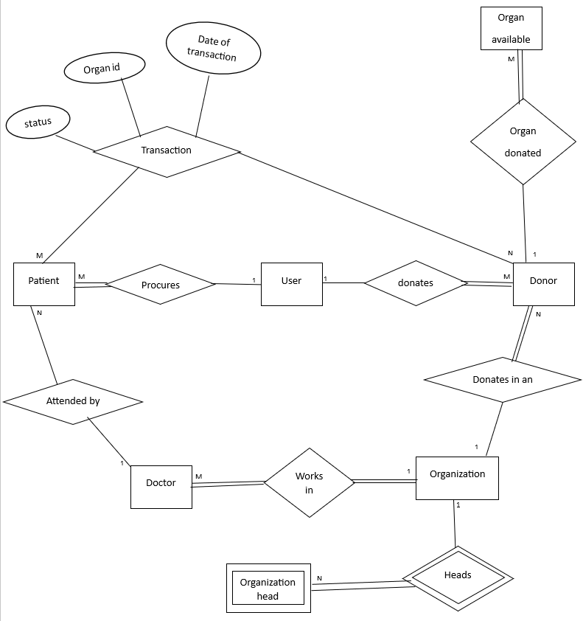

1. User

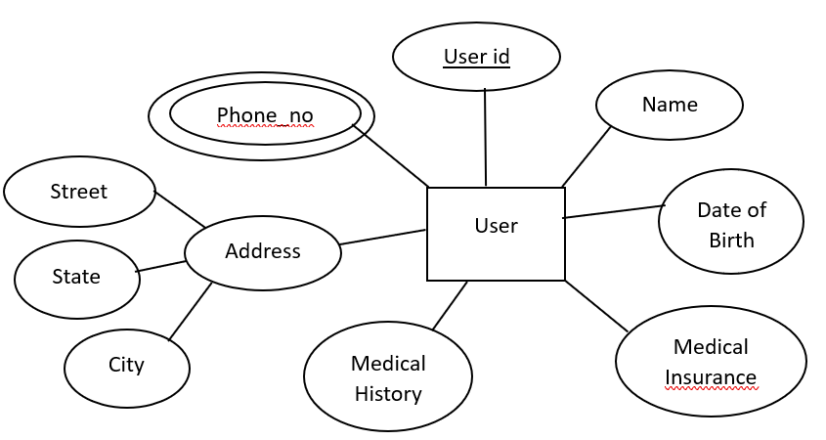

1. Donor

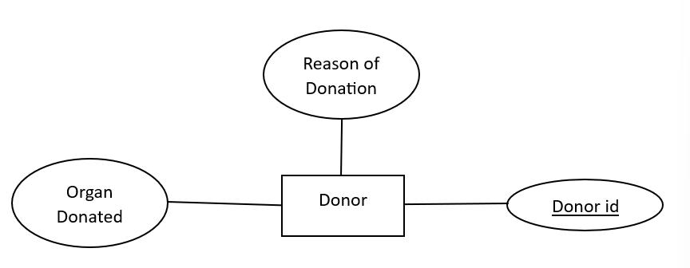

1. Patient

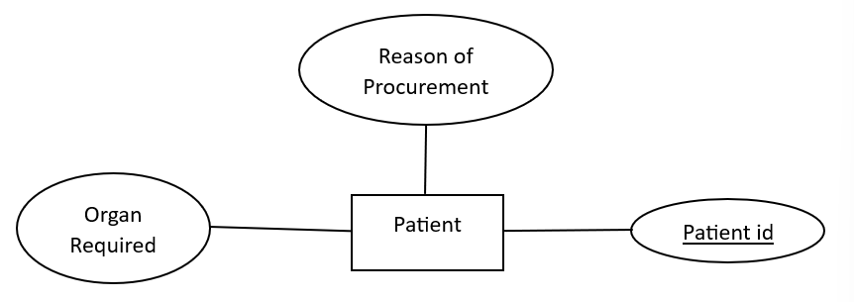

1. 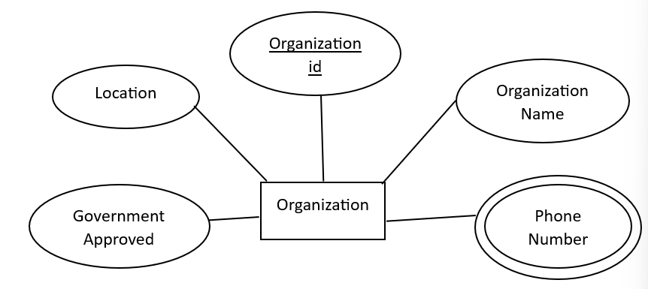Organization
2. Doctor

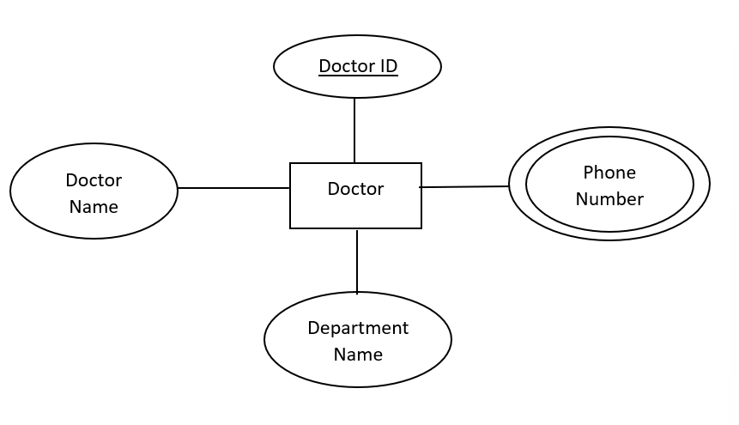

1. Organization Head

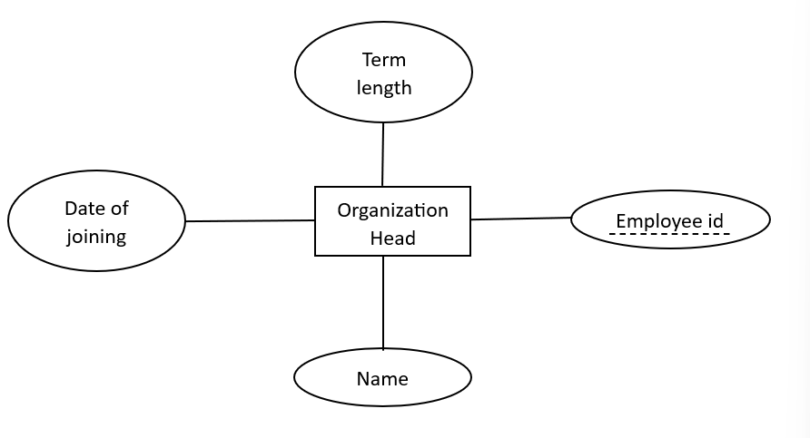

1. Organ Available

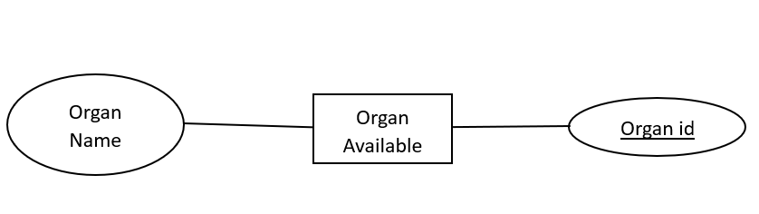

1. **ER to Table: -**
2. User - Donor

|  |
| --- |
| **DONOR** |
| Donor id (primary key) |
| User id (foreign key) |
| Rean of donation |
| Organ donated |
| Organization id (foreign key) |

1. User – Patient

|  |
| --- |
| **USER** |
| User id |
| Name |
| Date of birth |
| Medical insurance |
| Medical history |
| Street |
| State |
| City |
| Phone number |

|  |
| --- |
| **PATIENT** |
| Patient id (primary key) |
| User id (foreign key) |
| Reason of procurement |
| Organ required |
| Doctor id (foreign key) |

|  |
| --- |
| **USER** |
| User id (primary key) |
| Name |
| Date of birth |
| Medical insurance |
| Medical history |
| Street |
| State |
| City |
| Phone number |

|  |
| --- |
| **USER** |
| User id (primary key) |
| Name |
| Date of birth |
| Medical insurance |
| Medical history |
| Street |
| State |
| City |
| Phone number |

1. Patient – doctor

|  |
| --- |
| **PATIENT** |
| Patient id (primary key) |
| User id (foreign key) |
| Doctor id (foreign key) |
| Reason of procurement |
| Organ required |

|  |
| --- |
| **Doctor** |
| Doctor id (primary key) |
| Phone number |
| Department Name |
| Doctor name |
| Organization id (foreign key) |

1. Doctor - Organization

|  |
| --- |
| **Organization** |
| Organization id (primary key) |
| Organization Name |
| Phone number |
| Government Approved |
| Location |

|  |
| --- |
| **Doctor** |
| Doctor id (primary key) |
| Organization Id (foreign key) |
| Phone number |
| Department Name |
| Doctor name |

1. Donor – Patient

|  |
| --- |
| **Transaction** |
| Donor id(foreign key) |
| Patient id(foreign key) |
| Date of transaction |
| Status |
| Organ id |

|  |
| --- |
| **DONOR** |
| Donor id (primary key) |
| User id (foreign key) |
| Reason of donation |
| Organ donated |
| Organization id(foreign key) |

|  |
| --- |
| **PATIENT** |
| Patient id (primary key) |
| User id (foreign key) |
| Doctor id (foreign key) |
| Reason of procurement |

1. Organ available – donor

|  |
| --- |
| **DONOR** |
| Donor id (primary key) |
| User id (foreign key) |
| Reason of donation |
| Organ donated |
| Organization id (foreign key) |

|  |
| --- |
| **Organ available** |
| Organ id (primary key) |
| Donor id (foreign key) |
| Organ name |

1. Organization – Organization head

|  |
| --- |
| **Organization** |
| Organization id (primary key) |
| Organization Name |
| Phone number |
| Government Approved |
| Location |

|  |
| --- |
| **Organization head** |
| Organization id (foreign key) |
| Employee id |
| Name |
| Date of Joining |
| Term length |

1. Organization – Donor

|  |
| --- |
| **Organization** |
| Organization id (primary key) |
| Organization Name |
| Phone number |
| Government Approved |
| Location |

|  |
| --- |
| **DONOR** |
| Donor id (primary key) |
| User id (foreign key) |
| Reason of donation |
| Organ donated |
| Organization id (foreign key) |

1. **Normalization: -**

Table 1:

User_id, date_of_birth, medical_insurance,

medical_history, street, city, state, patient_id,

organ_required, reason_of_procurement, doctor_id, doctor_name, department_name,

organization_id, organ_id, organ_name, donor_id,

organ_donated, reason_of_donation, organisation_id, date_of_transaction, status

F.D:

User_id -> name, date_of_birth, medical_insurance, medical_history, street, city, state

Patient_id -> organ_required, reason_of_procurement, doctor_id, user_id

Donor_id -> organ_donated, reason_of_donation, organisation_id, user_id

Organ_id -> organ_name, donor_id

Patient_id, organ_id -> date_of_transaction, status, donor_id

Doctor_id -> doctor_name, department_name, organization_id

*Prime attribute:* (organ_id patient_id)

1 NF :

TABLE 1:

User_id -> name

User_id -> date_of_birth

User_id -> medical_insurance

User_id -> medical_history

User_id -> street

User_id -> city

User_id -> state

Doctor_id -> doctor_name

Doctor_id -> department_name

Doctor_id -> organization_id

Patient_id, organ_id -> date_of_transaction

Patient_id, organ_id -> Status

Patient_id, organ_id -> donor_id

Organ_id -> organ_name

Organ_id -> donor_id

Donor_id -> organ_donated

Donor_id -> reason_of_donation

Donor_id -> organisation_id

Donor_id -> user_id

Patient_id -> organ_required

Patient_id -> reason_of_procurement

Patient_id -> doctor_id

Patient_id -> user_id

*Candidate key:* (patient_id, organ_id)

*Foreign key:* organization_id

2NF:

Table 1.1:

Patient_id, organ_id -> date_of_transaction

Patient_id, organ_id -> Status

Patient_id, organ_id -> donor_id

*Candidate key:* (patient_id,organ_id)

*Foreign key:* patient_id, organ_id

Table 1.2:

User_id -> name

User_id -> date_of_birth

User_id -> medical_insurance

User_id -> medical_history

User_id -> street

User_id -> city

User_id -> state

Doctor_id -> doctor_name

Doctor_id -> department_name

Doctor_id -> organization_id

Patient_id -> organ_required

Patient_id -> reason_of_procurement

Patient_id -> doctor_id

Patient_id -> user_id

*Primary Key:* patient_id

*Foreign key:* organization_id

Table 1.3:

Organ_id -> organ_name

Organ_id -> donor_id

Donor_id -> organ_donated

Donor_id -> reason_of_donation

Donor_id -> organisation_id

Donor_id -> user_id

*Primary Key:* organ_id

*Foreign key:* organization_id

3NF:

Table 1.1: ***transaction:***

Patient_id, organ_id -> date_of_transaction

Patient_id, organ_id -> Status

Patient_id, organ_id -> donor_id

*Primary Key:* Patient_id, organ_id

*Foreign key:* patient_id, organ_id,donor_id

Table 1.2.1: ***patient:***

Patient_id -> organ_required

Patient_id -> reason_of_procurement

Patient_id -> doctor_id

Patient_id -> user_id

*Primary Key:* patient_id

*Foreign key:* doctor_id,user_id

Table 1.2.2: ***user:***

User_id -> name

User_id -> date_of_birth

User_id -> medical_insurance

User_id -> medical_history

User_id -> street

User_id -> city

User_id -> state

*Primary Key:* user_id

Table 1.2.3: ***doctor:***

Doctor_id -> doctor_name

Doctor_id -> department_name

Doctor_id -> organization_id

*Primary Key:* doctor_id

*Foreign key:* organization_id

Table 1.3.1: ***organ_available:***

Organ_id -> organ_name

Organ_id -> donor_id

*Primary Key:* organ_id

*Foreign key:* donor_id

Table 1.3.2: ***donor:***

Donor_id -> organ_donated

Donor_id -> reason_of_donation

Donor_id -> organization_id

Donor_id -> user_id

*Primary Key:* donor_id

*Foreign key:* user_id, organization_id

Table2:

Organization_id, organization_name, location, government_approved, employee_id, name, date_of_joining, term_length

F.D:

Organization_id -> organization_name,location,

government_approved

Organization_id, employee_id -> name, date_of_joining, term_length

*Prime attributes:* (employee_id organization_id)

1NF:

Table 1:

Organization_id -> organization_name

Organization_id -> location

Organization_id -> government_approved

Organization_id, employee_id -> name Organization_id, employee_id -> date_of_joining

Organization_id, employee_id -> term_length

2NF:

Table1.1: ***organization_head***

Organization_id, employee_id -> name Organization_id, employee_id -> date_of_joining

Organization_id, employee_id -> term_length

*Candidate key:* (Organization_id, employee_id)

*Foreign key:* organization_id

Table 1.2: ***organization:***

Organization_id -> organization_name

Organization_id -> location

Organization_id -> government_approved

*Primary key:* organization_id

Table 3: ***user_phone_number:***

User_id, phone_number

F.D:

User_id -> phone_number

*Prime attribute:* user_id

*Foreign key:* user_id

Table 4: ***organization_phone_number:***

organization_id, phone_number

F.D:

organization_id -> phone_number

*Prime attribute:* organization_id

*Foreign key:* organization_id

Table 5: ***doctor_phone_number***

doctor_id, phone_number

F.D:

doctor_id -> phone_number

*Prime attribute:* doctor_id

*Foreign key:* doctor_id

Table 6: ***login:***

User_name, password

F.D:

user_id -> password

*Prime attribute:* user_name

1. **SQL and PL/SQL**

CREATE TABLE login(

username VARCHAR(20) NOT NULL,

password VARCHAR(20) NOT NULL

);

INSERT INTO login VALUES ('admin','admin');

CREATE TABLE User1(

User_ID int NOT NULL,

Name varchar(20) NOT NULL,

Date_of_Birth date NOT NULL,

Medical_insurance int,

Medical_history varchar(20),

Street varchar(20),

City varchar(20),

State varchar(20),

PRIMARY KEY(User_ID)

);

CREATE TABLE User_phone_no(

User_ID int NOT NULL,

phone_no varchar(15),

FOREIGN KEY(User_ID) REFERENCES User1(User_ID) ON DELETE CASCADE

);

CREATE TABLE Organization(

Organization_ID int NOT NULL,

Organization_name varchar(20) NOT NULL,

Location varchar(20),

Government_approved int not null,check (Government_approved in(0,1)),

PRIMARY KEY(Organization_ID)

);

CREATE TABLE Doctor(

Doctor_ID int NOT NULL,

Doctor_Name varchar(20) NOT NULL,

Department_Name varchar(20) NOT NULL,

organization_ID int NOT NULL,

FOREIGN KEY(organization_ID) REFERENCES Organization(organization_ID) ON DELETE CASCADE,

PRIMARY KEY(Doctor_ID)

);

CREATE TABLE Patient(

Patient_ID int,

organ_req varchar(20) NOT NULL,

reason_of_procurement varchar(20),

Doctor_ID int NOT NULL,

User_ID int NOT NULL,

FOREIGN KEY(User_ID) REFERENCES User1(User_ID) ON DELETE CASCADE,

FOREIGN KEY(Doctor_ID) REFERENCES Doctor(Doctor_ID) ON DELETE CASCADE,

PRIMARY KEY(Patient_Id)

);

CREATE TABLE Donor(

Donor_ID int,

organ_donated varchar(20) NOT NULL,

reason_of_donation varchar(20),

Organization_ID int NOT NULL,

User_ID int NOT NULL,

FOREIGN KEY(User_ID) REFERENCES User1(User_ID) ON DELETE CASCADE,

FOREIGN KEY(Organization_ID) REFERENCES Organization(Organization_ID) ON DELETE CASCADE,

PRIMARY KEY(Donor_ID)

);

CREATE TABLE Organ_available(

Organ_ID int GENERATED BY DEFAULT ON NULL AS IDENTITY START WITH 1 INCREMENT BY 1,

Organ_name varchar(20) NOT NULL,

Donor_ID int NOT NULL,

FOREIGN KEY(Donor_ID) REFERENCES Donor(Donor_ID) ON DELETE CASCADE,

PRIMARY KEY(Organ_ID)

);

CREATE TABLE Transaction(

Patient_ID int NOT NULL UNIQUE,

Organ_ID int NOT NULL,

Donor_ID int NOT NULL,

Date_of_transaction date NOT NULL,

Status int NOT NULL,check( Status in(1,0)),

FOREIGN KEY(Patient_ID) REFERENCES Patient(Patient_ID) ON DELETE CASCADE,

FOREIGN KEY(Donor_ID) REFERENCES Donor(Donor_ID) ON DELETE CASCADE,

PRIMARY KEY(Patient_ID,Organ_ID)

);

CREATE TABLE Organization_phone_no(

Organization_ID int NOT NULL,

Phone_no varchar(15),

FOREIGN KEY(Organization_ID) REFERENCES Organization(Organization_ID) ON DELETE CASCADE

);

CREATE TABLE Doctor_phone_no(

Doctor_ID int NOT NULL,

Phone_no varchar(15),

FOREIGN KEY(Doctor_ID) REFERENCES Doctor(Doctor_ID) ON DELETE CASCADE

);

CREATE TABLE Organization_head(

Organization_ID int NOT NULL,

Employee_ID int NOT NULL,

Name varchar(20) NOT NULL,

Date_of_joining date NOT NULL,

Term_length int NOT NULL,

FOREIGN KEY(Organization_ID) REFERENCES Organization(Organization_ID) ON DELETE CASCADE,

PRIMARY KEY(Organization_ID,Employee_ID)

);

insert into user1 values( 1 ,'Name-1','19-8-2001',1,'NIL','Street-1','New Delhi','Delhi');

insert into user1 values( 2 ,'Name-2','10-12-1975',0,'NIL','Street-2','Mumbai','Maharashtra');

insert into user1 values( 3 ,'Name-3','4-6-1976',0,'NIL','Street-3','Mumbai','Maharashtra');

insert into user1 values( 4 ,'Name-4','13-10-1985',1,'NIL','Street-4','Ahmedabad','Gujarat');

insert into user1 values( 5 ,'Name-5','12-10-1983',1,'NIL','Street-5','Kolkata','West Bengal');

insert into user1 values( 6 ,'Name-6','18-1-1977',1,'NIL','Street-6','Kolkata','West Bengal');

insert into user1 values( 7 ,'Name-7','26-2-1996',0,'NIL','Street-7','New Delhi','Delhi');

insert into user1 values( 8 ,'Name-8','12-4-1973',1,'NIL','Street-8','Mumbai','Maharashtra');

insert into user1 values( 9 ,'Name-9','1-11-976',0,'NIL','Street-9','Mumbai','Maharashtra');

insert into user1 values( 10 ,'Name-10','18-11-1978',1,'NIL','Street-10','New Delhi','Delhi');

insert into user1 values( 11 ,'Name-11','6-1-1976',1,'NIL','Street-11','Mumbai','Maharashtra');

insert into user1 values( 12 ,'Name-12','1-11-1983',1,'NIL','Street-12','Mumbai','Maharashtra');

insert into user1 values( 13 ,'Name-13','9-1-1989',1,'NIL','Street-13','New Delhi','Delhi');

insert into user1 values( 14 ,'Name-14','5-10-1972',1,'NIL','Street-14','Mumbai','Maharashtra');

insert into user1 values( 15 ,'Name-15','23-9-1986',0,'NIL','Street-15','Ahmedabad','Gujarat');

insert into user1 values( 16 ,'Name-16','26-11-1982',1,'NIL','Street-16','New Delhi','Delhi');

insert into user1 values( 17 ,'Name-17','19-3-1976',0,'NIL','Street-17','Mumbai','Maharashtra');

insert into user1 values( 18 ,'Name-18','17-10-1973',0,'NIL','Street-18','New Delhi','Delhi');

insert into user1 values( 19 ,'Name-19','18-3-1980',0,'NIL','Street-19','Kolkata','West Bengal');

insert into user1 values( 20 ,'Name-20','1-8-1998',1,'NIL','Street-20','Kolkata','West Bengal');

insert into User_phone_no values(1,'9876543215');

insert into User_phone_no values(1,'9876542645');

insert into User_phone_no values(2,'6546543215');

insert into User_phone_no values(3,'9878353215');

insert into User_phone_no values(4,'9876587615');

insert into User_phone_no values(5,'9876542345');

insert into User_phone_no values(6,'8876543215');

insert into User_phone_no values(7,'7976543215');

insert into User_phone_no values(8,'9892543215');

insert into User_phone_no values(9,'9887643215');

insert into User_phone_no values(10,null);

insert into Organization values(1, 'Organization-1','New Delhi',1);

insert into Organization values(2, 'Organization-2','Mumbai',0);

insert into Organization values(3, 'Organization-3','Kolkata',0);

insert into Organization values(4, 'Organization-4','Kolkata',1);

insert into Organization values(5, 'Organization-5','Ahmedabad',1);

insert into Doctor values(1,'Doctor-1','Department-1',1);

insert into Doctor values(2,'Doctor-2','Department-2',1);

insert into Doctor values(3,'Doctor-3','Department-3',2);

insert into Doctor values(4,'Doctor-4','Department-4',2);

insert into Doctor values(5,'Doctor-5','Department-5',3);

insert into Doctor values(6,'Doctor-6','Department-6',3);

insert into Doctor values(7,'Doctor-7','Department-7',5);

insert into Doctor values(8,'Doctor-8','Department-8',4);

insert into Doctor values(9,'Doctor-9','Department-9',5);

insert into Doctor values(10,'Doctor-10','Department-10',3);

insert into Doctor values(11,'Doctor-11','Department-11',4);

insert into Doctor values(12,'Doctor-12','Department-12',1);

insert into Patient values(1,'Heart','Reason-1',1,1);

insert into Patient values(2,'Kidney','Reason-2',2,2);

insert into Patient values(3,'Pancreas','Reason-3',3,4);

insert into Patient values(4,'Kidney','Reason-4',2,5);

insert into Patient values(5,'Heart','Reason-5',1,6);

insert into Patient values(6,'Lung','Reason-6',6,7);

insert into Patient values(7,'Intestine','Reason-7',9,8);

insert into Patient values(8,'Intestine','Reason-8',9,9);

insert into Patient values(9,'Lung','Reason-9',6,10);

insert into Patient values(10,'Kidney','Reason-10',2,3);

insert into Donor values(1,'Heart','Reason-1',1,11);

insert into Donor values(2,'Pancreas','Reason-2',1,12);

insert into Donor values(3,'Pancreas','Reason-3',2,13);

insert into Donor values(4,'Intestine','Reason-4',2,14);

insert into Donor values(5,'Kidney','Reason-5',3,15);

insert into Donor values(6,'Pancreas','Reason-6',4,16);

insert into Donor values(7,'Kidney','Reason-7',5,17);

insert into Donor values(8,'Kidney','Reason-8',5,18);

insert into Donor values(9,'Heart','Reason-9',3,19);

insert into Donor values(10,'Heart','Reason-10',2,20);

insert into Transaction values(1,100,1,'19-9-2014',0);

insert into Transaction values(5,190,9,'30-4-2013',1);

insert into Transaction values(2,154,5,'10-4-2017',1);

insert into Transaction values(4,110,7,'28-9-2013',1);

insert into Transaction values(10,136,8,'27-3-2017',0);

insert into Transaction values(3,128,2,'1-8-2010',0);

insert into Transaction values(7,164,4,'2-4-2012',1);

insert into organization_phone_no values(1,'9871234568');

insert into organization_phone_no values(1,'9457234568');

insert into organization_phone_no values(2,'9871915568');

insert into organization_phone_no values(3,'9845234568');

insert into organization_phone_no values(4,'8871234568');

insert into organization_phone_no values(5,'9871273458');

insert into organization_phone_no values(1,'68712335568');

insert into organization_phone_no values(2,'8871274568');

insert into organization_phone_no values(3,'7871234568');

insert into organization_phone_no values(4,'7871224568');

insert into organization_phone_no values(5,'8871294568');

insert into organization_head values(1,1,'ram','19-9-2019',20);

insert into organization_head values(2,2,'shyam','2-7-2005',20);

insert into organization_head values(3,3,'arjun','13-12-1992',40);

insert into organization_head values(4,4,'harjot','2-1-2017',30);

insert into organization_head values(5,5,'kiran','12-6-2012',27);

**JOINS:**

select o.organization_id,o.organization_name,o.location,o.Government_approved,

h.employee_id,h.name,h.date_of_joining,h.term_length,

p.phone_no from organization o inner join organization_head h on o.organization_id=h.organization_id inner join organization_phone_no p on h.organization_id=p.organization_id;

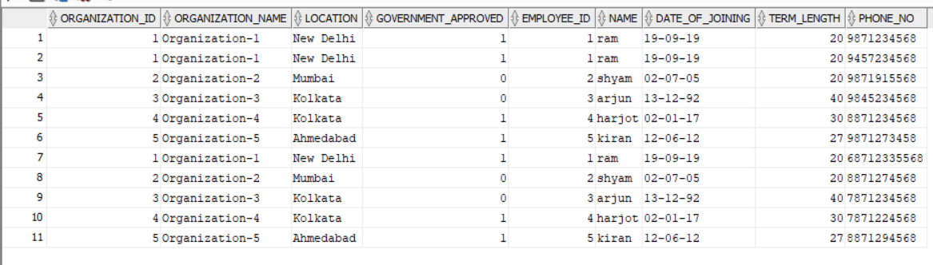

select p.patient_id, p.organ_req ,p.reason_of_procurement,p.doctor_id,p.user_id,u.name,u.date_of_birth,u.medical_insurance,u.medical_history,u.street,u.city,u.state from Patient p left join User1 u on p.user_id=u.user_id;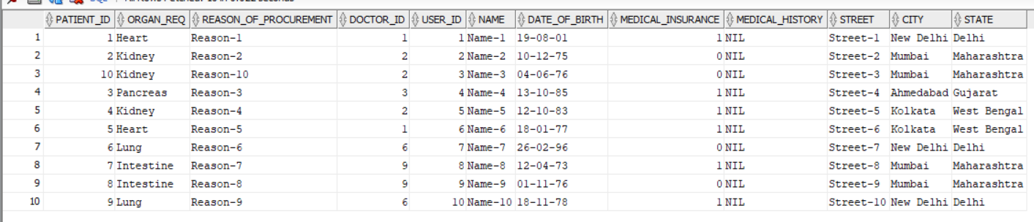

**PL/SQL:**

create trigger ADD_DONOR

after insert

on Donor

for each row

begin

insert into Organ_available(Organ_name, Donor_ID)

values (:new.organ_donated, :new.Donor_ID);

end;

create trigger REMOVE_ORGAN

after insert

on Transaction

for each row

begin

delete from Organ_available

where Organ_ID = :new.Organ_ID;

end;

set serveroutput on

create or replace procedure change_government_approved(a in int,c in int)

is

b Organization%rowtype;

large_value exception;

pragma exception_init(large_value,-02290);

begin

update Organization set Government_approved=c where Organization_ID =a;

select *into b from Organization where Organization_ID=a;

dbms_output.put_line('Organization id:'|| b.Organization_ID);

dbms_output.put_line('Organization name: '|| b.Organization_name);

dbms_output.put_line('Location: '|| b.Location);

dbms_output.put_line('Government approved: '|| b.Government_approved);

exception

when large_value then

dbms_output.put_line('value too big for column');

end change_government_approved;

/

begin

change_government_approved(&Organization_id,&Government_approved);

end;

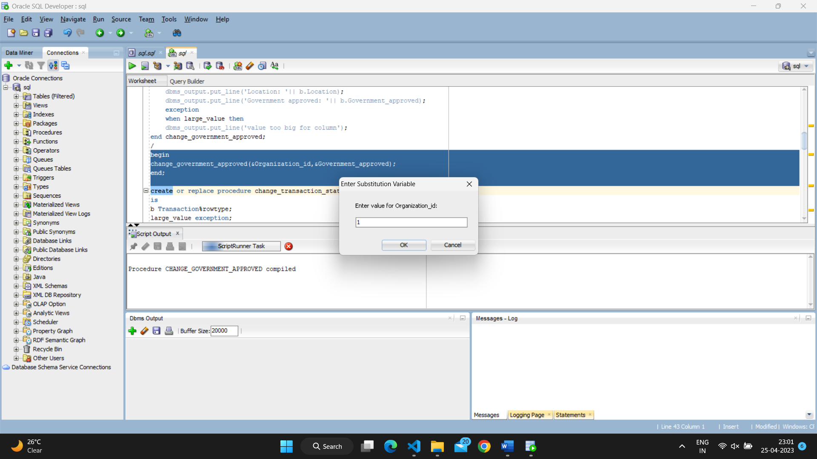

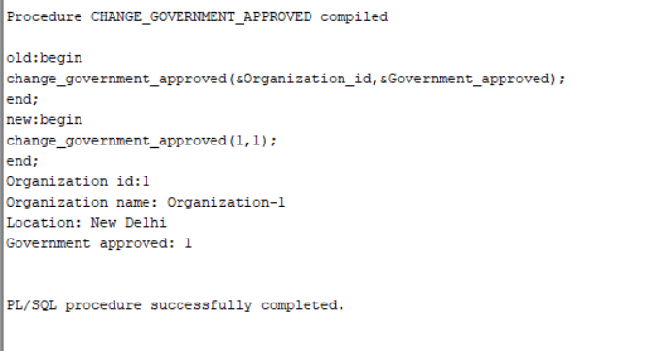

create or replace procedure change_transaction_status_of_patient(a in int,c in int)

is

b Transaction%rowtype;

large_value exception;

pragma exception_init(large_value,-02290);

begin

update Transaction set Status=c where Patient_ID =a;

select *into b from Transaction where Patient_ID=a;

dbms_output.put_line('Patient id: '|| b.Patient_ID);

dbms_output.put_line('Organ id: '|| b.Organ_ID);

dbms_output.put_line('donor id '|| b.Donor_ID);

dbms_output.put_line('Status: '|| b.Status);

dbms_output.put_line('date of transaction: '|| b.Date_of_transaction);

exception

when large_value then

dbms_output.put_line('value to big for column');

end change_transaction_status_of_patient;

/

begin

change_transaction_status_of_patient(&patient_id,&status);

end;

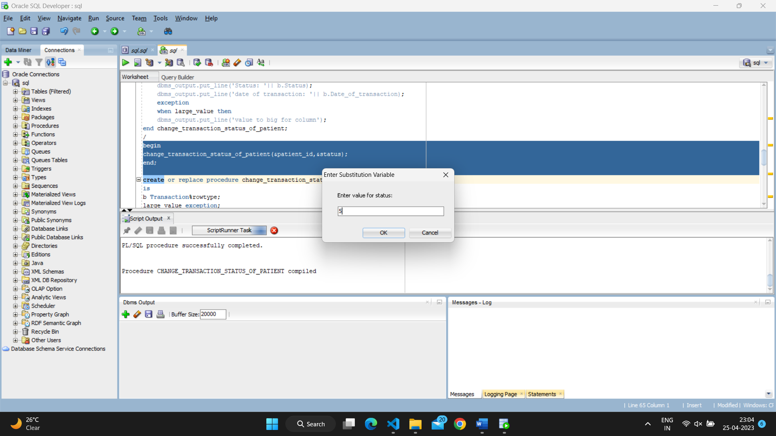

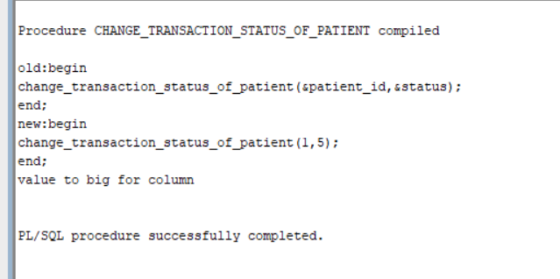

create or replace procedure change_transaction_status_of_donor(a in int,c in int)

is

b Transaction%rowtype;

large_value exception;

pragma exception_init(large_value,-02290);

begin

update Transaction set Status=c where Donor_ID =a;

select * into b from Transaction where Donor_ID=a;

dbms_output.put_line('Patient id: '|| b.Patient_ID);

dbms_output.put_line('Organ id: '|| b.Organ_ID);

dbms_output.put_line('donor id '|| b.Donor_ID);

dbms_output.put_line('Status: '|| b.Status);

dbms_output.put_line('date of transaction: '|| b.Date_of_transaction);

exception

when large_value then

dbms_output.put_line('value to big for column');

end change_transaction_status_of_donor;

/

begin

change_transaction_status_of_donor(&donor_id,&status);

end;

declare

cursor o1(a int) is

select * from Organization where Government_approved=a;

begin

for rec in o1(&Government_approved) loop

dbms_output.put_line('Organisation ID: '||rec.Organization_ID);

dbms_output.put_line('Organisation name: '||rec.Organization_name);

dbms_output.put_line('Government Approved: '||rec.Government_approved);

end loop;

end;

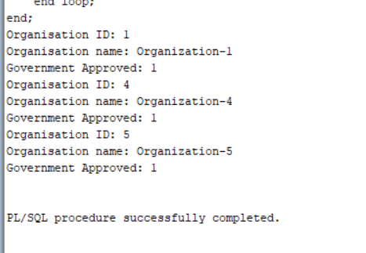

1. **Conclusion: -**

To sum up, this Organ Donation Management System helps us to keep track of and manage the transplantation operations carried till date. This database system helps us manage the information regarding the donor, patient, doctor, and other people and organizations involved.

1. **References: -**

<https://www.tutorialspoint.com/plsql/plsql_triggers.htm>

<https://www.tutorialspoint.com/plsql/plsql_procedures.htm>

<https://www.tutorialspoint.com/plsql/plsql_cursors.htm>

<https://forums.oracle.com/ords/apexds/post/database-trigger-pl-sql-ora-00984-column-not-allowed-here-7506>

<https://stackoverflow.com/questions/64487272/pls-00103-encountered-the-symbol-begin-when-expecting-one-of-the-following>