Alpha-Beta Pruning

Algorithm:
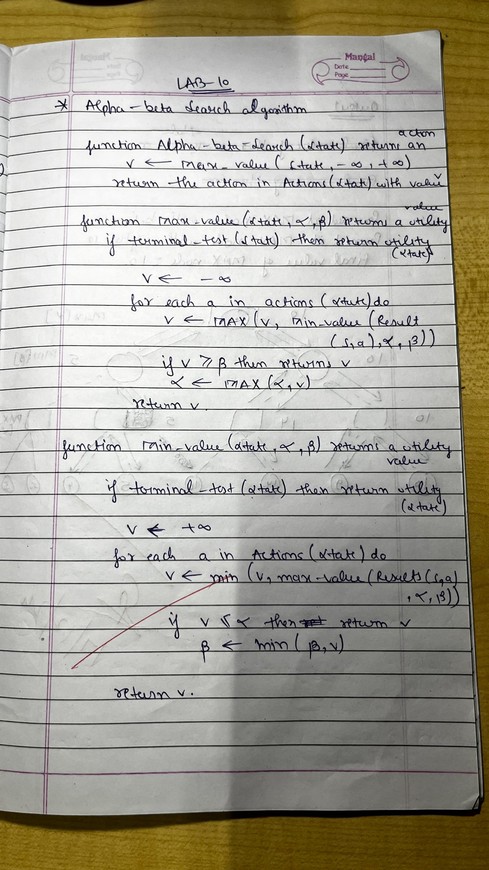

State Space Diagram: 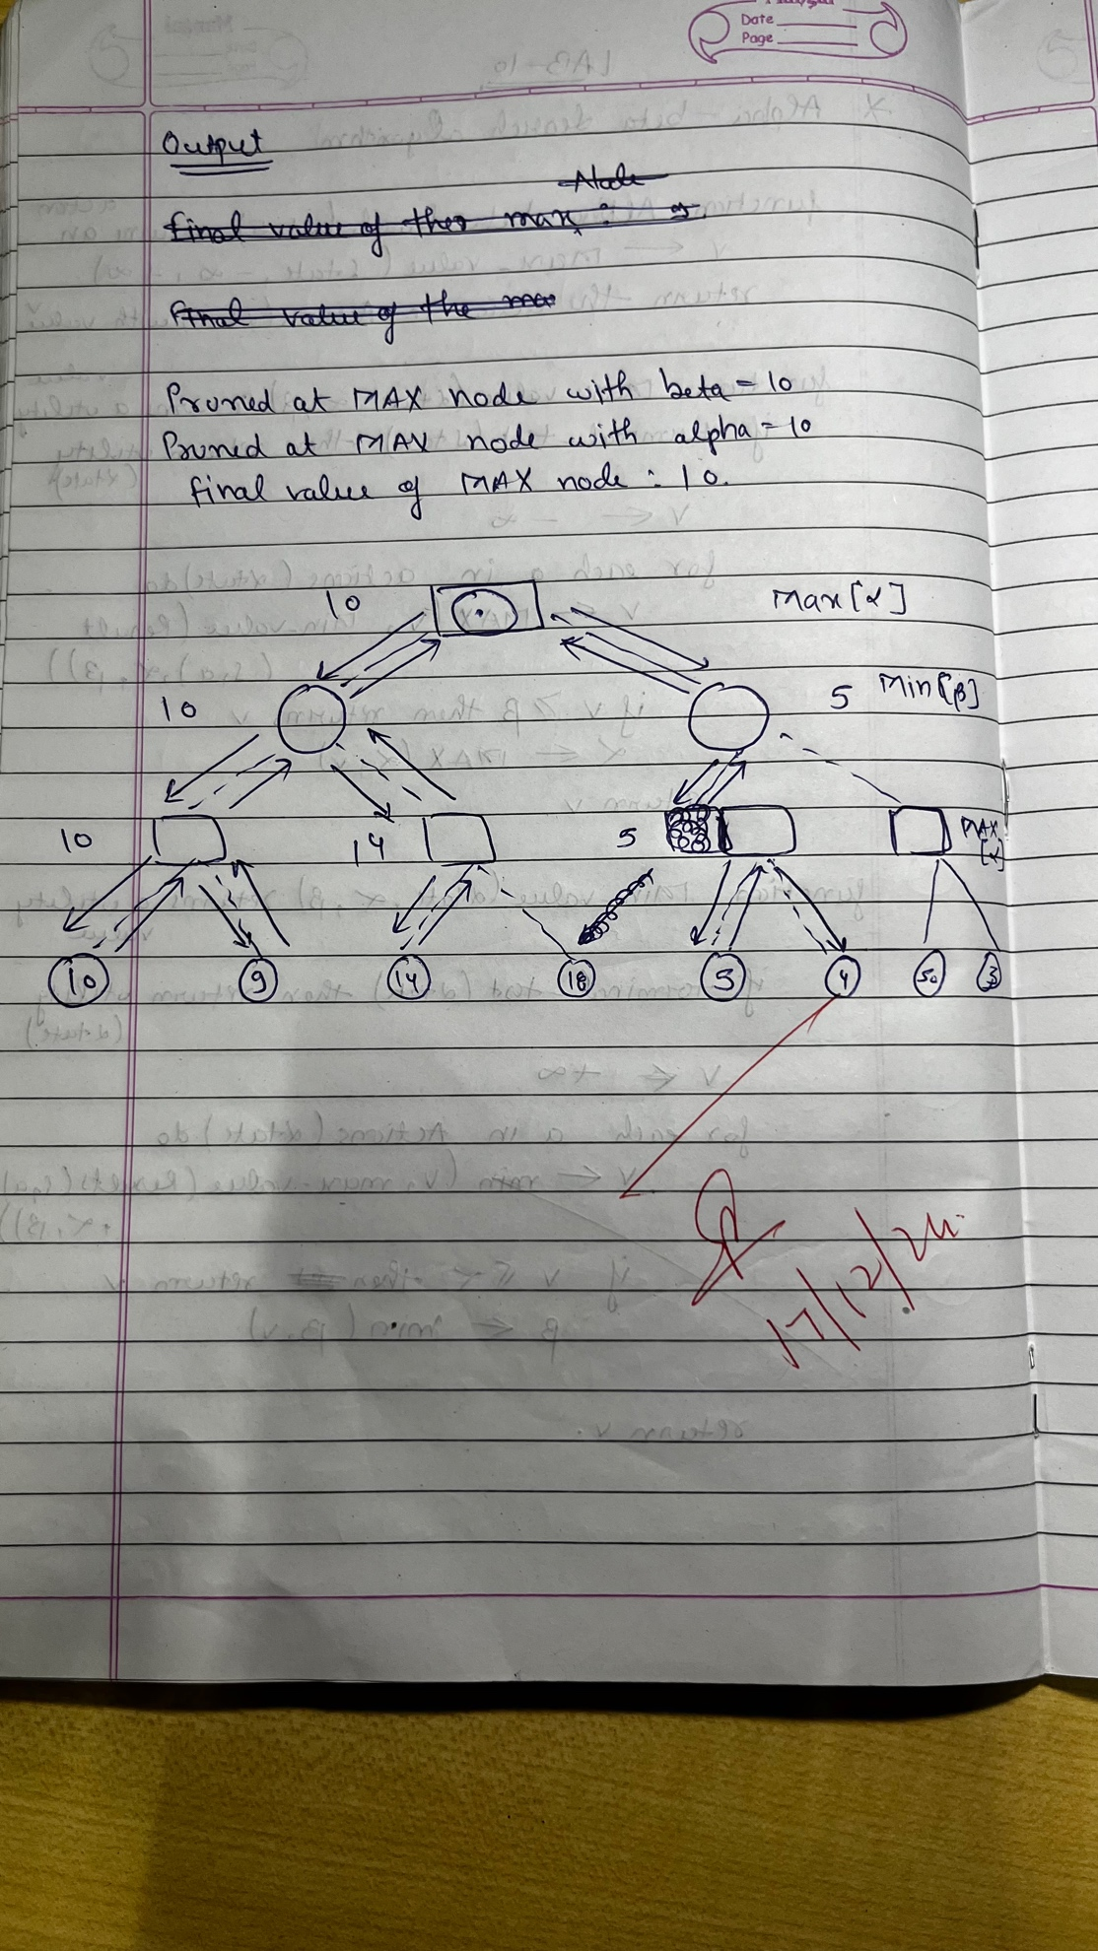
Code:
import math
def alpha_beta_search(tree, depth, alpha, beta, maximizing_player):
if depth == 0 or isinstance(tree, int):
return tree
if maximizing_player:
max_eval = -math.inf
for child in tree:
eval = alpha_beta_search(child, depth - 1, alpha, beta, False)
max_eval = max(max_eval, eval)
alpha = max(alpha, eval)
if beta <= alpha:
print("Pruned at MAX node with beta =", beta)
break
return max_eval
else:
min_eval = math.inf
for child in tree:
eval = alpha_beta_search(child, depth - 1, alpha, beta, True)
min_eval = min(min_eval, eval)
beta = min(beta, eval)
if beta <= alpha:
print("Pruned at MIN node with alpha =", alpha)
break
return min_eval
game_tree = [
[[10, 9], [14, 18]],
[[5, 4], [50, 3]]
]
final_value = alpha_beta_search(game_tree, 3, -math.inf, math.inf, True)
print("Final Value of the MAX Node:", final_value)

Output:
