Tic Tac Toe
Algorithm:
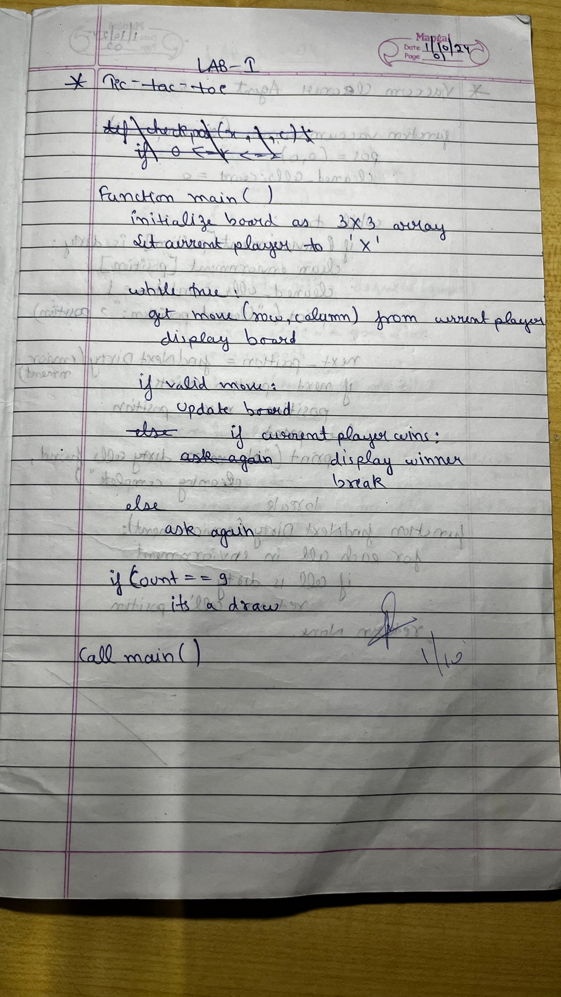

State Space Tree:
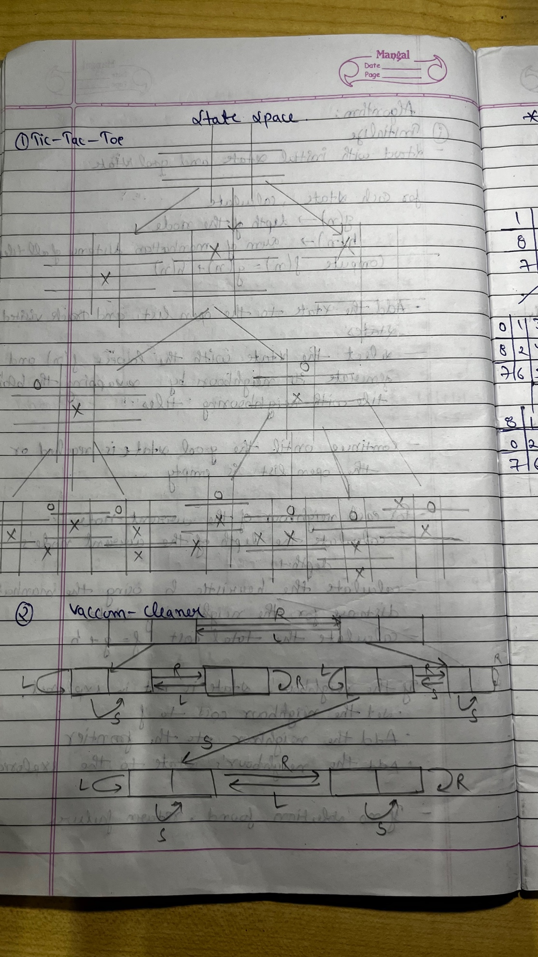

Code:
def checkpos(x, r, c):
if 0 <= r <= 2 and 0 <= c <= 2:
if x[r][c] != "X" and x[r][c] != "O":
return True
return False

def checkwinner(x):
for i in range(3):
j = 0
if x[i][j] == x[i][j+1] == x[i][j+2] != '-':
return True
elif x[j][i] == x[j+1][i] == x[j+2][i] != '-':
return True
elif(x[0][0] == x[1][1] == x[2][2] != '-' or x[0][2] == x[1][1] == x[2][0] != '-'):
return True
return False

def checkdraw(n):
if n == 9:
return True
return False

def display(x):
for i in range(3):
print(x[i])

def initialise():
x = []
for i in range(3):
l = []
for j in range(3):
l.append("-")
x.append(l)
return x

def main():
count = 0
gameover = False
x = initialise()
while count < 9:
while count%2 == 0:
print("Player X's turn: ")
r = int(input("Enter row: "))
c = int(input("Enter column: "))
if checkpos(x, r, c):
x[r][c] = 'X'
count += 1
display(x)
if checkwinner(x):
print("Player X won!")
gameover = True
break
else:
continue
if checkdraw(count):
print("It's a draw")
break
if gameover:
break

while count%2 == 1:
print("Player O's turn: ")
r = int(input("Enter row: "))
c = int(input("Enter column: "))
if checkpos(x,r,c):
x[r][c] = 'O'
display(x)
count += 1
if checkwinner(x):
print("Player O won!")
gameover = True
break
else:
continue
if checkdraw(count):
print("It's a draw")
break
if gameover:
break
main()

Output:
