Vacuum Cleaner Agent
Algorithm:
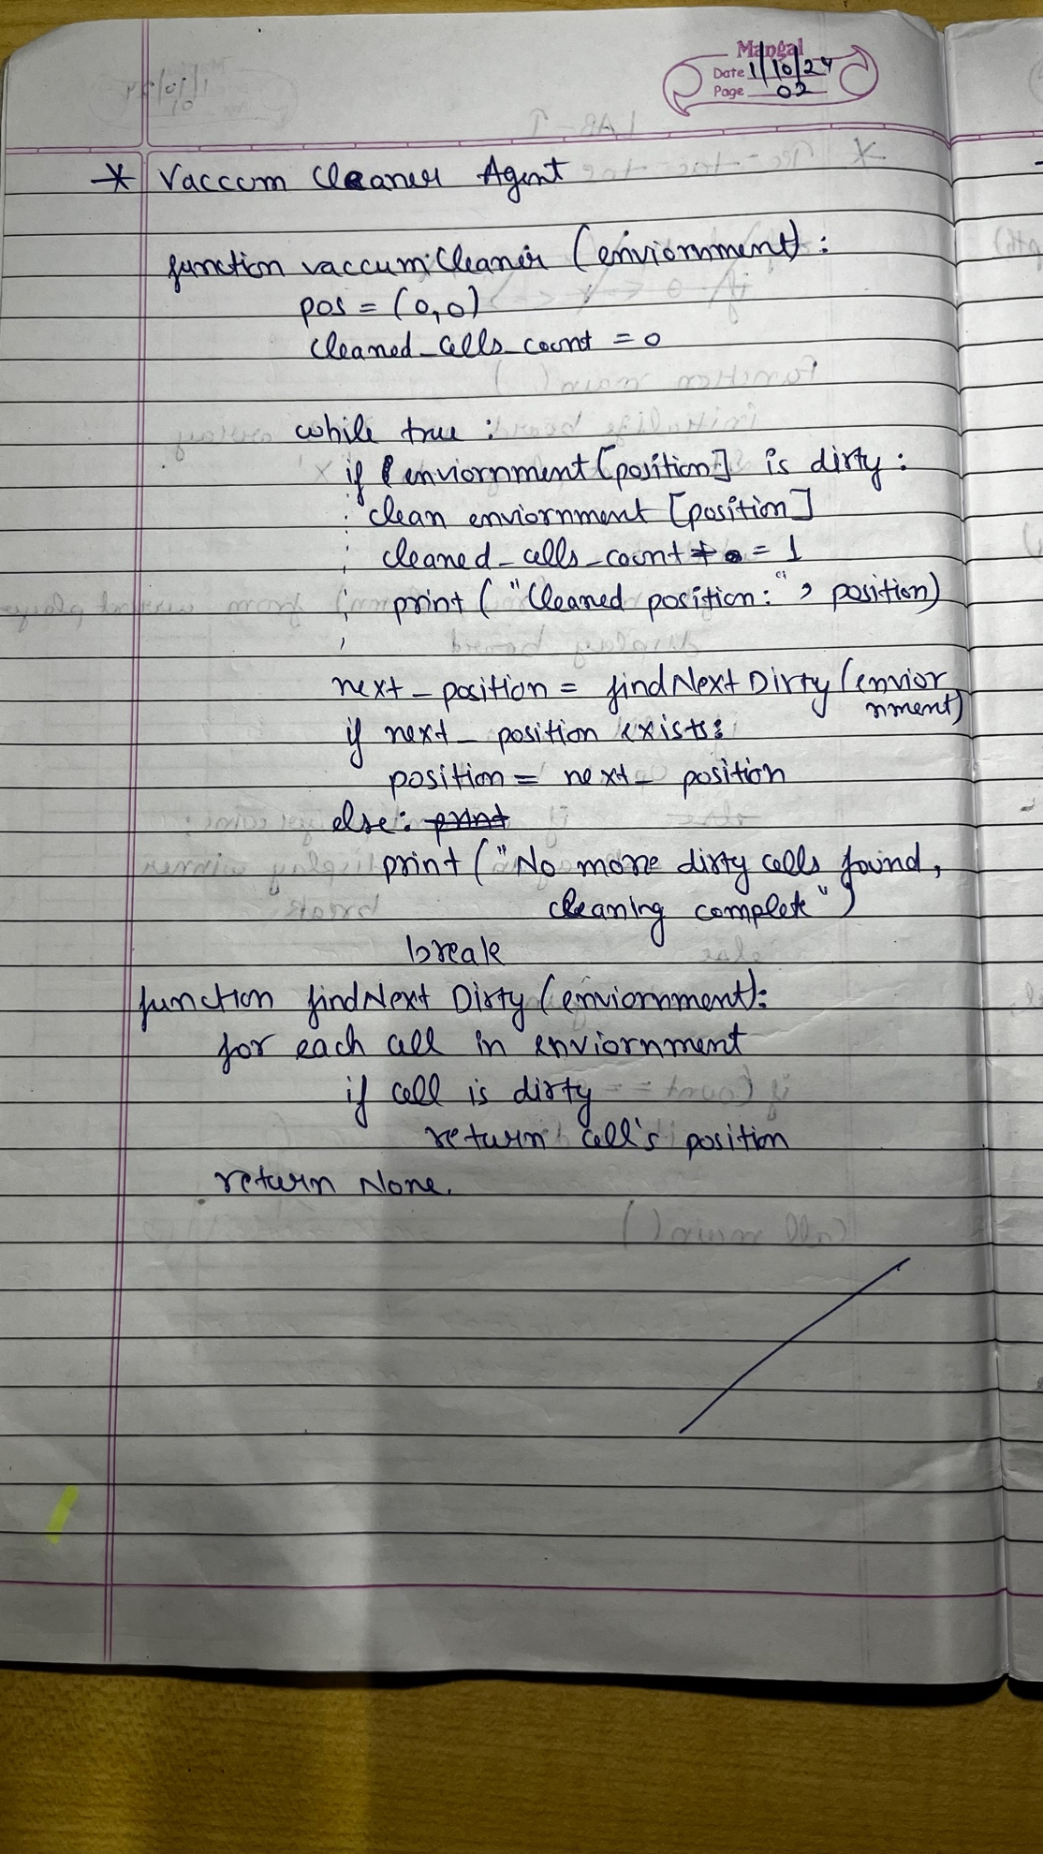

State Space Tree:
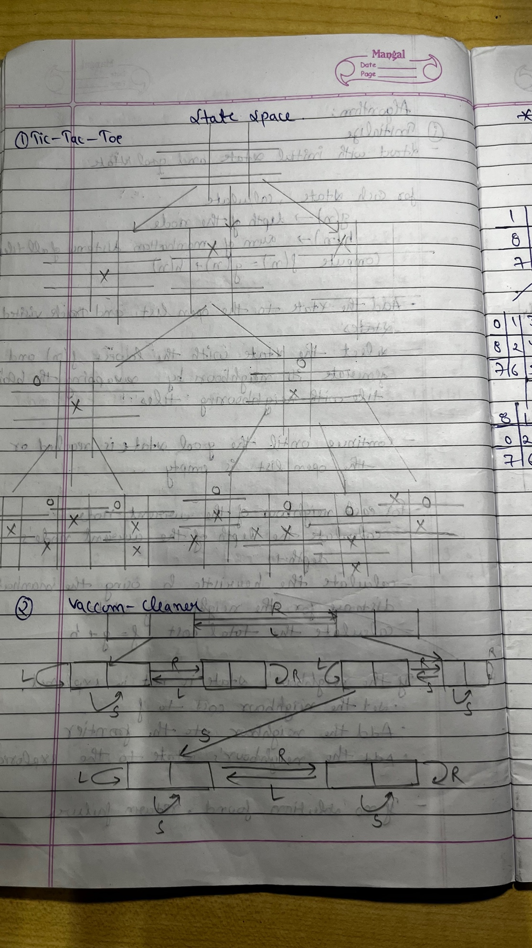

Code:
def vacuum_world():
goal_state = {'A': '0', 'B': '0'}
cost = 0
location_input = input("Enter Location of Vacuum: ")
status_input = input("Enter status of " + location_input + " (0 for Clean, 1 for Dirty): ")
status_input_complement = input("Enter status of the other room: ")

print("Initial Location Condition: " + str(goal_state))

if location_input == 'A':

print("Vacuum is placed in Location A")
if status_input == '1':
print("Location A is Dirty.")

goal_state['A'] = '0'
cost += 1
print("Cost for CLEANING A: " + str(cost))
print("Location A has been Cleaned.")

if status_input_complement == '1':

print("Location B is Dirty.")
print("Moving right to Location B.")
cost += 1
print("COST for moving RIGHT: " + str(cost))

goal_state['B'] = '0'
cost += 1
print("COST for SUCK: " + str(cost))
print("Location B has been Cleaned.")
else:
print("No action. Cost: " + str(cost))
print("Location B is already clean.")

else:
print("Location A is already clean.")
if status_input_complement == '1':
print("Location B is Dirty.")
print("Moving RIGHT to Location B.")
cost += 1
print("COST for moving RIGHT: " + str(cost))

goal_state['B'] = '0'
cost += 1
print("COST for SUCK: " + str(cost))
print("Location B has been Cleaned.")
else:
print("No action. Cost: " + str(cost))
print("Location B is already clean.")

else:
print("Vacuum is placed in Location B")

if status_input == '1':
print("Location B is Dirty.")

goal_state['B'] = '0'
cost += 1
print("COST for CLEANING B: " + str(cost))
print("Location B has been Cleaned.")

if status_input_complement == '1':

print("Location A is Dirty.")
print("Moving LEFT to Location A.")
cost += 1
print("COST for moving LEFT: " + str(cost))

goal_state['A'] = '0'
cost += 1
print("COST for SUCK: " + str(cost))
print("Location A has been Cleaned.")
else:
print("Location A is already clean.")
else:
print("Location B is already clean.")
if status_input_complement == '1':
print("Location A is Dirty.")
print("Moving LEFT to Location A.")
cost += 1
print("COST for moving LEFT: " + str(cost))

goal_state['A'] = '0'
cost += 1
print("COST for SUCK: " + str(cost))
print("Location A has been Cleaned.")
else:
print("No action. Cost: " + str(cost))
print("Location A is already clean.")

print("GOAL STATE: ")
print(goal_state)
print("Performance Measurement: " + str(cost))

vacuum_world()

Output:
