8 Puzzle Problem
Algorithm:
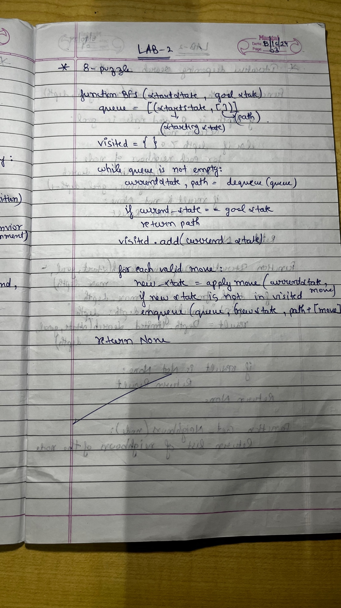

State Space Tree:
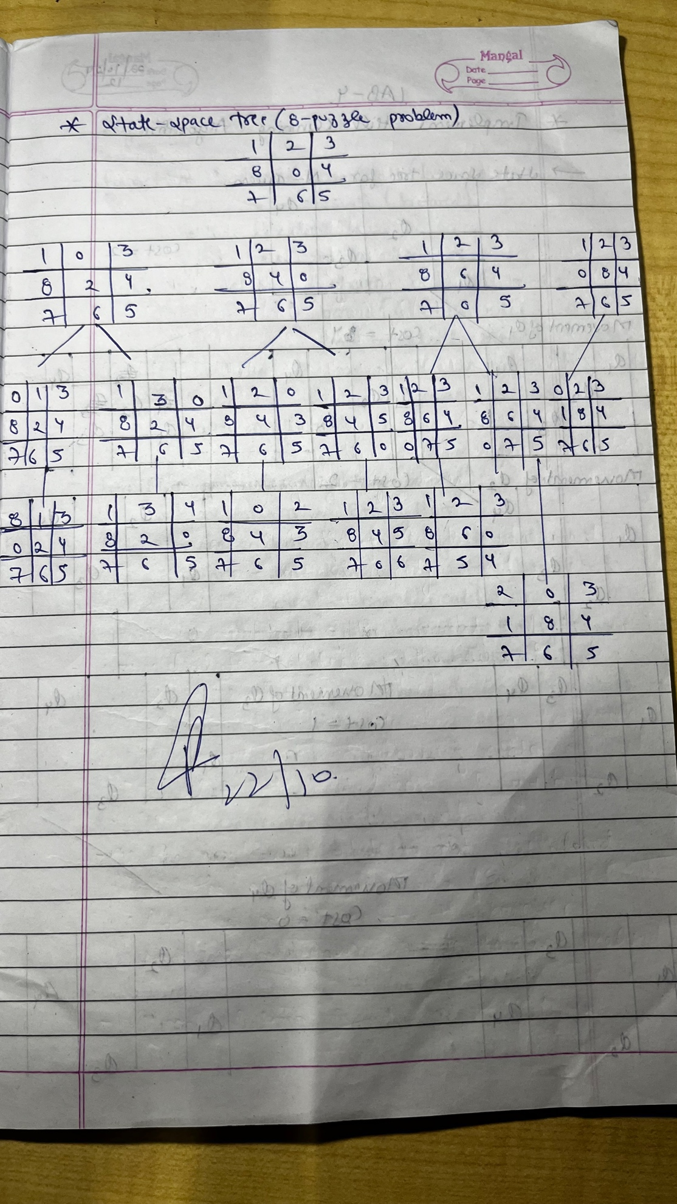

Code:
from collections import deque
# Moves: Up, Down, Left, Right
moves = {
'U': (-1, 0),
'D': (1, 0),
'L': (0, -1),
'R': (0, 1)
}

# Convert puzzle to string format for hashing
def puzzle_to_string(puzzle):
return ''.join(str(num) for row in puzzle for num in row)

# Print puzzle for better visualization
def print_puzzle(puzzle):
for row in puzzle:
print(row)
print()

# BFS algorithm
def bfs_8_puzzle(start, goal):
queue = deque([(start, [])]) # Each element is (current_state, path_taken)
visited = set()
visited.add(puzzle_to_string(start))
state_space_tree = []

while queue:
current, path = queue.popleft()

if current == goal:
state_space_tree.append((current, path)) # Record final state and path
return state_space_tree # Puzzle solved, return best path

zero_pos = [(i, j) for i in range(3) for j in range(3) if current[i][j] == 0][0]

for move, (dx, dy) in moves.items():
x, y = zero_pos[0] + dx, zero_pos[1] + dy
if 0 <= x < 3 and 0 <= y < 3:
new_state = [row[:] for row in current]
new_state[zero_pos[0]][zero_pos[1]], new_state[x][y] = new_state[x][y], new_state[zero_pos[0]][zero_pos[1]]

if puzzle_to_string(new_state) not in visited:
visited.add(puzzle_to_string(new_state))
queue.append((new_state, path + [move])) # Add move to the path
state_space_tree.append((new_state, path + [move])) # Record the state and path

return state_space_tree # Return the entire state space tree if no solution

# Function to get input from user
def get_input():
start_state = []
goal_state = []

print("Enter the start state (3x3 matrix, row by row, with 0 representing the blank space):")
for i in range(3):
row = list(map(int, input().split()))
start_state.append(row)

print("Enter the goal state (3x3 matrix, row by row, with 0 representing the blank space):")
for i in range(3):
row = list(map(int, input().split()))
goal_state.append(row)

return start_state, goal_state

# Example Usage
start_state, goal_state = get_input()

# Get the best path using BFS
solution_tree = bfs_8_puzzle(start_state, goal_state)

# Print all states in the best move sequence
if solution_tree:
print("goal state achieved")

print_puzzle(goal_state)
else:
print("No solution found.")

Output:
