Iterative Deepening Search
Algorithm:
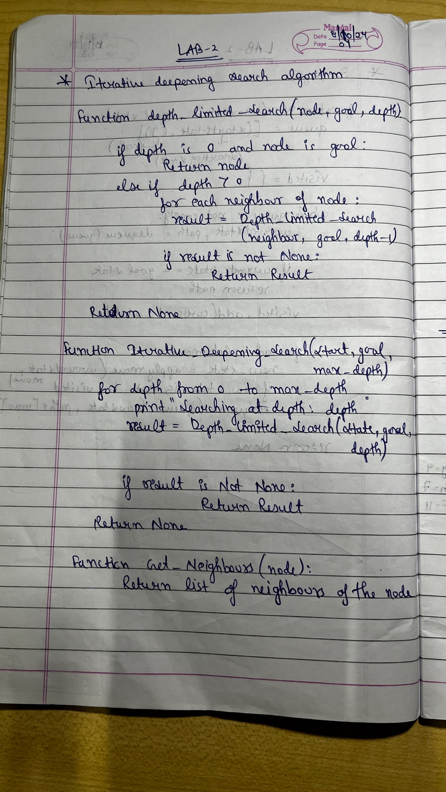
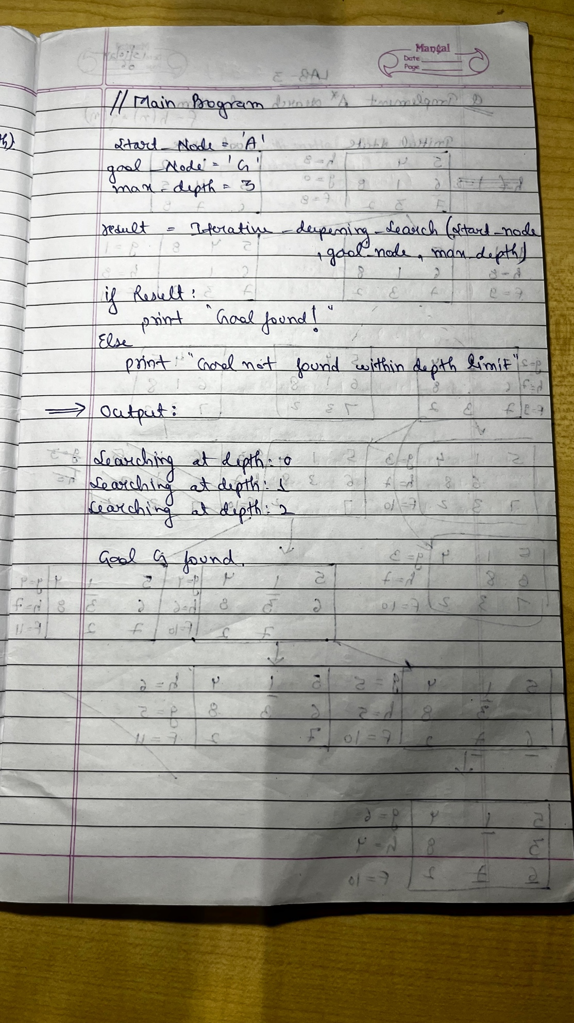

State Space Tree:
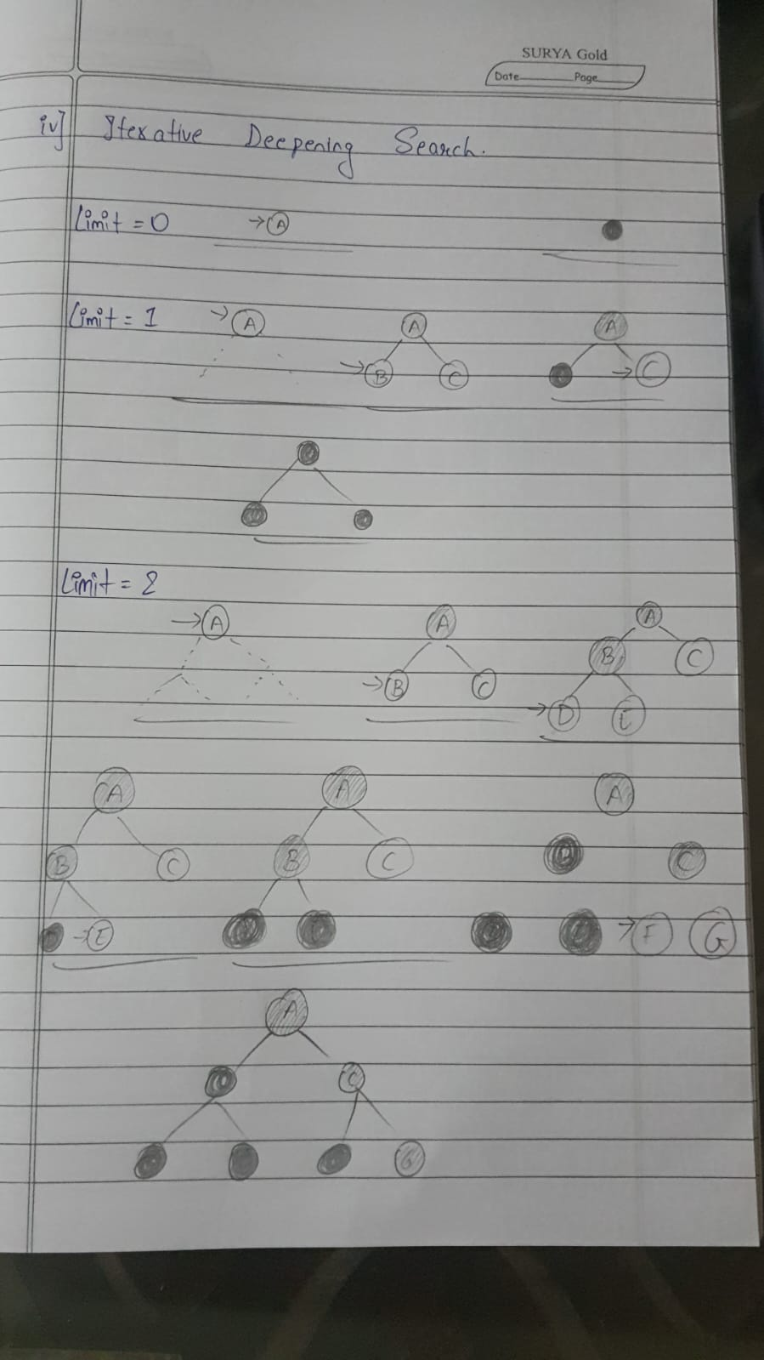

Code:
def depth_limited_search(node, goal, depth):
if depth == 0 and node == goal:
return node # Goal found
if depth > 0:
for neighbor in get_neighbors(node):
result = depth_limited_search(neighbor, goal, depth - 1)
if result is not None:
return result
return None
def iterative_deepening_search(start, goal, max_depth):
for depth in range(max_depth):
print(f"Searching at depth: {depth}")
result = depth_limited_search(start, goal, depth)
if result is not None:
return result
return None

def get_neighbors(node):
neighbors = {
'A': ['B', 'C'],
'B': ['D', 'E'],
'C': ['F', 'G'],
'D': [],
'E': [],
'F': [],
'G': []
}
return neighbors.get(node, [])

start_node = 'A' # Start node
goal_node = 'G' # Goal node
max_depth = 3 # Maximum depth to search
result = iterative_deepening_search(start_node, goal_node, max_depth)

if result:
print(f"Goal {goal_node} found!")
else:
print(f"Goal {goal_node} not found within depth limit.")

Output:
