A* using Manhattan Distance
Algorithm:
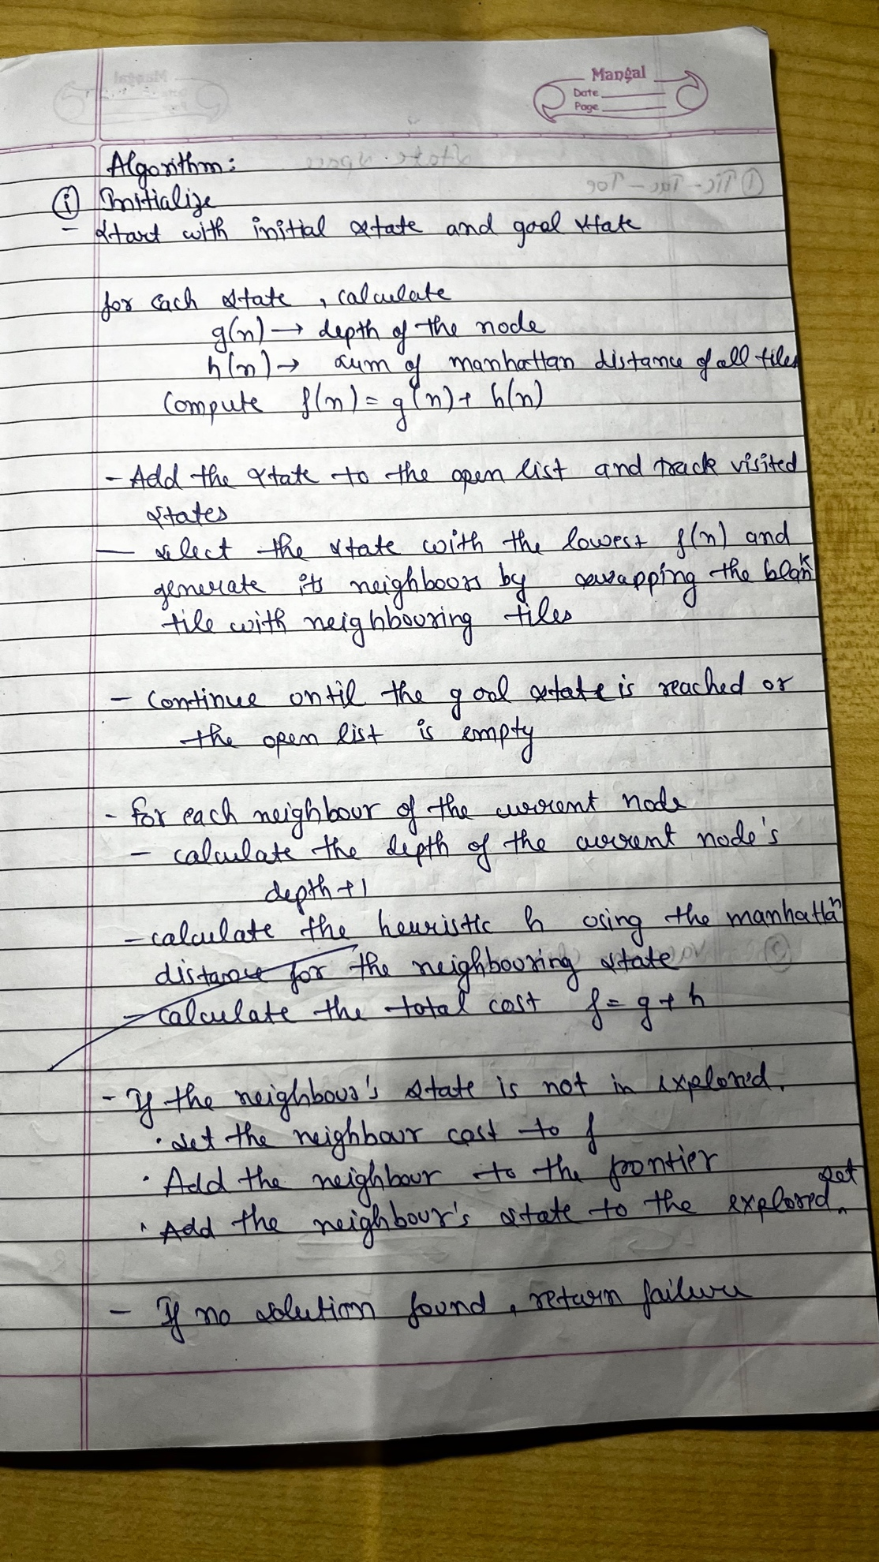

State Space Tree:
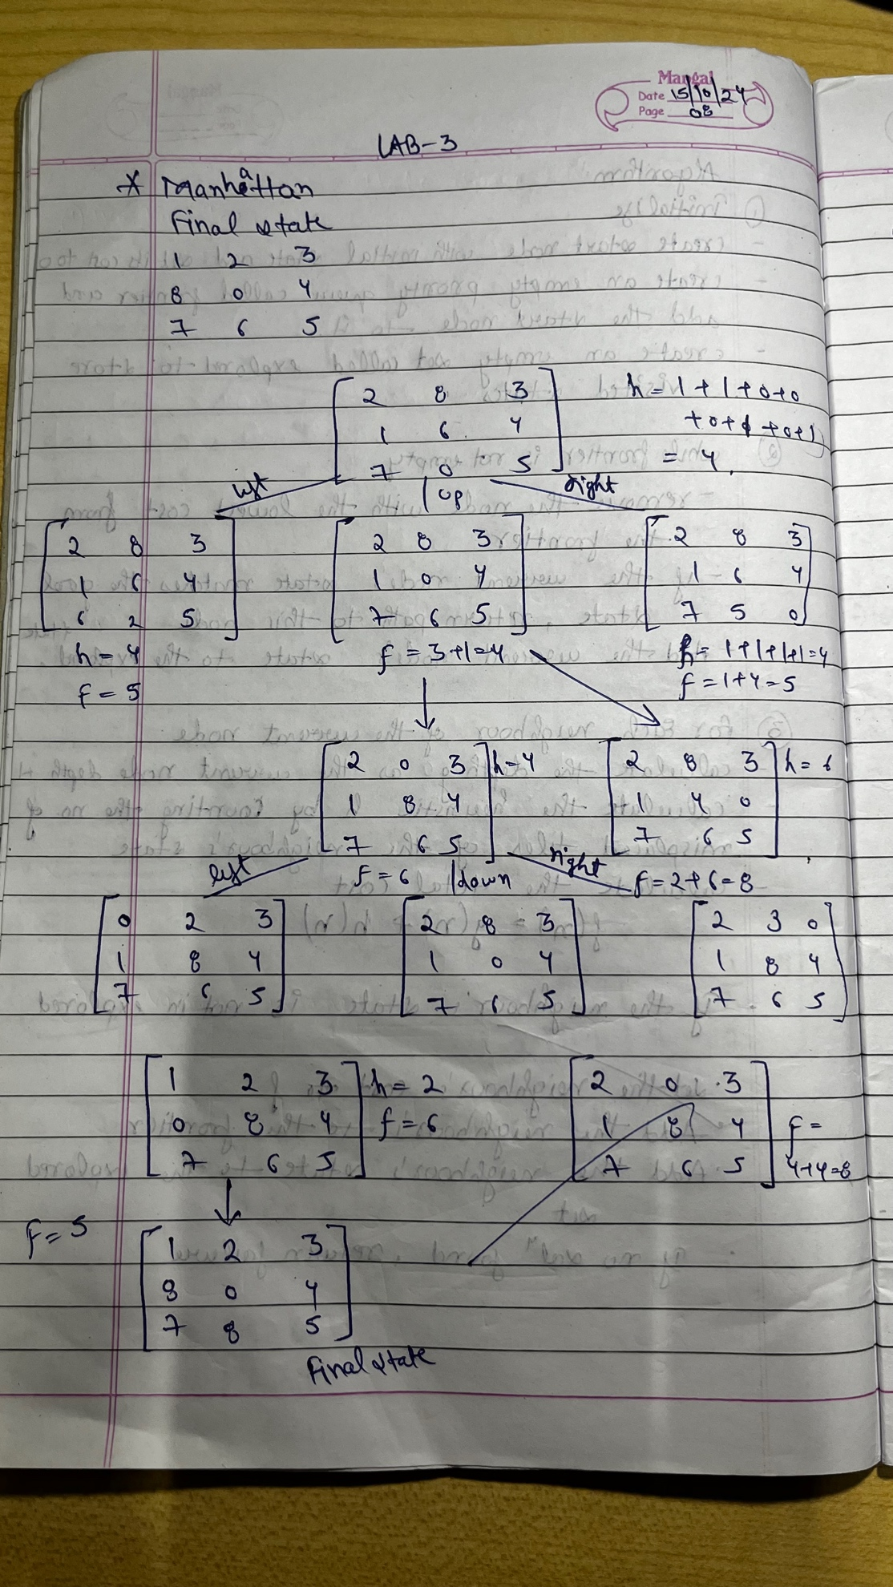
Code:
import heapq

# Define the goal state for the puzzle
goal_state = [[1, 2, 3], [8, 0, 4], [7, 6, 5]]

# Helper function to calculate the Manhattan distance heuristic
def manhattan_distance(state, goal_state):
"""Calculate the Manhattan distance heuristic."""
distance = 0
for i in range(3):
for j in range(3):
if state[i][j] != 0:
# Get current tile number (1-8)
value = state[i][j]
# Find its goal position in the goal state
goal_x, goal_y = divmod(value, 3)
# Calculate Manhattan distance
distance += abs(i - goal_x) + abs(j - goal_y)
return distance

def is_goal(state):
"""Check if the current state is the goal state."""
return state == goal_state

def get_neighbors(state):
"""Generate neighbors for a given state."""
neighbors = []
# Find the position of the empty space (0)
x, y = [(ix, iy) for ix, row in enumerate(state) for iy, i in enumerate(row) if i == 0][0]
# Possible moves: up, down, left, right
moves = [(x-1, y), (x+1, y), (x, y-1), (x, y+1)]

for move_x, move_y in moves:
if 0 <= move_x < 3 and 0 <= move_y < 3:
# Create a copy of the current state and swap the empty space
new_state = [row[:] for row in state]
new_state[x][y], new_state[move_x][move_y] = new_state[move_x][move_y], new_state[x][y]
neighbors.append(new_state)
return neighbors

# A* algorithm using Manhattan distance heuristic
def a_star_manhattan(initial_state):
"""A* algorithm implementation for 8-puzzle problem with Manhattan distance heuristic."""
open_list = []
closed_set = set()

# Initial cost
g = 0
f = g + manhattan_distance(initial_state, goal_state)

# Add the initial state to the open list
heapq.heappush(open_list, (f, g, initial_state, []))

while open_list:
f, g, current_state, path = heapq.heappop(open_list)

if is_goal(current_state):
return path + [current_state]

closed_set.add(tuple(map(tuple, current_state)))

for neighbor in get_neighbors(current_state):
if tuple(map(tuple, neighbor)) in closed_set:
continue

new_g = g + 1
new_f = new_g + manhattan_distance(neighbor, goal_state)
heapq.heappush(open_list, (new_f, new_g, neighbor, path + [current_state]))

return None

# Helper function to print a state
def print_state(state):
for row in state:
print(row)
print()

# Initial state
initial_state = [[2, 8, 3], [1, 6, 4], [7, 0, 5]]

# Run the A* algorithm with Manhattan distance heuristic
print("Solution using Manhattan distance heuristic:")
solution_manhattan = a_star_manhattan(initial_state)
if solution_manhattan:
for step in solution_manhattan:
print_state(step)
else:
print("No solution found using Manhattan distance heuristic.")

Output:
Solution using Manhattan distance heuristic:
[2, 8, 3] [1, 6, 4] [7, 0, 5]
[2, 8, 3] [1, 0, 4] [7, 6, 5]
[2, 0, 3] [1, 8, 4] [7, 6, 5]
[0, 2, 3] [1, 8, 4] [7, 6, 5]
[1, 2, 3] [0, 8, 4] [7, 6, 5]
[1, 2, 3] [8, 0, 4] [7, 6, 5]

