N-Queens using Hill Climbing
Algorithm:
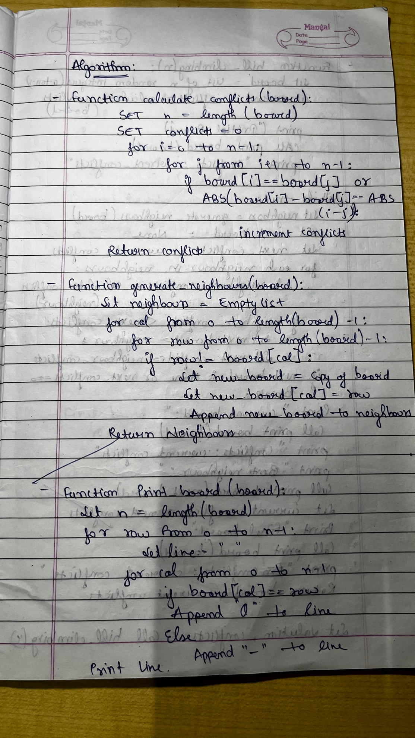
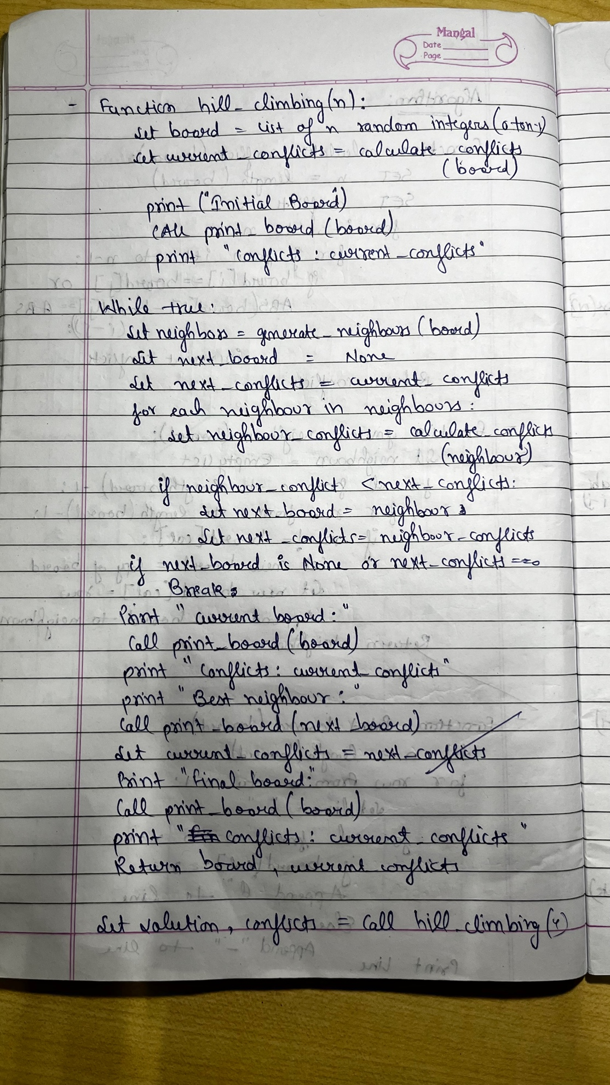

Sate Space Tree:
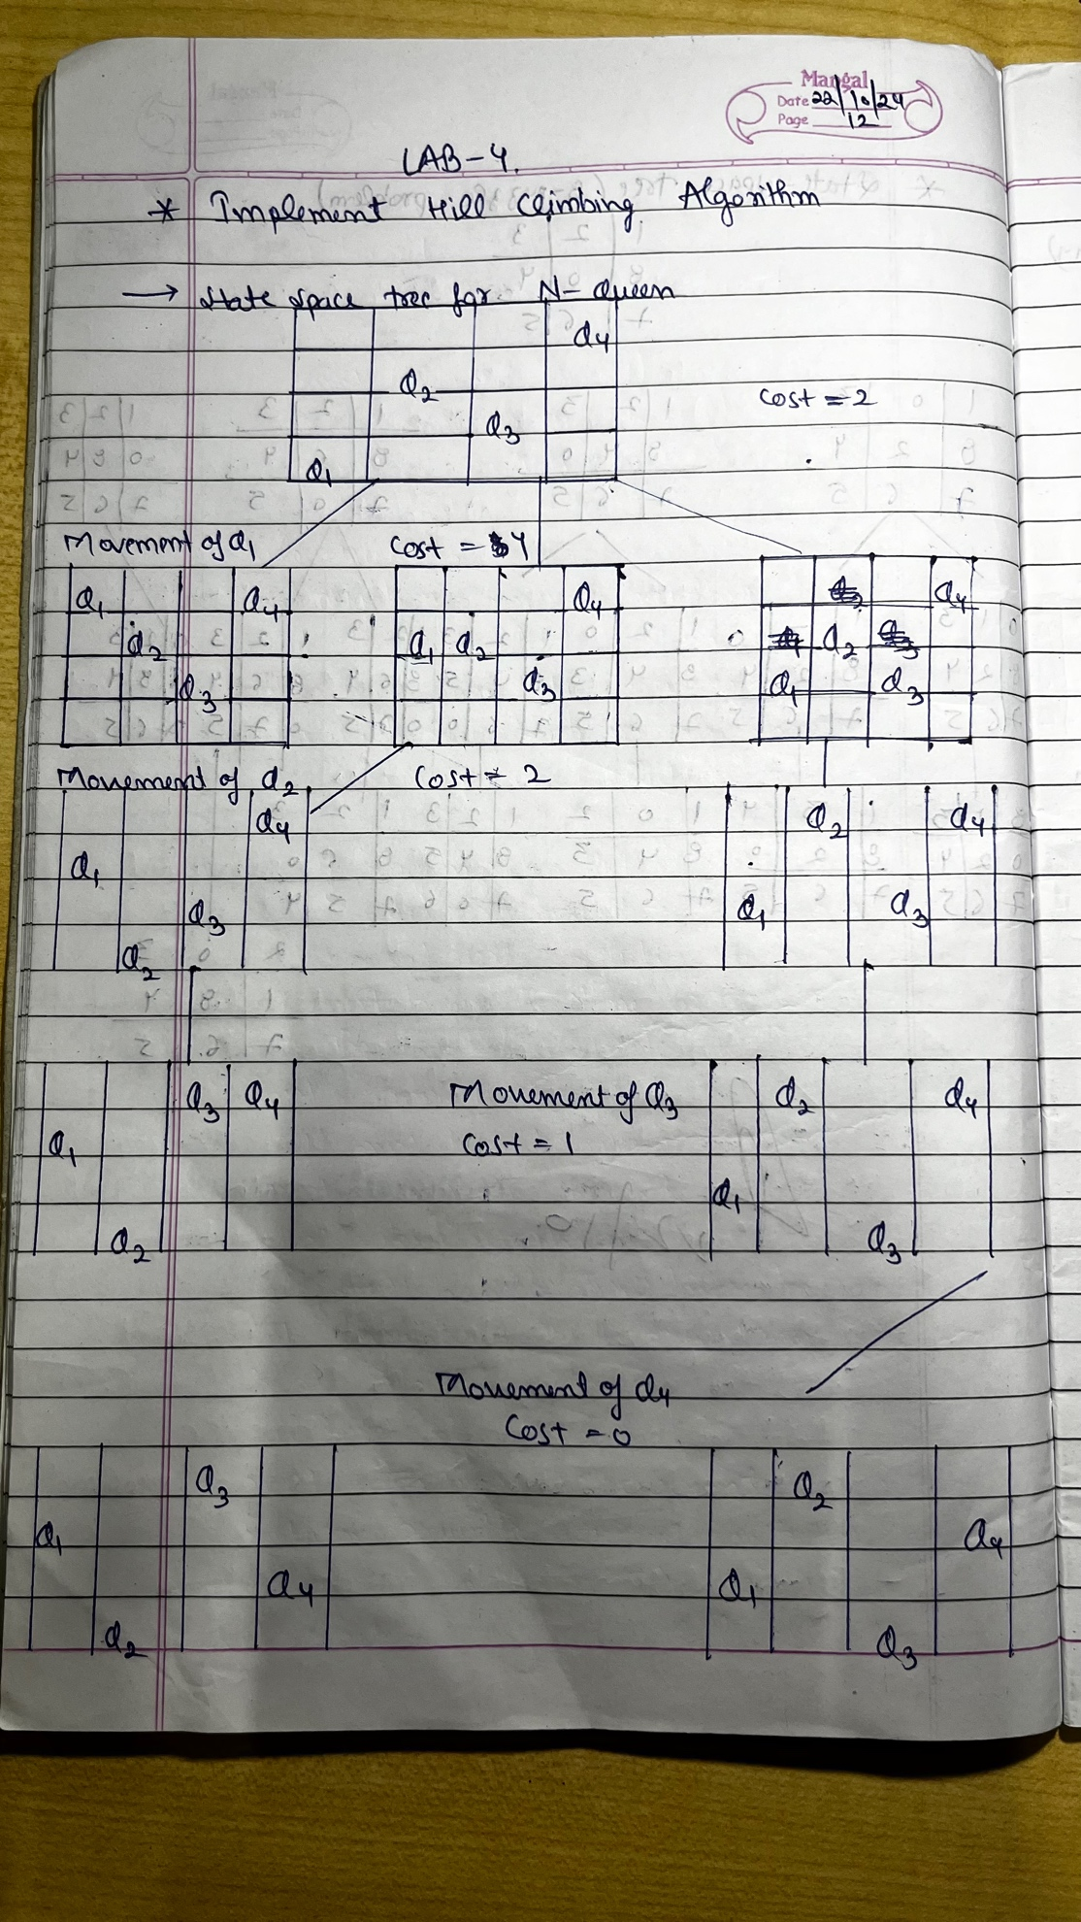
Code:
import random

def calculate_conflicts(board):
n = len(board)
conflicts = 0
for i in range(n):
for j in range(i + 1, n):
if board[i] == board[j] or abs(board[i] - board[j]) == abs(i - j):
conflicts += 1
return conflicts

def generate_neighbors(board):
neighbors = []
for col in range(len(board)):
for row in range(len(board)):
if row != board[col]:
new_board = board[:]
new_board[col] = row
neighbors.append(new_board)
return neighbors

def print_board(board):
n = len(board)
for row in range(n):
line = ""
for col in range(n):
line += "Q " if board[col] == row else ". "
print(line)
print()

def hill_climbing(n):
board = [random.randint(0, n - 1) for _ in range(n)]
current_conflicts = calculate_conflicts(board)
print("Initial board:")
print_board(board)
print(f"Conflicts: {current_conflicts}")

while True:
neighbors = generate_neighbors(board)
next_board = None
next_conflicts = current_conflicts
for neighbor in neighbors:
neighbor_conflicts = calculate_conflicts(neighbor)
if neighbor_conflicts < next_conflicts:
next_board = neighbor
next_conflicts = neighbor_conflicts
if next_board is None or next_conflicts == 0:
break
print("Current board:")
print_board(board)
print(f"Conflicts: {current_conflicts}")
print("Best neighbor:")
print_board(next_board)
print(f"Conflicts: {next_conflicts}")
board = next_board
current_conflicts = next_conflicts
print("Final board:")
print_board(board)
print(f"Conflicts: {current_conflicts}")
return board, current_conflicts

n = 4
solution, conflicts = hill_climbing(n)
print("Solution:", solution)
print("Conflicts:", conflicts)

Output:
Initial board:
. Q . .
Q . Q .
. . . .
. . . Q

Conflicts: 3
Current board:
. Q . .
Q . Q .
. . . .
. . . Q

Conflicts: 3
Best neighbor:
. Q . .
. . Q .
Q . . .
. . . Q

Conflicts: 1
Final board:
. Q . .
. . Q .
Q . . .
. . . Q

Conflicts: 1
Solution: [2, 0, 1, 3]
Conflicts: 1

