N-Queens using Hill Climbing
Algorithm:

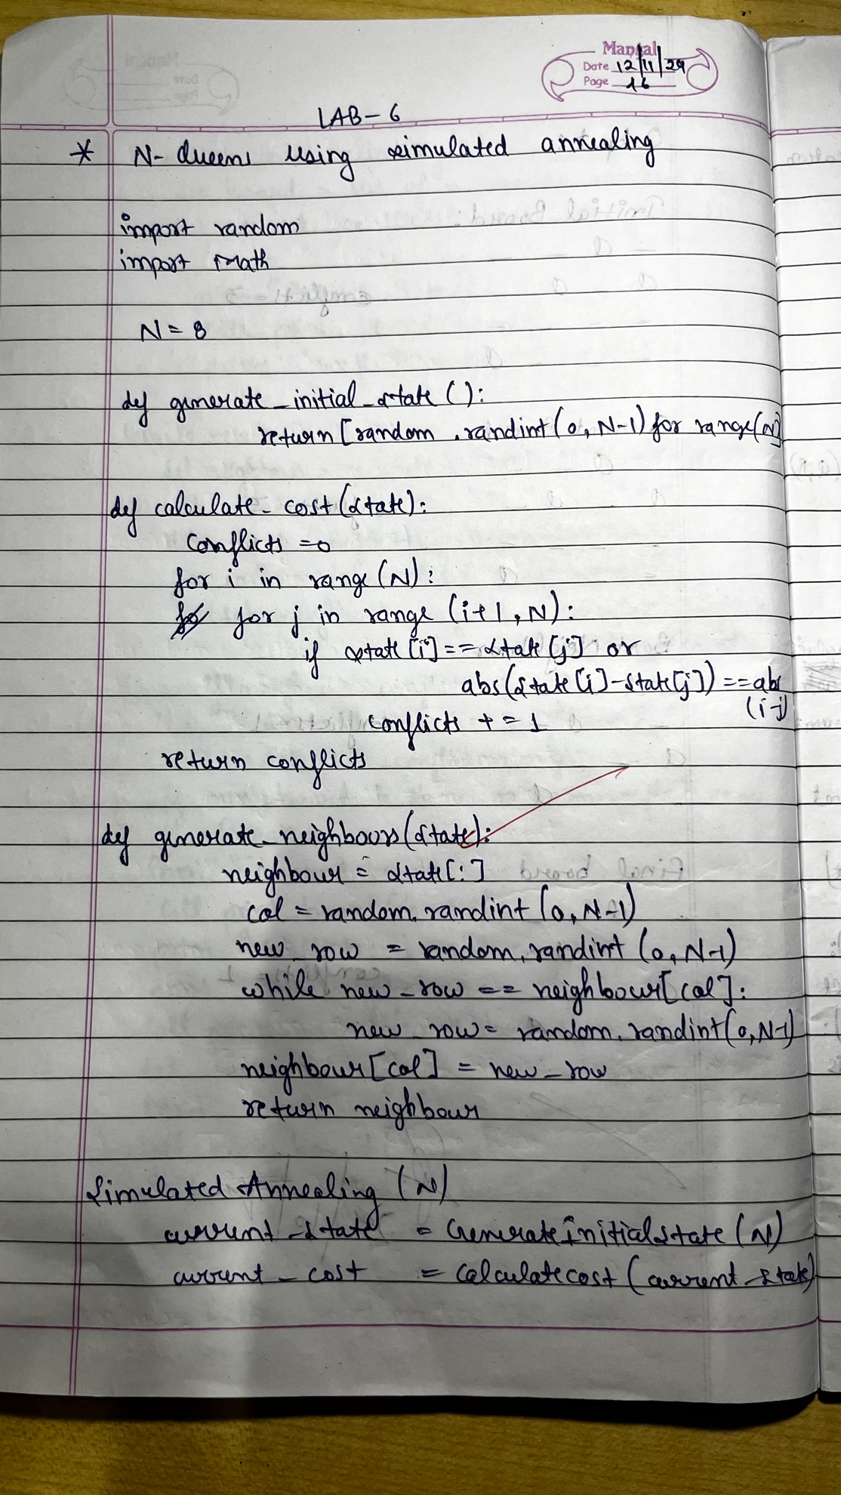

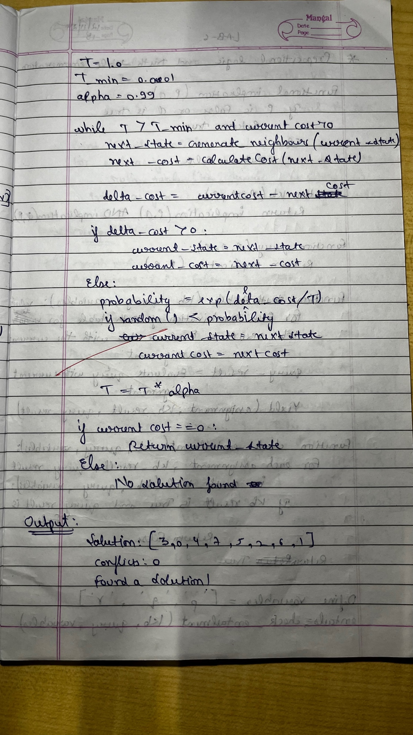
Code:
import random
import math
# Configuration and parameters
N = 8 # Number of queens and size of the board
# Define a function to generate an initial random state
def generate_initial_state():
# Place one queen in each column at a random row
return [random.randint(0, N-1) for _ in range(N)]
# Define a function to calculate the number of conflicts
def calculate_cost(state):
conflicts = 0
for i in range(N):
for j in range(i + 1, N):
if state[i] == state[j] or abs(state[i] - state[j]) == abs(i - j):
conflicts += 1
return conflicts
# Define a function to generate a neighboring state
def generate_neighbor(state):
neighbor = state[:]
col = random.randint(0, N - 1)
new_row = random.randint(0, N - 1)
while new_row == neighbor[col]:
new_row = random.randint(0, N - 1)
neighbor[col] = new_row
return neighbor
# Simulated Annealing algorithm
def simulated_annealing():
current_state = generate_initial_state()
current_cost = calculate_cost(current_state)
T = 1.0 # Initial temperature
T_min = 0.0001 # Minimum temperature threshold
alpha = 0.99 # Cooling rate
while T > T_min and current_cost > 0:
next_state = generate_neighbor(current_state)
next_cost = calculate_cost(next_state)
delta_cost = current_cost - next_cost
if delta_cost > 0:
# Move to the next state if it has fewer conflicts
current_state, current_cost = next_state, next_cost
else:
# Move to the next state with a probability that decreases with T
probability = math.exp(delta_cost / T)
if random.random() < probability:
current_state, current_cost = next_state, next_cost
# Decrease temperature
T *= alpha
return current_state, current_cost
# Run Simulated Annealing and print result
solution, conflicts = simulated_annealing()
print("Solution:", solution)
print("Conflicts:", conflicts)
if conflicts == 0:
print("Found a solution!")
else:
print("Failed to find a solution with 0 conflicts.")

Output:


