Prepositional Logic and Truth Table Enumeration

Algorithm:
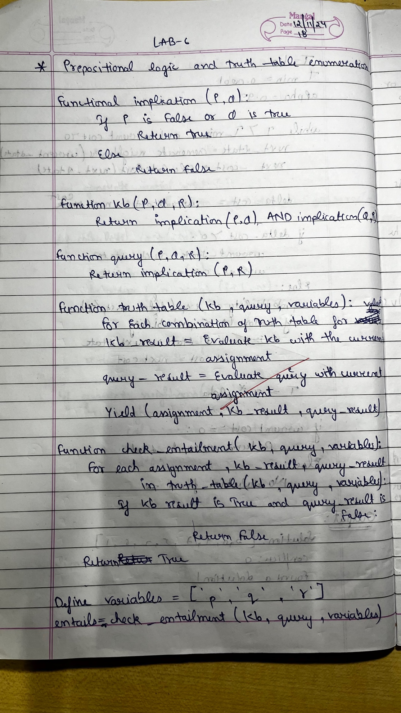
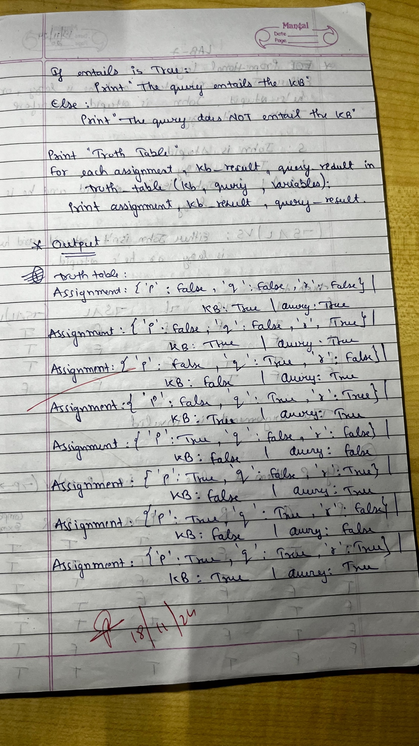
Code:
from itertools import product
def implication(p, q):
return not p or q
def kb(p, q, r):
return implication(p, q) and implication(q, r)
def query(p, q, r):
return implication(p, r)
def truth_table(kb, query, variables):
for truth_values in product([False, True], repeat=len(variables)):
# Create a dictionary for the current variable assignments
assignment = dict(zip(variables, truth_values))
kb_result = kb(**assignment)
query_result = query(**assignment)
yield (assignment, kb_result, query_result)
def check_entailment(kb, query, variables):
for assignment, kb_result, query_result in truth_table(kb, query, variables):
if kb_result and not query_result:
return False # Query does not entail KB
return True # Query entails KB
variables = ['p', 'q', 'r']
entails = check_entailment(kb, query, variables)
if entails:
print("The query entails the KB.")
else:
print("The query does NOT entail the KB.")
print("\nTruth Table:")
for assignment, kb_result, query_result in truth_table(kb, query, variables):
print(f"Assignment: {assignment} | KB: {kb_result} | Query: {query_result}")

Output:
