First Order Logic - Unification

Algorithm:
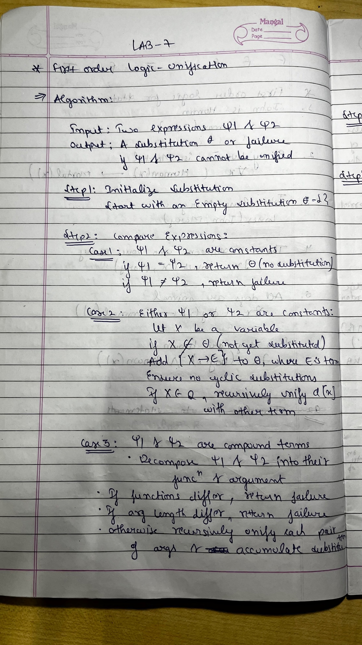
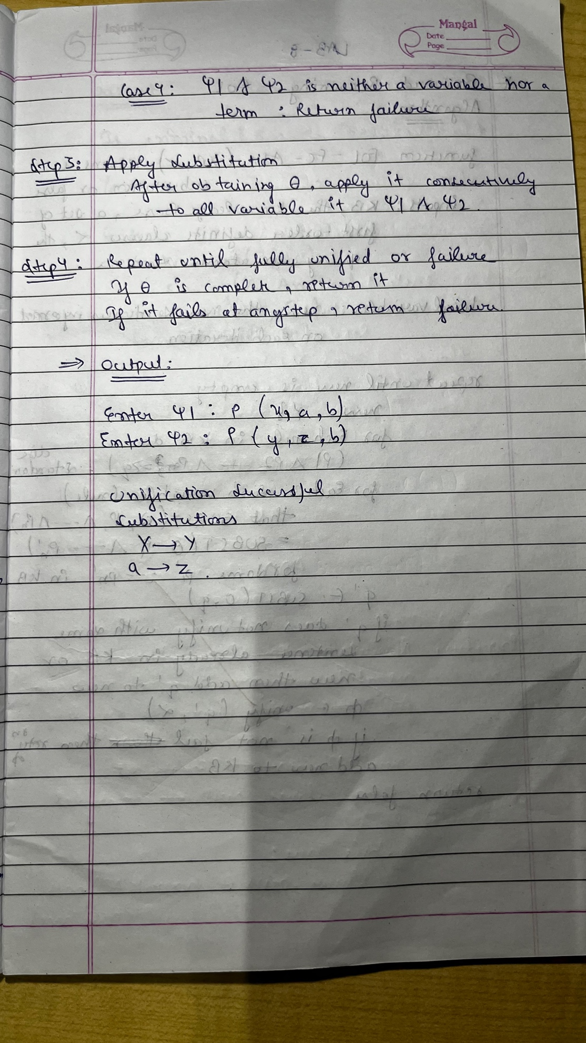
Code:
def is_variable(term):
return isinstance(term, str) and term.islower() and len(term) == 1
def occurs_check(var, term):
if var == term:
return True
if isinstance(term, tuple):
return any(occurs_check(var, sub_term) for sub_term in term[1:])
return False
def unify(psi1, psi2, subst=None):
if subst is None:
subst = {}
if psi1 == psi2:
return subst
if is_variable(psi1):
return unify_variable(psi1, psi2, subst)
if is_variable(psi2):
return unify_variable(psi2, psi1, subst)
if isinstance(psi1, tuple) and isinstance(psi2, tuple):
if psi1[0] != psi2[0]:
return None
if len(psi1) != len(psi2):
return None
for arg1, arg2 in zip(psi1[1:], psi2[1:]):
subst = unify(arg1, arg2, subst)
if subst is None: # Step 5(b)
return None
return subst
return None
def unify_variable(var, term, subst):
if var in subst:
return unify(subst[var], term, subst)
elif isinstance(term, str) and term in subst:
return unify(var, subst[term], subst)
elif occurs_check(var, term):
return None
else:
subst[var] = term
return subst
def parse_term(term_str):
term_str = term_str.strip()
if "(" in term_str and term_str.endswith(")"):
predicate = term_str[:term_str.index("(")]
arguments = term_str[term_str.index("(") + 1:-1].split(",")
return (predicate,) + tuple(arg.strip() for arg in arguments)
return term_str
psi1 = input("Enter Ψ1: ").strip()
psi2 = input("Enter Ψ2: ").strip()
term1 = parse_term(psi1)
term2 = parse_term(psi2)
result = unify(term1, term2)
if result is not None:
print("Unification Successful!")
print("Substitutions:")
for var, value in result.items():
print(f"{var} -> {value}")
else:
print("Unification Failed!")

Output:
