First Order Logic – Forward Reasoning

Algorithm:
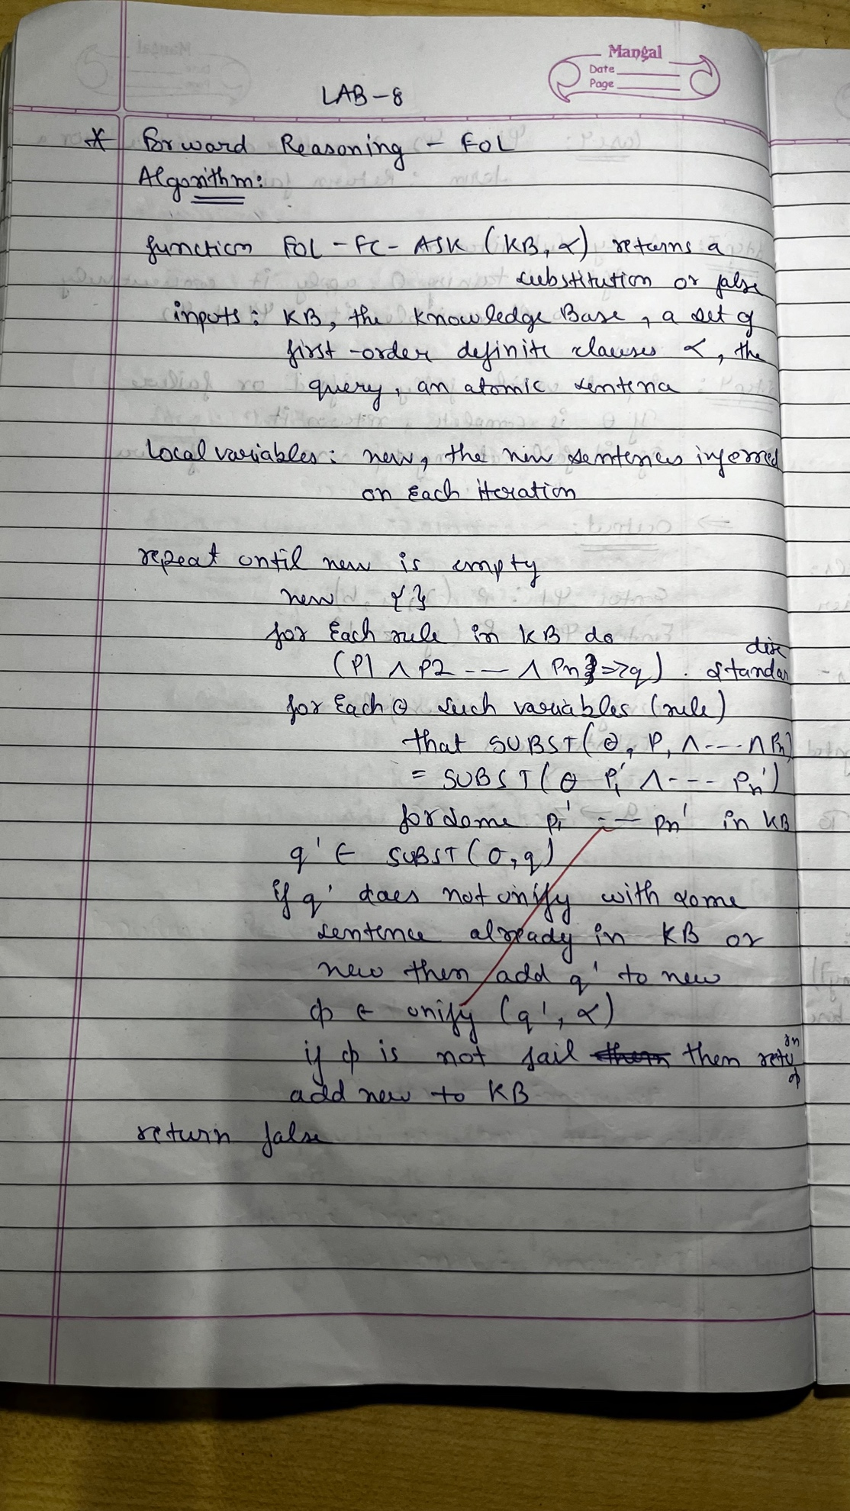
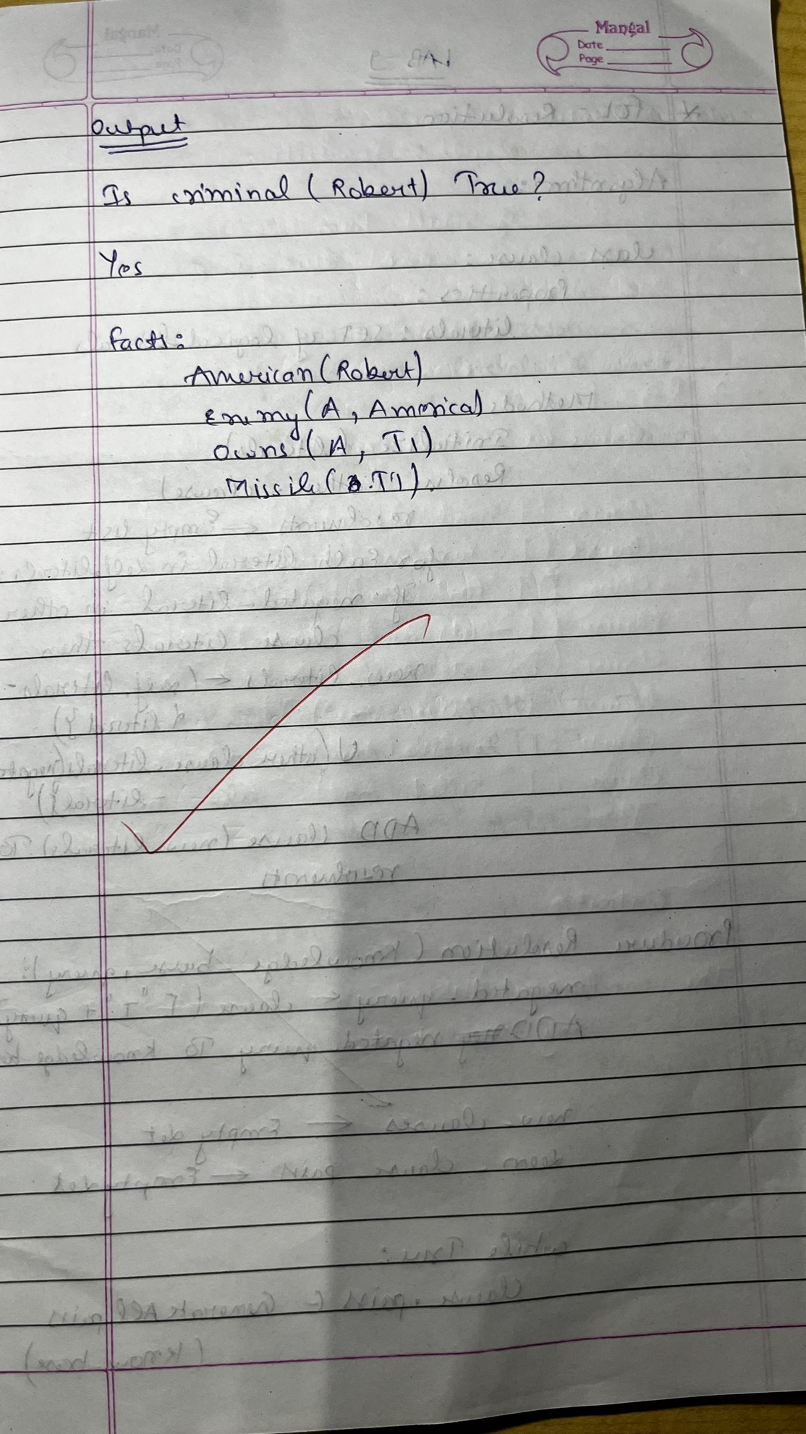
Code:
class KnowledgeBase:
def __init__(self):
self.facts = set()
self.rules = []
def add_fact(self, fact):
self.facts.add(fact)
def add_rule(self, rule):
self.rules.append(rule)
def forward_reason(self):
new_facts = set()
while True:
for rule in self.rules:
inferred = rule(self.facts)
# Add only new facts that aren't already in the knowledge base
new_facts.update(inferred - self.facts)
if not new_facts:
break
self.facts.update(new_facts)
new_facts.clear()
def query(self, fact):
return fact in self.facts
def rule_american_criminal(facts):
inferred = set()
for fact in facts:
if fact.startswith("Sells("): # Find sells facts
parts = fact[6:-1].split(", ") # Extract parts: Sells(person, weapon, country)
person, weapon, country = parts[0], parts[1], parts[2]
if f"American({person})" in facts and f"Weapon({weapon})" in facts and f"Hostile({country})" in facts:
inferred.add(f"Criminal({person})")
return inferred

def rule_hostile_enemy(facts):
inferred = set()
for fact in facts:
if fact.startswith("Enemy("):
parts = fact[6:-1].split(", ") # Extract parts: Enemy(country, America)
country = parts[0]
inferred.add(f"Hostile({country})")
return inferred

def rule_weapons_from_missiles(facts):
inferred = set()
for fact in facts:
if fact.startswith("Missile("):
missile = fact[8:-1] # Extract missile name
inferred.add(f"Weapon({missile})")
return inferred

def rule_sells_missiles(facts):
inferred = set()
for fact in facts:
if fact.startswith("Owns("):
parts = fact[5:-1].split(", ") # Extract parts: Owns(country, item)
country, item = parts[0], parts[1]
if f"Missile({item})" in facts:
inferred.add(f"Sells(Robert, {item}, {country})")
return inferred
kb = KnowledgeBase()
kb.add_fact("American(Robert)")
kb.add_fact("Enemy(A, America)")
kb.add_fact("Owns(A, T1)")
kb.add_fact("Missile(T1)")
kb.add_rule(rule_american_criminal)
kb.add_rule(rule_hostile_enemy)
kb.add_rule(rule_weapons_from_missiles)
kb.add_rule(rule_sells_missiles)
kb.forward_reason()
query = "Criminal(Robert)"
print(f"Is '{query}' true? \n{'Yes' if kb.query(query) else 'No'}")

Output:
