First Order Logic – Resolution

Algorithm:
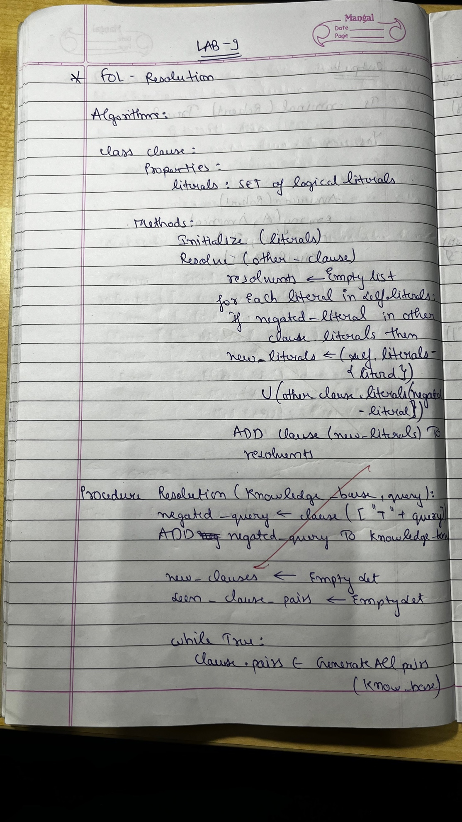
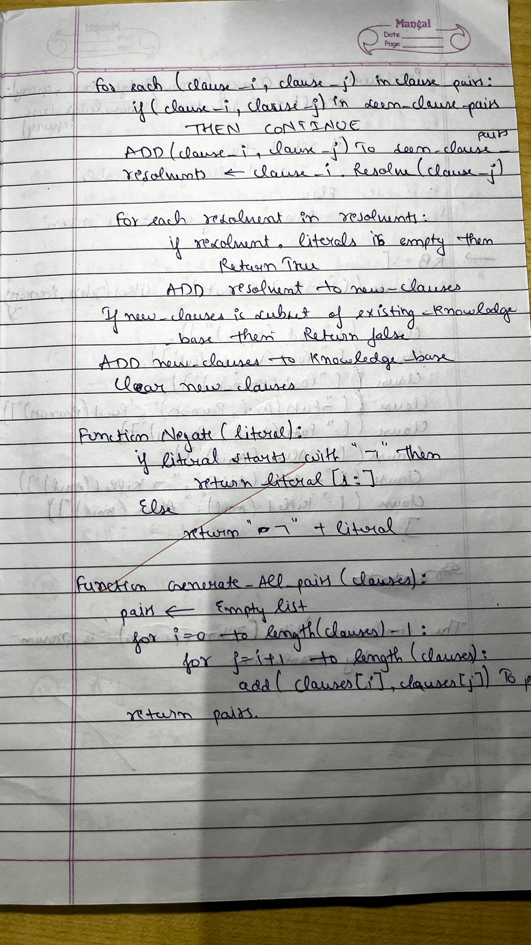
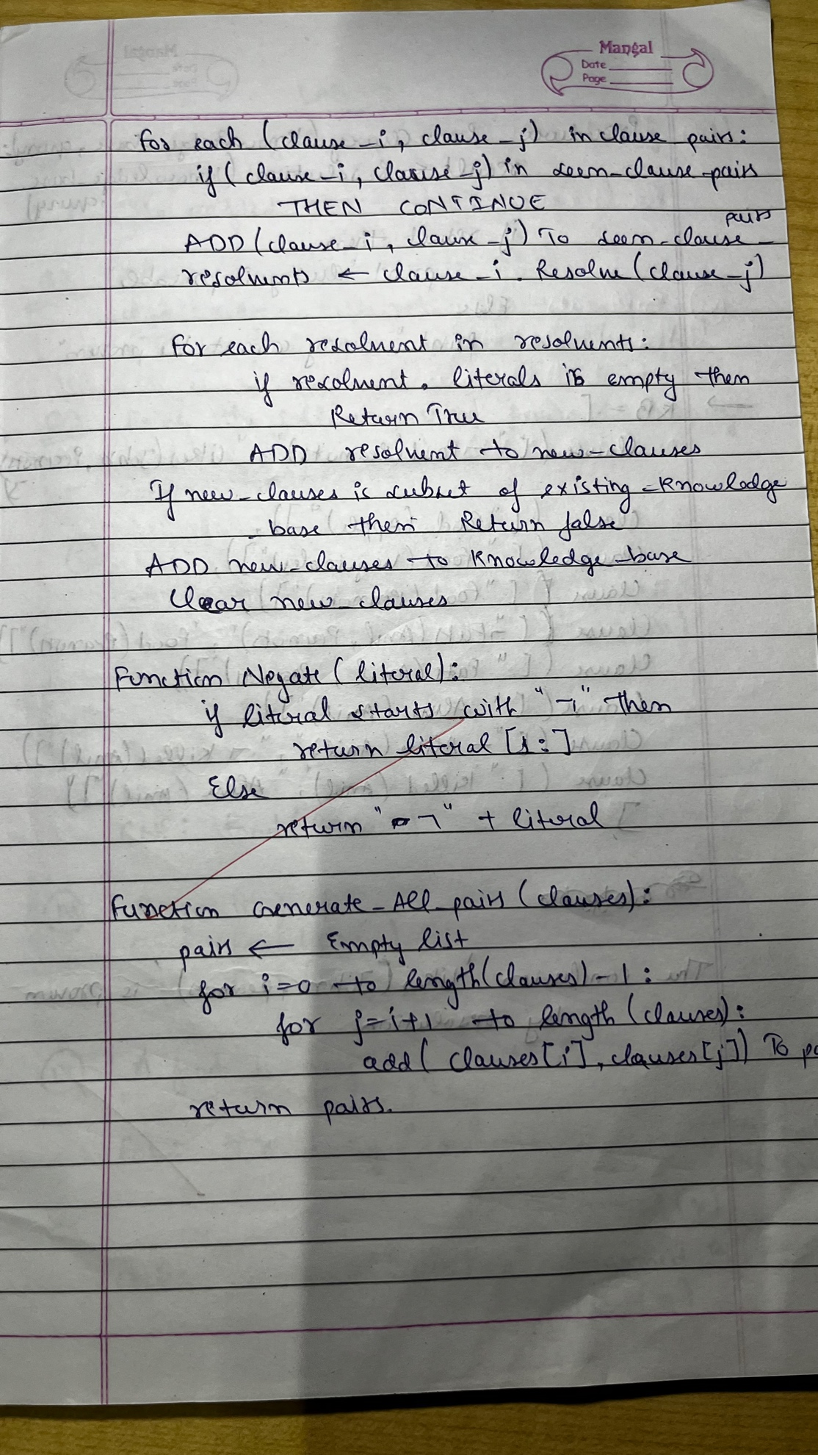

Code:
class Clause:
def __init__(self, literals):
self.literals = set(literals)
def __repr__(self):
return " ∨ ".join(sorted(self.literals))

def resolve(self, other):
resolvents = []
for literal in self.literals:
negated_literal = f"¬{literal}" if not literal.startswith('¬') else literal[1:]
if negated_literal in other.literals:
new_literals = (self.literals - {literal}) | (other.literals - {negated_literal})
resolvents.append(Clause(new_literals))
return resolvents

def resolution(clauses, query):
negated_query = Clause([f"¬{query}"])
clauses.append(negated_query)
new = set()
seen_pairs = set()
while True:
pairs = [(clauses[i], clauses[j]) for i in range(len(clauses)) for j in range(i + 1, len(clauses))]
for ci, cj in pairs:
if (ci, cj) in seen_pairs or (cj, ci) in seen_pairs:
continue
seen_pairs.add((ci, cj))
resolvents = ci.resolve(cj)
for resolvent in resolvents:
if not resolvent.literals:
return True
new.add(frozenset(resolvent.literals))
if new.issubset(set(map(frozenset, (c.literals for c in clauses)))):
return False
clauses.extend(Clause(list(literals)) for literals in new - set(map(frozenset, (c.literals for c in clauses))))
new.clear()
KB = [
Clause(["¬Food(Peanuts)", "Likes(John, Peanuts)"]),
Clause(["Food(Apple)"]),
Clause(["Food(Vegetables)"]),
Clause(["Food(Peanuts)"]),
Clause(["¬Eats(Anil, Peanuts)", "Food(Peanuts)"]),
Clause(["Eats(Anil, Peanuts)"]),
Clause(["Alive(Anil)"]),
Clause(["¬Alive(Anil)", "¬Killed(Anil)"]),
Clause(["Killed(Anil)", "Alive(Anil)"])
]
query = "Likes(John, Peanuts)"
if resolution(KB, query):
print(f"The conclusion '{query}' is proven by resolution.")
else:
print(f"The conclusion '{query}' cannot be proven.")

Output:

