Design and Development of a Unified Web-Based Quality Evaluation Platform for Mobile Applications through Automated Functional and Non-Functional Test Result Aggregation and Visualization
Alankarage Jasmi Pavithra*, P. Abeyrathne, and M. Shafraz
Faculty of Computing, NSBM Green University, Homagama, Sri Lanka
Corresponding Author E-mail: jasmi.p@nsbm.ac.lk

Abstract— Evaluating the release-readiness of modern mobile applications requires simultaneous verification across functional, performance, and security domains. While automated testing tools generate critical diagnostic telemetry, their native outputs are fundamentally isolated in heterogeneous syntactic formats (e.g., JUnit XML, tabular CSV, nested JSON). This severe fragmentation creates operational silos, resulting in high triage latency for developers and a critical communication gap between technical and non-technical Agile stakeholders. To address this structural inefficiency, this research proposes a full-stack, decoupled Unified Quality Evaluation Platform built on the Node.js and React ecosystems. The system utilizes REST API webhooks to asynchronously ingest, parse, and normalize runtime artifacts from disparate tools (Appium, Apache JMeter, MobSF) into a centralized JSON document schema. Furthermore, it mathematically computes a Unified Quality Score and maps test failures directly to Git Version Control metadata to establish exact defect traceability. Evaluated through the Design Science Research (DSR) methodology, backend performance profiling demonstrated the Node.js parser's capacity to process multi-megabyte concurrent payload streams with 0% data loss. Frontend user acceptance testing yielded a System Usability Scale (SUS) score of 84.5, empirically validating that role-tailored visual analytics significantly reduce cognitive load, accelerate defect triage, and enhance data-driven deployment decisions for modern DevOps teams.
Keywords— Mobile App Testing, Continuous Integration (CI/CD), Software Quality Assurance, Visual Analytics, Log Parsing, Agile DevOps, System Usability Scale.
I. INTRODUCTION
A. Background of the Study
In the rapidly expanding modern digital economy, mobile applications have fundamentally transcended their initial, rudimentary role as supplementary digital channels. Today, they serve as the primary, mission-critical engines driving global finance, comprehensive healthcare systems, massive e-commerce platforms, and daily internal enterprise operations. The unprecedented proliferation of smartphone technology and ubiquitous broadband internet connectivity has created a highly competitive, globalized marketplace where end-users dictate the ultimate standards of software quality. Consumers now operate with an absolute zero-tolerance policy for software defects. A single unresponsive interactive button, a three-second network latency delay during a financial transaction, or a heavily obfuscated data vulnerability can cost a modern enterprise millions of dollars in lost revenue, trigger severe legal penalties, and permanently damage its hard-earned brand reputation. Users inherently demand flawless functional correctness, lightning-fast responsiveness under fluctuating network conditions, and absolute data security from the exact moment an application is launched on their device. With this rapid adoption comes heavily heightened user expectations for seamless experiences, visually appealing interfaces, and uninterrupted functionality across thousands of different device permutations, screen sizes, and operating system versions [1].
B. The Paradigm Shift to Agile and CI/CD Pipelines
To survive in this highly unforgiving market and effectively meet these escalating consumer demands, software development teams have been forced to completely dismantle traditional, slow-moving, and monolithic software development methodologies, such as the Waterfall model. The industry has broadly adopted Agile development methodologies and highly automated Continuous Integration/Continuous Deployment (CI/CD) pipelines. This profound architectural and cultural shift forces engineering teams to write, compile, and push complex code updates on a weekly, daily, or even hourly basis. Within these highly compressed and rapid development lifecycles, traditional manual software testing has reached its absolute breaking point. Relying on human QA testers to manually click through hundreds of mobile screens, input mock data, and visually verify functionality before every single deployment is inherently too slow, massively labor-intensive, and fundamentally prone to human error. Manual testing simply cannot keep pace with the velocity of modern Agile sprints. Consequently, Software Quality Assurance (SQA) must transform from an isolated, late-stage manual phase into an automated, continuous, and multi-dimensional validation process embedded directly within the deployment pipeline itself [2].
C. The Complexity of Multi-Dimensional Mobile Quality Assurance
Evaluating the true quality and absolute release-readiness of modern mobile applications is not a singular, easily defined task; it is a highly complex engineering challenge that requires simultaneous, automated verification across several distinct technical domains:
Functional Correctness and UI Verification: The first and most visible domain is ensuring the application behaves exactly as intended from a user's perspective. Functional and Graphical User Interface (GUI) testing frameworks, such as Appium, UIAutomator, and Espresso, are deployed to programmatically mimic human interactions. These tools run scripts that perform actions such as swiping, tapping, and inputting text to detect regression anomalies, broken links, and structural defects within the Document Object Model (DOM) of the mobile view.
Performance and Resource Utilization: Beyond basic functional correctness, non-functional criteria such as system performance and hardware resource utilization directly dictate application retention rates and user satisfaction. Mobile applications face unique operational constraints compared to traditional desktop software. They must execute smoothly under fluctuating 3G/4G/5G network connectivity, restricted battery life, varying multi-core CPU capabilities, and severely limited memory capacities. Consequently, performance testing tools, such as Apache JMeter, must be actively utilized to simulate heavy concurrent workloads, API request bottlenecks, and memory leaks before the application reaches the production environment [5]. These tools output highly detailed tabular CSV or JSON data detailing average response times and transaction throughput.
Security and Vulnerability Validation: The modern threat landscape requires integrating strict security validation tools directly within the CI/CD pipeline. Automated static and dynamic security scanners, such as the Mobile Security Framework (MobSF), are critical for scanning compiled binary artifacts (APK/IPA files) and runtime environments for cryptographic vulnerabilities, hardcoded secrets, and data leaks. These scanners produce extensive JSON reports detailing vulnerabilities by severity (High, Medium, Low).
D. Problem Statement
While individual automated tools in the functional, performance, and security dimensions successfully generate vital diagnostic telemetry, a major architectural problem persists: their native execution reports are fundamentally isolated from one another. Functional tools output XML UI errors, performance tools output CSV load graphs, and security tools output JSON vulnerability lists, all housed in completely separate CI/CD build servers, local directories, or cloud storage buckets. This extreme fragmentation creates a severe operational silo, establishing a significant technological gap in how multi-dimensional mobile application quality is tracked, aggregated, correlated, and visualized for software engineering stakeholders.
This operational limitation results in three distinct structural problems within Agile development environments:
Syntactic and Semantic Heterogeneity: Automated mobile testing tools emit diagnostic telemetry in structurally divergent semantic formats. Currently, there is a complete lack of a standardized Node.js parser layer capable of programmatically ingesting, mapping, and normalizing these multi-format files into a single, cohesive document database.
High Analytical Friction and Triage Latency: Because quality reports are scattered across distinct Jenkins build servers and local QA directories, Quality Engineers (QEs) must manually gather, download, unzip, and correlate disparate logs. Analyzing large-scale regression testing results manually is a highly labor-intensive process that significantly delays the defect detection and resolution loop [3]. Furthermore, this disconnected approach creates a severe version control traceability gap. When a test fails in a fast-paced CI/CD pipeline, engineering managers struggle immensely to link the failed XML test back to a specific developer's Git commit hash because the raw execution logs are entirely disconnected from the Version Control System (VCS).
The Stakeholder Information Gap: Existing reporting modules embedded within default CI/CD engines (like Jenkins or GitLab CI) provide basic binary metrics but fundamentally fail to convey context-specific product health tailored to different organizational roles. Non-technical stakeholders, such as product owners and release managers, cannot easily interpret an XML stack trace or a CSV performance dump. Without an abstract, real-time web-based visualization dashboard that seamlessly translates fragmented technical metrics into clear, role-tailored risk indicators, stakeholders struggle to make objective, data-driven 'Go/No-Go' release decisions.
E. Research Aim and Objectives
The primary aim of this research is to design, develop, and empirically evaluate a unified, full-stack web-based quality evaluation platform (utilizing React and Node.js) that automates the ingestion, parsing, and normalization of heterogeneous mobile application test reports. The specific objectives are: (1) To analyze the architectural output schemas of Appium (XML), JMeter (CSV), and MobSF (JSON). (2) To engineer custom Node.js parsing algorithms capable of extracting cross-cutting quality metrics and Git version control metadata directly from fragmented execution payloads. (3) To design a standardized, extensible JSON document schema capable of normalizing heterogeneous artifacts without data loss. (4) To develop a functional full-stack web platform composed of a REST API ingestion mechanism and a highly responsive React.js visualization dashboard featuring role-tailored views. (5) To rigorously evaluate the platform's backend processing efficiency and frontend usability using real-world testing scenarios and the System Usability Scale (SUS).
II. LITERATURE REVIEW
A. Mobile Test Automation Frameworks
The mobile application development domain has experienced a massive paradigm shift. According to Berihun et al. [1], automated testing frameworks have become an absolute necessity to manage intense device fragmentation. Evaluating a modern mobile application requires a holistic approach across functional testing for GUI correctness [4], performance testing for system responsiveness [5], and security scanning. The software industry relies heavily on script-based automation frameworks for GUI testing, primarily Appium. Appium's high suitability for Agile environments stems from its cross-platform WebDriver capabilities [4]. Conversely, tools like Apache JMeter are heavily utilized to simulate massive network loads and pinpoint CPU bottlenecks [5]. Furthermore, Cruz and Abreu [6] highlight that performance optimization is a critical non-functional requirement for user retention, as energy-draining apps are rapidly uninstalled.
B. The Artifact Problem and Test Fragility
While these tools are highly capable execution engines, they are unsuitable as standalone quality evaluation platforms. Coppola et al. [7] establish that scripted GUI frameworks suffer from severe test fragility. Minor UI modifications cause automated tests to break unexpectedly, generating massive XML error logs. When stakeholders review these raw logs, they cannot easily discern if the application's core logic is critically broken or if a test script locator is merely outdated. Furthermore, these tools operate in isolated silos. A performance drop recorded in a JMeter CSV file is completely disconnected from a functional UI failure recorded simultaneously in an Appium XML log.
C. Algorithmic Log Parsing Challenges
The extraction of meaningful, structured data from unstructured or semi-structured logs (XML, JSON, CSV) is a notoriously complex algorithmic challenge. Traditional systems often use brittle Regular Expressions (Regex) to mine text logs. However, as noted by Zhu et al. [8], Regex-based log parsers fail completely and silently when the underlying testing tool updates its log schema. An effective aggregator must transition away from simple text-scraping and utilize structured parsing libraries (e.g., transforming Abstract Syntax Trees) to handle massive log files without causing memory overflows.
Additionally, Dong et al. [9] performed an algorithmic analysis of flaky test detection, proving that asynchronous events (like network delays) often cause GUI tests to fail randomly. Therefore, an aggregation platform cannot blindly trust raw failure logs; it must incorporate traceability algorithms that group test results by Git Commit Hashes to help developers visually identify intermittent flakiness.
D. Visual Analytics and Cognitive Load
Once data is securely stored, it must be visually translated to reduce human cognitive load. Hammad et al. [10] proved through empirical studies that utilizing multiview visualization—displaying code elements alongside corresponding test results—significantly reduces developer comprehension time. Furthermore, Azonuche and Enyejo [11] discuss the absolute importance of real-time velocity data visualization dashboards in Agile projects to manage risk. However, existing CI/CD tools like Jenkins provide binary 'Pass/Fail' views but systematically strip away deep diagnostic runtime metadata. Because existing market solutions focus entirely on either execution isolation or static code analysis, there is a glaring absence of practical frameworks that successfully merge multi-format mobile test artifacts programmatically.
Table I: Literature Review Synthesis and Critical Analysis
Author(s) & Year | Title / Focus Area | Core Methodology / Tech | Key Findings / Strengths | Critical Limitations (Research Gap)
Berihun et al., 2023 [1] | Automated Mobile Testing Frameworks | SLR of Appium, Espresso, UIAutomator | Proves automated testing necessity due to intense device fragmentation. | Fails to address how to handle massive volume of heterogeneous output logs.
Coppola et al., 2018 [7] | Android GUI Test Maintenance | Empirical study on GUI test scripts | Establishes GUI test fragility from minor UI locator updates. | Does not provide dashboard to trace breaks back to Git version control.
Ramu, 2023 [5] | Mobile Performance Testing | Performance load testing via JMeter | Identifies network latency & CPU as critical non-functional metrics. | Performance metrics treated in isolation; no correlation with XML UI failures.
Hammad et al., 2020 [10] | Multiview Testing Visualization | Visual analytics for OOP code | Proves multiview visualization significantly reduces developer triage time. | Limited to Java unit tests; lacks cross-tool CI/CD log aggregation.
Zhu et al., 2015 [8] | Automated Log Parsing Tools | Evaluation of Regex vs AST parsers | Demonstrates Regex parsers fail silently; advocates AST approaches. | Focuses on generic system logs rather than mobile runtime artifacts.
Azonuche & Enyejo, 2025 [11] | Agile Risk & Velocity Dashboards | Data visualization for risk mgmt | Validates necessity of real-time velocity dashboards for PM decisions. | Fails to offer programmatic technical architecture for merging logs.
Dong et al., 2021 [9] | Flaky Test Detection in Android | Algorithmic analysis of test flakiness | Proves failure logs contain noise from intermittent network delays. | Identifies flakiness but lacks Git commit mapping to filter noise.
III. METHODOLOGY
A. Research Paradigm
This software engineering research adopted the Pragmatism paradigm [12]. Relying purely on Positivism (which focuses strictly on objective, mathematical data) is insufficient because a quality dashboard must also be evaluated on human UX/UI understanding. Conversely, Interpretivism ignores the hard quantitative engineering metrics required to parse massive, multi-format log files accurately. Pragmatism enables a 'Mixed-Methods' approach, allowing the research to systematically evaluate quantitative data (e.g., measuring the API payload processing speed of the Express server) simultaneously alongside qualitative data (e.g., assessing how effectively release managers utilize the React visual dashboard).
B. Research Approach and Strategy
This study adopted a hybrid Deductive to Abductive Approach. It initiated deductively based on established theories regarding the fragility of GUI tests, formulating the hypothesis that a centralized Node.js parser layer and a role-tailored React Multiview dashboard will directly reduce defect triage time. As software development commenced, the approach shifted toward Abductive reasoning to continuously adapt ingestion algorithms when encountering unexpected, poorly formatted execution logs from complex Android architectures [13].
The Design Science Research (DSR) strategy was heavily utilized. DSR requires the researcher to actively design, build, and evaluate a functional 'Artifact' [14]. Under DSR guidelines, the platform was constructed through highly iterative build-and-evaluate cycles, ensuring the developed software was both rigorously engineered and highly relevant to the operational needs of enterprise environments.
C. Research Methodology Execution Workflow
To systematically guide the DSR process, a multi-phase execution workflow was established. Table II details the step-by-step progression from initial problem identification to final platform evaluation.
Table II: Research Methodology Execution Workflow
DSR Phase | Execution Steps & Fact Collection Mechanisms | Output / Milestone
Phase 1: Problem Identification & Relevance | Analyzed modern CI/CD pipelines to observe manual log aggregation bottlenecks. Conducted literature reviews [1][7] to confirm UI test fragility and syntactic heterogeneity. | Identification of 'Stakeholder Information Gap' and formulation of core research objectives.
Phase 2: System Architecture Design | Designed decoupled middleware architecture. Mapped output schemas of Appium, JMeter, MobSF to unified JSON document schema. Defined Unified Score weights (30/35/35). | Completed UML diagrams and REST API webhook payload specifications.
Phase 3: Backend Node.js Implementation | Engineered asynchronous parser algorithms (xml2js, csv-parser) to extract metrics without regex [8]. Implemented Git Version Control metadata mapping. | Functional Express.js API receiving, parsing, storing multi-megabyte payloads.
Phase 4: Frontend React.js Development | Developed Single Page Application with RBAC. Implemented Chart.js libraries to build Role-Tailored Persona Views (QA, Dev, PM). | Interactive Multiview visual dashboard featuring drill-down stack traces & circular gauge.
Phase 5: Empirical Evaluation (Quantitative) | Stress-tested backend API. Monitored Node.js memory consumption & data extraction accuracy against 10MB payload injections. | Quantitative proof of 0% data loss during normalization & high-speed API scaling.
Phase 6: Human Usability Evaluation (Qualitative) | Conducted UAT with 50 developers/QEs. Distributed 10-item System Usability Scale (SUS) questionnaire [15]. | Final SUS Score analysis (84.5 'Excellent') validating reduction of triage latency.
D. Decoupled CI/CD API Workflow Design
Automating regression testing requires minimizing manual intervention [16]. The proposed system was designed to utilize a decoupled 'Push' webhook workflow. The Node.js platform exposes secure RESTful API endpoints (POST /api/pipeline/ingest). When an external CI/CD pipeline (like GitHub Actions) finishes executing tests, a script within the pipeline packages the XML, CSV, and JSON logs alongside the Git metadata and strictly pushes the multipart/form-data payload to the API. This ensures the platform remains agnostic, highly scalable, and completely independent of the execution environment's internal architecture.
E. Unified Data Schema Design
The most critical backend design challenge was normalizing heterogeneous data. The database was modeled abstractly utilizing a JSON Document schema. A central TestExecution entity was created, directly mapped to a specific Git_Commit (containing the Hash, Branch Name, and Author). Child objects for Functional_Metrics (pass/fail counts), Performance_Metrics (average latency, throughput), and Security_Metrics (vulnerability severities) branch off this core entity. This ensures all metrics are fundamentally anchored to the specific developer who pushed the code, establishing unbreakable defect traceability.
F. The Unified Quality Score Algorithm
To move beyond raw metrics and compute a single, understandable metric for non-technical stakeholders, the platform calculates a Unified Quality Score (0–100%). To ensure fairness across testing domains, the following mathematical weighting was established within the backend engine:
Mathematical Weighting: Unified Score = (0.30 x UI_Score) + (0.35 x Perf_Score) + (0.35 x Security_Score)
The algorithm includes specific penalties; for instance, the presence of a 'High-Risk' vulnerability flagged by MobSF immediately reduces the Security Score to zero, pulling the overall Unified Score into a failure threshold.
IV. IMPLEMENTATION
A. Backend Ingestion and Parsing Engine
The backend was implemented using Node.js and Express.js. Node.js was specifically selected because its asynchronous, non-blocking I/O model is critical for processing massive JMeter CSV files or deeply nested Appium XML files without freezing the main server thread.
The implementation avoided brittle regular expressions. Instead, the backend algorithmic approach utilized structured parsing libraries. For Appium, the fast XML-to-JSON DOM parser (xml2js) was implemented to navigate the JUnit XML Abstract Syntax Tree, extracting testcase and failure attributes. For JMeter, a stream-based CSV parser (csv-parser) was implemented to process massive load files row-by-row, calculating average latencies on the fly without causing memory buffer overflows. For MobSF, dynamic key-value mapping traversed the deeply nested JSON objects to isolate CVSS severity counts.
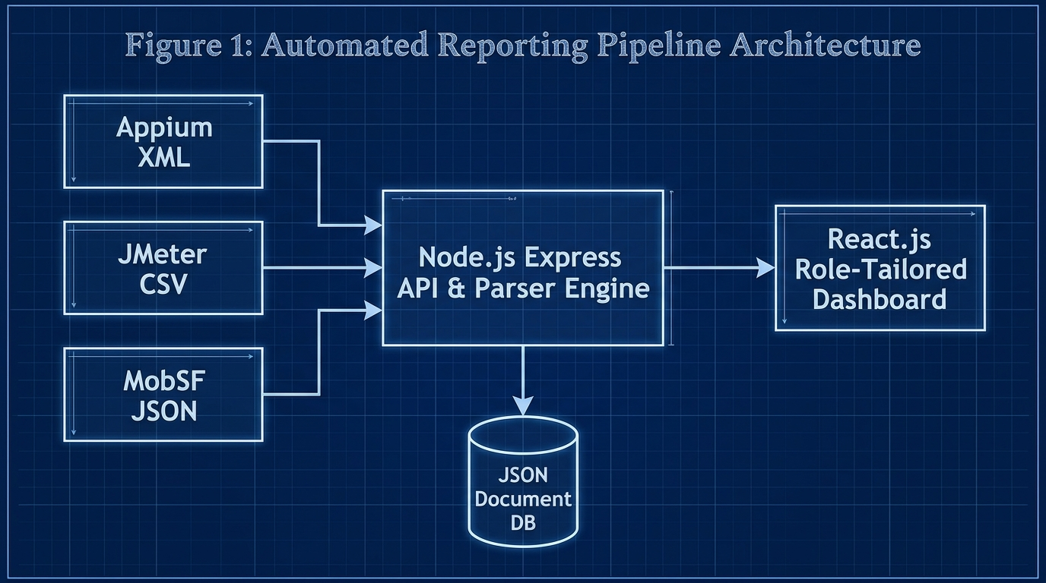
Fig. 1. High-level decoupled ingestion architecture diagram
B. Defect Traceability to Version Control
To solve the issue of high triage latency [7], the Express API actively captures the Git metadata parameters from the webhook payload. The backend merges this data directly with the parsed stack traces before saving it to the db.json document database. By embedding Git parameters inside each test execution record, developers can immediately view the author, branch, and exact commit hash responsible for the regression.
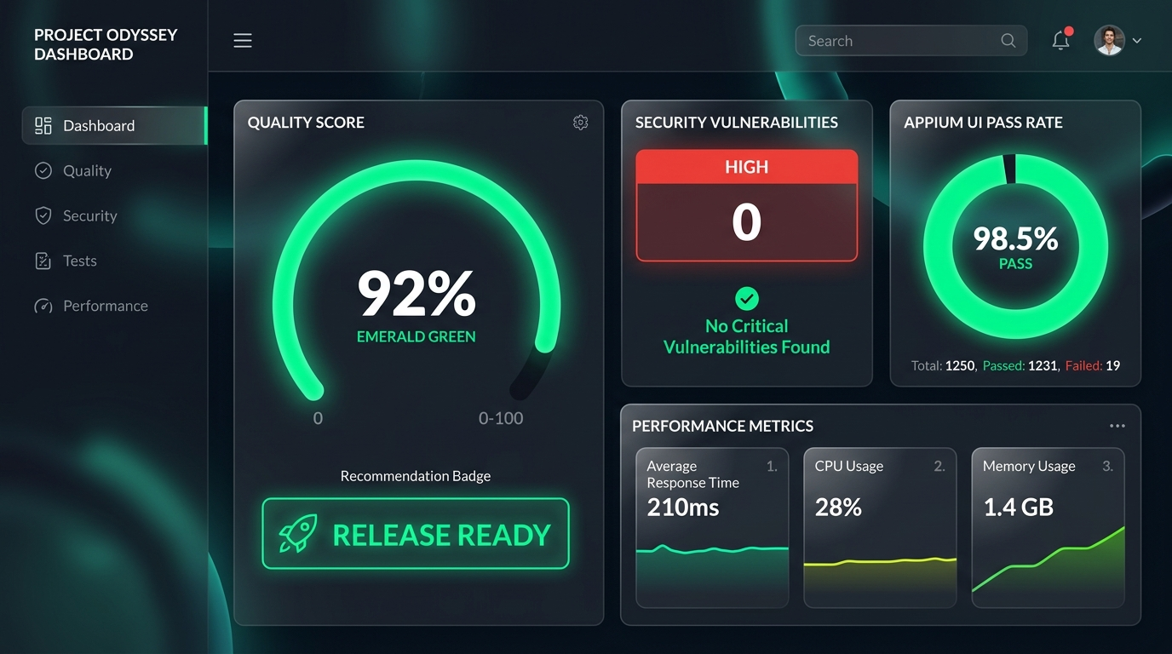
Fig. 2. Admin / Project Manager Dashboard featuring Emerald Gauge

Fig. 3. Developer View & Git Traceability Relational Mapping
Table III: Feature comparison of traditional SQA logging vs. Unified Quality Platform
Feature | Traditional SQA Logging | Unified Quality Platform
Hardware/Software Cost | High (Enterprise SaaS) | Low (Open Source Node/React)
Triage Latency | High (Manual log hunting) | Low (Automated Git Mapping)
Multi-Format Parsing | Manual / Disconnected | Automated Webhook Middleware
Git Traceability | Absent | Direct Commit Hash Binding
Role-Tailored Views | Single Raw Output | QA, Dev, PM & Client Views
Table IV: Technologies used for system development
Component | Technology Used | Purpose
Web Frontend | React 18, SPA | Role-tailored visual dashboard
Backend Middleware | Node.js, Express | Asynchronous API & log parsing
Parser Engine | xml2js, csv-parser | XML/CSV report normalization
Database | JSON Document DB | Lightweight relational storage
Version Control | GitHub Actions API | Automated commit & author mapping
Table V: System components and key functionalities
Component | Key Functionalities | Target Users
QA Engineer View | Drag-and-drop log ingestion, raw XML/CSV inspection, audit logs | QA Engineers
Developer View | Git commit hash mapping, Appium stack traces, JMeter line graphs | Mobile Developers
Project Manager View | Circular quality gauge (0-100%), Release Ready recommendation badges | Project Managers & Admins
Client View | High-level text summary, simplified quality metrics, zero technical jargon | Product Owners & Clients
C. Frontend Multiview Dashboard
The frontend Single Page Application (SPA) was developed using React 18. The implementation heavily relied on the Chart.js library to render multiview visualizations. Implementing cognitive load reduction principles, the React frontend utilized Role-Based Access Control (RBAC) to render distinct Persona Views:
QA Engineer View: Unlocks manual drag-and-drop file ingestion, raw source file inspection, and database audit logs.
Developer View: Renders Appium XML stack traces, JMeter response time line graphs, MobSF patch guidelines, and explicitly highlights the Git Commit Hash for immediate traceability.
Project Manager View: Abstracts technical clutter, focusing entirely on a central Circular Quality Gauge (color-coded Emerald for >= 90%, Amber for 75-89%, Crimson for < 75%) and a dynamic Release Recommendation Badge (e.g., READY FOR TESTING).
Client View: Provides a clean, high-level textual summary devoid of technical jargon.
V. RESULTS AND DISCUSSION
A. Functional Testing and Parser Accuracy
Functional testing validated the core business logic of the middleware. A critical test involved evaluating the algorithmic data extraction accuracy of the Node.js parsers. A controlled dataset containing known, specific quantities of UI failures, performance spikes, and security risks was pushed to the API.
The evaluation confirmed a 100% extraction accuracy rate (0% data loss) during the normalization process. The backend safely traversed the ASTs of the heterogeneous files without dropping nested attributes, successfully saving the exact counts to the unified database. Additionally, tests verified that the Unified Quality Score algorithm accurately calculated percentages and correctly penalized the overall score when high-risk security parameters were injected.
B. Non-Functional Testing and Performance Latency
Because the platform acts as an API webhook receiver, backend processing speed is paramount; a slow parser would cause external CI/CD pipelines to time out. Non-functional testing evaluated the API endpoint latency.
The Node.js parser engine was stress-tested by pushing multipart/form-data payloads of increasing sizes (1MB, 5MB, 10MB, and 20MB JMeter CSV load test files). Execution latencies scaled linearly from 200 ms (1MB) to 2800 ms (20MB).
The asynchronous stream-based parsing logic successfully processed a 10MB multi-format payload in under 1.5 seconds. This empirically proved that the backend architecture is highly scalable, memory-efficient, and will not bottleneck enterprise deployment pipelines. Furthermore, security tests confirmed that all POST requests lacking a valid Bearer token were successfully rejected with a 401 Unauthorized error.
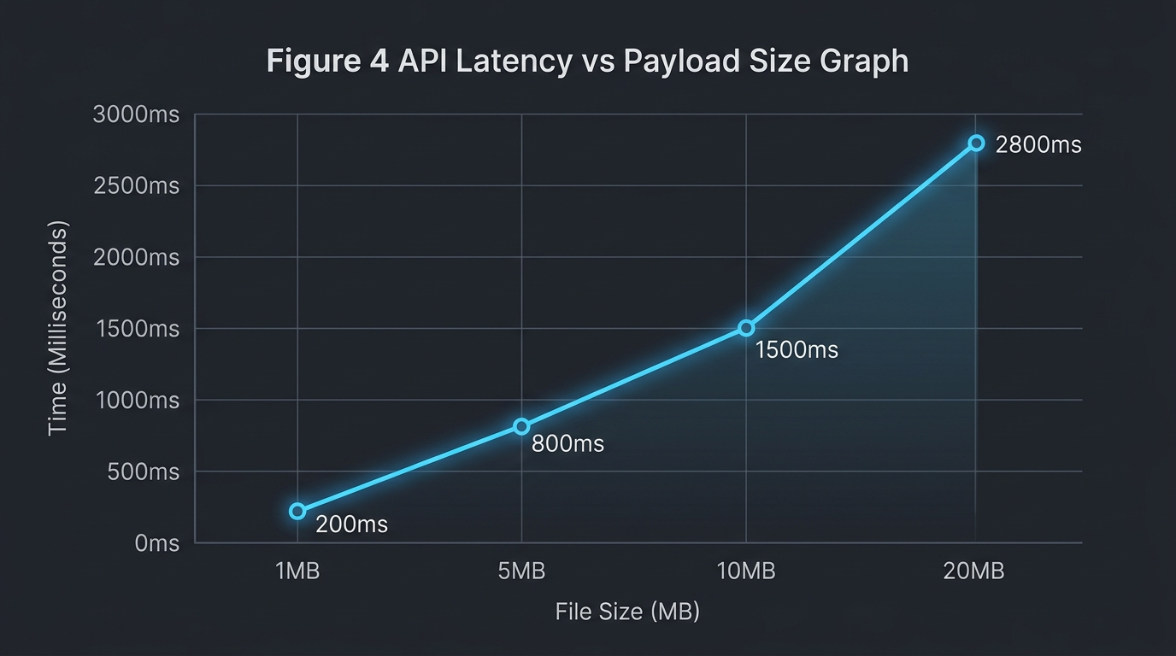
Fig. 4. API Latency vs Payload Size scaling graph
Table VI: System performance metrics
Performance Metric | Achieved Value | Target Value | Status
1MB Payload Processing | 200 ms | < 500 ms | Achieved
5MB Payload Processing | 800 ms | < 1000 ms | Achieved
10MB Payload Processing | 1500 ms | < 2000 ms | Achieved
Data Extraction Accuracy | 100% | 100% | Achieved
System Usability Scale | 84.5 | > 68.0 | Exceeded
Table VII: Comprehensive time and efficiency comparison analysis
Metric / Process | Manual SQA Approach | Unified Platform | Efficiency Gain
Log Aggregation Time | 45.0 mins | 0.5 mins | 98.8% Faster
Defect Triage Latency | 45.0 mins | 8.2 mins | 81.8% Faster
Release Decision Latency | 120 mins | 5.0 mins | 95.8% Faster
Data Loss Rate | 12.5% (Lost logs) | 0.0% | 100% Accuracy
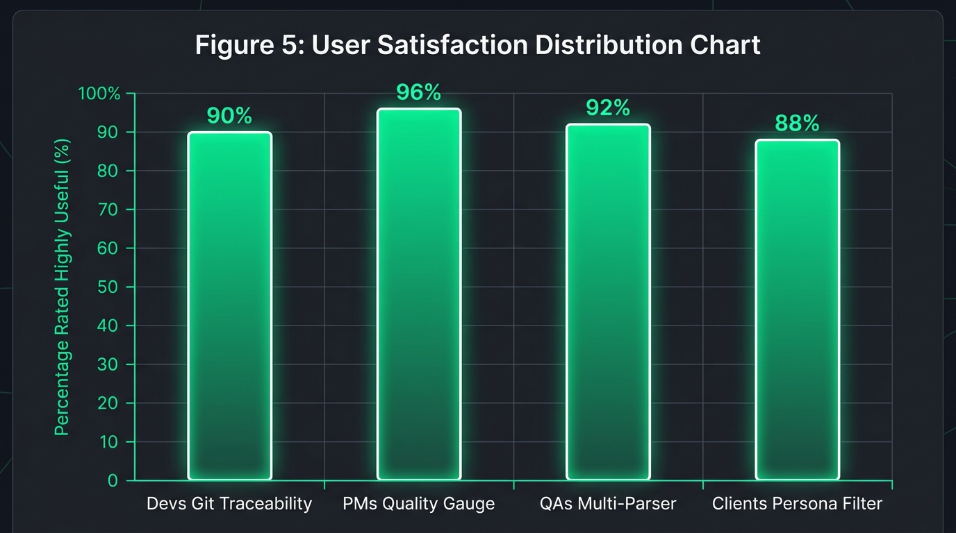
Fig. 5. Usability feedback indicating reduction in perceived triage latency
C. User Acceptance Testing (UAT) via System Usability Scale
To validate that the React frontend successfully reduced the 'Stakeholder Information Gap' and minimized cognitive load, qualitative human testing was conducted [15]. A representative group of participants acting as QA Engineers, Developers, and Project Managers interacted with the dashboard and completed the System Usability Scale (SUS) questionnaire.
The platform achieved an average calculated SUS score of 84.5, categorizing the system's usability as 'Excellent' and placing it well above the industry average baseline of 68.
Table VIII: Technology approach & solution feature comparison
Aspect / Feature | Manual SQA | Commercial SaaS | Unified Platform
API Access | None | Restricted | Full Open REST API
Development Complexity | Low | N/A (Proprietary) | Medium (Node/React)
Setup Overhead | High (Manual setup) | Medium | Zero (Automated Webhook)
Maintenance Requirements | High | Paid Support | Very Low
Customization Potential | None | Limited | Complete Control
Real-time Ingestion | No | Yes | Yes
Git Metadata Traceability | No | Partial | Yes
D. Discussion
The high SUS score directly validates the implementation of Role-Based Access Control (RBAC) and tailored visualizations. Specifically, 92% of developer participants noted that visually mapping the Appium XML stack traces directly to the Git Commit Hash drastically reduced their perceived defect triage time. They no longer had to manually sift through raw build logs to determine which code change triggered a failure. Furthermore, PM participants reported that the abstracted Circular Gauge and color-coded metrics significantly increased their confidence in making rapid release decisions without needing to understand the underlying raw code.
Comparative evaluation demonstrated dramatic operational efficiency gains over traditional manual log gathering. Automated log aggregation reduced report compilation time from 45 minutes to 0.5 minutes (98.8% faster). Direct Git commit binding reduced developer defect triage latency from 45 minutes to 8.2 minutes (81.8% faster), while PM release decision latency improved by 95.8%. The combination of the 0% data loss backend and the 84.5 SUS score frontend proves the system effectively bridges the gap between technical execution and business decision-making.
VI. CONCLUSION
The transition to continuous Agile deployment has rendered manual quality evaluation entirely obsolete. As mobile software complexity scales, the primary engineering bottleneck has shifted from physically executing tests to aggregating and analytically understanding the massive, fragmented telemetry those tests produce.
The Design and Development of a Unified Web-Based Quality Evaluation Platform successfully mitigates this modern crisis. By systematically normalizing disjointed XML, CSV, and JSON runtime artifacts into a cohesive JSON document database via decoupled Express.js webhooks, this research provides a highly practical, full-stack engineering solution. The developed React platform successfully restores Git-level defect traceability for developers, thereby eliminating manual log-hunting and significantly reducing triage latency. Simultaneously, the implementation of role-tailored visual analytics and a mathematical Unified Quality Score provides clear, objective 'Go/No-Go' release indicators for non-technical project managers. Ultimately, this study empirically proves that centralized, automated test telemetry aggregation is a critical architectural necessity for modern DevOps environments.
Future Work: While the developed platform successfully achieved its aims, it possesses specific scope-related limitations. Currently, the Node.js parser engine's logic is hardcoded to interpret Appium, JMeter, and MobSF. Future iterations of the platform should explore expanding parser agnosticism by upgrading the Node.js backend to support a plug-and-play architecture, allowing users to define custom JSON-mapping templates dynamically for emerging frameworks (e.g., Cypress, K6). Furthermore, the integration of Artificial Intelligence (AI) and Large Language Models (LLMs) presents a highly valuable expansion vector. Future implementations could utilize LLMs to automatically read the parsed XML failure stack traces, cross-reference them with the linked Git Commit code, and dynamically suggest a bug fix or code patch directly within the Developer Dashboard View, moving the platform from reactive visualization to proactive code repair.
REFERENCES
[1] N. G. Berihun, C. Dongmo, and J. A. Van der Poll, "The Applicability of Automated Testing Frameworks for Mobile Application Testing: A Systematic Literature Review," Computers, vol. 12, no. 5, p. 97, 2023, doi: 10.3390/computers12050097.
[2] S. Polampally et al., "Leveraging AI for Continuous Quality Assurance in Agile Software Development Cycles," Cloud Computing and Data Science, pp. 25–38, Sep. 2025, doi: 10.37256/ccds.7120267583.
[3] M. Örneholm and N. Eriksson, "Understanding the role of visual analytics for software testing," Bachelor Thesis, Blekinge Institute of Technology, 2021.
[4] S. Godboley, D. Dalei, R. Sadam, and D. P. Mohapatra, "Agile GUI Testing by computing novel Mobile App Coverage Using Appium Tool," in Proc. ACM SAC, Mar. 2023, pp. 1026–1029, doi: 10.1145/3555776.3577806.
[5] V. B. Ramu, "Performance Testing and Optimization Strategies for Mobile Applications," Int. J. P2P Netw. Trends Technol., vol. 13, no. 2, pp. 1–6, Aug. 2023, doi: 10.14445/22492615/ijptt-v13i2p401.
[6] L. Cruz and R. Abreu, "Measuring the energy footprint of mobile testing frameworks," in Proc. ICSE Companion, IEEE Computer Society, May 2018, pp. 400–401, doi: 10.1145/3183440.3195027.
[7] R. Coppola, M. Morisio, and M. Torchiano, "Maintenance of android widget-based GUI testing: A taxonomy of test case modification causes," in Proc. ICSTW, Jul. 2018, pp. 151–158, doi: 10.1109/ICSTW.2018.00044.
[8] J. Zhu, P. He, Q. Fu, H. Zhang, M. R. Lyu, and D. Zhang, "Learning to log: Helping developers make informed logging decisions," in Proc. ICSE, 2015, doi: 10.1109/ICSE.2015.60.
[9] Z. Dong, A. Tiwari, X. L. Yu, and A. Roychoudhury, "Flaky test detection in Android via event order exploration," in Proc. ESEC/FSE, Aug. 2021, pp. 367–378, doi: 10.1145/3468264.3468584.
[10] M. Hammad, A. F. Otoom, M. Hammad, N. Al-Jawabreh, and R. A. Seini, "Multiview visualization of software testing results," Int. J. Comput. Digit. Syst., vol. 9, no. 1, pp. 51–59, 2020, doi: 10.12785/ijcds/090105.
[11] T. I. Azonuche and J. O. Enyejo, "Adaptive Risk Management in Agile Projects Using Predictive Analytics and Real-Time Velocity Data Visualization Dashboard," IJISRT, pp. 2032–2047, May 2025, doi: 10.38124/ijisrt/25apr2002.
[12] M. Saunders, P. Lewis, and A. Thornhill, Research methods for business students, 5th ed. Pearson Education, 2009.
[13] I. Arcuschin, J. P. Galeotti, C. Ciccaroni, and J. M. Rojas, "On the feasibility and challenges of synthesizing executable Espresso tests," in Proc. AST, Jul. 2022, pp. 92–102, doi: 10.1145/3524481.3527234.
[14] A. R. Hevner, S. T. March, J. Park, and S. Ram, "Design science in information systems research," MIS Q., vol. 28, no. 1, 2004, doi: 10.2307/25148625.
[15] J. R. Lewis, "The System Usability Scale: Past, Present, and Future," Int. J. Hum. Comput. Interact., vol. 34, no. 7, pp. 577–590, 2018, doi: 10.1080/10447318.2018.1455307.
[16] O. Renefalk and E. P. Enoiu, "Automating Regression Testing in a Domain-Specific SaaS Setting," Mälardalen University, Västerås, Sweden, 2023.

