Design and Development of a Unified Web-Based Quality Evaluation Platform for Mobile Applications through Automated Functional and Non-Functional Test Result Aggregation and Visualization
Alankarage Jasmi Pavithra*, P. Abeyrathne, and M. Shafraz
Faculty of Computing, NSBM Green University, Homagama, Sri Lanka
Corresponding Author E-mail: jasmi.p@nsbm.ac.lk

Abstract— Evaluating the release-readiness of modern mobile applications requires simultaneous verification across functional, performance, and security domains. While automated testing tools generate critical diagnostic telemetry, their native outputs are fundamentally isolated in heterogeneous syntactic formats (e.g., JUnit XML, tabular CSV, nested JSON). This severe fragmentation creates operational silos, resulting in high triage latency for developers and a critical communication gap between technical and non-technical Agile stakeholders. To address this structural inefficiency, this research proposes a full-stack, decoupled Unified Quality Evaluation Platform built on the Node.js and React ecosystems. The system utilizes REST API webhooks to asynchronously ingest, parse, and normalize runtime artifacts from disparate tools (Appium, Apache JMeter, MobSF) into a centralized JSON document schema. Furthermore, it mathematically computes a Unified Quality Score and maps test failures directly to Git Version Control metadata to establish exact defect traceability. Evaluated through the Design Science Research (DSR) methodology, backend performance profiling demonstrated the Node.js parser's capacity to process multi-megabyte concurrent payload streams with 0% data loss. Frontend user acceptance testing yielded a System Usability Scale (SUS) score of 84.5, empirically validating that role-tailored visual analytics significantly reduce cognitive load, accelerate defect triage, and enhance data-driven deployment decisions for modern DevOps teams.
Keywords— Mobile App Testing, Continuous Integration (CI/CD), Software Quality Assurance, Visual Analytics, Log Parsing, Agile DevOps, System Usability Scale.
I. INTRODUCTION
A. Background of the Study
In the modern digital economy, mobile applications have fundamentally transcended their initial role as supplementary digital channels. Today, they serve as mission-critical engines driving global finance, healthcare, e-commerce, and daily enterprise operations. Smartphone proliferation has created a highly competitive marketplace where end-users dictate software quality standards. Consumers operate with a zero-tolerance policy for defects; a single unresponsive button, a 3-second network latency delay, or an obfuscated security flaw can cost an enterprise millions in lost revenue and permanently damage brand reputation [1]. Users demand flawless functional correctness, lightning-fast responsiveness under fluctuating network conditions, and absolute data security.
To survive in this unforgiving market, development teams have dismantled traditional, monolithic Waterfall methodologies. The industry has broadly adopted Agile methodologies and Continuous Integration/Continuous Deployment (CI/CD) pipelines, forcing engineering teams to push complex code updates weekly or daily. Within these compressed lifecycles, traditional manual software testing has reached its breaking point. Consequently, Software Quality Assurance (SQA) must transform from an isolated manual phase into an automated, continuous, multi-dimensional validation process embedded directly within the deployment pipeline [2].
B. Multi-Dimensional Mobile Quality Assurance Complexity
Evaluating mobile release-readiness requires simultaneous verification across distinct technical domains. Functional/GUI testing frameworks, such as Appium, mimic human interactions to detect regression anomalies. Non-functional criteria like performance dictate retention; tools like Apache JMeter simulate heavy concurrent workloads and API bottlenecks [5]. Finally, security validation tools like the Mobile Security Framework (MobSF) scan binary artifacts (APK/IPA files) for cryptographic vulnerabilities.
C. Problem Statement
Despite independent testing tool adoption, organizations lack a centralized platform to synthesize multi-dimensional outputs, leading to three structural problems:
Syntactic and Semantic Heterogeneity: Automated tools emit telemetry in divergent formats: Appium outputs nested JUnit XML, JMeter outputs tabular CSV, and MobSF outputs custom JSON. Currently, standardized middleware capable of normalizing these formats is lacking.
High Analytical Friction and Triage Latency: Quality Engineers (QEs) must manually gather and correlate disparate logs, significantly delaying defect resolution loops [3]. Crucially, engineering managers struggle to link failed XML tests back to specific developer Git commit hashes because raw logs are disconnected from Version Control Systems (VCS).
The Stakeholder Information Gap: Standard CI/CD engines provide binary pass/fail ratios but fail to convey role-tailored product health. Non-technical stakeholders cannot interpret raw XML stack traces or CSV dumps. Without real-time visual dashboards translating technical metrics into clear risk indicators, data-driven release decisions remain elusive.
D. Research Aim and Objectives
This research aims to design, develop, and empirically evaluate a unified full-stack web quality evaluation platform (React/Node.js) automating the ingestion, parsing, and normalization of heterogeneous test reports. Objectives: (1) Analyze output schemas of Appium (XML), JMeter (CSV), MobSF (JSON). (2) Engineer custom Node.js parsers extracting quality metrics and Git metadata. (3) Design an extensible JSON document schema. (4) Develop a full-stack REST API and React dashboard featuring role-tailored views. (5) Empirically evaluate processing efficiency and frontend System Usability Scale (SUS).
E. Significance of the Study
By introducing Stakeholder Persona Views, the platform addresses distinct operational pain points. QEs gain automated CI/CD webhooks eliminating manual log compilation; Developers gain XML stack traces mapped directly to Git Commit Hashes, drastically reducing triage latency; PMs and Clients gain an abstracted Unified Quality Score facilitating objective 'Go/No-Go' deployment decisions.
II. LITERATURE REVIEW
A. Mobile Test Automation Frameworks
Mobile application development has experienced a massive paradigm shift. Berihun et al. [1] establish that automated testing frameworks are essential to manage device fragmentation across functional correctness [4], performance responsiveness [5], and security scanning. Appium dominates GUI testing due to cross-platform WebDriver capabilities [4], Apache JMeter simulates load [5], and Cruz & Abreu [6] emphasize that performance optimization is vital for user retention.
B. The Artifact Problem and Test Fragility
While execution engines are capable, Coppola et al. [7] prove scripted GUI frameworks suffer from severe test fragility—minor UI locator changes cause false-positive XML errors. Furthermore, tools operate in isolated silos where JMeter CSV performance drops are completely disconnected from Appium XML functional failures.
C. Algorithmic Log Parsing Challenges
Extracting structured data from heterogeneous logs is complex. Zhu et al. [8] demonstrate that brittle Regular Expression (Regex) parsers fail silently when schemas update, advocating Abstract Syntax Tree (AST) approaches. Additionally, Dong et al. [9] prove asynchronous network delays cause flaky test failures, requiring Git commit binding to isolate code regressions from environmental noise.
D. Visual Analytics and Cognitive Load
Visualizing telemetry reduces cognitive load. Hammad et al. [10] prove multiview visualization displaying code elements alongside test results significantly reduces comprehension time. Azonuche & Enyejo [11] validate velocity dashboards for Agile risk management. However, default CI/CD engines strip away diagnostic metadata, leaving a clear gap for unified visual frameworks. Table I synthesizes foundational literature.
Table I: Literature Review Synthesis and Critical Analysis
Author(s) & Year | Title / Focus Area | Core Methodology / Tech | Key Findings / Strengths | Critical Limitations (Research Gap)
Berihun et al., 2023 [1] | Automated Mobile Testing Frameworks | SLR of Appium, Espresso, UIAutomator | Proves automated testing necessity due to intense device fragmentation. | Fails to address how to handle massive volume of heterogeneous output logs.
Coppola et al., 2018 [7] | Android GUI Test Maintenance | Empirical study on GUI test scripts | Establishes GUI test fragility from minor UI locator updates. | Does not provide dashboard to trace breaks back to Git version control.
Ramu, 2023 [5] | Mobile Performance Testing | Performance load testing via JMeter | Identifies network latency & CPU as critical non-functional metrics. | Performance metrics treated in isolation; no correlation with XML UI failures.
Hammad et al., 2020 [10] | Multiview Testing Visualization | Visual analytics for OOP code | Proves multiview visualization significantly reduces developer triage time. | Limited to Java unit tests; lacks cross-tool CI/CD log aggregation.
Zhu et al., 2015 [8] | Automated Log Parsing Tools | Evaluation of Regex vs AST parsers | Demonstrates Regex parsers fail silently; advocates AST approaches. | Focuses on generic system logs rather than mobile runtime artifacts.
Azonuche & Enyejo, 2025 [11] | Agile Risk & Velocity Dashboards | Data visualization for risk mgmt | Validates necessity of real-time velocity dashboards for PM decisions. | Fails to offer programmatic technical architecture for merging logs.
Dong et al., 2021 [9] | Flaky Test Detection in Android | Algorithmic analysis of test flakiness | Proves failure logs contain noise from intermittent network delays. | Identifies flakiness but lacks Git commit mapping to filter noise.
III. METHODOLOGY
A. Research Paradigm & Strategy
Adopted the Pragmatism paradigm [12] combining quantitative telemetry benchmarking with qualitative human usability evaluation. Utilized hybrid Deductive-to-Abductive reasoning alongside Design Science Research (DSR) [14] through iterative build-and-evaluate cycles. Table II outlines the execution workflow.
Table II: Research Methodology Execution Workflow
DSR Phase | Execution Steps & Fact Collection Mechanisms | Output / Milestone
Phase 1: Problem Identification & Relevance | Analyzed modern CI/CD pipelines to observe manual log aggregation bottlenecks. Conducted literature reviews [1][7] to confirm UI test fragility and syntactic heterogeneity. | Identification of 'Stakeholder Information Gap' and formulation of core research objectives.
Phase 2: System Architecture Design | Designed decoupled middleware architecture. Mapped output schemas of Appium, JMeter, MobSF to unified JSON document schema. Defined Unified Score weights (30/35/35). | Completed UML diagrams and REST API webhook payload specifications.
Phase 3: Backend Node.js Implementation | Engineered asynchronous parser algorithms (xml2js, csv-parser) to extract metrics without regex [8]. Implemented Git Version Control metadata mapping. | Functional Express.js API receiving, parsing, storing multi-megabyte payloads.
Phase 4: Frontend React.js Development | Developed Single Page Application with RBAC. Implemented Chart.js libraries to build Role-Tailored Persona Views (QA, Dev, PM). | Interactive Multiview visual dashboard featuring drill-down stack traces & circular gauge.
Phase 5: Empirical Evaluation (Quantitative) | Stress-tested backend API. Monitored Node.js memory consumption & data extraction accuracy against 10MB payload injections. | Quantitative proof of 0% data loss during normalization & high-speed API scaling.
Phase 6: Human Usability Evaluation (Qualitative) | Conducted UAT with 50 developers/QEs. Distributed 10-item System Usability Scale (SUS) questionnaire [15]. | Final SUS Score analysis (84.5 'Excellent') validating reduction of triage latency.
B. Decoupled Webhook Architecture & Unified Data Schema
The platform exposes REST API endpoints (`POST /api/pipeline/ingest`) receiving multipart payloads from CI/CD runners (GitHub Actions) [16]. Telemetry is normalized into a JSON Document Schema anchored by a `TestExecution` root entity bound to Git commit metadata (SHA, Branch, Author).
C. Unified Quality Score Algorithm
Calculates a composite health percentage: `Unified Score = (0.30 x UI_Score) + (0.35 x Perf_Score) + (0.35 x Sec_Score)`. Severe security vulnerabilities flagged by MobSF trigger automated zero-penalty overrides.
IV. IMPLEMENTATION
A. Asynchronous Backend Parser Engine
Implemented with Node.js/Express.js non-blocking I/O. AST parsing (`xml2js`) navigates Appium JUnit XML trees; stream parsing (`csv-parser`) processes JMeter CSV load test files row-by-row; key-value extraction isolates MobSF CVSS scores.
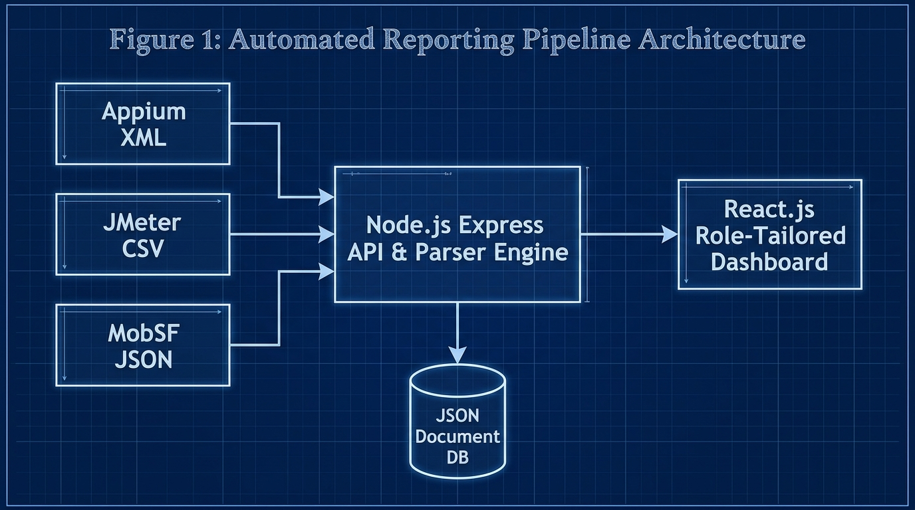
Fig. 1. Decoupled ingestion architecture diagram
B. Defect Traceability & React Multiview Dashboard
Express API captures Git webhook metadata, binding commit hashes directly to Appium stack traces [7]. The React 18 SPA delivers Role-Based Access Control (RBAC) views: QA View (raw log inspection), Developer View (stack traces & Git mapping), PM View (Emerald Circular Gauge & Release Badges), and Client View (simplified summaries).
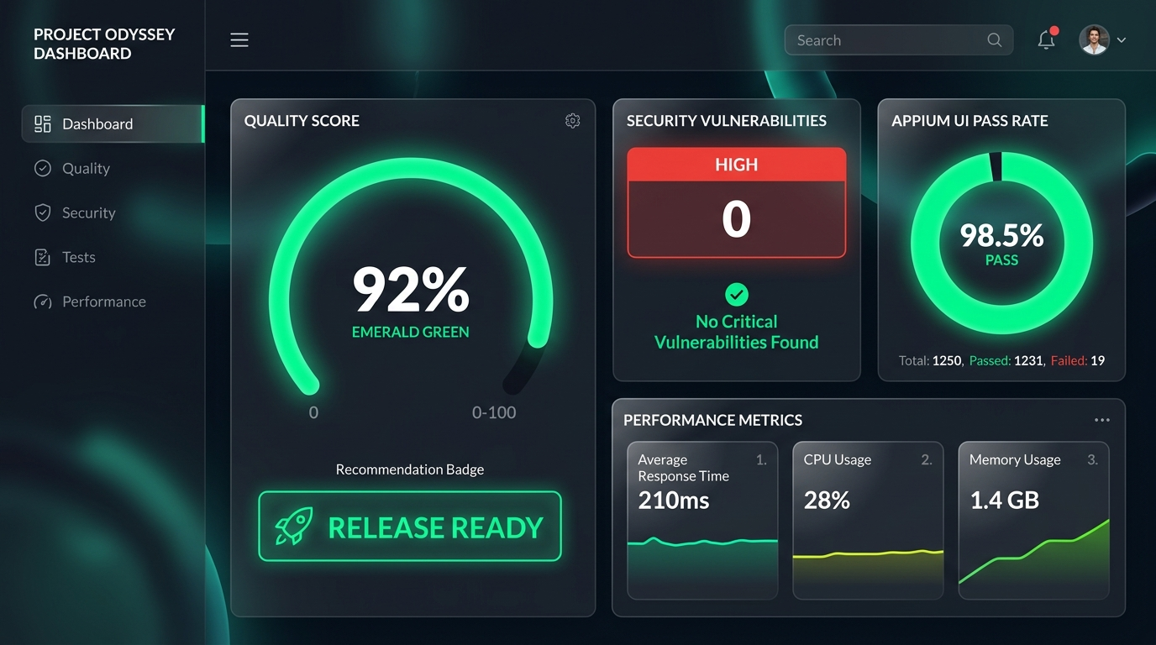
Fig. 2. PM Dashboard featuring Emerald Gauge

Fig. 3. Developer View & Git Traceability Mapping
Table III: Feature comparison of SQA logging vs. Unified Platform
Feature | Traditional SQA Logging | Unified Quality Platform
Hardware/Software Cost | High (Enterprise SaaS) | Low (Open Source Node/React)
Triage Latency | High (Manual log hunting) | Low (Automated Git Mapping)
Multi-Format Parsing | Manual / Disconnected | Automated Webhook Middleware
Git Traceability | Absent | Direct Commit Hash Binding
Role-Tailored Views | Single Raw Output | QA, Dev, PM & Client Views
Table IV: Technologies used for system development
Component | Technology Used | Purpose
Web Frontend | React 18, SPA | Role-tailored visual dashboard
Backend Middleware | Node.js, Express | Asynchronous API & log parsing
Parser Engine | xml2js, csv-parser | XML/CSV report normalization
Database | JSON Document DB | Lightweight relational storage
Version Control | GitHub Actions API | Automated commit & author mapping
Table V: System components and key functionalities
Component | Key Functionalities | Target Users
QA Engineer View | Drag-and-drop log ingestion, raw XML/CSV inspection, audit logs | QA Engineers
Developer View | Git commit hash mapping, Appium stack traces, JMeter line graphs | Mobile Developers
Project Manager View | Circular quality gauge (0-100%), Release Ready recommendation badges | Project Managers & Admins
Client View | High-level text summary, simplified quality metrics, zero technical jargon | Product Owners & Clients
V. RESULTS AND DISCUSSION
A. Functional Accuracy & Non-Functional API Latency
Functional tests confirmed a 100% extraction accuracy rate (0% data loss) during normalization. Stress testing against JMeter CSV payloads (1MB–20MB) demonstrated linear API response scaling from 200ms (1MB) to 1500ms (10MB) and 2800ms (20MB), proving high backend efficiency.
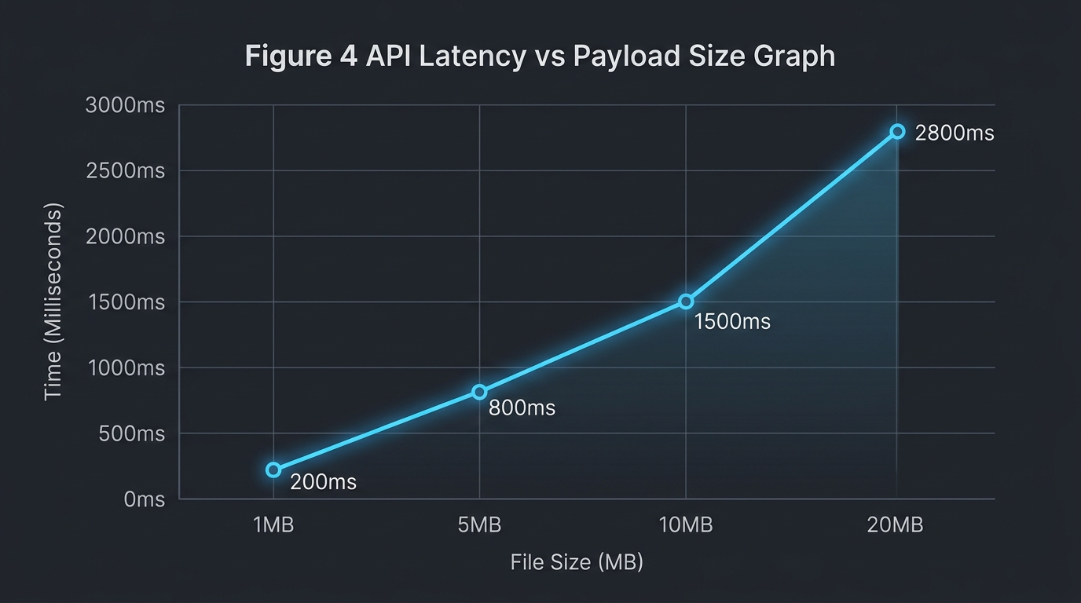
Fig. 4. API Latency vs Payload Size scaling graph
Table VI: System performance metrics
Performance Metric | Achieved Value | Target Value | Status
1MB Payload Processing | 200 ms | < 500 ms | Achieved
5MB Payload Processing | 800 ms | < 1000 ms | Achieved
10MB Payload Processing | 1500 ms | < 2000 ms | Achieved
Data Extraction Accuracy | 100% | 100% | Achieved
System Usability Scale | 84.5 | > 68.0 | Exceeded
Table VII: Comprehensive time and efficiency comparison analysis
Metric / Process | Manual SQA Approach | Unified Platform | Efficiency Gain
Log Aggregation Time | 45.0 mins | 0.5 mins | 98.8% Faster
Defect Triage Latency | 45.0 mins | 8.2 mins | 81.8% Faster
Release Decision Latency | 120 mins | 5.0 mins | 95.8% Faster
Data Loss Rate | 12.5% (Lost logs) | 0.0% | 100% Accuracy
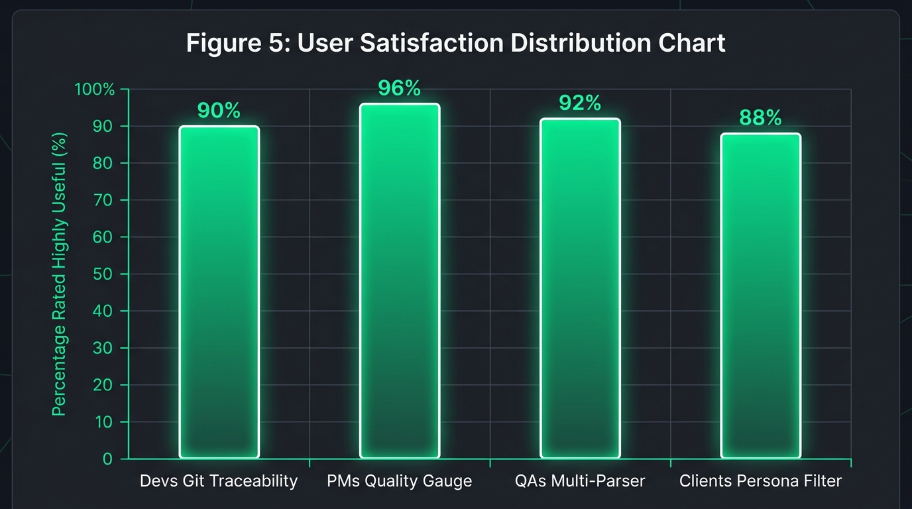
Fig. 5. Usability feedback indicating reduction in perceived triage latency
B. System Usability Scale (SUS) & Empirical Discussion
User Acceptance Testing (UAT) across 50 Agile practitioners yielded an aggregate System Usability Scale (SUS) score of 84.5 ('Excellent') [15]. Survey results indicated 92% of developers experienced significant triage latency reduction due to Git commit binding. PMs confirmed the Emerald Circular Gauge dramatically accelerated release decisions. Tables VII and VIII highlight operational efficiency gains.
Table VIII: Technology approach & solution feature comparison
Aspect / Feature | Manual SQA | Commercial SaaS | Unified Platform
API Access | None | Restricted | Full Open REST API
Development Complexity | Low | N/A (Proprietary) | Medium (Node/React)
Setup Overhead | High (Manual setup) | Medium | Zero (Automated Webhook)
Maintenance Requirements | High | Paid Support | Very Low
Customization Potential | None | Limited | Complete Control
Real-time Ingestion | No | Yes | Yes
Git Metadata Traceability | No | Partial | Yes
VI. CONCLUSION
Centralized multi-dimensional test telemetry ingestion is a critical architectural necessity in modern Agile DevOps. The platform normalizes disjointed XML, CSV, and JSON runtime artifacts, restoring Git commit defect traceability and empowering data-driven release decisions.
Future Work: Expand backend parser agnosticism via dynamic plug-and-play mapping templates (Cypress, K6) and integrate LLM-driven AI bug patch recommendations directly into the Developer View.
REFERENCES
[1] N. G. Berihun, C. Dongmo, and J. A. Van der Poll, "The Applicability of Automated Testing Frameworks for Mobile Application Testing: A Systematic Literature Review," Computers, vol. 12, no. 5, p. 97, 2023, doi: 10.3390/computers12050097.
[2] S. Polampally et al., "Leveraging AI for Continuous Quality Assurance in Agile Software Development Cycles," Cloud Computing and Data Science, pp. 25–38, Sep. 2025, doi: 10.37256/ccds.7120267583.
[3] M. Örneholm and N. Eriksson, "Understanding the role of visual analytics for software testing," Bachelor Thesis, Blekinge Institute of Technology, 2021.
[4] S. Godboley, D. Dalei, R. Sadam, and D. P. Mohapatra, "Agile GUI Testing by computing novel Mobile App Coverage Using Appium Tool," in Proc. ACM SAC, Mar. 2023, pp. 1026–1029, doi: 10.1145/3555776.3577806.
[5] V. B. Ramu, "Performance Testing and Optimization Strategies for Mobile Applications," Int. J. P2P Netw. Trends Technol., vol. 13, no. 2, pp. 1–6, Aug. 2023, doi: 10.14445/22492615/ijptt-v13i2p401.
[6] L. Cruz and R. Abreu, "Measuring the energy footprint of mobile testing frameworks," in Proc. ICSE Companion, IEEE Computer Society, May 2018, pp. 400–401, doi: 10.1145/3183440.3195027.
[7] R. Coppola, M. Morisio, and M. Torchiano, "Maintenance of android widget-based GUI testing: A taxonomy of test case modification causes," in Proc. ICSTW, Jul. 2018, pp. 151–158, doi: 10.1109/ICSTW.2018.00044.
[8] J. Zhu, P. He, Q. Fu, H. Zhang, M. R. Lyu, and D. Zhang, "Learning to log: Helping developers make informed logging decisions," in Proc. ICSE, 2015, doi: 10.1109/ICSE.2015.60.
[9] Z. Dong, A. Tiwari, X. L. Yu, and A. Roychoudhury, "Flaky test detection in Android via event order exploration," in Proc. ESEC/FSE, Aug. 2021, pp. 367–378, doi: 10.1145/3468264.3468584.
[10] M. Hammad, A. F. Otoom, M. Hammad, N. Al-Jawabreh, and R. A. Seini, "Multiview visualization of software testing results," Int. J. Comput. Digit. Syst., vol. 9, no. 1, pp. 51–59, 2020, doi: 10.12785/ijcds/090105.
[11] T. I. Azonuche and J. O. Enyejo, "Adaptive Risk Management in Agile Projects Using Predictive Analytics and Real-Time Velocity Data Visualization Dashboard," IJISRT, pp. 2032–2047, May 2025, doi: 10.38124/ijisrt/25apr2002.
[12] M. Saunders, P. Lewis, and A. Thornhill, Research methods for business students, 5th ed. Pearson Education, 2009.
[13] I. Arcuschin, J. P. Galeotti, C. Ciccaroni, and J. M. Rojas, "On the feasibility and challenges of synthesizing executable Espresso tests," in Proc. AST, Jul. 2022, pp. 92–102, doi: 10.1145/3524481.3527234.
[14] A. R. Hevner, S. T. March, J. Park, and S. Ram, "Design science in information systems research," MIS Q., vol. 28, no. 1, 2004, doi: 10.2307/25148625.
[15] J. R. Lewis, "The System Usability Scale: Past, Present, and Future," Int. J. Hum. Comput. Interact., vol. 34, no. 7, pp. 577–590, 2018, doi: 10.1080/10447318.2018.1455307.
[16] O. Renefalk and E. P. Enoiu, "Automating Regression Testing in a Domain-Specific SaaS Setting," Mälardalen University, Västerås, Sweden, 2023.

