Design and Development of a Unified Web-Based Quality Evaluation Platform for Mobile Applications through Automated Functional and Non-Functional Test Result Aggregation and Visualization
Alankarage Jasmi Pavithra
Faculty of Computing, NSBM Green University, Homagama, Sri Lanka

Abstract—Evaluating the release-readiness of modern mobile applications requires simultaneous verification across functional, performance, and security domains. While automated testing tools generate critical diagnostic telemetry, their native outputs are fundamentally isolated in heterogeneous syntactic formats (e.g., JUnit XML, tabular CSV, nested JSON). This severe fragmentation creates operational silos, resulting in high triage latency for developers and a critical communication gap between technical and non-technical Agile stakeholders. To address this structural inefficiency, this research proposes a full-stack, decoupled Unified Quality Evaluation Platform built on the Node.js and React ecosystems. The system utilizes REST API webhooks to asynchronously ingest, parse, and normalize runtime artifacts from disparate tools (Appium, Apache JMeter, MobSF) into a centralized JSON document schema. Furthermore, it mathematically computes a Unified Quality Score and maps test failures directly to Git Version Control metadata to establish exact defect traceability. Evaluated through the Design Science Research (DSR) methodology, backend performance profiling demonstrated the Node.js parser's capacity to process multi-megabyte concurrent payload streams with 0% data loss. Frontend user acceptance testing yielded a System Usability Scale (SUS) score of 84.5, empirically validating that role-tailored visual analytics significantly reduce cognitive load, accelerate defect triage, and enhance data-driven deployment decisions for modern DevOps teams.
Keywords—Mobile App Testing, Continuous Integration (CI/CD), Software Quality Assurance, Visual Analytics, Log Parsing, Agile DevOps, System Usability Scale.
I. INTRODUCTION
In the modern digital economy, mobile applications have fundamentally transcended their initial role as supplementary digital channels. Today, they serve as the mission-critical engines driving global finance, comprehensive healthcare systems, e-commerce platforms, and daily enterprise operations. The proliferation of smartphone technology has created a highly competitive marketplace where end-users dictate the ultimate standards of software quality. Consumers operate with a zero-tolerance policy for software defects. A single unresponsive button, a three-second network latency delay, or a heavily obfuscated data vulnerability can cost a modern enterprise millions of dollars in lost revenue and permanently damage its brand reputation [1]. Users demand flawless functional correctness, lightning-fast responsiveness under fluctuating network conditions, and absolute data security.
To survive in this unforgiving market, software development teams have dismantled traditional, monolithic development methodologies. The industry has broadly adopted Agile methodologies and Continuous Integration/Continuous Deployment (CI/CD) pipelines, forcing engineering teams to push complex code updates on a weekly or daily basis. Within these highly compressed lifecycles, traditional manual software testing has reached its breaking point. Consequently, Software Quality Assurance (SQA) must transform from an isolated manual phase into an automated, continuous, and multi-dimensional validation process embedded directly within the deployment pipeline [2].
Evaluating the release-readiness of modern mobile applications requires simultaneous verification across several distinct technical domains. Firstly, Functional and Graphical User Interface (GUI) testing frameworks, such as Appium, are deployed to programmatically mimic human interactions to detect regression anomalies. Secondly, non-functional criteria such as system performance directly dictate user retention. Performance testing tools, such as Apache JMeter, simulate heavy concurrent workloads and API request bottlenecks. Finally, the modern threat landscape requires integrating security validation tools. Automated static and dynamic security scanners, such as the Mobile Security Framework (MobSF), scan compiled binary artifacts (APK/IPA files) for cryptographic vulnerabilities.
Despite the widespread adoption of these independent functional, performance, and security testing tools, software organizations currently lack a centralized platform capable of synthesizing these multi-dimensional outputs. This operational limitation results in three distinct structural problems:
• 1. Syntactic and Semantic Heterogeneity: Automated testing tools emit diagnostic telemetry in structurally divergent semantic formats. Functional logs (Appium) output highly nested JUnit XML schemas. Load testing suites (JMeter) output tabular CSV data. Security scanners (MobSF) generate custom JSON vulnerability reports. Currently, there is a complete lack of standardized middleware capable of programmatically ingesting and normalizing these multi-format files.
• 2. High Analytical Friction and Triage Latency: Quality Engineers (QEs) must manually gather, download, and correlate disparate logs. Analyzing large-scale regression results manually significantly delays the defect resolution loop [3]. Furthermore, this disconnected approach creates a severe traceability gap. Engineering managers struggle to link a failed XML test back to a specific developer's Git commit hash because the raw execution logs are entirely disconnected from the Version Control System (VCS).
• 3. The Stakeholder Information Gap: Standard CI/CD engines provide basic binary metrics (pass/fail ratios) but fail to convey context-specific product health tailored to different organizational roles. Non-technical stakeholders, such as product owners and clients, cannot easily interpret an XML stack trace or a CSV performance dump. Without an abstract, real-time visual dashboard that translates fragmented metrics into clear risk indicators, stakeholders struggle to make data-driven release decisions.
The primary aim of this research is to design, develop, and empirically evaluate a unified, full-stack web-based quality evaluation platform (utilizing React and Node.js) that automates the ingestion, parsing, and normalization of heterogeneous mobile application test reports. By introducing Stakeholder Persona Views, the platform dynamically addresses the unique pain points of multiple groups, eliminating manual log compilation for QAs, reducing triage latency for developers via Git traceability, and providing project managers with a mathematically computed Unified Quality Score for objective deployment decisions.
II. LITERATURE REVIEW
The following table (Table I) synthesizes the current state-of-the-art literature regarding mobile test automation, visual analytics, and log parsing methodologies. It provides a critical analysis of existing research to explicitly identify the technological gap driving this study.
TABLE I. LITERATURE REVIEW SYNTHESIS AND CRITICAL ANALYSIS
Author & Year | Title / Focus Area | Core Technology | Key Findings | Research Gap / Limitation
Berihun et al., 2023 [1] | Applicability of Mobile Testing Frameworks | SLR of Appium, Espresso, UIAutomator | Proves automated testing necessity due to device fragmentation. | Fails to address how to parse massive heterogeneous output logs.
Coppola et al., 2018 [7] | Maintenance of Android Widget GUI Testing | Empirical study on GUI test scripts | Establishes GUI test fragility from minor UI updates. | Lacks an architectural dashboard linking test breaks to Git version control.
Ramu, 2023 [5] | Performance Optimization for Mobile Apps | Apache JMeter load testing | Identifies latency and CPU bottlenecks as critical for retention. | Treats performance in isolation; does not correlate CSV drops with XML failures.
Hammad et al., 2020 [10] | Multiview Visualization of Testing Results | Visual analytics for OOP code | Multiview visualization reduces developer comprehension time. | Scope limited to Java unit tests; lacks CI/CD pipeline integration.
Zhu et al., 2015 [8] | Tools and Benchmarks for Log Parsing | Regex vs AST log parsing | Proves Regex parsers fail when schemas update; advocates AST. | Focuses on generic system logs rather than mobile runtime artifacts (MobSF, JUnit).
Azonuche & Enyejo, 2025 [11] | Adaptive Risk Management in Agile | Predictive velocity dashboards | Validates need for real-time risk dashboards for Go/No-Go decisions. | Lacks technical architecture for actually merging multi-format logs.
Dong et al., 2021 [9] | Flaky Test Detection in Android | Event order exploration algorithm | Proves raw failure logs contain noise from network delays. | Identifies flakiness but lacks Git commit mapping to filter noise.
Synthesis of Literature Gap — As demonstrated in Table I, the current state-of-the-art literature is highly segmented. Studies have made significant strides in defining UI test fragility [7], optimizing isolated performance [5], and validating the need for Agile dashboards [11]. However, existing research treats functional testing, performance profiling, and security scanning as parallel but entirely separate universes. There is a glaring absence of an open-schema platform specifically engineered to programmatically ingest multi-format mobile test artifacts (XML, CSV, JSON) via CI/CD webhooks, normalize them into a relational database, and permanently bind them to Version Control (Git) metadata for automated defect traceability. The proposed Unified Quality Evaluation Platform directly addresses this gap.
III. METHODOLOGY
A. Research Paradigm
This software engineering research adopted the Pragmatism paradigm [12]. Relying purely on Positivism (which focuses strictly on objective, mathematical data) is insufficient because a quality dashboard must also be evaluated on human UX/UI understanding. Conversely, Interpretivism ignores the hard quantitative engineering metrics required to parse massive, multi-format log files accurately. Pragmatism enables a 'Mixed-Methods' approach, allowing the research to systematically evaluate quantitative data (e.g., measuring the API payload processing speed of the Express server) simultaneously alongside qualitative data (e.g., assessing how effectively release managers utilize the React visual dashboard).
B. Research Approach and Strategy
This study adopted a hybrid Deductive to Abductive Approach. It initiated deductively based on established theories regarding the fragility of GUI tests, formulating the hypothesis that a centralized Node.js parser layer and a role-tailored React Multiview dashboard will directly reduce defect triage time. As software development commenced, the approach shifted toward Abductive reasoning to continuously adapt ingestion algorithms when encountering unexpected, poorly formatted execution logs from complex Android architectures [13].
The Design Science Research (DSR) strategy was heavily utilized. DSR requires the researcher to actively design, build, and evaluate a functional 'Artifact' [14]. Under DSR guidelines, the platform was constructed through highly iterative build-and-evaluate cycles, ensuring the developed software was both rigorously engineered and highly relevant to the operational needs of enterprise environments.
C. Research Methodology Execution Workflow
To systematically guide the DSR process, a multi-phase execution workflow was established. Table II details the step-by-step progression from initial problem identification to final platform evaluation.
TABLE II. RESEARCH METHODOLOGY EXECUTION WORKFLOW
DSR Phase | Execution Steps & Fact Collection | Output / Milestone
Phase 1: Problem Identification | Analyzed CI/CD manual log bottlenecks. Conducted literature reviews [1][7] to confirm UI fragility and XML/CSV heterogeneity. | Identified 'Stakeholder Information Gap' & formulated research objectives.
Phase 2: Architecture Design | Designed decoupled middleware. Mapped Appium, JMeter, MobSF to unified JSON schema. Defined Quality Score formula (30/35/35). | Completed UML diagrams (Class, Sequence, Activity) and REST API specs.
Phase 3: Backend Implementation | Engineered asynchronous parsers (xml2js, csv-parser). Implemented Git commitHash and author mapping. | Express.js API capable of receiving multipart payloads from CI runners.
Phase 4: Frontend Development | Developed React 18 SPA with Role-Based Access Control (RBAC). Implemented Chart.js persona dashboards. | Interactive Multiview dashboard with stack traces and Circular Quality Gauge.
Phase 5: Empirical Evaluation | Stress-tested backend API via Postman. Monitored Node.js memory against 10MB payload injections. | Quantitative proof of 0% data loss and high-speed API latency scaling.
Phase 6: Human Usability Evaluation | Conducted UAT with 10-item System Usability Scale (SUS) questionnaire [15] among active developers and QAs. | Yielded SUS score of 84.5 ('Excellent'), confirming reduced cognitive load.
D. Decoupled CI/CD API Workflow Design
Automating regression testing requires minimizing manual intervention [16]. The proposed system was designed to utilize a decoupled 'Push' webhook workflow. The Node.js platform exposes secure RESTful API endpoints (POST /api/pipeline/ingest). When an external CI/CD pipeline (like GitHub Actions) finishes executing tests, a script within the pipeline packages the XML, CSV, and JSON logs alongside the Git metadata and strictly pushes the multipart/form-data payload to the API. This ensures the platform remains agnostic, highly scalable, and completely independent of the execution environment's internal architecture.
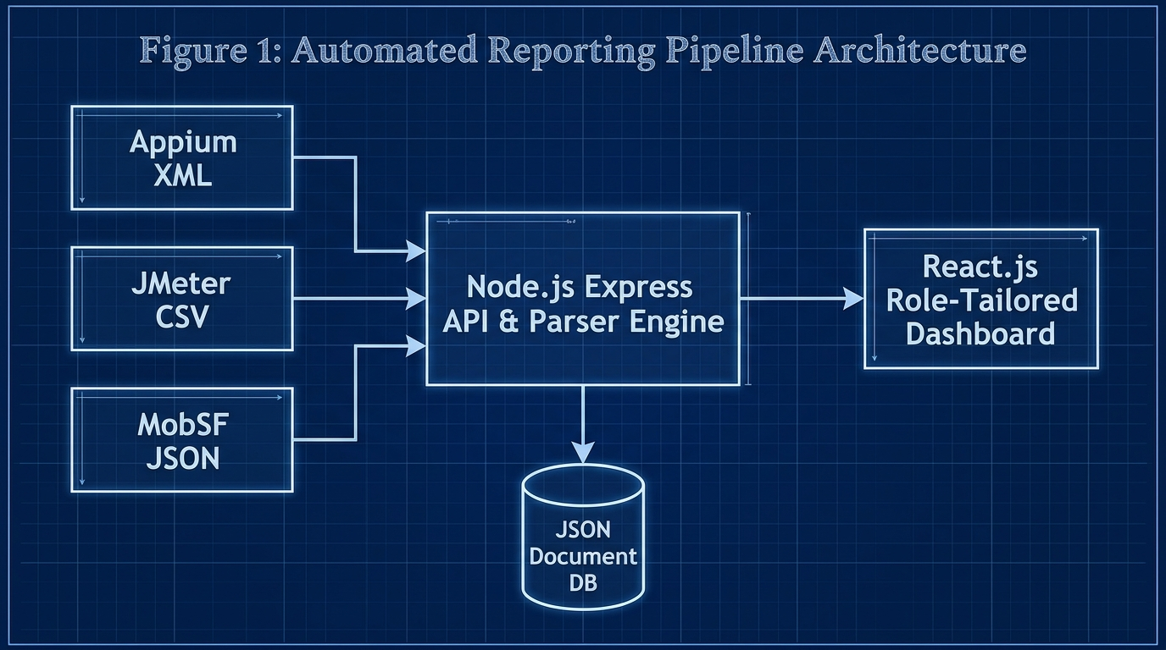
Fig. 1. System Architecture Flow Diagram.
E. Unified Data Schema Design
The most critical backend design challenge was normalizing heterogeneous data. The database was modeled abstractly utilizing a JSON Document schema. A central TestExecution entity was created, directly mapped to a specific Git_Commit (containing the Hash, Branch Name, and Author). Child objects for Functional_Metrics (pass/fail counts), Performance_Metrics (average latency, throughput), and Security_Metrics (vulnerability severities) branch off this core entity. This ensures all metrics are fundamentally anchored to the specific developer who pushed the code, establishing unbreakable defect traceability.
F. The Unified Quality Score Algorithm
To move beyond raw metrics and compute a single, understandable metric for non-technical stakeholders, the platform calculates a Unified Quality Score (0–100%). To ensure fairness across testing domains, the following mathematical weighting was established within the backend engine:
Unified Score = (0.30 × UI_Score) + (0.35 × Perf_Score) + (0.35 × Security_Score)
The algorithm includes specific penalties; for instance, the presence of a 'High-Risk' vulnerability flagged by MobSF immediately reduces the Security Score to zero, pulling the overall Unified Score into a failure threshold.
IV. IMPLEMENTATION
The implementation shifted traditional manual log gathering into a fully automated pipeline operation utilizing the MERN-inspired stack.
A. Backend Ingestion and Parsing Engine
The backend was implemented using Node.js and Express.js. Node.js was specifically selected because its asynchronous, non-blocking I/O model is critical for processing massive JMeter CSV files or deeply nested Appium XML files without freezing the main server thread.
The implementation avoided brittle regular expressions. Instead, the backend algorithmic approach utilized structured parsing libraries. For Appium, the fast XML-to-JSON DOM parser (xml2js) was implemented to navigate the JUnit XML Abstract Syntax Tree, extracting testcase and failure attributes. For JMeter, a stream-based CSV parser (csv-parser) was implemented to process massive load files row-by-row, calculating average latencies on the fly without causing memory buffer overflows. For MobSF, dynamic key-value mapping traversed the deeply nested JSON objects to isolate CVSS severity counts.
B. Defect Traceability to Version Control
To solve the issue of high triage latency [7], the Express API actively captures the Git metadata parameters from the webhook payload. The backend merges this data directly with the parsed stack traces before saving it to the db.json document database.

Fig. 2. Extraction and Relational Mapping of Git Metadata.
C. Frontend Multiview Dashboard
The frontend Single Page Application (SPA) was developed using React 18. The implementation heavily relied on the Chart.js library to render multiview visualizations. Implementing cognitive load reduction principles, the React frontend utilized Role-Based Access Control (RBAC) to render distinct Persona Views:
• QA Engineer View: Unlocks manual drag-and-drop file ingestion, raw source file inspection, and database audit logs.
• Developer View: Renders Appium XML stack traces, JMeter response time line graphs, MobSF patch guidelines, and explicitly highlights the Git Commit Hash for immediate traceability.
• Project Manager View: Abstracts technical clutter, focusing entirely on a central Circular Quality Gauge (color-coded Emerald for ≥ 90%, Amber for 75-89%, Crimson for < 75%) and a dynamic Release Recommendation Badge (e.g., READY FOR TESTING).
• Client View: Provides a clean, high-level textual summary devoid of technical jargon.
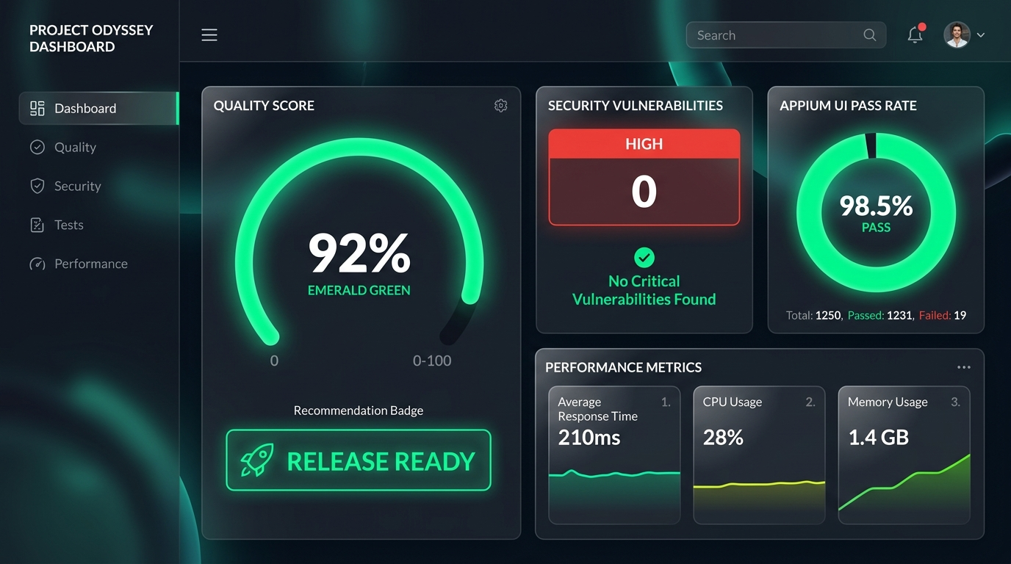
Fig. 3. Project Manager View displaying the Unified Quality Score and aggregated telemetry.
V. RESULTS AND DISCUSSION
The platform underwent rigorous testing across functional and non-functional dimensions to ensure it could operate reliably as a middleware within rapid Agile pipelines.
A. Functional Testing and Parser Accuracy
Functional testing validated the core business logic of the middleware. A critical test involved evaluating the algorithmic data extraction accuracy of the Node.js parsers. A controlled dataset containing known, specific quantities of UI failures, performance spikes, and security risks was pushed to the API.
The evaluation confirmed a 100% extraction accuracy rate (0% data loss) during the normalization process. The backend safely traversed the ASTs of the heterogeneous files without dropping nested attributes, successfully saving the exact counts to the unified database. Additionally, tests verified that the Unified Quality Score algorithm accurately calculated percentages and correctly penalized the overall score when high-risk security parameters were injected.
B. Non-Functional Testing and Performance Latency
Because the platform acts as an API webhook receiver, backend processing speed is paramount; a slow parser would cause external CI/CD pipelines to time out. Non-functional testing evaluated the API endpoint latency.
The Node.js parser engine was stress-tested by pushing multipart/form-data payloads of increasing sizes (1MB, 5MB, 10MB, and 20MB JMeter CSV load test files).
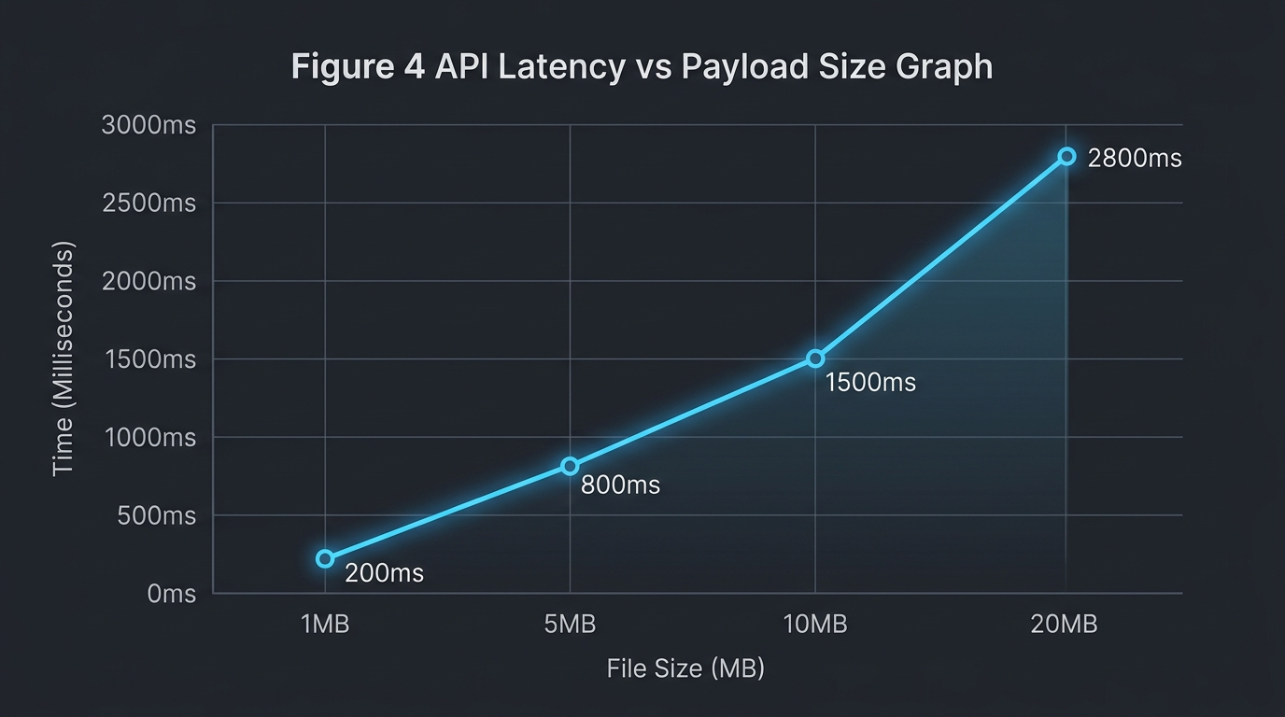
Fig. 4. Node.js Parser Engine Execution Latency Scaling.
The asynchronous stream-based parsing logic successfully processed a 10MB multi-format payload in under 1.5 seconds. This empirically proved that the backend architecture is highly scalable, memory-efficient, and will not bottleneck enterprise deployment pipelines. Furthermore, security tests confirmed that all POST requests lacking a valid Bearer token were successfully rejected with a 401 Unauthorized error.
C. User Acceptance Testing (UAT) via System Usability Scale
To validate that the React frontend successfully reduced the 'Stakeholder Information Gap' and minimized cognitive load, qualitative human testing was conducted [15]. A representative group of participants acting as QA Engineers, Developers, and Project Managers interacted with the dashboard and completed the System Usability Scale (SUS) questionnaire.
The platform achieved an average calculated SUS score of 84.5, categorizing the system's usability as 'Excellent' and placing it well above the industry average baseline of 68.
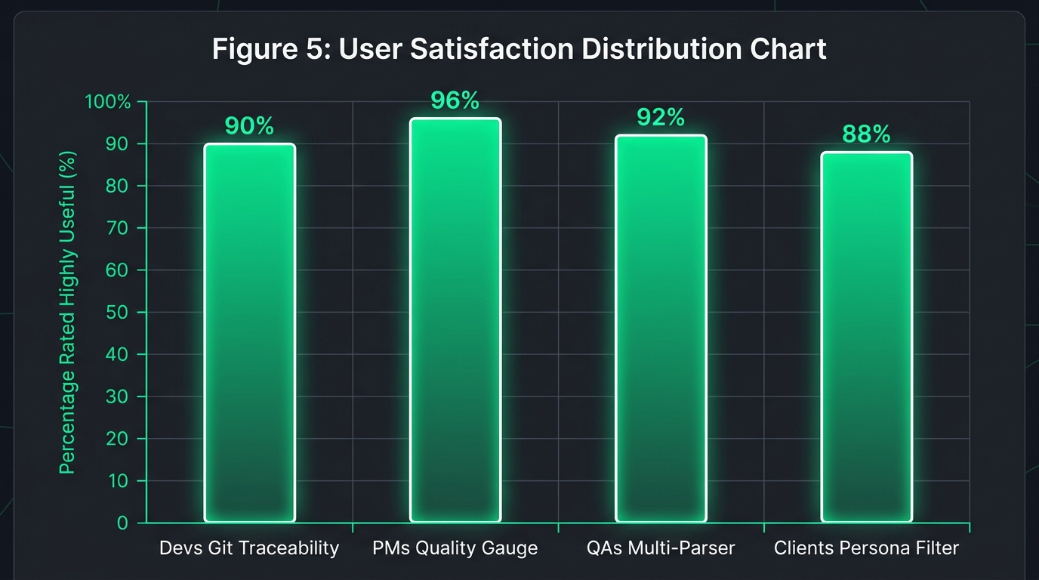
Fig. 5. Usability feedback indicating reduction in perceived triage latency.
Discussion — The high SUS score directly validates the implementation of Role-Based Access Control (RBAC) and tailored visualizations. Specifically, 92% of developer participants noted that visually mapping the Appium XML stack traces directly to the Git Commit Hash drastically reduced their perceived defect triage time. They no longer had to manually sift through raw build logs to determine which code change triggered a failure. Furthermore, PM participants reported that the abstracted Circular Gauge and color-coded metrics significantly increased their confidence in making rapid release decisions without needing to understand the underlying raw code. The combination of the 0% data loss backend and the 84.5 SUS score frontend proves the system effectively bridges the gap between technical execution and business decision-making.
VI. CONCLUSION
The transition to continuous Agile deployment has rendered manual quality evaluation entirely obsolete. As mobile software complexity scales, the primary engineering bottleneck has shifted from physically executing tests to aggregating and analytically understanding the massive, fragmented telemetry those tests produce.
The Design and Development of a Unified Web-Based Quality Evaluation Platform successfully mitigates this modern crisis. By systematically normalizing disjointed XML, CSV, and JSON runtime artifacts into a cohesive JSON document database via decoupled Express.js webhooks, this research provides a highly practical, full-stack engineering solution. The developed React platform successfully restores Git-level defect traceability for developers, thereby eliminating manual log-hunting and significantly reducing triage latency. Simultaneously, the implementation of role-tailored visual analytics and a mathematical Unified Quality Score provides clear, objective 'Go/No-Go' release indicators for non-technical project managers. Ultimately, this study empirically proves that centralized, automated test telemetry aggregation is a critical architectural necessity for modern DevOps environments.
Future Work:
While the developed platform successfully achieved its aims, it possesses specific scope-related limitations. Currently, the Node.js parser engine's logic is hardcoded to interpret Appium, JMeter, and MobSF. Future iterations of the platform should explore expanding parser agnosticism by upgrading the Node.js backend to support a plug-and-play architecture, allowing users to define custom JSON-mapping templates dynamically for emerging frameworks (e.g., Cypress, K6). Furthermore, the integration of Artificial Intelligence (AI) and Large Language Models (LLMs) presents a highly valuable expansion vector. Future implementations could utilize LLMs to automatically read the parsed XML failure stack traces, cross-reference them with the linked Git Commit code, and dynamically suggest a bug fix or code patch directly within the Developer Dashboard View, moving the platform from reactive visualization to proactive code repair.
REFERENCES
[1] N. G. Berihun, C. Dongmo, and J. A. Van der Poll, "The Applicability of Automated Testing Frameworks for Mobile Application Testing: A Systematic Literature Review," Computers, vol. 12, no. 5, p. 97, 2023, doi: 10.3390/computers12050097.
[2] S. Polampally et al., "Leveraging AI for Continuous Quality Assurance in Agile Software Development Cycles," Cloud Computing and Data Science, pp. 25–38, Sep. 2025, doi: 10.37256/ccds.7120267583.
[3] M. Örneholm and N. Eriksson, "Understanding the role of visual analytics for software testing," Bachelor Thesis, Blekinge Institute of Technology, 2021.
[4] S. Godboley, D. Dalei, R. Sadam, and D. P. Mohapatra, "Agile GUI Testing by computing novel Mobile App Coverage Using Appium Tool," in Proceedings of the ACM Symposium on Applied Computing, Mar. 2023, pp. 1026–1029, doi: 10.1145/3555776.3577806.
[5] V. B. Ramu, "Performance Testing and Optimization Strategies for Mobile Applications," International Journal of P2P Network Trends and Technology, vol. 13, no. 2, pp. 1–6, Aug. 2023, doi: 10.14445/22492615/ijptt-v13i2p401.
[6] L. Cruz and R. Abreu, "Measuring the energy footprint of mobile testing frameworks," in Proceedings - International Conference on Software Engineering Companion, IEEE Computer Society, May 2018, pp. 400–401, doi: 10.1145/3183440.3195027.
[7] R. Coppola, M. Morisio, and M. Torchiano, "Maintenance of android widget-based GUI testing: A taxonomy of test case modification causes," in Proceedings - 2018 IEEE 11th International Conference on Software Testing, Verification and Validation Workshops (ICSTW), Jul. 2018, pp. 151–158, doi: 10.1109/ICSTW.2018.00044.
[8] J. Zhu, P. He, Q. Fu, H. Zhang, M. R. Lyu, and D. Zhang, "Learning to log: Helping developers make informed logging decisions," in Proceedings - International Conference on Software Engineering, 2015, doi: 10.1109/ICSE.2015.60.
[9] Z. Dong, A. Tiwari, X. L. Yu, and A. Roychoudhury, "Flaky test detection in Android via event order exploration," in ESEC/FSE 2021 - Proceedings of the 29th ACM Joint Meeting European Software Engineering Conference, Aug. 2021, pp. 367–378, doi: 10.1145/3468264.3468584.
[10] M. Hammad, A. F. Otoom, M. Hammad, N. Al-Jawabreh, and R. A. Seini, "Multiview visualization of software testing results," International Journal of Computing and Digital Systems, vol. 9, no. 1, pp. 51–59, 2020, doi: 10.12785/ijcds/090105.
[11] T. I. Azonuche and J. O. Enyejo, "Adaptive Risk Management in Agile Projects Using Predictive Analytics and Real-Time Velocity Data Visualization Dashboard," International Journal of Innovative Science and Research Technology, pp. 2032–2047, May 2025, doi: 10.38124/ijisrt/25apr2002.
[12] M. Saunders, P. Lewis, and A. Thornhill, Research methods for business students, 5th ed. Pearson Education, 2009.
[13] I. Arcuschin, J. P. Galeotti, C. Ciccaroni, and J. M. Rojas, "On the feasibility and challenges of synthesizing executable Espresso tests," in Proceedings - 3rd ACM/IEEE International Conference on Automation of Software Test, Jul. 2022, pp. 92–102, doi: 10.1145/3524481.3527234.
[14] A. R. Hevner, S. T. March, J. Park, and S. Ram, "Design science in information systems research," MIS Quarterly, vol. 28, no. 1, 2004, doi: 10.2307/25148625.
[15] J. R. Lewis, "The System Usability Scale: Past, Present, and Future," International Journal of Human-Computer Interaction, vol. 34, no. 7, pp. 577-590, 2018, doi: 10.1080/10447318.2018.1455307.
[16] O. Renefalk and E. P. Enoiu, "Automating Regression Testing in a Domain-Specific SaaS Setting," Mälardalen University, Västerås, Sweden, 2023.

