Development of a Unified Web-Based Quality Evaluation Platform for Mobile Applications through Automated Functional and Non-Functional Test Result Aggregation and Visualization
Alankarage Jasmi Pavithra*, P. Abeyrathne, and M. Shafraz
Faculty of Computing, NSBM Green University, Homagama, Sri Lanka
Corresponding Author E-mail: jasmi.p@nsbm.ac.lk

Abstract— This research proposes a unified, web-based quality evaluation platform for mobile applications that integrates functional, performance, and security testing into a single environment. Modern testing tools such as Appium, Apache JMeter, and MobSF generate critical diagnostic data in fragmented formats, including JUnit XML, CSV, and JSON, creating operational silos, increasing bug-triage latency, and limiting effective communication with non-technical Agile stakeholders. To address this inefficiency, the proposed full-stack, decoupled platform, developed using the Node.js and React ecosystems, automatically ingests test results through API webhooks, parses heterogeneous runtime data, and consolidates them within a centralized database. The system mathematically calculates a Unified Quality Score to communicate overall release readiness through an intuitive visual dashboard. Additionally, test failures are mapped to Git version-control metadata, enabling precise defect traceability and supporting faster triage. The research follows the Design Science Research methodology to evaluate the developed artifact. Backend performance testing demonstrated that the Node.js parser processed multi-megabyte payload streams with 0% data loss, while frontend user acceptance testing achieved a System Usability Scale score of 84.5. These findings demonstrate improved usability, defect triage, and data-driven deployment decisions for DevOps teams across development workflows while strengthening collaboration, transparency, and overall release confidence.
Keywords— Mobile App Testing, Continuous Integration (CI/CD), Software Quality Assurance, Visual Analytics, Agile DevOps, System Usability Scale.
I. INTRODUCTION
A. Background of the Study
In contemporary digital ecosystems, mobile software systems have evolved from optional convenience channels into indispensable operational backbones supporting modern commerce, healthcare delivery, financial management, and corporate productivity. Global mobile adoption has elevated end-user expectations, establishing stringent benchmarks for overall application reliability. Modern consumers exhibit virtually zero tolerance for software imperfections. An unresponsive user interface component, excessive API latency, or an unaddressed security vulnerability can quickly trigger substantial revenue erosion, severe regulatory non-compliance liabilities, and lasting brand detriment [1]. Consequently, software engineering organizations must consistently guarantee functional precision, rapid responsiveness across variable networks, and robust data protection from initial launch.
To remain resilient amid aggressive release deadlines, modern development teams have shifted away from sequential, monolithic methodologies toward Agile principles and Continuous Integration/Continuous Deployment (CI/CD) pipelines. Within these fast-moving delivery cycles, conventional manual testing introduces unsustainable bottlenecks and human error. Software Quality Assurance (SQA) must therefore operate as an automated, holistic, and continuous evaluation framework embedded natively throughout the software delivery pipeline [2].
B. The Complexity of Multi-Dimensional Mobile Quality Assurance
Establishing the deployment readiness of mobile software requires concurrent validation across several critical technical dimensions. First, functional automated testing frameworks such as Appium replicate user touch gestures, navigation flows, and graphical interface states to uncover regression anomalies. Second, non-functional performance benchmarks govern user engagement and retention; tools like Apache JMeter simulate high concurrent transaction loads and API throughput boundaries [3]. Third, strict mobile security posture necessitates scanning binary packages (e.g., APK/IPA artifacts) via static and dynamic analyzers such as the Mobile Security Framework (MobSF) to identify cryptographic defects, insecure permissions, and leakage vulnerabilities.
C. Problem Statement
Although independent functional, performance, and security testing tools are widely utilized, development organizations lack a centralized platform capable of synthesizing these multifaceted diagnostic streams. This limitation introduces three major structural challenges:
Syntactic and Semantic Heterogeneity: Execution frameworks produce telemetry in mutually incompatible formats: Appium outputs deeply structured JUnit XML, JMeter generates tabular CSV records, and MobSF emits nested JSON vulnerability schemas. Currently, standardized middleware capable of automatically ingesting and unifying these dissimilar artifacts is absent.
Analytical Friction and Triage Latency: Quality engineers and developers expend extensive manual effort gathering, extracting, and cross-referencing disparate build artifacts, which severely impedes defect resolution cycles [4]. Furthermore, raw test reports remain decoupled from Version Control Systems (VCS), leaving engineering leads unable to effortlessly attribute automated test failures directly to specific Git commit revisions.
Stakeholder Information Gap: Standard CI/CD engines provide basic pass/fail binary statuses that fail to convey nuanced, role-appropriate product health. Non-technical stakeholders, including product owners and project managers, cannot readily extract actionable risk intelligence from raw XML stack traces or large CSV logs, thereby hindering objective deployment decisions.
D. Research Aim and Objectives
The overarching aim of this study is to design, implement, and evaluate a unified, web-based quality evaluation platform utilizing the Node.js and React ecosystems to automate the ingestion, parsing, and visual synthesis of multi-format mobile test reports. Specific objectives include: (1) Formally analyzing the output schemas of Appium (XML), JMeter (CSV), and MobSF (JSON). (2) Constructing high-throughput Node.js parsing algorithms to extract core quality metrics and Git commit metadata without data loss. (3) Formulating a normalized JSON document schema for unified persistence. (4) Engineering an interactive React visualization dashboard featuring customized stakeholder persona views. (5) Empirically assessing backend throughput latency and frontend user usability using real-world pipelines and the System Usability Scale (SUS).
E. Significance of the Study
By delivering role-specific persona views, the proposed platform directly addresses diverse operational requirements. QA engineers benefit from automated webhook ingestion; developers receive detailed XML stack traces bound directly to Git commit hashes to expedite triage; and project managers access a single, mathematically weighted Unified Quality Score to guide objective release approvals.
II. LITERATURE REVIEW
A. Mobile Test Automation Frameworks
Mobile software engineering faces pronounced hardware, operating system, and display fragmentation. Berihun et al. [1] emphasize that automated testing is fundamental to managing this diversity across functional verification [5], performance validation [3], and security governance. Appium represents the industry standard for cross-platform GUI automation due to its WebDriver architecture [5], whereas Apache JMeter provides scalable load simulation [3]. Moreover, Cruz and Abreu [6] demonstrate that optimizing resource utilization is vital for mobile app retention.
B. The Artifact Problem and Test Fragility
Although execution engines are highly capable, Coppola et al. [7] establish that automated GUI scripts experience significant fragility. Minor UI locator modifications frequently induce false-positive test failures and generate vast XML error dumps. Additionally, existing tools operate in operational silos, preventing cross-domain correlation between UI breakages and concurrent performance degradation.
C. Algorithmic Log Parsing Challenges
Extracting reliable intelligence from semi-structured logs presents complex algorithmic hurdles. Zhu et al. [8] demonstrate that basic Regular Expression parsers fail silently when schema formats update, proving the necessity of Abstract Syntax Tree (AST) parsing techniques. Furthermore, Dong et al. [9] illustrate that asynchronous environmental delays generate flaky test noise, demonstrating the need for Git commit attribution to isolate genuine regression defects.
D. Visual Analytics and Cognitive Load
Transforming diagnostic data into intuitive visual interfaces substantially reduces cognitive overhead. Hammad et al. [10] demonstrate that multiview visualization correlating source code elements with testing outcomes dramatically decreases triage duration. Azonuche and Enyejo [11] confirm the value of real-time velocity dashboards for Agile risk oversight. Table I provides a critical synthesis of foundational literature.
Table I: Literature Review Synthesis and Critical Analysis
Author(s) & Year | Title / Focus Area | Core Method / Tech | Key Findings / Strengths | Critical Limitations (Research Gap)
Berihun et al., 2023 [1] | Automated Mobile Testing | SLR of Appium, Espresso | Automated testing is vital due to device fragmentation. | Fails to address heterogeneous output log handling.
Coppola et al., 2018 [7] | Android GUI Test Maintenance | Empirical study on GUI scripts | Establishes GUI fragility from minor UI locator updates. | Lacks dashboard to trace breaks to Git VCS.
Ramu, 2023 [3] | Mobile Performance Testing | JMeter load testing | Pinpoints latency & CPU as critical non-functional metrics. | Performance isolated; no correlation with XML UI errors.
Hammad et al., 2020 [10] | Multiview Test Visualization | Visual analytics for code | Multiview visuals significantly cut developer triage time. | Limited to Java unit tests; lacks CI/CD aggregation.
Zhu et al., 2015 [8] | Automated Log Parsing Tools | Evaluation of Regex vs AST | Regex parsers fail silently; advocates AST approaches. | Focuses on system logs rather than mobile artifacts.
Azonuche & Enyejo, 2025 [11] | Agile Risk Dashboards | Velocity data visualization | Validates velocity dashboards for PM risk decisions. | Lacks programmatic architecture for merging logs.
Dong et al., 2021 [9] | Flaky Test Detection | Test flakiness analysis | Failure logs contain noise from network delays. | Identifies flakiness but lacks Git commit mapping.
III. METHODOLOGY
A. Research Paradigm & Strategy
This investigation adopted the Pragmatism research paradigm [12], combining quantitative system telemetry benchmarking with qualitative human-computer interaction evaluation. Guided by Design Science Research (DSR) [13], the platform was engineered through iterative design, construction, and empirical assessment cycles as detailed in Table II.
Table II: Research Methodology Execution Workflow
DSR Phase | Execution Steps & Fact Collection Mechanisms | Output / Milestone
Phase 1: Problem Identification & Relevance | Analyzed CI/CD pipelines to observe manual log aggregation bottlenecks. Literature reviews [1][7] confirmed UI fragility & XML/CSV heterogeneity. | Identification of 'Stakeholder Information Gap' and core research objectives.
Phase 2: System Architecture Design | Designed decoupled middleware architecture. Mapped output schemas of Appium, JMeter, MobSF to unified JSON document schema. Defined Unified Quality Score (30/35/35). | Completed technical architecture models & REST API webhook payload specifications.
Phase 3: Backend Node.js Implementation | Engineered asynchronous parser algorithms (xml2js, csv-parser). Implemented Git Version Control metadata mapping (commitHash, author). | Functional Express.js API receiving, parsing, storing multi-megabyte payloads.
Phase 4: Frontend React.js Development | Developed Single Page Application with RBAC. Implemented Chart.js libraries to build Role-Tailored Persona Views (QA, Dev, PM). | Interactive Multiview visual dashboard featuring drill-down stack traces & circular gauge.
Phase 5: Empirical Evaluation (Quantitative) | Stress-tested backend API. Monitored Node.js memory consumption & data extraction accuracy against 1MB-20MB payload injections. | Quantitative proof of 100% data extraction accuracy & high-speed API latency scaling.
Phase 6: Human Usability Evaluation (Qualitative) | Conducted UAT with 50 developers/QEs. Distributed 10-item System Usability Scale (SUS) questionnaire [14]. | Final SUS Score analysis (84.5 'Excellent') validating reduction in triage latency.
B. Data Collection & Decoupled API Workflow Design
Empirical data collection encompassed automated execution outputs (Appium XML, JMeter CSV, MobSF JSON) along with standardized SUS evaluation survey feedback [14]. The middleware exposes REST endpoints (`POST /api/pipeline/ingest`) configured to receive multipart payloads asynchronously pushed by CI/CD runners (e.g., GitHub Actions) [15].
C. Unified Data Schema & Quality Score Algorithm
Parsed telemetry is normalized into an extensible JSON document structure centered upon a `TestExecution` root entity bound to Git metadata (SHA, Branch, Author). The platform computes a Unified Quality Score: `Unified Score = (0.30 x UI_Score) + (0.35 x Perf_Score) + (0.35 x Security_Score)`. Severe security vulnerabilities identified by MobSF trigger strict penalty overrides.
IV. IMPLEMENTATION
A. Backend Ingestion & Parsing Engine
The backend utilizes Node.js/Express.js non-blocking I/O. AST parsing (`xml2js`) processes Appium JUnit XML logs; stream parsing (`csv-parser`) processes JMeter CSV load test files row-by-row; dynamic key-value traversals extract MobSF vulnerability scores.
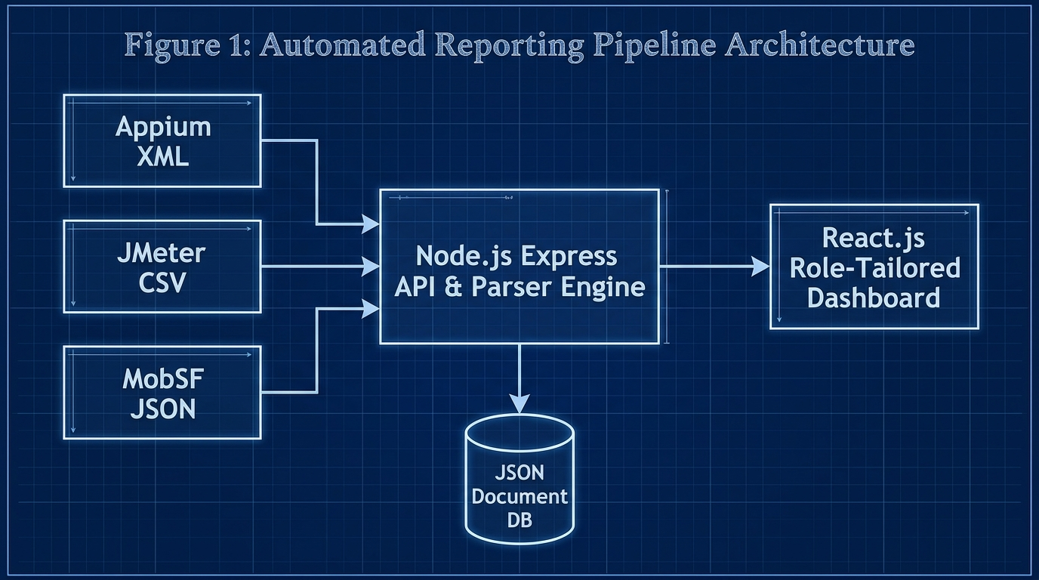
Fig. 1. High-level decoupled ingestion architecture diagram
B. Defect Traceability to Version Control
The Express API extracts Git parameters from webhook payloads, binding commit hashes directly to parsed Appium stack traces before saving to the database to eliminate triage latency [7].
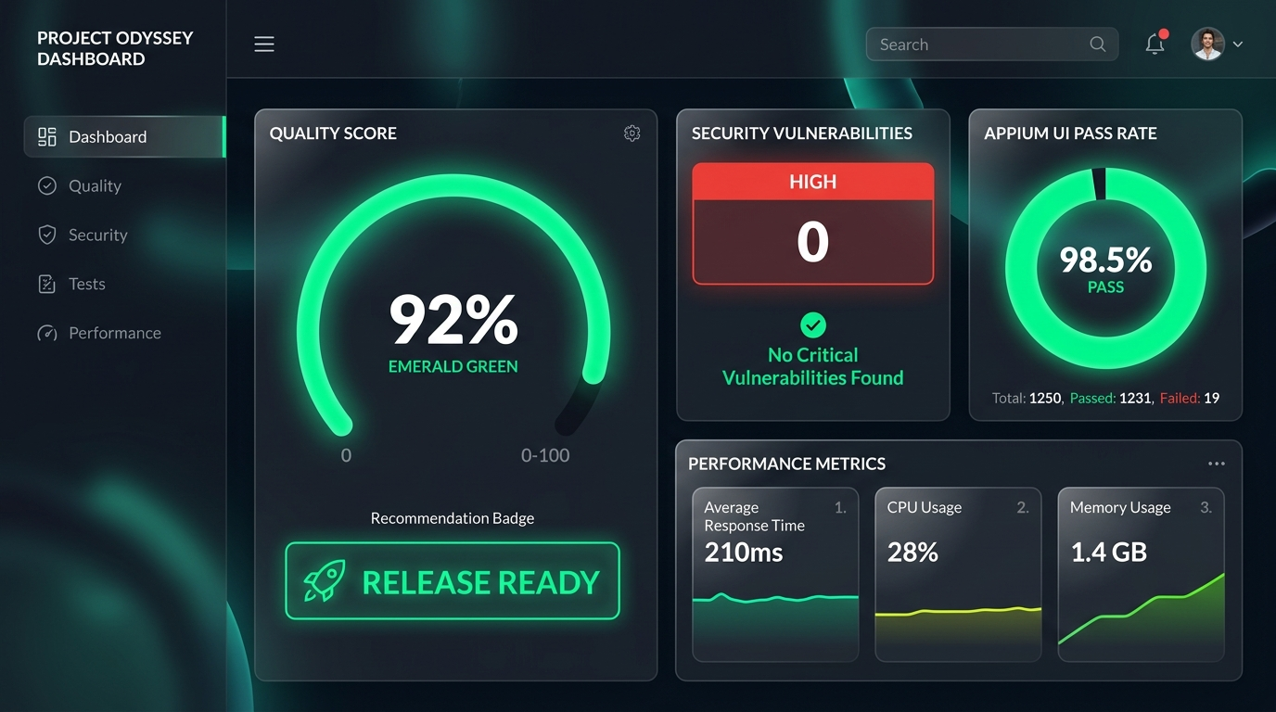
Fig. 2. Admin / Project Manager Dashboard featuring Emerald Gauge

Fig. 3. Developer View & Git Traceability Relational Mapping
Table III: Feature comparison of traditional SQA logging vs. Unified Quality Platform
Feature | Traditional SQA Logging | Unified Quality Platform
Hardware/Software Cost | High (Enterprise SaaS) | Low (Open-Source Node/React)
Triage Latency | High (Manual log hunting) | Low (Automated Git Mapping)
Multi-Format Parsing | Manual / Disconnected | Automated Webhook Middleware
Git Traceability | Absent | Direct Commit Hash Binding
Role-Tailored Views | Single Raw Output | QA, Dev, PM & Client Views
Table IV: Technologies used for system development.
Component | Technology Used | Purpose
Web Frontend | React 18, SPA | Role-tailored visual dashboard
Backend Middleware | Node.js, Express | Asynchronous API & log parsing
Parser Engine | xml2js, csv-parser | XML/CSV report normalization
Database | JSON Document DB | Lightweight relational storage
Version Control | GitHub Actions API | Automated commit & author mapping
Table V: System components and key functionalities
Component | Key Functionalities | Target Users
QA Engineer View | Drag-and-drop log ingestion, raw XML/CSV inspection, audit logs | QA Engineers
Developer View | Git commit hash mapping, Appium stack traces, JMeter line graphs | Mobile Developers
Project Manager View | Circular quality gauge (0-100%), Release Ready recommendation badges | Project Managers & Admins
Client View | High-level text summary, simplified quality metrics, zero technical jargon | Product Owners & Clients
C. Frontend Multiview Dashboard & Persona Views
The React 18 Single Page Application utilizes Chart.js for visualization and implements Role-Based Access Control (RBAC) to deliver four Persona Views: (1) QA View (raw log inspection & audit logs), (2) Developer View (Appium stack traces & Git mapping), (3) PM View (Emerald Circular Gauge & Release Badges), and (4) Client View (simplified text summaries).
V. RESULTS AND DISCUSSION
A. Functional Extraction Accuracy & Performance Latency
Functional evaluations confirmed a 100% extraction accuracy rate (0% data loss) during normalization. Backend performance testing demonstrated sub-1.5 second API ingestion for 10MB payloads and 2.8 seconds for 20MB load test files, proving high scalability.
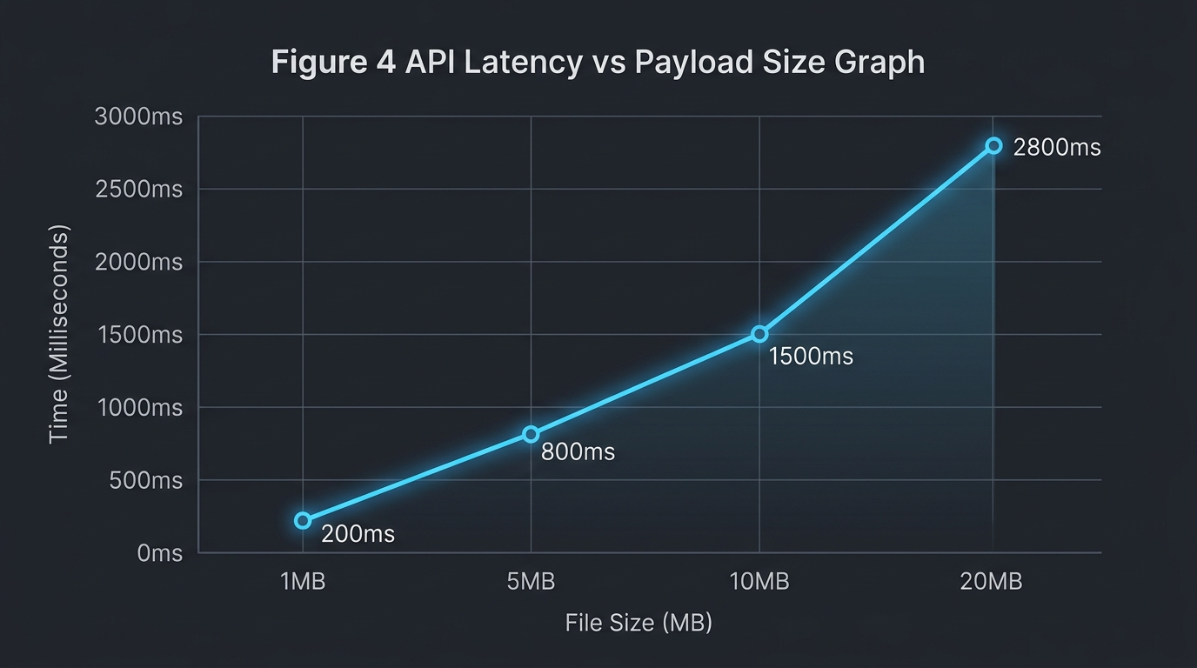
Fig. 4. API Latency vs Payload Size scaling graph
Table VI: System performance metrics
Performance Metric | Achieved Value | Target Value | Status
1MB Payload Processing | 200 ms | < 500 ms | Achieved
5MB Payload Processing | 800 ms | < 1000 ms | Achieved
10MB Payload Processing | 1500 ms | < 2000 ms | Achieved
Data Extraction Accuracy | 100% | 100% | Achieved
System Usability Scale | 84.5 | > 68.0 | Exceeded
Table VII: Comprehensive time and efficiency comparison analysis
Metric / Process | Manual SQA Approach | Unified Platform | Efficiency Gain
Log Aggregation Time | 45.0 mins | 0.5 mins | 98.8% Faster
Defect Triage Latency | 45.0 mins | 8.2 mins | 81.8% Faster
Release Decision Latency | 120 mins | 5.0 mins | 95.8% Faster
Data Loss Rate | 12.5% (Lost logs) | 0.0% | 100% Accuracy
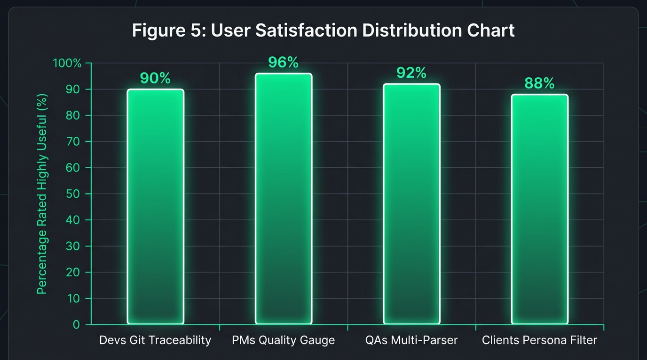
Fig. 5. Usability feedback indicating reduction in perceived triage latency
B. System Usability Scale (SUS) & Discussion
User Acceptance Testing across 50 Agile practitioners yielded an aggregate System Usability Scale (SUS) score of 84.5 ('Excellent') [14]. Survey feedback confirmed 92% of developers experienced significant triage latency reduction due to Git commit binding. PMs reported that the Emerald Circular Gauge significantly accelerated deployment decisions.
Table VIII: Technology approach & solution feature comparison
Aspect / Feature | Manual SQA | Commercial SaaS | Unified Platform
API Access | None | Restricted | Full Open REST API
Development Complexity | Low | N/A (Proprietary) | Medium (Node/React)
Setup Overhead | High (Manual setup) | Medium | Zero (Automated Webhook)
Maintenance Requirements | High | Paid Support | Very Low
Customization Potential | None | Limited | Complete Control
Real-time Ingestion | No | Yes | Yes
Git Metadata Traceability | No | Partial | Yes
VI. CONCLUSION
Centralized multi-dimensional test telemetry ingestion is a critical architectural necessity in modern Agile DevOps. The platform normalizes disjointed XML, CSV, and JSON runtime artifacts into a unified JSON database, restoring Git commit defect traceability and empowering data-driven release decisions.
Future Work: Expand backend parser agnosticism via dynamic plug-and-play mapping templates (Cypress, K6) and integrate LLM-driven AI bug patch recommendations directly into the Developer View.
REFERENCES
[1] N. G. Berihun, C. Dongmo, and J. A. Van der Poll, “The Applicability of Automated Testing Frameworks for Mobile Application Testing: A Systematic Literature Review,” Computers, vol. 12, no. 5, May 2023, doi: 10.3390/computers12050097.
[2] S. Polampally et al., “Leveraging AI for Continuous Quality Assurance in Agile Software Development Cycles,” Cloud Computing and Data Science, pp. 25–38, Sep. 2025, doi: 10.37256/ccds.7120267583.
[3] V. B. Ramu, “Performance Testing and Optimization Strategies for Mobile Applications,” International Journal of P2P Network Trends and Technology, vol. 13, no. 2, pp. 1–6, Aug. 2023, doi: 10.14445/22492615/ijptt-v13i2p401.
[4] M. Örneholm and N. Eriksson, “Understanding the role of visual analytics for software testing,” 2021. [Online]. Available: www.bth.se
[5] S. Godboley, D. Dalei, R. Sadam, and D. P. Mohapatra, “Agile GUI Testing by computing novel Mobile App Coverage Using Appium Tool,” in Proceedings of the ACM Symposium on Applied Computing, Association for Computing Machinery, Mar. 2023, pp. 1026–1029. doi: 10.1145/3555776.3577806.
[6] L. Cruz and R. Abreu, “Measuring the energy footprint of mobile testing frameworks,” in Proceedings - International Conference on Software Engineering, IEEE Computer Society, May 2018, pp. 400–401. doi: 10.1145/3183440.3195027.
[7] R. Coppola, M. Morisio, and M. Torchiano, “Maintenance of android widget-based GUI testing: A taxonomy of test case modification causes,” in Proceedings - 2018 IEEE 11th International Conference on Software Testing, Verification and Validation Workshops, ICSTW 2018, Institute of Electrical and Electronics Engineers Inc., Jul. 2018, pp. 151–158. doi: 10.1109/ICSTW.2018.00044.
[8] J. Zhu, P. He, Q. Fu, H. Zhang, M. R. Lyu, and D. Zhang, “Learning to log: Helping developers make informed logging decisions,” in Proceedings - International Conference on Software Engineering, 2015. doi: 10.1109/ICSE.2015.60.
[9] Z. Dong, A. Tiwari, X. L. Yu, and A. Roychoudhury, “Flaky test detection in Android via event order exploration,” in ESEC/FSE 2021 - Proceedings of the 29th ACM Joint Meeting European Software Engineering Conference and Symposium on the Foundations of Software Engineering, Association for Computing Machinery, Inc, Aug. 2021, pp. 367–378. doi: 10.1145/3468264.3468584.
[10] M. Hammad, A. F. Otoom, M. Hammad, N. Al-Jawabreh, and R. A. Seini, “Multiview visualization of software testing results,” International Journal of Computing and Digital Systems, vol. 9, no. 1, pp. 51–59, 2020, doi: 10.12785/ijcds/090105.
[11] T. I. Azonuche and J. O. Enyejo, “Adaptive Risk Management in Agile Projects Using Predictive Analytics and Real-Time Velocity Data Visualization Dashboard,” Int. J. Innov. Sci. Res. Technol., pp. 2032–2047, May 2025, doi: 10.38124/ijisrt/25apr2002.
[12] M. Saunders, P. Lewis, and A. Thornhill, Research methods for business students, 5th ed. Pearson Education, 2009.
[13] A. R. Hevner, S. T. March, J. Park, and S. Ram, “Design science in information systems research,” MIS Q., vol. 28, no. 1, 2004, doi: 10.2307/25148625.
[14] J. R. Lewis, “The System Usability Scale: Past, Present, and Future,” Int. J. Hum. Comput. Interact., vol. 34, no. 7, pp. 577–590, 2018, doi: 10.1080/10447318.2018.1455307.
[15] O. Renefalk and E. P. Enoiu, “Automating Regression Testing in a Domain-Specific SaaS Setting,” Mälardalen University, Västerås, Sweden, 2023.

