A
Project Report
on
Smart Home Events Processing Platform

Developed at
eInfochips (An Arrow Company)

Developed by
Pranjal Sunil Yadav - Department of IT, DD University

Guided By
Internal Guide:  Prof. Deepak C Vegda  Department of Information Technology  DD University | External Guide:  Chetan Charadva  Senior Technical Lead  eInfochips (An Arrow Company)  Ognaj, Ahmedabad, Gujarat



Department of Information Technology
Faculty of Technology, Dharmsinh Desai University
College Road, Nadiad-387001
April – 2026
DHARMSINH DESAI UNIVERSITY
NADIAD-387001, GUJARAT


CERTIFICATE

This is to certify that the project entitled “Smart Home Events Processing Platform” is a Bonafide report of the work carried out by Mr. Pranjal Sunil Yadav, Student ID No: 22ITUSS032 of Department of Information Technology, semester VIII, under the guidance and supervision for the award of the degree of Bachelor of Technology at Dharmsinh Desai University, Nadiad. (Gujarat). He was involved in Project training during the academic year 2025-2026.

Prof. Deepak C Vegda (Project Guide)
Department of Information Technology, Faculty of Technology,
Dharmsinh Desai University, Nadiad Date:

Prof. (Dr.)V. K. Dabhi,
Head , Department of Information Technology, Faculty of Technology,
Dharmsinh Desai University, Nadiad Date:

CANDIDATE’S DECLARATION

I declare that final semester report entitled “Smart Home Events Processing Platform” is my own work conducted under the supervision of the external guide Chetan Charadva from eInfochips (An Arrow Company).

I further declare that to the best of my knowledge the report for B.Tech. final semester does not contain part of the work which has been submitted for the award of B.Tech. Degree either in this or any other university without proper citation.

(Signature)
Pranjal Sunil Yadav
Branch: Information Technology, Student ID: 22ITUSS032
ACKNOWLEDGEMENT

I would like to express my sincere gratitude to Prof. Deepak C Vegda, my internal project guide, for his valuable guidance and support throughout the development of this project.
I am also deeply thankful to Mr. Chetan Charadva, Senior Technical Lead at eInfochips (An Arrow Company), for providing industry guidance, technical insights, and continuous encouragement during the project work.
I would also like to thank the Department of Information Technology, Dharmsinh Desai University, for providing the opportunity and necessary resources to successfully complete this project.
Finally, I would like to express my gratitude to my family and friends for their constant support and motivation throughout the project development.

Pranjal Sunil Yadav

ABSTRACT

The rapid growth of Internet of Things (IoT) devices has significantly increased the volume of events generated within smart home environments. Efficient processing, storage, and visualization of these events are essential for monitoring home security, automation, and device behavior. This project presents the design and implementation of a Smart Home Events Processing Platform based on a microservices architecture.
The system is built using Spring Boot microservices, Apache Kafka for event streaming, MongoDB for scalable event storage, and React with Vite for the frontend interface. The platform processes smart home events generated by various devices such as cameras, doors, sensors, thermostats, and appliances. Events are produced through a Kafka-based event pipeline where producers generate events and consumers process and store them in the database.
The architecture consists of several microservices including a Naming Service (Netflix Eureka) for service discovery, a Generic Event Service that provides raw event data from the database, an Enriched Event Service that transforms raw events into frontend-optimized responses, and an API Gateway that handles routing and load balancing. A dedicated Event Producer Service integrates Kafka producers and consumers to enable asynchronous event processing and real-time event updates through WebSocket communication.
The frontend application provides a user-friendly dashboard with multiple pages such as Home, Account, and Search. The Account page offers real-time visualization and analytics of events, while the Search page provides advanced filtering capabilities for detailed event analysis. The system also supports multi-language functionality, currently supporting English, Hindi, German, and French.
The proposed platform demonstrates an efficient and scalable architecture for processing high-volume smart home events while providing real-time monitoring and analytical capabilities for users.

COMPANY PROFILE

eInfochips is a leading global product engineering and semiconductor design services company, offering comprehensive solutions in embedded systems, IoT, cloud computing, and digital transformation. It operates as a part of Arrow Electronics, a Fortune 500 company, which strengthens its global presence and technological capabilities.
The company provides end-to-end product engineering services, including the design, development, testing, and deployment of both software and hardware systems. eInfochips caters to a wide range of industries such as healthcare, automotive, industrial automation, and consumer electronics, delivering innovative and scalable solutions tailored to industry-specific needs.
The organization strongly emphasizes innovation, scalability, and real-time system development. Its focus on cutting-edge technologies makes it an ideal environment for working on advanced projects involving event-driven architectures, cloud-native applications, and IoT-based systems.
During the project tenure, the company offered a highly professional and collaborative work environment. It provided access to modern development tools, frameworks, and infrastructure, which significantly supported the successful design and implementation of the Smart Home Events Processing Platform. Additionally, continuous guidance from experienced mentors and exposure to industry best practices contributed greatly to the overall learning and development experience.

LIST OF FIGURES
Fig 4.1 Use Case Diagram 15
Fig 4.2 Frontend Navigation Chart 17
Fig 4.3 Class Diagram (Analysis Level) 19
Fig 4.4 Event Ingestion Activity Diagram 20
Fig 4.5 Event Retrieval Activity Diagram 21
Fig 4.6 Event Ingestion Sequence Diagram 22
Fig 4.7 Event Retrieval Sequence Diagram 23
Fig 4.8 ER Diagram 25
Fig 6.1 Event Dashboard Interface 32
Fig 6.2 Event Search and Filtering 33
Fig 6.3 Enriched Event UI 34
Fig 6.4 Enriched Event JSON 34
Fig 6.5 Event Statistics 35
Fig 6.6 Real-Time Event Updates 36

LIST OF TABLES

Table 2.1 Milestones and Deliverables 6
Table 2.2 Project Scheduling Chart 8
Table 3.1 Hardware Requirements 11
Table 3.2 Software Requirements 11
Table 5.1 Generic Event APIs 29
Table 5.2 Enriched Event APIs 29

ABBREVIATIONS

- IoT – Internet of Things
- API – Application Programming Interface
- REST – Representational State Transfer
- CRUD – Create, Read, Update, Delete
- UI – User Interface
- UX – User Experience
- DB – Database
- JSON – JavaScript Object Notation
- HTTP – HyperText Transfer Protocol
- WS – WebSocket
- ER – Entity Relationship
- SRS – Software Requirement Specification
- API Gateway – (optional, but sometimes written as APIGW)
- IDE – Integrated Development Environment
- NoSQL – Not Only SQL
- CPU – Central Processing Unit (used in hardware requirements indirectly via processor)
- RAM – Random Access Memory (you mentioned it but didn’t define it)
- UI Dashboard – (optional clarification if used repeatedly)
- JSON Schema – JavaScript Object Notation Schema (since you refer to schemas explicitly)

TABLE OF CONTENTS

Contents
ABSTRACT i
COMPANY PROFILE ii
LIST OF FIGURES iii
LIST OF TABLES iv
ABBREVIATIONS v
TABLE OF CONTENTS i
CHAPTER 1 INTRODUCTION 1
1.1 Project Details 1
1.2 Purpose 1
1.3 Scope 1
1.4 Objectives 2
1.5 Technology and Literature Review 2
CHAPTER 2 PROJECT MANAGEMENT 3
2.1 Feasibility Study 3
2.1.1 Technical Feasibility 3
2.1.2 Time Schedule Feasibility 4
2.1.3 Operational Feasibility 4
2.1.4 Implementation Feasibility 5
2.2 Project Planning 5
2.2.1 Project Development Approach and Justification 5
2.2.2 Milestones and Deliverables 6
2.2.3 Roles and Responsibilities 7
2.2.4 System Dependencies 7
2.2.5 Project Scheduling Chart 8
CHAPTER 3 SYSTEM REQUIREMENTS STUDY 9
3.1 Study of Current System 9
3.2 Problems and Weaknesses of Current System 9
3.3 User Characteristics 10
3.4 Hardware and Software Requirements 11
3.4.1 Hardware Requirements 11
3.4.2 Software Requirements 11
3.5 Constraints 12
3.5.1 Regulatory Policies 12
3.5.2 Hardware Limitations 12
3.5.3 Interfaces to Other Applications 12
3.5.4 Parallel Operations 12
3.5.5 Higher Order Language Requirements 12
3.5.6 Reliability Requirements 12
3.5.7 Criticality of the Application 12
3.5.8 Safety and Security Considerations 12
3.6 Assumptions and Dependencies 13
CHAPTER 4 SYSTEM ANALYSIS 14
4.1 Requirements of New System 14
4.1.1 Use Case Diagram 14
4.1.2 System Requirements (Software Requirement Specification) 15
4.2 Features of the New System 16
4.3 Frontend Navigation Chart 17
4.4 Class Diagram (Analysis Level) 18
4.5 System Activity Diagram 20
4.5.1 Event Ingestion and Real-Time Update Workflow 20
4.5.2 Event Retrieval and Enrichment Workflow 21
4.6 Sequence Diagram 22
4.6.1 Event Ingestion and Real-Time Update 22
4.6.2 Event Retrieval and Enrichment 23
4.7 Data Modelling – ER Diagram 24
4.7.1 Events Collection 24
4.7.2 Event Schemas Collection 24
CHAPTER 5 SYSTEM IMPLEMENTATION 26
5.1 Introduction 26
5.2 Technology Stack 26
5.3 System Services 27
5.4 Event Ingestion Implementation 28
5.5 Event Retrieval and Enrichment Implementation 28
5.6 API Design and Implementation 28
5.7 Database Implementation 30
5.8 Frontend Implementation 30
5.9 Real-Time Event Updates 31
CHAPTER 6 RESULTS AND DISCUSSION 32
6.1 Introduction 32
6.2 Event Dashboard Interface 32
6.3 Event Search and Filtering 33
6.4 Event Enrichment Results 34
6.5 Event Statistics 35
6.6 Real-Time Event Updates 35
6.7 Internationalization 36
6.8 Discussion 37
CHAPTER 7 CONCLUSION AND FUTURE WORK 38
7.1 Conclusion 38
7.2 Future Work 38
7.3 Limitations 39
REFERENCES 40
EXPERIENCE 41

INTRODUCTION

Project Details
Smart homes consist of numerous interconnected IoT devices that continuously generate events such as motion detection, door status changes, alarm triggers, and appliance state updates. These events provide valuable insights into device activity, home security, and system automation.
The Smart Home Events Processing Platform is designed to efficiently collect, process, store, and visualize such events in real time. The system uses a microservices architecture where different services handle specific responsibilities including event ingestion, event enrichment, data storage, and user interface interaction.
The platform integrates modern technologies such as Spring Boot, Apache Kafka, MongoDB, and React to ensure scalability, fault tolerance, and efficient data processing.

Purpose
The purpose of this project is to design and develop a scalable platform capable of processing large volumes of smart home events generated by IoT devices while providing real-time monitoring and analytics through a web interface.

Scope
The system provides functionality for:
- Event generation and ingestion using Kafka.
- Storage of events in MongoDB using flexible schema definitions.
- Processing and enrichment of event data for efficient frontend visualization.
- Real-time event updates through WebSocket connections.
- Advanced event searching and filtering capabilities.
- Visualization and analytics of event activity.
- Multi-language support for improved accessibility.
The system is designed to support multiple accounts and various event types generated by smart home devices.

Objectives
The primary objectives of the project are:
- To design a microservices-based event processing platform.
- To implement event streaming using Apache Kafka.
- To store and manage event data using MongoDB.
- To provide real-time updates using WebSocket communication.
- To design a responsive and interactive frontend dashboard.
- To support multi-language user interfaces.
- To enable efficient event filtering, searching, and analytics.

Technology and Literature Review
The following technologies are used in the development of the system:
- Spring Boot
Spring Boot is used to develop independent microservices that handle specific functionalities such as event retrieval, event enrichment, and service discovery.
- Apache Kafka
Apache Kafka is used as the distributed event streaming platform to enable asynchronous communication between producers and consumers.

- MongoDB
MongoDB is used as the primary database to store event records and event schema definitions due to its flexibility and scalability for handling JSON-like data structures.

- React with Vite
React is used to build the frontend application, while Vite provides a fast development environment and optimized build system.

- Docker
Docker is used to run Kafka services using the Confluent Kafka image, enabling easy deployment and containerized infrastructure.

PROJECT MANAGEMENT

Feasibility Study
A feasibility study is conducted to determine whether the proposed system is practical and beneficial to implement. It evaluates different aspects such as technical feasibility, time feasibility, operational feasibility, and implementation feasibility.
The proposed Smart Home Events Processing Platform aims to process large volumes of IoT-generated events using a scalable microservices architecture. The feasibility of implementing such a system is analysed below.

Technical Feasibility
Technical feasibility evaluates whether the required technology, tools, and infrastructure are available to develop the proposed system.
The system uses modern technologies that are widely adopted in the industry. The backend services are developed using Spring Boot, which simplifies the development of microservices. Service discovery is implemented using Netflix Eureka, allowing microservices to dynamically locate and communicate with each other.
For handling event streaming and asynchronous communication, Apache Kafka is used. Kafka provides a distributed event streaming platform capable of processing large volumes of events efficiently. The Kafka cluster is deployed using the Confluent Kafka Docker image, which simplifies configuration and management.
The system uses MongoDB as the primary database due to its flexibility in handling JSON-based event data and dynamic schemas. The database stores both event records and event schema definitions.
The frontend application is built using React with Vite, which enables fast development and provides a responsive user interface. The platform also integrates WebSocket communication to deliver real-time event updates to the frontend dashboard.
Since all required technologies are open-source and well-supported, the system is technically feasible to develop and deploy.

Time Schedule Feasibility
Time feasibility evaluates whether the project can be completed within the available timeframe.
The development of the Smart Home Events Processing Platform was planned in multiple phases, including system design, backend service development, database design, frontend development, and testing.
By dividing the project into modular microservices, development tasks could be implemented incrementally. Each service such as the Generic Event Service, Enriched Event Service, and API Gateway was developed independently and later integrated into the overall system.
The project timeline allowed sufficient time for system design, implementation, testing, and documentation. Therefore, the project is feasible within the given academic duration.

Operational Feasibility
Operational feasibility determines whether the system will function effectively in real-world scenarios and whether users will be able to operate it efficiently.
The Smart Home Events Processing Platform is designed with a user-friendly web interface that allows users to easily monitor and analyze events generated by their smart home devices.
The system provides multiple pages for different functionalities:
- Home Page for entering account details and navigating the platform.
- Account Page for visualizing real-time events and statistics.
- Search Page for performing detailed event searches with filtering capabilities.
The platform also provides multilingual support, enabling users to interact with the interface in different languages including English, Hindi, German, and French.
Because of its intuitive design and structured event visualization, the system is operationally feasible for end users.

Implementation Feasibility
Implementation feasibility examines whether the system can be successfully implemented with the available resources and infrastructure.
The platform uses containerized services and distributed architecture, which allows the system to scale as the number of smart home devices increases. Microservices architecture also improves maintainability since each service can be developed, deployed, and updated independently.
Event processing through Apache Kafka ensures reliable and fault-tolerant communication between components. Additionally, MongoDB provides high performance for storing and retrieving event data.
The use of modern development tools and frameworks simplifies implementation and deployment, making the project practical to implement.

Project Planning
Project planning involves organizing tasks, defining milestones, and allocating responsibilities to ensure successful project completion.
The development of the Smart Home Events Processing Platform followed a modular approach where different components were implemented in stages. The project planning included system design, backend service development, database design, frontend interface creation, and system testing.
The modular microservices architecture allowed each service to be developed independently while ensuring seamless integration through APIs and event streaming.

Project Development Approach and Justification
The project follows a Microservices-based Development Approach.
In this approach, the application is divided into multiple independent services, each responsible for a specific functionality. These services communicate with each other through REST APIs and asynchronous messaging systems.

The major services implemented in the system include:
- Naming Service for service discovery using Netflix Eureka.
- Generic Event Service for retrieving raw event data from the database.
- Enriched Event Service for processing and enriching events for frontend consumption.
- API Gateway for routing requests and managing load balancing.
- Event Producer Service for producing and consuming events through Kafka.
This architecture offers several advantages such as scalability, fault isolation, independent deployment, and improved maintainability.

Milestones and Deliverables
The development process was divided into several milestones to ensure systematic progress.
Table 2.1 Milestones and Deliverables
Milestone | Description
System Design | Designing the overall architecture and selecting technologies
Database Design | Designing event schemas and MongoDB collections
Kafka Integration | Implementing event streaming using Kafka producer and consumer
Microservices Development | Developing individual Spring Boot services
API Gateway Integration | Implementing centralized routing and service communication
Frontend Development | Developing the React-based user interface
Real-Time Communication | Implementing WebSocket-based live updates
Testing and Debugging | Performing system testing and fixing issues
Final Deployment | Integrating all components and preparing final system

Roles and Responsibilities
Since the project was developed by a single student under the supervision of an external guide, all major development responsibilities were handled individually. The student was responsible for the complete design, implementation, testing, and documentation of the system.
The responsibilities undertaken during the development of the Smart Home Events Processing Platform include:
- Designing the overall system architecture based on a microservices approach.
- Developing backend services using the Spring Boot framework.
- Implementing event streaming and messaging using Apache Kafka.
- Designing and managing the MongoDB database schemas for event storage.
- Implementing event validation and schema-driven event models.
- Developing the frontend user interface using React and Vite.
- Integrating WebSocket communication for real-time event updates.
- Implementing multilingual support for the user interface.
- Performing system testing and debugging.
- Preparing technical documentation and the final project report.
The external guide provided technical guidance and supervision throughout the development process.

System Dependencies
The development of the Smart Home Events Processing Platform involves several interdependent components that work together to ensure proper functionality.
For example:
- The Enriched Event Service depends on the Generic Event Service to retrieve raw event data from the database.
- The API Gateway relies on the Naming Service for service discovery and routing requests to appropriate microservices.
- The Frontend Application interacts with backend services through the API Gateway to retrieve and display event information.
- The Real-Time Dashboard depends on the Kafka-based event pipeline where events are produced, processed by consumers, stored in the database, and pushed to the frontend through WebSocket communication.
Proper coordination between these components ensures efficient event processing and real-time monitoring.

Project Scheduling Chart
The project development followed a structured timeline consisting of design, development, testing, and deployment phases.
Table 2.2 Project Scheduling Chart
Phase | Activity
Phase 1 | Requirement analysis and architecture design
Phase 2 | Database schema design and event modeling
Phase 3 | Kafka setup and event streaming implementation
Phase 4 | Development of Spring Boot microservices
Phase 5 | Development of frontend application
Phase 6 | Integration of WebSocket real-time updates
Phase 7 | System testing and debugging
Phase 8 | Documentation and report preparation

This schedule ensured that all stages of the project were completed in a systematic and organized manner.

SYSTEM REQUIREMENTS STUDY

Study of Current System
With the increasing adoption of Internet of Things (IoT) devices, smart home environments generate a large number of events from various sensors and devices such as motion detectors, cameras, door locks, thermostats, smoke detectors, and household appliances. These events contain important information about device activity, security alerts, and system automation.
In many traditional systems, smart home events are stored and processed using centralized architectures. Such systems typically rely on monolithic applications where all functionalities including event ingestion, storage, processing, and visualization are tightly coupled within a single application.
While these systems may work for small-scale environments, they often face limitations when the number of devices and events increases. Large volumes of event data require scalable processing mechanisms and efficient data storage solutions.
In addition, traditional systems often lack real-time event processing capabilities and advanced event visualization features. Users may find it difficult to monitor device activity or detect anomalies efficiently.
To address these challenges, modern systems increasingly adopt distributed architectures and event-driven processing platforms.

Problems and Weaknesses of Current System
Existing smart home event management systems suffer from several limitations, especially when dealing with large-scale IoT environments.
Some of the major problems include:
1. Limited Scalability
Traditional monolithic architectures struggle to handle large volumes of event data generated by numerous smart home devices.
2. Lack of Real-Time Processing
Many existing systems process events in batches rather than in real time, which delays important notifications such as security alerts.
3. Tight Coupling of Components
In monolithic systems, different functionalities such as data storage, processing, and user interface are tightly coupled. This makes it difficult to maintain, update, or scale individual components.
4. Inefficient Event Visualization
Users often receive raw event data without proper visualization or analytics, making it difficult to interpret device activity.
5. Limited Flexibility in Event Data Models
Some systems use rigid relational database schemas that make it difficult to store diverse event types generated by different IoT devices.
6. Lack of Advanced Search and Filtering
Many systems do not provide powerful search capabilities, limiting the ability to analyze historical events based on time, severity, or event type.

User Characteristics
The system is intended to be used by individuals who manage or monitor smart home environments. Users interact with the platform through a web-based interface.
Typical users may include:
- Homeowners
Homeowners use the system to monitor events generated by devices installed in their homes such as door sensors, cameras, and appliances.
- System Administrators
Administrators may analyze event logs and monitor system performance for maintenance and troubleshooting purposes.
Users are expected to have basic familiarity with web applications. The interface is designed to be simple and intuitive so that users can easily navigate between pages and view event information.
The system also supports multiple languages to improve accessibility for users from different regions.

Hardware and Software Requirements

Hardware Requirements
The minimum hardware requirements for running the system are:
Table 3.1 Hardware Requirements
Component | Requirement
Processor | Intel i5 or equivalent
RAM | Minimum 8 GB
Storage | Minimum 10 GB available disk space
Network | Stable internet connection

These requirements ensure that the backend services, Kafka broker, MongoDB database, and frontend application can run efficiently.

Software Requirements
The system requires the following software components:
Table 3.2 Software Requirements
Software | Purpose
Java 17 or later | Backend microservices development
Spring Boot Framework | Microservices implementation
Apache Kafka | Event streaming platform
Confluent Kafka Docker Image | Kafka container deployment
MongoDB | Database for event storage
Node.js | Frontend development environment
React with Vite | Frontend application
Docker | Containerized deployment
Git | Version control

Constraints
Constraints represent limitations or conditions that affect the design and implementation of the system.

Regulatory Policies
The system should follow general data management practices and ensure that event data is handled securely.

Hardware Limitations
The development environment may have limited computational resources, which restricts the scale of deployment during testing.

Interfaces to Other Applications
The system interacts with frontend applications and external event sources through REST APIs and Kafka messaging.

Parallel Operations
Multiple services may run simultaneously in a distributed environment, requiring proper synchronization and communication.

Higher Order Language Requirements
The backend system is implemented using the Java programming language along with the Spring Boot framework.

Reliability Requirements
The system must reliably process and store events without data loss. Kafka’s distributed messaging architecture helps ensure reliable event delivery.

Criticality of the Application
Certain events such as fire alarms or security alerts may require immediate attention, making real-time processing important.

Safety and Security Considerations
The system must ensure secure handling of event data and prevent unauthorized access to sensitive information.

Assumptions and Dependencies
The following assumptions and dependencies are considered during system design:
- Smart home devices are capable of generating event data in the required format.
- Network connectivity is available for communication between services.
- Apache Kafka is properly configured to handle event streaming.
- MongoDB provides sufficient storage and performance for event data.
- Backend services are deployed and registered with the service discovery mechanism.
- The frontend application communicates with backend services through the API Gateway.
These assumptions ensure smooth operation of the platform and effective communication between system components.

SYSTEM ANALYSIS

Requirements of New System
The proposed Smart Home Events Processing Platform is designed to overcome the limitations of traditional event management systems by providing a scalable, event-driven architecture capable of handling large volumes of smart home events efficiently.
The system collects events generated by smart home devices such as cameras, door locks, sensors, and appliances. These events are processed through an event streaming pipeline and stored in a database for further analysis and visualization.
The platform provides multiple services responsible for different functionalities such as event ingestion, event storage, event enrichment, and user interface interaction. The use of a microservices architecture enables the system to process events efficiently while maintaining modularity and scalability.
Users interact with the platform through a web-based interface where they can monitor events, view analytics, and perform advanced searches.
The system also supports real-time updates, allowing users to observe event activity as it occurs.

Use Case Diagram
A use case diagram represents the interactions between the user and the system.
In the Smart Home Events Processing Platform, the primary user interacts with the system through the web interface to perform actions such as searching events, monitoring device activity, and viewing analytics.
Primary Actor
User (Homeowner / System User)
Main Use Cases
- Search events by account ID
- View real-time event dashboard
- View event analytics and statistics
- Filter events based on event type, severity, or date
- View detailed event information
- Monitor smart home device activities
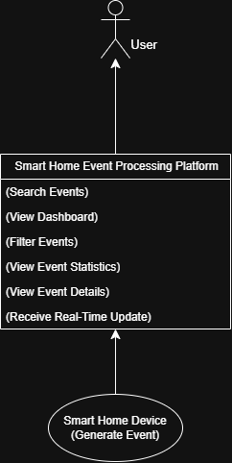
Fig 4.1 Use Case Diagram

System Requirements (Software Requirement Specification)
The system requirements define the functionalities that the platform must provide.
Functional Requirements
- The system shall allow users to search events using an account identifier.
- The system shall store smart home events in a database.
- The system shall process incoming events through an event streaming platform.
- The system shall provide real-time event updates to the user interface.
- The system shall allow users to filter events based on severity, event type, and time range.
- The system shall provide detailed event information including metadata and device information.
- The system shall provide event analytics and statistical summaries.
- The system shall support multilingual user interfaces including English, Hindi, French, and German.
Non-Functional Requirements
- The system should support scalable event processing.
- The system should provide real-time event updates with minimal latency.
- The system should maintain high reliability and availability.
- The system should provide secure access to event data.
- The system should support multiple users simultaneously.

Features of the New System
The Smart Home Events Processing Platform introduces several features that improve event monitoring and analysis.
- Microservices Architecture
The system is divided into multiple independent services including naming service, generic event service, enriched event service, API gateway, and event producer service. This modular architecture improves scalability and maintainability.
- Event Streaming with Kafka
The system uses Apache Kafka as a distributed event streaming platform to handle high volumes of events generated by smart home devices.
- Real-Time Event Updates
Users can monitor events in real time through a live dashboard that updates automatically using WebSocket communication.
- Event Enrichment
Raw event data retrieved from the database is processed by the enrichment service to add additional fields and remove unnecessary data, making the response optimized for frontend display.
- Advanced Search and Filtering
The system allows users to search events using multiple criteria such as account ID, event type, severity level, event ID, and date.
- Multi-Language Support
The platform supports four languages: English, Hindi, French, and German.
Users can dynamically switch between languages from the user interface,
allowing improved accessibility and usability for users from different regions.
- Event Schema Management
The system uses JSON-based schemas stored in the database to define the structure of different event types. This allows the platform to support multiple device types and event formats.

Frontend Navigation Chart
The navigation chart describes how users move between different pages of the frontend application.
The Smart Home Events Processing Platform consists of three primary pages. A common sidebar is available on all pages which allows users to navigate between the Home Page and the Search Page, as well as change the interface language.
- Home Page
The home page provides basic information about the system and allows the user to enter an account identifier to access event data. Users can also access frequently used accounts through quick access tabs.
- Account Page
The account page displays a real-time dashboard containing event lists, statistics, and visual representations of smart home activities for a specific account.
- Search Page
The search page provides advanced filtering options that allow users to search events using parameters such as account ID, event type, severity, event ID, and date range.

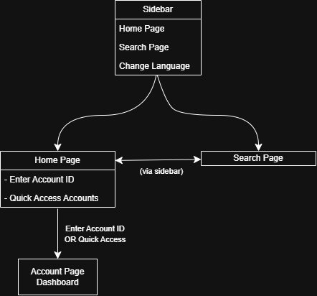
Fig 4.2 Frontend Navigation Chart

Class Diagram (Analysis Level)
The class diagram represents the structure of the event data model used in the system.
Key entities include:
- Event
Attributes:
- eventId
- eventType
- timestamp
- accountId
- severity
- data
- Subject
Attributes:
- type
- id
- name
- category
- Actor
Attributes:
- type
- id
- name
- EventSchema
Attributes:
- schemaId
- eventType
- schemaType
- definition
- active
The relationship between these classes represents how events are structured and validated using JSON schemas.

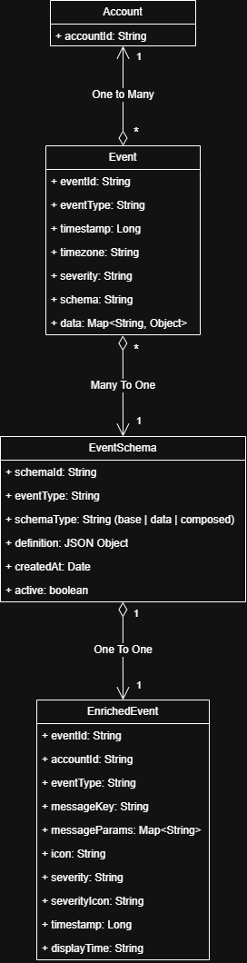
Fig 4.3 Class Diagram (Analysis Level)

System Activity Diagram

Event Ingestion and Real-Time Update Workflow
The first activity diagram represents how events are generated, processed, and delivered to the system. The process begins when a smart device or external system generates an event. The event is sent to the event producer service, which publishes the event to a Kafka topic. A Kafka consumer service subscribes to this topic and receives the event for processing. After processing, the consumer stores the event in the database for persistence. In addition to storing the event, the consumer also pushes the newly received event to connected clients through a WebSocket connection. This enables the frontend dashboard to receive real-time updates whenever new events occur in the system.
Typical workflow:
- A smart device or external system generates an event.
- The event is sent to the event producer service.
- The producer publishes the event to a Kafka topic.
- A Kafka consumer receives and processes the event.
- The consumer stores the event in the database.
- The consumer sends the event through a WebSocket connection to connected clients.
- The frontend dashboard receives the update and displays the new event in real time
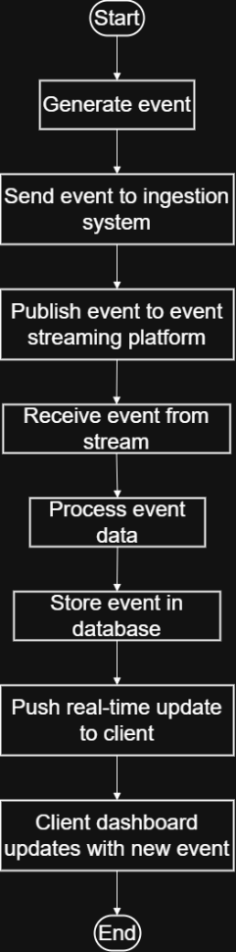
Fig 4.4 Event Ingestion Activity Diagram

Event Retrieval and Enrichment Workflow
The second activity diagram shows how a client application retrieves enriched events. A client, such as a frontend dashboard, sends a request to the API Gateway, which serves as the entry point and routes it to the Enriched Event Service. This service handles the creation of enriched, display-ready event data and requests the underlying raw events from the Generic Event Service.
The Generic Event Service fetches raw event data from the database and returns it to the Enriched Event Service. The data is then enriched through operations like generating message keys, extracting parameters, assigning icons, and formatting timestamps. Once processed, the enriched events are sent back through the API Gateway to the client.
Typical workflow:
- The client sends a request for enriched events.
- The request is received by the API Gateway.
- The API Gateway routes the request to the Enriched Event Service.
- The Enriched Event Service calls the Generic Event Service to retrieve raw event data.
- The Generic Event Service fetches the events from the database and returns them.
- The Enriched Event Service enriches the events by generating additional display-related information.
- The enriched events are returned through the API Gateway to the requesting client.
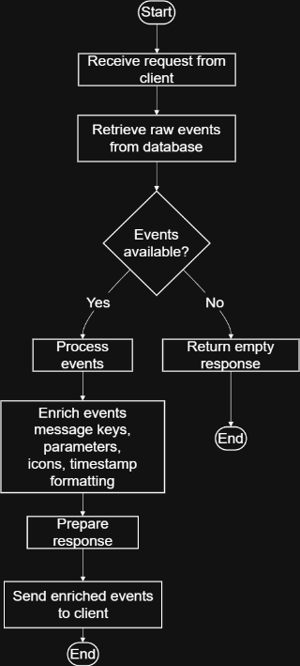
Fig 4.5 Event Retrieval Activity Diagram

Sequence Diagram
The sequence diagrams illustrate the interactions between different system components during event ingestion and event retrieval. Since the system contains two major interaction flows, two sequence diagrams are presented.

Event Ingestion and Real-Time Update
The first sequence diagram represents how events are generated, processed, stored, and delivered to clients in real time. A device or external system generates an event and sends it to the Event Producer Service. The producer publishes the event to a Kafka topic. The Kafka broker distributes the event to the Kafka Consumer Service.
The consumer processes the received event and stores it in the MongoDB database. After storing the event, the consumer sends the event to connected clients through a WebSocket connection. The frontend dashboard receives this event notification and updates the interface in real time.
Typical interaction flow:
- Device sends event to the Event Producer Service.
- The producer publishes the event to a Kafka topic.
- Kafka broker distributes the event to the Kafka Consumer Service.
- The consumer processes the event.
- The consumer stores the event in MongoDB.
- The consumer pushes the event to connected clients through WebSocket.
- The frontend dashboard receives the update and refreshes the display.

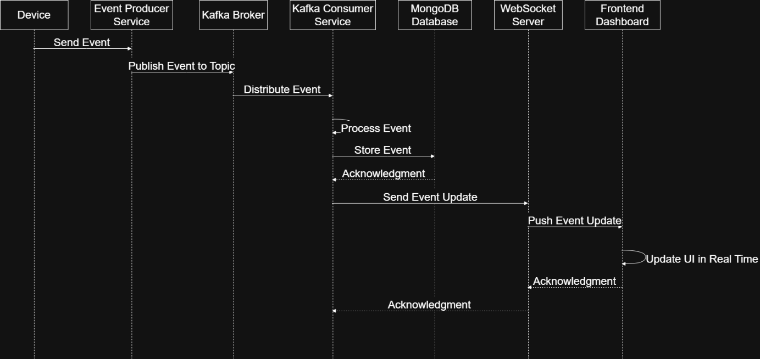
Fig 4.6 Event Ingestion Sequence Diagram

Event Retrieval and Enrichment
The second sequence diagram illustrates how enriched events are retrieved when requested by a client application. A frontend client sends a request to retrieve events through the API Gateway. The API Gateway routes the request to the Enriched Event Service.
The Enriched Event Service calls the Generic Event Service to obtain raw event data. The Generic Event Service queries MongoDB to fetch the stored events and returns them to the Enriched Event Service. The Enriched Event Service then enriches the events by generating additional display-related information such as message keys, parameters, icons, and formatted timestamps.
Finally, the enriched events are returned through the API Gateway to the requesting client.
Typical interaction flow:
- Frontend client sends a request for events to the API Gateway.
- The API Gateway forwards the request to the Enriched Event Service.
- The Enriched Event Service calls the Generic Event Service.
- The Generic Event Service queries MongoDB to retrieve events.
- MongoDB returns the raw events.
- The Generic Event Service sends the events to the Enriched Event Service.
- The Enriched Event Service enriches the events.
- The enriched events are returned to the client through the API Gateway
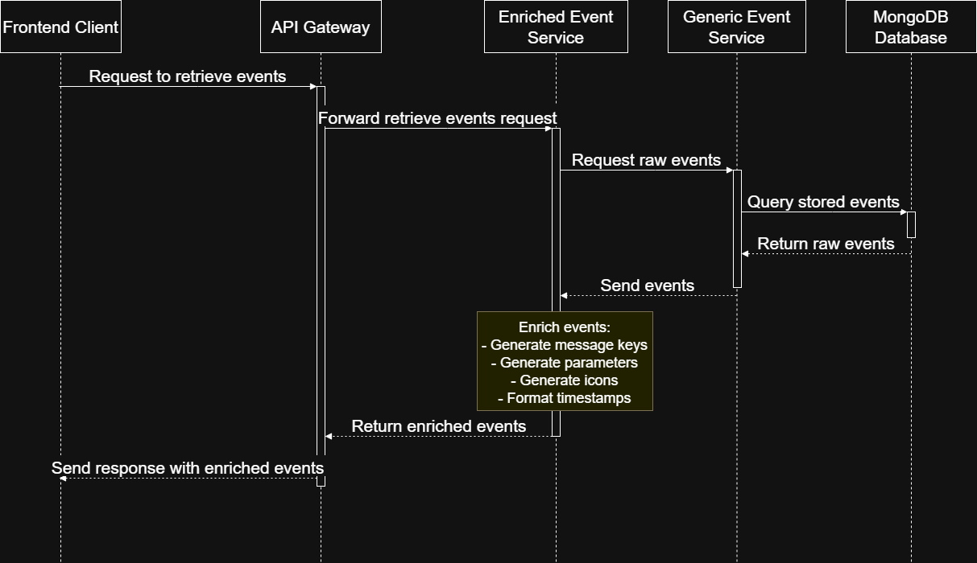
Fig 4.7 Event Retrieval Sequence Diagram

Data Modelling – ER Diagram
The system uses MongoDB as the primary database to store smart home events. The data model is designed to support flexible event structures, allowing different types of devices to generate events with varying payload formats.
The primary collections used in the system include the Events Collection and the Event Schemas Collection.

Events Collection
The Events collection stores all raw smart home events generated by devices and external systems. Each event contains an event envelope that describes the event and a payload that stores event-specific information.
Important fields include:
• eventId – Unique identifier of the event
• eventType – Type of event (e.g., DOOR_LOCKED, MOTION_DETECTED)
• timestamp – Time at which the event occurred
• timezone – Timezone associated with the account
• accountId – Identifier of the account or smart home
• severity – Indicates event importance (LOW, MEDIUM, HIGH, CRITICAL)
• schema – Reference to the schema associated with the event
• data – Flexible payload storing event-specific attributes

Event Schemas Collection
The Event Schemas collection stores schema definitions describing the structure of different event types. These schemas can be used by event producers or validation services to ensure that events follow a consistent format.
Important fields include:
• schemaId – Unique identifier of the schema
• eventType – Type of event associated with the schema
• definition – JSON schema definition of the event structure
• active – Indicates whether the schema is currently active
In addition to the stored collections, the system also generates Enriched Events, which are enhanced representations of raw events created dynamically by the Enriched Event Service. These enriched events include additional display-related information such as message keys, icons, and formatted timestamps. They are generated at runtime and are not stored in the database.
The ER diagram illustrates the relationship between Accounts, Events, Event Schemas, and Enriched Events within the system.
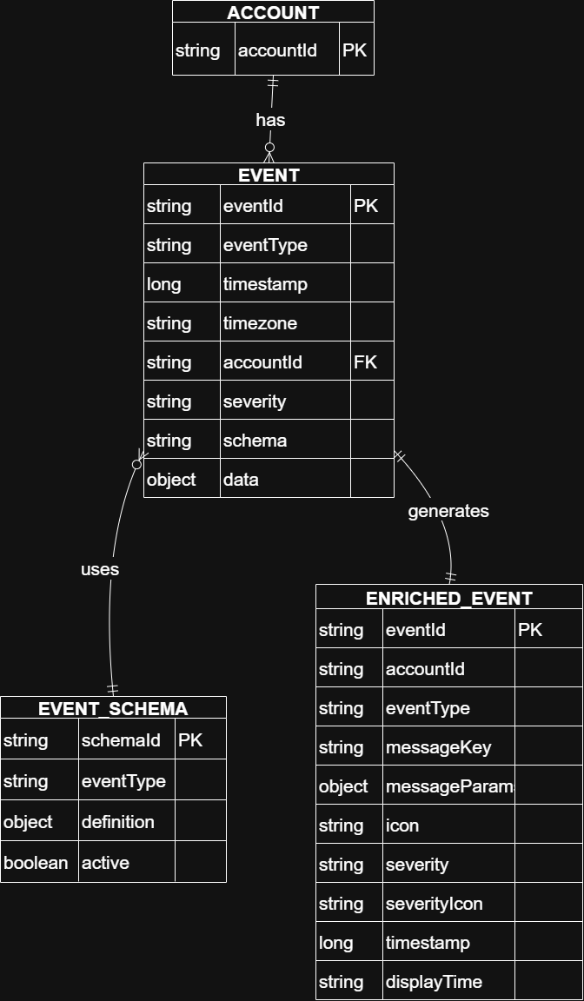
Fig 4.8 ER Diagram

SYSTEM IMPLEMENTATION

Introduction
This chapter describes the implementation of the Smart Home Event Processing System. The implementation focuses on building a scalable event-driven architecture capable of ingesting, storing, and retrieving smart home events efficiently.
The system is implemented using a microservices-based architecture where different services are responsible for specific tasks such as event ingestion, event storage, and event enrichment. The implementation leverages modern technologies including Java Spring Boot for backend services, MongoDB for data storage, Apache Kafka for event streaming, and a web-based frontend dashboard for event visualization.
The goal of the implementation is to provide a flexible system capable of handling different types of smart home events while ensuring efficient event processing and real-time updates to the client application.

Technology Stack
The system is developed using several technologies that support scalability, flexibility, and real-time data processing.
- Backend Framework
The backend services are developed using Java Spring Boot, which provides a robust framework for building RESTful APIs and microservices. Spring Boot simplifies application configuration and enables rapid development of backend services.
- Database
The system uses MongoDB, a NoSQL document-oriented database, to store event data. MongoDB allows flexible schema design, which is suitable for handling events with varying payload structures generated by different smart home devices.
- Event Streaming Platform
Apache Kafka is used as the event streaming platform to enable asynchronous communication between system components. Kafka allows events generated by devices or producers to be published to topics and consumed by backend services for processing and storage.
- Frontend Technology
The frontend dashboard is implemented using React.js, which provides a responsive and interactive user interface for visualizing events. The dashboard allows users to view events, filter them, and monitor system activity in real time.
- Real-Time Communication
Real-time event updates are delivered to the frontend using WebSocket connections, allowing the dashboard to update automatically when new events are processed.

System Services
The system consists of multiple backend services responsible for different functionalities.
- Event Producer Service
The Event Producer Service receives events generated by smart home devices or external systems. These events are published to Kafka topics, allowing them to be processed asynchronously by downstream services.
- Generic Event Service
The Generic Event Service is responsible for storing raw event data in the MongoDB database. It provides APIs for retrieving events based on different filters such as account ID, event type, or time range.
- Enriched Event Service
The Enriched Event Service generates enriched event representations suitable for display on the frontend dashboard. It retrieves raw events from the Generic Event Service and performs enrichment operations such as generating message keys, extracting parameters, assigning icons, and formatting timestamps.
- API Gateway
The API Gateway acts as the entry point for external requests and routes them to the appropriate backend services.

Event Ingestion Implementation
The event ingestion pipeline processes events generated by devices and stores them in the system.
The process begins when an event is generated by a smart home device or external system. The event is sent to the Event Producer Service, which publishes the event to a Kafka topic. A Kafka consumer service listens to the topic and processes incoming events.
After processing the event, the consumer stores the event in the MongoDB database using the Generic Event Service. Once the event is stored, a real-time notification can be pushed to connected clients through WebSocket connections.
This architecture ensures that the system can process events asynchronously while maintaining scalability and reliability.

Event Retrieval and Enrichment Implementation
When a client application requests events, the request is first received by the API Gateway. The API Gateway forwards the request to the Enriched Event Service.
The Enriched Event Service retrieves raw events from the Generic Event Service. After retrieving the events, the service performs enrichment operations such as generating message keys, building message parameters, assigning icons, and formatting timestamps.
The enriched events are then returned to the client through the API Gateway. This approach allows the system to keep raw event data in the database while generating enriched representations dynamically when required.

API Design and Implementation
The system exposes RESTful APIs that allow clients to retrieve event data and perform event searches. These APIs are implemented using Spring Boot REST controllers. Two primary services provide APIs for event retrieval: the Generic Event Service and the Enriched Event Service.
The controllers handle incoming HTTP requests and delegate the processing logic to service layer implementations.

- Generic Event APIs
The Generic Event Service provides APIs to access raw event data stored in MongoDB. These APIs allow clients to retrieve events using filters such as account identifier, date, or search parameters.
Important API endpoints include:
Table 5.1 Generic Event APIs
Endpoint | Description
GET /events | Retrieves all events with pagination
GET /events/account | Retrieves events belonging to a specific account
GET /events/account-and-date | Retrieves events for a specific account on a given date
GET /events/search | Searches events using dynamic query parameters
GET /events/stats | Retrieves event statistics grouped by severity and type
The controller processes request parameters and forwards them to the service layer, which interacts with the database to retrieve the required data.
Pagination support is implemented using Spring Data Pageable, enabling efficient retrieval of large datasets.

- Enriched Event APIs
The Enriched Event Service provides APIs for retrieving enriched event representations that are suitable for frontend display.
Unlike raw events, enriched events contain additional attributes such as display messages, icons, and formatted timestamps.
Important API endpoints include:
Table 5.2 Enriched Event APIs
Endpoint | Description
GET /events/account | Retrieves enriched events for a specific account
GET /events/account-and-date | Retrieves enriched events filtered by account and date
GET /events/search | Searches enriched events using dynamic filters
These APIs internally call the Generic Event Service to retrieve raw event data and then perform enrichment operations before returning the response.

Database Implementation
The system uses MongoDB, a NoSQL document database, for storing event data. MongoDB is suitable for the system because smart home events may have varying payload structures depending on the device type.
Events are stored as documents in the events collection. Each event contains both metadata fields and a flexible payload.
The metadata includes fields such as event identifier, event type, timestamp, and severity level. The payload is stored in a dynamic data field, which allows different event types to store different attributes without requiring schema modifications.
The system uses Spring Data MongoDB to interact with the database. This framework simplifies database operations by mapping Java objects to MongoDB documents.
Indexes are also used to improve query performance. For example, a compound index is created on accountId and timestamp to efficiently retrieve events for a specific account within a time range.

Frontend Implementation
The frontend dashboard is implemented using React.js, which provides a responsive interface for visualizing smart home events.
The dashboard communicates with backend services using REST APIs exposed through the API Gateway. Users can view event lists, search for specific events, and filter events based on different criteria such as date or event type.
To improve usability, the frontend also displays enriched information such as event icons, human-readable messages, and formatted timestamps. These enriched attributes are generated by the Enriched Event Service before the data is returned to the frontend. The frontend interface is designed to handle large numbers of events by using pagination and filtering mechanisms.
The frontend application implements multilingual support using a localization approach. Text content is managed through language-specific JSON files, and the UI dynamically updates based on the selected language. A language switcher is provided in the interface, enabling users to seamlessly change between English, Hindi, French, and German.

Real-Time Event Updates
To provide real-time visibility of system activity, the system uses WebSocket communication between the backend and the frontend dashboard.
When new events are ingested into the system through the Kafka event processing pipeline, the event consumer stores the event in MongoDB and pushes a notification through the WebSocket connection.
Connected clients receive this notification and update the dashboard automatically without requiring a manual refresh.
This approach ensures that users can monitor smart home activity in real time while maintaining efficient event processing through the asynchronous Kafka pipeline.

RESULTS AND DISCUSSION

Introduction
This chapter presents the results obtained from implementing the Smart Home Event Processing System. The system was developed to ingest, store, and retrieve smart home events efficiently while providing enriched event representations suitable for visualization on a dashboard.
The implemented system demonstrates the ability to process events through an event-driven architecture, store them in a scalable database, and present them to users through a web-based interface. The results highlight how the system handles event ingestion, event retrieval, event enrichment, and real-time updates.

Event Dashboard Interface
The frontend dashboard provides a user interface for monitoring smart home events. The dashboard displays events retrieved from the backend services and presents them in an organized and user-friendly format.
Each event displayed on the dashboard includes information such as the event type, severity level, timestamp, and additional contextual information generated during the enrichment process. Icons and descriptive messages are used to make the events easier to interpret. Pagination and filtering options allow users to navigate through large numbers of events efficiently.
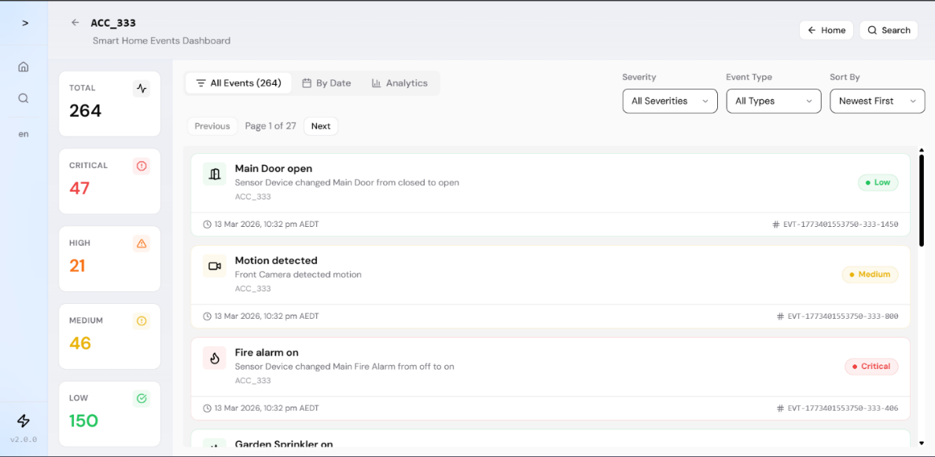
Fig 6.1 Event Dashboard Interface

Event Search and Filtering
The system provides functionality to search and filter events using multiple parameters such as account identifier, event type, severity level, and date.
The search functionality is implemented using flexible query parameters that allow the backend services to dynamically build queries. This allows users to retrieve specific events of interest without needing to manually browse through large datasets. Search results are returned in paginated format to ensure efficient data transfer and responsive user experience
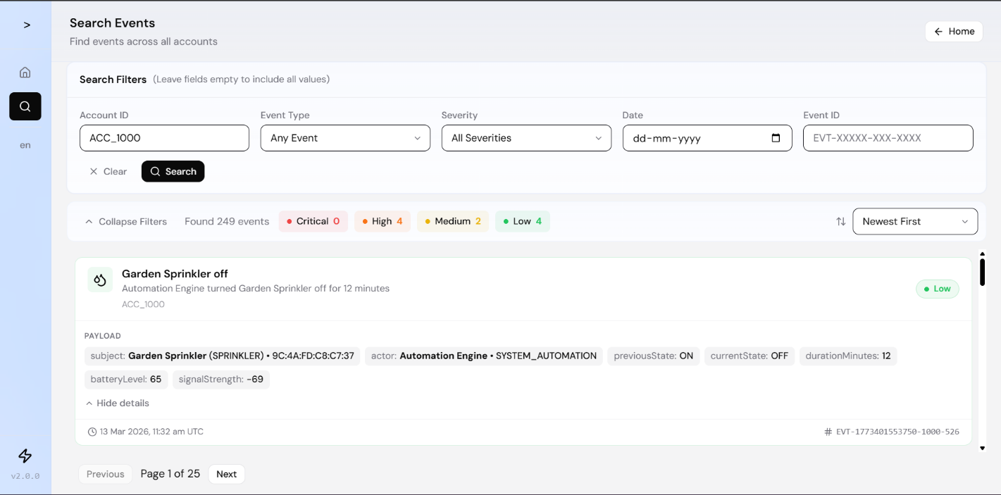
Fig 6.2 Event Search and Filtering

Event Enrichment Results
The system generates enriched event representations dynamically using the Enriched Event Service. Raw events stored in the database are transformed into enriched events that include additional information useful for visualization.
Enrichment operations include:
- Generating message keys used for constructing descriptive event messages
- Extracting parameters required to build human-readable messages
- Assigning icons corresponding to event types
- Formatting timestamps into display-friendly formats
These enriched events are returned to the frontend, where they are displayed in the event dashboard.
Usage in Dashboard:
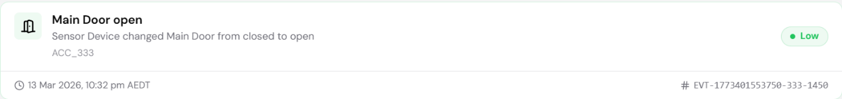
Fig 6.3 Enriched Event UI

What is received as Enriched Event in the form of JSON:
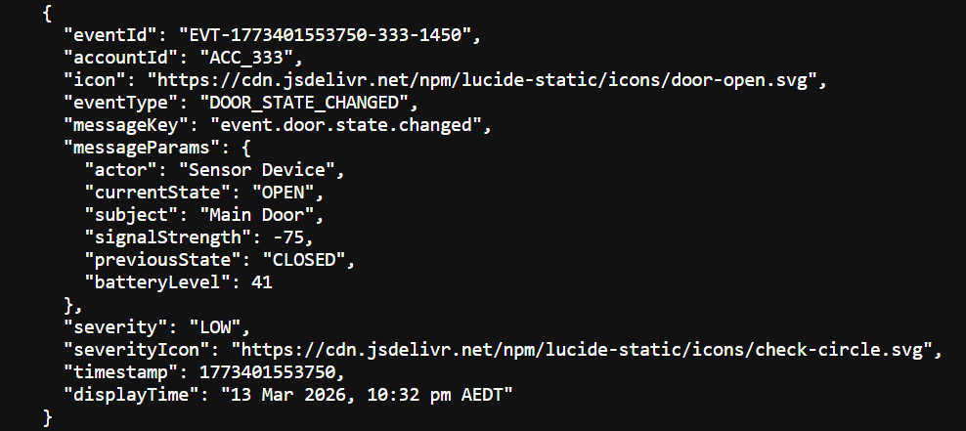
Fig 6.4 Enriched Event JSON

Event Statistics
The system also provides statistical insights about events. The backend services compute aggregated statistics such as the total number of events and the distribution of events by severity level.
These statistics help users understand the overall activity within the smart home environment and identify important events that require attention.
The statistics are generated using aggregation queries on the event data stored in MongoDB.

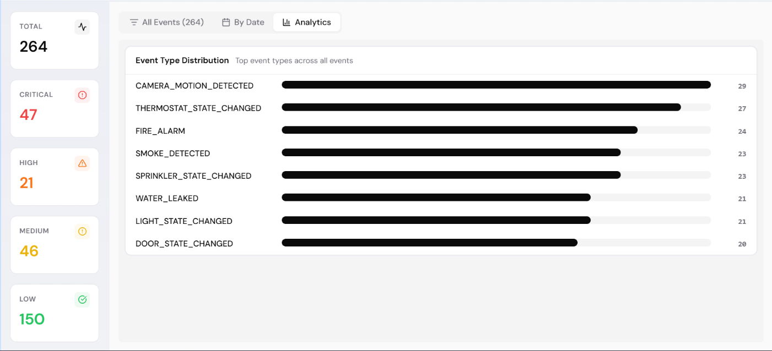
Fig 6.5 Event Statistics

Real-Time Event Updates
The system supports real-time event updates using WebSocket communication between the backend and the frontend dashboard.
When a new event is processed through the event ingestion pipeline, the system sends a notification through the WebSocket connection. The frontend dashboard receives this notification and updates the event list automatically.
This functionality ensures that users can monitor smart home activity in real time without needing to manually refresh the interface.
New Events are highlighted automatically.

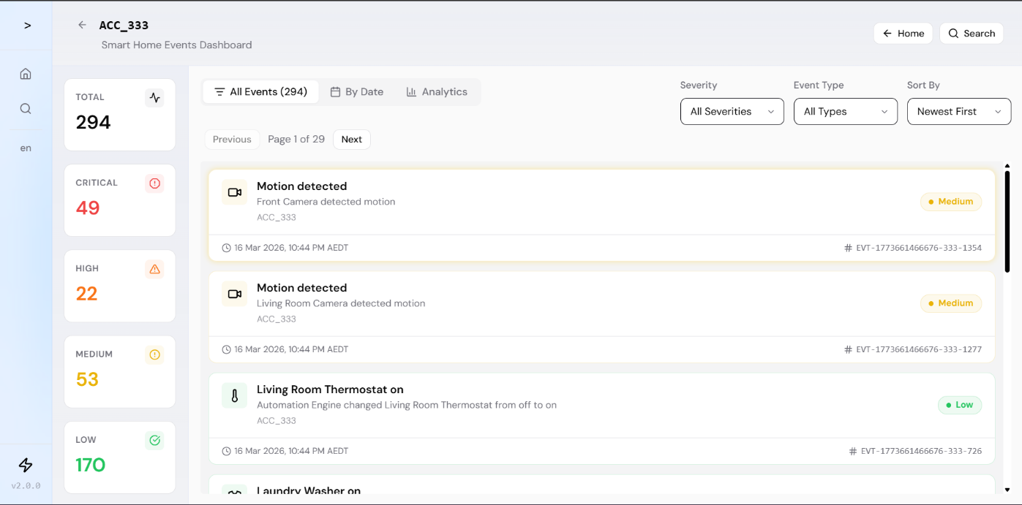
Fig 6.6 Real-Time Event Updates

Internationalization
The dashboard also provides multilingual support, allowing users to switch between different languages such as English, Hindi, French, and German. The interface dynamically updates all labels, messages, and event descriptions based on the selected language, improving accessibility for users from different regions.
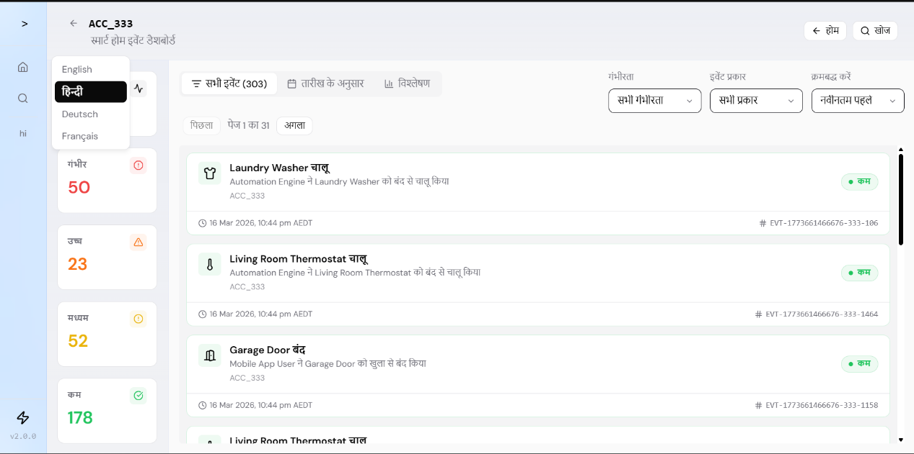
Fig 6.7 Multi-Language Interface (English, Hindi, French, German)

Discussion
The implemented system successfully demonstrates the use of an event-driven architecture for processing smart home events. By using Apache Kafka for event streaming and MongoDB for event storage, the system can handle events asynchronously while maintaining scalability.
The use of microservices allows different components of the system to operate independently, improving modularity and maintainability. The enrichment layer ensures that raw event data can be transformed into meaningful information suitable for user interfaces.
Overall, the system provides a flexible and scalable solution for managing smart home event data.

CONCLUSION AND FUTURE WORK

Conclusion
This project presented the design and implementation of a Smart Home Event Processing System capable of handling events generated by smart home devices in a scalable and efficient manner. The system was developed using an event-driven microservices architecture that enables asynchronous processing of events while maintaining flexibility and extensibility.
The implemented system provides a complete pipeline for smart home event management. Events generated by devices or external systems are ingested through an event producer and published to Apache Kafka topics. Kafka acts as the central event streaming platform that enables reliable event delivery to backend services. Event consumers process the events and store them in a MongoDB database, which provides flexible document-based storage suitable for handling different event payload structures.
To support user-friendly visualization, the system includes an enrichment layer that transforms raw events into enriched event representations. These enriched events contain additional information such as descriptive message keys, parameters, icons, and formatted timestamps, making them suitable for display on a frontend dashboard.
The frontend interface allows users to monitor events, search and filter event data, and view statistical insights about system activity. Real-time updates are provided through WebSocket communication, enabling the dashboard to display new events as they occur.
Overall, the developed system demonstrates how modern technologies such as microservices, event streaming platforms, and NoSQL databases can be integrated to build scalable systems capable of processing high volumes of smart home events.

Future Work
Although the implemented system successfully demonstrates the core functionalities of event ingestion, storage, and retrieval, several improvements and extensions can be explored in future work.
One potential enhancement is the implementation of event schema validation using JSON schemas. Event producers or consumers could validate events against predefined schemas to ensure data consistency and improve reliability.
Another possible improvement is the addition of advanced analytics and visualization features in the frontend dashboard. These features could include trend analysis, anomaly detection, and graphical representations of event activity.
The system could also be extended to support multiple smart homes or multi-tenant environments, allowing the platform to manage events from a larger number of users and devices.
In addition, implementing event retention policies and archival mechanisms would allow the system to efficiently manage long-term event storage while maintaining database performance.
Finally, the integration of machine learning techniques could enable intelligent processing of events, such as predicting unusual activity patterns or detecting potential security incidents within the smart home environment.

Limitations
The current system has certain limitations. It depends on stable network connectivity for real-time event streaming and processing. The system is designed for a controlled number of devices and may require additional scaling mechanisms for large-scale deployments.
Security features such as advanced authentication and encryption mechanisms can be further enhanced. Additionally, integration with external third-party smart home ecosystems is limited in the current implementation.

REFERENCES

1. Apache Kafka Documentation, https://kafka.apache.org/documentation/

2. MongoDB Documentation, https://www.mongodb.com/docs/

3. Spring Boot Documentation, https://spring.io/projects/spring-boot

4. React Documentation, https://react.dev/

5. Node.js Documentation, https://nodejs.org/en/docs

6. Socket.IO Documentation, https://socket.io/docs/

7. MDN Web Docs, https://developer.mozilla.org/

8. Martin Kleppmann, “Designing Data-Intensive Applications”, O’Reilly Media, 2017.

9. IEEE Research Papers on Event-Driven Systems and Real-Time Processing.

EXPERIENCE

The project work on “Smart Home Events Processing Platform” provided valuable industry-level exposure and hands-on experience in designing and developing a real-time event-driven system.
During the project, I worked in a professional environment where I gained practical knowledge of modern technologies such as Apache Kafka, Spring Boot, MongoDB, and React. The project helped me understand how large-scale systems handle real-time data processing, event streaming, and system scalability.
The organizational environment was supportive and collaborative. Guidance from mentors and team members played a crucial role in understanding complex system design concepts, debugging issues, and improving implementation quality.
I also learned the importance of clean coding practices, modular design, and efficient data handling. Exposure to real-world problem-solving enhanced my analytical thinking and technical decision-making abilities.
This experience significantly contributed to bridging the gap between academic learning and industry requirements, and it has prepared me for future professional challenges in software development and system design.

