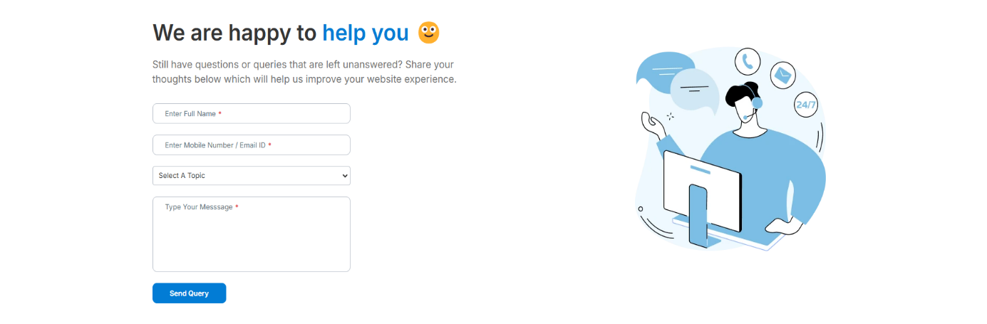

**Purpose:** This form will allow the target end Users to give a feedback to our system, the following information will be encoded in the system.

|  |  |  |  |  |  |
| --- | --- | --- | --- | --- | --- |
| Sr. | Screen Element | Input Type | O/M | 1/N | Description |
| 1. | Username | Textbox | M | 1 | Username field should be editable and accept the user’s name |
| 2. | Mobile Number /Email Id | Textbox | M | 1 | Mobile Number or Email field should be editable and accept the mobile number or email Id |
| 3. | Topic | Dropdown | M | 1 | Topic field should be editable and accept the user’s choice in which they want to give feedback |
| 4. | Feedback | Textbox | M | 1 | Feedback field should be editable and accept the feedback which user want to give on particular topic |

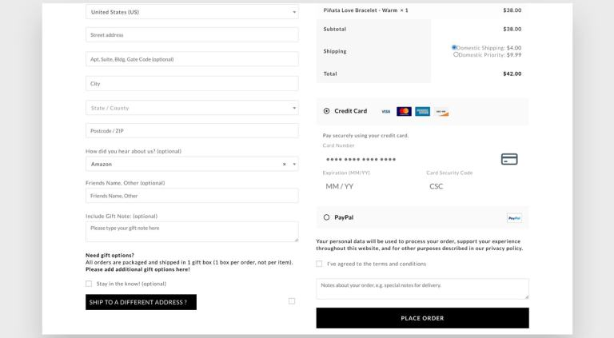

**Purpose:** This form will allow the target end Users to choose payment methods after purchasing products, the following information will be encoded in the system.

|  |  |  |  |  |  |
| --- | --- | --- | --- | --- | --- |
| Sr. | Screen Element | Input Type | O/M | 1/N | Description |
| 1. |  |  |  |  |  |
|  |  |  |  |  |  |
|  |  |  |  |  |  |
|  |  |  |  |  |  |
|  |  |  |  |  |  |



