Comprehensive Linux Operations

Part 1: Creating and Editing Text Files

- Using Nano
Create a file server_config.txt using Nano#!/bin/bash
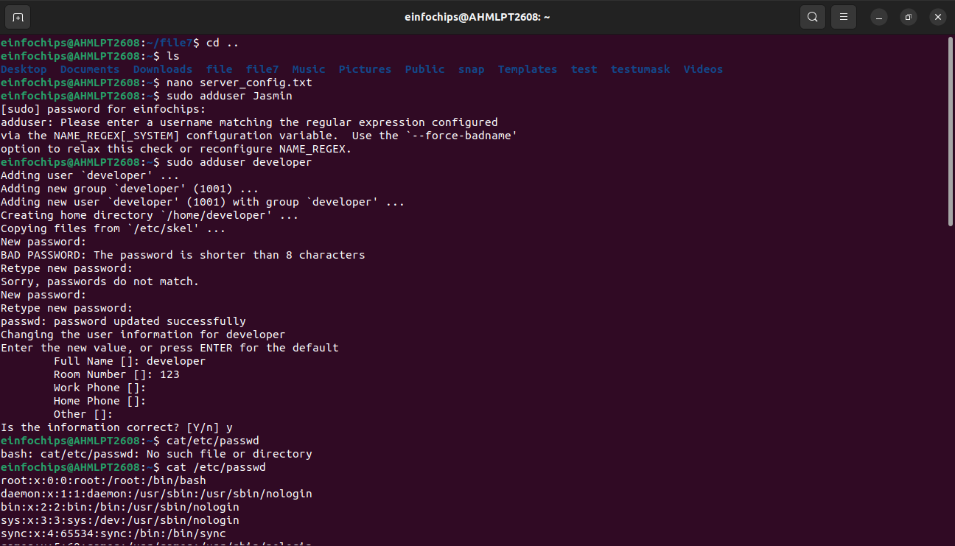
Part 2: User & Group Management

Add a new user developer:
sudo adduser developer

- Managing Groups
Create a group devteam:
sudo groupadd devteam

Add the user developer to the devteam group:
sudo usermod -aG devteam developer

Remove the user developer from the devteam group:
sudo gpasswd -d developer devteam

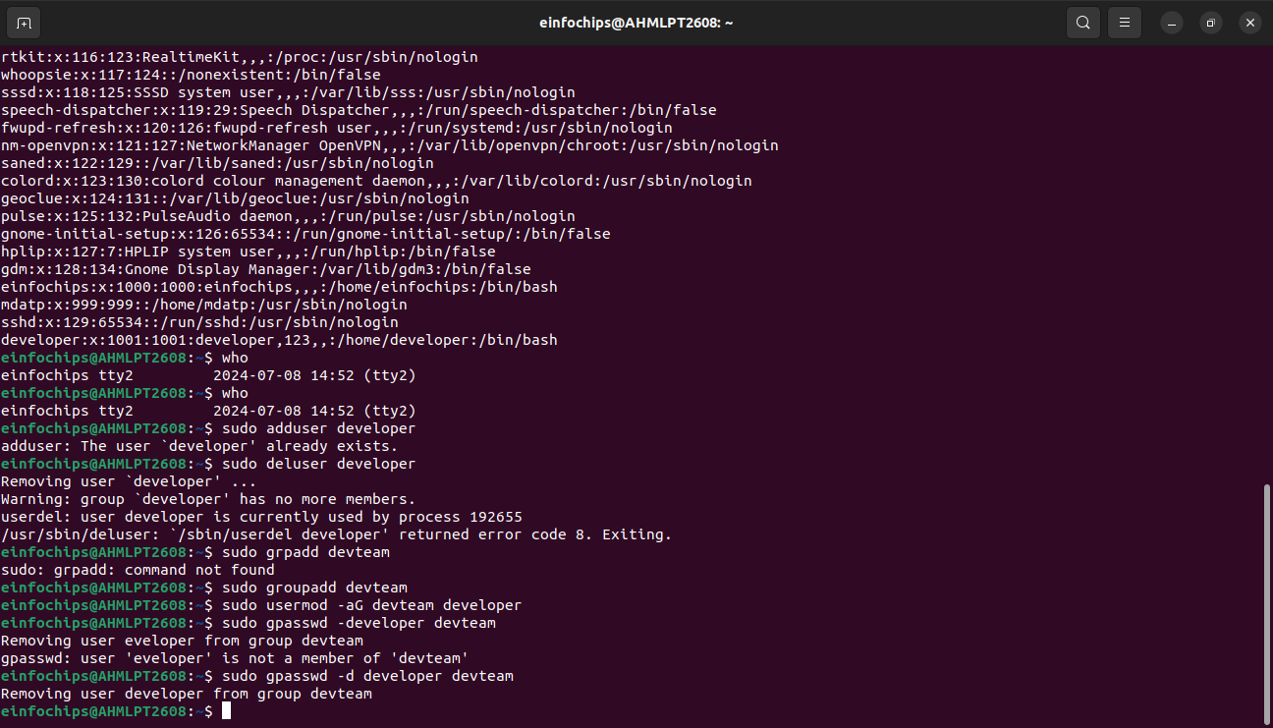

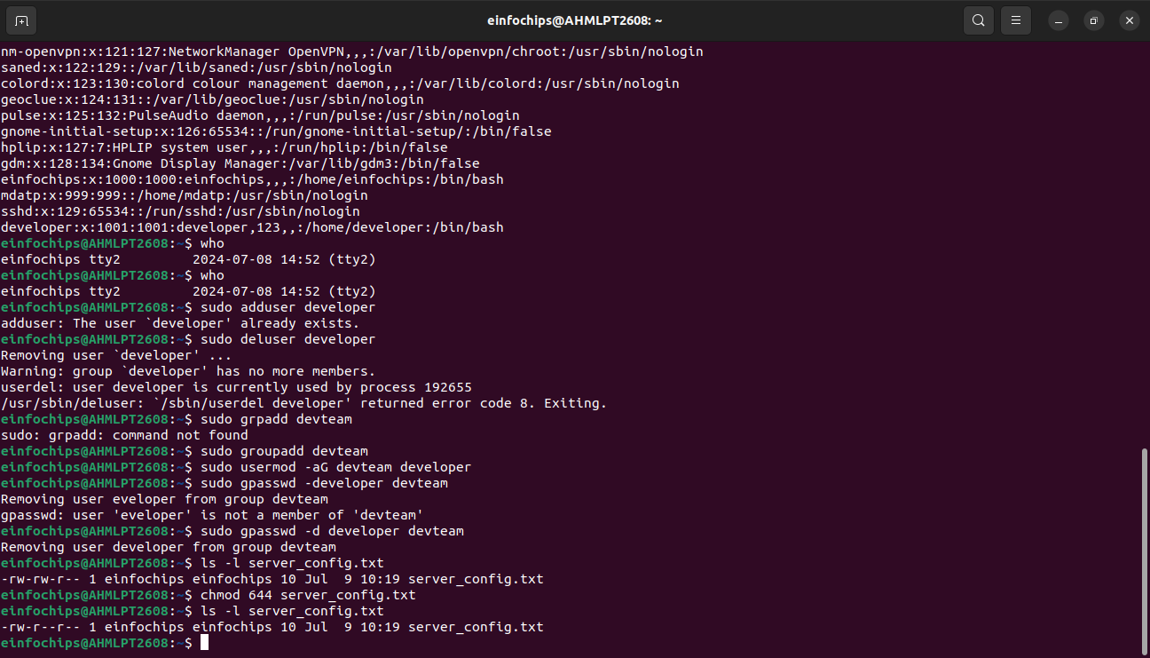
Part 3: File Permissions Management

Understanding File Permissions
View permissions for server_config.txt:
ls -l server_config.txt
- Discuss the output (e.g., -rw-r--r--).
- Changing Permissions and Ownership
Change permissions to read/write for the owner and read-only for others:
chmod 644 server_config.txt

Verify the change:
ls -l server_config.txt

Change the owner to developer and the group to devteam:
sudo chown developer:devteam server_config.txt

Verify the change:
ls -l server_config.txt

Part 4: Controlling Services and Daemons

1 Managing Services with systemctl

Start the Apache service:
sudo systemctl start apache2

Stop the Apache service:
sudo systemctl stop apache2

Enable the Apache service to start on boot:
sudo systemctl enable apache2

Disable the Apache service:
sudo systemctl disable apache2

Check the status of the Apache service:
sudo systemctl status apache2
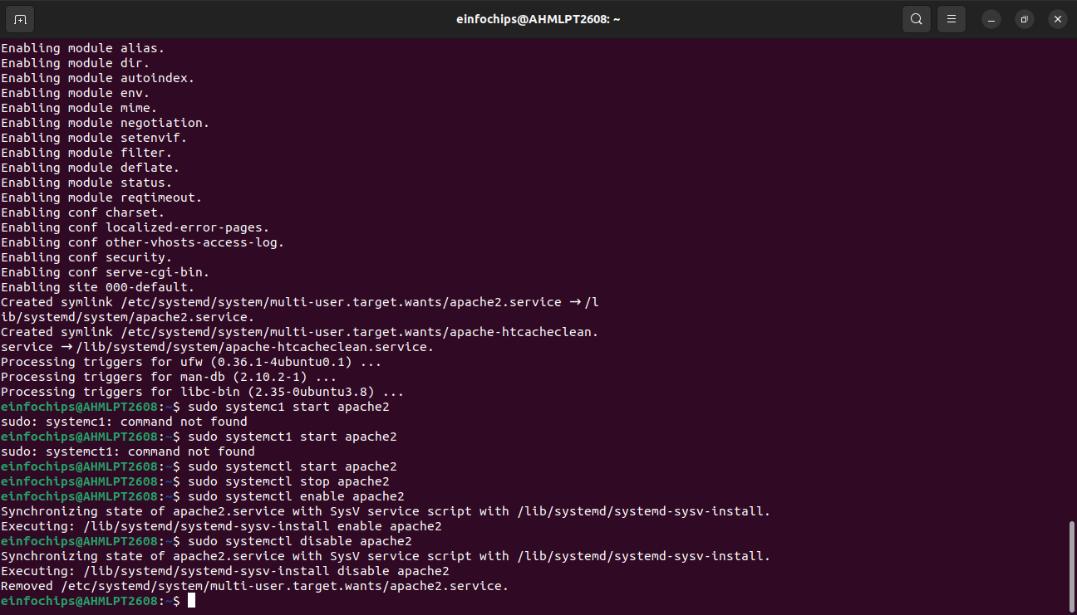

Part 5: Process Handling

Viewing Processes
List all running processes:
ps aux

Use top to view processes in real-time:
top

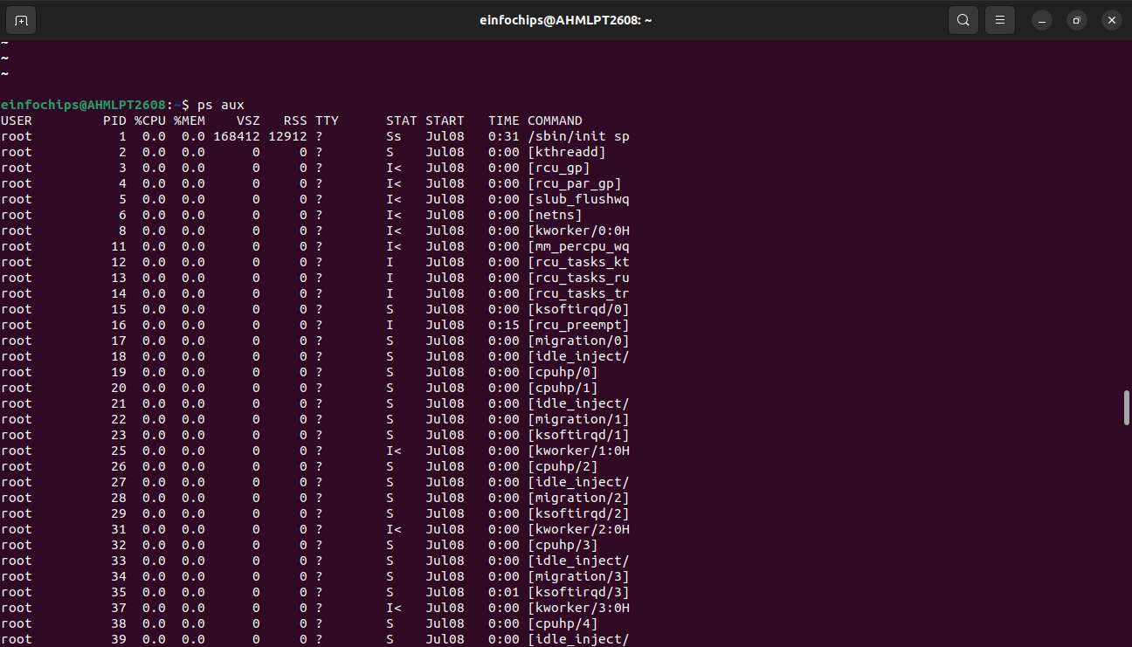

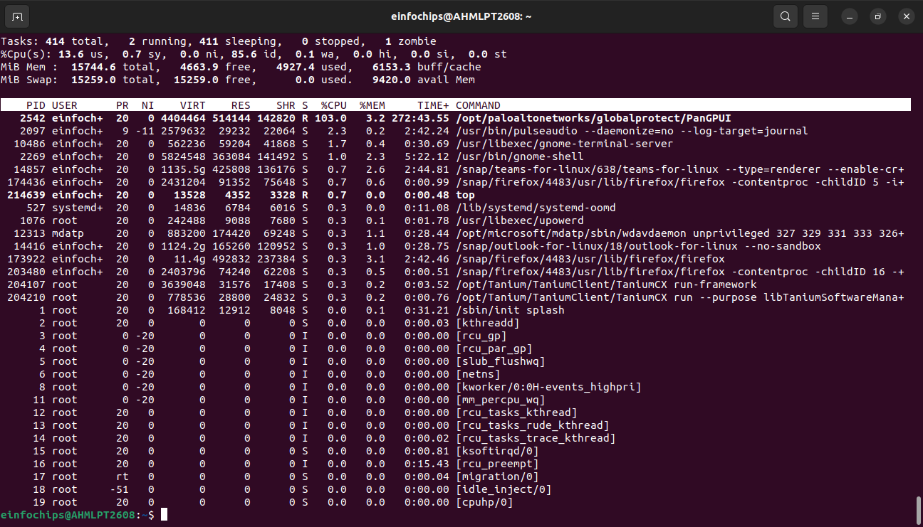

Creating and Deploying a Static Website with Apache2

Part 1: Installing Apache2 (5 minutes)
- Update Package Lists
Open the terminal and run:
sudo apt update

- Install Apache2
Install Apache2 by running:
sudo apt install apache2

- Start and Enable Apache2
Start the Apache2 service:
sudo systemctl start apache2
Enable Apache2 to start on boot:
sudo systemctl enable apache2
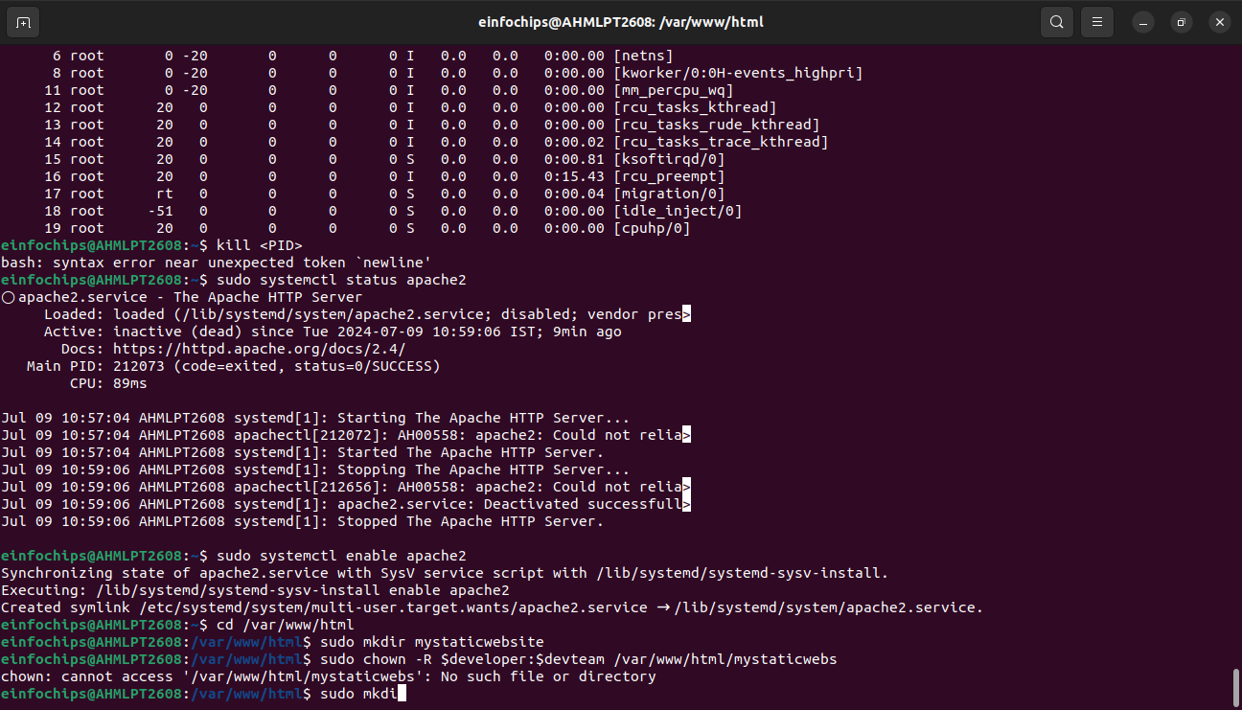

Part 2: Creating the Website

Create HTML File

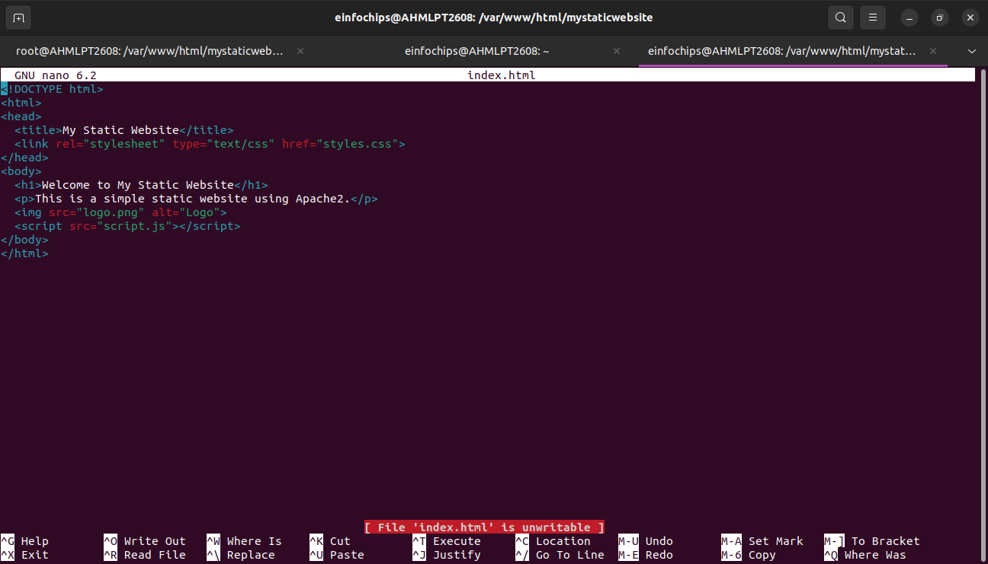

Create CSS File

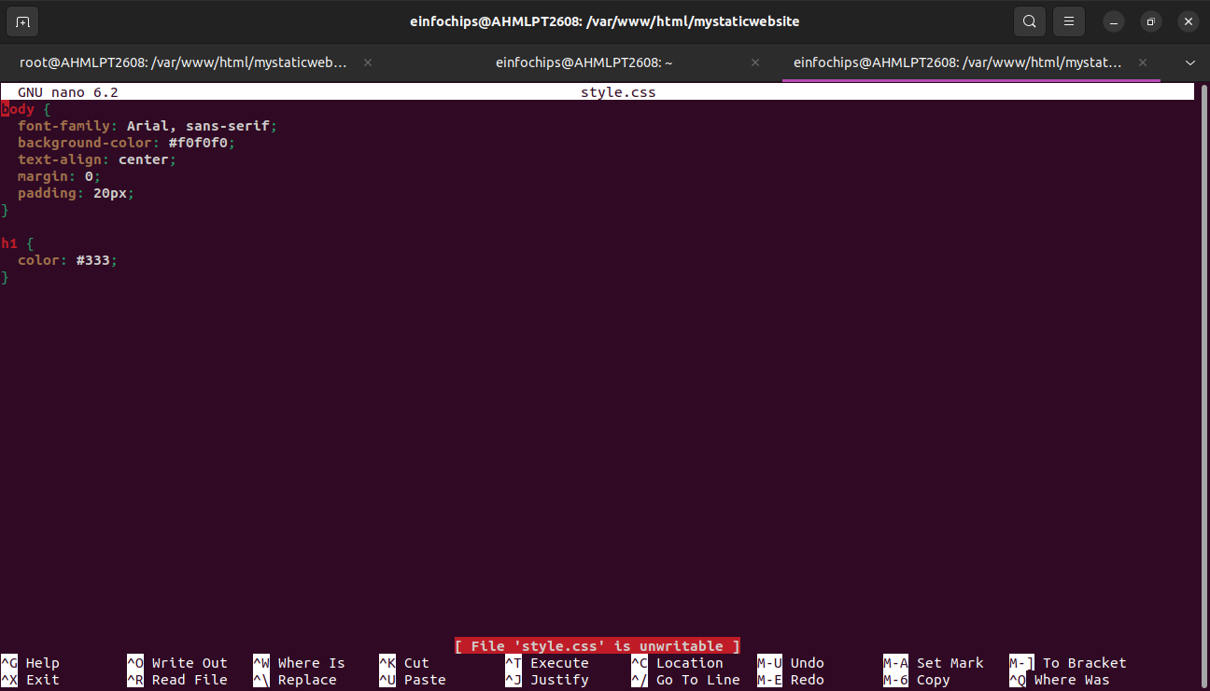

Create JavaScript File
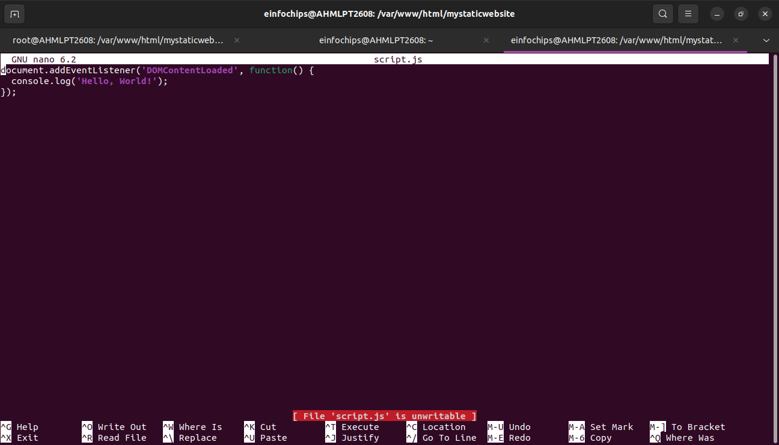

Part 3: Configuring Apache2 to Serve the Website (10 minutes)
- Create a Virtual Host File
Create and edit the virtual host configuration file:
sudo nano /etc/apache2/sites-available/mystaticwebsite.conf

Add the following content:
<VirtualHost *:80>
ServerAdmin webmaster@localhost
DocumentRoot /var/www/html/mystaticwebsite
ErrorLog ${APACHE_LOG_DIR}/error.log
CustomLog ${APACHE_LOG_DIR}/access.log combined
</VirtualHost>

- Save and exit (Ctrl+O, Enter, Ctrl+X).
- Enable the New Virtual Host
Enable the virtual host configuration:
sudo a2ensite mystaticwebsite.conf

- Disable the Default Site
Disable the default site configuration:
sudo a2dissite 000-default.conf
Reload Apache2
Reload the Apache2 service to apply the changes:
sudo systemctl reload apache2

- Test the Configuration
  - Open a web browser and navigate to http://your_server_ip. You should see the static website with the HTML, CSS, JS, and image.
