Git Project

Install Git:

1 Set Up Git:
2 Create a GitHub Repository:
3 Initialize the Project:

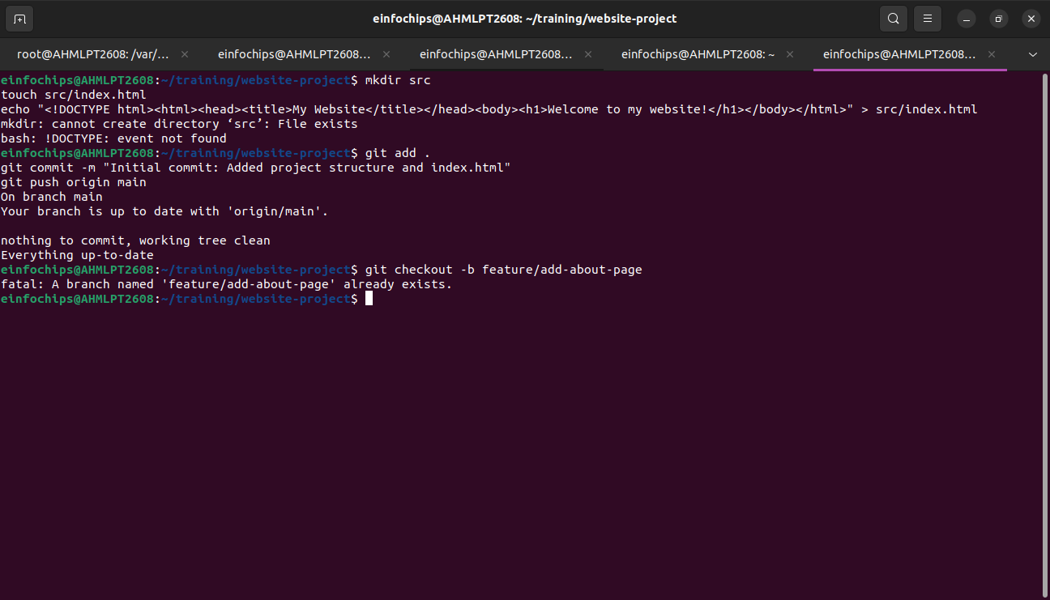

Exercise 1: Branching and Basic Operations
Create a New Branch:
Add a New Page:

Exercise 2: Merging and Handling Merge Conflicts
Create Another Branch:
Update the Homepage:
Create a Merge Conflict:
Merge and Resolve Conflict:
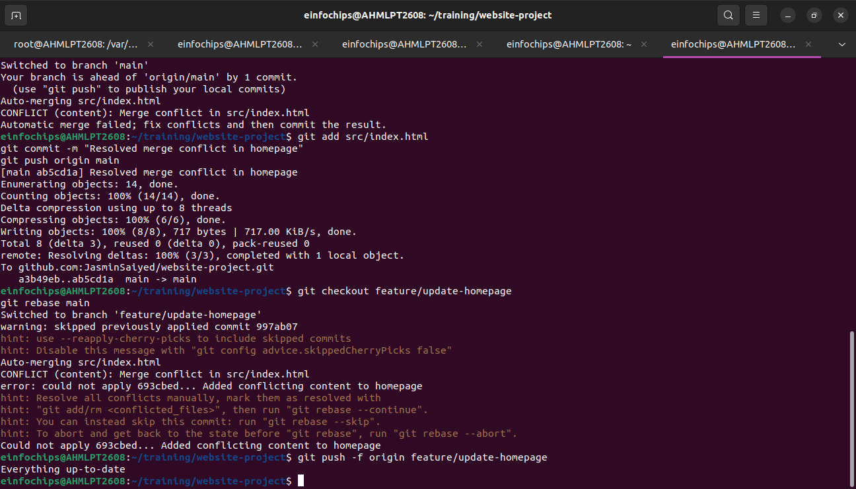
Exercise 3: Rebasing
Rebase a Branch:
Push the Rebased Branch:

Exercise 4: Pulling and Collaboration

Pull Changes from Remote:

Simulate a Collaborator's Change:

Pull Collaborator's Changes:

Exercise 5: Versioning and Rollback
Tagging a Version:
Make a Change that Needs Reversion:
Revert to a Previous Version:
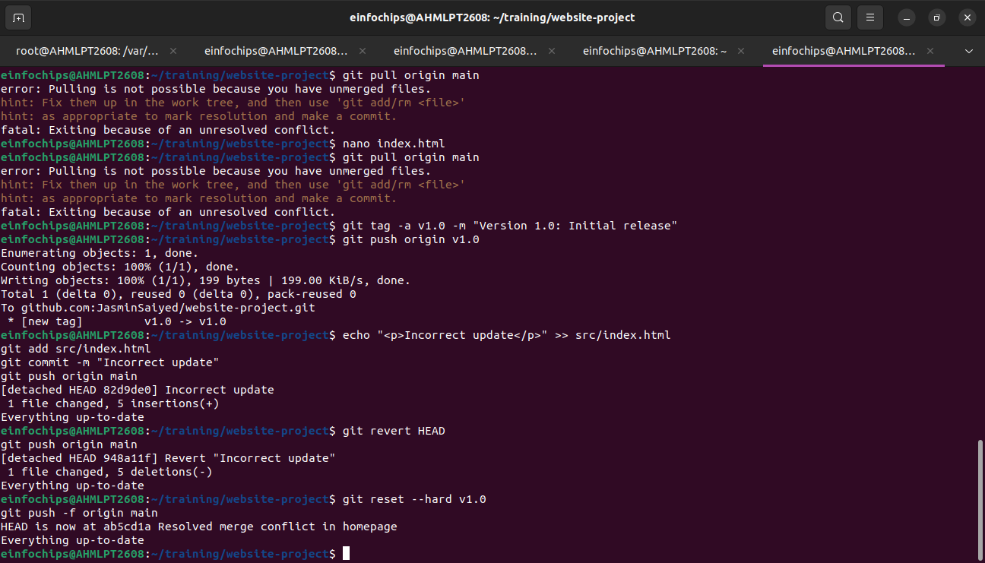

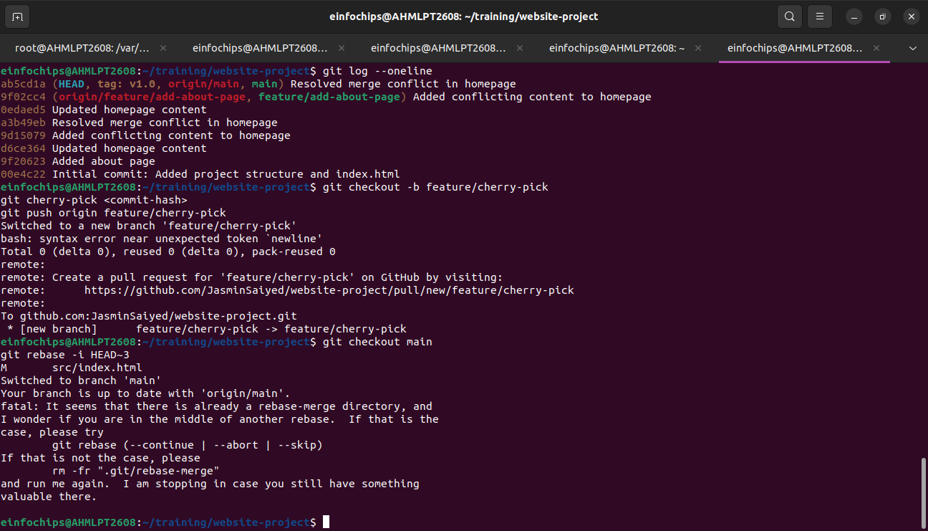

Extra Activities

Stashing Changes:
Viewing Commit History:
Cherry-Picking Commits:
Interactive Rebase:

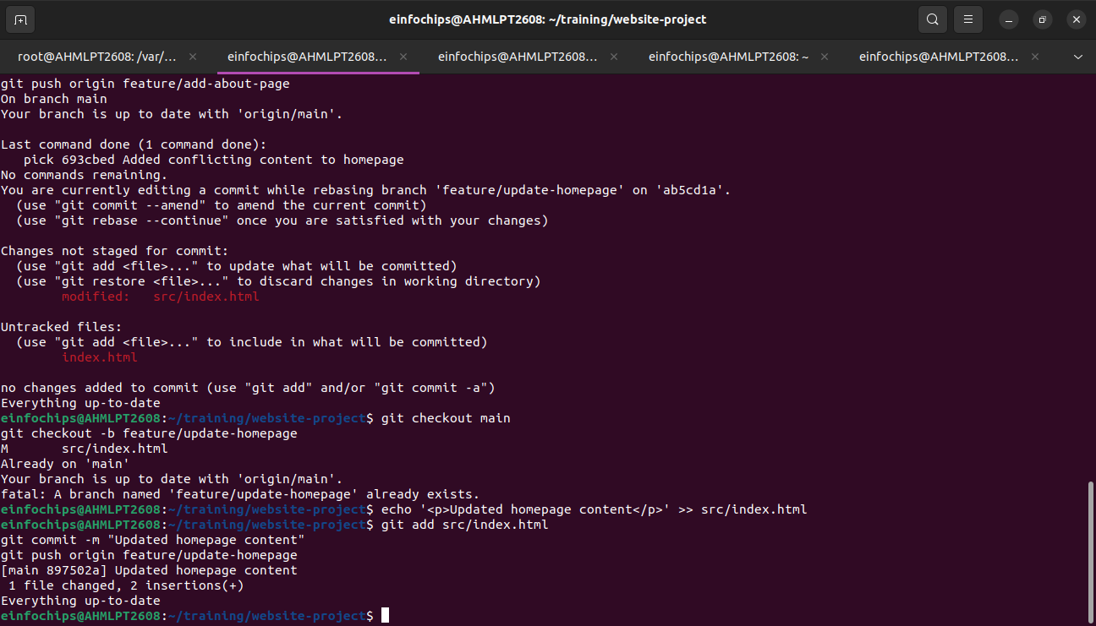

Collaborative Blogging Platform

Create a GitHub Repository:
Initialize the Project:

Exercise 1: Branching and Adding Features (

Create a New Branch for Blog Post Feature:
Add a Blog Post Page:

Exercise 2: Collaborating with Merging and Handling Merge Conflicts (25 minutes)
Create Another Branch for Author Info:
Add Author Info to Blog Page:
Create a Merge Conflict:
Merge and Resolve Conflict:

Exercise 3: Rebasing and Feature Enhancement
Exercise 4: Pulling and Simulating Collaboration
Exercise 5: Versioning and Rollback

