**Onion Market Analysis in India**

Name: **Babariya Jasmin Bhikhubha**i

Registration no: **daiict19001**

M.Sc.(AA) : Agriculture Analytics

Programming For Geo Data Processing

Submitted to:

Prasun Kumar Gupta

Geoinformatics Department

Indian Institute Of Remote Sensing

18 January 2024



# **Abstract** :

My project on **Onion market analysis in Indian** trends nowadays, based on past 13 years of data. I have taken 3 data frames from different data sources and websites. I am using dataset have different District state wise with different year of onion Area of sowing, production, it's yield and as well as market arrival (2022) and 2023 and also my dataset in all over state in all district wise wholesale price january,2011 to january,2024 etc.

* **Research Question**

1) Did the yield of onion vary in the last decade, and if so, how did it fluctuate?

2) How has the onion yield fluctuated year-wise from 2011 to 2020?

3) Did the area of onion sowing and its production vary over the last decade?

4) Did the area of onion sowing and its production change state-wise in India?

5) Did the area of onion sowing and its production change both state-wise and year-wise in India?

6) How can the market arrivals of onions in 2022 and 2023 be analysed, and what insights can be gained from their trends?

7) How has the onion price fluctuated state-wise in the last 13 years in December months?

8) What is the analysis of onion prices from January 2023 to January 2024, and what is the trend of prices on a monthly basis during this period?

9) What will be the predicted prices for the last few months of onion based on the December prices of all states over the last 13 years?

* **Method**

After cleaning the raw data, I extracted relevant columns for analysis. In the first CSV, I used Python to clean the data by removing uncertain entries. For the second CSV, I converted percentage columns into numerical form. In the third CSV, I extracted specific columns based on project requirements. Then, I calculated statistics and aggregated onion data across all years. By finding the average of these values, I gained insights into the overall trend of the onion market. To make the trend more understandable, I plotted a graph for easy visualisation.

* **Based on Analysis:**
* onion yield fluctuated year-wise from 2011 to 2020.
* onion Area of sowing and its production change state-wise in India.
* onion price fluctuated state-wise in the last 13 years in December months.
* onion prices from 2023 to January 2024, and what is the trend of prices on a monthly basis during this period.
* predicted prices for the last few months of onion based on the December prices of all states over the last 13 years.
* **News Articles(Finding)**
* **Rabi onion sowing falls by 10-15% in main producing regions**

[**https://economictimes.indiatimes.com/news/economy/agriculture/rabi-onion-sowing-falls-by-10-15-in-main-producing-regions/articleshow/106676142.cms**](https://economictimes.indiatimes.com/news/economy/agriculture/rabi-onion-sowing-falls-by-10-15-in-main-producing-regions/articleshow/106676142.cms)

**&**

# **Govt procures 25,000 tonnes of kharif onion so far for buffer stock**

[**https://economictimes.indiatimes.com/news/economy/agriculture/govt-procures-25000-tonnes-of-kharif-onion-so-far-for-buffer-stock/articleshow/106455794.cms**](https://economictimes.indiatimes.com/news/economy/agriculture/govt-procures-25000-tonnes-of-kharif-onion-so-far-for-buffer-stock/articleshow/106455794.cms)

**&**

* **Why have onion prices crashed in the past three weeks?**

[**https://economictimes.indiatimes.com/news/economy/agriculture/why-have-onion-prices-crashed-in-the-past-three-weeks/articleshow/106482389.cms?utm_source=contentofinterest&utm_medium=text&utm_campaign=cppst**](https://economictimes.indiatimes.com/news/economy/agriculture/why-have-onion-prices-crashed-in-the-past-three-weeks/articleshow/106482389.cms?utm_source=contentofinterest&utm_medium=text&utm_campaign=cppst)

* **Data Source : -**

We got the data from /[**https://aps.dac.gov.in/APY/Public_Report1.aspx**](https://aps.dac.gov.in/APY/Public_Report1.aspx) website and as well as other data from **agmarknet.gov.in** Data having year wise data of Onion area in each year.

* **Hypothesis :** How Onion Price Fluctuation over the last few weeks.

# **Introduction and Datasets** :-

* In Dataset 1 Crop Production Statistics for Selected States, Crops and Range of Year 2011 to 2020. All data contain distinct wise Onion Area of Sowing and Production and its yield.
* **Dataset link:**

[**https://aps.dac.gov.in/APY/Public_Report1.aspx**](https://aps.dac.gov.in/APY/Public_Report1.aspx)

* In Dataset 2 I have got data on agmarknet government official website. This dataset in Onion Market Arrival 2022 and 2023, also its different percentage of both Arrival case and Each state in which APMC mandi share rate of Onion Arrival form 202-23.
* **Dataset link:**

[**https://agmarknet.gov.in/PriceTrends/SA_TotalArrival.aspx**](https://agmarknet.gov.in/PriceTrends/SA_TotalArrival.aspx)

* In Dataset 3 I have got data on agmarknet government official website. This dataset is the Onion Wholesale market price of all the states from 2011 to January, 2024.
* **Dataset link:**

[**https://agmarknet.gov.in/PriceTrends/SA_Pri_Month.aspx**](https://agmarknet.gov.in/PriceTrends/SA_Pri_Month.aspx)

* Task : -

1. Read the all excel file and Clean the unusefull data in all the dataset
2. Make requirement wise new Data frame
3. Plot the graph for analysis and extract more information
4. Use of Historical data prediction of future Onion price for particular State wise.

# **2. Research Question :**

* **Claim-1**: = **Onion prices rise by 20% after heavy rains in Maharashtra**

**Article link:**

[**https://www.zeebiz.com/india/news-onion-prices-jump-by-20-after-heavy-rains-damage-crops-in-maharashtra-nafed-sells-food-staple-at-subsidised-rate-266399**](https://www.zeebiz.com/india/news-onion-prices-jump-by-20-after-heavy-rains-damage-crops-in-maharashtra-nafed-sells-food-staple-at-subsidised-rate-266399)

* Based on the Export Nearly 1 lakh hectares of land under cultivation in different parts of Maharashtra has been affected due to unseasonal rains. Due to unseasonal rains, the wholesale price of onions has jumped by over 20 per cent. The onion crop is grown in three seasons - kharif, late kharif, and rabi—and is experiencing a price rise due to delayed kharif crop arrivals.

**Question:-Why Maharashtra state in November 2023 onion Price is raised?**

* Based on the article and my 2023 to 2024 price trend graph it clearly shows October in price is going up after between October and November price was dropped and November month on price is little bit increased. So that gives one reason that it may also be November in heavy rainfall.
* **Claim-2** :- **India extends curbs on onion exports till March 31, 2024 amid price spike**

**Article link:**

[**https://economictimes.indiatimes.com/news/economy/foreign-trade/india-extends-curbs-on-onion-exports-till-march-31-2024-amid-price-spike/articleshow/105826967.cms?from=mdr**](https://economictimes.indiatimes.com/news/economy/foreign-trade/india-extends-curbs-on-onion-exports-till-march-31-2024-amid-price-spike/articleshow/105826967.cms?from=mdr)

* India has extended restrictions on onion exports until March 31, 2024, aiming to maintain ample supply and curb escalating prices of this politically significant vegetable.
* **Question:-Why India ban the Export on Onion Due to March ending?**
* The Indian government's decision to ban onion exports until March 2024 resulted in a drastic 60% price decline in less than three weeks. So my 2023 to 2024 price trend graph clearly shows December month in high fall occurs in Onion Wholesale price.
* Export says The ban aimed to address issues like under-invoicing and wrong export policies, including the absence of a fixed floor price with the initial export duty and the subsequent removal of duty without a minimum export price.
* I was Predict future price of onion by the use of ARIMA Model, Model graph in clearly show near March month slow the fluctuation of the market price.
* Also, The government has raised the buffer stock target to 7 lakh tonnes for the 2023-24 fiscal, against the actual stock of 3 lakh tonnes last year. According to the Secretary, the government had procured 5 lakh tonnes from last year's rabi season and is purchasing 2 lakh tonnes of kharif onion as the buffer stock target has been raised.

# **3. Analysis :**

1. **Area of Sowing and its Production Relationship**

* My Dataset 1 in State wise all district Onion Area of sowing,Production(Tones) and Yield(Tones/Ha) due to 2011 to 2020 are there. After cleaning the empty cell and making a new main csv file.
* After I have conducted some statistical functions for more understanding of the data.Then make a new Dataframe of year wise sum of all the states by the use of group by function.
* Like in 2019-20 in Area of sowing 192813.0 ha., Production(Tones) 1935082.0 Tones and Yield 1170.69 (Tones/Ha).
* After I am plotting the line chart because time series data is there. Which in Area of Sowing and Production are plotted with Year(2011 to 2020)
* The 2012-13 year in Onion Area of Sowing and its production are decreasing because the 2012 monsoon rains were patchy and deficient in major onion-growing regions like Maharashtra and Gujarat. This led to water scarcity and difficulty in irrigating the crop, discouraging farmers from planting onions. Also Fluctuations in onion prices in the previous year might have made farmers hesitant to invest in the crop for the 2012-13 season.

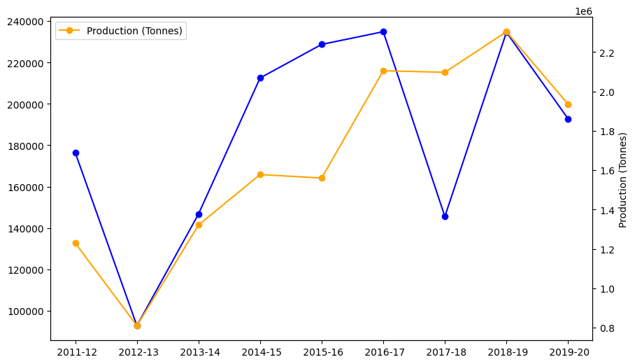

* In 2017-18 Area of sowing is decreasing but Production is not fluctuating because of **Shift in Sowing Season, Favourable Weather Conditions.**
* Farmers might have shifted onion cultivation to the Kharif (monsoon) season from the traditional Rabi (winter) season. This is due to the development of high-yielding Kharif onion varieties that are more resistant to pests and diseases. While the sown area in Rabi might have decreased, the Kharif cultivation could have compensated for it to some extent.

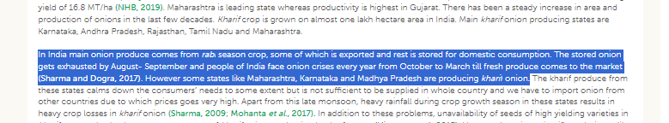

1. **market arrivals of onions in 2022 and 2023 Comparison**

* This Analysis for i am using dataset-2 which in all state all APMC Onion Market Arrival data of 2022 and 2023.This data through i am plotting Bar plot for visuling analysis of onion market position state wise.
* Chart shows highest onion share is covered by Maharashtra, and easily shown on graphs 2022 and 2023 Onion Market Arrival in around 6 lakh tones difference means high supply in market from 2023 is compared to 2022. So, 2023 in price is less compared to 2022.

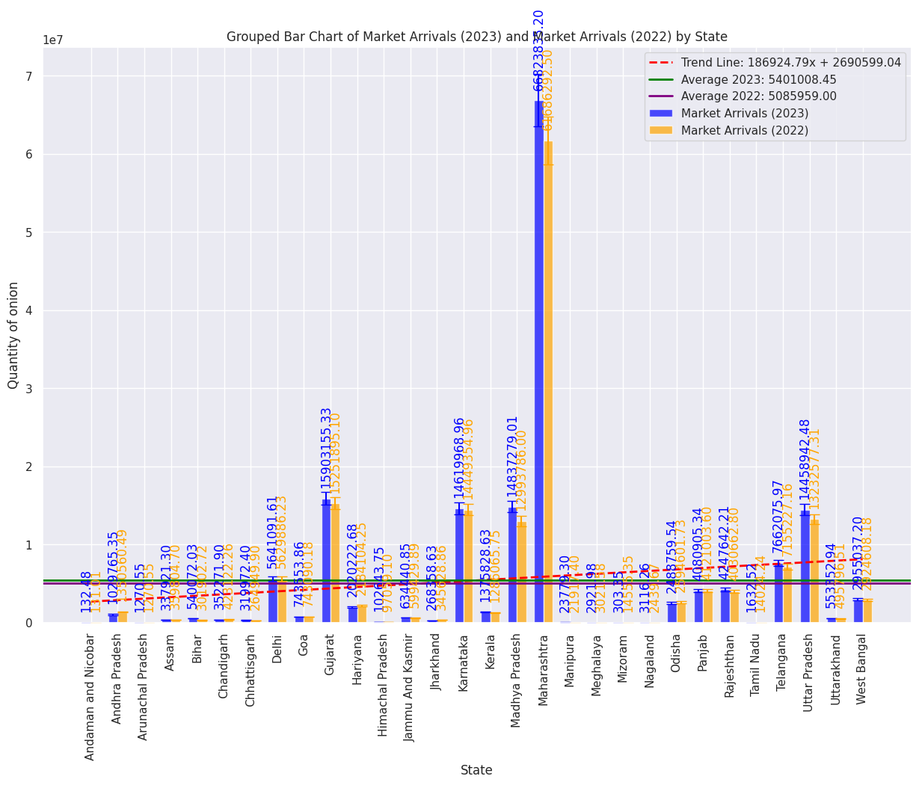

1. **onion prices from January 2023 to January 2024 trend**

* This analysis for i am using dataset 3 for analysis of 2023 to 2024 Onion price flution state wise.
* This analysis for i am using only top Onion Producing State. So, make a new dataframe and draw a graph price(quintal ) and time series data.
* **Claim:-1**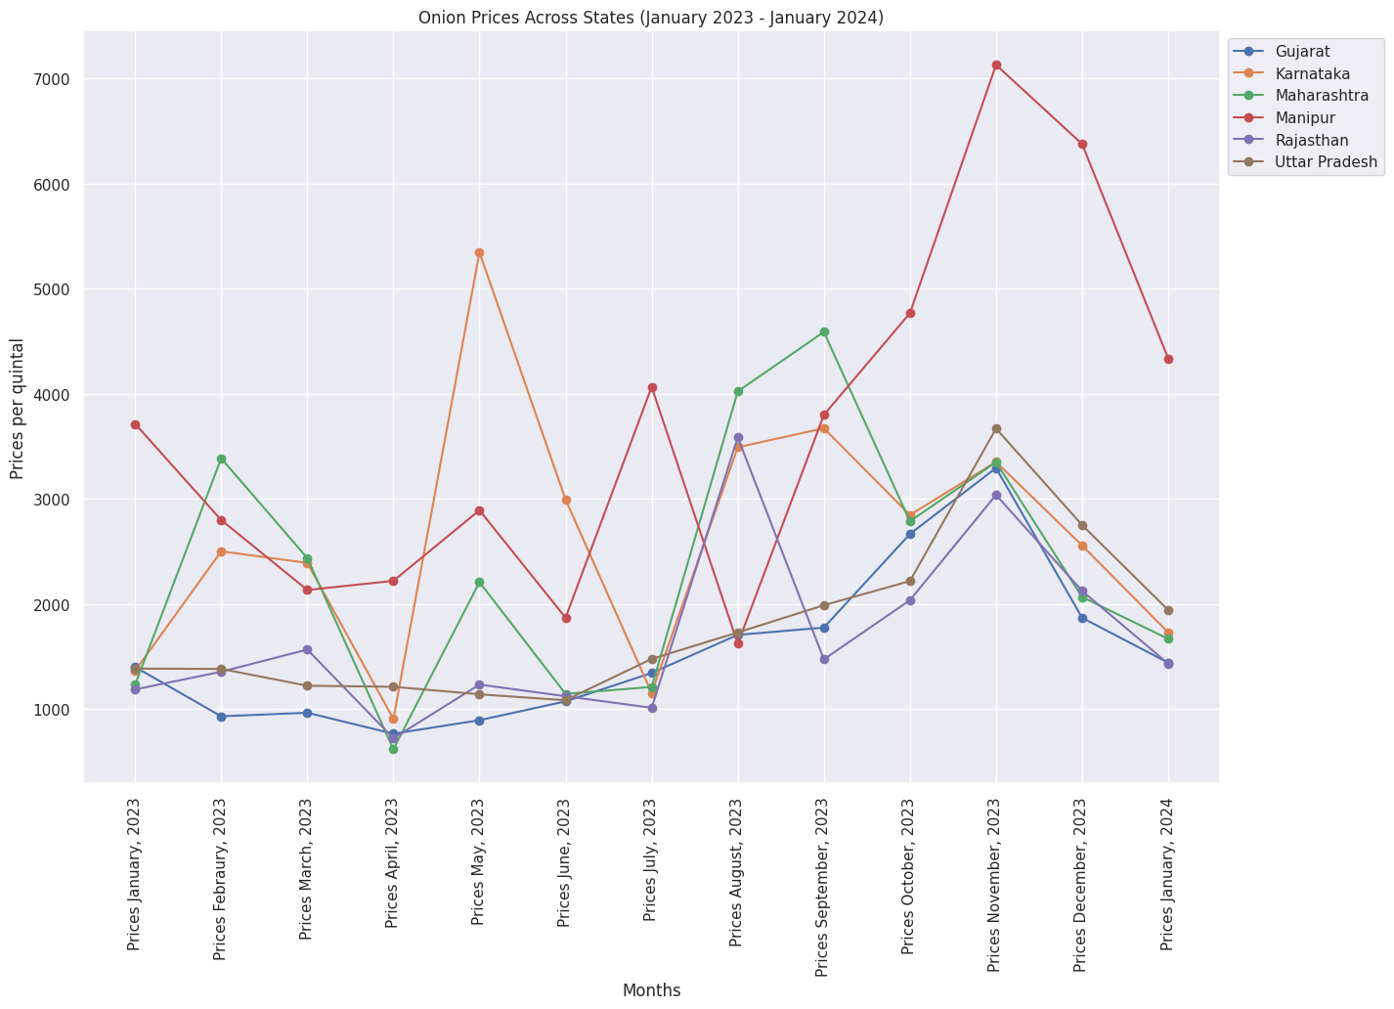
* Claim 1 reason is shown in the graph where November Month in Price Suddenly increased because of November in Maharashtra offseason heavy rain. So, heavy damage in the kharif Onion crop, Therefore market supply is decreasing, so the price increases drastically.
* Also Manipur is an Eastern State of India with highly sloppy roads. Therefore transportation facilities are not good so, price increase as well as bad weather also affect. **So, claim-1 is True.**

1. **Predicted prices for the after few months of onion based on Historical data (ARIMA) Model**

* This analysis for i am using dataset 3 for analysis of 2023 to 2024 Onion price flution state wise.
* This analysis used one time only one state in Onion price are predicted
* **Claim:-2**
* Claim 2 is ban on export of Onion till March,2024. That Government action's main reason is to reduce market price fluctuation of Onion in India and store the fiscal commodity for storage in use.That is to make a model fit on Historical data of past Year of Onion Wholesale prices.Graphs in Easily show after some time line of graph is made constant that time price reduces flution. This is claim-2 Answer.
* So called **claim-2 is True step of the Government of India.**

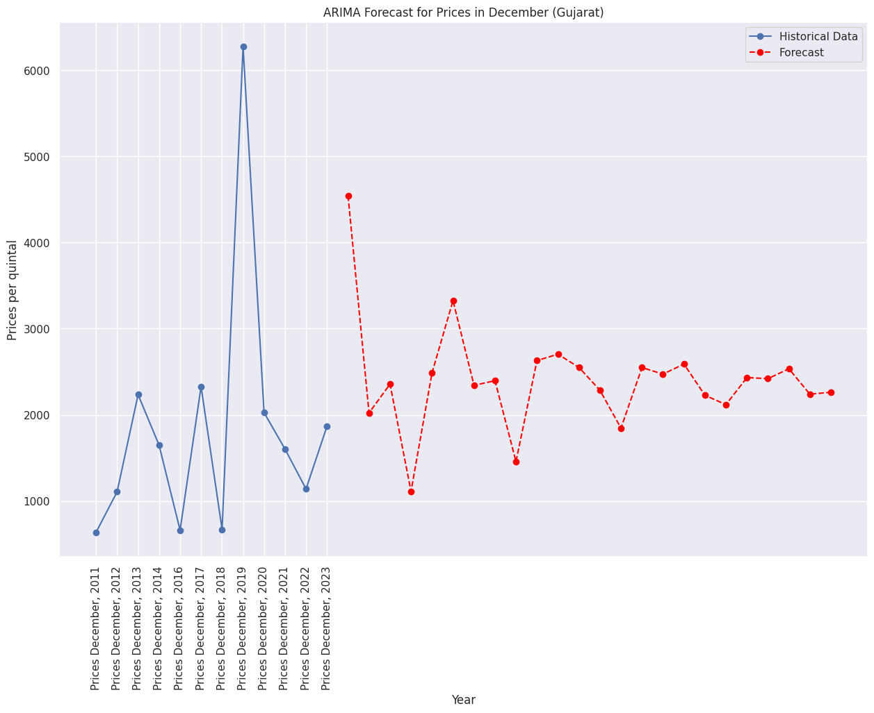

**4. Conclusions:**

* According to all Dataset Analysis Onion Historical as well as Future Market Price.
* Dataset-2 represents market Arrival quantity of Onion. So, analysis market Demand and Supply chain of Onion
* My data does not give perfect Claim-2 is True .
* ARIMA models in one time only one State are fit. So, one time one state price will be predicted.
* As per my Dataset-1 I conclude that there are missing 2020 to 2023 Area of sowing and production data whenever predict accure price.

**Reference**

1. **Dataset-1** Onion 2011 to 2020 Area_of_sowing and Production

<https://aps.dac.gov.in/APY/Public_Report1.aspx>

1. **Dataset-2** 2022 to 2023_onion_MARKET_Arrivel_and_it_precentage

<https://agmarknet.gov.in/PriceTrends/SA_TotalArrival.aspx>

1. **Dataset-3** 2011 to 2023 State wise Wholesale Prices Monthly Analysis

<https://agmarknet.gov.in/PriceTrends/SA_Pri_Month.aspx>

1. **NEWS Article**

* **Why have onion prices crashed in the past three weeks?**

<https://economictimes.indiatimes.com/news/economy/agriculture/why-have-onion-prices-crashed-in-the-past-three-weeks/articleshow/106482389.cms?utm_source=contentofinterest&utm_medium=text&utm_campaign=cppst>

* **Rabi onion sowing falls by 10-15% in main producing regions**

<https://economictimes.indiatimes.com/news/economy/agriculture/rabi-onion-sowing-falls-by-10-15-in-main-producing-regions/articleshow/106676142.cms>

# **Govt procures 25,000 tonnes of kharif onion so far for buffer stock**

<https://economictimes.indiatimes.com/news/economy/agriculture/govt-procures-25000-tonnes-of-kharif-onion-so-far-for-buffer-stock/articleshow/106455794.cms>