Troubleshooting Networking (Lab C)

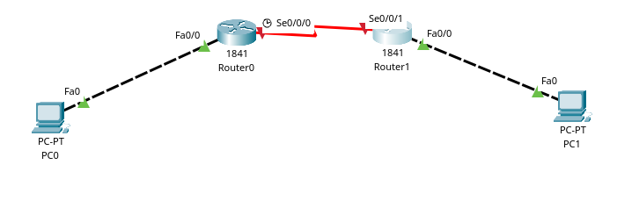

Use commands like **show run, show ip int brief and show ip route** to assist you in troubleshooting the routers.

* Fill in the table by entering the IP addresses for each device:

|  |  |  |  |  |
| --- | --- | --- | --- | --- |
| **Device** | **Interface** | **IP Address** | **Subnet Mask** | **Gateway** |
| Router0 | F0/0 | 1.0.0.1 | 255.0.0.0 | N/A |
| S0/0/0 | 2.0.0.1 | 255.0.0.0 | N/A |
| Router1 | F0/0 | 3.0.0.1 | 255.0.0.0 | N/A |
| S0/0/0 | 2.0.0.2 | 255.0.0.0 | N/A |
| PC0 | NIC | 1.0.0.2 | 255.0.0.0 | 1.0.0.3  1.0.0.1 |
| PC1 | NIC | 3.0.0.2 | 255.0.0.0 | 2.0.0.1  3.0.0.1 |

* What are the routers’s hostname? How would you fix it to reflect what the diagram above say?
* The routers did not have a set host name to fix this I entered hostname Router0 and hostname Router1 to the respective routers giving it a hostname
* Are the IP addresses on the devices correct including the Gateway? What would you need to do to fix this?
* The gateways for PC0 and PC1 were incorrect
* PC0 had a gateway of 1.0.0.1 when the correct gate way is 1.0.0.3
* PC1 had a gateway of 3.0.0.1 when the correct gateway is 2.0.0.1
* to fix this I went into the ip configuration of the PCs and changed the gateway to the correct ones
* Are the links connected to the right ports? If not, how would you fix this?
* The serial cables between router 0 and 1 are not correct this is fixed by unplugging the port and plugging it into the correct port s0/0/0
* Examine the RIP statements. Do all routers have it and if not, what would you need to do to fix this up.
* Both routers did not have it to fix it I added a RIP statement advertising the correct IP address on version 2
* I did this by typing into the routers
* Configure terminal
* Router rip
* Version 2
* And adding the correct IPs

**Your intention is troubleshoot the design above to get it to work. Once complete, show your teacher to mark you off.**