

ESOFT Metro Campus
School of Computing
Bachelor of Information Technology Honours
Batch 03 - Level 03 – Semester 02
ECU3307 – Wireless Network
Assignment 01

Time Allowed: 2 weeks March 2025

WLAN site survey and analysis

Objectives: (100 Marks)

Conduct a WLAN site survey and collect data on available wireless networks. Analyse the wireless network performance based on the data collected. Produce a floor plan with survey data and write a report on your findings, including an analysis of channel occupancy, signal attenuation, interference, and other relevant aspects.

Scenario:
You will perform a WLAN site survey in specified area or floor (e.g. Campus) if it satisfies a few conditions (see ‘Assignment Requirements’ below). Using a Wi-Fi-enabled laptop (or smartphone), collect data from locations in the area using a WLAN sniffing tool (see ‘Tools’ below). Your analysis should cover technical characteristics of the detected wireless networks, including channel usage, signal strength, and more.

Assignment Requirements:
-Cover an area of at least 110 square meters (e.g., 11x10 meters, or any combination of dimensions).
-The area (floor plan) should include walls, doors, and other obstacles to depict the environment's effect on the wireless signal.
-Use a Wi-Fi sniffing tool to survey the area (see ‘Tools’ below).
-The survey must identify at least three (03) Access Points (APs). These APs can be inside your area but can also include neighbours’ APs. (If you want, you can create an additional AP with a phone- using personal hotspot or tethering features).
-Using the Wi-Fi sniffing tool, you should collect data from at least eight (08) different locations in the area.
-For each location, record the technical characteristics of all visible APs such as SSID (Network Name), MAC address of each AP, Signal strength (RSSI), 802.11
protocols supported (e.g., 802.11n, 802.11ac), frequency band: 2.4 GHz or 5 GHz, channels in Use, etc. Provide screenshots from the Wi-Fi tool at each of the eight survey locations.

Deliverables:
In your report, include,
1.Floor Plan Map: A simple floor plan showing the survey area. Include survey locations and approximate positions of the Access Points (APs).
2.Data Visualization: maps that show various WLAN characteristics, such as: Signal strength variations across the survey locations, channel usage or frequency band distribution, mark the locations of APs (based on signal strength or observation).
3.Screenshots: Eight screenshots from the WLAN sniffing tool showing data collected at each survey location.
4.Analysis: Analysis based on the following (and other) aspects:
-Channel Occupancy: Analyse channel usage and possible interference.
-Signal Attenuation: Discuss how signal strength changes across different locations.
-Optional Aspects: Coverage, Interference, Roaming, AP Placement, Upload/Download Speed, etc.
-Include technical explanations with diagrams supporting your findings.

Tools:
You may use one of the following Wi-Fi sniffing tools based on your operating system:
-Windows: Acrylic Wi-Fi (https://www.acrylicwifi.com/en/)
-Mac OS / Windows: NetSpot (https://www.netspotapp.com)
-Linux: LinSSID or wavemon
-Android: Wi-Fi Analyzer
-Note for iOS users: iPhones will not provide sufficient detail for this assignment. Please use another device or contact your instructor for alternatives.

Evaluation Criteria
-Floor Plan and Survey Locations: Clarity and accuracy of the floor plan and survey locations.
-Data Collection: Completeness and accuracy of the recorded technical characteristics for each AP.
-Data Visualization: Quality of maps showing wireless network characteristics such as signal strength and channel usage.
-Channel Occupancy Analysis: Depth of analysis regarding channel usage and interference.
-Signal Attenuation and Strength Analysis: Assessment of how the environment affects signal strength.
-Additional Aspects: Exploration of optional topics such as roaming, AP placement, coverage, or speed tests.
-Technical Explanations and Diagrams: Use of technical details and diagrams to support your analysis.

Criteria | Excellent (Full Marks) | Good (Partial Marks) | Needs Improvement (Few Marks) | Poor (No Marks) | Marks
1. Floor Plan and Survey Locations. | Floor plan is clear, accurate, and meets the 110m² requirement. Survey locations (8) and AP positions are properly marked. | The floor plan is included but lacks details, missing some survey locations or AP positions. | Incomplete floor plan or unclear survey locations and AP positions. | No floor plan, survey locations, or AP positions. | /20
2. Wi-Fi Data Collection and Accuracy. | Screenshots from 8 survey locations, all technical characteristics (SSID, MAC, RSSI, protocols, frequency, channels) are correctly recorded. | Some missing data points or unclear screenshots, minor inaccuracies in recorded values. | Incomplete data from survey locations, missing key Wi-Fi characteristics. | No screenshots or missing most required data points. | /25
3. Data Visualization and Interpretation. | Clear visualizations of signal strength, channel usage, and AP locations. Effective use of charts/maps. | Some visualizations provided, but missing details or clarity in presenting data. | Poorly structured or unclear visualizations with minimal analysis. | No visualizations or charts provided. | /20
4. Analysis and Technical Justification. | Strong analysis of channel occupancy, interference, and signal attenuation. Additional insights on coverage, roaming, AP placement, or speed tests. Uses technical explanations and diagrams. | Adequate analysis but lacks depth or technical details in one or more areas. Limited use of diagrams or explanations. | Basic analysis with minimal insights, lacks supporting evidence. | No analysis or incorrect technical explanations. | /25
5. Report Quality and Presentation. | Well-structured, professional, clear writing, proper formatting, and excellent integration of visuals. | Mostly well-organized, but some sections lack clarity or formatting consistency. | Poor structure, grammar issues, and weak integration of visuals. | Disorganized, difficult to read, or unprofessional presentation. | /10

END OF ASSIGNMENT

ESOFT Metro Campus
School of Computing
Bachelor of Information Technology Honours
Batch 03 - Level 03 – Semester 02
ECU3307 – Wireless Network
Assignment 01

Time Allowed: 2 weeks March 2025

WLAN Site Survey and Analysis Report

for ESOFT Metro Campus

Group No: 04
Group Members:
Student ID | Student Name
E180713 | A.M. Danuja V. Adhikari
E180707 | W.A. Pramod Dilshan Jayarathna
E169640 | Sithmi Shamasha Ramanayaka
E145267 | A.M. Aruni Wathsala

Acknowledgement
We would like to express our sincere gratitude to Mr. Niroshan Dhananjaya, module lecturer for the Wireless Network, for his invaluable guidance and support throughout the analysis and site survey. As students, we are grateful for his insights and expertise that have been instrumental in the completion of this report.
We would like to extend further our thanks to everyone who has contributed to this study, who have offered their time, support, and assistance.

Table of Contents

1. Introduction to the WLAN Survey 9
2. Methodology 11
3. Floor Plans and AP Assignments 12
3.1. Ground Floor 12
➢ Floor Plan 12
➢ Survey Data and Observations 12
➢ Data Visualization 13
3.2. First Floor 15
➢ Floor Plan 15
➢ Survey Data and Observations 16
➢ Data Visualization 16
➢ Analysis and Recommendations for both Ground and 1st Floor 18
3.3. Second Floor 22
➢ Floor Plan 22
➢ Survey Data and Observations 23
➢ Data Visualization 23
➢ Analysis and Recommendations 24
3.4. Third Floor 28
➢ Floor Plan 28
➢ Survey Data and Observations 29
➢ Data Visualization 29
➢ Analysis and Recommendations 30
3.5. Fourth Floor 34
➢ Floor Plan 34
➢ Survey Data and Observations 35
➢ Data Visualization 35
➢ Analysis 36
➢ Recommendations 36
3.6. Fifth Floor 40
➢ Floor Plan 40
➢ Survey Data and Observations 41
➢ Data Visualization 41
➢ Analysis 42
➢ Recommendations 42
3.7. Sixth Floor 47
➢ Floor Plan 47
➢ Survey Data and Observations 48
➢ Data Visualization 48
➢ Analysis 49
➢ Recommendations 49
3.8. Eight Floor 54
➢ Floor Plan 54
➢ Survey Data and Observations 55
➢ Data Visualization 55
➢ Analysis 57
➢ Recommendations 57
Conclusion 61

Introduction to the WLAN Survey
The primary purpose of this WLAN site survey is to examine the efficiency of the wireless network at the ESOFT Metro Campus located on de Fonseka Lane, Colombo 04. The investigation will collect and analyze data for consideration of WLAN coverage, connectivity, and reliability improvement.
Objectives of the Report
- Conduct a WLAN site survey of the selected locations of the ESOFT Metro Campus.

- Scan for wireless networks with the Wi-Fi scanning utilities on selected locations on each level.

- Analyze wireless network performance based on the collected data, addressing aspects such as channel occupancy, signal attenuation, interference, and coverage.

- Provide a clear analysis with images such as floor plans and heat maps.

- Include steps that should be taken for further improvement of the network.

Survey Area
The experiment was conducted at the ESOFT Metro Campus, a nine-storey building with numerous facilities for administration and teaching. The chairman's offices and other members' offices on the 7th floor and the 9th-floor cafeteria were excluded from the experiment. All the remaining floors were covered in the experiment, which has numerous varied spaces such as the classrooms, reception, and administrative offices. There will be walls, doors, and other obstructions on each floor that will serve the purpose of demonstrating the behaviour of the signals and the weakening of the signals.

Methodology

The following tools were used for the WLAN site survey.
- Acrylic Wi-Fi Analyzer: The software searches for and receives information on available wireless networks.
- Acrylic Wi-Fi HeatMap: Displays the intensity and breadth of the wireless signals throughout the zone that was covered.
- EDrawMax Diagramming Software: Utilized to create concise and comprehensive floor plans to visualize how spaces appear
- Microsoft Excel: Utilized for the correct documentation and organization of the data obtained.

Research Background
The ESOFT Metro Campus building consists of seven floors. The 7th and the 9th floors could not be incorporated into the survey because the 7th floor is reserved for the chairmen's offices and the 9th floor is reserved for the cafeteria, according to the assignment. All the floors covered by the survey had a minimum of 110 square meters of area, which was the minimum required for the assignment. The walls, doors, and furniture were considered during the survey, and the impact of these on wireless signals.

Methods of Obtaining Information
The measurements were made at eight locations for each site for the purpose of ensuring that everything was documented. The shared access points at all locations were also documented.

Floor Plans and AP Assignments

Ground Floor

Floor Plan
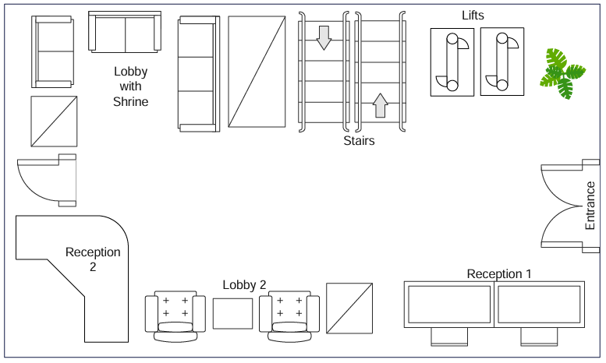
The below floor plan is both the entrance and the exit of the university where it has the security checks, lobby areas, the shrine and a door that leads to the car park
Figure 1: Ground Floor Plan

Survey Data and Observations
The following table indicates the output of the WLAN site survey from locations around the ESOFT Metro Campus building by floor, where it provides significant information on the Access Points, such as SSID, MAC address, RSSI (signal strength), supported protocols, frequency bands, and utilized channels. All these helps to analyze the performance of the network, such as the usage of channels, variation of the strength of the signals, and potential interference zones. These results will be analyzed and recommended.
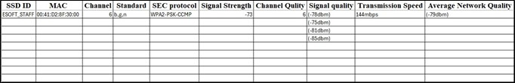
Ground Floor MAC Address:- 00:41:D2:8F:30:00
Figure 2: Survey Details_Ground Floor

Data Visualization
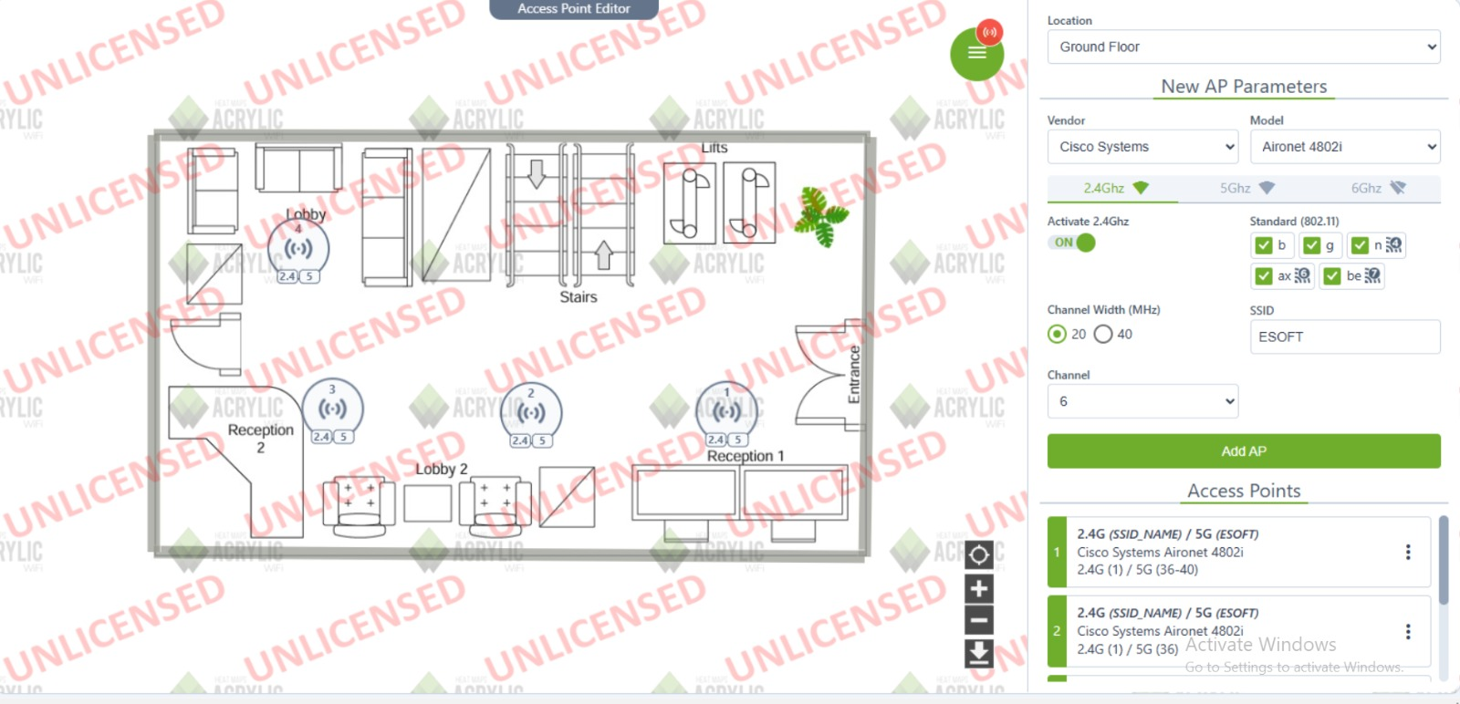
To give a better understanding of the WLAN Performance we had surveyed, we prepared a set of charts from the data that we gathered:
Figure 3: Access Point Assign_Ground Floor

Access Point Configuration:
- Location: Ground Floor
- Vendor: Cisco Systems
- Model: Aironet 4802i
- Frequency Bands: 2.4 GHz (selected), 5 GHz, 6 GHz
- Activation: 2.4 GHz is ON
- Standards: 802.11 b, g, n, ax, be (selected)
- Channel Width: 20 or 40 MHz (selected)
- SSID: ESOFT
- Channel: 6
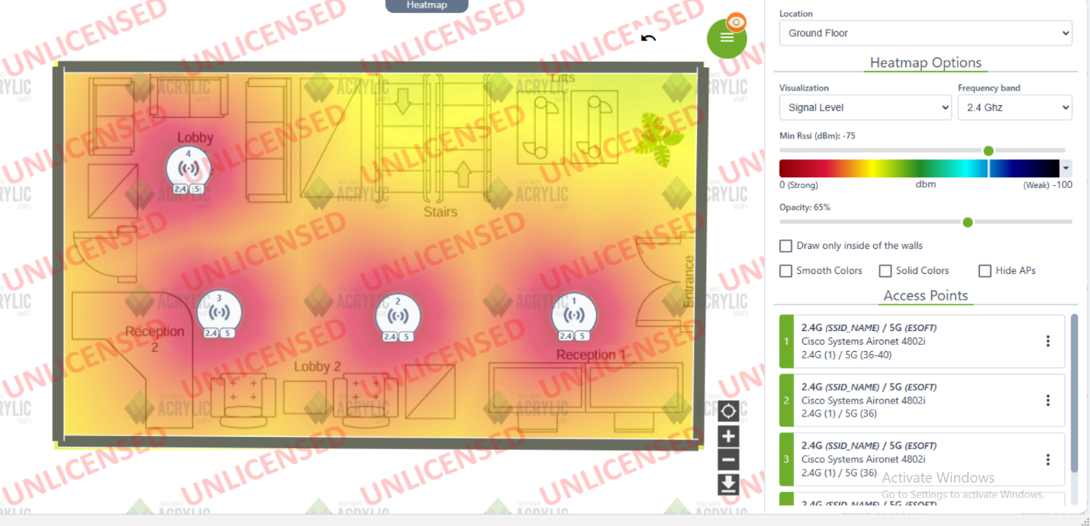
The heatmap shows the distribution of the Wi-Fi strength on ground floor.
Figure 4: HeatMap_Ground Floor

First Floor

Floor Plan
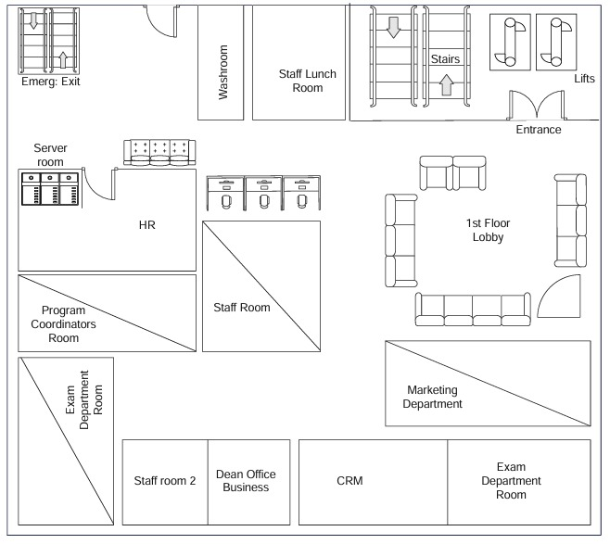
This floor plan represents an organized office space with various functional areas. The entrance leads to a spacious lobby with seating arrangements, providing a welcoming atmosphere. Nearby, there are stairs and lifts for easy access to other floors. The workspace includes different departments such as HR, Marketing, CRM, and Program Coordinators, along with two staff rooms for employees. The Exam Department has two separate rooms, ensuring a dedicated space for academic or certification purposes. Additionally, the Server Room is strategically placed for IT infrastructure management. Essential facilities like a washroom, a staff lunchroom, and an emergency exit contribute to convenience and safety.
Figure 5: 1st Floor Plan

Survey Data and Observations
1st Floor MAC Address: - 00:41:D2:8F:30:00
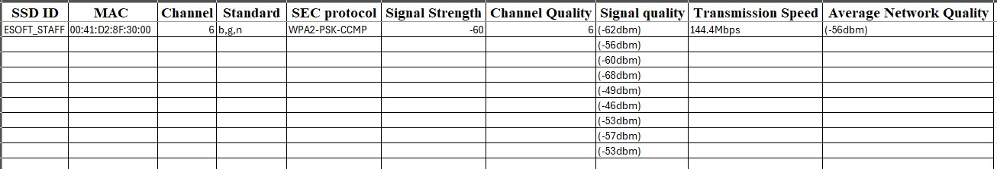
** For both ground and first floors, same MAC Address was used as there were less usage of Wi-Fi on the ground floor than 1st floor, and we have decided to use the same Wi-Fi Access Points for both floors
Figure 6: Survey Details_1st Floor

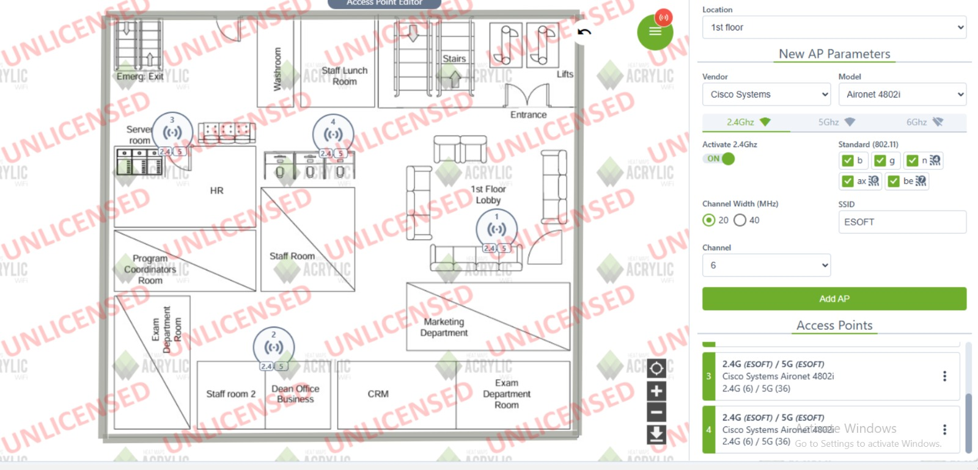
Data Visualization
Figure 7: Access Point Assign_1st Floor

Access Point Configuration
- Location: 1st Floor
- Vendor: Cisco Systems
- Model: Aironet 4802i
- Frequency Bands: 2.4 GHz (selected), 5 GHz, 6 GHz
- Activation: 2.4 GHz is ON
- Channel Width: 20MHz
- SSID: ESOFT
- Channel: 6

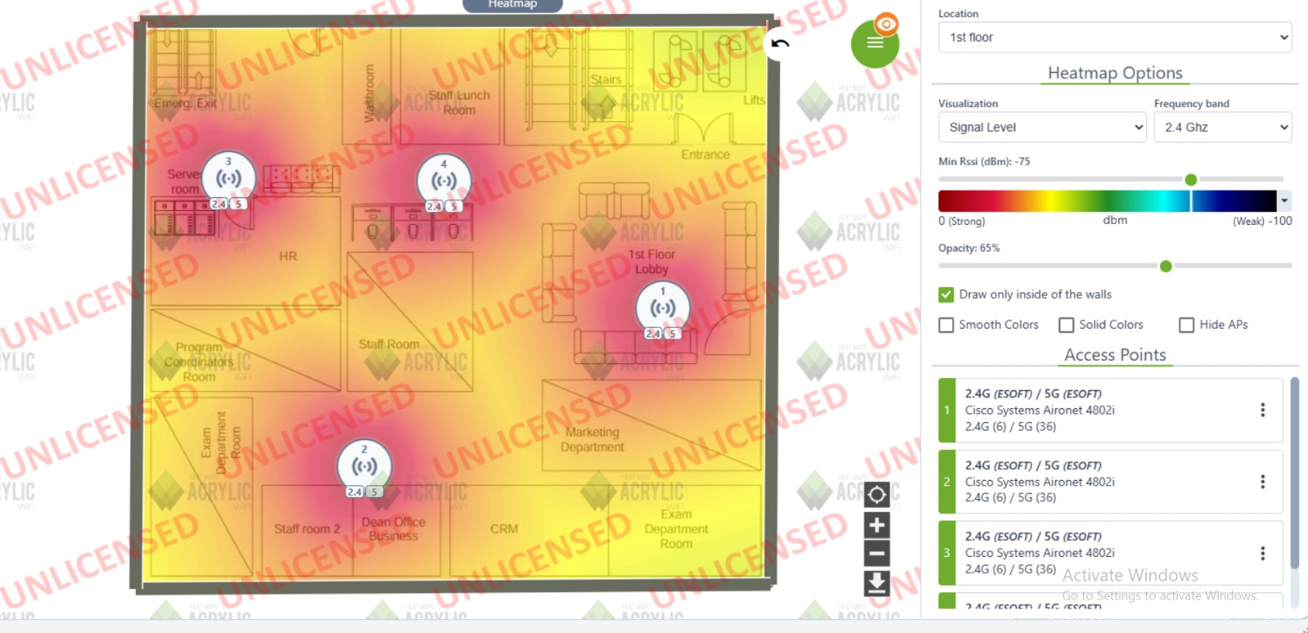
The heatmap shows the distribution of the Wi-Fi strength on ground floor.
Figure 8: HeatMap_1st Floor

Analysis and Recommendations for both Ground and 1st Floor
For both ground and 1st Floor, we have done the analysis and recommendations as both floors have been used the same MAC Addresses of the same SSID

1. Channel Occupancy & Interference
Analysis
- The 2.4GHz band is congested, particularly on Channel 6, leading to interference.
- Channel 1 remains inactive and offers prospects to decrease traffic congestion in the network.
- Channel 36 on the 5GHz band stands as the most suitable option because the frequency spectrum remains less dense.
Recommendation
- To improve wireless distribution the organization needs to modify 2.4GHz APs to operate with Channels 1, 6 along with 11.
- Users should connect to 5GHz bandwidth whenever technology permits to reduce network traffic.

2. Signal Attenuation
Analysis
- The present signal magnitude reaches -78 dBm which surpasses the recommended range between -50 and -55 dBm.
- The signal quality becomes poor when APs show RSSI measurement of -92 dBm.
- The physical elements within the space are likely to cause degradation of the signal path.

Recommendation
- An improvement in signal quality requires moving access points away from obstacles into areas with clear line of sight.
- To improve poor signal coverage additional wireless access points should be installed strategically.
- When possible, you should raise the transmission power settings for AP devices.

3. Coverage & Dead Zones
Analysis
- The areas where radio signal strength indicator falls beneath -80 dBm have been identified as dead zones.
- Users located in these reception areas encounter unstable signal connections and reduced network speeds.
Recommendation
- Add Wi-Fi extenders together with additional APs in areas with weak signal reception.
- A comprehensive Wi-Fi site survey needs to be performed in order to identify and eradicate dead zones.

4. Roaming & AP Placement
Analysis:
- When a network contains multiple SSIDs clients face difficulties in moving automatically to different access points.
- Handoff efficiency stands as a critical factor because it generates temporary disconnections when moving between different locations.

Recommendation:
- Users will experience better roaming transitions when eliminating difficulties through the implementation of 802.11k, 802.11r and 802.11v features.
- The positioning of AP networks must be readjusted to create continuous signal coverage which ensures uninterrupted roaming.

5. Upload/Download Speed
Analysis:
- Slow signal intensity leads to degraded speeds that reach half the normal speed across impacted areas.

Recommendation
- Users should consider the implementation of Wi-Fi 6 (802.11ax) to improve their speed and operational effectiveness.
- The network should have optimized QoS configuration to give higher priority to essential traffic flows.

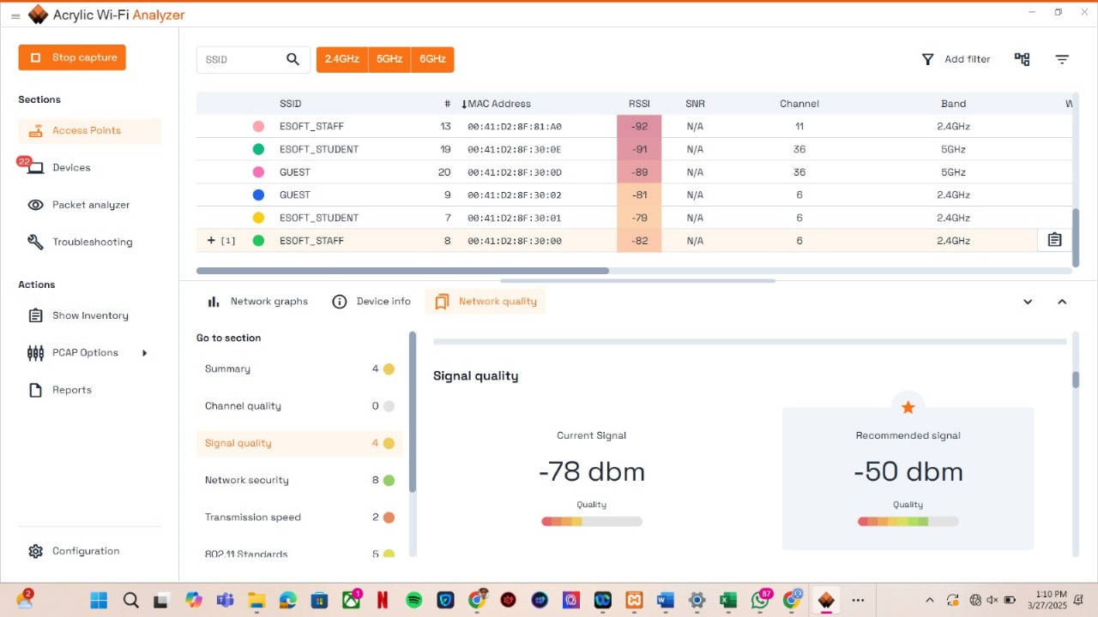
Figure 9: Analysis_Ground and 1st floor

Second Floor

Floor Plan
This floor plan represents the second floor of a building, featuring multiple rooms and essential facilities. There are six rooms labelled E2-1 to E2-6, likely used as offices or workspaces. A Vice Chancellor Room is located near the 2nd Floor Lobby, which is furnished with seating arrangements for visitors or staff. The floor also includes a staff lunchroom, a washroom, and an emergency exit for safety. Additionally, staircases provide access to other floors.
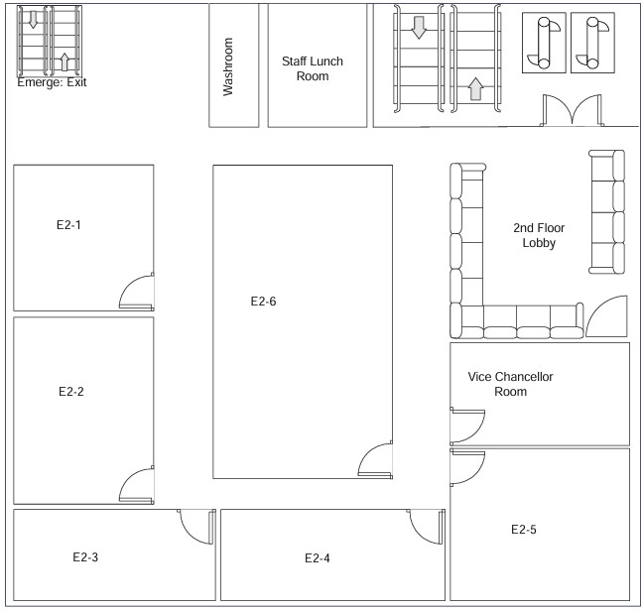
Figure 10: 2nd Floor Plan

Survey Data and Observations
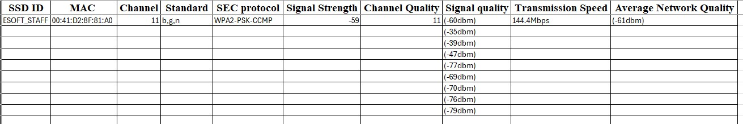
2nd Floor MAC Address: - 00:41:D2:8F:81:A0
Figure 11: Survey Details_2nd Floor

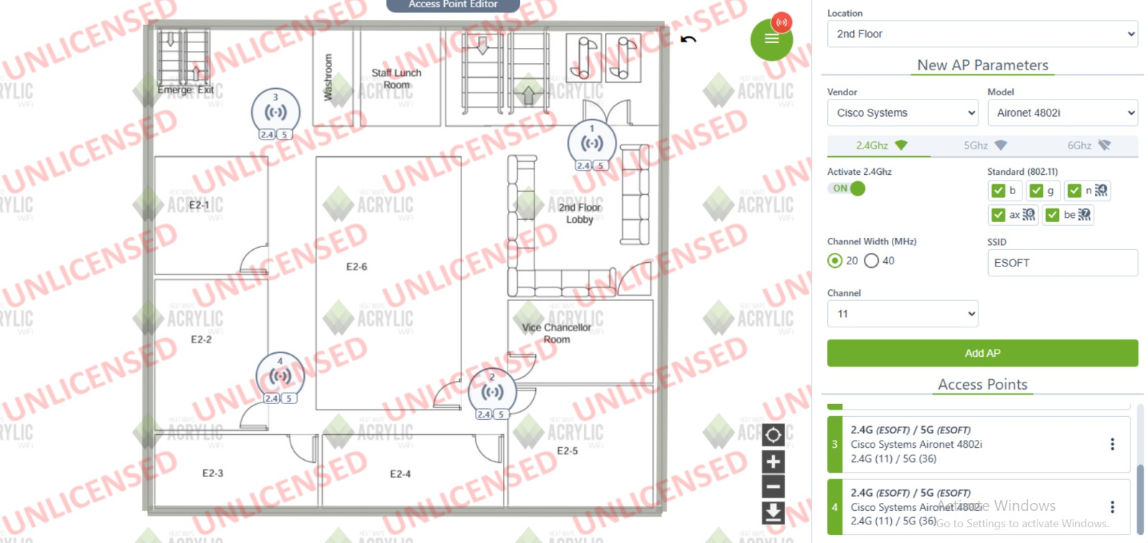
Data Visualization
Figure 12: Access Point Assignment_2nd Floor

Access Point Configuration
- Location: 2nd Floor
- Vendor: Cisco Systems
- Model: Aironet 4802i
- Frequency Bands: 2.4 GHz (selected), 5 GHz, 6 GHz
- Activation: 2.4 GHz is ON
- Channel Width: 20MHz
- SSID: ESOFT
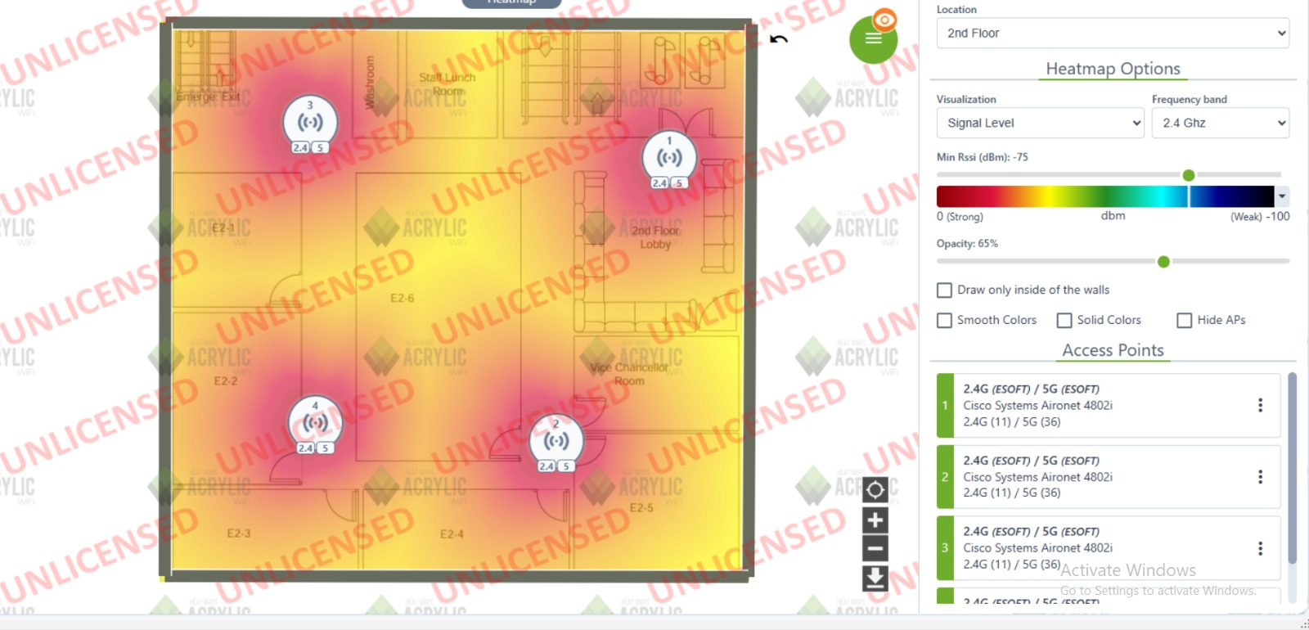
- Channel: 11
Figure 13: HeatMap_2nd Floor

Analysis and Recommendations

1.Channel Occupancy & Interference
Analyze:
- The 2.4GHz frequency band demonstrates heavy traffic because a mix of Access Points uses Channel 1 and 11.
- Channel 12 stands out as the optimal channel for achieving better performance results.
- The invisible status of the 5GHz band suggests the networks lack sufficient systems occupying that frequency range.

Recommendation:
- The device needs to relocate its 2.4GHz Access Points to run on Channels 1, 6 and 11 to achieve load distribution across all channels.
- User connection to the 5GHz band should be promoted because it provides better speed and stability.

2. Signal Attenuation
Analyze:
- The received signal strength indicator covers values from -55 dBm to -78 dBm.
- The network performance improves when the signal strength measures between -51 dBm and -55 dBm on Channel 11.
- The weak -77 dBm and -78 dBm signal strength on Channel 1 indicates the presence of dead zones in that area.

Recommendation:
- Place access points in optimal locations to enhance signal quality.
- You should install Wi-Fi extenders to strengthen weak signal zones.

3. Coverage & Dead Zones
Analysis
- The network performance becomes inadequate when signals drop below -78 dBm.
- The existence of dead zones results in regular interruptions of user connectivity.
Recommendation:
- Low-coverage areas require the deployment of new APs together with network extender units.
- Moving routers to different positions will minimize signal interference that comes from walls and furniture.

4. Roaming & AP Placement
Analysis
- The change between different APs generates slight interruptions that disconnect users temporarily.
Recommendation:
- Enable 802.11k, 802.11r, and 802.11v for seamless roaming.
- Network devices should have efficient AP coverage to perform better handoffs.

5. Upload/Download Speed
Analysis
- Radio signals that are weak will decrease network speeds up to 50% of their potential.
Recommendation:
- New Wi-Fi 6 technology will improve both speed and operational effectiveness of your network.
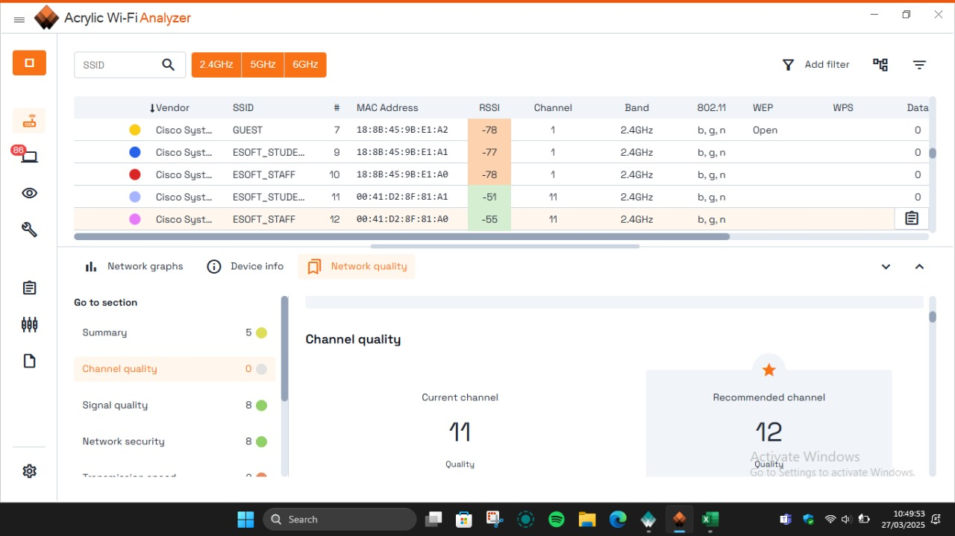
- Noise detection mechanisms should be installed to optimize Quality of Service (QoS) settings which prioritize bandwidth use.
Figure 14: Analysis_2nd Floor

Third Floor

Floor Plan
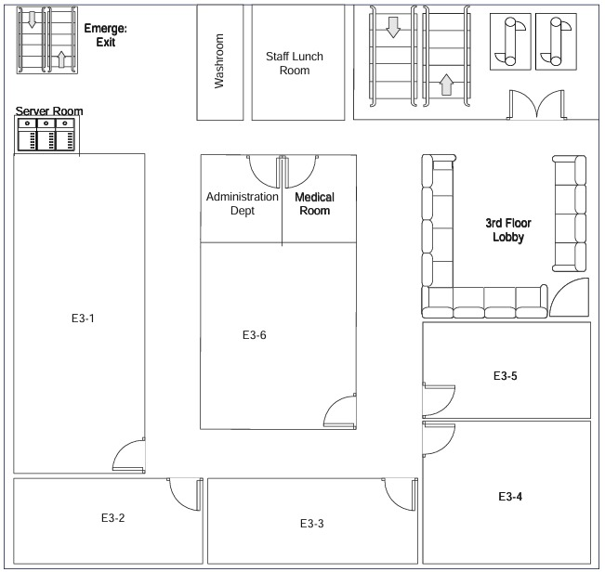
The below flow plan is third floor of the university. Where it has lectures halls, lobby areas, administration dept, medical room, staff lunchroom, server room, washroom and emergency exit.
Figure 15: 3rd Floor Plan

Survey Data and Observations
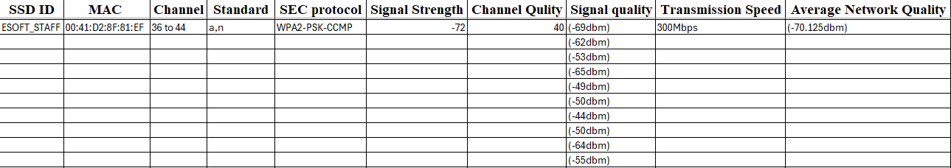
MAC Address: 00:41:D2:8F:81:EF
Figure 16: Survey Details_3rd floor

Data Visualization
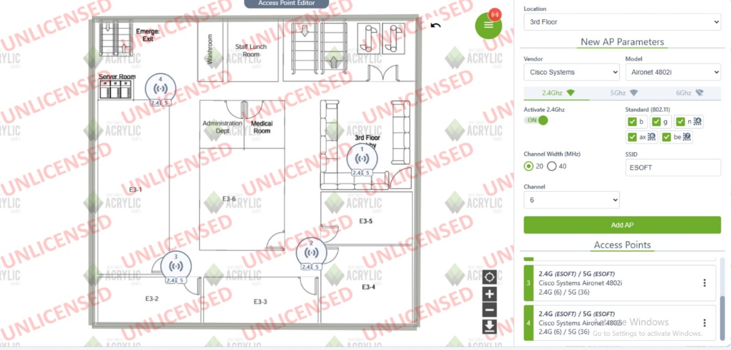
Figure 17: Access Point Assign_3rd Floor

Access Point Configuration:
- Location: Third Floor
- Vendor: Cisco Systems.
- Model: Aironet 4802i
- Frequency Bands: 2.4 GHz (selected), 5 GHz, 6 GHz
- Activation: 2.4 GHz is ON
- Standards: 802.11 b, g, n, ax, be (selected)
- Channel Width: 20 or 40 MHz (selected)
- SSID: ESOFT
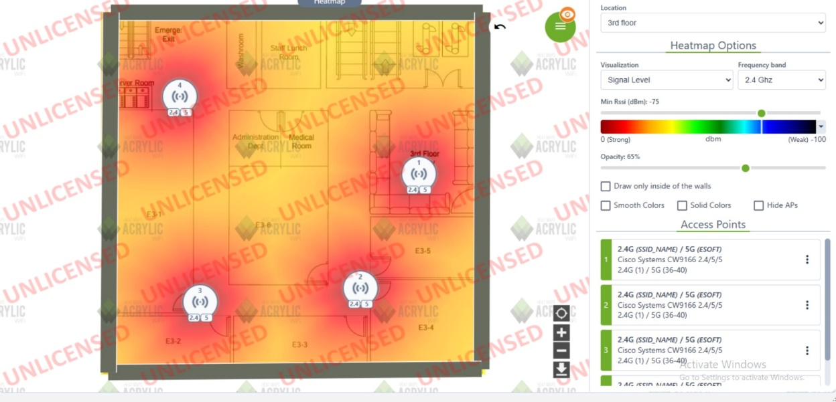
- Channel: 6
Figure 18: HeatMap_3rd Floor

Analysis and Recommendations

1.Channel Occupancy & Interference
Analyze:
- The AP functions within Channel 40 from the 5GHz band because this spectrum generally shows less traffic congestion.
- The absence of visible AP frequency overlaps in the scan reduces the amount of interference in the area.
- Channel 1 and 11 on the 2.4GHz range shows heavy use by other Wi-Fi devices yet 5GHz offers more open frequencies for connection.

Recommendation:
- The 5GHz channel should serve as the primary wireless band for high-speed devices while users must connect to 5GHz networks.
- The combination of Channels 1, 6, and 11 should be used on 2.4GHz to reduce interference.
2. Signal Attenuation
Analyze:
- The wireless signal maintains a moderate strength of -73 dBm.
- The signal strength measures below -50 dBm suggests that interference from walls or distance or radio frequency obstacles may be affecting the reception.

Recommendation:
- To improve reception quality move the AP toward a direct view or make sure everything blocks the signal path.
- The available increase in transmission power should be considered as a potential option.

3. Coverage & Dead Zones
Analyze:
- Some coverage problems are present in the areas where signal quality decreases.
- The 2.4GHz connectivity shows signs of weakness since the registered APs report dual signals of -81 dBm and -82 dBm.

Recommendation:
- The network requires Wi-Fi extenders or mesh systems to address blocked signal parts.

4. Roaming & AP Placement
Analyze:
- Gadgets that transfer between 2.4GHz and 5GHz networks may encounter delayed switching speeds.

Recommendation:
- Provide 802.11k, 802.11r and 802.11v support to optimize wireless client roaming.
- The AP density must be optimized to enable transition without interruptions.

5. Upload/Download Speed
Analyze:
- A 5GHz signal at RSSI -73 dBm provides enough bandwidth for basic browsing and streaming when improved to higher levels would be better.
- Strong signals on 2.4GHz RSSI should reach above -81 dBm and -82 dBm for consistent speed performance.

Recommendation:
- Prioritize 5GHz for high-speed devices.
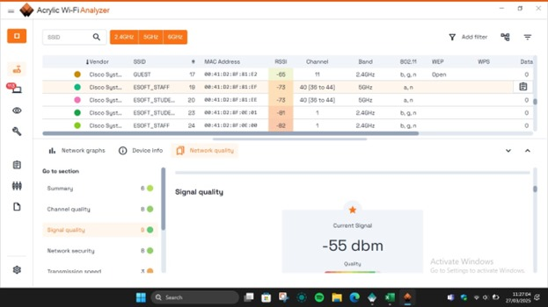
- Choose Wi-Fi 6 as an upgrade option when handling numerous connected devices.
Figure 19: Analysis_3rd Floor

Fourth Floor

Floor Plan
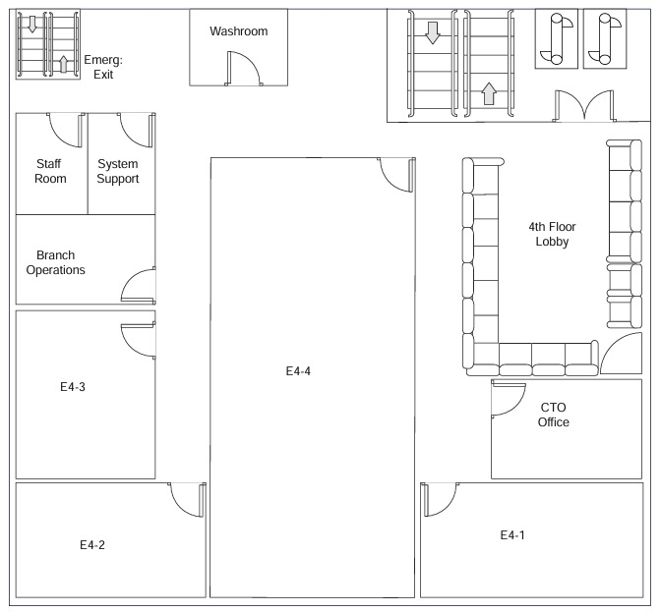
The below floor plan is fourth floor in university. Where it has the lectures halls, CTO office, fourth floor lobby, washroom, emergency exit, staff room, system support, branch and branch operations.
Figure 20: 4th Floor Plan

Survey Data and Observations
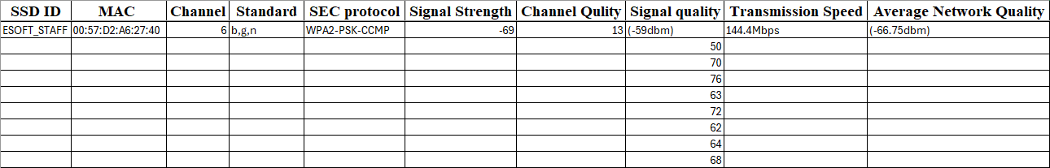
MAC Address : 00:57:D2:A6:27:40
Figure 21: Survey Details_4th Floor

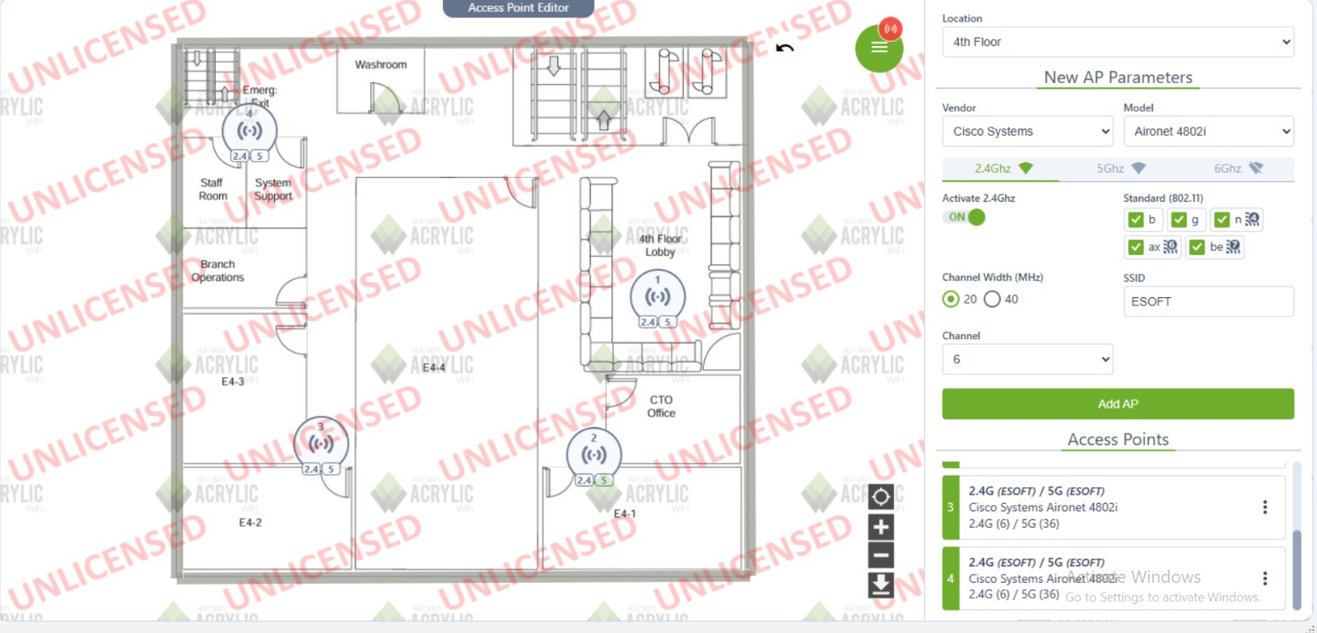
Data Visualization
Figure 22: Access point Assign_4th floor

Access Point Configuration:
- Location: Fourth Floor
- Vendor: Cisco Systems.
- Model: Aironet 4802i
- Frequency Bands: 2.4 GHz (selected), 5 GHz, 6 GHz
- Activation: 2.4 GHz is ON
- Standards: 802.11 b, g, n, ax, be (selected)
- Channel Width: 20 or 40 MHz (selected)
- SSID: ESOFT
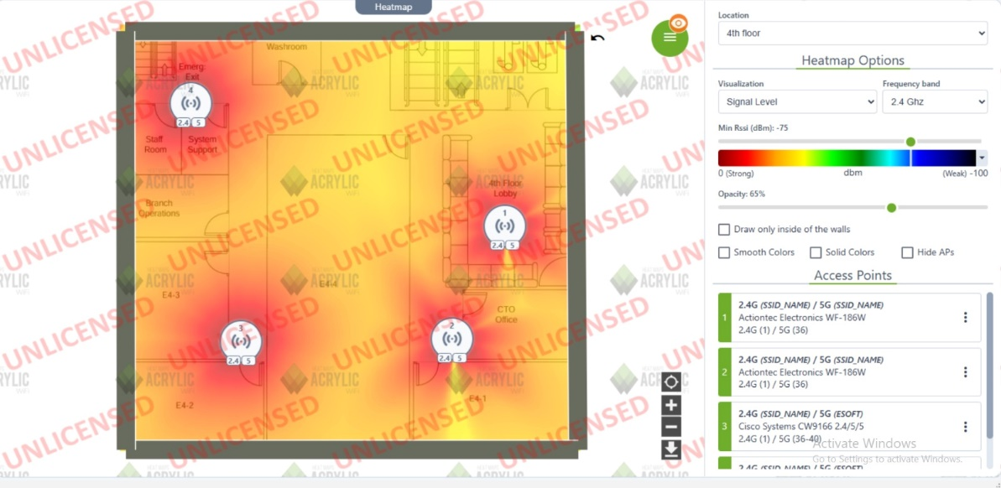
- Channel: 6
Figure 23:HeatMap_4th Floor

Analysis and Recommendations

1. Channel Occupancy & Interference
Analysis:
- The displayed networks exist on dual bands using both 2.4 GHz and 5 GHz sections.
- Three non-standard channels 4 and 6 and 9 operate within the 2.4 GHz band thus they present a risk of causing interference.
- The 5 GHz band includes networks on channels 56 and 155 but these channels normally experience fewer interference issues and might collide with adjacent networks.
- When many devices connect to the same channel then users experience slower data speeds and lost packets while experiencing higher delays.

Recommendations:
- The optimal channels for 2.4 GHz operation are channels 1, 6 or 11 because selecting other channels can create cross-interference between networks.
- 5 GHz users should select a channel through automatic channel selection or with the help of Wi-Fi analyzer tools to choose an underutilized channel.
- The user should lower transmission power or select a dual-band router to move network traffic between 5 GHz if interference continues.
2. Signal Attenuation
Analysis:
- The RSSI value measurement scale reaches from -89 dBm (lowest strength) to -68 dBm (medium signal strength).
- The physical barrier of walls together with furniture and distance from the access point (AP) cause signal strength reduction.
- Connections may become unstable for devices operating with -89 dBm reception values.

Recommendations:
- The router should be positioned inside your home where it does not face thick boundaries and metal items.
- Should use both Wi-Fi extenders and mesh systems as signal enhancement tools to overcome strong attenuation in specific areas.
- If possible, switch to a 5 GHz band for better performance in short-range scenarios.

3. Coverage & Dead Zones
Analysis:
- The wireless fidelity signal exhibits diverse intensity levels between the various service set identifiers which implies possible signal range limitations.
- The evidence of dead zones exists when signals register at lower than -80 dBm levels.
- The screenshot lacks a visibility of the coverage display though the signal values hint at possible dead zones.

Recommendations:
- The evaluation of Wi-Fi signal zones through a mapping process will reveal locations with weak reception.
- Install new access points together with mesh Wi-Fi systems to improve network extension capabilities.
- Users should modify their router antenna angles to achieve improved signal distribution across the network.
- Set up powerline adapters to replace poor wireless service when implementation proves ineffective.

4. Roaming & AP Placement
Analysis:
- A network consisting of multiple access points (APs) is evident when multiple SSIDs appear.
- Devices encounter connection drops when roaming setup is incorrect which prevents them from switching to the best AP.
- Unsmooth roaming occurs when APs are set either too close together or too far from each other.

Recommendations:
- Users should have access to fast roaming technology based on 802.11r/k/v standards to experience uninterrupted AP switches.
- Arrange the access points by choosing placement that allows their coverage areas to cross each other but avoids significant signal crossing.
- Network devices should automatically transition to 5GHz for enhanced performance when you enable band steering.

Fifth Floor

Floor Plan
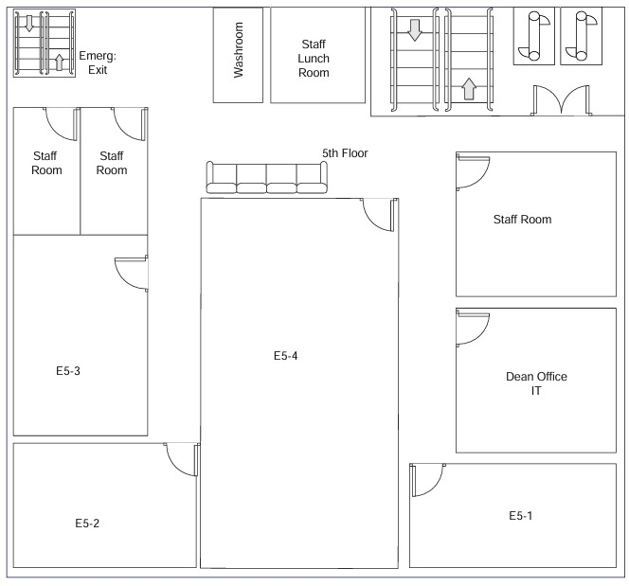
The below floor plan is fifth floor in university. Where it has the lectures halls, staff rooms, staff lunchroom, Dean Office, washrooms and emergency exit.
Figure 24: 5th Floor Plan

Survey Data and Observations
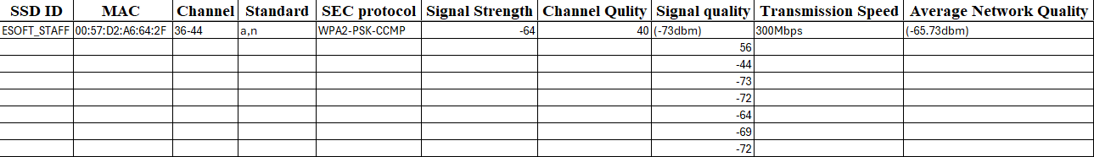
MAC Address : 00:57:D2:A6:64:2F
Figure 25: Survey Details_5th Foor

Data Visualization
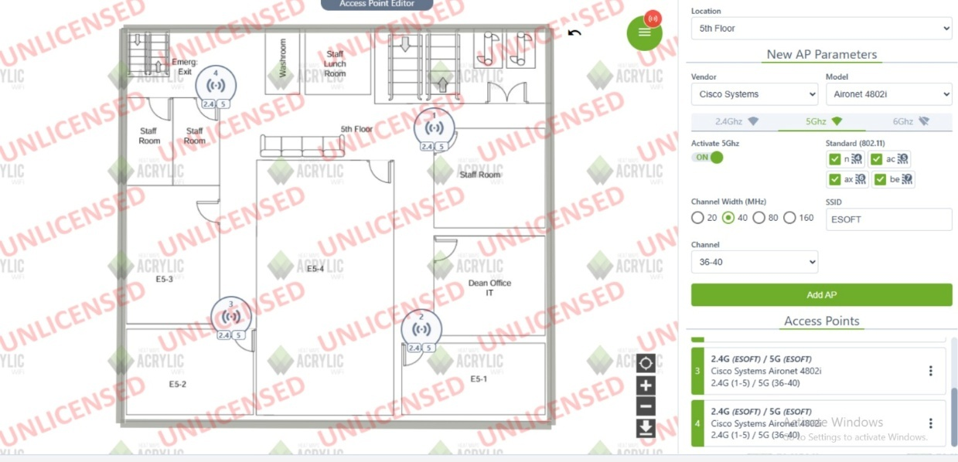
Figure 26: Access Point Assign_5th floor

Access Point Configuration:
- Location: Fifth Floor
- Vendor: Cisco Systems.
- Model: Aironet 4802i
- Frequency Bands: 2.4 GHz (selected), 5 GHz, 6 GHz
- Activation: 5 GHz is ON
- Standards: 802.11 n, ac, ax, be (selected)
- Channel Width: 20,40,80 or 160 MHz (selected)
- SSID: ESOFT
- Channel: 36-40
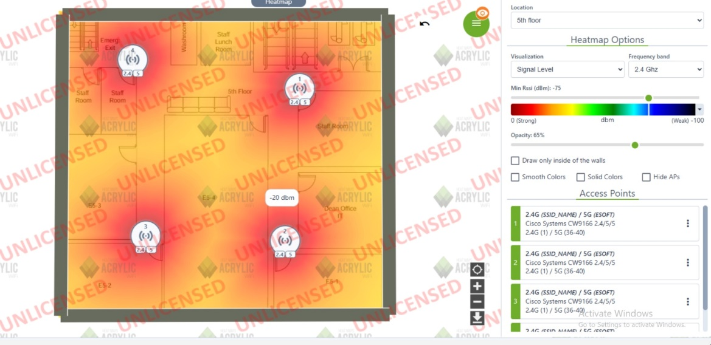
Figure 27: HeatMap_5th Floor

Analysis and Recommendations

1. Channel Occupancy & Interference
Analysis:
- 2.4 GHz band faces network congestion because it operates using the overlapping SSIDs EZVIZ-2.4G, SITREK_AP, DCP_D5A0_0 and DCP_D5A0.
- Hashing issues exist in the 5 GHz frequency range due to ESOFT_STAFF and ESOFT_STUDENT networks using channel 40.
- The Received Signal Strength Indicator (RSSI) values show weak signals on SLT-Fiber-DH2gv-5G since they register at -92 dBm.

Recommendations:
- The consumer should utilize channels 1, 6 or 11 as they are less populated in the 2.4 GHz frequency band to decrease interference levels.
- To mitigate interference between 5 GHz APs administrators should configure them to operate on separate channels selected among 36, 44, 149.
- The co-channel interference could be minimized through implementing 20 MHz and 40 MHz channel widths at 2.4 GHz and 5 GHz respectively.

2. Signal Attenuation
Analysis:
- Most wireless networks in the area have minimal signal power. The wireless signal currently stands at -72 dBm which falls into the weaker signal category.
- The standard -50 dBm signal level for excellent quality indicates that the wireless signals face degradation because of distance and blocking elements.

Recommendations:
- Moving router access points to different positions will help minimize signal loss created by walls and furniture as well as electronic interference.
- To improve signal reception in poorly covered areas you should utilize Wi-Fi extenders together with mesh systems.
- For 5 GHz network users place their wireless device near the router since 5 GHz signals experience more rapid attenuation than 2.4 GHz signals.

3. Coverage & Dead Zones
Analysis:
- Connections experience weak signals because the network has dead zones and coverage problems.
- Network quality indicators display weak performance which backs up the argument for better position of access points.

Recommendations:
- To identify weak spots within the building perform a site survey and install new Access Points where needed.
- The router should be situated at the office center and should avoid being blocked by physical objects.
- Consider implementing Wi-Fi mesh systems together with powerline adapters for coverage areas which do not receive signals.

4. Roaming & AP Placement
Analysis:
- The network contains three access points named ESOFT_STAFF, ESOFT_STUDENT, and DCP_D5A0 but their wave bands and signal output levels cannot guarantee uninterrupted roaming connections between them.
- The devices experience poor performance during switching because they fail to change access points properly.

Recommendations:
- Devices should use band steering which adjusts their 5 GHz or 2.4 GHz connection according to signal quality.
- Apertures that provide multiple wireless access points must enable the 802.11k, 802.11r, 802.11v specifications for seamless device roaming.

- AP transmit power levels need adjustment to eliminate unnecessary interference zones between access points.

5. Upload/Download Speed
Analysis:
- The network speed might be affected because the current RSSI and SNR measurements are unsatisfactory.
- The strong channel congestion in the 2.4 GHz band seems to decrease the speed of wireless connections and promote higher delay rates.
- The 5 GHz network delivers faster internet but still experiences weak signal transmission.

Recommendations:
- Make 5 GHz channels reserved for devices that require fast internet throughput including streaming and gaming systems.
- The network performance improves by cutting down the number of devices connected to the same channel.
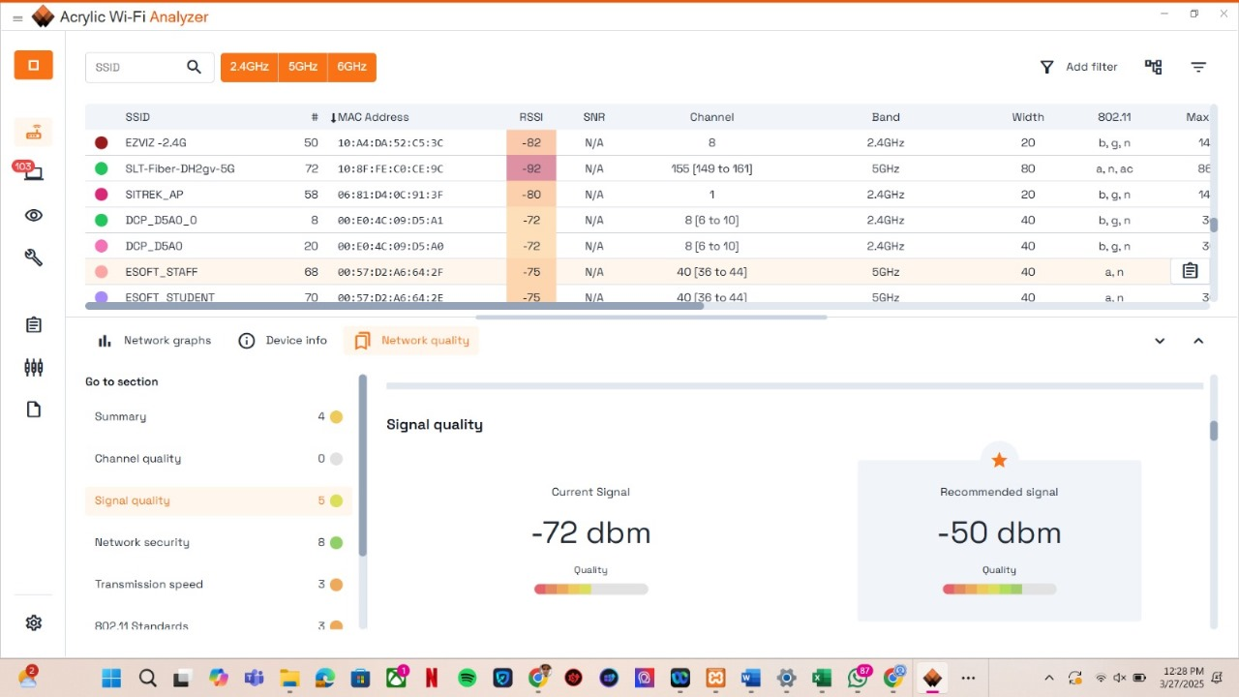
- The network needs better performance which can be achieved by replacing the current router with a Wi-Fi 6 (802.11ax) model.
Figure 28: Analysis_5th floor

Sixth Floor

Floor Plan
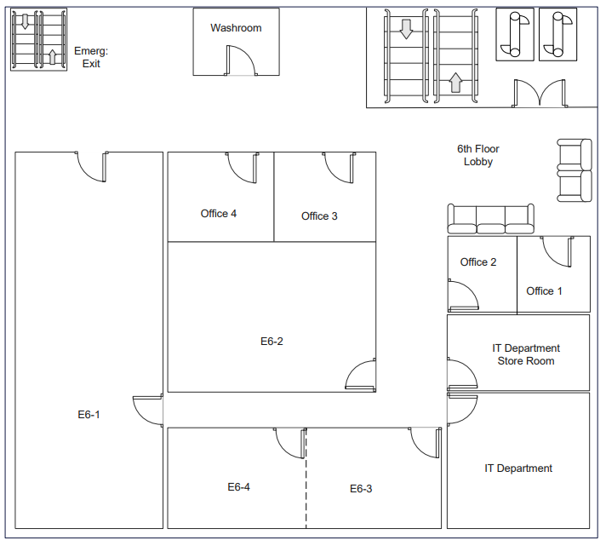
The 6th Floor layout ensures efficient flow with clear access points. The Exit is at the top-left for quick evacuation, with an Emergency Exit and Washroom nearby. The Lobby, in the top-right, connects to multiple offices and workspaces. Offices 1 and 2 are in the bottom right, while Offices 3 and 4 are near the top-left, across from the IT Department. The IT Department, along with its Storeroom, is in the bottom-right. Workspaces E6-1 to E6-4 are centrally located for flexible use.
Figure 29: 6th Floor Plan

Survey Data and Observations
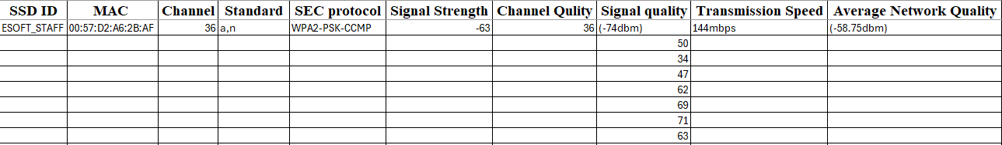
MAC Address : 00:57:D2:A6:2B:AF
Figure 30: Survey Details_6th Floor

Data Visualization
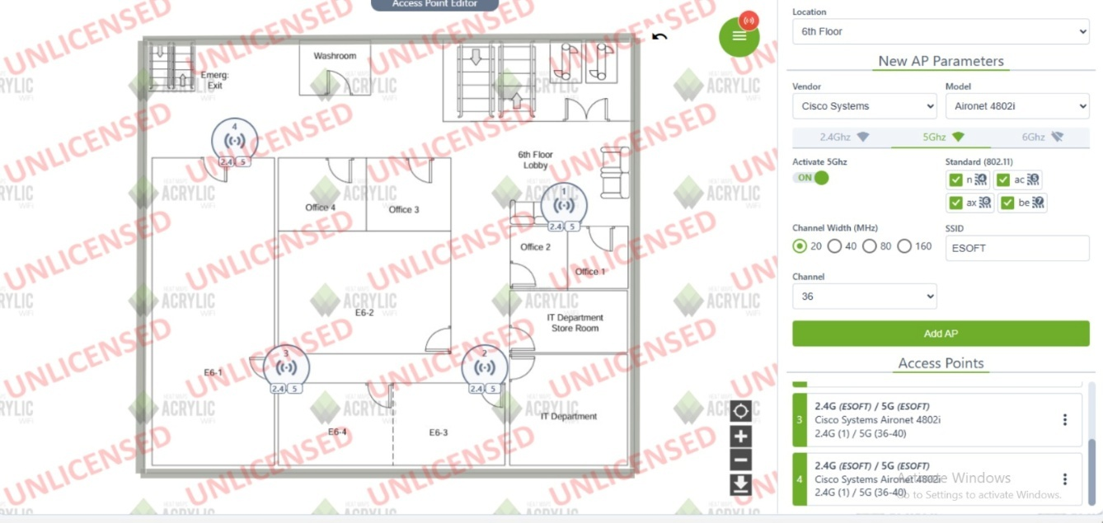
Figure 31: Access Point Assign_6th Floor

Access Point Configuration
- Location: 6th Floor
- Vendor: Cisco Systems
- Model: Aironet 4802i
- Frequency Bands: 2.4 GHz, 5 GHz (selected), 6 GHz
- Activation: 5 GHz is ON
- Standards: 802.11 ac, ax, be (selected)
- Channel Width: 20, 40, 80, 160 MHz (20 MHz selected)
- SSID: ESOFT
- Channel: 36
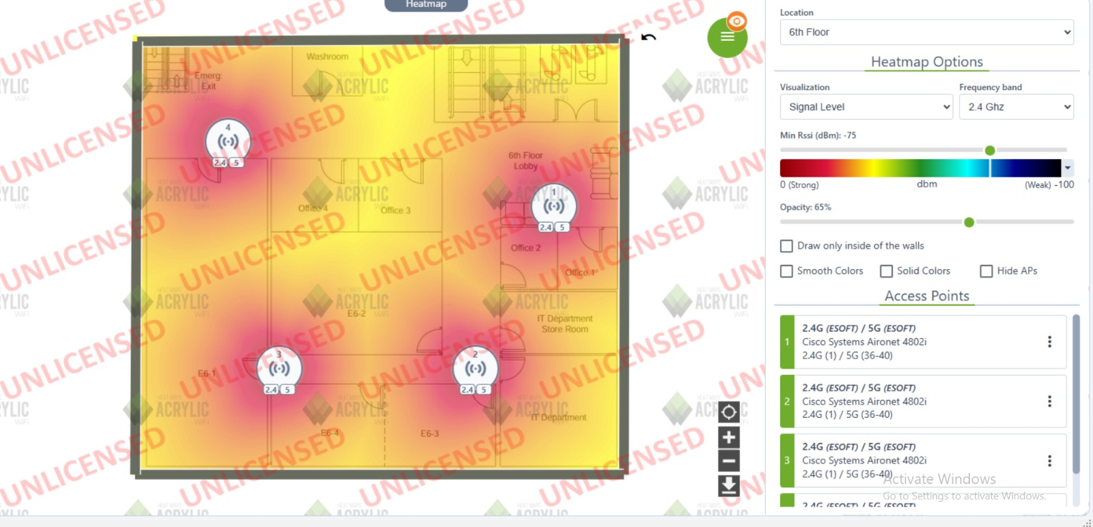
Figure 32: HeatMap_6th Floor

Analysis and Recommendations

1. Channel Occupancy & Interference
Analysis:
- A congestion problem arises from multiple networks operating on channel 11 because of ESOFT_STUDENT and ESOFT_STAFF sharing the same frequency.
- The combined use of APs operating on 5 GHz channels 36 and 40 produces interference between their signals.
- Due to their low RSSI readings at -88 dBm (GUEST) and -81 dBm (ESOFT_STUDENT), these networks tend to produce unstable connection performance.

Recommendations:
- Use channels 1 or 6 when selecting 2.4 GHz because they normally have less network congestion.
- Networks should use DFS channels among options 52, 100, and 120 when DFS features are available to reduce channel congestion.
- The adjustment of AP transmit power will minimize frequency congestion while stopping interferences.

2. Signal Attenuation
Analysis:
- The current wireless signal measures -71 dBm which constitutes below the required -50 dBm threshold for peak performance.
- Signals below -70 dBm will cause connections to drop while decreasing speed and heightening latency.
- Wall structure and spatial distance and competing electronic signals probably cause the signal decay.

Recommendations:
- The installation of router/APs at a central building point will enhance wireless signal connectivity.
- Physical obstacles extending between the AP and the device should be minimized by getting rid of partitions and placement obstructions.
- To achieve the best performance keep a shorter distance to the AP when employing the 5 GHz frequency because its range is shorter than the 2.4 GHz frequency.
- Weak signal zones can be addressed by implementing Wi-Fi repeaters and mesh systems as well as Wi-Fi extenders.

3. Coverage & Dead Zones
Analysis:
- Evaluation of weak RSSI signals shows the existence of dead zones in several parts of the area.
- The fifth of ten points in signal quality displays coverage irregularities.
- The network signals from GUEST (-88 dBm) and ESOFT_STUDENT (-81 dBm) experience low power which results in limited network coverage.

Recommendations:
- Inspect and mark all areas with poor signal reception during a site measurement process.
- Fitting additional APs and implementing a mesh network system can achieve continuous network access throughout extensive areas.
- The router/AP should be elevated by wall mounting for expanded reception range.
- Changing the antenna direction will enhance signal transmission capabilities.

4. Roaming & AP Placement
Analysis:
- The ESOFT_STAFF and ESOFT_STUDENT as well as the GUEST APs share identical wireless frequencies.
- Users will face connection delays and disconnections when devices fail to properly change access points.
- The 5 GHz channels overlap by having channel 36 reside within channel 40 boundaries which results in disruptive interference instead of good roaming between APs.

Recommendations:
- Users should enable 802.11k 802.11r and 802.11v to facilitate automatic AP transfer processes.
- All Access Points should use identical network names to optimize automatic device switching between networks.
- Position Access Points in locations that maximize their radio zone with minimal signal interference.
- AP transmit power should be lowered when multiple APs overlap due to interfere with communications unnecessarily.

5. Upload/Download Speed
Analysis:
- Poor signal strength and network traffic overload together cause reduced wireless data transfer velocity.
- The performance declines because both 2.4 GHz and 5 GHz bands experience interference.
- The slow transmission speed rating stands at 2/10 which signals the existence of system operational problems.

Recommendations:
- For streaming and gaming activities use the 5 GHz band to improve bandwidth performance.
- A reduction in simultaneous devices on APs that experience heavy congestion will decrease network load level.
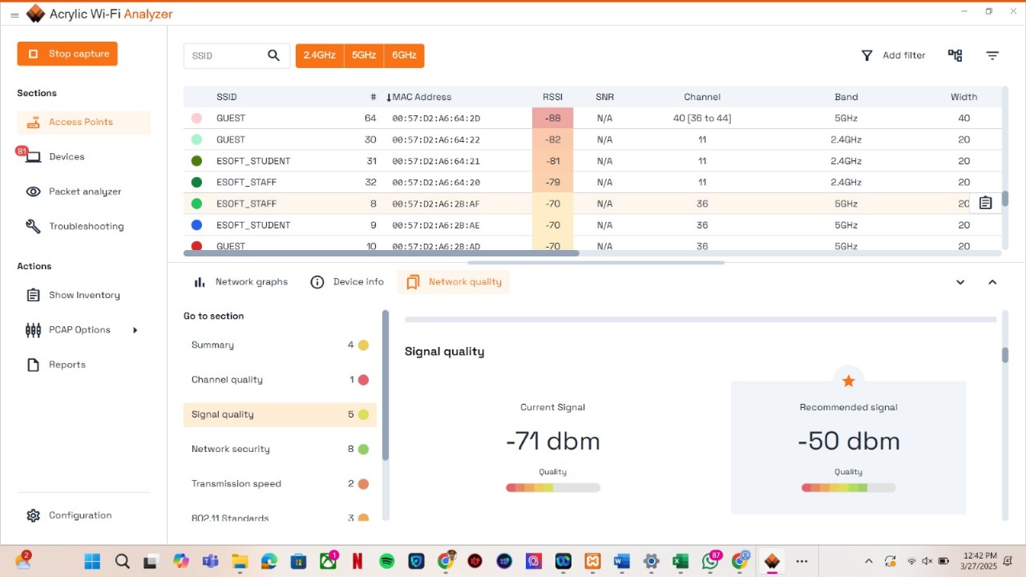
- Upgrades to Wi-Fi 6 (802.11ax) router systems should be pursued to achieve superior network performance.
Figure 33: Analysis_6th Floor

Eight Floor

Floor Plan
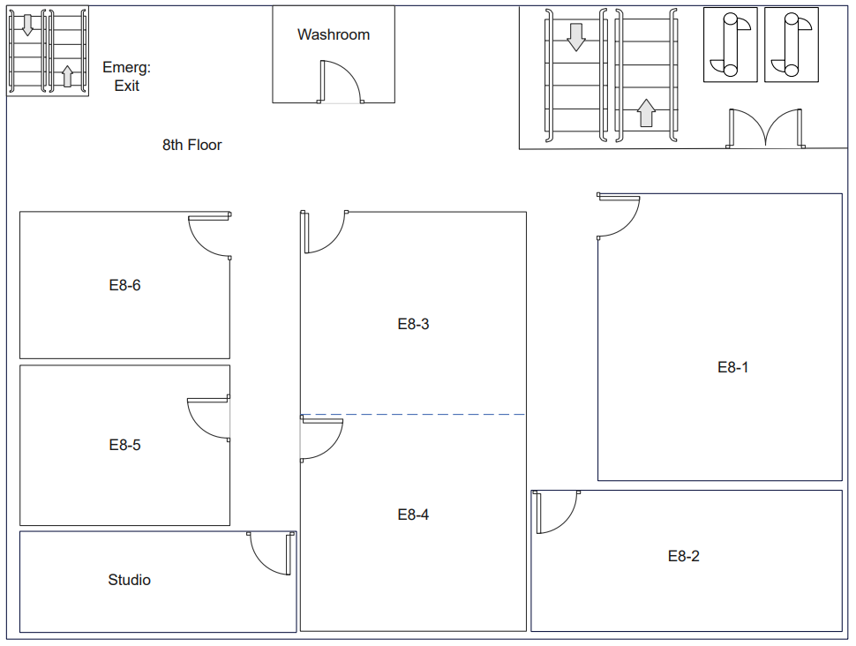
The 8th Floor layout is designed for optimal accessibility. The Emergency Exit and Washroom are located at the top-left for easy access. The main entry is at the top-right, with rooms E8-1 and E8-2 on the right, offering ample workspace. Rooms E8-3 and E8-4 are centrally located, providing flexibility for various uses. On the left, E8-5 and E8-6 offer specialized spaces. The Studio at the bottom-left provides additional specialized functionality, ensuring efficient movement and versatile use of the space.
Figure 34: 8th Floor Plan

Survey Data and Observations
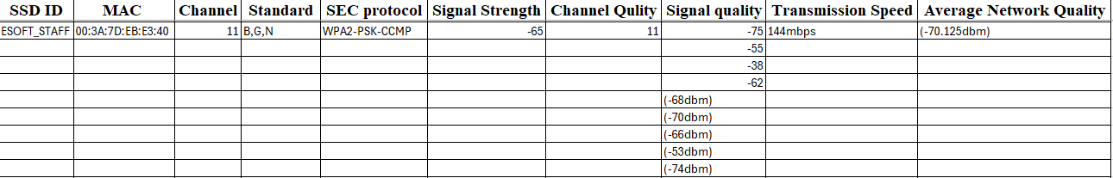
MAC Address : 00:3A:7D:E8:E3:40
Figure 35: Survey Details_8th Floor

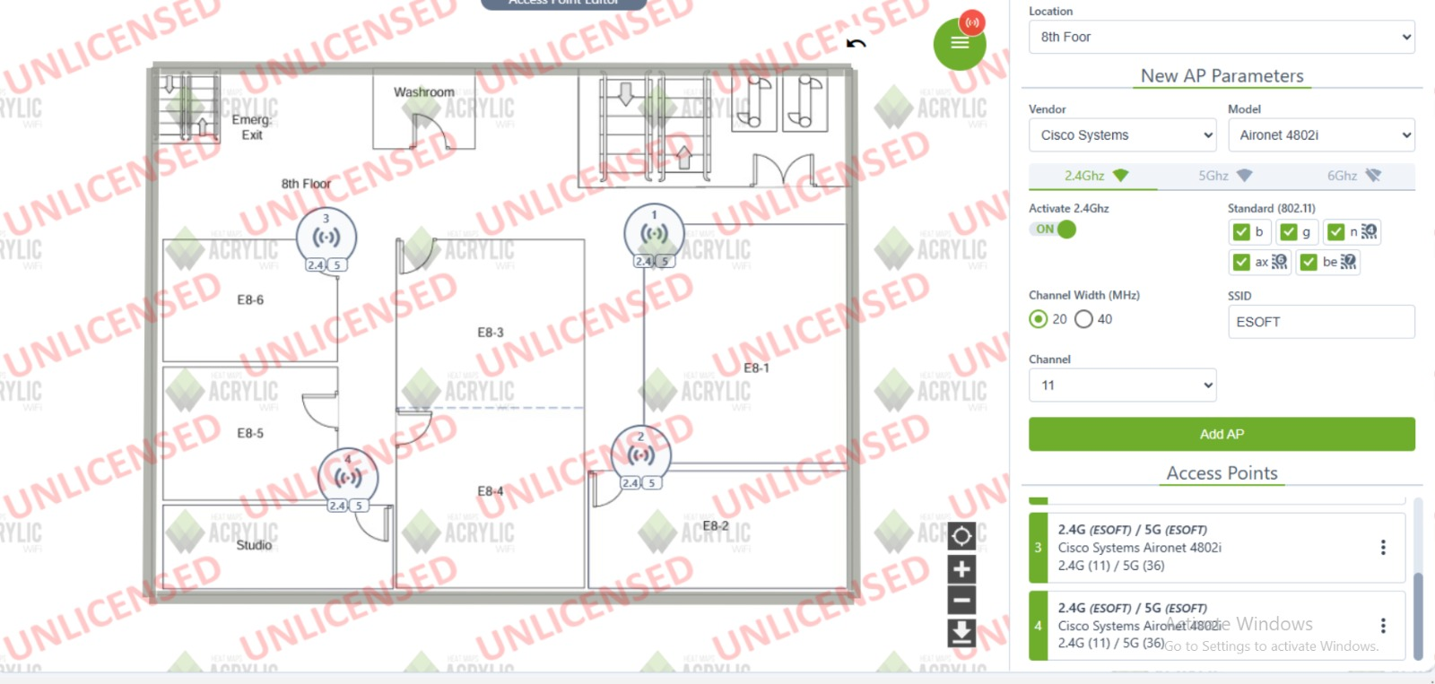
Data Visualization
Figure 36: Access Point Assign_8th Floor

Access Point Configuration
- Location: 8th Floor
- Vendor: Cisco Systems
- Model: Aironet 4802i
- Frequency Bands: 2.4 GHz, 5 GHz (selected)
- Activation: 2.4 GHz is ON
- Standards: 802.11 b, g, n, ac, ax, be (selected)
- Channel Width: 20 MHz (selected)
- SSID: ESOFT
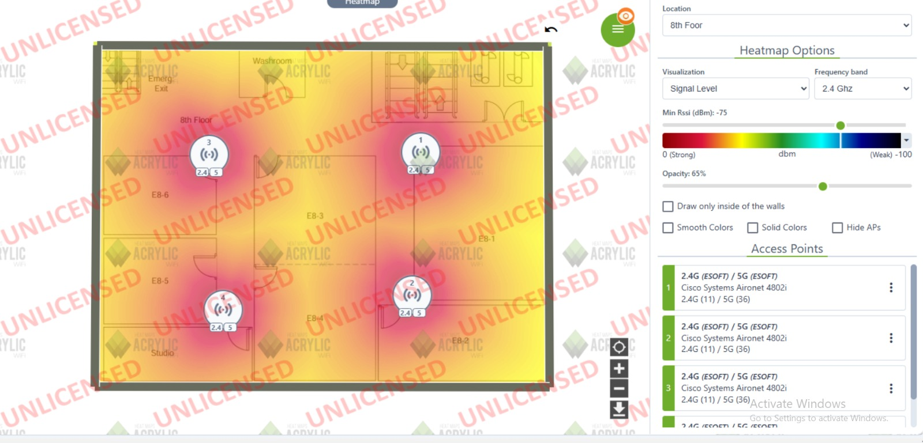
- Channel: 11
Figure 37: HeatMap_8th Floor

Analysis and Recommendations

1. Channel Occupancy & Interference
Analysis:
- 2.4 GHz Band: The wireless network operates three service set identifiers (SSIDs) named ESOFT_STAFF, GUEST, ESOFT_STUDENT through Channel 11.
- High levels of channel utilization result in interferences which diminishes network operational effectiveness.

- 5 GHz Band: All the networks operating in the specified range utilize Channel 58 (52 to 64).
- Co-channel interference occurs because of this situation which leads to efficiency reduction.

Recommendations:
- For 2.4 GHz: Balancing the network load requires moving selected APs to Channel 1 or 6.
- Administrators should lower AP transmitters to decrease their signal strength.

- For 5 GHz: The network performance can be improved by distributing APs between different DFS channels specifically channels 100 and 120.

2. Signal Attenuation
Analysis:
- The present signal strength falls beneath recommendations at -70 dBm.
- The signal attenuation exists mainly because of structure impediments alongside equipment or wireless device disturbance.
- The quality of weak signals leads to the occurrence of packet loss in addition to increased network latency which causes slower connection speeds.

Recommendations:
- APs should be relocated to an accessible central space to reduce signal degradation affects.
- Devices connected to 5 GHz frequency should stay close to the access point.
- The signal strength becomes better with higher-gain antennas while Wi-Fi extenders help to enhance connection coverage throughout the space.

3. Coverage & Dead Zones
Analysis:
- Network signal reaches 6 points out of the 10-point scale and exhibits average reach alongside potential signal drop areas.
- RSSI measurements indicate network performance through their range from -63 dBm to -70 dBm.

Recommendations:
- Heatmapping the Wi-Fi network will reveal all coverage areas that need improvement.
- Implement extra APs together with mesh Wi-Fi systems where signal quality becomes poor.
- To enhance network coverage, implement the practice of raising AP mounts such as walls and ceilings.

4. Roaming & AP Placement
Analysis:
- The deployment of multiple APs leads to covered areas with double zones however these zones might lack optimized roaming acceleration features.
- Users may encounter communication drops together with reconnection delays when roaming is not seamlessly executed.

Recommendations:
- The wireless network should support the standards of 802.11k and 802.11r and 802.11v to enable rapid transitions between access points.
- Lower the transmitting power of access points in situations when coverage areas overlap excessively.
- All Access Points should be placed to create uniform coverage zones.

5. Upload/Download Speed
Analysis:
- The low score of 2/10 indicates potentially slow transmission speed and network congestion conditions.
- The combination of poor signal reception leads directly to a reduction in network performance with increased data loss.

Recommendations:
- High-speed applications streaming and gaming should use the 5 GHz band.
- AP congestion will have its performance limited by reducing device activity on those points of access.
- The adoption of Wi-Fi 6 technology (802.11ax) will provide better performance to users.
- Connect computers and gaming consoles via Ethernet since these devices need priority access to the network.

Conclusion

The WLAN site survey conducted on all 9 floors revealed there exist key areas where Wi-Fi performance and coverage and interference handling should be improved upon. The survey revealed issues such as interference in the channels, poor signals due to obstacles, dead spots, weak roaming, and changing speeds.
To optimize network performance, adjusting AP placements, changing channel configurations, and implementing additional APs or extenders are recommended. Wi-Fi 6 upgrades could further enhance network efficiency, particularly in high-traffic areas.
The solutions will be less prone to interference in the wireless network and offer a stronger connection. The WLAN will be configured to run per floor.

