**A05P01 Report**

**Interface Design**

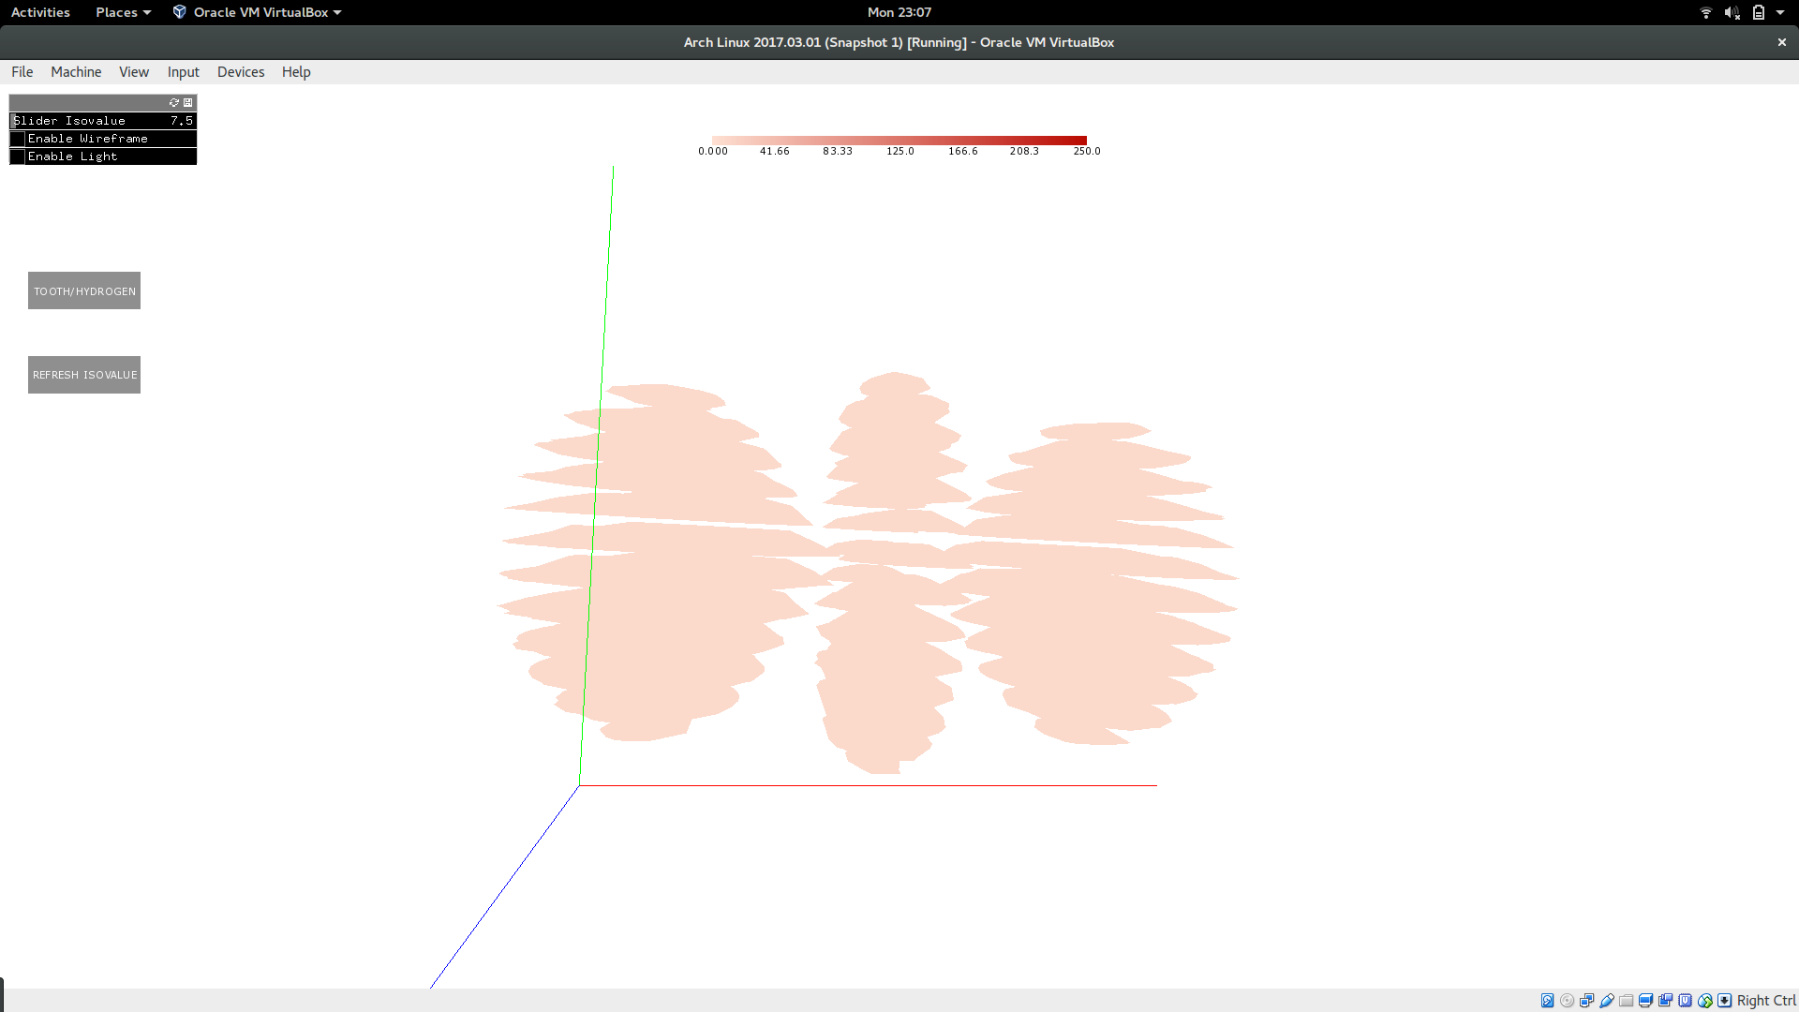In this part of the assignment, I used a similar design as the previous part. The zooming in and out, rotation of the image, and the three axes are available to provide more context to the data. A slider on the panel on the top left corner of the window has been provided for the user to adjust the isovalue of the isosurface drawn. By default, it has been set to the average of the range. The slider shows the current selected value, so the adjusting the slider becomes convenient. After the appropriate isovalue has been chosen, the user should click the refresh isovalue button to redraw the image with the selected isovalue. Another button below the panel can be used to toggle between tooth and hydrogen datasets. By default, the visualization loads hydrogen.vti. The image is drawn using a color map depending on the isovalue of the image. When the visualization is refreshed by changing the isovalue, the color of the image changes. A legend showing the various colors for various isovalues has been drawn on the top side with appropriate tick values. Additional features to make viewing the isosurface easier have been enabled, lighting and wireframe. A button on the panel on the top left corner can be clicked to enable a single lighting source in the image. Another button on the same button named Enable wireframe can be clicked to enable wireframe in the visualization. Wireframe helps us view each triangular face separately and lighting helps us view the change in angle in the faces and the contours in the isosurface more clearly. To implement the marching cubes algorithm, I used the edge table and the triangle vertices table from the link posted on piazza. Using the vertices of the triangular faces, the normal of each face was added into the image. To make the viewer more efficient, I would like to use the slicing technique we used in Assignment 2 in paraview slice through the mesh and visualize that part of the triangular faces with lighting and wireframe. Also, I would like to enable the user slice through and choose the transparency that each triangular face is drawn with(the tube filter in paraview). The sliced area can be drawn with a higher transparency than the unsliced part. I prefer slicing over isocontouring (even though it gives a 2D view), as slicing the helps one view the inside of the image than isocontouring. For example, in the engine dataset, when you slice the dataset through any plane, we can see the inside structure of the engine. Without the sliced view, the image looks like a big block. Isocontouring does not help view the inside structure of the image. Tooth.vti when viewed though slice viewer shows no resemblance to a tooth. Once you use the isocontour view with lighting and wireframe, you can see the cavity on top of the tooth, and the gradual bends in the triangular faces, which gives you an indication that it is an image of a molar.

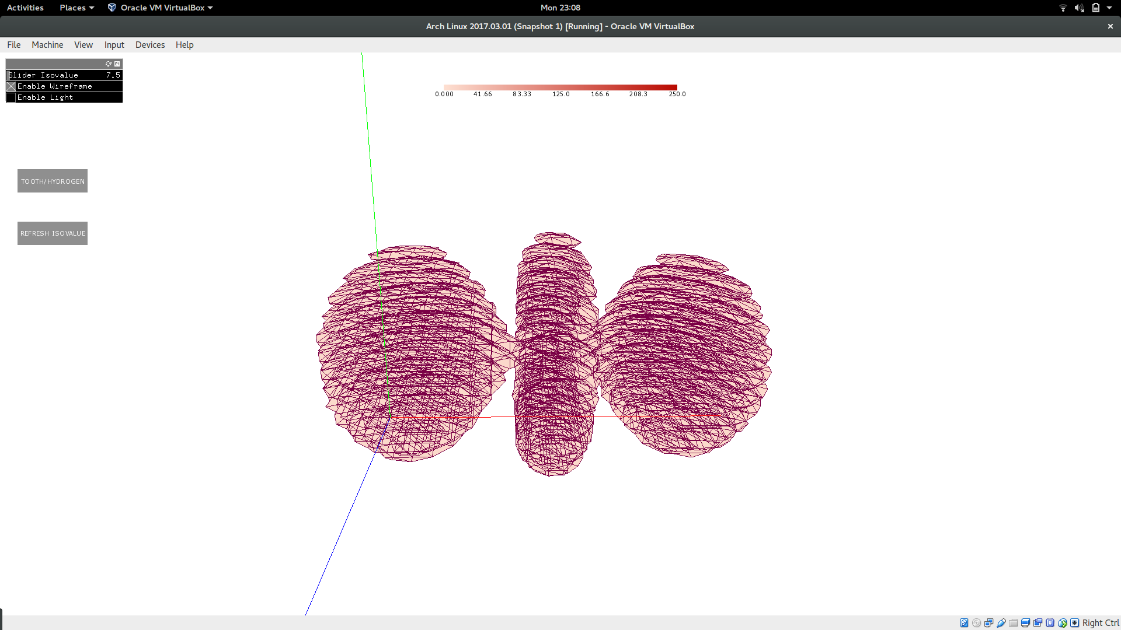

Wireframe view of hydrogen.vti

Wireframe view of tooth.vti

