**A05P01 Report**

**Design**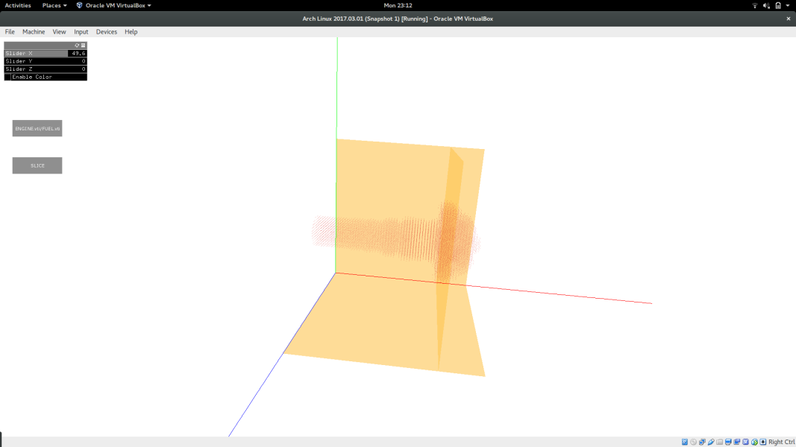

The image is drawn in 3D volume with the three axis and the three planes drawn to provide reference to the user. Camera has been enabled to allow the user to interact with the image by zooming in and out and rotating the image. The image is drawn in a medium dark color instead of black/white to make viewing of each point easier by rotating and zooming in appropriately and at the same time contrasts the white background. This allows the user to view the data more efficiently. Three separate sliders namely Slider X, Slider Y and Slider Z have been provided on a panel on the top left corner of the window to slide the planes through the image on their respective axis. The user can use the 3D rendering of the image to position the plane in the exact x/y/z coordinate where the user wants to slice the image through. The value selected is dynamically shown on the right side of the slider in the panel. Once the user has fixed on the exact x/y/z coordinate to slice, a button below the panel named slice can be clicked to see the sliced view of the image. Another button, in the panel, named enable color can be used to view a colored sliced view of the image. If the button is not pressed the sliced view will be a grayscale image. In both, grayscale and colored slice image, a legend depicts the visual encoding used in the view. The color map used is a blue to light green to yellow to represent high, medium and low values. This is a multi hue color map, which did not use too many colors and the difference in high and low values was clearly visible. I also tried a single hue color map with a variation from dark blue to light blue. While this color map easily differentiates between the high and the low values, it made it difficult to view the mid range values clearly. A third button on the left side of the window can be used to change datasets. By default, the image loads fuel.vti, but clicking on the button will change the dataset to engine.vti, and clicking twice will change back to fuel.vti.

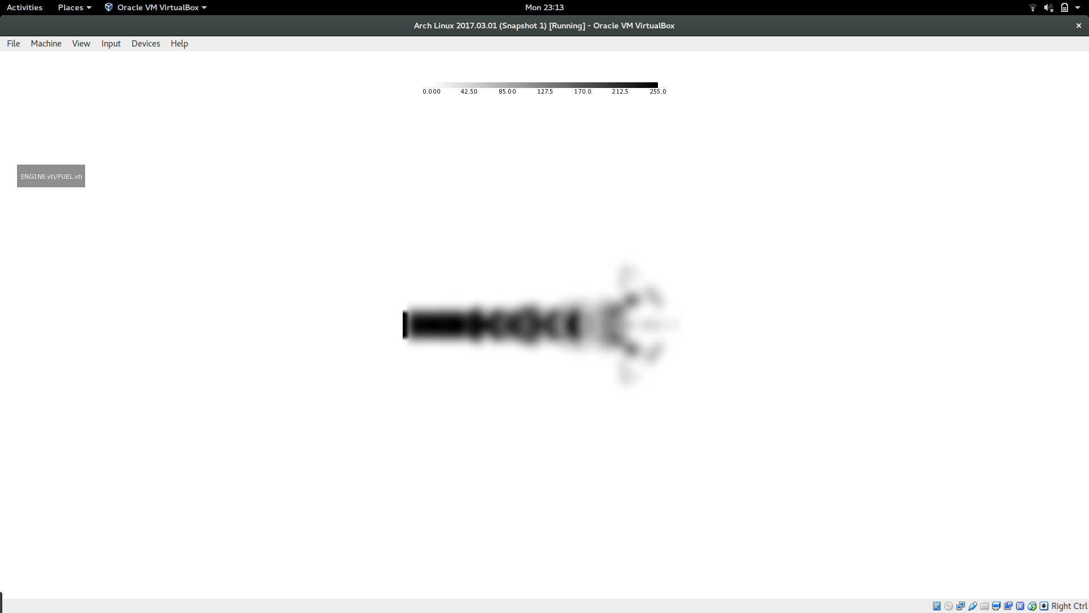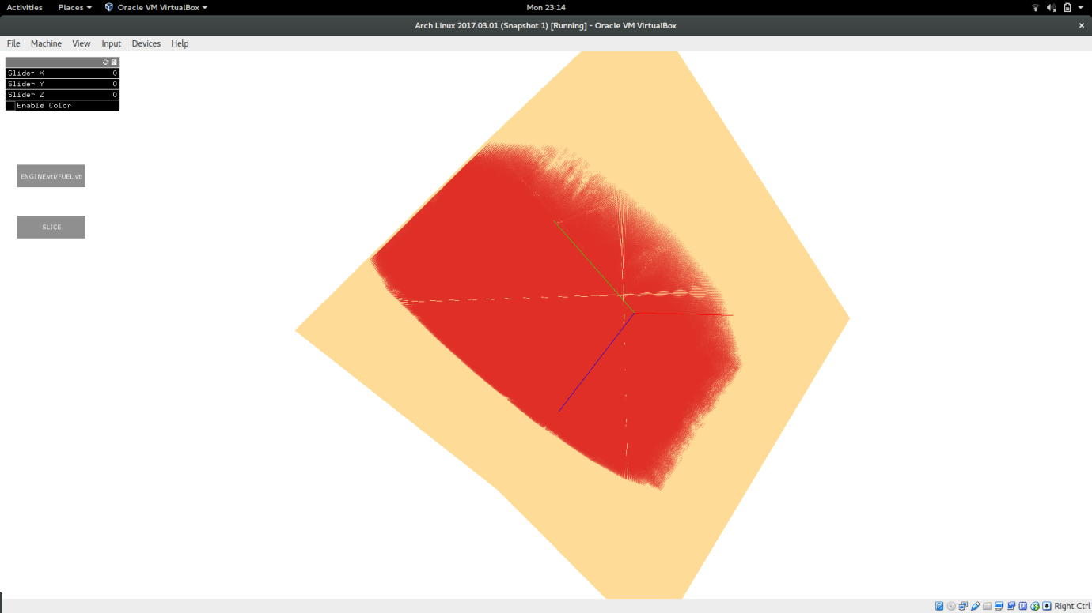

Grayscale slice of fuel.vti

3D image of engine.vti

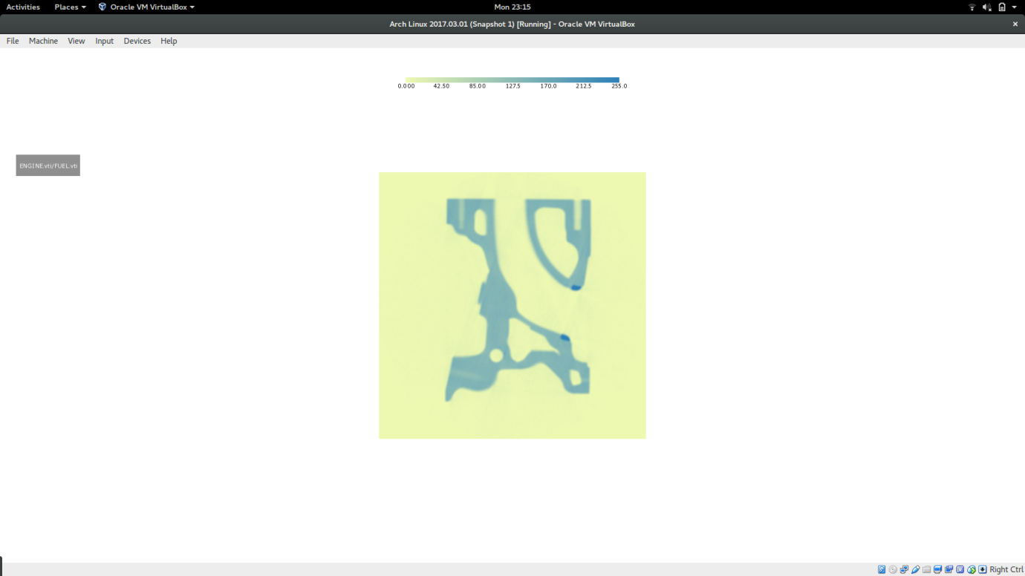

Colored slice of hydrogen.vti