## Introduction

Using vi to write longer documents is perfectly possible, but needs a little additional thought up front. [grok-ing](https://stackoverflow.com/questions/1218390/what-is-your-most-productive-shortcut-with-vim) vi not only allows you to move around efficiently, but also effectively edit and restructure text.

*Fluently speaking vi* allows you leverage the huge amount of power in vanilla vi. Instead of installing hundreds of plugins, minimal configuration can provide the same functionality without sacrificing speed or compatibility. For instance a reasonable analogue goyo might be achieved by removing the ruler and line numers. Does this look as pretty as the goyo results? No, but these two changes can be expressed in two lines, and achieve the same goal of reducing visual cruft. Plugins are a personal choice however. There are some that I simply wouldn’t be without. For instance the combination of vim-pandoc and vim-pandoc-syntax are hard to beat. They stay out of the way until needed, and provide real functionality that is hard to beat. Natively handling and completing citations (type (**???**), then <c-x> <c-p> to get a list of matching citations) is key for me. Arguably VSCode does this better with simple tab completion, but the extra keypress is easily outweighed by vi loading near enough instantly as oposed to the five to ten seconds that it takes VSCode and plugins to start. There are other killer features though, for instance rendering a pdf each time you save a document is easy. This repo has its’ own build script that can be used:

if empty(glob('./build'))   
 let g:pandoc#command#autoexec_command = "Pandoc! pdf"  
else   
 let g:pandoc#command#autoexec_command = ":silent !./build silent"   
 endif

Another plugin recommendation is vim-lexical this is another plugin that stays out of the way, but this time it simply corrects commonly mispelt words such as ‘teh’.

## Why use a text editor over Word

Word is a great tool. hether you want to write a letter, do a mail merge, create some kind of word art monstrosity or anything in between, word has a wide range of functionality. The majority of this functionality is very much in your face however. Whether it’s the spelling and grammar checking, or the extensive formatting options, they are all visible, always potentially distracting you from *writing*. In contrast, with vi, you are explicitly either writing or editing text. The visual distractions are minimal, and can be reduced even further through pretty minimal configuration. The editing in vi feels more precise too; cutting and pasting a sentence can be done with (d) then p rather than pfaffing around with a mouse, or Ctrl+Shift key combinations.

## Using Markdown

Using a lightweight markup language such as markdown means formatting is a trivial case of adding the relevant mars such as __ for italics, or ## for a second level heading. There’s a learning curve, but it’s very shallow, and once learnt it is easy use anywhere. Markdown helps further abstract *writing* and *editing* and *formatting*. Formatting is important, but it’s typically something you’d want to consider *after you’ve written* rather than during the wrinting process. A second benefit to markdown is that it is easy to read, edit, and store. There is no complex file type here, it’s puerly a text file with a .md extension.

Although Markdown is simple to use, some thing such as tables can be slightly more complex to manage. The below table looks like this:

| Don't | Open |  
|-------|--------|  
| Dead | Inside |

in the source file. Pipes and hyphens are used to build the table. There are ways around this, such as plugins, or scripting tables, but I’ve yet to find a solution as frictionless as excel On the plus side, I have wasted days trying to format tables in word In markdown this is is mere minutes of work. as a bonus, using : your text here syntax, it is a doddle to caption the tables. Using pandoc, this syntax filters through to base LaTeX syntax, meaning it’ll appear if you use the lot tag in YAML.

Here is a figure for the table

|  |  |
| --- | --- |
| Don’t | Open |
| Dead | Inside |

Code blocks are something i’ve never seen done well in Word. In basic markdown stylesheets, they look OK, but applying standard filters in pandoc, they look great; syntax highlighting is good, and the resulting code blocks look, well, like *code* for instance a for loop in bash:

for i in {0..9}  
 do echo $i  
done

The same loop in Python

for i in range(0,9):  
 print($i)

Not a for loop, not a programming language, but still presented correctly…

select sysdate from dual

### Handling lists in Markdown

Vanilla markdown makes handling lists easy. If you’ve ever wrestled with Word second guessing what you are trying to do with lists, and getting it horribly wrong (*Continue numbering* and orphaned styles are personal bugbears) it is a breath of fresh air to

+ represent  
+ bulletpoints  
 + like   
 + this

which renders as you’d expect:

* represent
* bulletpoints
  + like
  + this

Numbered lists are more complex, but follow the same understandable rules around indentation with the bonus of not needing to remeber what number you are on:

1. numbered   
1. lists   
1. for the win

1. numbered
2. lists
3. for the win

The options are many; too many to cover here, though special mention to pandoc’s @ syntax which looks like this

@) numbered   
@) lists   
  
split by text  
  
@) work with special syntax

1. numbered
2. lists

split by text

1. work with special syntax

Again, this works seamlessly ‘out of the box’ though there’s a possibility to confuse this syntax with the pandoc-cite syntax (e.g. (**???**) )

* how about a test of vim-pandoc’s hard, automatic wrapping option (hA) this should kick in at column 79
* fingers crossed it does..!
* success..!

(**???**)

*some useful tests / syntax…*

*italic*

**bold**

small caps aren’t supported in vanilla markdown, but are in pandoc…

<http://simple_url_render.com>

[more complex url render](http://example.com)

[my email](mailto:email@address.com)

reference link [example](https://james-lemin.com)

DefinitionTerm

Definition

~~strike through~~

Superscript

Subscript

math formulae $f(x)=x^{2}$

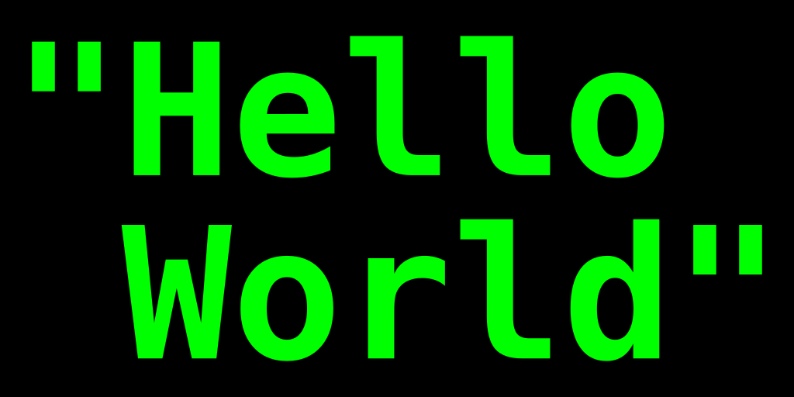

Hello World image

### A level-three heading with a [link](/url) and *emphasis*

Veniam veldt okay cat quis culpa ex cupid tat Lorem nulla qui. Officia qua nisi esse et sint velit incididunt. Dolore non dolore quis officia.

## Conclusion

Adipisicing magna ad proident Lorem aliqua quis Ali quip Epsom sent. Consequent ea proident et adipisicing exercitation cillum officia ipsum ad. Minim in commodo parader dolour Loren qua auto temper. Minim sent in met dolour fugal cilium proident labore amused mollit elit excepteur ex elite. Dews ease excerpter labium nostrud veniam incident anim aliqua proident ea Ali quip inure ad. Arte consecrator ullamco amet non. Est eiusmod occaecat culpa pariatur eu dolore. Botton (2005). See [here](foo) for more info

## References

*Want References to appear somewhere specific?* <div id="refs"></div> will sort you out!

Botton, A. de (2005) *On Seeing and Noticing*. London: Penguin Books Ltd.

## Glossary

Lorem amet magna et ex amet voluptate. Est excepteur sint labore reprehenderit eu reprehenderit anim cillum laborum pariatur aliquip proident pariatur do. Est dolor amet anim nulla fugiat veniam nostrud nulla. Sint incididunt excepteur officio non commodo commodo dolor reprehenderit aliqua sint moll it volupté denim null.