**WORK FORCE MANAGEMENT DOCUMENTATION**

* Login Page

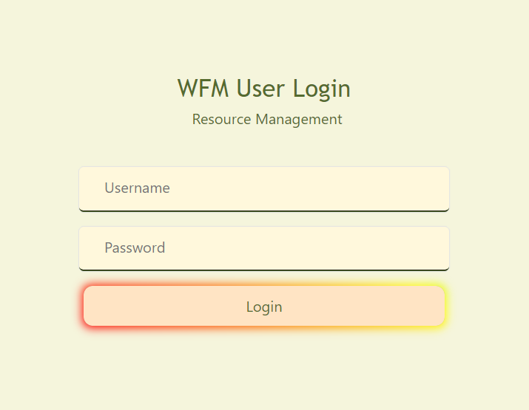

Only the authenticated users are allow for login. Authentication implemented by using the JWT security, a token will be generating and pass to get the API data. If not the users are authenticated then will show the message ‘Authentication Failed’

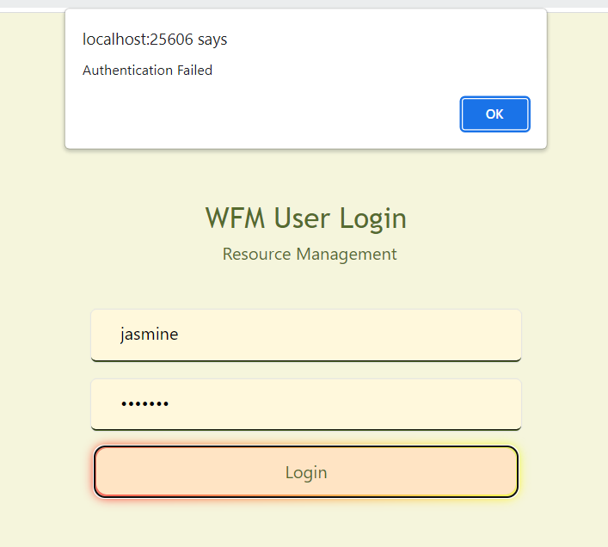

After the token was successfully generated then the users are allow for login.

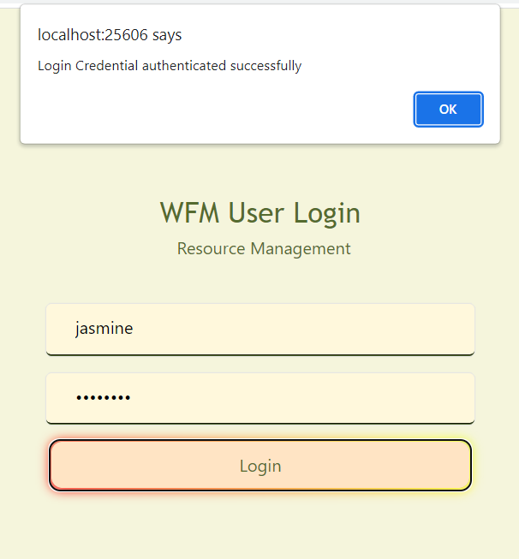

* Manager Home Page

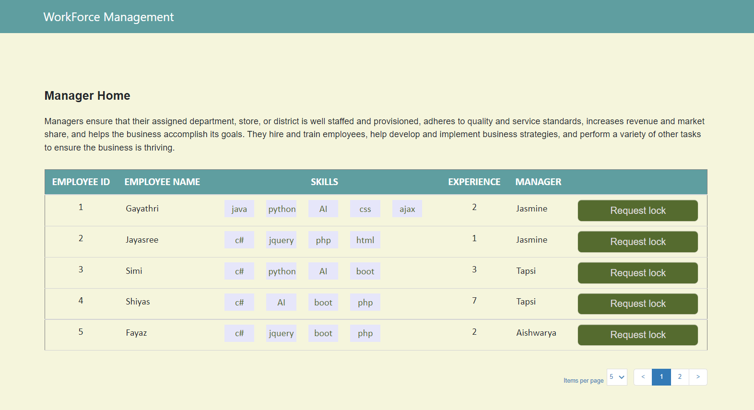

If the login user’s role is manager then it will redirect to the manager home page. This page will shows the employee details with skills (used many to many relationship).

And also included the pagination using script.

There is a request lock button is there in the table and this button requesting to lock the employee. A model popup will be popping while clicking the request lock button. The screenshot was represented below

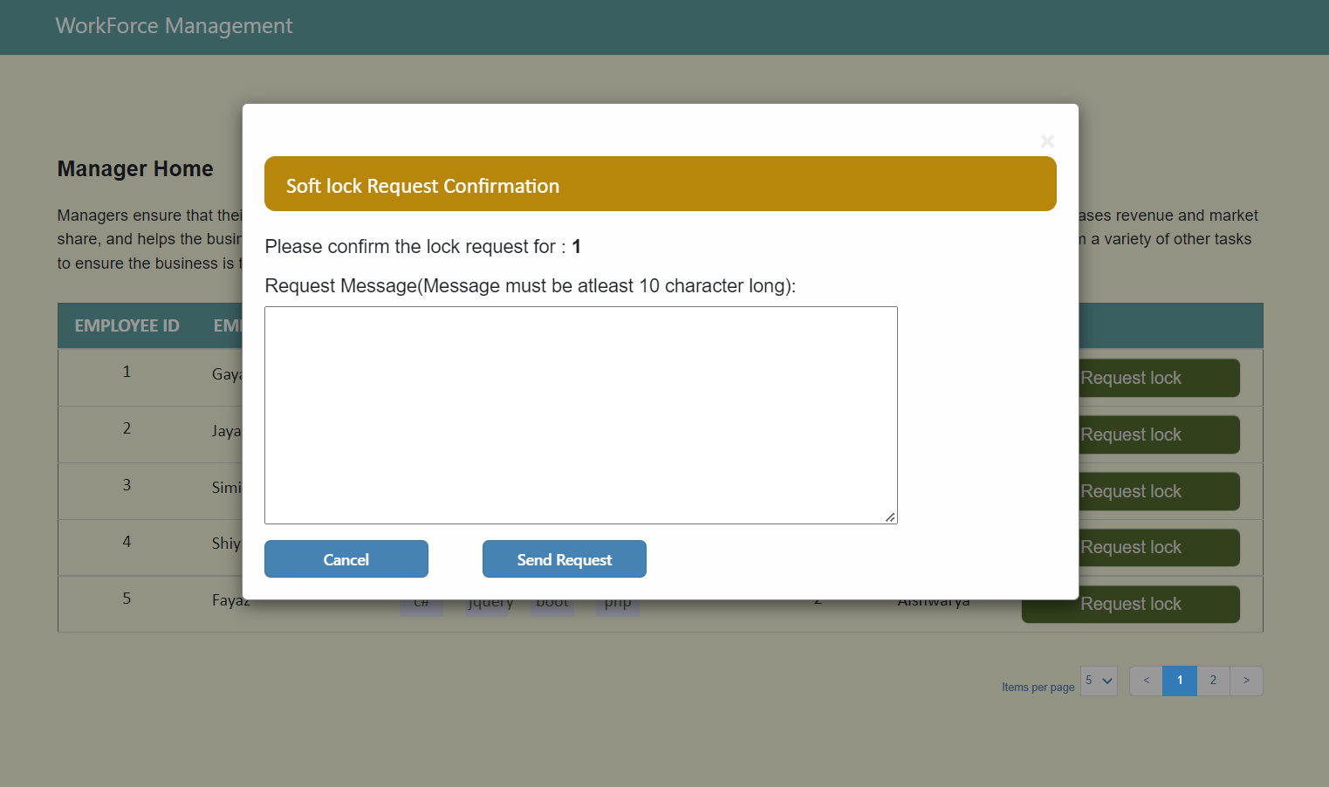

After entering the request message and when click on the send request button then the request will be added to the softlock table with respective details and the status will be “waiting” and the manager status will be “awaiting_confirmation” . And if click the cancel button then popup will be disappear.

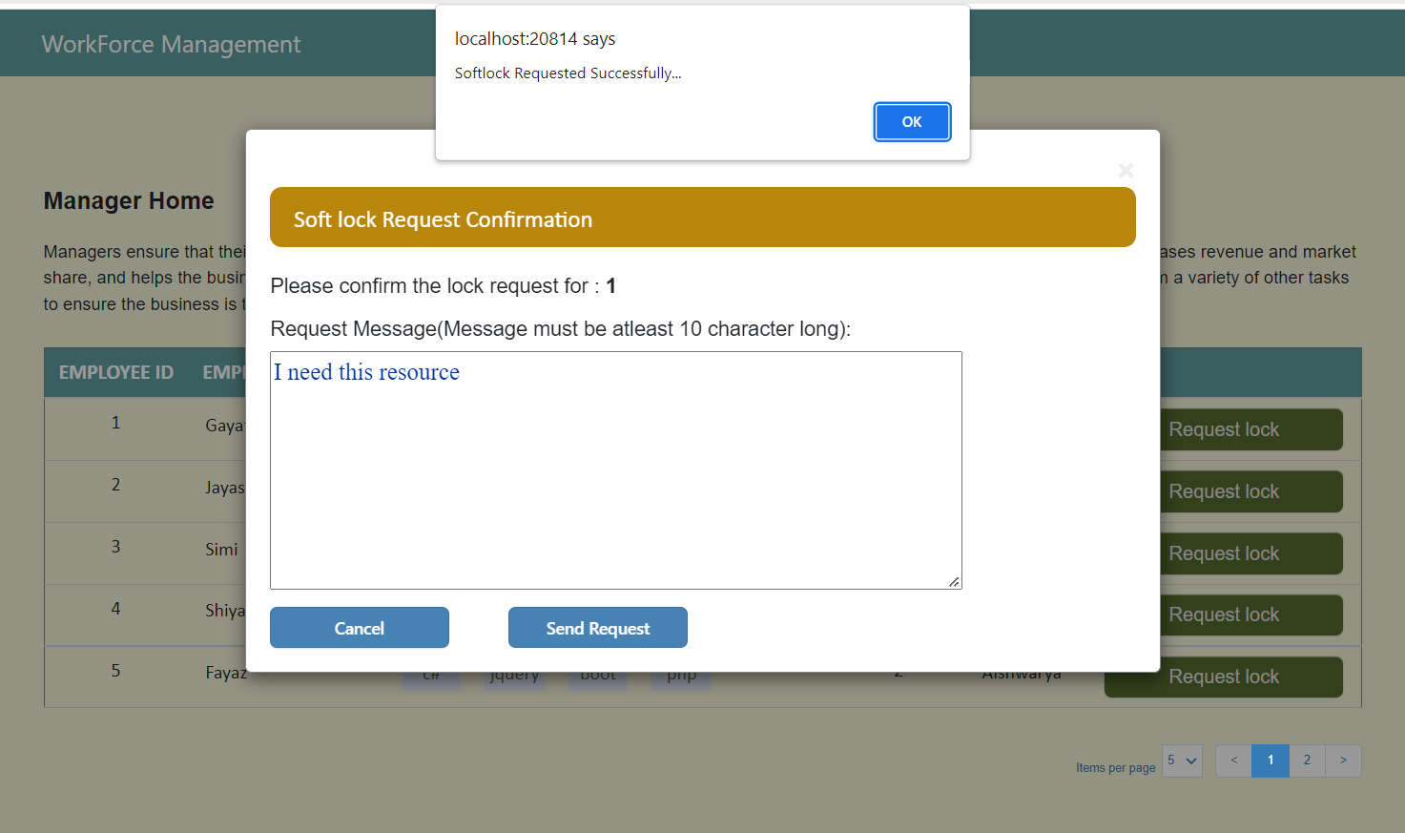

* WFM Login Page

If the authenticated login user’s role is wfm manager then it will redirect to the wfm manager home page (JWT Security was used for authentication).

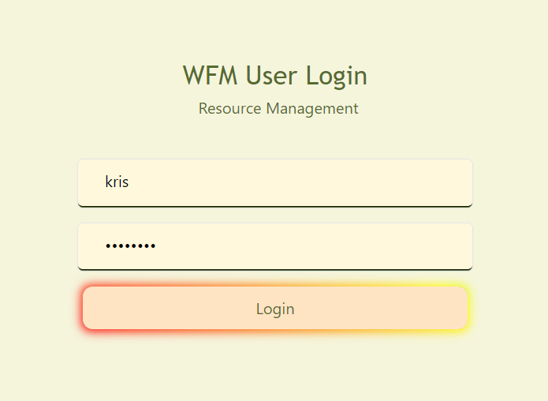

* WFM Home Page

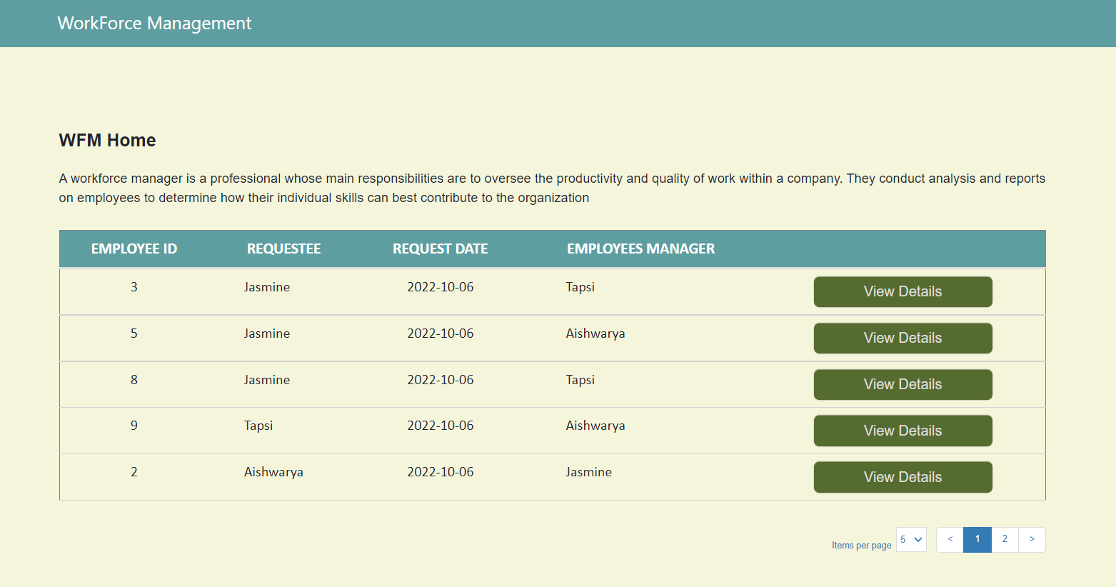

The above screenshot represents the WFM home page. In this page will shows the details of the lock requestees with details. This details will be fetched from the softlock table.

In the table view details buttons are there, when click this button a model popup will be popped with the requested details.

In addition there is a status drop down list is there and the status would be either **approve** or **reject**

The screenshot was representing below

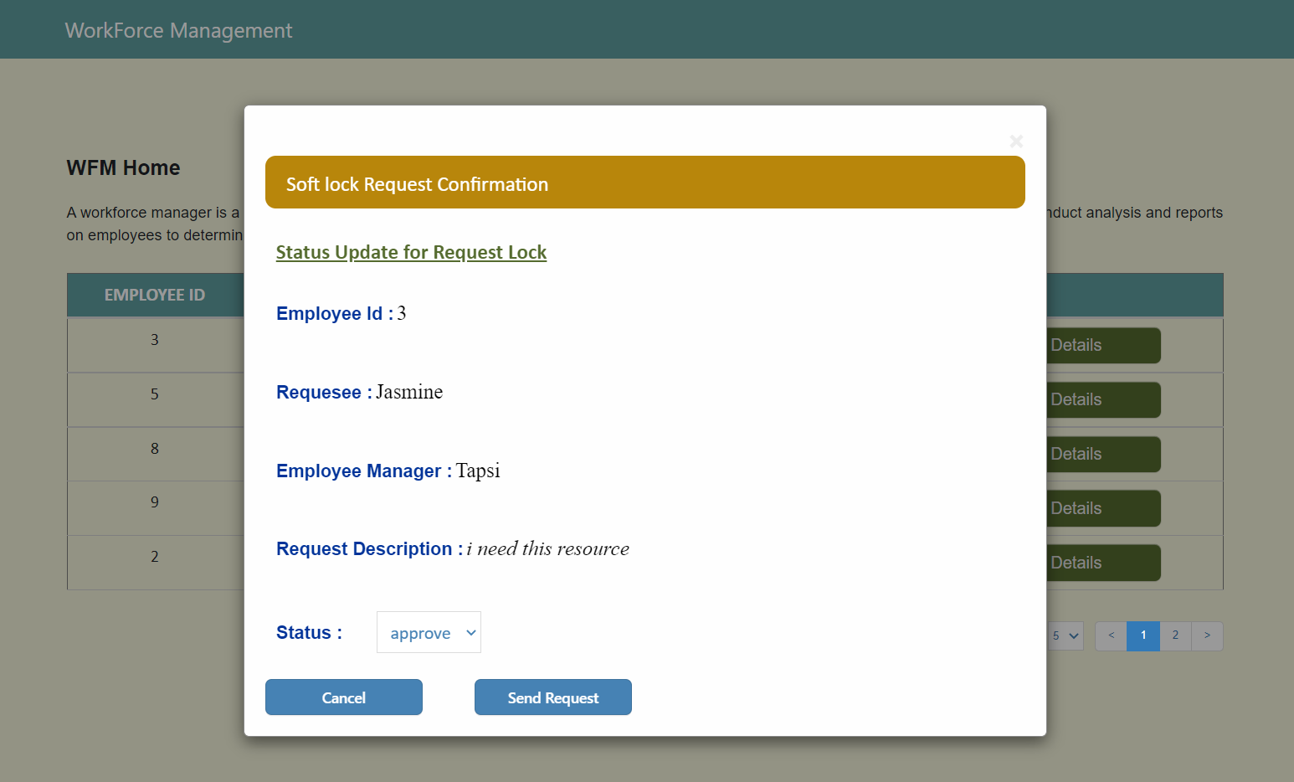

If select the status as approved then the softlock table will be updated with the corresponding row and in employee table the lock status will be updated as “locked”

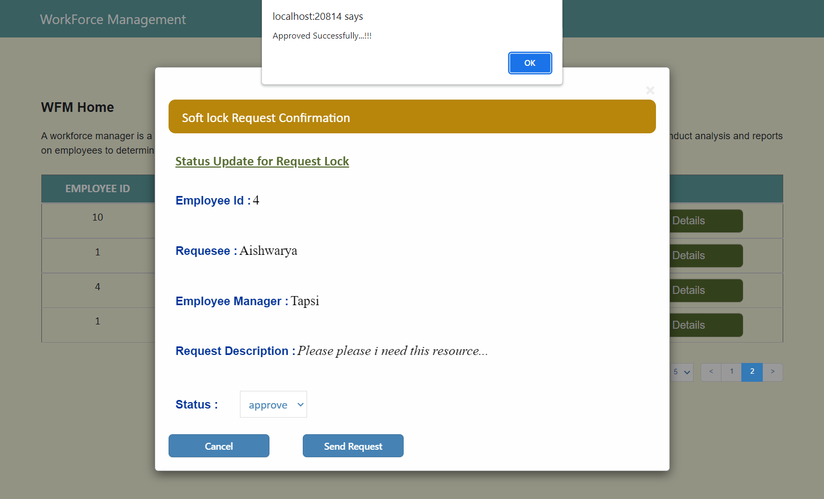

If select the status as rejected then the softlock table will be updated with the corresponding row and in employee table the lock status will be updated as “not_requested”

