**FUNCTION 1 - Create a new local user**

* Before running script, make sure the path is pointed to the script folder.
* Please check for PowerShell version also, if Windows 10 should be >5.0 .
* My script is namely Main.ps1

1.Make selection by input ‘1’

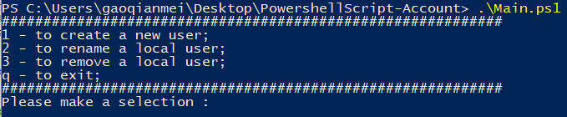

2. Test with below values:

**New user name:** testuser1

**Fullname:** testuser1gao

**Password:** Gqm123!@#

**Description purpose:** testing purpose

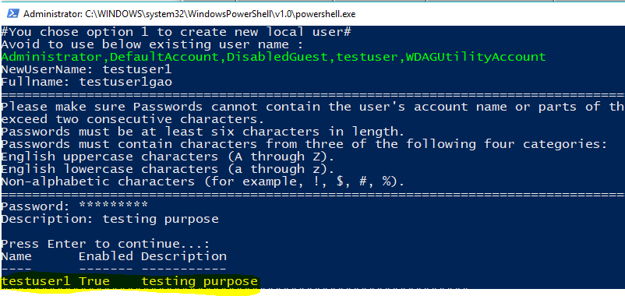

**FUNCTION 2 – Rename for a local user**

1. Make selection by input ‘2’

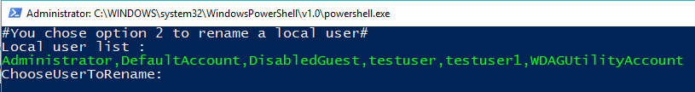

2.Choose “testuser1” to perform rename, new name “testuser2”.

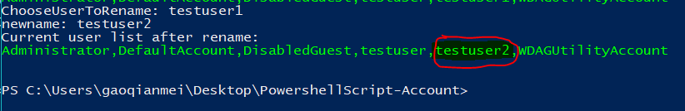

**FUNCTION 3 – Remove a local user**

1. Make selection by input ‘3’

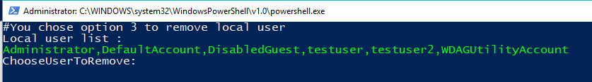

2.To remove “testuser2’ , script console prompt out operation select, put “Y” and Enter.

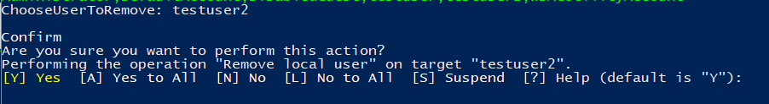

3. Type “q” to quite the script, double verify current user list (testuser2 has been removed)

