Design and Implementation of a Rule-Enhanced Personalized Training Agent for Substation Operation and Maintenance

Ziying Qu
Class 2 of Cybersecurity (2024), Guangke
3237586467@qq.com
15917497332
Baotong Feng
Class 2 of Cybersecurity (2024), Guangke
912507522@qq.com
15015504550
Jingxuan Feng*
Class 2 of Cybersecurity (2024), Guangke
3597425662@qq.com
*Corresponding author
13435641398

Abstract—Training for substation operation and maintenance (O&M) positions is constrained both by safety regulations and by individual capability differences. Directly using a general-purpose large language model (LLM) to generate training advice leads to regulation hallucination and untraceable conclusions, and merely placing retrieved regulation text into the context cannot guarantee that the output falls within business thresholds. To address this problem, this paper designs a rule-enhanced personalized training agent: the judgment of safety and business thresholds is delegated to a declarative rule engine, while the model is only responsible for verbalizing the conclusions; the two sides are connected by four defense lines—structural contract, numerical reconciliation, input-side authorization, and safety handling. Structurally invalid outputs are rolled back to the rule conclusion as a whole, and numbers without sources are logged with their confidence capped. A single execution chains the matched rules, the advice, and the human decision with one execution ID. The model is fine-tuned from Qwen2.5-3B-Instruct with 4-bit QLoRA. On 150 factor-design-generated structured profiles, 450 rule executions were replayed: the profile-level coverage is 150/150, and the false-negative rates of the two negative classes (failed exams and insufficient certificate levels) are both 0; on a 200-case parameter grid, the tier assignment, keyword supplement, and severity merging are all fully consistent with expectations; repeated executions are byte-for-byte identical, with an in-process single evaluation averaging 0.012 ms. The model outputs of 26 test samples passed the hard validation on the first attempt without triggering rollback; a 16-case error-injection test of the validator intercepted all 11 structural cases and logged both numerical cases, while 3 semantic cases went undetected, which constitutes the coverage boundary of the current implementation. The architecture applies to industrial training scenarios where position capabilities are gradable, business thresholds are enumerable, and advice must be confirmed by humans.
Keywords—substation O&M; personalized training; large language model; declarative rule engine; parameter-efficient fine-tuning

1 Introduction
1.1 Research Background
Substation operation and maintenance (O&M) covers high-risk tasks such as equipment inspection, switching operations, and abnormality handling, and every step is constrained by safety regulations. O&M personnel differ greatly in qualification level, hands-on performance, exam scores, and safety records, and the data are scattered across three ledgers—HR, training, and safety—so the traditional practice of pushing uniform courses can hardly produce individualized advice. In recent years, LLMs have begun to enter intelligent O&M of power equipment, whose technical challenges and development paths have been systematically surveyed^{[1]}; the training scenario is no different: LLMs can offer new means for case generation, regulation Q&A, and learning advice^{[2]}, and knowledge embedding and decision support have been attempted in power grid dispatching^{[3]}, yet safety-critical scenarios cannot simply copy these practices.
1.2 Problem Statement and Approach
Placing an LLM directly into a safety-critical training process involves three concentrated risks. Regulation hallucination comes first^{[4]}: the model may state, in a very confident tone, clauses or thresholds that do not exist at all. Next is untraceable conclusions—the pass lines, headcounts, and amounts appearing in the advice often have no corresponding data source. There is also unstable output: the same input may yield different conclusions across calls. A systematic assessment in the electric energy sector likewise points to “external judgment is required”^{[5]}. Instruction tuning and human-feedback alignment can reduce the hallucination rate^{[6]} but cannot eliminate it; retrieval-augmented generation (RAG) alleviates hallucination^{[7][8]}, yet retrieved regulations do not equal generated content conforming to the regulations—whether the output falls within business thresholds remains unguaranteed.
1.3 Contributions
The idea of this paper is to separate judgment from expression: the judgment of safety and business thresholds is delegated to an auditable declarative rule engine, the model only handles narrative expression, and the two sides are connected by four defense lines, where structurally invalid outputs are rolled back to the rule conclusion as a whole. The rule engine, parameter-efficient fine-tuning, and output validation are not original contributions of this paper; what this paper claims is an architecture-and-governance contribution for this scenario: a three-layer architecture of rule configuration, rule computation, and decision governance, with the rule path and the model path isolated by source tags so that model replacement does not touch interfaces or the front end; JSON declarative rules supporting group convergence, fact reference, and hot update, where thresholds always reference facts instead of literals; and validation split into four channels—structure, numerical, authorization, and safety—corresponding to rollback, logging, rejection, and rule-based handling, with the coverage boundary given. On this basis, the corpus was rebuilt to be isomorphic with the online prompt for fine-tuning, and four groups of experiments—rule replay, semantic grid, model measurement, and error injection—were conducted for verification.
2 Related Work
2.1 Constraint Enforcement in Five Technical Routes
Divided by “where constraints are enforced”, existing routes fall into roughly five categories, as shown in Table 1. Fixed courseware places constraints at authoring time, and once a course is formed it is detached from individuals. General LLMs and tool-calling agents leave constraints in prompts^{[9]}, while prompts only affect generation tendency and hardly constitute verifiable judgment. RAG demotes constraints to context—retrieved regulations do not equal generated content conforming to the regulations. Knowledge graphs are good at describing relations between concepts but lack threshold-triggered judgment logic. By contrast, the rule engine enforces constraints via runtime condition matching, with the best determinism and auditability, at the cost of fixed expressiveness; rule-base maintenance is prone to inconsistent calibers and rule shadowing—such degradation raises no error and only shows up as a silently dropping hit rate.
Table 1. Constraint enforcement locations and main limitations of five technical routes.
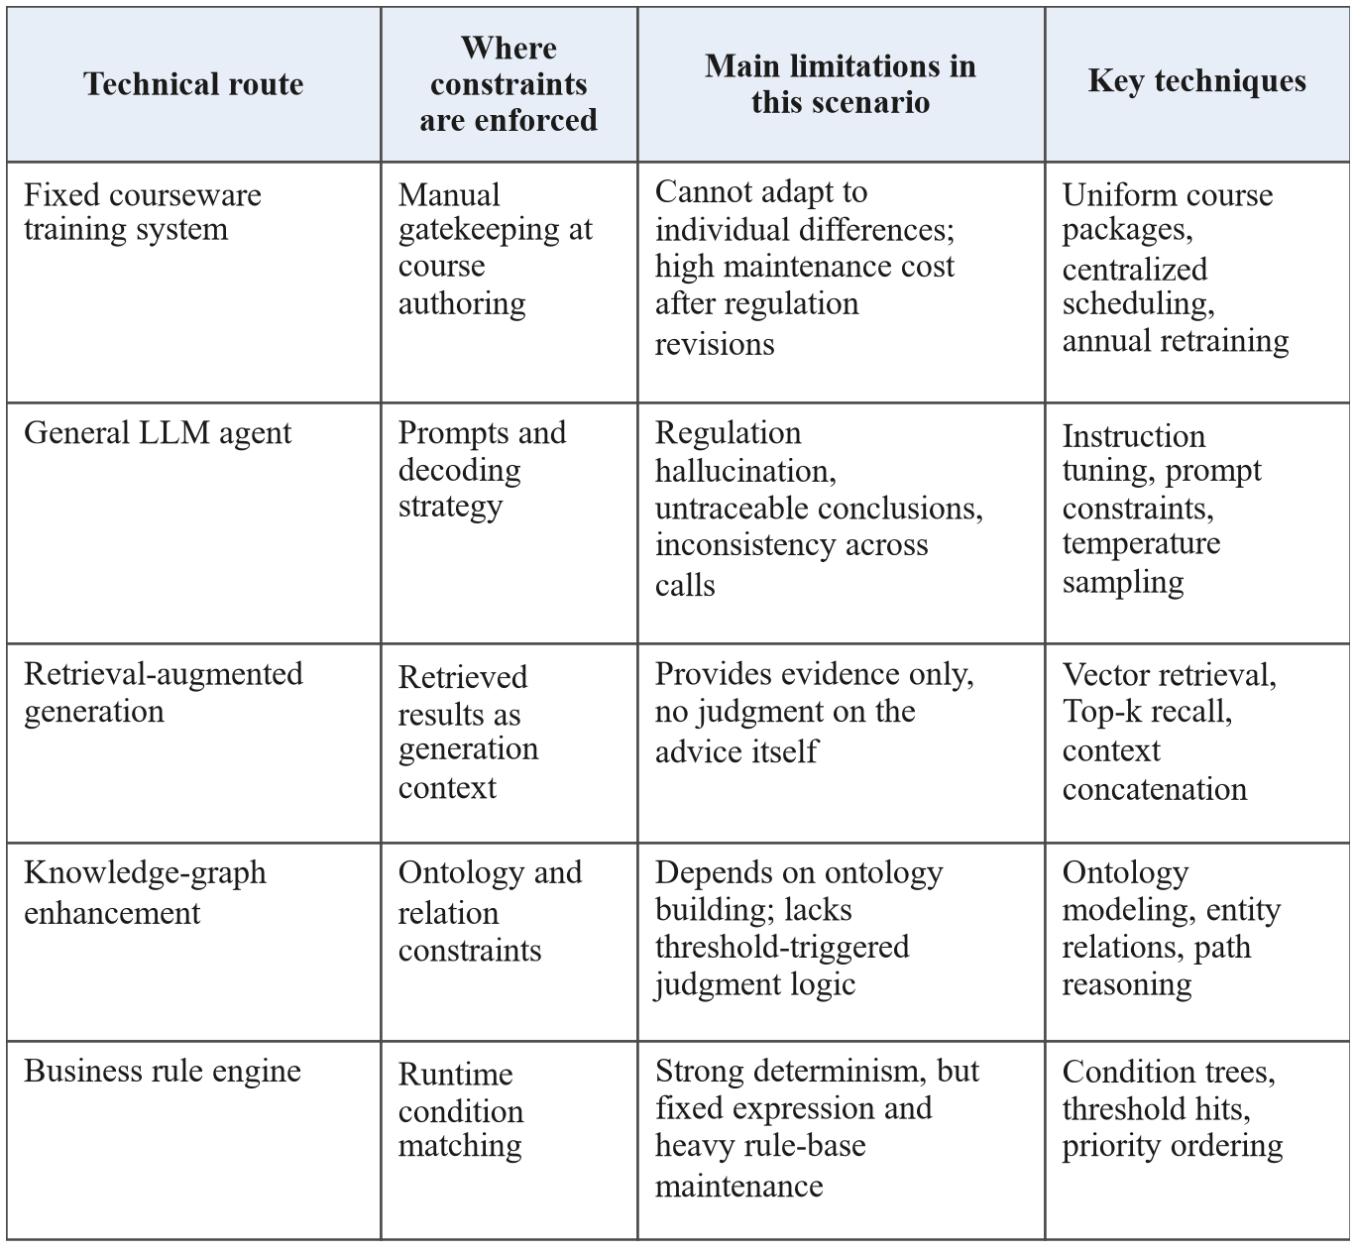

2.2 Differences from Programmable Guardrails
The closest work to ours is programmable guardrails^{[10]}, with three differences. Guardrails use a dedicated language to set I/O boundaries at the dialogue layer and judge dialogue behavior, whereas we put judgment conditions into a business rule base and judge position standards, course pass lines, and safety records, with rules maintained by the business side; guardrails usually intercept or rewrite text, while we keep, beyond interception, a complete rule conclusion as the fallback product so that a deliverable result still exists upon failure. These routes are not mutually exclusive; what is missing is the division of labor and failure handling—judgment must be carried by an auditable vehicle, expression can be left to the model, and between them a mechanism is needed that can reject, can roll back, and leaves evidence.
3 System Architecture
The system is subject to three engineering constraints: data boundaries exist between roles, safety judgment takes precedence over general business judgment, and only single-database deployment is allowed without introducing external rule frameworks. Accordingly, rules are stored as JSON columns in MySQL 8, read and written directly by the server without an object-relational mapping layer. The system has three layers (Figure 1): the rule configuration layer handles rule CRUD and enabling/disabling with immediate effect; the rule computation layer assembles facts and evaluates per scenario; the decision governance layer handles validation, rollback, and human confirmation. Two invariants run through the chain—the rule engine only writes intermediate results and never rewrites raw business data; need_human_confirm in the external output is always true. One execution chains matched rules, advice, and the final decision with one execution ID, so conclusions are traceable to rule IDs and data points.
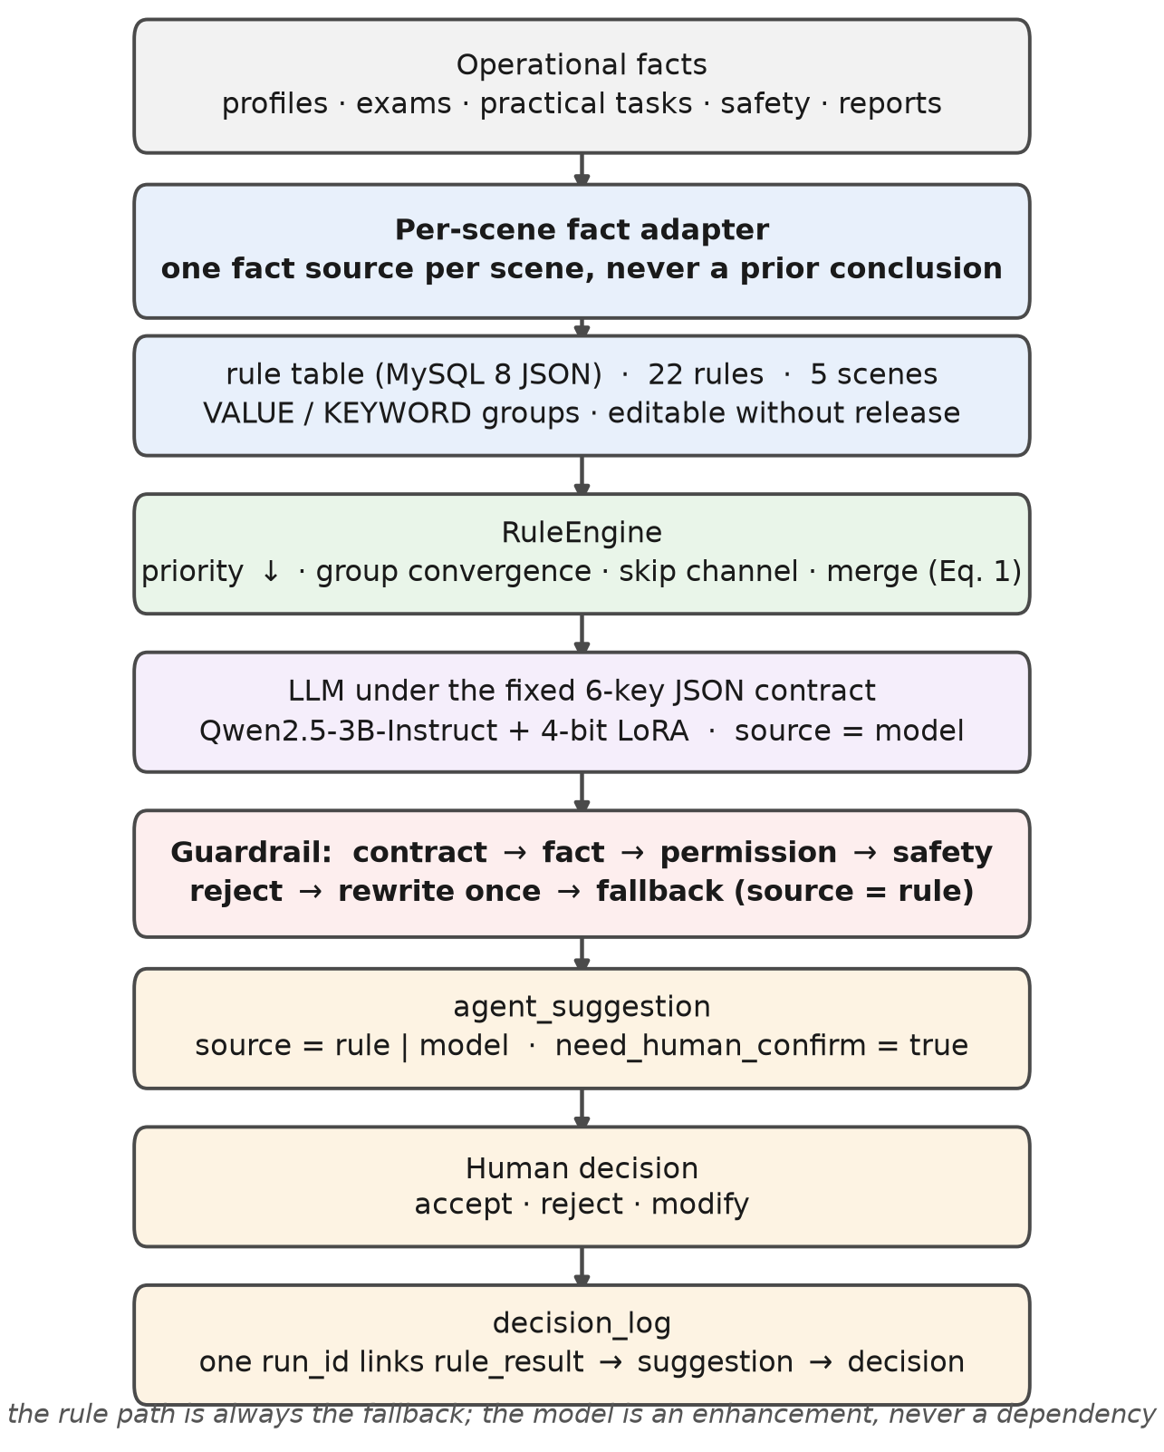
Figure 1. Overall system architecture.
3.1 Declarative Rule Engine
Rules are described as JSON condition trees; operators come from a whitelist, and expression evaluation and string concatenation are disabled, excluding injection risks mechanically. Condition evaluation uses three-valued semantics: satisfied, unsatisfied, and undecidable. Undecidable (missing facts, type mismatch, operator out of scope) only skips that rule and logs the reason; when all rules of a scenario are undecidable, the miss reason is labeled “decidable” rather than “no risk”, preventing insufficient evidence from being misread as a normal conclusion. To support coexistence of “tier assignment” and “keyword supplement”, three mechanisms are designed: rule_group converges within a group—once hit, the group is closed without affecting others; max_hits limits the upper bound of hits within a group; star_from lets action fields reference values of other facts, so one rule can serve multiple object types. Before evaluation, rules are sorted by priority descending and then by ID ascending, so results are independent of physical row order; multi-group hits are deduplicated and merged by severity, keeping the most severe one. Taking exam judgment as an example, the condition body only declares “score below pass line”; both sides of the comparison come from facts, and switching courses only requires changing data.
3.2 Validation and Failure Handling
Model output enters the governance layer and passes through four defense lines in sequence; the judgment objects, dispositions, and implementation locations are shown in Table 2. These four lines are not the same kind of “validation”. The structural contract is a hard judgment: any failure voids the whole conclusion and rolls back to the rule conclusion, and the system has no automatic rewriting—rewriting would turn one failure into two model calls without guaranteeing a better second attempt, while the rule conclusion is already available. Numerical reconciliation is a soft judgment: only logging and capping confidence. Input-side authorization happens before fact assembly—an unauthorized request cannot even fetch data, so the situation “unauthorized data already in context, then trim output” does not exist. Safety handling is not in the validator but in the rule layer via the SAFETY group's hard handling; fact group 8 always provides safety records, and the prompt requires “the one-vote veto must be named with top priority”. The failure paths and source tags are shown in Figure 2; the external source tag takes only rule and model, so replacing the model service does not change business interfaces or the front end.
Table 2. Judgment objects and dispositions of the four defense lines.
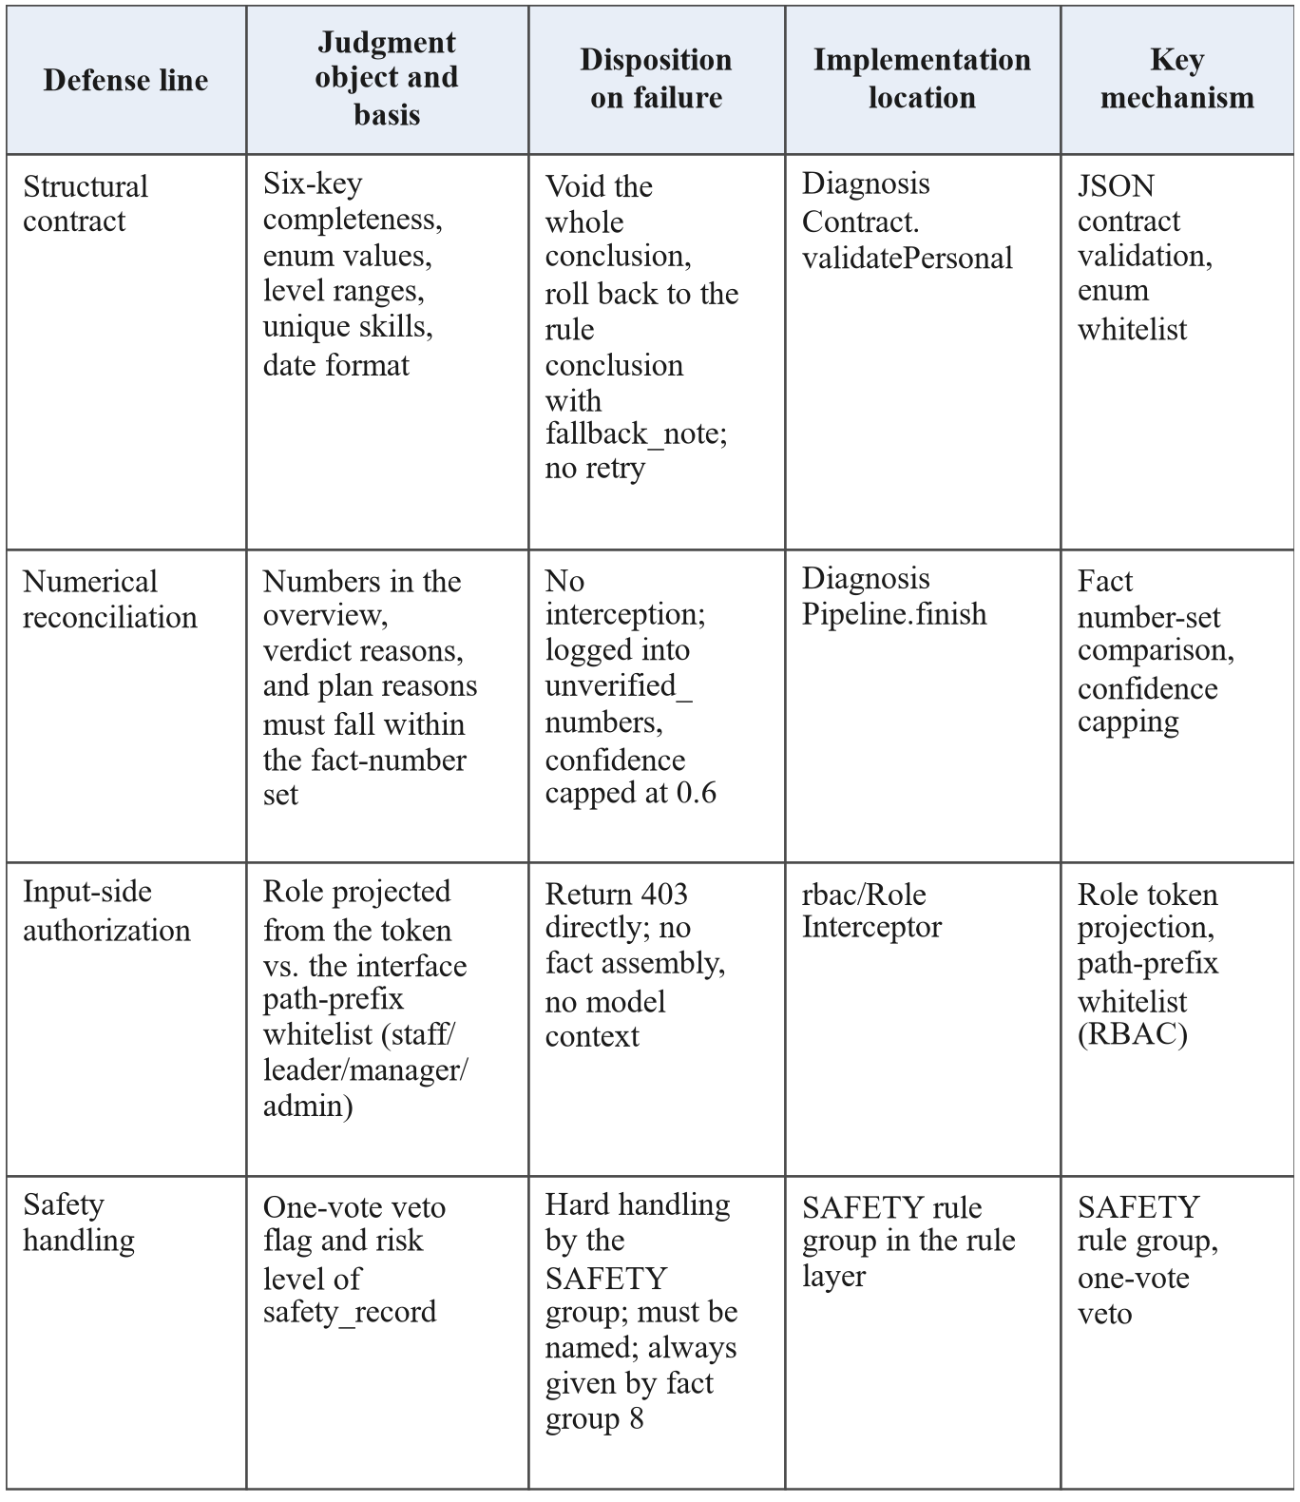

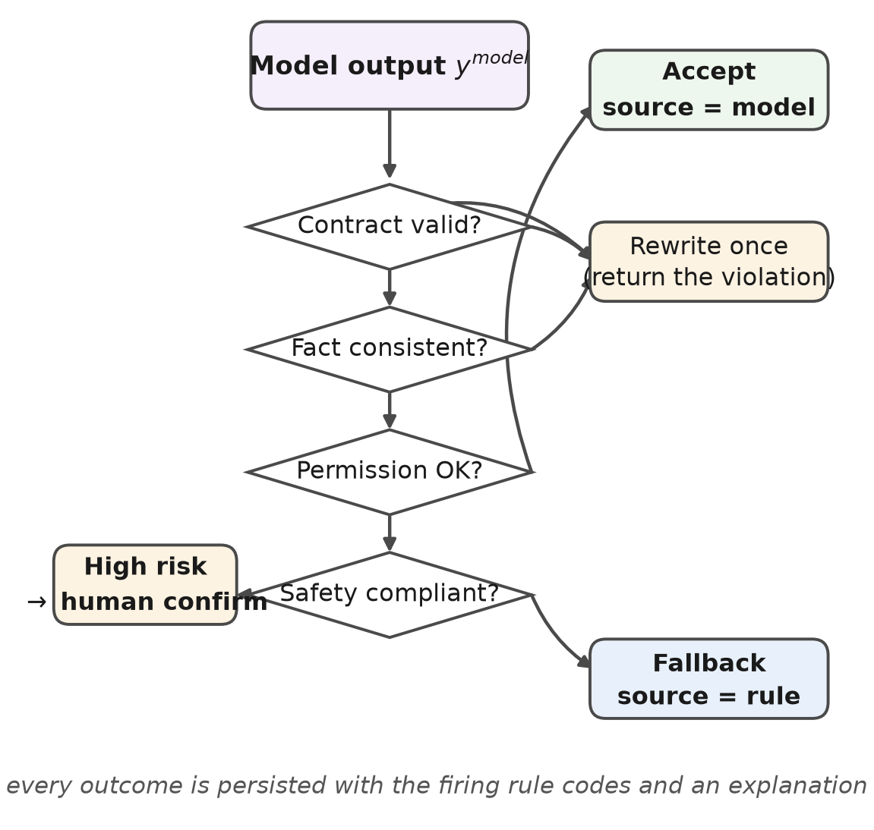
Figure 2. The four defense lines and failure handling.
4 Key Implementation
4.1 Rule Set and Fact Adaptation
The rule base has 22 rules covering five business scenarios, of which 20 participate in evaluation and 2 are kept as historical versions for tracing existing conclusions; the distribution is shown in Table 3. Two principles are followed in modeling. One is that thresholds reference facts rather than literals: the course pass line comes from the course table and the position-required level from the position table, so one rule fits different calibers such as 80 vs. 85 points and L2–L4; when business calibers change, only data change. The other is that composition beats enumeration: the conclusions and dispositions of gas attribution take values from the gas configuration via star_from, so five tier rules serve all gas types; otherwise the rule count would grow linearly with gas types. Two kinds of input must be distinguished: personnel level, scores, and time ratio are observed facts from ledger queries; pass lines, required levels, and gas thresholds are business configurations given by position standards and regulations and released with rule versions; the two are distinguished by source tags in the fact list.
Table 3. Distribution of the rule set over five business scenarios.
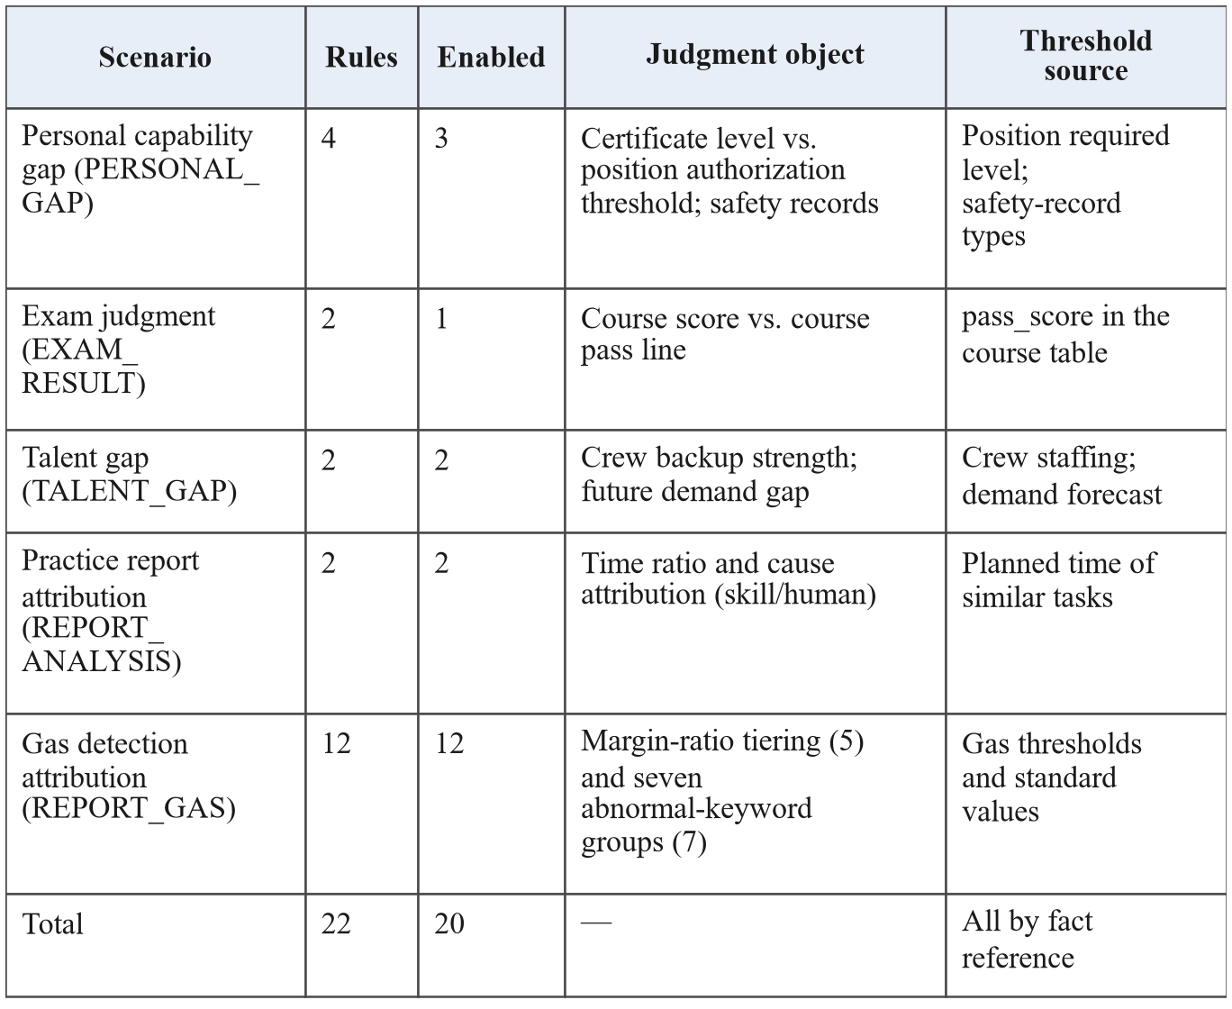

The fact adaptation layer reads only four ledgers—HR, examination, practice, and safety—and assembles profiles into numbered, source-tagged fact lists. Each scenario allows only one fact source and never reads historical diagnosis conclusions, suppressing conclusion feedback. This only reduces feedback pollution; making replay inputs identical further requires fixed ledger snapshots and rule versions, and the replay experiments in this paper are conducted under this premise. The skill gap list is pre-merged by the backend from the skill radar, and the model can only cite it without adding or deleting—this constraint demotes “which skills constitute gaps” from a generation task to a paraphrase task, which is the premise of output stability.
The quantification caliber is as follows: the position gap is the required level minus the current level, the future-demand gap is the future demand minus the current level, both truncated at zero; the four deviations of exam, practice, certificate, and safety are normalized to [0,1]. The six items are weighted into a reinforcement priority, see Eq. (1), with weights configured by the business side per management focus, and then mapped to three tiers P1–P3 by Eq. (2), with thresholds also given by the business side. The scheduling order is therefore homologous with rule judgment and not decided freely by the model.
(1)
(2)
4.2 Output Contract, Corpus and Fine-Tuning
The model outputs under a six-key contract: summary as the overview, confidence, verdict containing the conclusion title and reasons, gaps as gap items (skill, current, required, future, impact, severity, priority), plan as the learning plan (type, target skill, target level, due date, reason), and compound_path as the cross-skill composite path. The diagnosis ID, runtime, source tag, evidence count, and human-confirmation flag are all post-written by the backend without model participation. This division is the premise for the four defense lines: structural fields belong to code, and the model only writes narrative fields.
The first corpus version was organized as “fixed instruction, profile prose, eleven-key target output” with 150 entries, and exposed three mismatches when connected to the online service: prompt non-isomorphism—the online prompt is a four-part form of date, fact list, gap list, and output template, while this version concatenated by profile sections; contract non-isomorphism—six keys vs. eleven keys share only the gap-item name, and all 150 target answers failed validation; incomplete answers—the median answer length was 1,795 tokens while the first-round window was 1,024, truncating about 78% of answer tokens. The second version was therefore rebuilt as 500 entries: the generator replicated the four-part online prompt verbatim from the backend source code, profiles serving only as fact sources; each sample resampled fact combinations, with 124, 232, and 144 samples of 1, 2, and 3 gap items respectively, covering 49 positions without duplicate prompts. The window was set to 4,096, based on a median single-entry length of 3,432 tokens, 95th percentile 3,806, maximum 3,924; the first version's median total length was only 2,368 tokens yet was truncated at 1,024, indicating that the binding factor is the answer share rather than the total length.
Fine-tuning used Qwen2.5-3B-Instruct^{[11]} as the base model, with low-rank adaptation^{[12]} and 4-bit quantization^{[13]}, training only the seven projection matrices of the attention and FFN layers, rank 16, scaling factor 32, batch size 1 with 8 accumulation steps, learning rate 1e-4 with cosine annealing, 5 epochs and 300 steps in total. The trainable parameters are 29.94 million, 0.96% of the full model, yielding a 120 MB adapter. The deployment is a Spring Boot and MySQL 8 backend with a Vue3 front end; the inference service exposes an OpenAI-compatible API via LLaMA-Factory^{[14]} in api mode, with sampling temperature fixed at 0.2 and output forced to JSON objects. Since the model path takes over one hundred seconds end to end, deployment should follow “rule conclusion first, model narrative supplemented with a re-check reminder”, distinguished by source tags, with final human confirmation.

5 Experiments and Result Analysis
5.1 Experimental Setup and Data Relations
Training, inference, and evaluation were done on one device: an RTX 5060 Laptop 8 GB GPU, 32 GB RAM, OpenJDK 17, MySQL 8, and LLaMA-Factory, with the backend and the inference service sharing one GPU. The experimental data are not real business samples but structured profiles generated by factor design: 25 entries of each of six safety-record types, 6 entries of each of 25 exam scores, and 5 entries of each of 30 position matches; the scale, construction, and relations of the five datasets and two replays are shown in Table 4. Note that the training corpus, held-out samples, and evaluation profiles are homologous: all were expanded from the same 150 profiles by the same generator, with held-out samples only changing random seeds and fact combinations. Model measurement therefore reflects “output compliance on unseen prompts” and cannot support inference of cross-organization generalization.
Table 4. Composition and usage of the experimental data and replays.
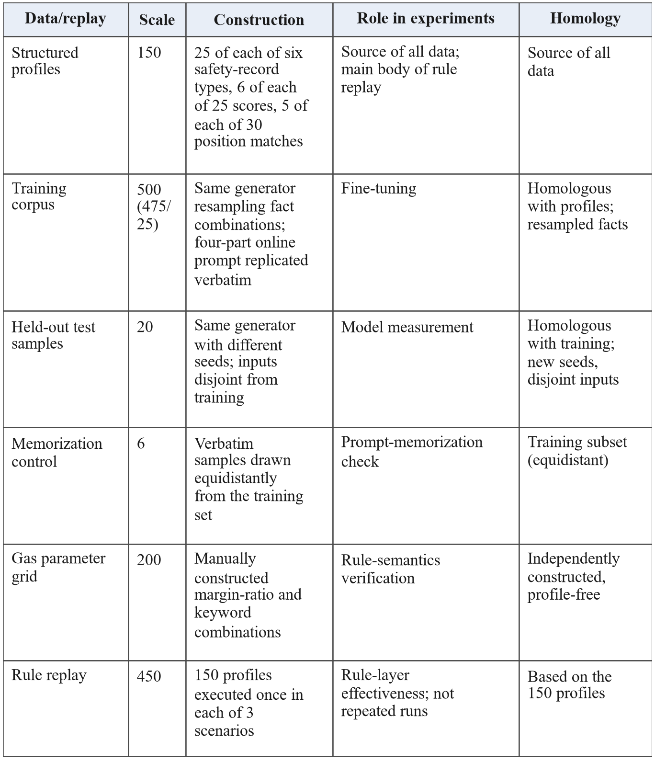

5.2 Effectiveness of the Rule Layer
Profile coverage is defined as the share of profiles hitting at least one rule, see Eq. (3). This metric only says that every profile gets an output, not that the judgment is correct: an always-hitting fallback rule would also yield 100%. Therefore, false positives and false negatives are additionally counted on the two items with independent criteria, which are computed by directly comparing profile fields with the course table, implemented separately from the condition bodies of the tested rules to exclude implementation-level circularity; but the design assumptions are homologous, and the results reflect consistency between rules and business calibers rather than new knowledge discovered by the rules.
(3)
Results of the 450 replays are shown in Table 5. All 132 profiles below the course pass line were hit, with false positives and false negatives both 0. All 120 profiles with certificate levels below authorization thresholds were hit likewise, plus 25 profiles triggering the safety group separately by safety records, totaling 145. Of the 150 profiles, 125 carry safety negatives, including 75 authorization violations, all handled by the safety group, with 0 unconsumed safety records. Practice attribution lacks independent criteria and only reports the hit rate. The applicability of the above rates is limited to this test set. The per-scenario hit rates and the profile-level coverage are shown in Figure 3.
Table 5. Results of the 450 rule replays by scenario.


The 200-case gas parameter grid verifies rule semantics, with every check compared against manually constructed expected conclusions. Five-tier assignment is consistent with expectations in both ratio calibers (200/200); the in-group hit cap and severity merging are likewise fully consistent; fact-reference resolution is 120/120. The deviation is zero: zero cases upgraded to “medium” despite a margin above the threshold by 10%, and the terminal rule is reachable on all 40 margin-sufficient cases. All 22 rules were hit at least once in the grid or the replays, i.e., no unreachable rule was found within the test scope constructed in this paper; this is an observation under finite sampling and does not prove the global reachability of the rule set, and automated detection of rule shadowing is left to future work.
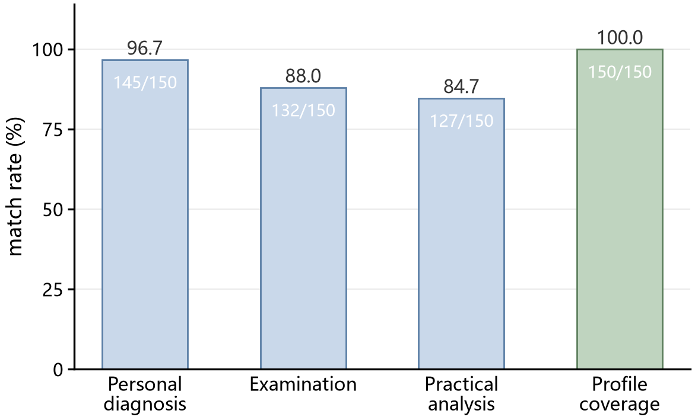
Figure 3. Match rates by scenario and profile-level coverage.
5.3 Determinism and Latency
The 450 executions are byte-for-byte identical across repeated runs; completely reversing the physical order of rules does not change conclusions, as sorting is normalized by priority and ID. In-process single evaluation averages 0.0122 ms, with a median of 0.0105 ms, a 95th percentile of 0.0194 ms, and a maximum of 0.0609 ms; the timing covers only condition evaluation and conclusion merging, not database access, fact assembly, serialization, or network round trips, and cannot be treated as end-to-end latency. The model path takes a median of 105.4 s, a mean of 124.3 s, and a maximum of 324.7 s on the 20 held-out samples, measuring one full request to the complete JSON—heterogeneous with the former, not a comparison within one chain, and no speed comparison is drawn here. These numbers come from single-GPU, single-request, no-concurrency measurements; whether batching and quantized inference can compress the latency was not measured. The single response times of the two paths are compared in Figure 4 on a log scale.
5.4 Fine-Tuning Convergence and Output Quality
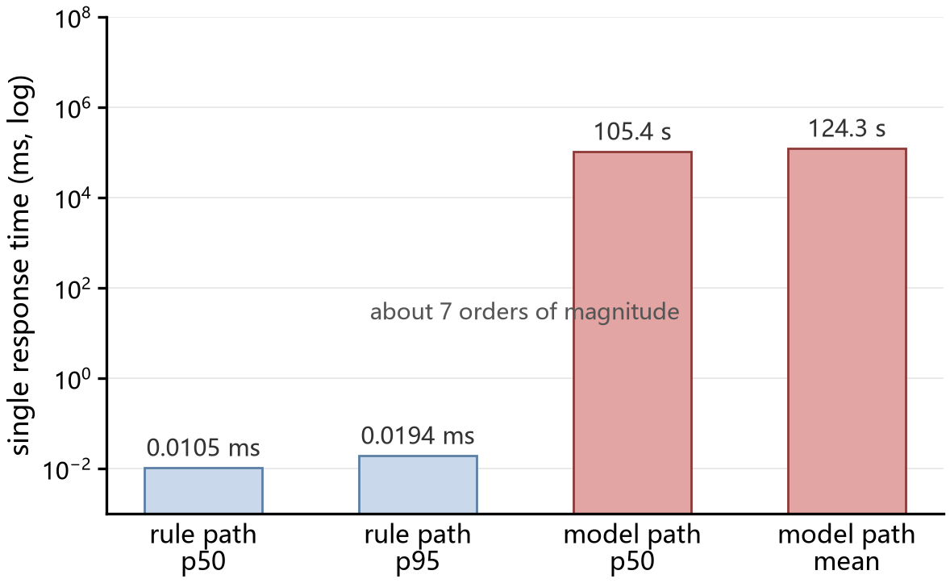
Figure 4. Single response time of the rule path and the model path (log scale).
Model output presumes training convergence. Figure 5 shows the training and validation losses: the first record point is at step 5 with 11.57, about 3% below the uniform-vocabulary entropy ln151936=11.93, indicating that no preference has been learned yet; it drops to 1.01 at step 25 and then slows down, averaging 0.086 and 0.074 over steps 105–200 and 205–300 respectively, ending at 0.063 with an overall average of 0.577. The validation loss decreases from 0.0198 to 0.0106, improving only 1.9% after step 200, with the optimum at the last step, indicating convergence under 5 epochs and the 4,096 window, with limited gains from more epochs. Single-GPU training took 27,428 s. The validation loss being lower than the final training loss stems from different calibers—the training loss is averaged over 5-step windows with dropout active, while validation disables dropout on a fixed set of 25 samples; given their homology and shared templates, this number only indicates good fitting and is not evidence of generalization.
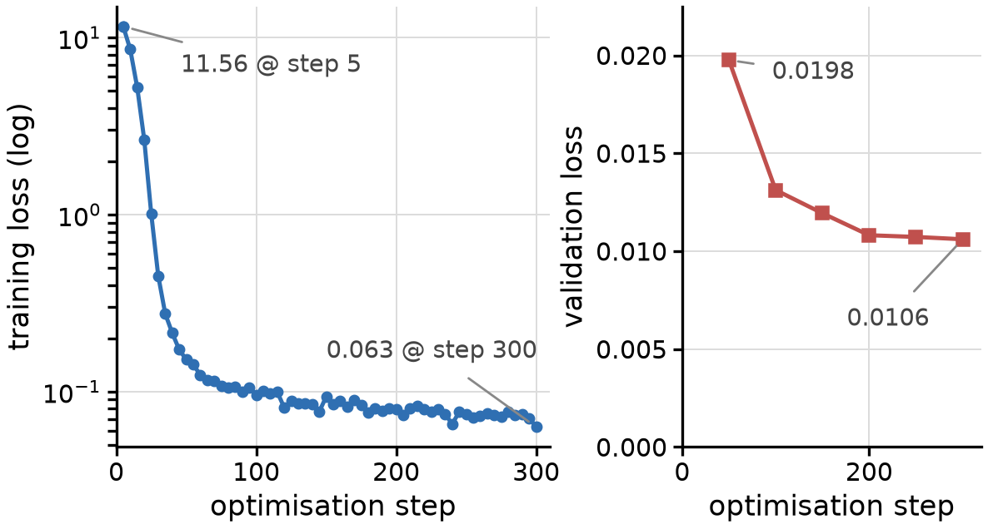
Figure 5. Loss curves of the fine-tuning process.
The 26 test samples consist of 20 held-out samples and 6 verbatim training samples; the results are shown in Table 6, with item-by-item comparison against the fact list as the criterion. The held-out outputs are all valid JSON satisfying the six-key contract; the gap sets match the backend list; levels correspond item by item with the fact list; impact levels match the radar priorities; schedules are later than the current period and strictly increasing; all reasons carry valid fact IDs, citing 4.75 on average; numbers are traceable. Regarding disposition, all 26 passed the hard validation on the first output without triggering rollback—the rollback path was never exercised in this measurement and can only be checked indirectly via the code paths and the injection tests in Section 5.5. The verbatim training samples match the held-out ones, indicating no reliance on prompt memorization; but the two groups are homologous with the same templates, and the consistency itself also indicates limited task difficulty, insufficient to support generalization conclusions.
Table 6. Measured results of the fine-tuned model's outputs.
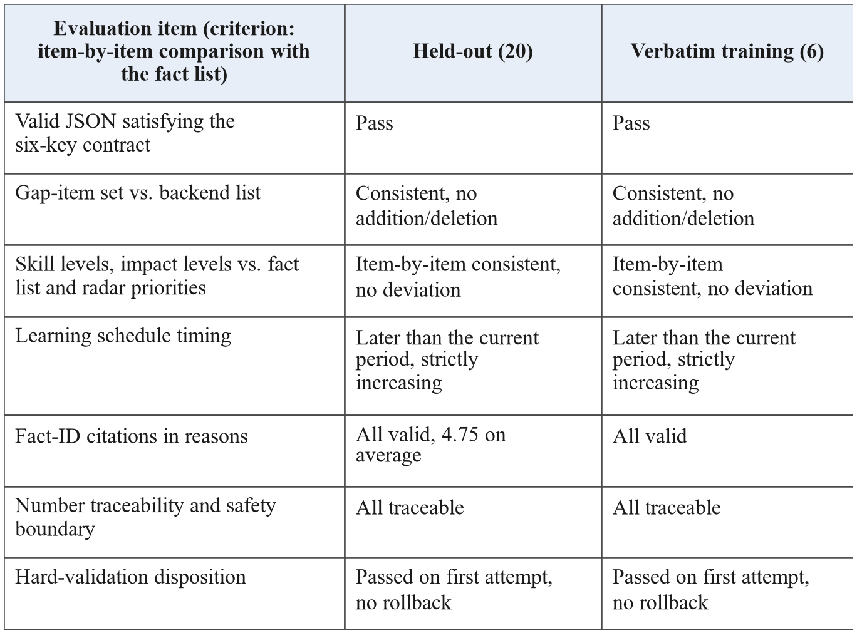

5.5 Error-Injection Testing of the Validator
“All outputs qualified” only reflects model behavior and does not test the validator itself. Therefore, 16 errors were injected item by item from a qualified-conclusion baseline, calling the backend's real validation code; the results are shown in Table 7. All 11 structural cases were rejected by the hard validation with rollback; both numerical cases were logged but not intercepted, as designed for soft judgment; all 3 semantic cases (changing a level to another legal value, a fact ID pointing to a nonexistent entry, and deleting a safety statement) went undetected—the contract only checks fields and enums, not whether field values agree with facts or whether fact IDs exist. This constitutes the coverage boundary of the current implementation: level consistency and fact-ID validity are currently discovered by offline evaluation and are not included in online hard validation. A feasible improvement is to add two checks to the structural contract: the level must equal the value of the same-named skill in the fact list, and fact IDs must exist in the current list; the change is confined to a single validation function.
Table 7. Error-injection tests of the validator.
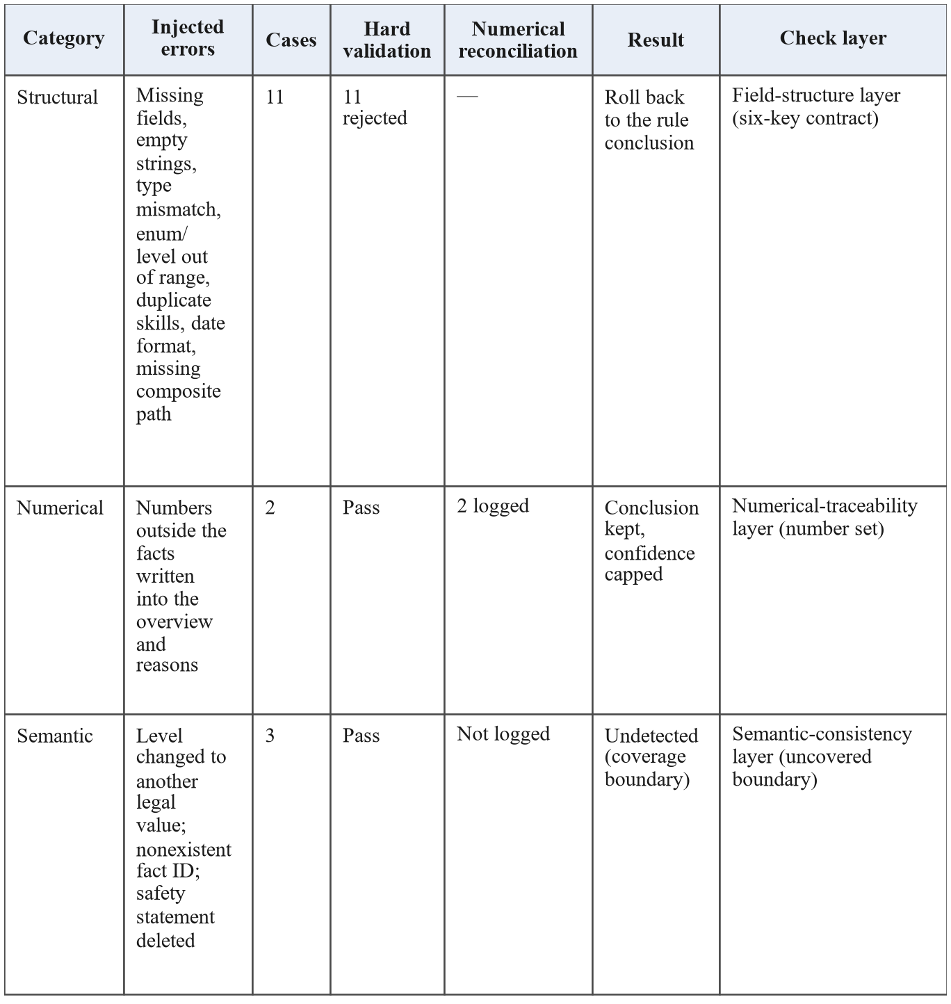

6 Discussion
6.1 Applicable Conditions and Non-Applicable Cases
The architecture holds only if four conditions hold simultaneously: position capabilities are gradable, with capability items mapped to ordered levels so that “currently below requirement” is decidable; business thresholds are enumerable, with quantitative requirements expressible as conditions and maintained as independent facts; profiles are structured, with the four record types summarizable per person into fact lists; and advice must be human-confirmed. Regulation-driven positions satisfying these conditions, such as dispatching, high-voltage testing, and relay protection, can in principle reuse the same architecture, but the rule set and the adaptation layer must be rebuilt and validated; no cross-position experiment was conducted. Four situations do not fit: open-domain Q&A, where judgment conditions cannot be enumerated and RAG should dominate; lacking structured profiles, where the rule path would largely enter the skip channel; real-time closed-loop control, where the model path at the hundred-second level cannot meet online control and interlocking requirements; and automated execution without human confirmation, where directly issuing operation commands requires re-evaluating the safety responsibility boundary.
6.2 Limitations
Six limitations should be noted. Corpus homology: training, held-out, and evaluation data were all expanded from the same 150 profiles, the rule base has only 22 rules, and cross-organization and cross-position generalization is unverified. No baseline comparison: no comparison with “rules plus fixed templates” or “un-fine-tuned base model plus the same validation”; the increment of fine-tuning and the value of model expression over templates are not quantified, which is the top-priority follow-up experiment. Small samples: 26 single-run samples give a proportion resolution of about 4%, and 20/20 passes correspond to a two-sided 95% confidence lower bound of about 83.2%, insufficient for strong reliability conclusions. The validator covers only the structural and numerical dimensions. Expert blind review and field adoption statistics were not conducted, so no causal conclusion on the training effect is drawn. The latency was measured single-GPU single-request, without concurrency or throughput. Future work includes baseline and ablation studies, enlarged held-out sets with multiple runs, semantic-consistency validation, and expert evaluation on real crew data.

7 Conclusion
This paper delegates safety and business judgment to a declarative rule engine, narrative expression to a fine-tuned model, and connects the two with four defense lines of structure, numerical, authorization, and safety. On 150 simulated profiles with 450 replays, the profile-level coverage is 150/150 and the false negatives of the two negative classes are 0; rule semantics are correct on the 200-case grid and repeated executions are identical; the model outputs of 26 samples passed the hard validation on the first attempt. The error-injection experiment also shows that the validator stops structural and numerical problems but not semantic tampering—a boundary closer to reality than “all compliant”. This division makes judgment auditable and expression iterable, offering an implementable scheme for intelligent training of safety-critical power positions; the training effect still requires expert evaluation and field pilots.

References
- Li Y, Lin J S, Bian C, et al. Technical challenges and development path of large models for intelligent operation and maintenance of power equipment[J]. Journal of Xi'an Jiaotong University, 2026, 60(6): 1-10. https://inds3.cnki.net/kmobile/Journal/detail/DLKJ/XAJT20260623001.
- Shu W T, Li R X, Sun T X, et al. Large language models: principles, implementation and development[J]. Journal of Computer Research and Development, 2024, 61(2): 351-361. DOI: 10.7544/issn1000-1239.202330303.
- Yang Q B, Zhu S G, Liu D, et al. Research on key technologies of capability improvement for power grid dispatching large language models[J]. Generating Technology, 2026, 47(4): 697-708. DOI: 10.12096/j.2096-4528.pgt.260402.
- Ji Z, Lee N, Frieske R, et al. Survey of hallucination in natural language generation[J]. ACM Computing Surveys, 2023, 55(12): 1-38. https://doi.org/10.1145/3571730.
- Majumder S, Dong L, Doudi F, et al. Exploring the capabilities and limitations of large language models in the electric energy sector[J]. Joule, 2024, 8(6): 1544-1549. https://doi.org/10.1016/j.joule.2024.05.009.
- Ouyang L, Wu J, Jiang X, et al. Training language models to follow instructions with human feedback[C]//Advances in Neural Information Processing Systems 35. 2022: 27730-27744. https://arxiv.org/abs/2203.02155.
- Lewis P, Perez E, Piktus A, et al. Retrieval-augmented generation for knowledge-intensive NLP tasks[C]//Advances in Neural Information Processing Systems 33. 2020: 9459-9474. https://arxiv.org/abs/2005.11401.
- Karakurt E, Akbulut A. Retrieval-augmented generation (RAG) and large language models (LLMs) for enterprise knowledge management and document automation: a systematic literature review[J]. Applied Sciences, 2026, 16(1): 368. https://doi.org/10.3390/app16010368.
- Yao S, Zhao J, Yu D, et al. ReAct: synergizing reasoning and acting in language models[C]//International Conference on Learning Representations. 2023. https://arxiv.org/abs/2210.03629.
- Rebedea T, Dinu R, Sreedhar M, et al. NeMo Guardrails: a toolkit for controllable and safe LLM applications with programmable rails[C]//Proceedings of the 2023 Conference on Empirical Methods in Natural Language Processing: System Demonstrations. 2023: 431-445. https://doi.org/10.18653/v1/2023.emnlp-demo.40.
- Qwen Team. Qwen2.5 technical report[EB/OL]. 2024. https://arxiv.org/abs/2412.15115.
- Hu E J, Shen Y, Wallis P, et al. LoRA: low-rank adaptation of large language models[C]//International Conference on Learning Representations. 2022. https://arxiv.org/abs/2106.09685.
- Li Y, Yu Y, Liang C, et al. LoftQ: LoRA-fine-tuning-aware quantization for large language models[C]//The Twelfth International Conference on Learning Representations. 2024. https://arxiv.org/abs/2310.08659.
- Zheng Y, Zhang R, Zhang J, et al. LlamaFactory: unified efficient fine-tuning of 100+ language models[C]//Proceedings of the 62nd Annual Meeting of the Association for Computational Linguistics: System Demonstrations. 2024: 400-410. https://doi.org/10.18653/v1/2024.acl-demos.38.

