# ADTTE(time to event) Domain

## strutcure

The structure of ADTTE is one record per parameter per visit and it might have the following variables and corresponding values:

|  |  |
| --- | --- |
| Param/paramcd | **PFS(progression-free survival)**  time from randomization to progression or death  **OS(Overall survival)**  time from randomization to death  **TTP**  Time from randomization to progression  **DOR(duration of response)**  Time from objective response to pd or death |
| Cnsr | 0 for event, 1 for censor |
| Startdt | PFS:randdt  OS:randdt  DOR: first OR date:CR or PR |
| Adt | PFS:   1. Cnsr=0/ event:   use death date or pddtc, whichever comes first as adt   1. Cnsr=1/censor:   Different censoring rules:   1. **lost-to-follow up and withdraw and no documented pd**   the last available tumor assessment date   1. **no baseline or no-post-baseline and pd**   Randdt   1. **For new anti-cancer therapy CM/PR**   the lrsdt before new anti-cancer date  OS:   1. cnsr=0/event:   Dthdt   1. Cnsr=1/censor: lost to follow up and withdraw   Lrsdt  DOR:   1. Cnsr=0/ event:   use death date or pddtc, whichever comes first as adt   1. Cnsr=1/censor:   Last tumor assessment |
| Aval | Adt-startdt+1 |
| Evntdesc | PD, DEATH |

## The derivation process

1. Adsl: subset by ittfl, keep usubjid randdt dthdt
2. Tu: get baseline and post-baseline flag
3. Merge adsl with rs and find the first PD date after randdt
4. Ds: find dsdt of censor(lost to follow-up, withdrawal by subject)
5. Set dtc together and find date of last adequate assessment
6. Merge adsl tmblfl tmpblfl pddt dsdt lrsdt by usubjid
7. If no baseline then adt=randdt cnsr=1

Else if no post-baseline and death (baseline) then adt=randdt cnsr=1

Else if min(dthdt,pddt) then min (baseline+post-baseline) then cnsr=0 adt=min

Else if not min then cnsr=1 adt=lrsdt

# KM plot

KM plot is a stepline going downwards and x- axis is the time usually in months like three six twelve month and y axis is the cumulative survival probability and there is 50% median survival reference line

And for my study, we have the no of partients at risk at each timepoint below the table

And we also display the hazard ratio p-value and confidence interval on the graph

## Simplified examples about KM

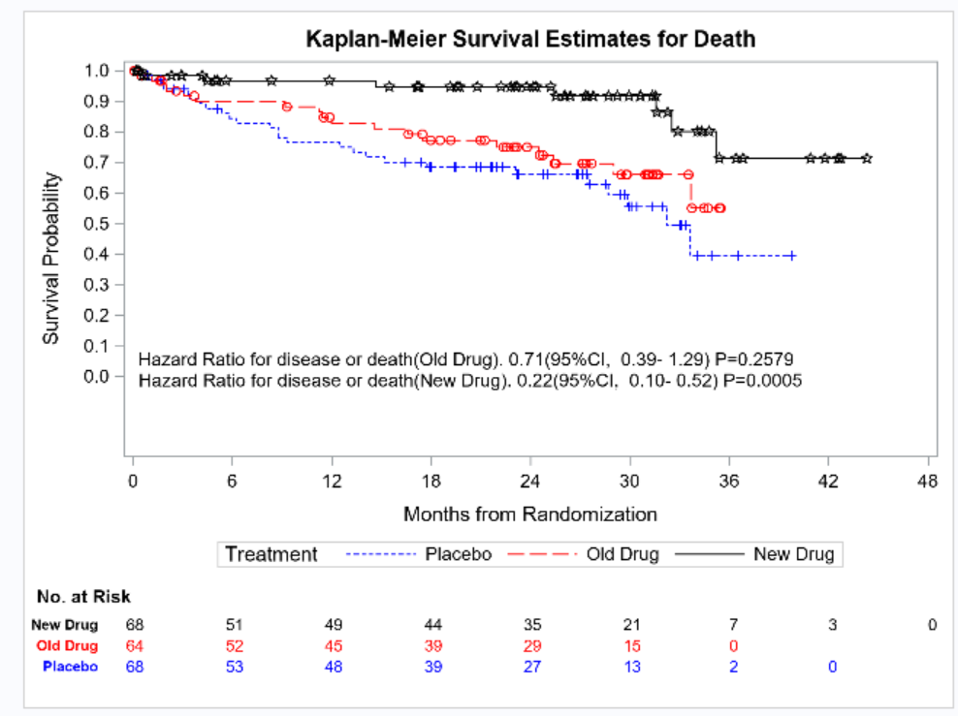

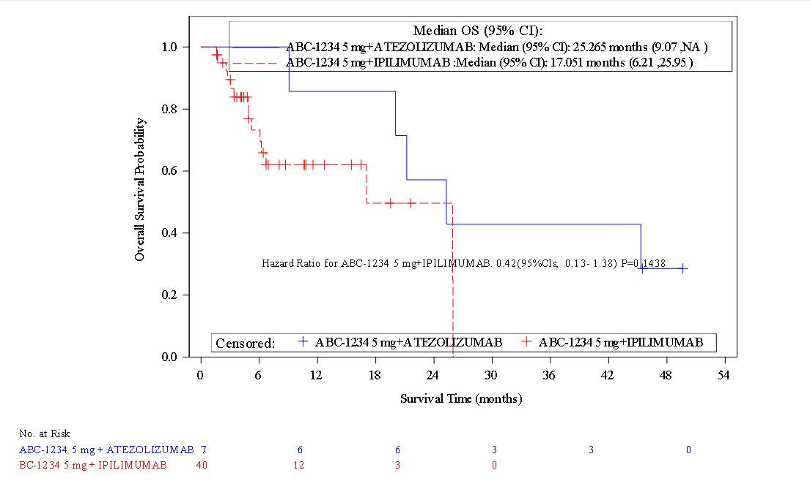

## Programming process

1. Merge adsl with adtte get trta
2. Transform the time unit( minutes to month/week)
3. Proc lifetest generate quartile, survivalplot containing number at risk for specific timelist and homtest dataset
4. Proc phreg calculate hazard ratio for each treatment groups
5. Proc sgplot produce Kaplan-Meier survival plot, with sganno option and custom formatting.

## Hazard ratio interpretation

For example,HR = 2 indicates that an unaffected subject in the treatment group has twice the probability of experiencing the event within a time span than someone in the control group. Whether the treatment is efficient or not depends on the nature of the event and whether you want shorter or longer times to the event. If the endpoint event is the resolution of symptoms(positive), then an HR of two is good. A subject in the treatment group has twice the probability of symptom resolution than someone in the control group at any given point. Patients feel better more quickly.

Conversely, suppose the event is patient death(negative). In that case, a hazard ratio of two indicates that the probability of dying is double in the treatment group relative to the control group at any point. That’s not good because patients are dying more quickly ( survival times are shorter)