# https://pbs.twimg.com/profile_images/1350087683/Logo_CEP-CCIT.JPG

**Continuing**

**Education**

**Program**

**Center for Computing and Information Technology**

**Faculty of EngineeringUniversity of Indonesia**

**PROJECT ON**

**“NY Sharia Cooperative”**

**Group : 7**

**Jasmine Nabila Novel**

**Yansiska**

**­­**

**Faculty : Emma Yulianti ST. MM**

**Class : 4 SC 4**

Faculty of Engineering University of Indonesia

Depok 16424

2018

**PROJECT ON**

*NYSharia Cooperative*

Developed By

*Name : Jasmine Nabila Novel*

*Yansiska*

NIIT

**NYSharia Cooperative**

Batch Code : 4 SC 4

Start Date : May 25th, 2018

End Date : June 5th, 2018

Name Of The Coordinator : Emma Yulianti ST, MM

Name Of Developer : Jasmine Nabila Novel

Yansiska

Date Of Submission : June 5th, 2018

NIIT

**CERTIFICATE**

This is to certify that this report, titled NYSharia Cooperative embodies the original work done by ***Jasmine Nabila Novel and Yansiska*** in partial fulfillment of their course requirement at NIIT.

Coordinator:

*Emma Yulianti S.T M.M*

**ACKNOWLEDGEMENT**

We have benefited a lot from the feedback and suggestions given to us by Ms. Emma Yulianti S.T, M.M and other faculty members. The Project presentation opportunity we have with CCIT-FTUI is a greatchance for learning and professional development. Therefore, we consider ourselves very lucky as we are provided with an opportunity to be a part of it. We are also grateful for having a change to meet so many wonderful people and professionals who led us through this project period.

Bearing in mind, we would like to express our deepest gratitude and special thanks to Ms Emma Yulianti ST, M.M of CCIT-FTUI faculty who is spite of being extraordinarily busy with her duties, took time out to hear, guide and keep us on the correct path and allowing us to carry out our project until completion.

Our Project assignment won’t be as good as it is now without any help, feedback and suggestion that were given to us by our friends within the campus. So, we would also like to say thank you to all of them. We will strive to use gained skills and knowledge in the best possible way, and we will continue to work on the improvements, in order to attain desired career objective.

**SYSTEM ANALYSIS**

**System Summary:**

The proposed software system for Rent House will be used by two different types of platform:

1. Web for User and Admin

The proposed software system needs to provide the following functionalities to the Admin of NY Sharia Cooperative:

1. Allow Admin to View Member Data, Loan Data.
2. Allow Admin to Change Status to Loan.

The proposed software system also provide the following functionality to the User of NY Sharia Cooperative :

1. Allow User to Registration, Login, Edit Profile, View History Loan

**HARDWARE AND SOFTWARE REQUIREMENTS**

**Hardware: - Acer Aspire ES14, AMD Quad-Core Processor 5000(1,5 Ghz)**

* **AMD Radeon HD 8330 8.00 GB (RAM)**

**Operating System: Microsoft Windows 10.1 Pro, 64-bit Operating System**

**Software: Astah Jude Professional**

**SQL Server 2012**

**Visual Studio 2015**

**INDIVIDUAL PROJECT SCHEDULE**

|  |  |  |  |  |  |
| --- | --- | --- | --- | --- | --- |
| **S. No** | **Activity Description** | **Planned Date of Completion** | **Actual Date** | **Responsibility** | **Remarks** |
| 1 | Creating the Database for Web | 29th May 2018 | 29th May 2018 | Yansiska and Jasmine |  |
| 2 | Creating WCF Service | 02th June 2018 | 05th June 2018 | Yansiska and Jasmine |  |
| 3 | Creating Web Application | 29st June 2018 | 29st June 2018 | Yansiska |  |
| 4 | Creating Paper Project | 05th June 2018 | 05th June 2018 | Jasmine and Yansiska |  |
| 5 | Creating UML DIagrams | 05th June 2018 | 05th June 2018 | Jasmine and Yansiska |  |

**WCF SYSTEM ARCHITECTURE DIAGRAM**

Manage Loan

**WCF**

Manage Admin

Manage User

Update Pinjam

Add Pinjam

Login Admin

Login User

Update Member

Add Member

Login Admin

DATABASE

FOR WEB

**ACTIVITY DIAGRAM FOR NYSharia**

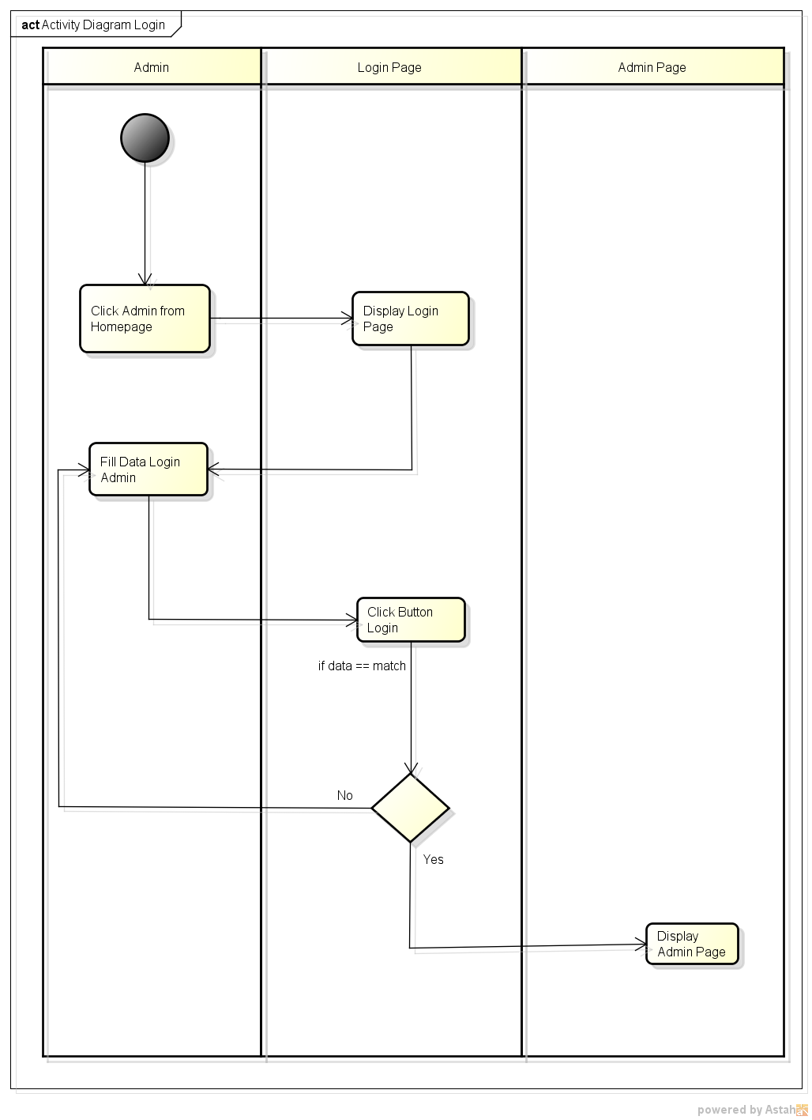

*Activity Diagram Login*

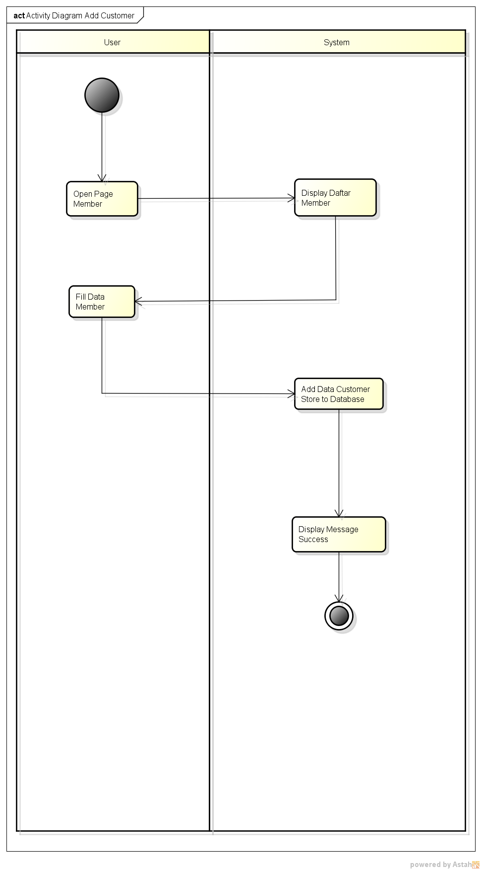

*Activity Diagram Registration*

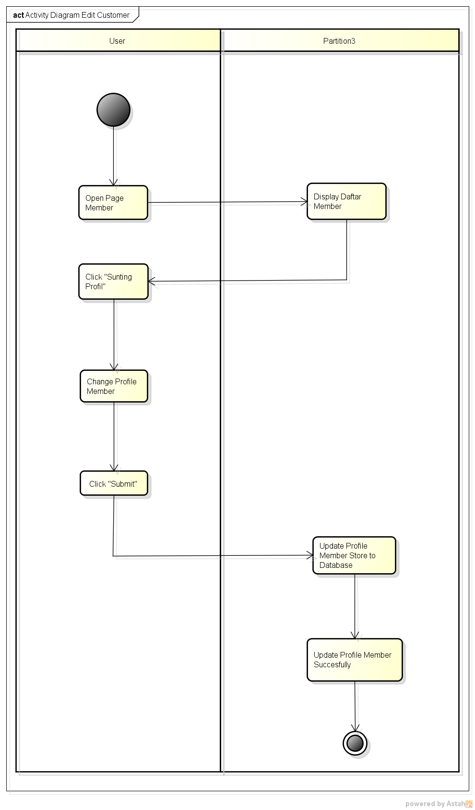

*Activity Diagram Edit Profile*

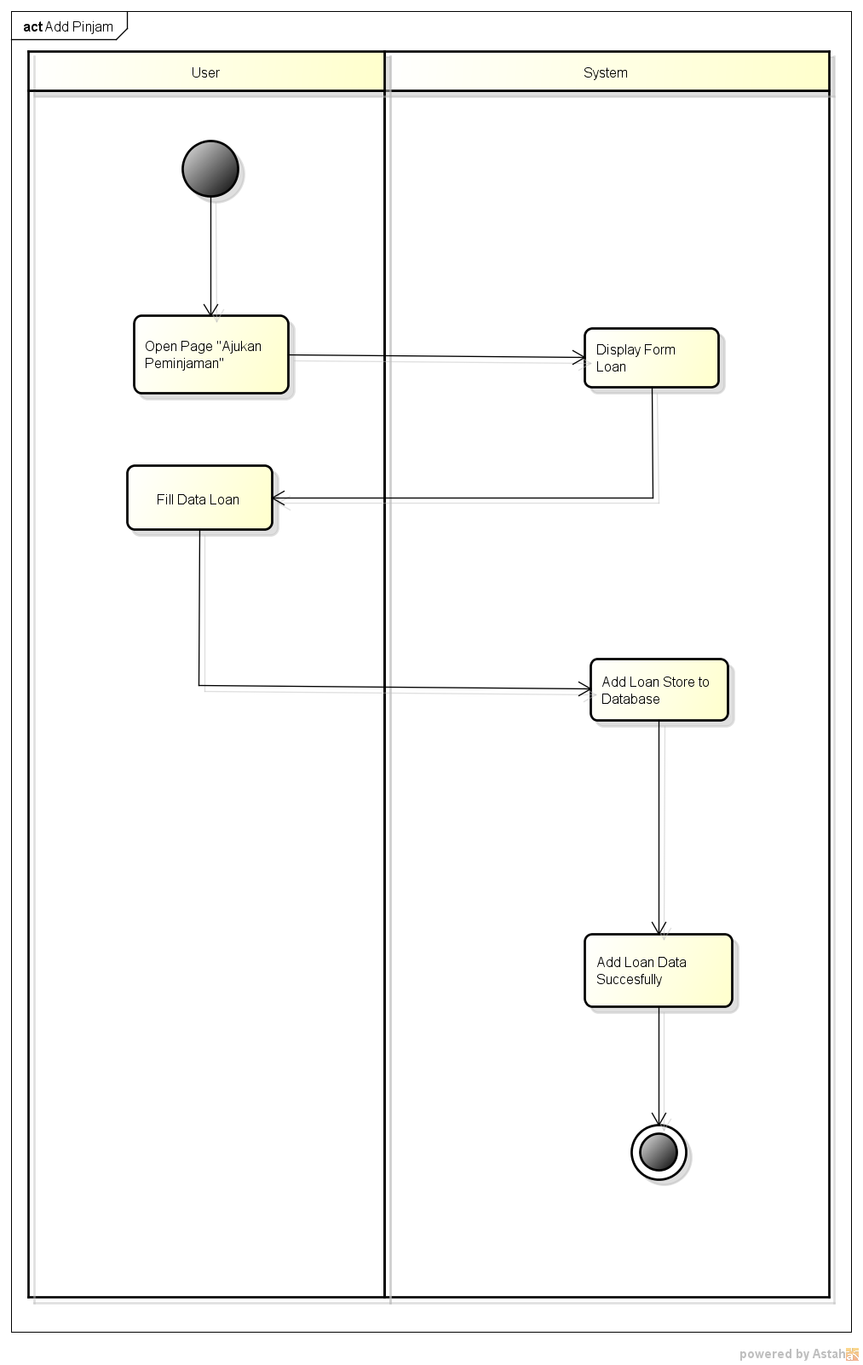

*Activity Diagram Add Pinjam*

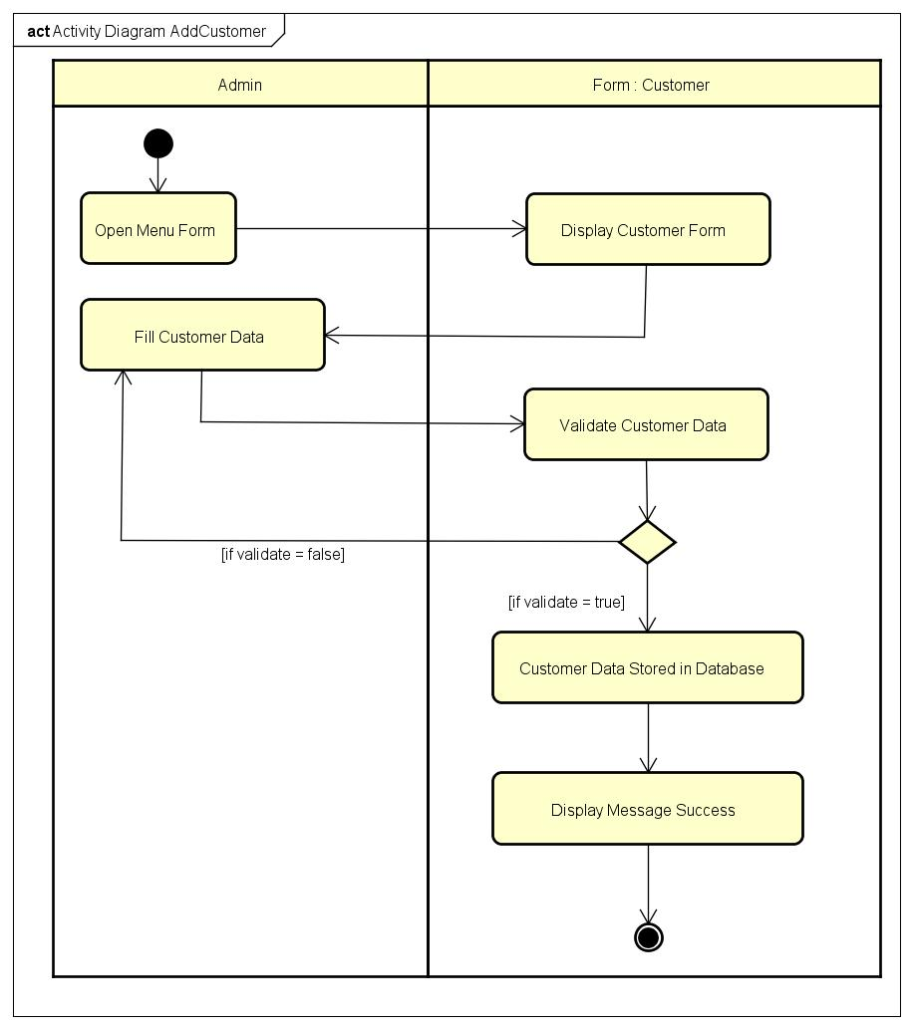

*Activity Diagram Add Customer*

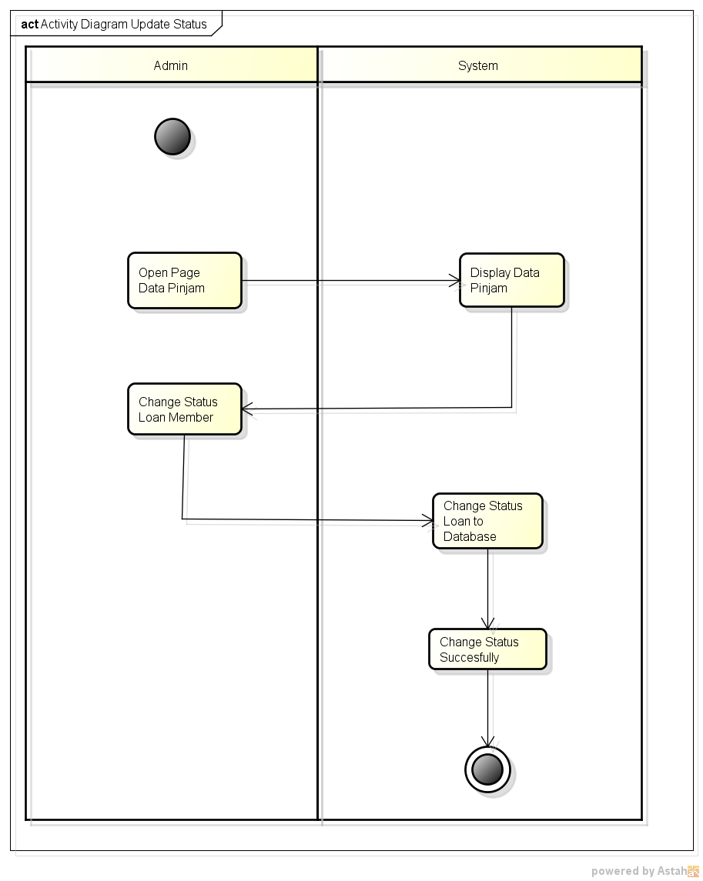

*Activity Diagram Update status pinjam*

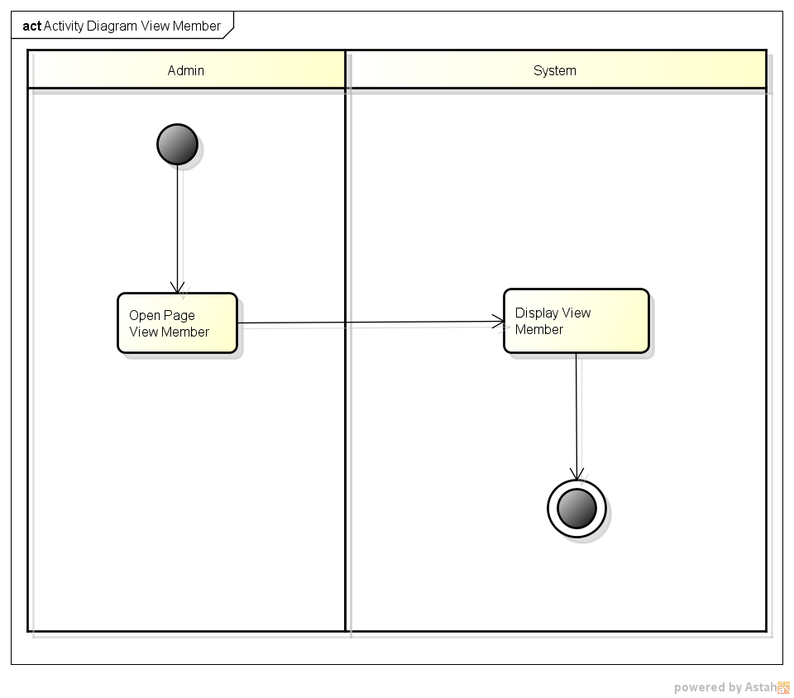

*Activity Diagram View Member*

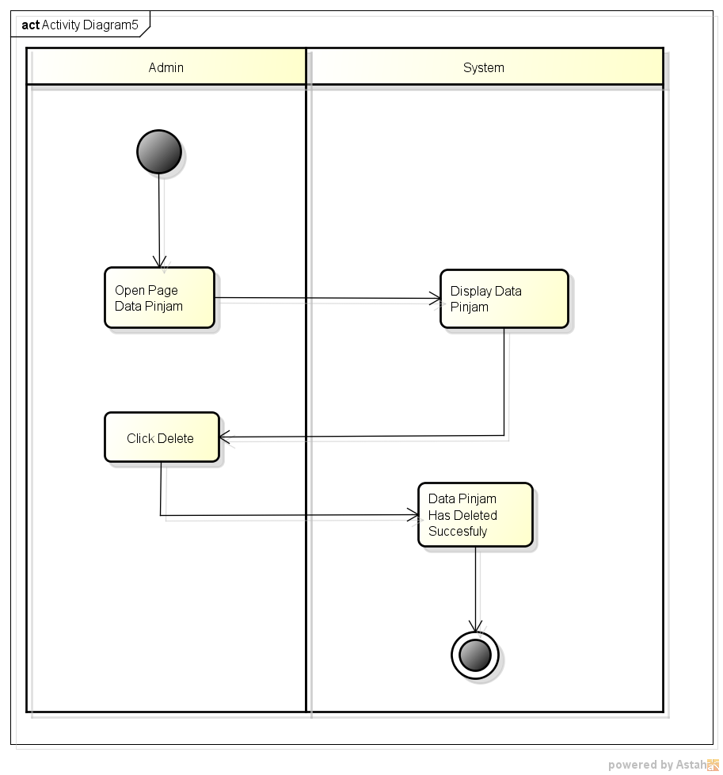

*Activity Diagram Delete Data Loan*

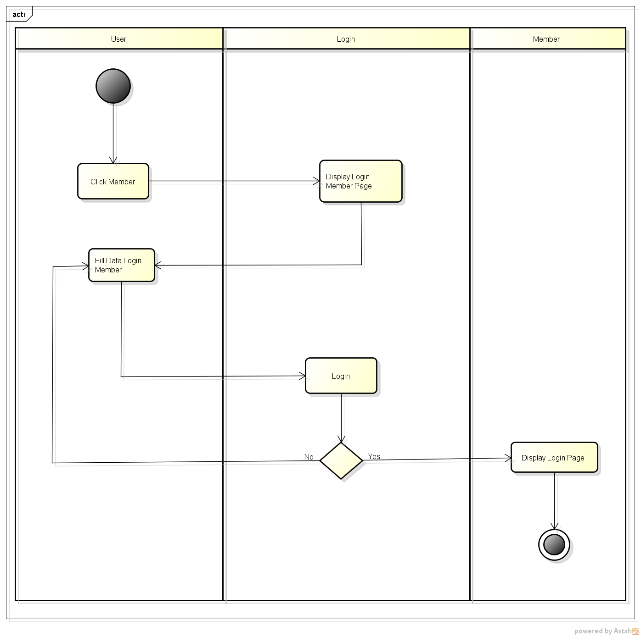

*Activity Diagram Login Member*

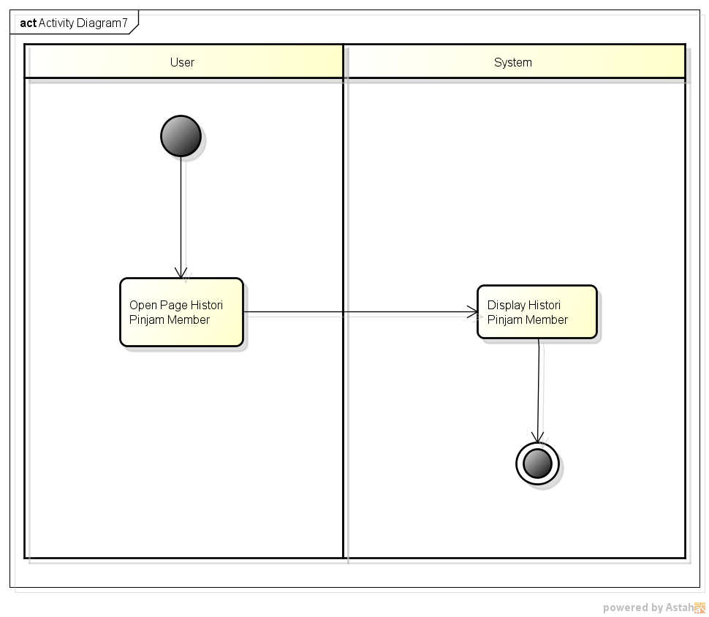

*Activity Diagram View Histori Pinjam Member*

**USE CASE DIAGRAM FOR NYSharia**

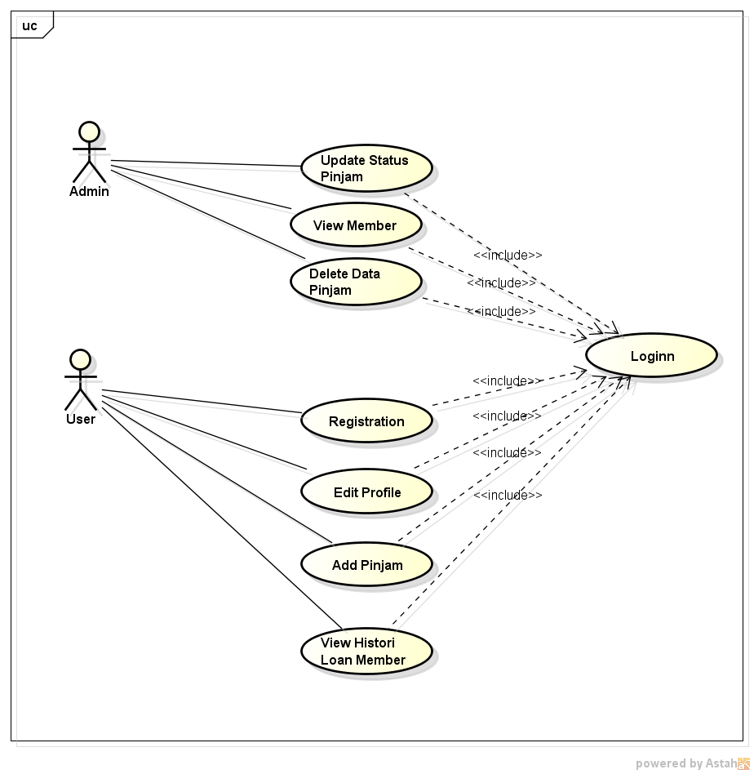

*Use Case Diagram*

**INTERFACE OF NYSHARIA FOR WEB**

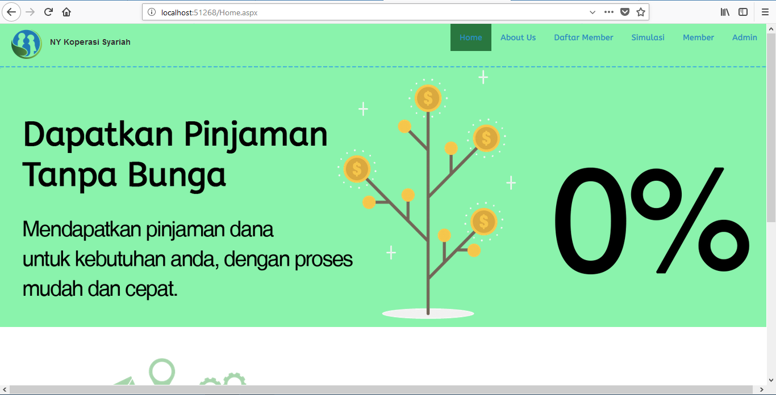

*Home*

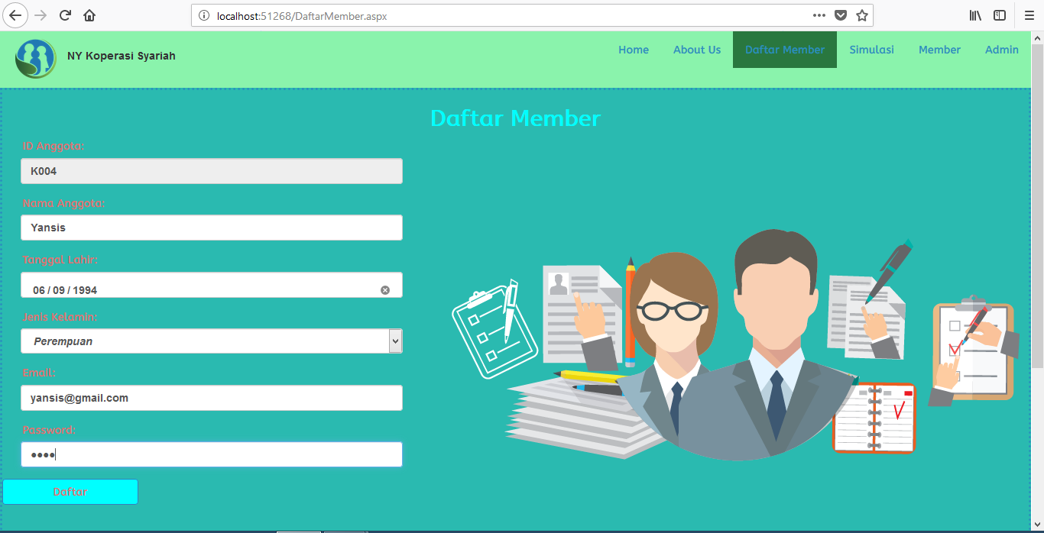

*Registration Member*

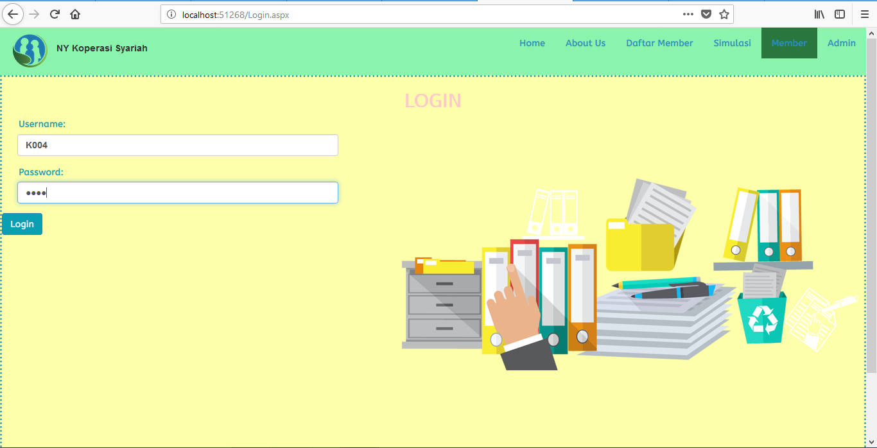

*Login Member*

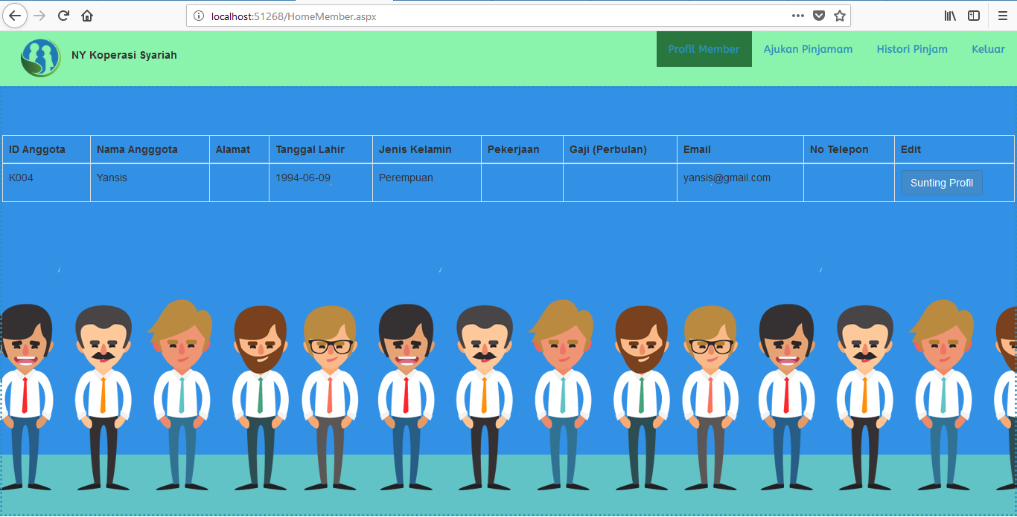

*Profile Member New Regis*

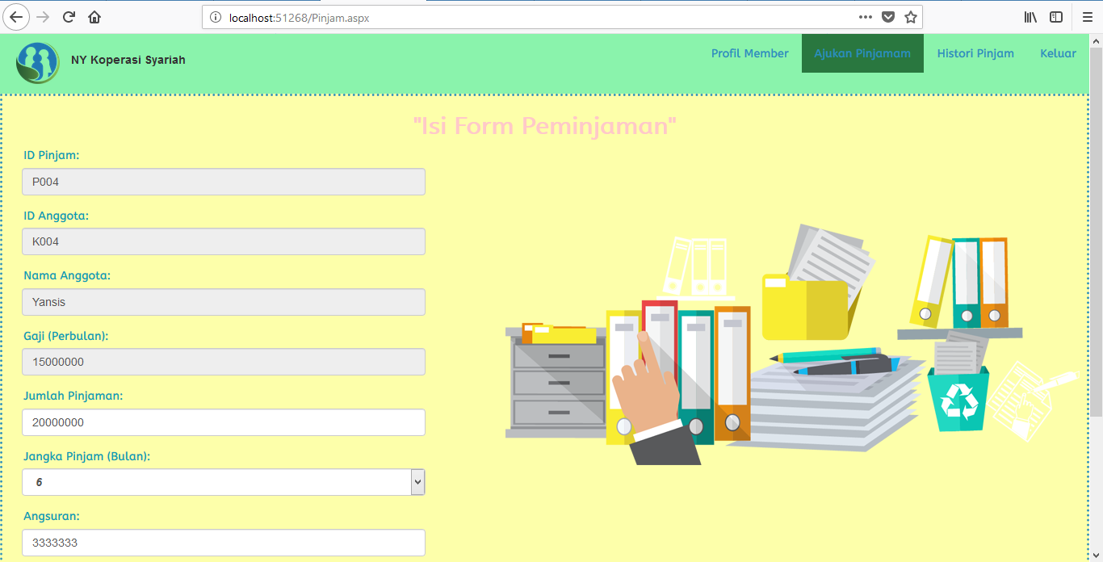

*Form Loan*

**

*Greetings After Loan*

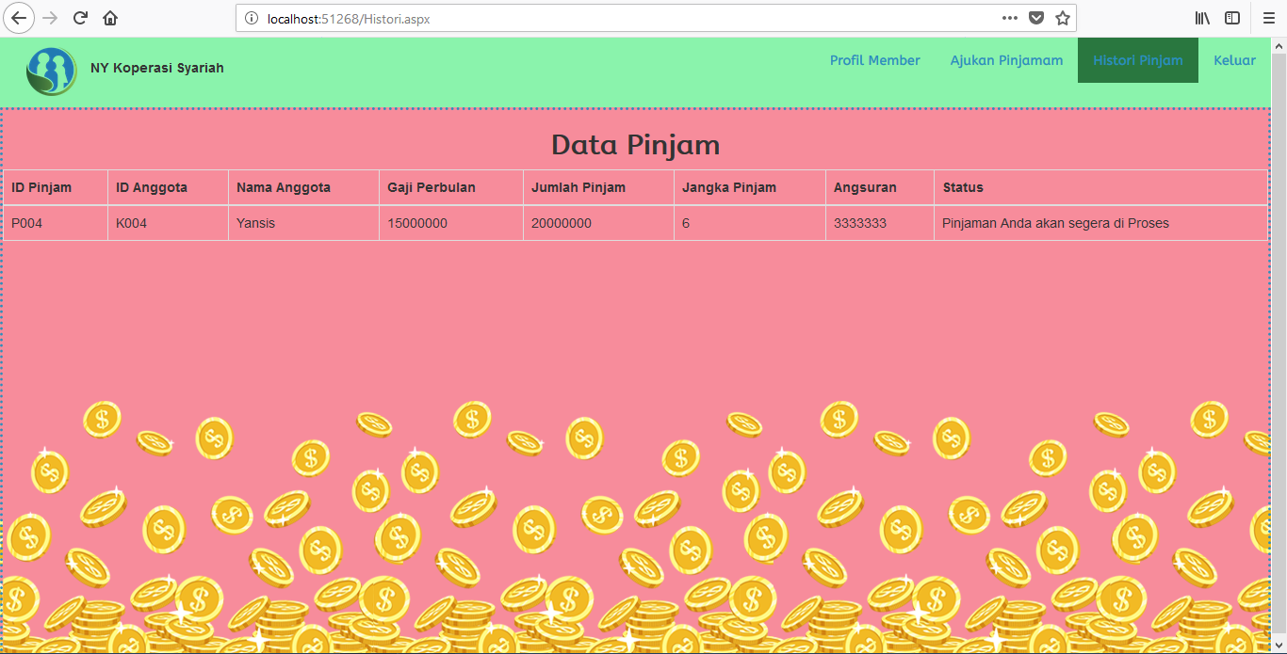

*History Status Member After Loaning*

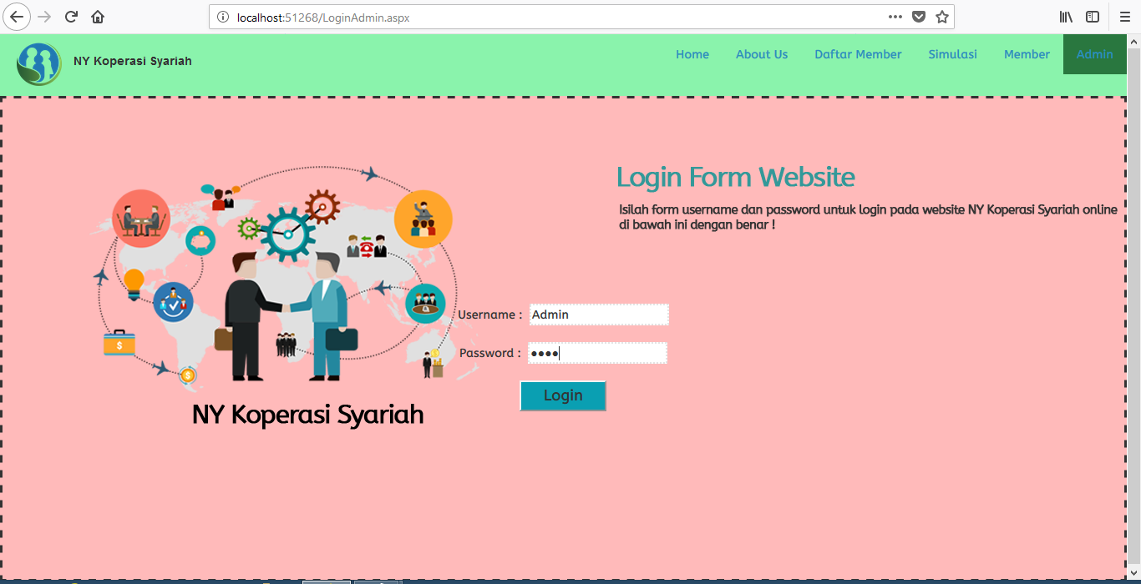

*Login Admin*

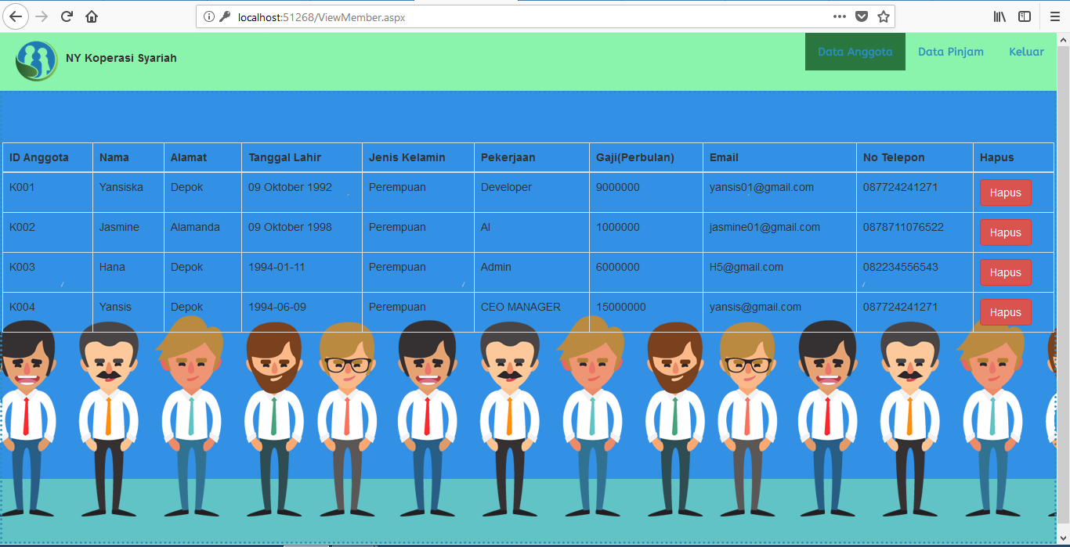

*Data Member for Admin*

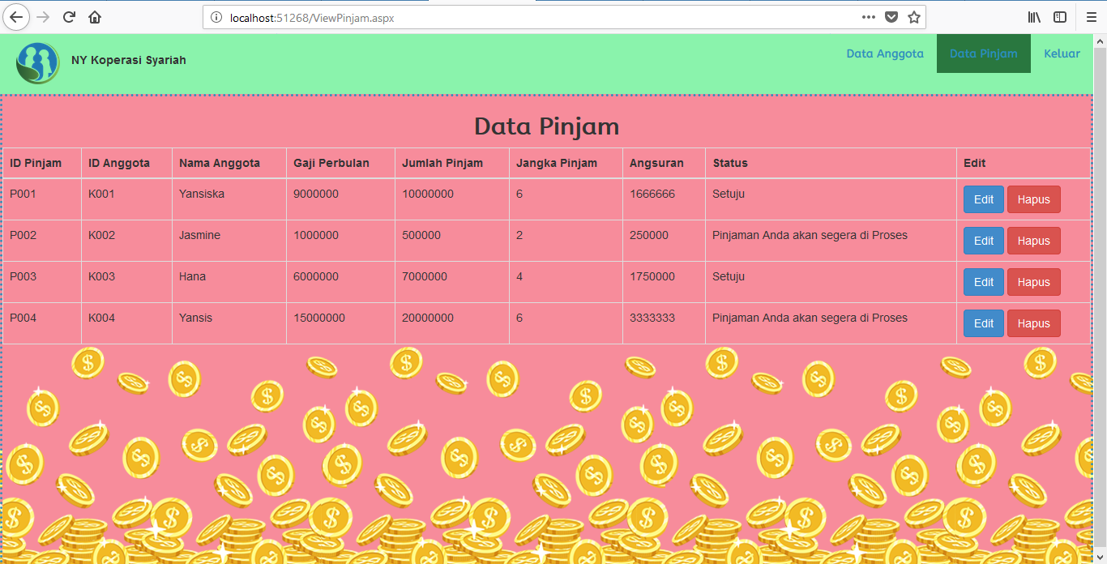

*Data Loan for Admin*

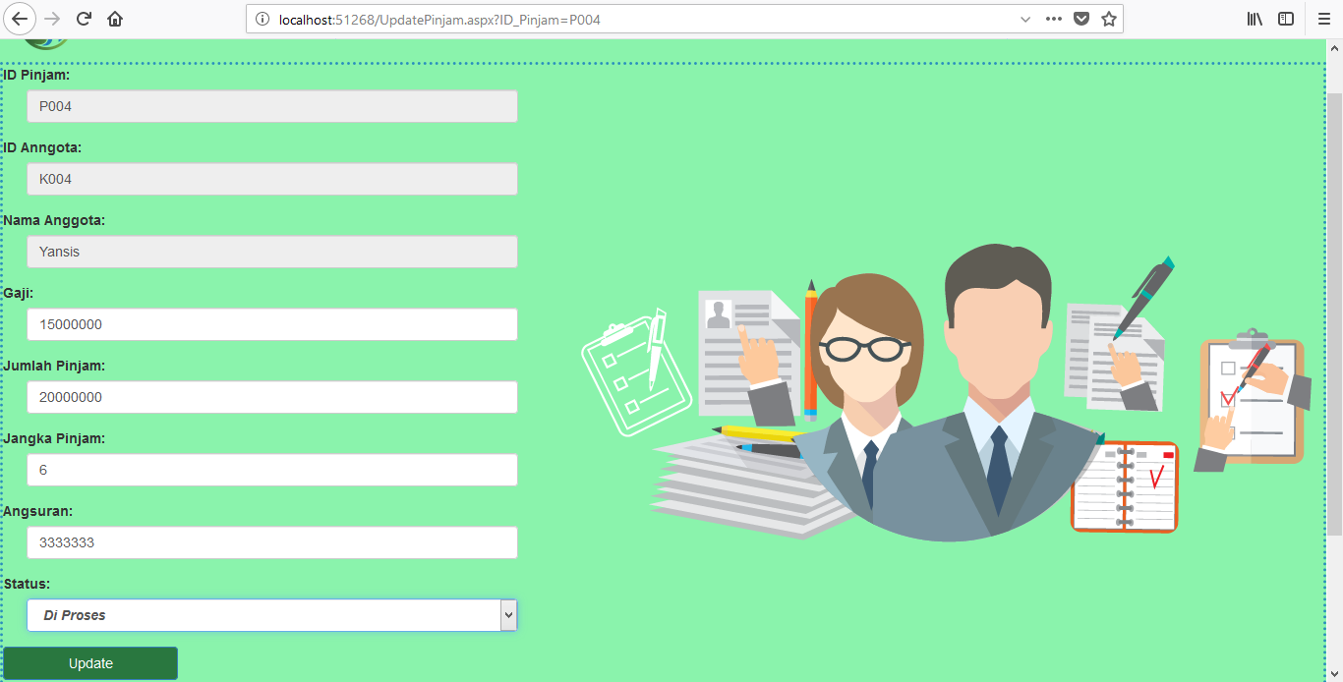

*Update Status for Admin*

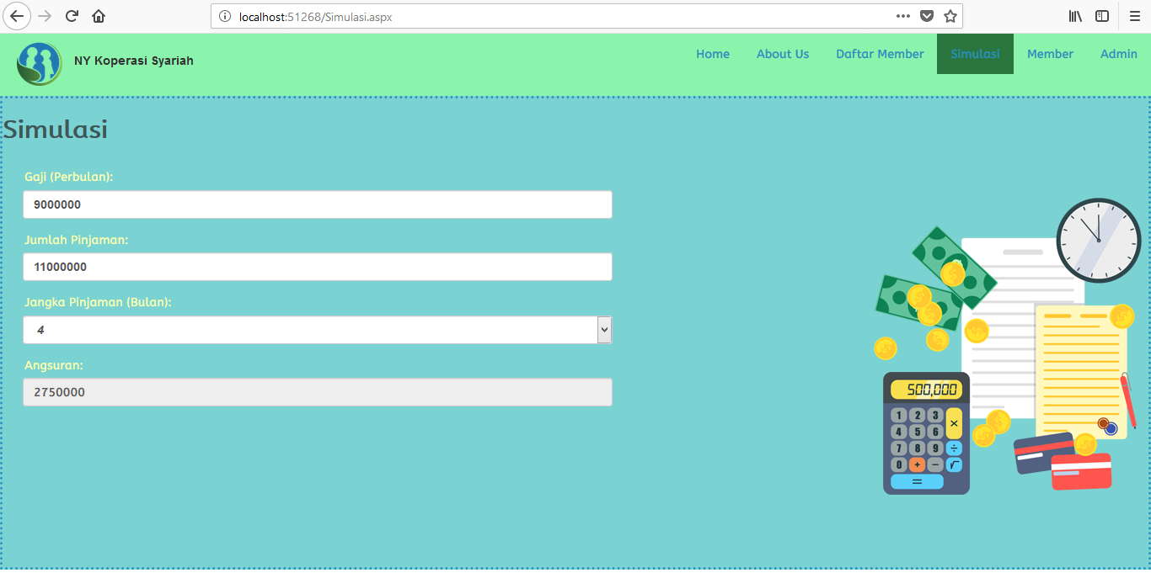

*Simulation*