Short-Horizon GPU Power and Thermal Forecasting for Predictive Two-Phase Direct-to-Chip Cooling: A Real-Telemetry Study with a Data-Center Digital Twin
Jasmitha
[Department], [Institution], [City, Country]

Abstract—Liquid cooling of AI-dense GPU racks is usually controlled reactively from the current temperature. We study whether 30–60 s forecasts of GPU power and temperature, learned from real NVIDIA telemetry, can drive a predictive cooling controller. Using 104 randomly sampled labelled jobs (2,996,039 GPU-seconds) from the public MIT Supercloud dataset (V100, nvidia-smi), we train persistence, utilization-only gradient boosting, gradient boosting with full telemetry and workload labels, and LSTM forecasters under a strict chronological job-level split. On the held-out test jobs, an LSTM gave the lowest power error at 30 s (MAE 11.37 W vs 12.79 W for persistence), but the improvement was not statistically significant. For temperature, no learned model was significantly better than persistence (MAE 0.455 °C at 30 s), and workload labels did not improve accuracy. We couple the selected forecaster to a model-predictive controller acting on a simplified two-phase cold-plate digital twin and compare it with threshold control on the same real power traces. Over 30 test traces, threshold control exceeded the limit for 993 s, PI control for 15 s and the predictive controller for 0 s; a predictive controller fed with a persistence forecast did equally well, so the gain here comes from model-based control rather than from the learned forecast. Cooling-side results are simulated, not measured.
Index Terms—GPU telemetry, thermal forecasting, LSTM, gradient boosting, predictive control, two-phase cooling, digital twin, data centers.

I. INTRODUCTION
GPU power in AI training and inference changes within seconds as jobs move between phases. With direct-to-chip liquid cooling, the coolant loop responds with actuator and transport delays, so a controller that reacts only after the temperature crosses a limit is late by construction. Forecasting the heat load a few tens of seconds ahead could let the loop act early.
This paper asks two questions. First, how well can GPU power and temperature be forecast 30, 45 and 60 s ahead from real telemetry, and do richer telemetry or workload labels help beyond simple baselines? Second, in a simulated two-phase cold-plate loop driven by real power traces, how does forecast-driven control compare with conventional threshold control? We keep measured data, model predictions and simulated cooling variables strictly separate.

II. DATA
We use the labelled deep-learning subset of the MIT Supercloud dataset [1]: nvidia-smi telemetry from NVIDIA V100 GPUs at ≈0.1 s, with a model-architecture label per job (26 labels, 3,430 jobs). For this study we drew a random subset of 104 jobs (four per label) among single-file jobs of 2–40 MB, to keep processing on a laptop. Files were streamed from the public bucket, hashed, de-duplicated, screened for impossible values and averaged onto a 1 s grid; series were split at gaps longer than 2 s.
TABLE I. Data actually used (measured from the processed files).
Item | Value
Raw rows | 28,193,026
Clean 1 s rows | 2,996,039
Missing / duplicate rows | 0 % / 0
Rows removed (impossible) | 28,842
Median raw interval | 0.106 s
Split (train/val/test jobs) | 73/16/15
Test windows | 94,926
Jobs were ordered by start time; the earliest 70 % form the training set, the next 15 % validation and the last 15 % test. No window crosses a job boundary. Because the split is chronological, 17 labels have no job in the test period, so test results cover 9 labels.

III. FORECASTING METHOD
For each anchor time t (every 5 s, after a 60 s warm-up) we predict the change in power and temperature at t+30, t+45 and t+60 s; the level is reconstructed as the current value plus the predicted change, so persistence is the natural zero point. Features use only data at or before t: current utilization, memory utilization and use, temperatures and power; rolling means, maxima and standard deviations over 10/30/60 s; least-squares slopes; lags; time since series start; and, where stated, the workload label and its family. A unit test asserts that changing future values never changes a feature.
Models: B0 persistence; B1 LightGBM [2] on utilization features only; A0 LightGBM on all telemetry; A1 A0 plus the workload label; L0 a two-layer LSTM [3] (64 units) on the last 60 s of six raw signals; L1 L0 plus a label embedding. Hyper-parameters were fixed in advance; early stopping uses validation MAE. LSTMs were trained with two seeds each (the full design uses five) and at most 10 epochs on up to 800,000 training windows, using PyTorch [4]. The model selected for control is the one with the lowest validation MAE at 30 s.

IV. FORECASTING RESULTS
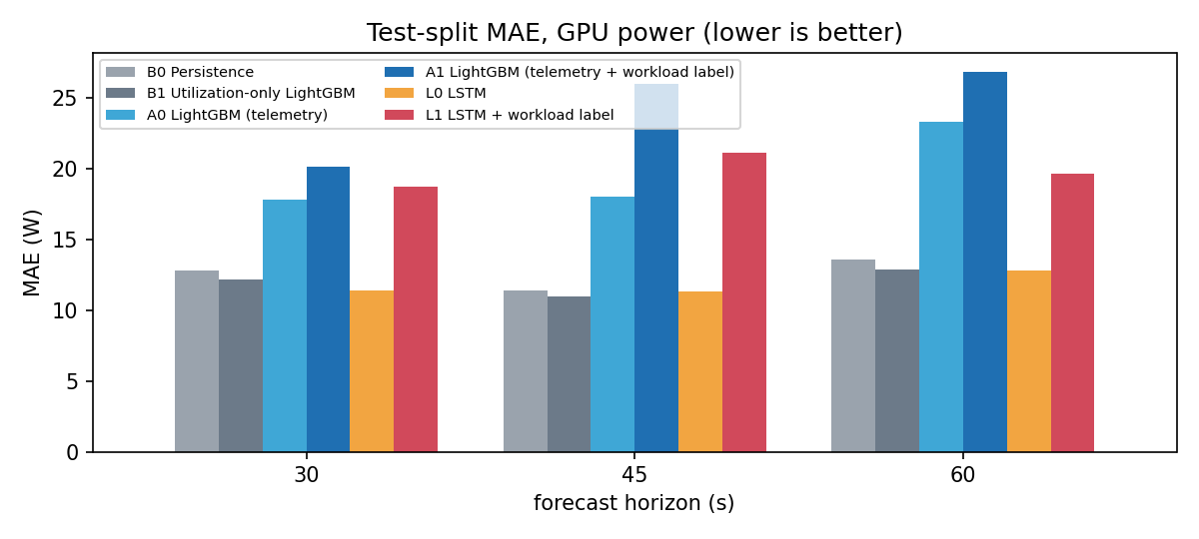
Fig. 1. Test-set MAE of GPU power forecasts by horizon.
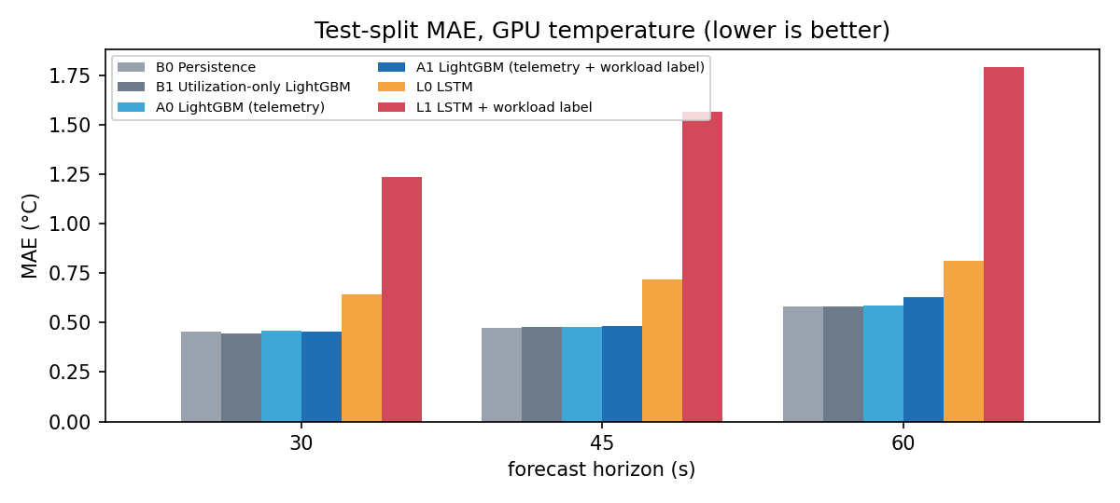
Fig. 2. Test-set MAE of GPU temperature forecasts (temperature of the source V100 system).
TABLE II. Power forecasts on the test split (W).
Model | h (s) | MAE | RMSE | R²
B0 Persistence | 30 | 12.79 | 27.85 | 0.71
B0 Persistence | 60 | 13.56 | 29.40 | 0.67
B1 Util.-only GBM | 30 | 12.17 | 25.83 | 0.75
B1 Util.-only GBM | 60 | 12.86 | 27.30 | 0.72
A0 GBM | 30 | 17.82 | 25.70 | 0.75
A0 GBM | 60 | 23.29 | 32.00 | 0.61
A1 GBM + label | 30 | 20.16 | 27.88 | 0.71
A1 GBM + label | 60 | 26.83 | 35.66 | 0.52
L0 LSTM | 30 | 11.37 | 21.14 | 0.83
L0 LSTM | 60 | 12.78 | 22.92 | 0.80
L1 LSTM + label | 30 | 18.71 | 27.48 | 0.71
L1 LSTM + label | 60 | 19.66 | 29.26 | 0.68
TABLE III. Temperature forecasts on the test split (°C).
Model | h (s) | MAE | RMSE | R²
B0 Persistence | 30 | 0.455 | 1.127 | 0.987
B0 Persistence | 60 | 0.580 | 1.484 | 0.977
B1 Util.-only GBM | 30 | 0.443 | 1.089 | 0.988
B1 Util.-only GBM | 60 | 0.580 | 1.469 | 0.978
A0 GBM | 30 | 0.460 | 1.120 | 0.987
A0 GBM | 60 | 0.585 | 1.451 | 0.978
A1 GBM + label | 30 | 0.455 | 1.114 | 0.987
A1 GBM + label | 60 | 0.629 | 1.451 | 0.978
L0 LSTM | 30 | 0.643 | 1.312 | 0.982
L0 LSTM | 60 | 0.811 | 1.729 | 0.969
L1 LSTM + label | 30 | 1.235 | 1.820 | 0.966
L1 LSTM + label | 60 | 1.791 | 2.626 | 0.928
Power. The lowest test MAE at every horizon was obtained by L0 LSTM at 30 s, B1 Util.-only GBM at 45 s and L0 LSTM at 60 s. L0 reduced MAE relative to persistence by 11.1 %, 0.4 % and 5.8 % at 30, 45 and 60 s, but the 95 % paired-bootstrap intervals over test jobs include zero (30 s: [-4.96, 1.65] W). The utilization-only model B1 gave a smaller but statistically significant improvement at 30 s ([-1.33, -0.11] W). The full-telemetry gradient-boosting models were better than persistence on validation but worse on the later test jobs, which suggests a shift in workload mix between periods.
Temperature. Persistence was already accurate (MAE 0.455 °C, R² 0.987 at 30 s), and no learned model improved on it significantly; the LSTMs were worse. Within one minute, the V100 temperature in this data changes little relative to its level.
Workload labels. Adding the label hurt in both families (A1 vs A0, L1 vs L0). With 26 labels, four jobs each, and only 9 labels in the test period, the label mostly adds a way to overfit. Seed spread for L0 was ±0.92 W (std) at 30 s.

V. PREDICTIVE COOLING IN A DIGITAL TWIN
The twin models one GPU on a two-phase cold plate as a two-node thermal network: Cj dTj/dt = P(t) − (Tj − Tcp)/Rjc and Ccp dTcp/dt = (Tj − Tcp)/Rjc − G(Q)(Tcp − Tsat), with coolant near its saturation temperature T_sat, flow Q set by a rate-limited valve with a 5 s transport delay, and conductance G(Q) increasing sub-linearly with flow. Heat input P(t) is the measured power of a real trace. The total heat capacity was fitted on training jobs from measured power and temperature (τ = 20 s, C = 169 J/K); all cooling-side parameters are assumptions. The model is not CFD and does not resolve boiling.
Controllers: a threshold controller (opens 10 %/s while T_j ≥ threshold), a PI controller, and a model-predictive controller [5] that, every second, simulates the twin 60 s ahead for 11 valve openings under the forecast power profile and picks the smallest opening keeping the predicted peak 2 °C below the threshold (59.1 °C). The ML forecaster is the model selected on validation (L0 LSTM); an oracle with true future power gives an upper bound. All controllers see identical traces and initial states.
TABLE IV. Simulated control response on 30 test-split power traces (101,976 s). Energy is relative to the threshold controller.
Controller | Time > thr. (s) | Traces > thr. | Pump energy (rel.) | Valve rev. (mean)
Reactive (threshold) | 993 | 4 | 1.00 | 8
Reactive (PI) | 15 | 2 | 0.67 | 464
Predictive (persistence) | 0 | 0 | 0.93 | 306
Predictive (oracle) | 0 | 0 | 0.95 | 301
Predictive (ML, L0) | 0 | 0 | 0.90 | 225
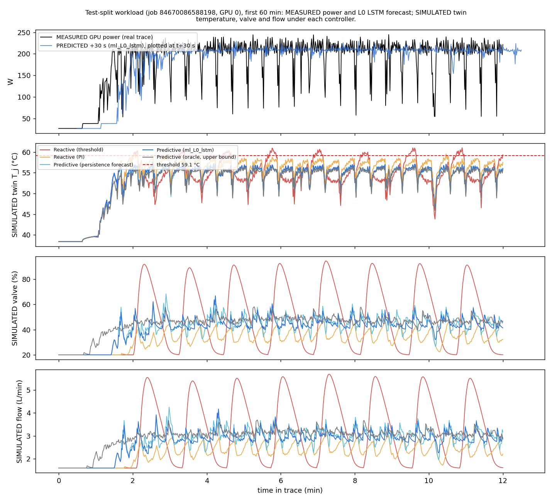
Fig. 3. One test-split workload under each controller: measured power (top) and simulated temperature, valve and flow.
Across the test traces, the threshold controller spent 993 s above the threshold, the PI controller 15 s, the predictive controller with the ML forecast 0 s and with the oracle 0 s. Only 4 of the 30 traces ever reached the threshold under threshold control, so the differences come from a few high-power workloads (Fig. 3). Predictive control with a persistence forecast also stayed below the threshold (0 s), i.e., on this subset the benefit comes from the model-based controller rather than from forecast accuracy. Estimated pump energy relative to threshold control was 0.67 (PI), 0.90 (ML-predictive), 0.93 (persistence-predictive) and 0.95 (oracle). PI and predictive control move the valve much more often (mean 464 and 225 direction reversals per trace vs 8 for threshold control), which a deadband or move penalty would need to address. The traces were limited to their first 60 min to bound simulation time.

VI. DIGITAL-TWIN VISUALIZATION
The same backend streams measured telemetry, forecasts and simulated cooling state to a browser-based 3D data hall (React Three Fiber) over WebSockets. Valve angle, coolant-particle speed and GPU colour are driven by the simulated values, and every displayed number is labelled as measured, predicted or simulated.
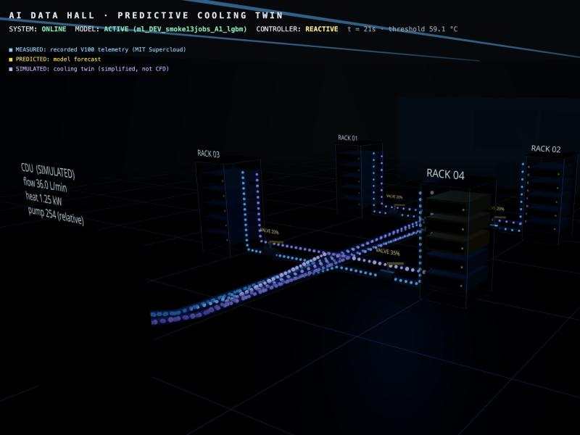
Fig. 4. 3D digital twin of the data hall (screenshot of the running system).

VII. LIMITATIONS
Results come from a 104-job subset (random, four per label, single-file jobs only), with two LSTM seeds instead of five; the test split holds 15 jobs and 9 labels, so confidence intervals are wide. All GPUs are V100s cooled by the source cluster, not by a two-phase loop. Clock features were unavailable for most jobs and the planned clock ablation could not be run. The cooling loop, its energy and all control outcomes are simulated with assumed parameters; there is no hardware validation and no CFD.

VIII. CONCLUSION
On real V100 telemetry, short-horizon power forecasts from an LSTM were the most accurate tested but not significantly better than persistence on this subset, no learned model significantly beat persistence for temperature, and workload labels did not help. In the digital twin, model-predictive control kept the GPU below the threshold on the same real workloads where threshold control did not, at a cost in valve activity; with this cooling model, a persistence forecast was sufficient, so the value of learned forecasts remains to be shown on longer transport delays and the full dataset. The next step is the full 3,430-job run with five seeds, which the released pipeline supports.

REFERENCES
[1] S. Samsi et al., "The MIT Supercloud Dataset," in Proc. IEEE High Performance Extreme Computing Conf. (HPEC), 2021, doi: 10.1109/HPEC49654.2021.9622850.
[2] G. Ke et al., "LightGBM: A highly efficient gradient boosting decision tree," in Proc. Adv. Neural Inf. Process. Syst. (NeurIPS), 2017, pp. 3146–3154.
[3] S. Hochreiter and J. Schmidhuber, "Long short-term memory," Neural Computation, vol. 9, no. 8, pp. 1735–1780, 1997.
[4] A. Paszke et al., "PyTorch: An imperative style, high-performance deep learning library," in Proc. NeurIPS, 2019, pp. 8024–8035.
[5] E. F. Camacho and C. Bordons, Model Predictive Control, 2nd ed. London, U.K.: Springer, 2007.

