Predictive Cooling Digital Twin
User guide: how to navigate the virtual data hall, watch the cooling respond, and find the results
Research project: Predictive Thermal Control for Two-Phase Direct-to-Chip GPU Cooling
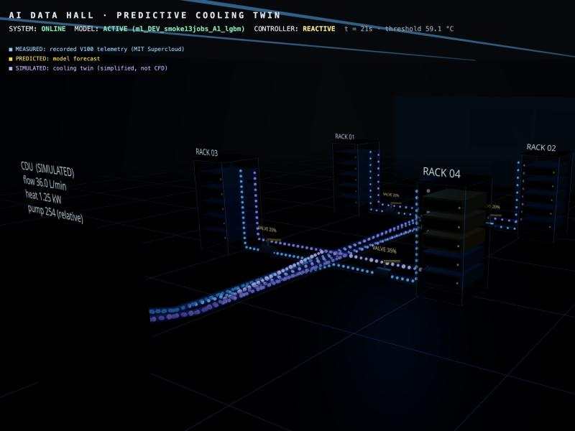
The virtual AI data hall: four GPU racks, the coolant loop and the coolant distribution unit (CDU).

1. What this website shows
The website is a 3D "digital twin" of a small AI data hall. Each GPU in the hall replays a real recorded workload from NVIDIA V100 GPUs (the MIT Supercloud dataset). A machine-learning model forecasts each GPU's power 30, 45 and 60 seconds ahead. A cooling controller then opens or closes a valve in a simulated two-phase direct-to-chip cooling loop, and the simulated GPU temperature responds.
Every number on screen carries a tag that says where it came from:
Tag | Meaning
MEASURED (blue) | Recorded by nvidia-smi on real V100 GPUs: utilization, power, temperature of the original server, memory use, clocks.
PREDICTED (amber) | Forecast made by the model (power, and the temperature the GPU will reach in the twin if the valve stays where it is).
SIMULATED (violet) | Produced by the simplified cooling model: twin GPU temperature, cold-plate temperature, valve position, coolant flow, heat removed, pump power. Not physical measurements, and not CFD.

Current status (please read before sharing numbers). The forecasting model in the live site is a small development model ("DEV", trained on 13 jobs) used to check that the whole pipeline works. The full research model is trained separately in Google Colab and will replace it. The comparison tables are marked PRELIMINARY until then.

2. Opening the site and moving around
Open https://predictive-cooling-twin.vercel.app (or http://localhost:5173 when running it on your own computer) in Chrome, Edge or Safari on a laptop or desktop. The page opens on the overview of the hall and starts streaming immediately. The top bar should say SYSTEM: ONLINE.
Action | How
Rotate the view | Left-click and drag on empty space
Zoom | Mouse wheel or two-finger scroll
Pan (slide sideways) | Right-click and drag
Fly to a rack | Click the top cap of a rack
Inspect one GPU | Click a GPU node (one of the five boxes in a rack). A close-up of the GPU and a data panel appear
Deselect | Click empty floor, or press OVERVIEW

What you are looking at
- Racks and GPU nodes. Each rack holds five GPU nodes. A node's colour shows its simulated temperature relative to the threshold: blue (normal), teal, yellow (within 5 °C of the threshold), orange (at the threshold) and red (5 °C or more above it). The small light on the front blinks faster when measured GPU utilization is higher.
- Coolant pipes and particles. Blue particles flow from the CDU to each rack (supply) and violet particles flow back (return). Particle speed is the simulated coolant flow. Return particles turn whiter as more coolant evaporates (two-phase cooling).
- Valves. Each rack has a valve with a yellow handle and a "VALVE n %" label. The handle angle is the simulated valve position (0 % closed to 100 % open).
- CDU (coolant distribution unit). The cabinet at the front of the hall. Its pump impeller spins faster with higher total flow. Its label shows total flow, heat removed and relative pump power.
- Event boxes (top right). "THERMAL EVENT PREDICTED" appears when the forecast says a GPU will approach the threshold within 60 seconds.

3. The top bar
Item | Meaning
SYSTEM | ONLINE when the page is connected to the backend. OFFLINE means the backend is not running or not reachable
MODEL | ACTIVE (model name) when a forecasting model is loaded. NOT_LOADED means forecasts fall back to "persistence" (assume power stays the same), and this is stated on screen
CONTROLLER | REACTIVE or PREDICTIVE: the cooling strategy currently running
t = … s | Simulated time since the traces (re)started
threshold | Temperature limit used by both controllers in the twin (59.1 °C in the current set-up; see section 5.3)
Badge (top right) | DIGITAL TWIN SIMULATION or RESEARCH DATA REPLAY: which mode is active

4. The buttons at the bottom
Button | What it does
WORKLOAD | Opens a list of real recorded workloads, with the dataset's own labels (for example resnet50, bert-base-uncased, U3-128). Select a GPU first, then pick a workload to replay it on that GPU. All traces restart so the comparison stays fair.
REACTIVE | Switches to the conventional controller: the valve opens only after the GPU temperature reaches the threshold. All traces restart from the beginning.
PREDICTIVE | Switches to the forecast-based controller: it looks 60 s ahead and opens the valve before the threshold would be reached. All traces restart from the beginning.
REPLAY | Research Data Replay mode: emphasises the recorded (measured) telemetry stream.
TWIN SIM | Digital Twin Simulation mode: emphasises the simulated cooling response. Both modes run the same engine; the mode name is stamped on every data update.
THERMAL VIEW | Top-down heat map. Each rack gets a translucent column whose height and colour follow its hottest simulated GPU.
OVERVIEW | Returns the camera to the whole hall and clears the selection.
COOLING LOOP | Moves the camera to the CDU, pump, pipes and valves.
CONTROL ROOM | Moves into the glass control room with three large screens: GPU fleet, cooling and events, and the reactive-vs-predictive comparison.
FOLLOW EVENTS | When on (highlighted), the camera automatically tours a GPU each time a thermal event is predicted, starting from the overview. Turn it off to explore freely.
PAUSE / RESUME | Freezes or resumes the simulation for everyone connected.
1× · 5× · 20× | Simulation speed (simulated seconds per real second). Use 20× to reach interesting moments quickly.
RESTART TRACES | Starts every workload again from its beginning, with the same initial cooling state.
RESULTS | Opens the research results page (section 6).
ENTER VR | Only appears in browsers and headsets that support WebXR.

Note: the site has one shared simulation. If several teammates use it at the same time, a button pressed by one person (for example REACTIVE or 20×) changes it for everyone.

5. Watching the cooling respond at the threshold
The cooling is simulated and it does react to the threshold. The two controllers behave differently, and seeing the difference is the point of the demonstration.

5.1 Reactive control: cooling starts when the threshold is reached
Rule implemented in the backend: when the simulated GPU temperature is at or above the threshold, the valve command rises by 10 % every second (up to 100 %). When the temperature has dropped 3 °C below the threshold, the valve closes by 2 % per second, down to a 20 % minimum. Between those two limits it holds its position.
- Press REACTIVE (traces restart), then 20×.
- Keep FOLLOW EVENTS on, or click a GPU in rack 04 (for example R04-G03, which replays a heavy U3-128 training job).
- Watch the panel next to the GPU. TWIN TEMP climbs towards the threshold while VALVE stays at 20 %: reactive control does nothing yet.
- When TWIN TEMP reaches the threshold, the valve label rises (20 % → 30 % → …), FLOW increases, the particles in that rack's pipes speed up, and TWIN TEMP starts to fall.
- Once the temperature is 3 °C below the threshold, the valve slowly closes again. The temperature rises again and the cycle repeats. This saw-tooth is typical of threshold control.
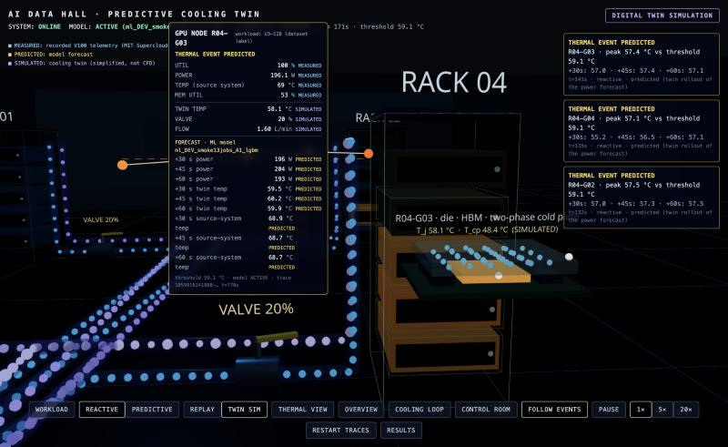
Reactive, before: twin temperature 58.1 °C, close to the 59.1 °C threshold, but the valve is still at 20 % and flow is 1.60 L/min.
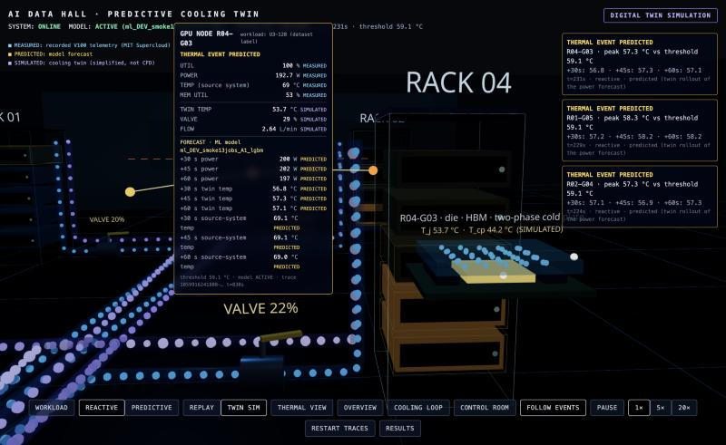
Reactive, after: the threshold was crossed, so the valve opened (29 %) and flow rose to 2.64 L/min. Twin temperature has fallen to 53.7 °C.

5.2 Predictive control: cooling starts before the threshold
- Press PREDICTIVE (the same workloads restart from the same state).
- Every second the controller takes the power forecast for the next 60 s and simulates the twin ahead for 11 possible valve openings. It chooses the smallest opening that keeps the predicted peak at least 2 °C below the threshold.
- Result to look for: the valve opens moderately before the temperature gets close. TWIN TEMP levels off below the threshold instead of crossing it. The event box shows the predicted peak and the +30/+45/+60 s values.
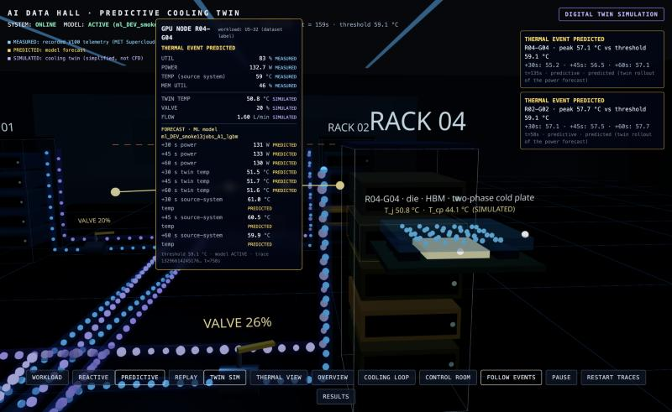
Predictive: a thermal event is predicted for R04-G04. The panel shows measured telemetry, the model forecast and the simulated cooling state.

5.3 Why the threshold is 59.1 °C
The threshold is a setting of the simulation, not a GPU limit. It is defined as the twin's steady temperature at 250 W (the V100 power limit seen in the data) with the valve half open. This puts the threshold where the recorded workloads can actually reach it, so the controllers have something to do. It can be changed for future experiments.

6. Where to find the results

6.1 RESULTS button (research results page)
- Dataset: source, licence and citation of the real telemetry, plus the dataset audit numbers once the full Colab run has produced them.
- Forecasting (E1): MAE, RMSE, R², MAPE, latency and model size for 30/45/60 s, for every model. It says "Not available yet" until the Colab training results are added. No numbers are shown until they exist.
- Reactive vs predictive control (E2): time above threshold, peak temperature, overshoot, estimated pump energy (relative to reactive), valve reversals and response time, all calculated from the simulation. Currently marked PRELIMINARY.
- Model in the live twin: which model is loaded and its provenance.
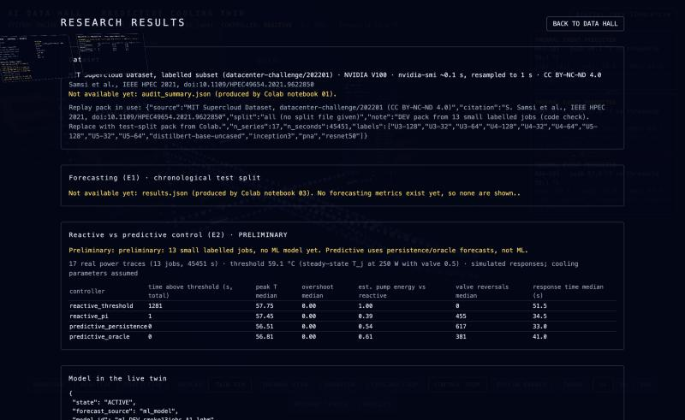
Research results page.

6.2 Control room
Press CONTROL ROOM. The left screen lists every GPU with its simulated temperature, measured power and workload label. The middle screen shows controller, model, fleet power, cooling demand, flow, heat removed and the latest predicted events. The right screen shows the reactive-vs-predictive table read from the experiment file.
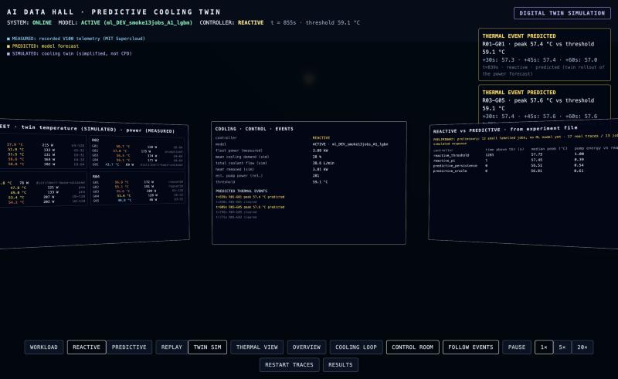
Control room screens.

6.3 Files (for the write-up)
File | Contents
research/reports/e2_preliminary_summary.md | Preliminary reactive-vs-predictive comparison on 17 real traces
research/reports/e2e_integration_summary.md | End-to-end demonstration, including the five-controller comparison on one high-load workload
research/figures/e2e_demo_highload_U3-128.png | Plot of one workload: measured power, forecast, simulated temperature, valve and flow under each controller
docs/dataset.md, docs/limitations.md | Dataset choice, audit and the limits of what can be claimed

7. Reading the numbers correctly
- Temperatures in the 3D hall are the twin's simulated temperatures. "TEMP (source system)" in the GPU panel is the real recorded temperature from the original server, which had its own cooling.
- Pump energy is an estimate from a simplified pump law and is only meaningful when comparing controllers with each other.
- The cooling loop is a simplified model of a two-phase cold plate. It does not simulate boiling in detail and is not CFD.
- Until the Colab-trained model is loaded, forecasting accuracy and the final comparison are not available. Numbers marked PRELIMINARY or DEV must not be quoted as final results.

8. Troubleshooting
Symptom | What to do
SYSTEM: OFFLINE | The backend is asleep or stopped. Wait about 30 s and reload. A free hosting plan may sleep after inactivity.
Scene is dark for a few seconds | Normal on first load while the 3D scene and fonts load.
Text labels in 3D are missing | They load a font from the internet; they appear once it loads. Everything else works without them.
Camera keeps jumping | Turn off FOLLOW EVENTS.
Nothing seems to change | Press 20×, or RESTART TRACES and pick a heavy workload (U3-128, U5-128, inception) with WORKLOAD.

