**Data Analyst Job Trends Dashboard**

**Aim:**

The aim of the "Data Analyst Job Trends Dashboard" project is to explore and visualize current trends in the job market for Data Analyst roles using real-world data. By leveraging data analysis and business intelligence tools, the project seeks to uncover key insights related to salary distributions, remote work patterns, job demand across different countries, and experience levels. The primary objective is to provide a comprehensive and interactive dashboard using Power BI that helps users such as job seekers, recruiters, and career advisors make informed decisions based on up-to-date labour market trends. Through effective data preprocessing in Python and engaging visual storytelling in Power BI, the project demonstrates the integration of technical and analytical skills to produce actionable insights and support strategic career planning in the evolving field of data analytics.

**1. Objective**:  
The objective of this project is to analyse global job market trends specifically for Data Analyst roles using a real-world dataset. The project aims to extract meaningful insights related to salary ranges, job availability by country, experience levels, employment types, and remote work dynamics. By preprocessing the data in Python and visualizing it through an interactive Power BI dashboard, the goal is to present clear and actionable insights for stakeholders such as job seekers, recruiters, and policy makers. The dashboard allows users to filter and explore data trends, supporting better decision-making in the field of data analytics careers.

**2.Dataset & Preprocessing**

The dataset used for this project was sourced from Kaggle and is titled *“Data Science Job Salaries.”* It provides a comprehensive overview of various job roles within the data science field, including detailed information such as job titles, work year, experience levels, employment types, salaries (normalized to USD), remote work ratios, and company locations. These fields are particularly relevant for analysing salary trends, remote job prevalence, and the geographical distribution of job opportunities. The goal of the preprocessing stage was to filter the data for roles specific to Data Analysts and prepare it for effective visualization in Power BI.

Data preprocessing was carried out in Google Colab using Python. The process began with importing essential libraries such as Pandas for data manipulation, and Matplotlib and Seaborn for visualization. The dataset was then loaded into a Pandas Data Frame from a CSV file stored on Google Drive. To ensure relevance to the project objective, the dataset was filtered to include only those records where the job title contained the term “analyst,” regardless of case sensitivity. This allowed for the inclusion of roles such as Data Analyst, Business Intelligence Analyst, and Financial Analyst.

Following this, an initial exploratory data analysis (EDA) was conducted to inspect the structure of the dataset, identify any missing values, and evaluate the distribution of categorical variables such as experience level. This step provided a foundational understanding of the dataset’s quality and guided further analysis. A bar chart was created using Seaborn to visualize the average salary across different experience levels, offering insight into how compensation varies with expertise.

After filtering and basic analysis, the cleaned dataset was saved as a new CSV file titled analyst_data.csv. This file served as the input for the Power BI dashboard. The preprocessing phase ensured that the dataset was clean, relevant, and structured—ready for interactive visualization. By narrowing the scope to analyst roles and performing essential cleaning, the data was optimized for generating accurate and meaningful insights into the job market for Data Analysts. The use of Python tools like Pandas, Matplotlib, and Seaborn facilitated a smooth and efficient data transformation process that laid a solid foundation for the subsequent dashboard development.

**3. Dashboard Design**

The "Data Analyst Job Trends Dashboard" was developed using Power BI to provide interactive and visually compelling insights into the job market for data analyst roles. The design focuses on clarity, interactivity, and meaningful analytics that cater to stakeholders such as job seekers, recruiters, and policy makers.

**Layout & Components:**

**1. KPI Cards**

* Average Salary by Year: Displays average salaries from 2020 to 2023, showing growth trends.
* Dynamic Q&A Visual: Allows users to query the dashboard (e.g., "What is the average salary in 2020?") and returns specific values (e.g., 126692.31).
* Job Titles in Company (Tile View): Interactive cards display various job titles present in the dataset, providing a quick visual reference.

**2. Main Visualizations:**

**a. Bar Chart – Average Salary by Job Title**

* Displays the variation in average salary across roles like BI Analyst, Financial Analyst, Data Analyst, etc.
* Highlights which job titles command the highest average compensation.

**b. Pie Chart – Count of Job Titles by Remote Status**

* Shows the distribution of remote, hybrid, and onsite roles.
* Emphasizes the dominance of remote jobs in the analyst field.

**c. Column Chart – Average Salary by Experience Level**

* Compares salaries across different levels: MI (Mid), EX (Executive), SE (Senior), and EN (Entry).
* Reveals how compensation scales with experience.

**d. Donut Chart – Count of Job Titles by Experience Level**

* Highlights the frequency of job listings based on experience levels.
* Indicates demand across career stages.

**3. User Interaction Features:**

* Slicers & Filters: Users can interact with slicers for:
  + Experience Level
  + Remote Status
  + Job Title
* Responsive Charts: All visualizations dynamically update based on slicer selections, enabling in-depth exploration.

**Design Highlights:**

* Clean, dark-themed layout for readability.
* Logical grouping of metrics (salary, job count, remote status, experience).
* Real-time Q&A integration enhances user engagement and insight retrieval.

4.**Insights & Interpretation**

The interactive Power BI dashboard offers a comprehensive view of the current job market landscape for Data Analyst roles, presenting clear, data-driven insights through well-structured visual components. The KPI cards at the top of the dashboard effectively summarize key metrics, such as average salaries over time, demonstrating a positive salary growth trend between 2020 and 2023. The integration of the dynamic Q&A visual allows users to ask natural language queries—for instance, "What is the average salary in 2020?"—and receive instant, precise answers, enhancing user engagement and accessibility of insights.

One of the standout visualizations is the bar chart showing average salary by job title, which reveals notable disparities across various analyst roles. Business Intelligence Analysts and Financial Analysts tend to command higher average salaries compared to general Data Analysts, indicating a higher valuation of domain-specific expertise and tool-based skills in the job market. Complementing this, the column chart illustrating average salary by experience level confirms that experience significantly influences earning potential. Executive and senior-level analysts earn substantially more than entry-level counterparts, reinforcing the importance of experience in career progression and compensation.

The pie chart analysing job titles by remote status provides a striking insight into the modern work environment, with remote roles dominating the landscape. Over half of the job listings are fully remote, highlighting a significant shift in employer flexibility and the global demand for data professionals who can work from anywhere. Similarly, the donut chart showing job title counts by experience level demonstrates a high concentration of opportunities at the mid and senior levels, suggesting a market preference for candidates with a balance of foundational knowledge and applied experience.

User interaction features—such as slicers for job title, remote status, and experience level—allow stakeholders to tailor the analysis to specific contexts. For example, selecting a particular experience level dynamically updates all related charts, enabling focused comparisons and deeper exploration of niche trends. The clean, dark-themed layout enhances readability, while the logical grouping of visuals supports intuitive navigation and decision-making.

Overall, the dashboard effectively translates complex data into actionable insights. It highlights not only salary trends and experience-based variations but also evolving work models and the demand for specialized analytical roles. These findings are particularly valuable for job seekers planning their career paths, recruiters aiming to benchmark compensation, and policy makers seeking to understand labor market dynamics in the data analytics sector.

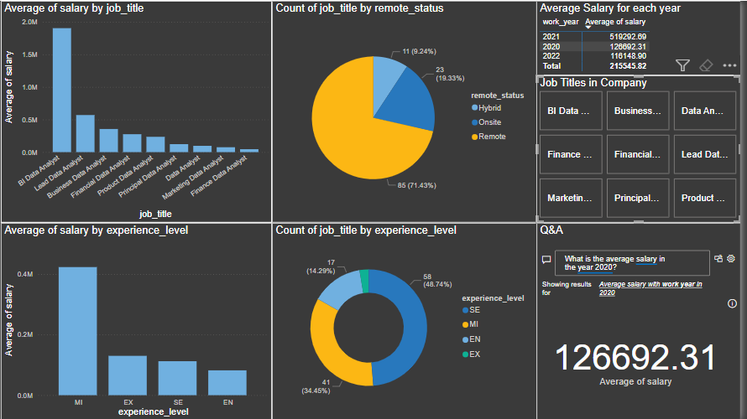

**5. Conclusion & Reflection**

The *Data Analyst Job Trends Dashboard* project demonstrates the effective integration of data analysis, visualization, and storytelling to uncover meaningful trends in the job market for data analyst roles. From the initial stages of data cleaning and transformation using Python and Google Colab to the development of an interactive Power BI dashboard, this project exemplifies a practical application of end-to-end data handling and reporting. By focusing specifically on analyst roles within the broader data science field, the analysis offers targeted insights that are directly relevant to professionals, employers, and decision-makers in this domain.

The dashboard successfully delivers key insights into salary progression, geographic demand, remote work patterns, and experience-based role distribution. It empowers users to interact with the data through intuitive filters and visual tools, enabling personalized exploration of job market dynamics. The inclusion of real-time Q&A features and KPI indicators enhances usability and promotes a deeper understanding of trends. The project also highlights the growing demand for mid to senior-level analysts and underscores the increased adoption of remote and hybrid working models.

Reflecting on the project, it has been a valuable learning experience in combining technical skills with domain understanding. It emphasized the importance of clear data preprocessing, thoughtful visualization design, and user-focused interactivity. The insights gained not only validate industry expectations but also offer a practical guide for stakeholders navigating the evolving landscape of data analytics careers. Moving forward, there is significant potential to expand this project by incorporating additional variables such as job descriptions, required skills, and company-specific trends. Introducing predictive analytics for salary forecasting and automating data updates could further enhance the dashboard's value and scalability. Overall, this project stands as a strong foundation for ongoing exploration and innovation in the field of data-driven job market analysis.

**Links**:

* <https://github.com/JasmithaM14/Data_Analyst_Job_Trends->
* <https://www.kaggle.com/datasets/ruchi798/data-science-job-salaries>