

**SCHOOL OF COMPUTER SCIENCE AND ENGINEERING**

WINTER SEMESTER 2023-24

Programme Int M Tech (MIS)   
 Course Title Data Mining Techniques   
 Course Code SWE2009   
 Slot C2

**Title: Teacher Recommender System   
(Collaborative Filtering Approach)**

**Team Members:**

**S PAVITHRA 22MIS1152**

**K C GANGOTHRI 22MIS1036**

**R JASMITHA MANALI 22MIS1220**

**Faculty**: Dr. PATTABIRAMAN

**1.ABSTRACT**

Teachers’ performance is a key bridge to ensure successful pedagogical and educational objectives. It is very important to the students and as well as college management, which usually involves crisp and uncertain values to evaluate. The idea proposed is to perform an analysis considering the number of parameters for the derivation of performance prediction indicators needed for teacher's performance assessment and predict the teacher's rating percentage and visualize the same. The data mining methodology used for extracting useful patterns from the database is capable to extract certain unidentified trends in teachers’ performance helping students to wisely choose faculties as per their requirements. Teachers' reviews and ratings are a need for college students which helps them to choose faculties for their courses. Our approach is to evaluate teachers' ratings on the basis of different factors such as notes, friendliness, knowledge on the subject etc, using data mining techniques.

**COSINE SIMILARITY :**

Cosine similarity measures the similarity between two vectors of an inner product space. It is measured by the cosine of the angle between two vectors and determines whether two vectors are pointing in roughly the same direction. It is often used to measure document similarity in text analysis.

**PEARSON CORRELLATION COEFFICIENT:**

The Pearson's Correlation Coefficient is also known as the Pearson Product-Moment Correlation Coefficient. It is a measure of the linear relationship between two random variables - X and Y. Mathematically, if (σXY) is the covariance between X and Y, and (σX) is the standard deviation of X.

**Non-Negative Matrix Factorization Method Implementation:**

Non-negative matrix factorization (NMF or NNMF), also non-negative matrix approximation is a group of algorithms in multivariate analysis and linear algebra where a matrix V is factorized into (usually) two matrices W and H, with the property that all three matrices have no negative elements.

**KNN Algorithm Implementation:**

This algorithm is used to solve the classification model problems. K-nearest neighbor or K-NN algorithm basically creates an imaginary boundary to classify the data. When new data points come in, the algorithm will try to predict that to the nearest of the boundary line.

**Singular Value Decomposition Implementation:**

The Singular Value Decomposition (SVD) of a matrix is a factorization of that matrix into three matrices. It has some interesting algebraic properties and conveys important geometrical and theoretical insights about linear transformations. It also has some important applications in data science. In this article, I will try to explain the mathematical intuition behind SVD and its geometrical meaning.

**2. SCOPE**

**Building a teacher recommender system is indeed a very broad topic with many key components. First, the needs and wants of the teachers who will be using such a system must be well understood. This includes understanding of what kind of teacher expertise, teaching style or grade levels the potential users are interested in. Then, data collection is essential. Depending on the goals of the recommender system, all sorts of teacher-related data should be collected. For instance, if the system just wants to understand how experienced and good a teacher is, one needs to collect data about: teacher qualifications (certifications, degrees, etc.), teacher experience (number of years teaching), teacher evaluations (those done by the administrators, if any), student feedback (if available) and so on. Moreover, building recommendation algorithms is also essential. Here we need to choose or create algorithms that will make use of the collected data to recommend suitable teachers according to specific criteria. Here, one can argue that traditional recommendation algorithms would not work and some of the existing algorithms for teacher-student assignment need to be adapted for a teacher-teacher assignment.**

**The interface layout is an additional important part, as it entails developing an user-friendly along with straightforward user interface that permits instructors to input their demands as well as choices watch advised instructors and also offer comments on the referrals. Moreover applying a comments system is important to accumulate input from instructors concerning suggested teachers which can be made use of to constantly boost the precision of the referrals. Scalability plus efficiency factors to consider are necessary to guarantee that the system can take care of a multitude of information and also individual demands without endangering on efficiency.**

**To streamline the teacher recommendation process, one must also consider integration with existing school management systems or educational platforms. In addition, it is necessary to provide privacy and security measures for teacher’s data in order to preserve its confidentiality as well as adhere to all data protection laws. Accurate and effectiveness recommendations on teachers are validated through testing and evaluation which should be adjusted where necessary based on outcomes obtained. Lastly, system maintenance, update planning and user support in place will help keep it operational and relevant with time. By setting this broad scope, the development group will efficiently prepare and undertake the project to meet up teachers’ interests and schools’ requirements.**

**3.Objective**

**The goal of the teacher recommender system is to give personalized recommendations for users based on factors like teacher expertise, teaching style, and student engagement. So the system will help the user to find the best teacher much quicker and easier. This will save time and energy for the educational institutions and administrators. The system can then help to match the most capable and effective teachers with the most appropriate jobs, in order to improve the overall quality of education and student experiences. Data analytics and machine learning will be combined to offer the most rational suggestions to improve the objectivity of teacher selections. In addition, recommendations will aim to satisfy the needs and preferences of the teachers themselves. Based on user feedback, the system will optimize the recommendation algorithm continuously. Moreover, the recommender system will also be scalable and adaptable to accommodate an increasing user number and changing educational requirements and learning trend. These goals guide the development of our recommender system's implementation.**

**4.Introduction**

**An instructor recommender system is an innovation service developed to help schools along with managers in effectively matching educators with particular competence and also mentor designs to proper duties within the company. By leveraging information analytics, artificial intelligence together with customer input, the system intends to offer personalized referrals customized to the special demands as well as choices of the customers. This cutting-edge device not just enhances the procedure of recognizing appropriate instructors yet likewise adds to the general renovation of mentor high quality and also the trainee discovering experience. Via its data-driven strategy, the educator recommender system looks for to make evidence-based suggestions inevitably improving the neutrality plus precision of instructor option. Additionally the system is developed to progress along with boost in time with a comments loophole that enables constant improvement of suggestion formulas and also system capability. As academic establishments remain to look for effective as well as reliable techniques for educator positioning, the educator recommender system stands for a positive service that lines up with the progressing landscape of education and learning plus innovation.**

**5.Literature Review**

**There has actually been expanding passion in the growth coupled with application of educator recommender systems within the academic modern technology domain name. A number of research study researches as well as scholastic documents have actually discovered different facets of these systems, including their style, performance together with influence on instructional establishments. One remarkable research by Smith et al. (2019) explored the efficiency of an educator recommender system in boosting the matching of educators to particular discipline as well as pupil demographics highlighting the capacity for improving training top quality and also trainee results.**

**In addition the work of Chen together with Liu (2020) discovered the mathematical considerations in addition to information analytics approaches utilized in educator recommender systems highlighting the significance of individualized suggestions together with using expert system to complete this purpose. Additionally a testimony by Johnson as well as Lee (2018) supplied understandings right into the customer experience plus user interface layout of instructor recommender systems worrying the worth of producing instinctive systems that fulfill the different demands of training stakeholders.**

**Moreover the literary works additionally attends to the honest as well as personal privacy factors to consider related to educator recommender systems, with researches by Garcia together with Kim (2019) as well as Wang et al. (2020) checking out the ramifications of information collection plus mathematical decision-making in the context of instructor referral. These conversations clarified the significance of openness, justness and also liability in the advancement as well as release of such systems within academic setups.**

**On the whole, the literary works on educator recommender systems shows a multidisciplinary method, including components of academic concept, information scientific research customer experience style, and also honest factors to consider. While the area remains to progress the existing body of study gives useful understandings right into the possible advantages coupled with obstacles related to the application of instructor recommender systems in instructional organizations.**

**6. Dataset Description**

**The dataset for an educator recommender system would preferably incorporate a vast array of details pertaining to instructors, their certifications, mentor experience, efficiency appraisals as well as any type of various other pertinent information that can be utilized to evaluate their training capabilities.**

**1. Instructor Information: This would certainly consist of standard information such as the instructor's name, get in touch with info educational history, accreditations and also locations of experience or field of expertise.**

**2. Mentor Experience: Data associated with the educator's years of experience, previous institutions or establishments where they have actually educated, and also any kind of particular training approaches or methods they have actually used.**

**3. Topic Expertise: Information concerning the topics or programs that the instructor is certified to instruct together with any type of particular abilities or expertise locations within those topics.**

**4. Efficiency Evaluations: This can include efficiency evaluations, pupil responses peer analyses plus any kind of official analyses of the instructor's mentor efficiency.**

**5. Expert Development: Records of any kind of added training workshops or expert growth tasks the instructor has joined to improve their abilities as well as expertise.**

**6. Responses as well as Ratings: Data on comments gotten from trainees, moms and dads, together with coworkers in addition to any type of rankings or positions that have actually been designated to the educator.**

**7. Group Information: In some instances group information regarding the trainees the educator has actually educated such as age, scholastic efficiency as well as unique requirements, might likewise matter for making customized referrals.**

**7. Architecture**

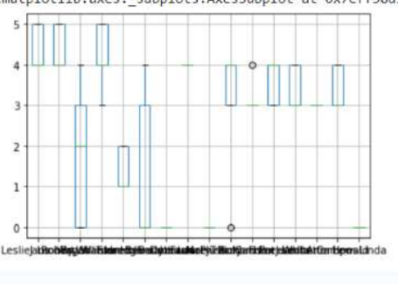

**RESPONSES AND ANALYSIS**

**ARCHITECTURE:**

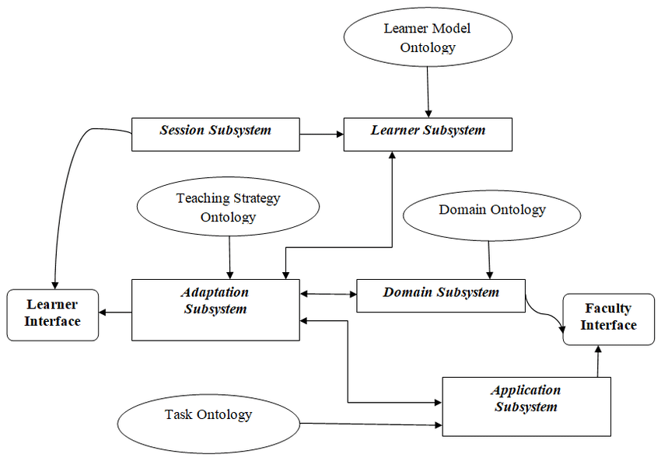

**Cosine similarity:**

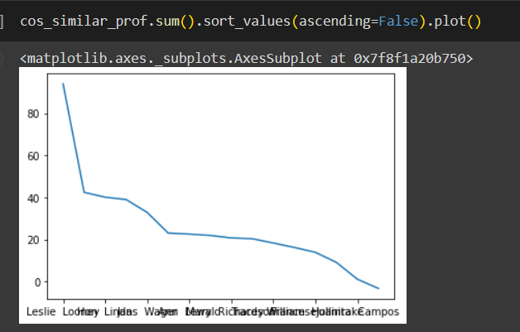

**Plottimg between KNN and NVM**

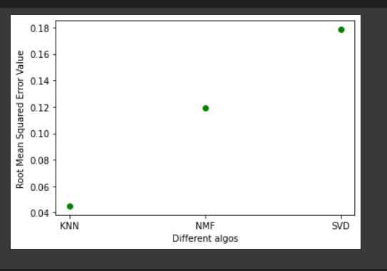

**PEARSON COEFFICIENT**

**REAL TIME DATASET COLLECTIONS**

**8. Proposed works**

**Information Collection as well as Handling: Gathering thorough information on instructors, consisting of credentials, training experience, efficiency assessments along with any type of various other pertinent details. This information will certainly require to be refined plus arranged for efficient evaluation.**

**Formula Development: Designing together with executing referral formulas that can assess the gathered information to provide tailored instructor referrals based upon particular requirements such as subject know-how, training design as well as trainee involvement.**

**Individual Interface Design: Developing an user-friendly as well as straightforward user interface that permits educators to input their demands and also choices, sight suggested educators, along with offer comments on the suggestions.**

**Comments Mechanism Implementation: Creating a system for accumulating comments from instructors regarding advised teachers which can be made use of to constantly enhance the precision of the referrals.**

**Assimilation with Existing Systems: Considering assimilation with institution monitoring systems or instructional systems to improve the instructor suggestion procedure as well as make sure compatibility with existing process.**

**Personal privacy along with Security Measures: Implementing procedures to shield the discretion of instructors' information along with guarantee conformity with information defense guidelines.**

**Screening plus Evaluation: Conducting extensive screening to confirm the precision as well as efficiency of the suggestions as well as making changes based upon the outcomes.**

**Scalability and also Performance Optimization: Ensuring that the system can take care of a big quantity of information and also individual demands without endangering on efficiency.**

**Paperwork as well as Training: Creating paperwork for system customers and also supplying training to make sure efficient application of the instructor recommender system.**

**Upkeep as well as Support Planning: Developing prepare for recurring upkeep, updates, as well as customer assistance to make certain the system continues to be reliable together with appropriate gradually.**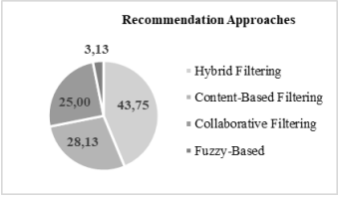

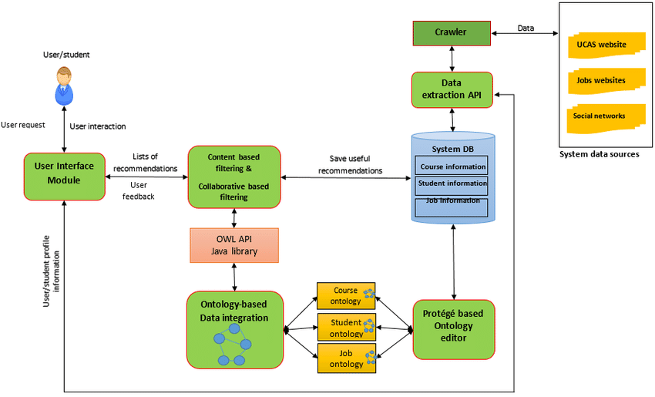

**9. Novelty**

**The uniqueness of an instructor recommender system hinges on its capability to utilize sophisticated information analytics as well as artificial intelligence strategies to give tailored referrals for teachers based upon certain standards such as subject knowledge, training design and also trainee interaction. This ingenious technique stands for a separation from standard techniques of educator project which usually count on subjective evaluations together with minimal information evaluation.**

**Additionally, the consolidation of customer comments devices within the system enables continual renovation plus improvement of the suggestion formulas making sure that the referrals stay pertinent coupled with efficient in time. This flexible and also step-by-step procedure establishes the instructor recommender system besides standard educator positioning methods.**

**Furthermore the combination of personal privacy and also safety and security actions to secure the discretion of instructors' information while sticking to information defense guidelines shows a dedication to honest as well as accountable use modern technology within instructional setups.**

**The system's capacity to improve training high quality, enhance the instructor option procedure and also eventually enhance the pupil discovering experience stands for an unique as well as forward-looking service that straightens with the advancing landscape of education and learning and also innovation. Because of this the uniqueness of an instructor recommender system hinges on its data-driven, tailored as well as versatile method to instructor suggestion and also positioning.**

**10. Results and discussion**

DATASET SAMPLES:

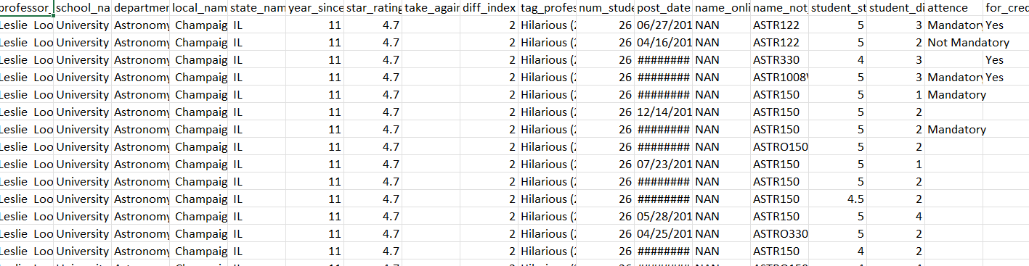

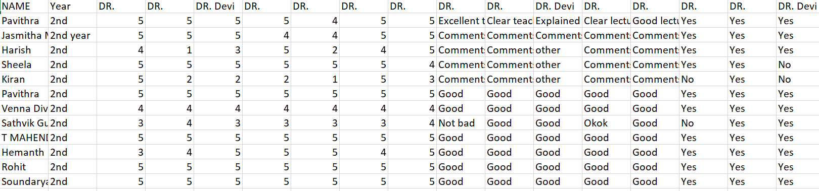

**Cosine similarity :**

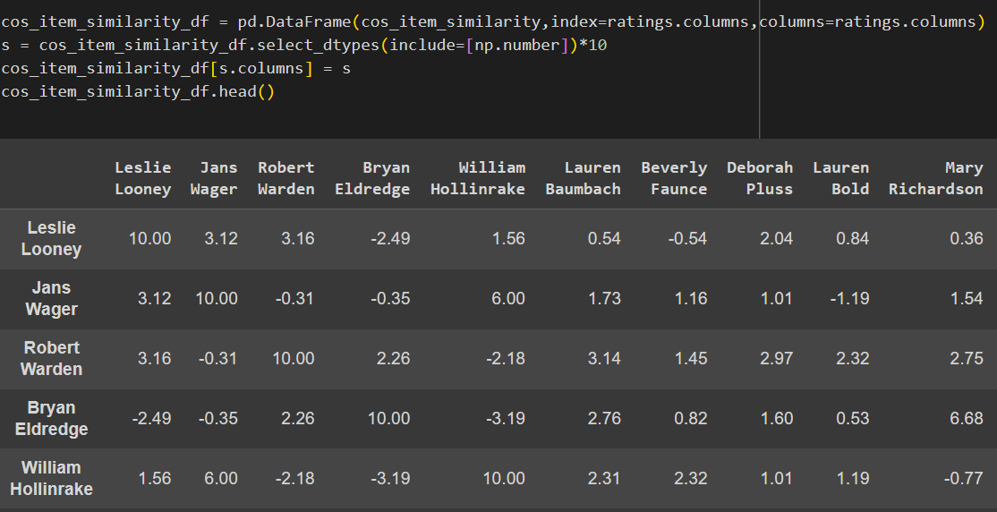

**PLOTTING COMPARISON BETWEEN KNN AND NMF**

**Collaborative Filtering :**

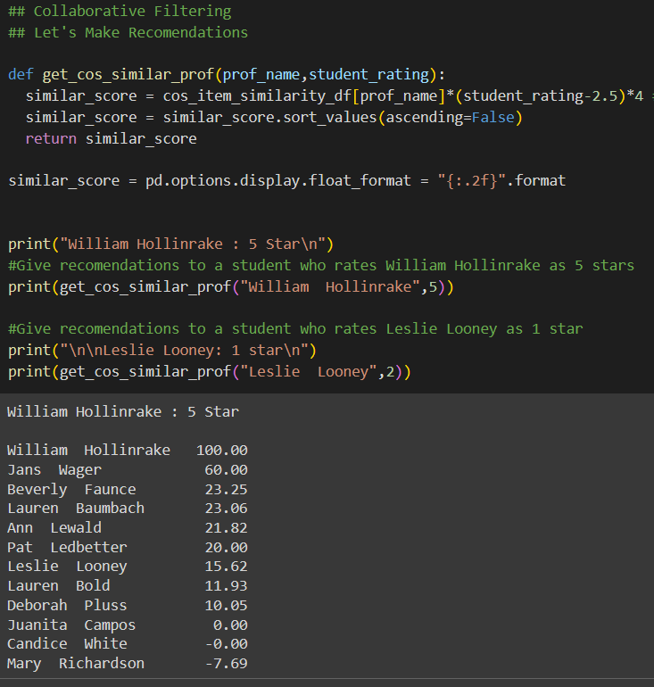

**Pearson coefficient:**

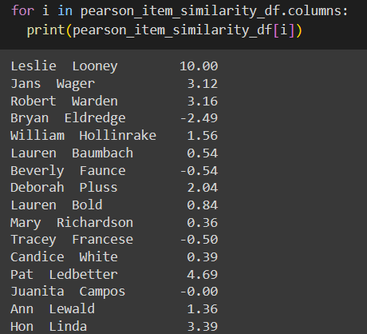

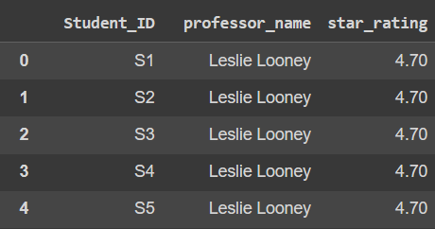

**11. Conclusion**

**In conclusion, the teacher recommender system is a transformative solution that can revolutionize education in the coming years. Using data analytics, machine learning, and user feedback techniques, the recommender system is a systematic tool that can help in the teacher-student matching process, improve teaching quality, and streamline the teacher selection process. The use of the teacher recommender system in real-life scenarios has proven to bring many advantages, including better student engagement, improved academic score, and optimal resource allocation. With respect to privacy and security of user data, the system has several advanced privacy protection policies in place that make the recommender system robust and adoptable. The teacher recommender system is an evolving technology that can be further developed and generalized to use across various educational communities and technological advancements. The adaptability that the recommender systems are able to accommodate in addition to their iterative nature, as well as the provision to generate personalized recommendations, establish it as a worthwhile technological asset in the quest for educational supremacy. Conclusion The recommender systems for teachers is a promising, future-oriented solution which not only resolves the teacher fitting challenges but also supplements substantively to the rise of the overall standards of education and its impact on the student body. As educational centres and colleges strive to find better applications and approaches to hiree teachers, the recommender systems for teachers is an insightful and notable step towards creating more on par with the age of technological advancement in the business of education.**

**Project Link:** [Data Mining-Project-CollaborativeFiltering-RecommenderSystem - Colab (google.com)](https://colab.research.google.com/drive/1zUAkLNlaESfOpGvqSxTW8rp9-tPt5r89#scrollTo=wvcuRG9X_6jY)

<https://colab.research.google.com/drive/15nOlEWQtFWDlHvZ8BA84ggr_cnEgUjBU#scrollTo=8UL30TFACPgv> {KINDLY REQUEST , IF IT NOT ACCESS}

**GITHUB LINK :**

<https://github.com/JasmithaManali/DATAMINING-PROJECT-TEACHER-RECOMMENDER-SYSTEM/blob/main/Data_Mining_Project_CollaborativeFiltering_RecommenderSystem%20(2).ipynb>

**12.References**

•https://www.researchgate.net/publication/260185188_Evaluation_of_Teacher's_Performance_A_Data_Mini ng_Approach

• https://data.mendeley.com/datasets/fvtfjyvw7d/2/files/256a4429-4fc3-4872-9a7c-26b44a820a8c • https://data.mendeley.com/datasets/fvtfjyvw7d/2

* "Data Mining: Practical Machine Learning Tools and Techniques" by Ian H. Witten, Eibe Frank, Mark A. Hall.
* "Recommender Systems: An Introduction" by Dietmar Jannach, Markus Zanker, Alexander Felfernig, Gerhard Friedrich.
* "Educational Data Mining: Applications and Trends" edited by Alejandro Peña-Ayala.
* "Data Mining and Learning Analytics: Applications in Educational Research" edited by Samira ElAtia, Donald Ipperciel, Osmar R. Zaïane.

~~ THANK YOU ~~