1. Get all customers whose first name starts with 'J' and who are active.

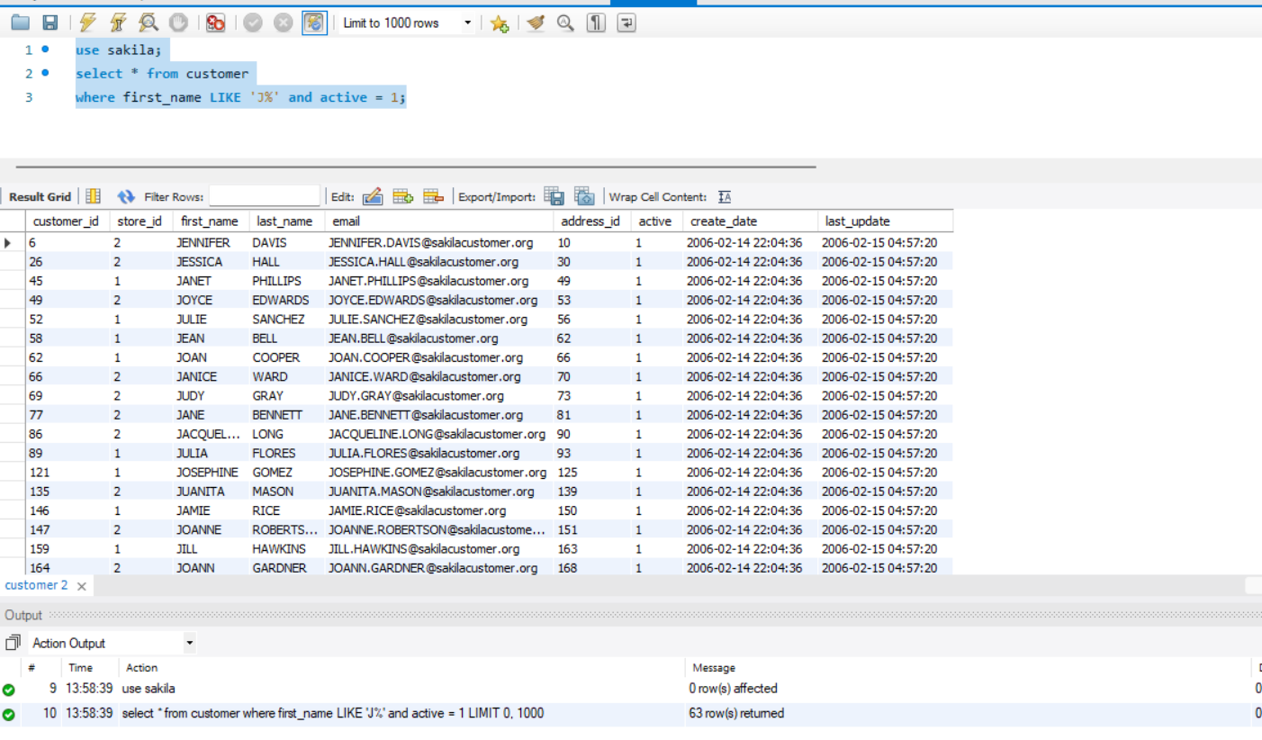
2. Find all films where the title contains the word 'ACTION' or the description contains 'WAR'.
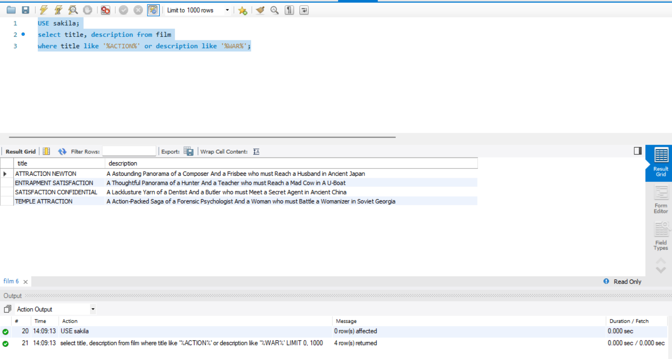
3. List all customers whose last name is not 'SMITH' and whose first name ends with 'a'.
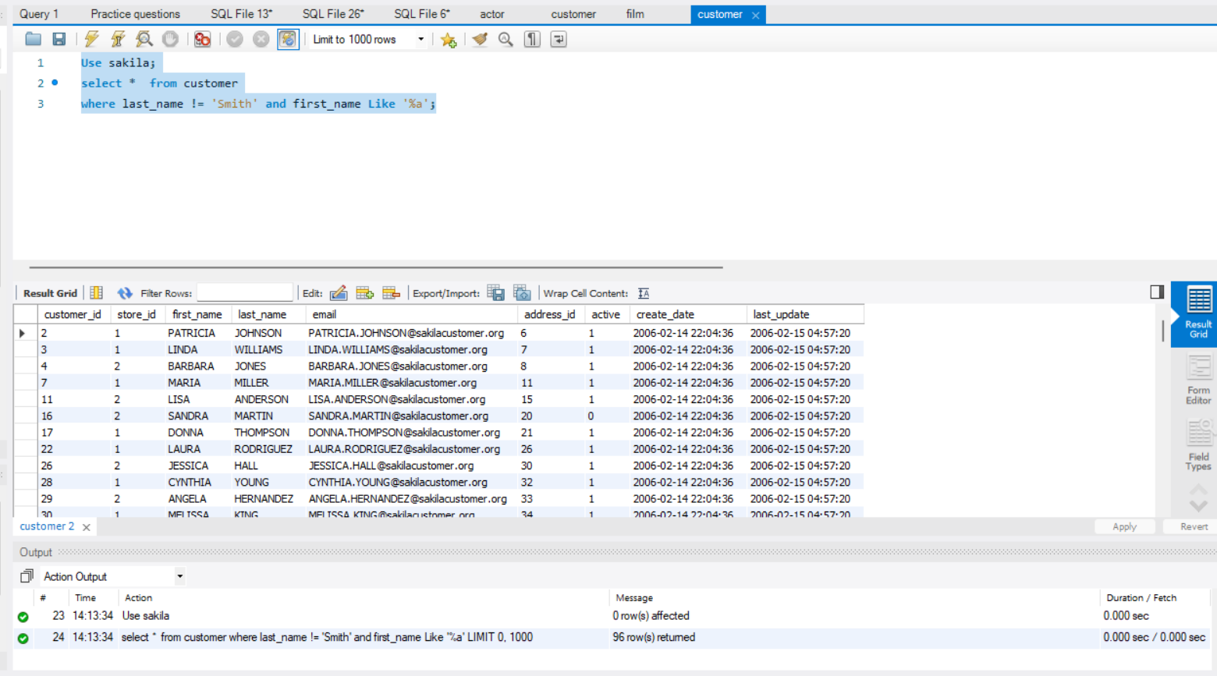
4. Get all films where the rental rate is greater than 3.0 and the replacement cost is not null.
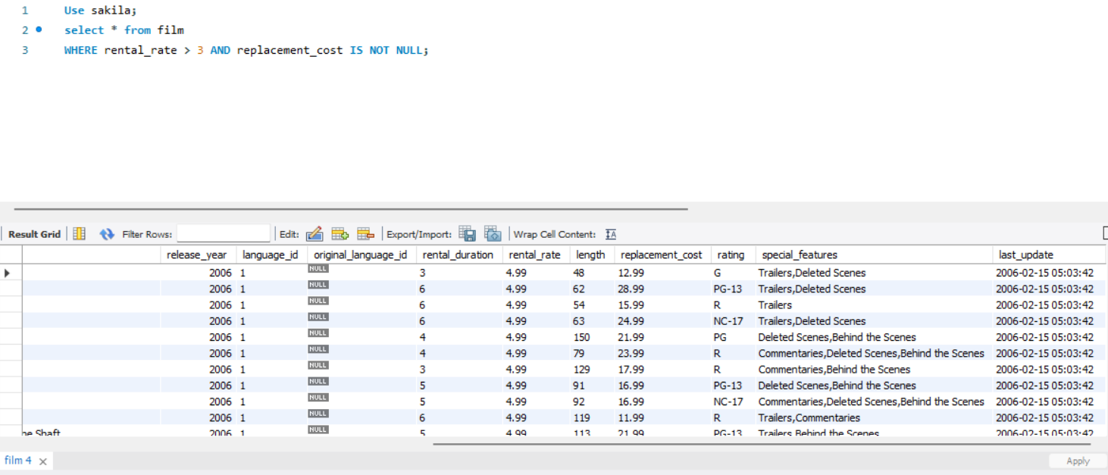

5. Count how many customers exist in each store who have active status = 1.
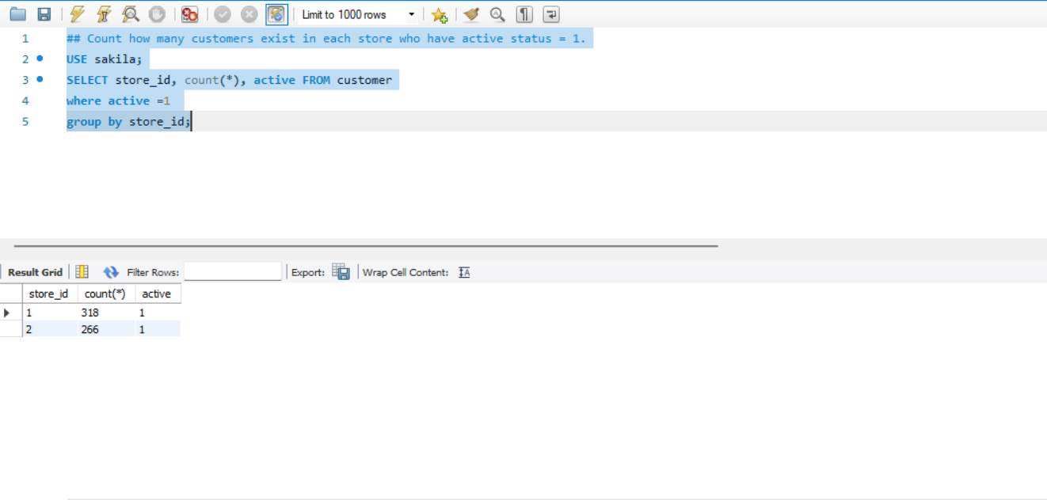

6. Show distinct film ratings available in the film table.
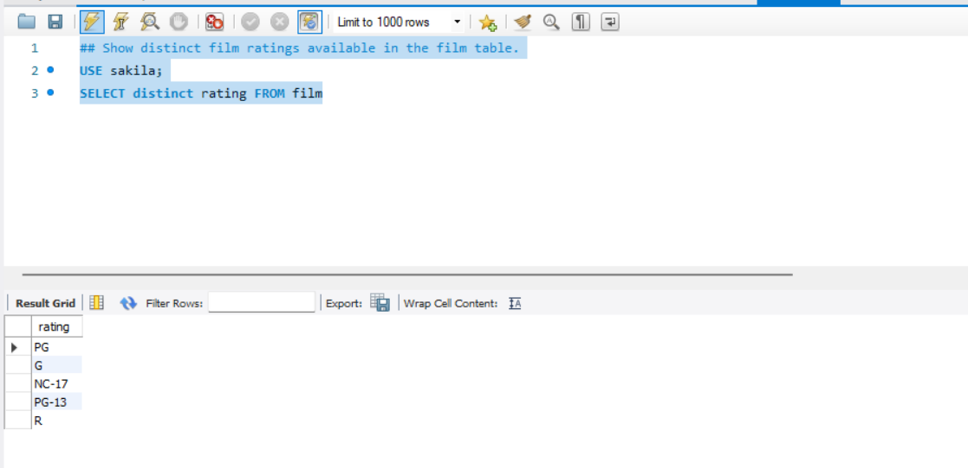

7. Find the number of films for each rental duration where the average length is more than 100 minutes.
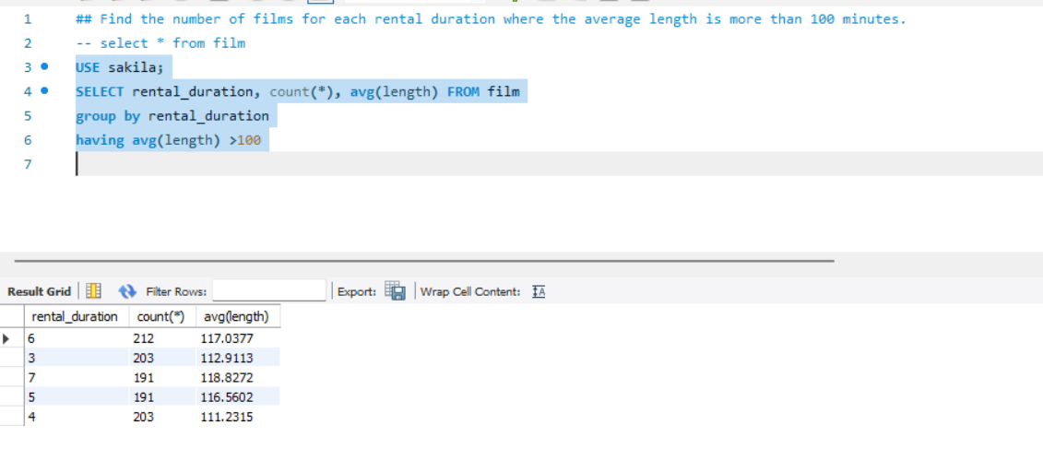

8. List payment dates and total amount paid per date, but only include days where more than 100 payments were made.
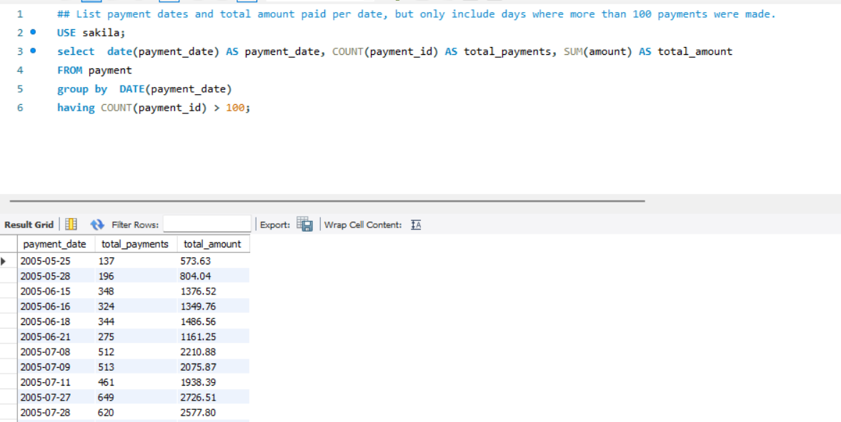

9. Find customers whose email address is null or ends with '.org'.
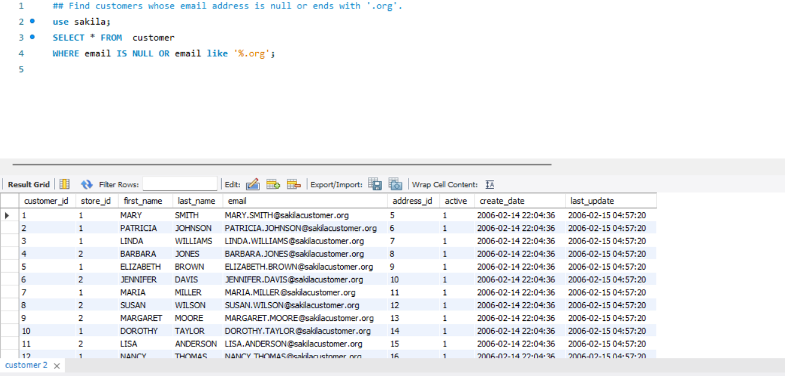

10. List all films with rating 'PG' or 'G', and order them by rental rate in descending order.
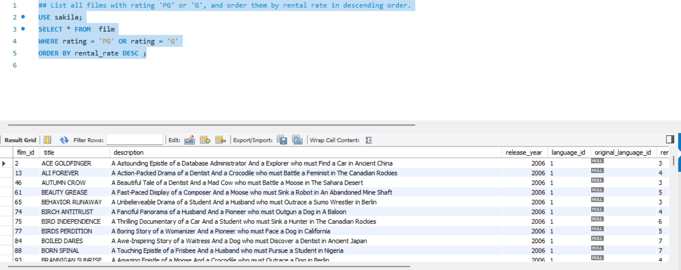

11. Count how many films exist for each length where the film title starts with 'T' and the count is more than 5.
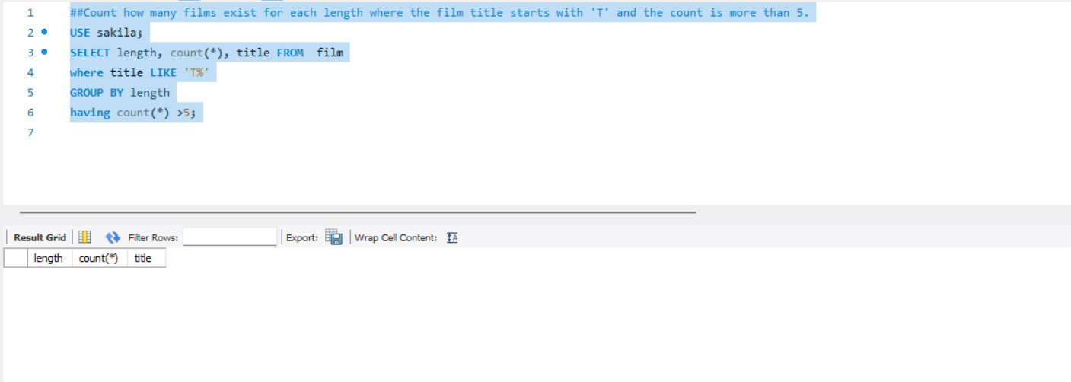

12. List all actors who have appeared in more than 10 films.
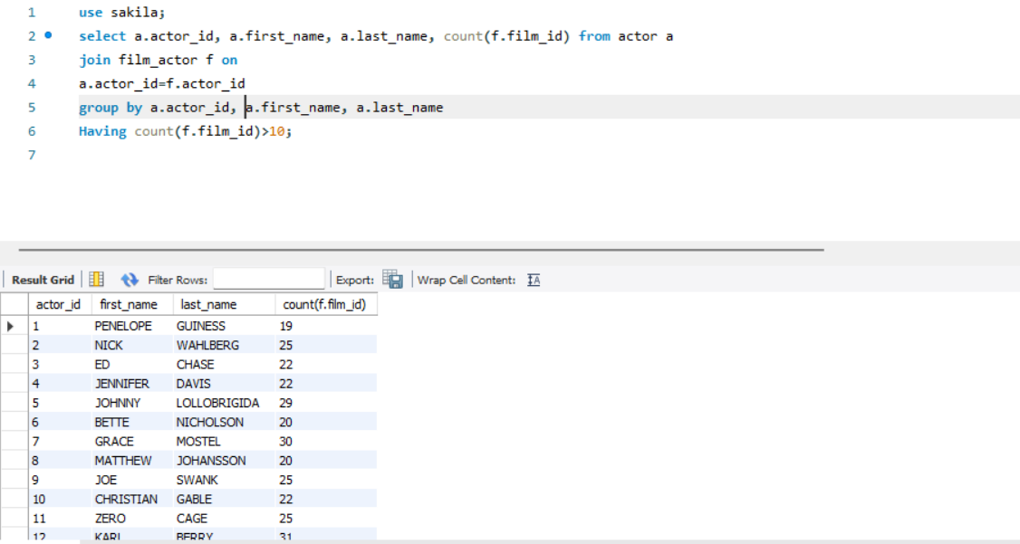

13. Find the top 5 films with the highest rental rates and longest lengths combined, ordering by rental rate first and length second.
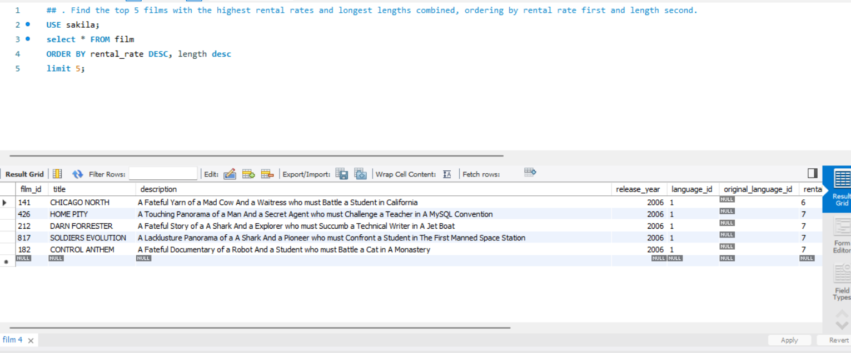

14. Show all customers along with the total number of rentals they have made, ordered from most to least rentals.
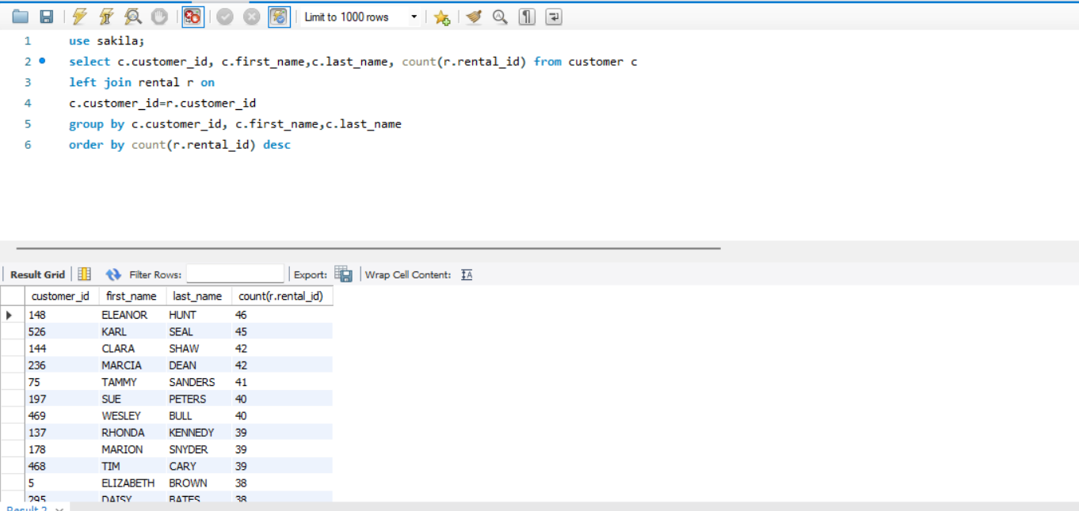

15. List the film titles that have never been rented.
