1. Identify if there are duplicates in Customer table. Don't use customer id to check the duplicates
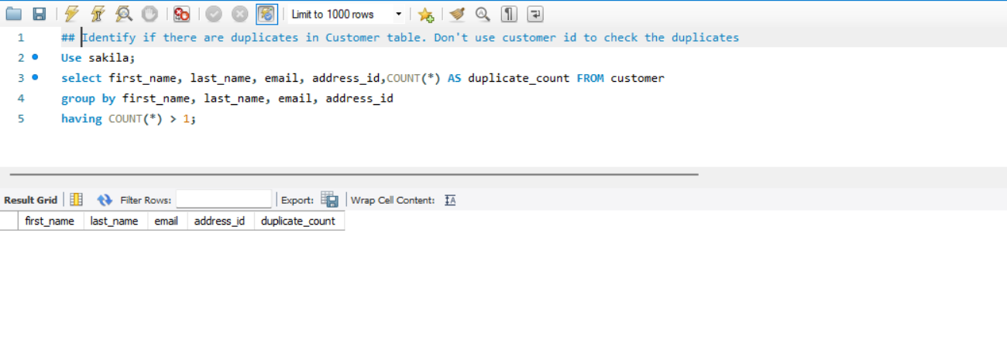
2. Number of times letter 'a' is repeated in film descriptions
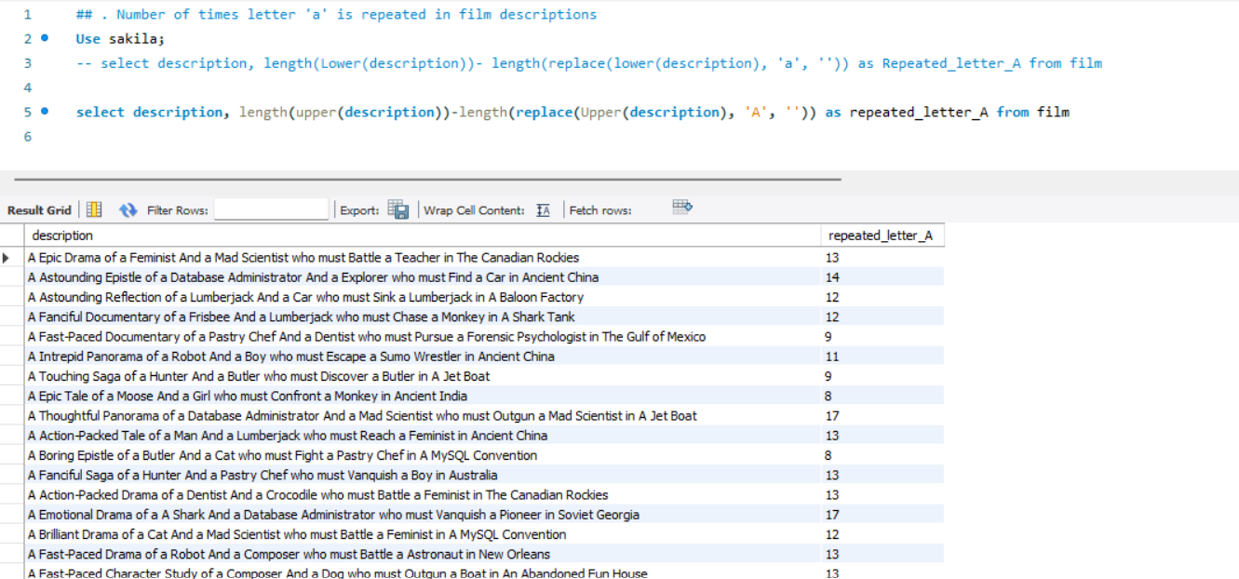
3. Number of times each vowel is repeated in film descriptions
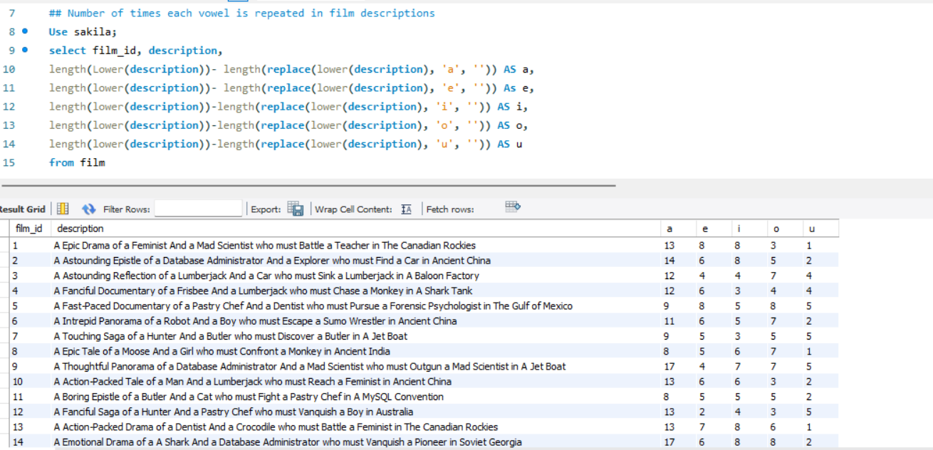
4. Display the payments made by each customer
1. Month wise
2. Year wise
3. Week wise
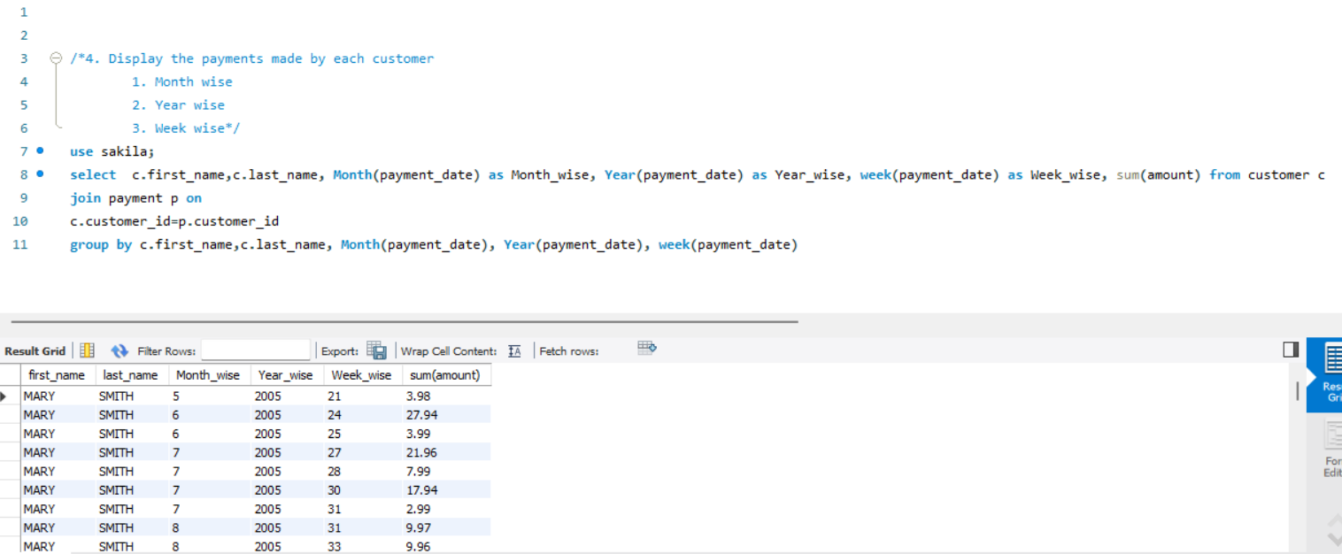

5. Check if any given year is a leap year or not. You need not consider any table from sakila database. Write within the select query with hardcoded date
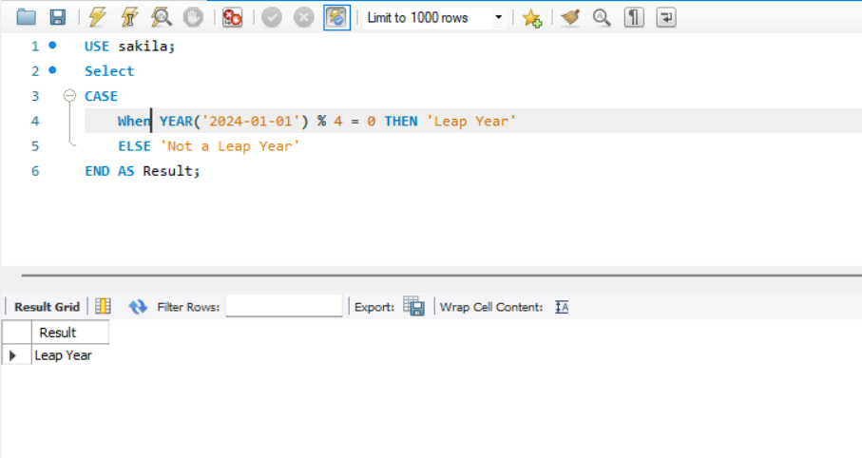
6. Display number of days remaining in the current year from today.
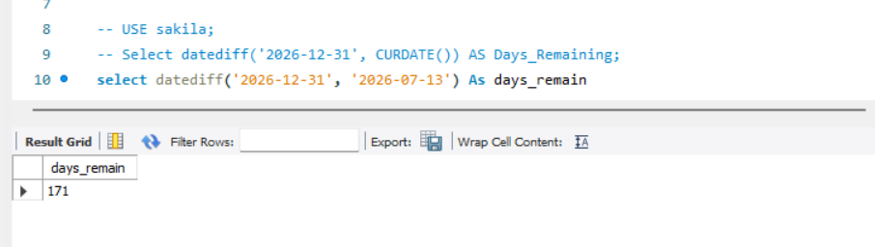
7. Display quarter number(Q1,Q2,Q3,Q4) for the payment dates from payment table.
