INVENTORY MANAGEMENT SYSTEM FOR A SMALL STORE

Submitted to:
PROF. GHEN MENDOZA MACATANGAY

Submitted by:
FELICIANO, DARLENE
GALLEGO, MICHAEL RODRIGO
JAVIER, RAINLEE
LANUZA, JASMYRE ANREI
OLDAN, LARVIE

BACKGROUND OF THE STUDY
‎ The purpose of this study is to investigate the efficiency of inventory management system in today's fast-paced retail environment. The shifting of traditional pen and paper technique into digital methods became a necessity for the survival of businesses.
Small businesses and retailers have been relying on manual ledgers and memory track of their stock. While this may work for a handful of items, It quickly becomes a hindrance as the business grows, It is prone to human errors leading to losing sales, typing up valuable capital in products that don't sell, difficulty in reconciling physical stock with recorded sales, and etc.
The introduction of a computer-based Inventory Management System (IMS) transforms these chaotic processes into an organized workflow. By centralizing product data, store owners of small businesses can monitor stock levels in real-time, update prices instantly, and maintain a digital trail of every transaction. This shift does more than just "keep count", It provides the data necessary to understand consumer behavior and seasonal trends.
For a small store, time is the most limited resource. Automating the boring tasks of inventory counting and report generation allows owners to focus on customer service and strategic growth. A well-implemented system ensures that operations are organized, data driven decisions, and accuracy is improved.
The Inventory Management System serves as the backbone of a modern small business. It bridges the gap between simple retailing and professionalized management, ensuring that the store remains competitive, organized, and profitable in an increasingly digital marketplace.

STATEMENT OF THE PROBLEM
‎ Small stores often manage their inventory manually, which can lead to problems such as inaccurate stock records, difficulty in tracking products, and time-consuming processes. Manual inventory systems may also result in errors in monitoring available items, delayed updates, and difficulty in generating reports for sales and stock levels. Because of these challenges, store owners may experience problems in maintaining an organized and efficient inventory system. ‎
‎ This study aims to develop an Inventory Management System that will help small store owners manage their inventory effectively.
‎ Specifically, the study seeks to answer the following questions:
‎ 1. How can a computerized system improve the process of managing inventory in a small store?
2. How can the system help store owners track product stock levels efficiently?
3. How can the system reduce errors commonly found in manual inventory management?
‎ 4. How can the system generate reports that help store owners monitor sales and inventory?
5. How can the proposed system improve the overall efficiency of inventory management in a small store?

OBJECTIVES
General Objective
The main objective of this study is to develop an Inventory Management System for a Small Store that will help improve the monitoring, recording, and management of store products efficiently.
‎ Specific Objectives
‎ 1. To create a system that can store and manage product information.
‎ 2. To create a system that can record and update product information and stock levels efficiently.
‎ 3. To reduce errors that commonly occur in manual inventory management.
‎ 4. To generate inventory reports that help in monitoring store operations.
‎5. To improve the overall efficiency and organization of inventory management in a small store.
‎ 6. To design a user-friendly graphical interface that allows easy interaction with the system.

SCOPE
This research focuses on the development of an Inventory Management System for a Small Store to improve the monitoring and control of store products. The system will allow the store owner to record product information, update stock quantities, and track the movement of items entering and leaving the inventory. It
will also help the store owner easily check available stocks and identify products that need restocking.
The current project scope covers the following functionalities:
Desktop-based store inventory and sales operations in a single application. The system provides a login screen with name/password inputs and a show-password toggle, followed by a main dashboard with multi-page navigation including Home, Products, Inventory, Sales, and Reports pages.
Product catalog management including add, edit, delete operations with basic validation. Each product contains Product ID (SKU), Name, Category, Unit price, Quantity, and Reorder level. The system enforces required field validation, numeric validation for price/quantity/reorder level, duplicate SKU prevention when adding, and delete confirmation dialog before removal.
Inventory monitoring with stock-status filtering and search capabilities. The Inventory page provides summary cards for Total Products, In Stock, Low Stock, and Out of Stock. Users can search by product name or SKU and filter by stock status (All, In Stock, Low Stock, Out of Stock). Each item row shows product metadata, stock and reorder level, and computed status badge.
Sales transaction recording with stock deduction and sales summaries. The Sales page supports transaction entry by selecting a product and quantity, with auto-filled current date, auto-calculated unit price and total, and stock validation before recording. When a sale is saved, a transaction is created, stock is reduced accordingly, and dashboard/sales metrics update.
Operational reporting for products, sales, and inventory. The Reports page provides three report views: Product Report, Sales Report, and Inventory Report. Users can view report details in-app and export report data as CSV files with timestamps in filenames (e.g., product_report_YYYYMMDD_HHMMSS.csv).
Demo-ready startup behavior with seeded sample data. On startup, the application preloads demo products and sample sales transactions, providing non-empty data by default for immediate UI walkthroughs.
The system is designed for day-to-day store operations including maintaining a product catalog, monitoring stock levels and low-stock conditions, recording sales transactions, and exporting CSV reports for analysis or sharing.

LIMITATION
The advanced features of inventory management, such as ordering suppliers, warehouse management, or connecting to accounting or financial packages, will not be included in the research, nor will it cover advanced data analytics, forecasting, or inventory management for multiple locations. The study will only cover the basic inventory management functions that are required by a small store, such as adding, editing, or viewing inventory records, but the system will show the benefits of these basic functions to the efficiency of the inventory management process.
Current implementation limitations include:
- Authentication is not secure in its current form; it relies on a hardcoded username/password pair (admin / password).
- Runtime data is in-memory only; product and sales data are held in memory while the app is open. No database or long-term persistence layer is currently active for core runtime data. This means runtime changes are not automatically restored on next launch, though exported CSV files remain available in the exports/ directory.
- Report exports are limited to CSV format only.
- The system is designed for single-user local execution and does not provide multi-user concurrency controls.
- Date/time, currency format (Philippine Peso - PHP), and labels are fixed in-app and are not configurable by users.
- Error handling and validation are focused on UI-level checks; there is no external persistence or transactional recovery layer.
Out of scope for this version are advanced user roles and permissions, multi-branch or multi-store inventory synchronization, purchase order management and supplier workflows, barcode scanning, receipt printing, and POS hardware integration, as well as cloud/mobile companion applications

DEFINITION OF TERMS
- Inventory Management System (IMS)
A computerized system used to track, record, and manage the quantity, movement, and information of products within a store. It helps store owners monitor stock levels and sales activities efficiently.
- Product
An item or merchandise sold in the store. Each product contains information such as its name, category, price, stock quantity, and identification code.
- SKU (Stock Keeping Unit)
A unique code assigned to a product that helps identify and track items in the inventory system.
- Stock Level
The current quantity of a product available in the inventory at a given time.
- Reorder Level
The minimum quantity of a product that should remain in stock before the store needs to restock the item.
- Sale Transaction
A recorded event where one or more products are sold to a customer. It includes details such as the transaction ID, date, items sold, and total amount.
- Sale Item
A specific product included in a sales transaction along with the quantity sold and the unit price.
- Inventory Manager
A system component responsible for managing product records, updating stock levels, and monitoring inventory data.
- Sales Manager
A system component responsible for recording sales transactions and maintaining the history of all sales activities.
- Report Service
A system feature that generates reports related to inventory and sales to help store owners analyze business performance.
- Low Stock
A condition where the quantity of a product in inventory falls below the defined reorder level.
- Out of Stock
A situation where a product is no longer available in inventory because its quantity has reached zero.
- User Interface (UI)
The graphical part of the system that allows users to interact with the program, such as pages, buttons, forms, and menus.
- Graphical User Interface (GUI)
A type of user interface that allows users to interact with the system using graphical elements such as windows, icons, and buttons instead of text commands.
- Sales Report
A generated document that summarizes sales transactions over a certain period of time.
- Inventory Report
A report that displays information about product quantities, stock levels, and inventory status.
- CSV (Comma-Separated Values)
A file format used for exporting report data from the system. CSV files can be opened in spreadsheet applications for further analysis or sharing.
- In-Memory Data
A data storage approach where product and sales information is held in the computer's RAM during runtime rather than being saved to a permanent database.
- Java Swing
A GUI widget toolkit for Java used to build the desktop interface of the Inventory Management System.
- Dashboard
The main overview screen displayed after login that provides a quick operational summary of the store's performance metrics.

PROTOTYPE
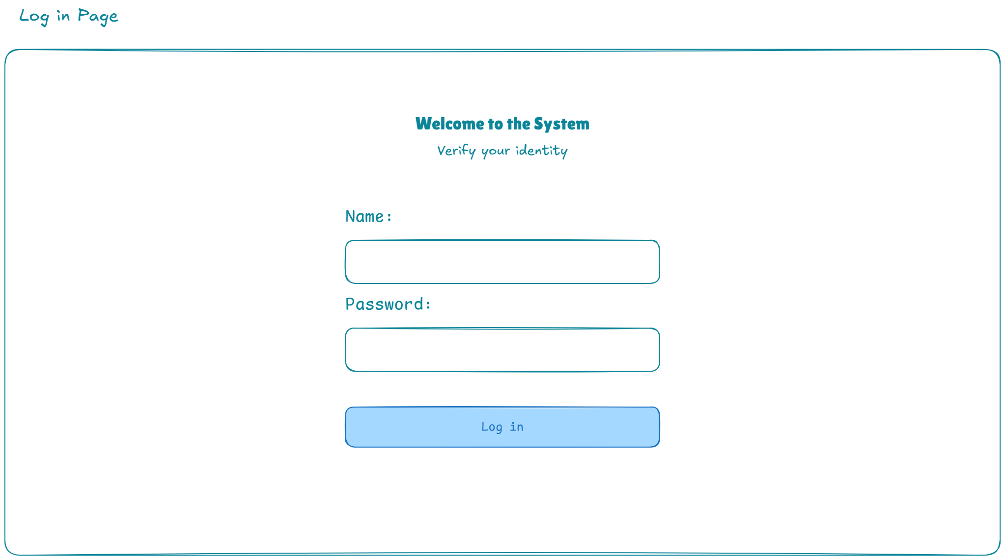
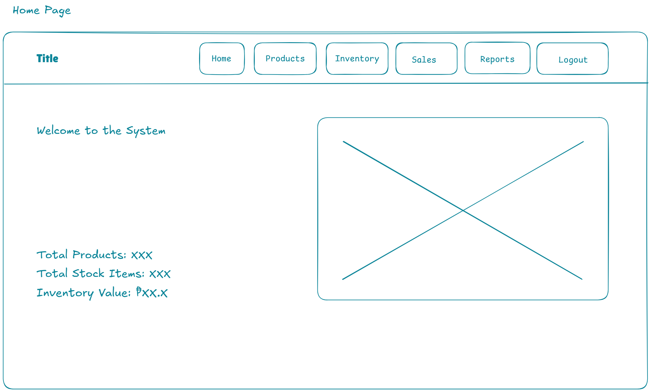
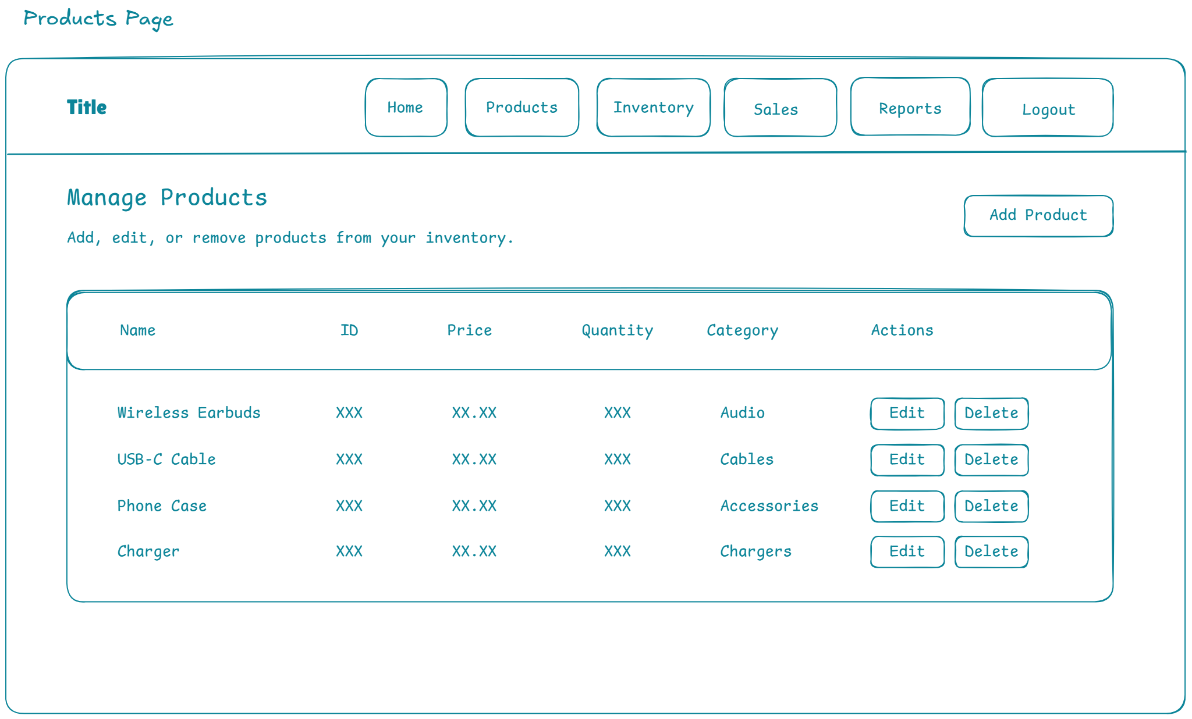
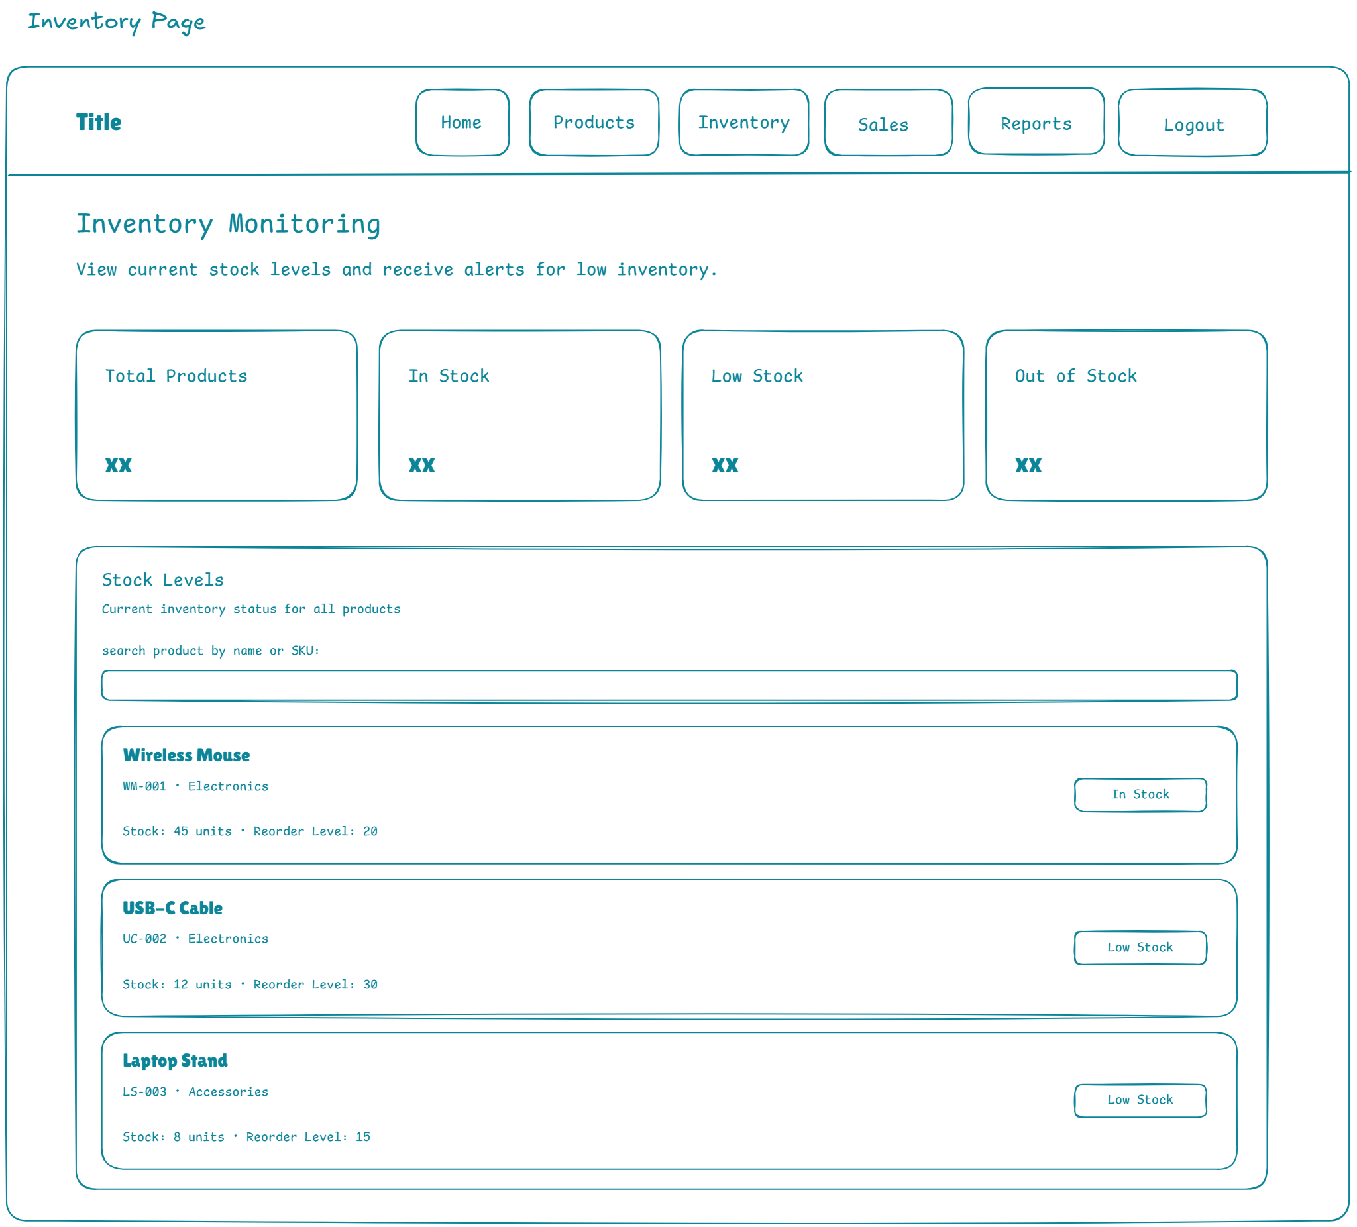
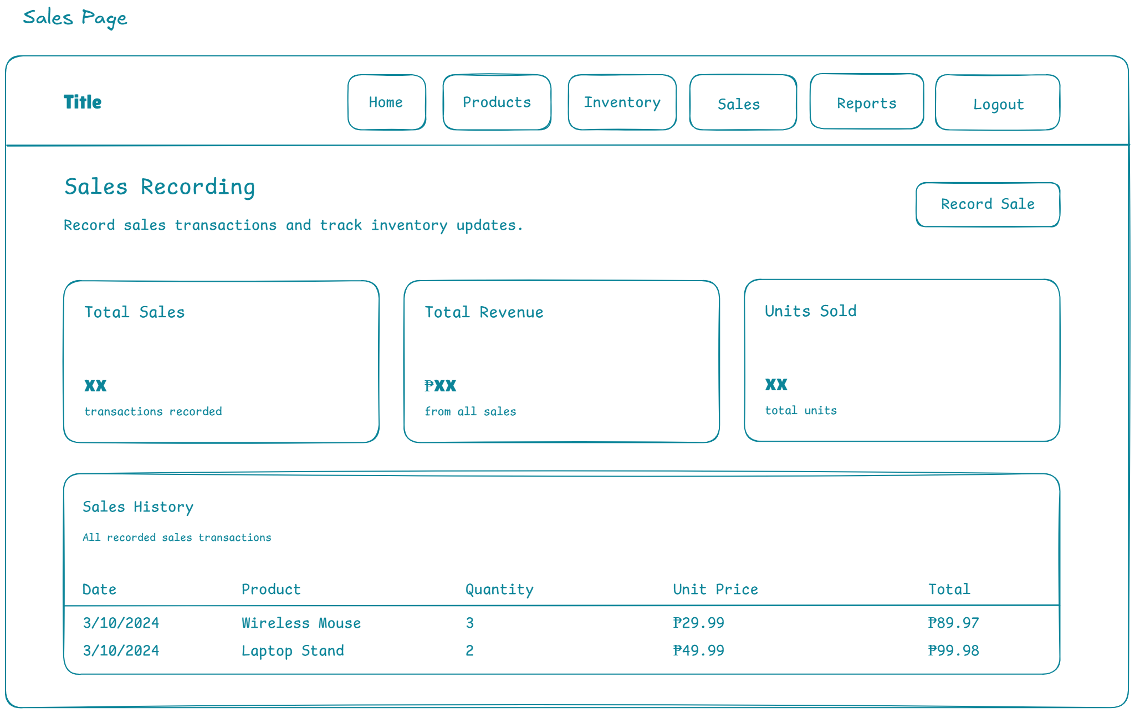
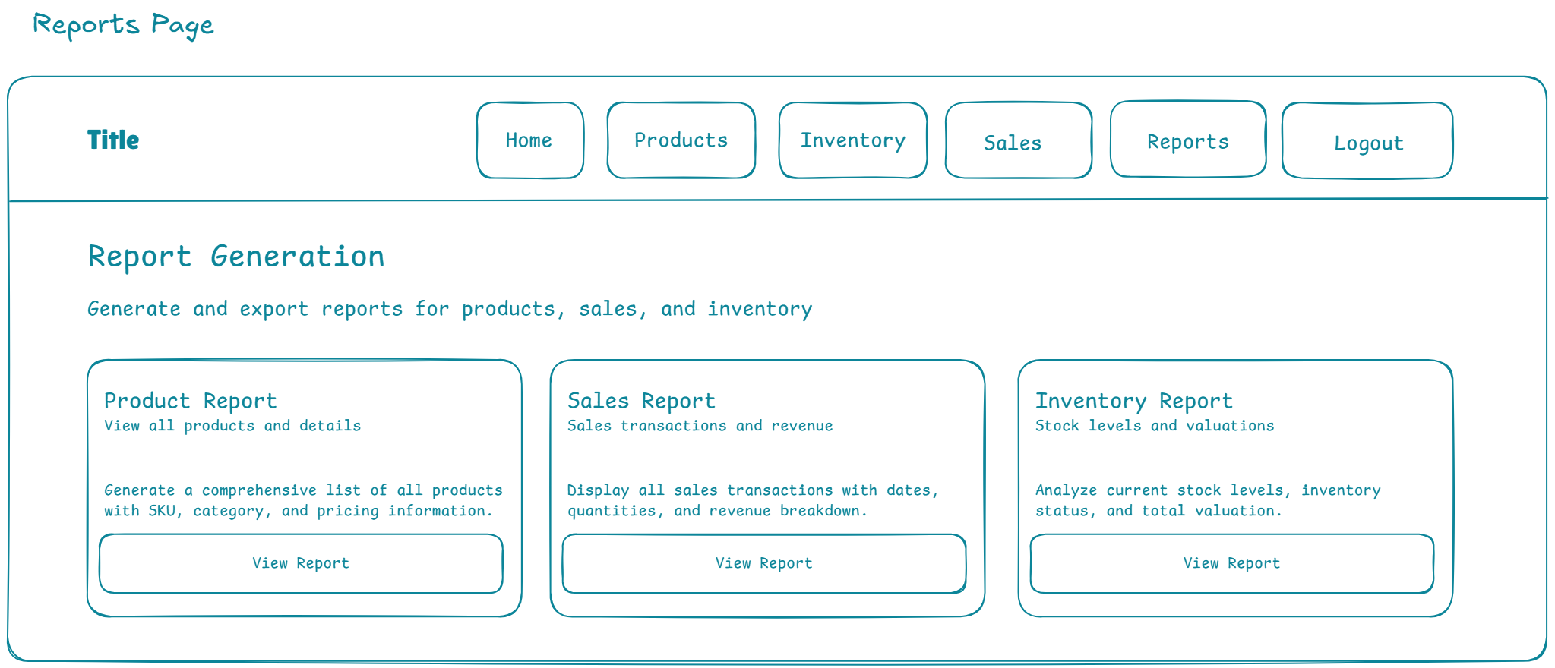
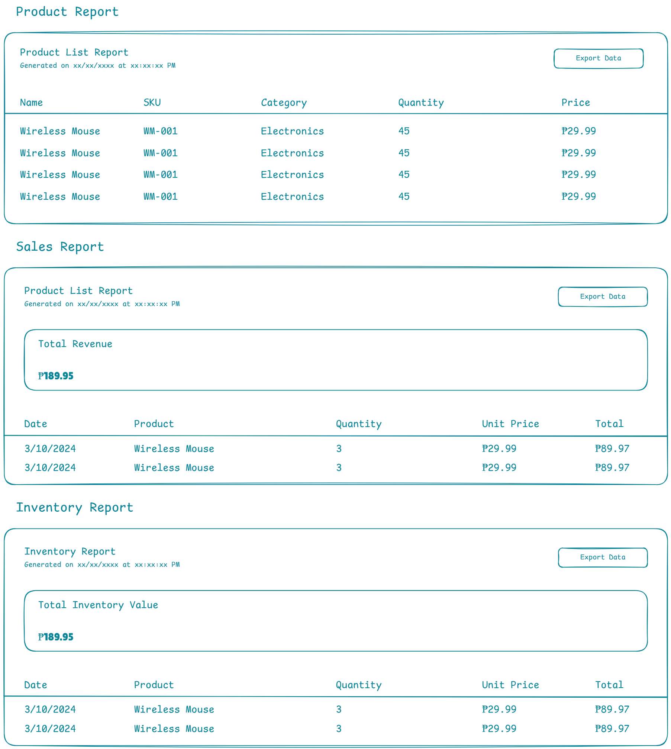

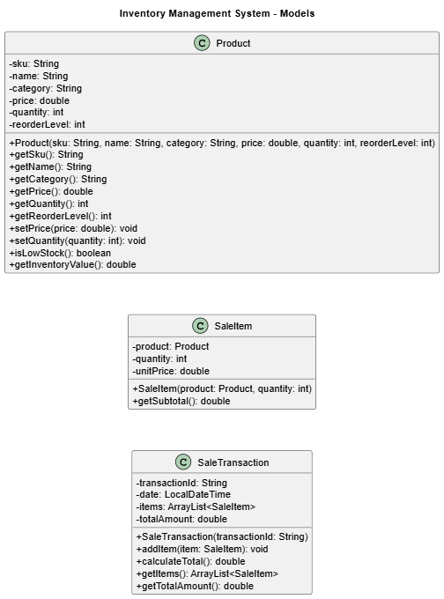
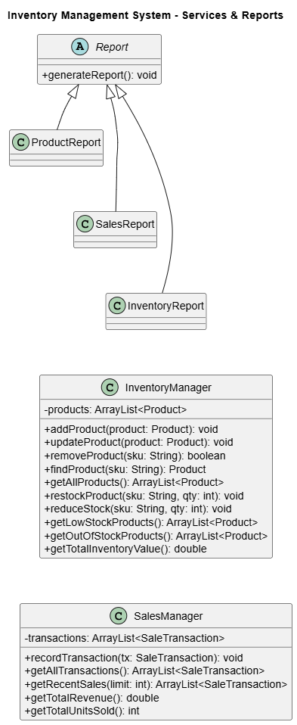
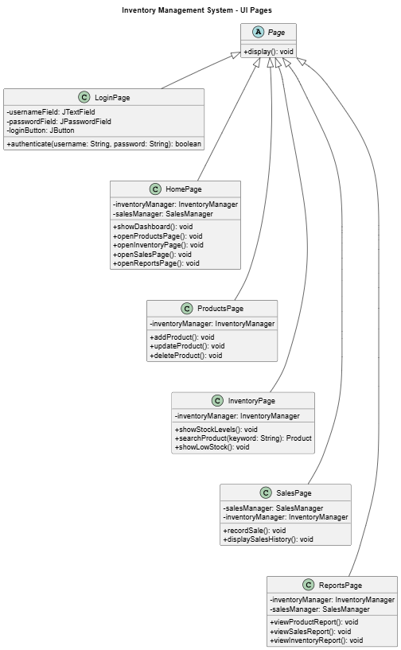

REFERENCES
Hashemi-Pour, C., Amsler, S., & O'Donnell, J. (2024). Inventory management definition. TechTarget
Lim, H. Q., Rahmat, A. R., & Suban Ani, S. (2025).
Pratama, A., & Hafsari, R.
https://al-kindipublishers.org/index.php/jbms/article/view/852?utm_source=chatgpt.com

