INVENTORY MANAGEMENT SYSTEM FOR A SMALL STORE

Submitted to:
PROF. GHEN MENDOZA MACATANGAY

Submitted by:
FELICIANO, DARLENE
GALLEGO, MICHAEL RODRIGO
JAVIER, RAINLEE
LANUZA, JASMYRE ANREI
OLDAN, LARVIE

BACKGROUND OF THE STUDY
‎The purpose of this study is to investigate the efficiency of inventory management system in today's fast-paced retail environment. The shifting of traditional pen and paper technique into digital methods became a necessity for the survival of businesses.
Small businesses and retailers have been relying on manual ledgers and memory track of their stock. While this may work for a handful of items, It quickly becomes a hindrance as the business grows, It is prone to human errors leading to losing sales, typing up valuable capital in products that don't sell, difficulty in reconciling physical stock with recorded sales, and etc.
The introduction of a computer-based Inventory Management System (IMS) transforms these chaotic processes into an organized workflow. By centralizing product data, store owners of small businesses can monitor stock levels in real-time, update prices instantly, and maintain a digital trail of every transaction.This shift does more than just "keep count", It provides the data necessary to understand consumer behavior and seasonal trends.
For a small store, time is the most limited resource. Automating the boring tasks of inventory counting and report generation allows owners to focus on customer service and strategic growth. A well-implemented system ensures that operations are organized, data driven decisions, and accuracy is improved.
The Inventory Management System serves as the backbone of a modern small business. It bridges the gap between simple retailing and professionalized management, ensuring that the store remains competitive, organized, and profitable in an increasingly digital marketplace.

STATEMENT OF THE PROBLEM
‎Small stores often manage their inventory manually, which can lead to problems such as inaccurate stock records, difficulty in tracking products, and time-consuming processes. Manual inventory systems may also result in errors in monitoring available items, delayed updates, and difficulty in generating reports for sales and stock levels. Because of these challenges, store owners may experience problems in maintaining an organized and efficient inventory system. ‎
‎This study aims to develop an Inventory Management System that will help small store owners manage their inventory effectively.
‎Specifically, the study seeks to answer the following questions:
‎1. How can a computerized system improve the process of managing inventory in a small store?
2. How can the system help store owners track product stock levels efficiently?
3. How can the system reduce errors commonly found in manual inventory management?
‎4. How can the system generate reports that help store owners monitor sales and inventory?
5. How can the proposed system improve the overall efficiency of inventory management in a small store?

OBJECTIVES
General Objective
The main objective of this study is to develop an Inventory Management System for a Small Store that will help improve the monitoring, recording, and management of store products efficiently.
‎Specific Objectives
‎1. To create a system that can store and manage product information.
‎2. To create a system that can record and update product information and stock levels efficiently.
‎3. To reduce errors that commonly occur in manual inventory management.
‎4. To generate inventory reports that help in monitoring store operations.
‎5. To improve the overall efficiency and organization of inventory management in a small store.
‎6. To design a user-friendly graphical interface that allows easy interaction with the system.

SCOPE
This research focuses on the development of an Inventory Management System for a Small Store to improve the monitoring and control of store products. The system will allow the store owner to record product information, update stock quantities, and track the movement of items entering and leaving the inventory. It will also help the store owner easily check available stocks and identify products that need restocking.

LIMITATION
The advanced features of inventory management, such as ordering suppliers, warehouse management, or connecting to accounting or financial packages, will not be included in the research, nor will it cover advanced data analytics, forecasting, or inventory management for multiple locations. The study will only cover the basic inventory management functions that are required by a small store, such as adding, editing, or viewing inventory records, but the system will show the benefits of these basic functions to the efficiency of the inventory management process.

DEFINITION OF TERMS
- Inventory Management System (IMS)
A computerized system used to track, record, and manage the quantity, movement, and information of products within a store. It helps store owners monitor stock levels and sales activities efficiently.
- Product
An item or merchandise sold in the store. Each product contains information such as its name, category, price, stock quantity, and identification code.
- SKU (Stock Keeping Unit)
A unique code assigned to a product that helps identify and track items in the inventory system.
- Stock Level
The current quantity of a product available in the inventory at a given time.
- Reorder Level
The minimum quantity of a product that should remain in stock before the store needs to restock the item.
- Sale Transaction
A recorded event where one or more products are sold to a customer. It includes details such as the transaction ID, date, items sold, and total amount.
- Sale Item
A specific product included in a sales transaction along with the quantity sold and the unit price.
- Inventory Manager
A system component responsible for managing product records, updating stock levels, and monitoring inventory data.
- Sales Manager
A system component responsible for recording sales transactions and maintaining the history of all sales activities.
- Report Service
A system feature that generates reports related to inventory and sales to help store owners analyze business performance.
- Low Stock
A condition where the quantity of a product in inventory falls below the defined reorder level.
- Out of Stock
A situation where a product is no longer available in inventory because its quantity has reached zero.
- User Interface (UI)
The graphical part of the system that allows users to interact with the program, such as pages, buttons, forms, and menus.
- Graphical User Interface (GUI)
A type of user interface that allows users to interact with the system using graphical elements such as windows, icons, and buttons instead of text commands.
- Sales Report
A generated document that summarizes sales transactions over a certain period of time.
- Inventory Report
A report that displays information about product quantities, stock levels, and inventory status.
PROTOTYPE
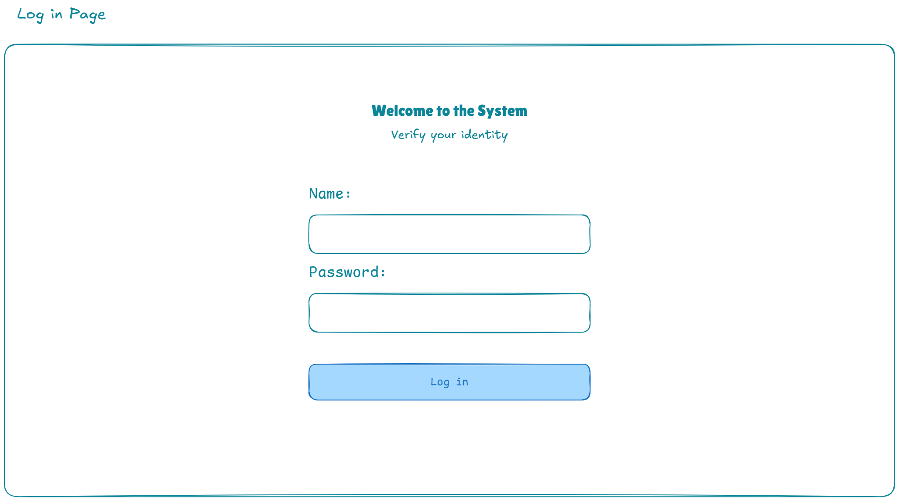
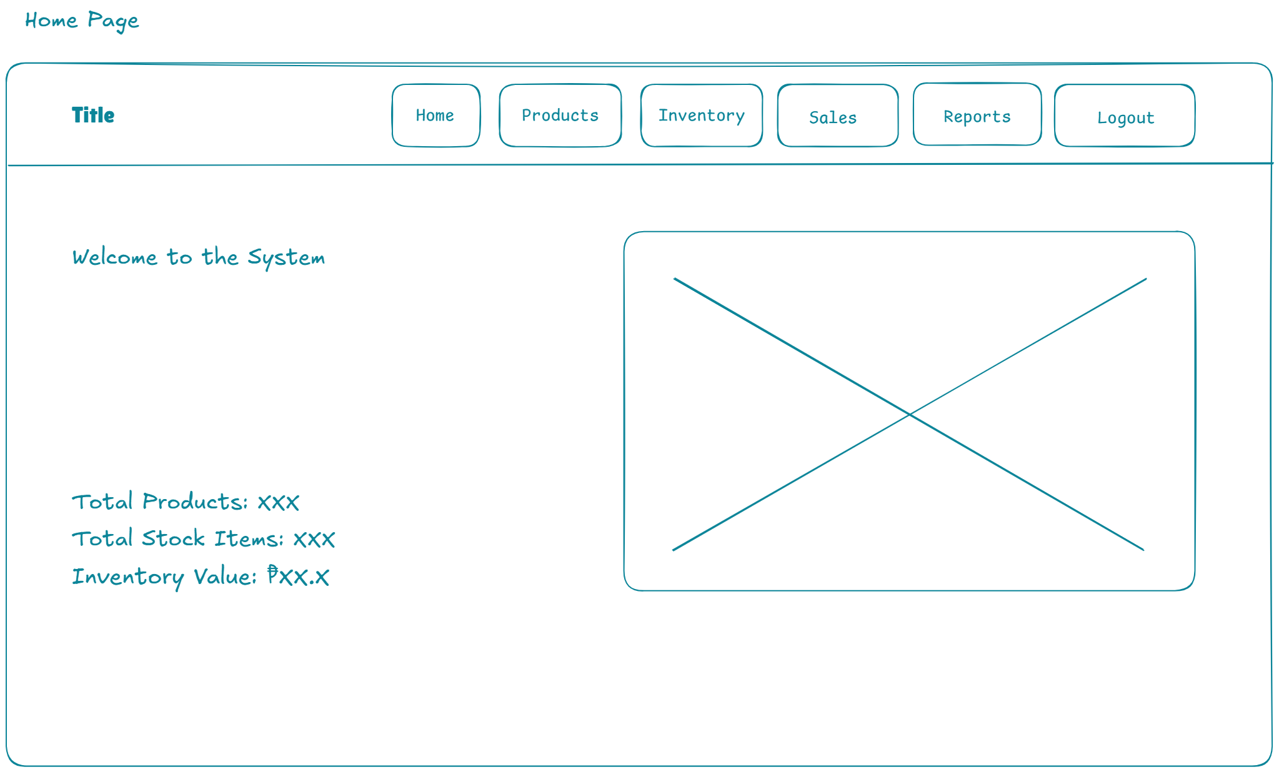
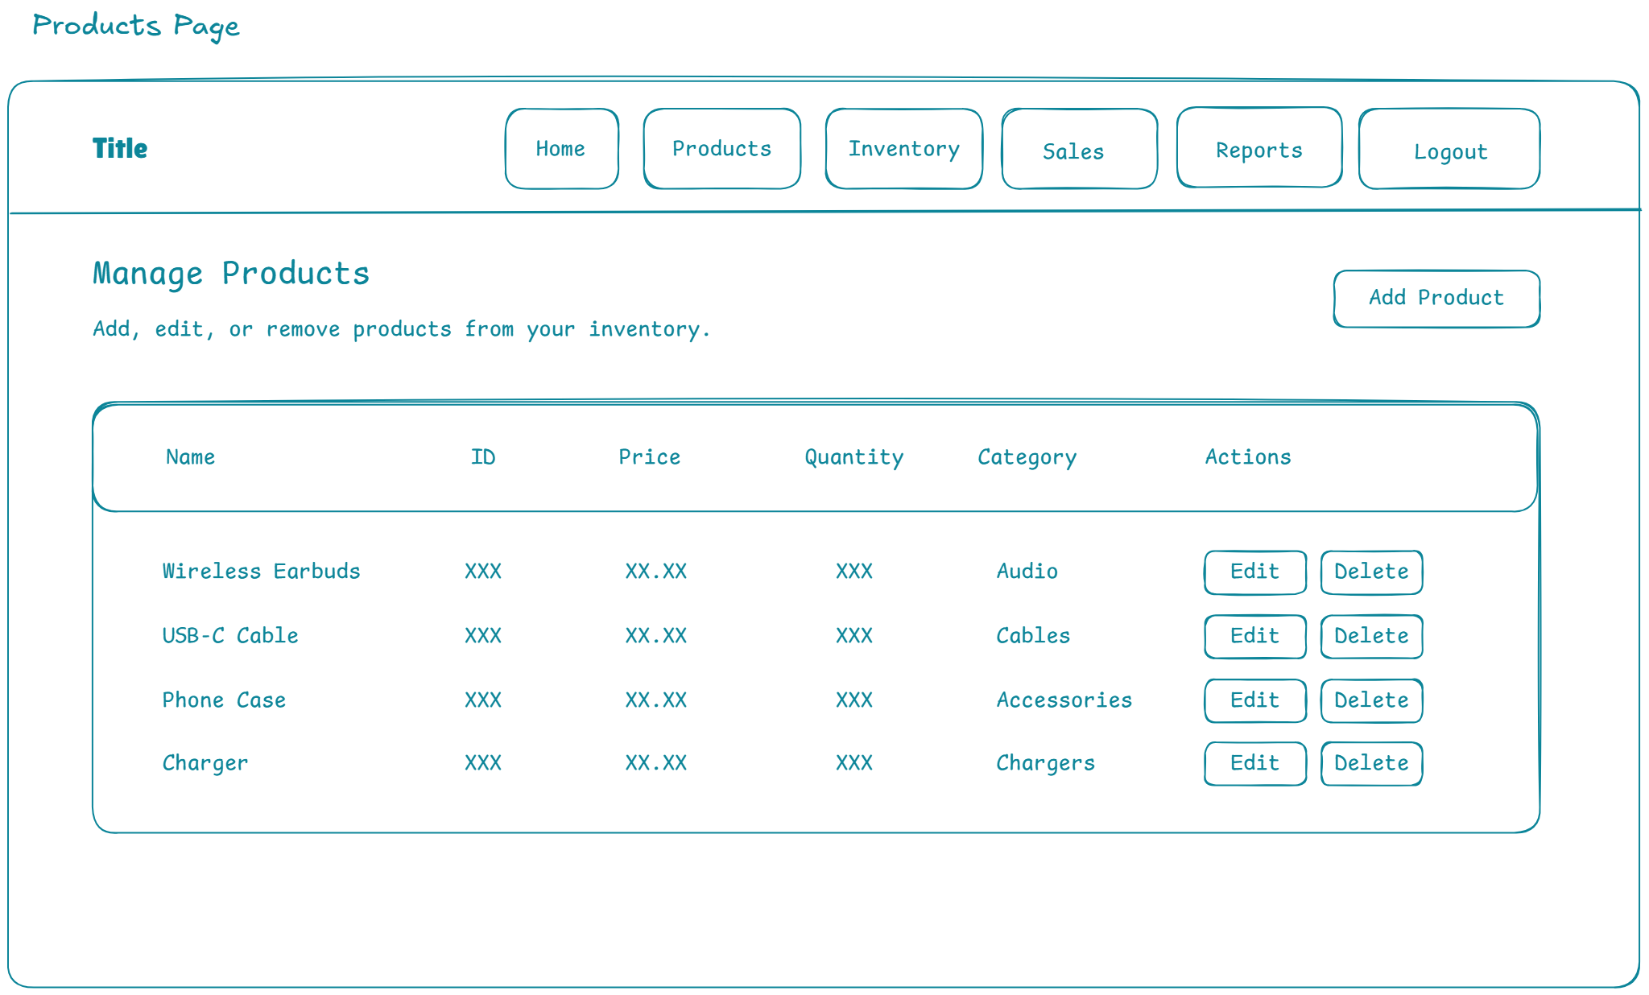
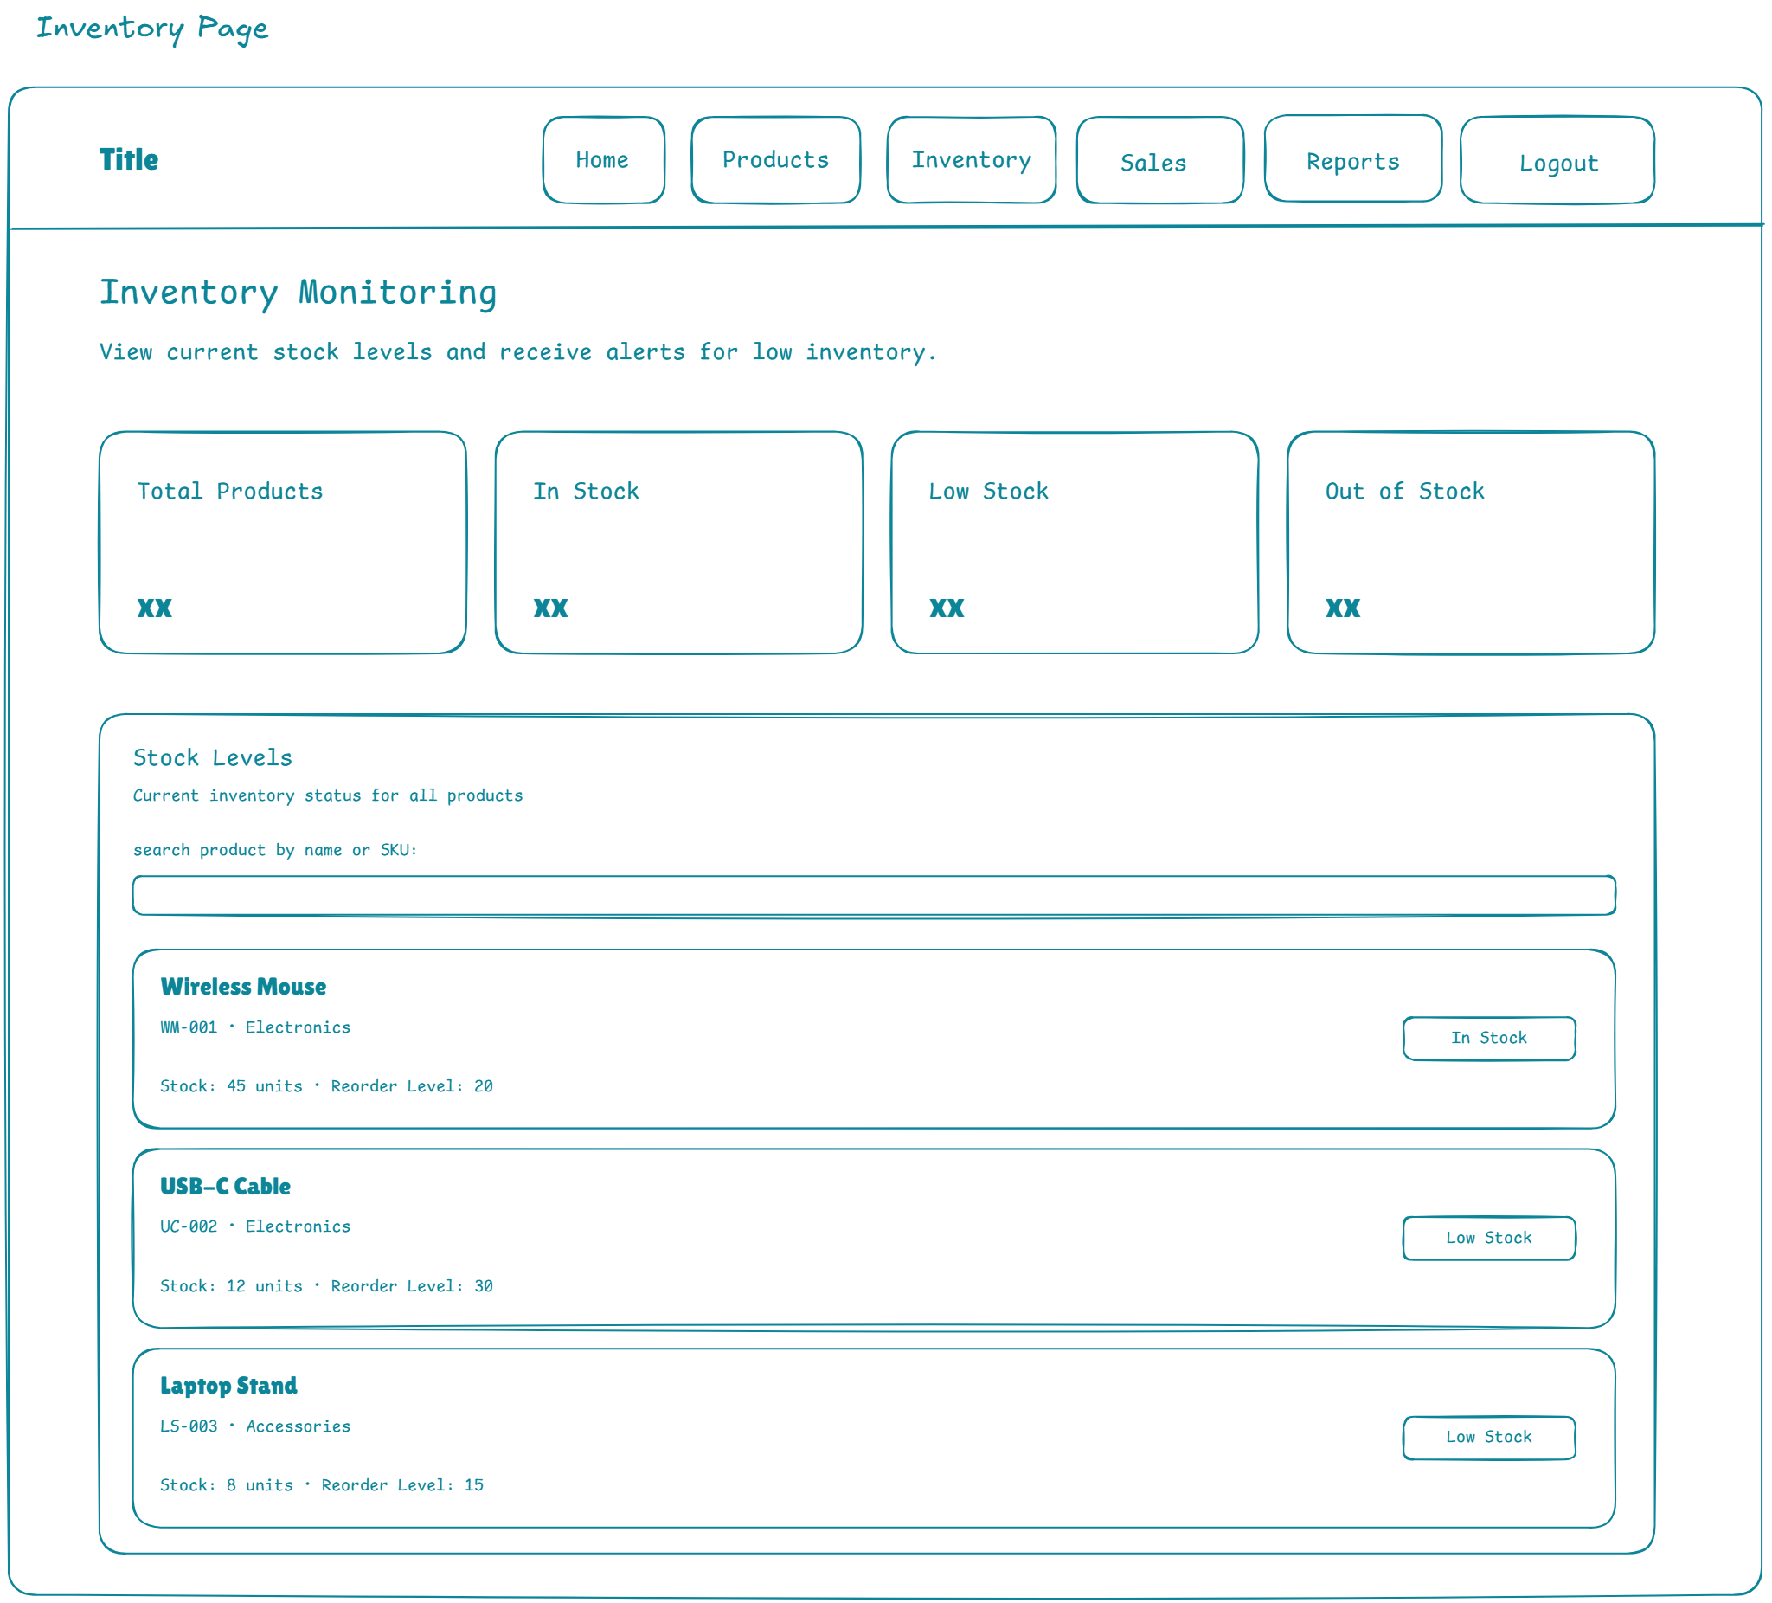
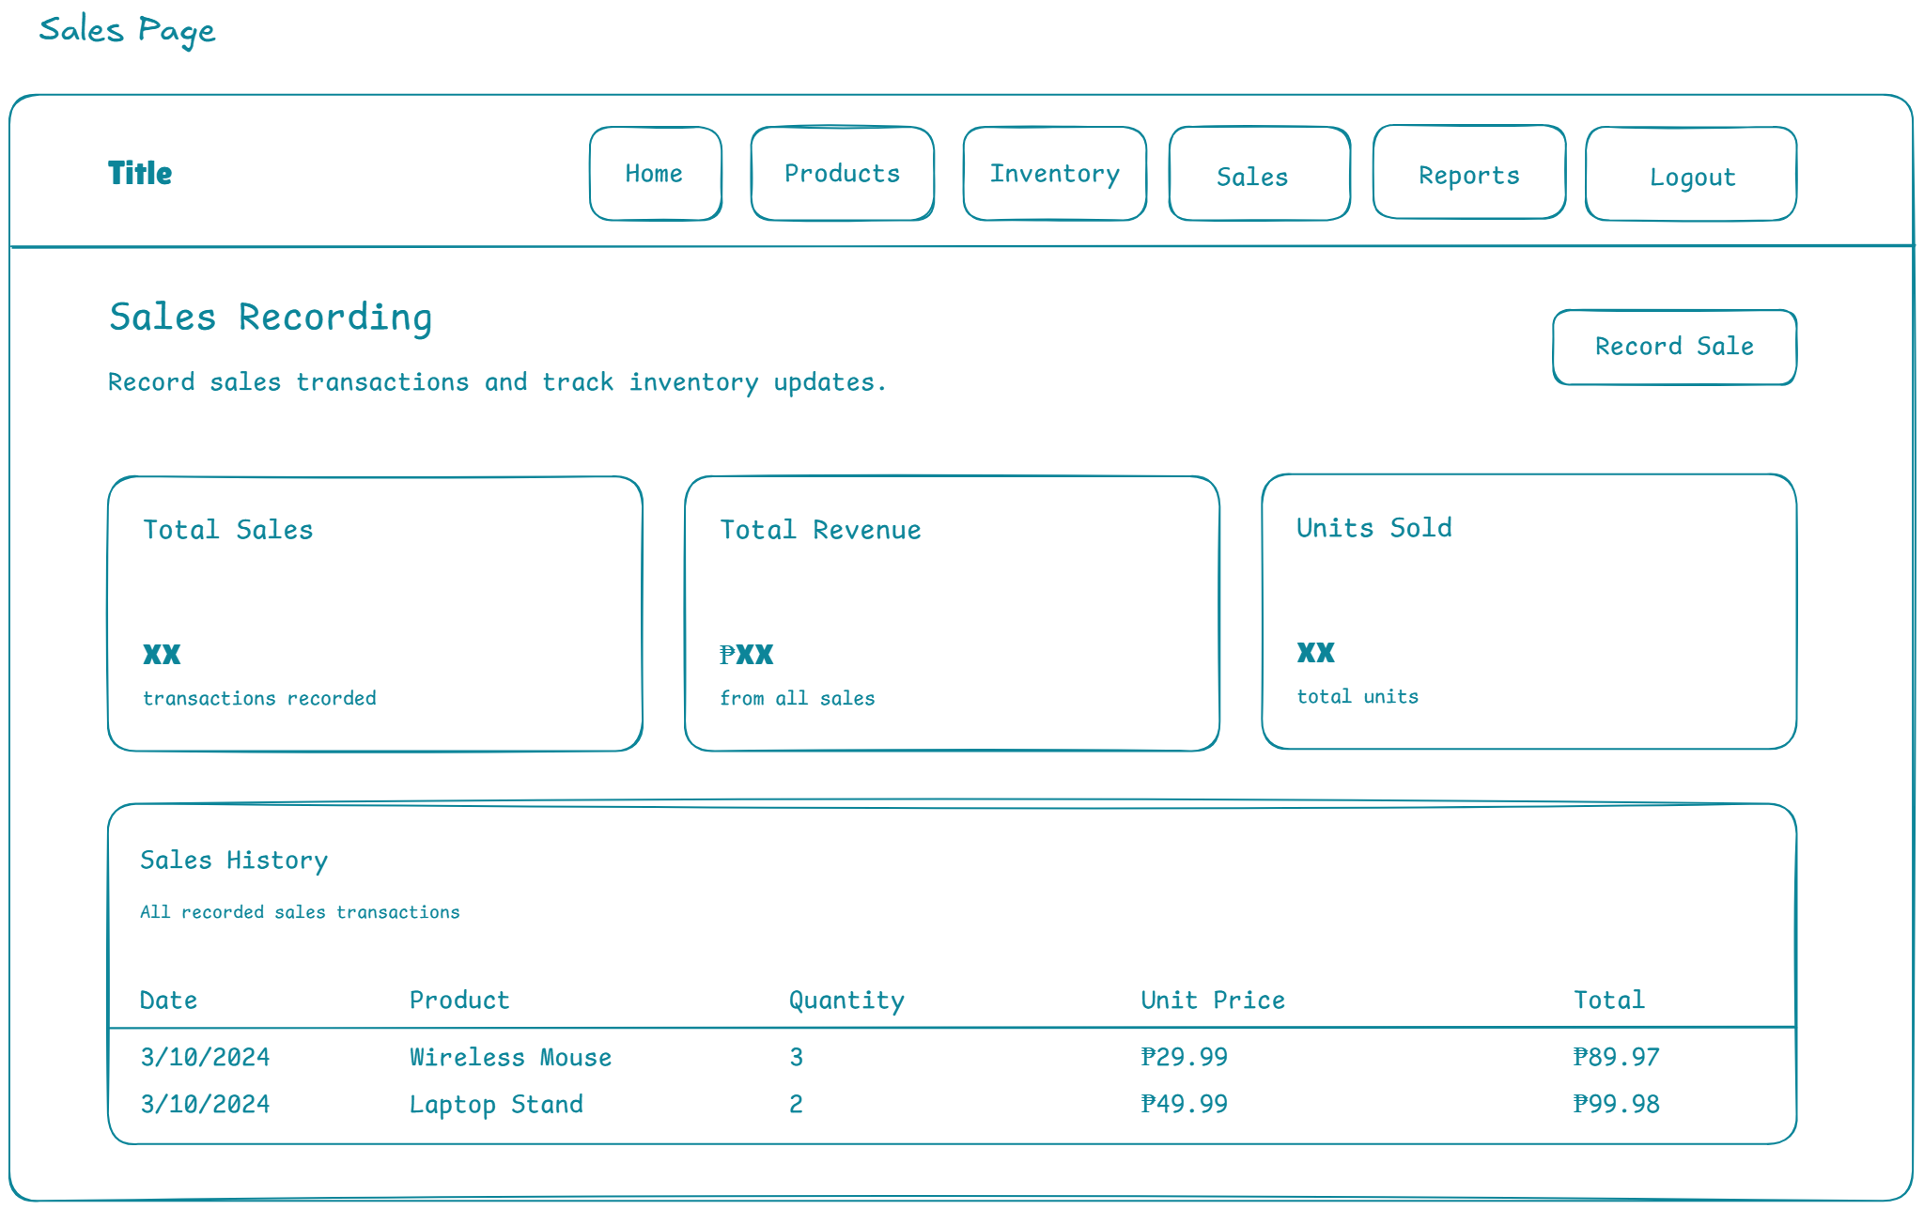
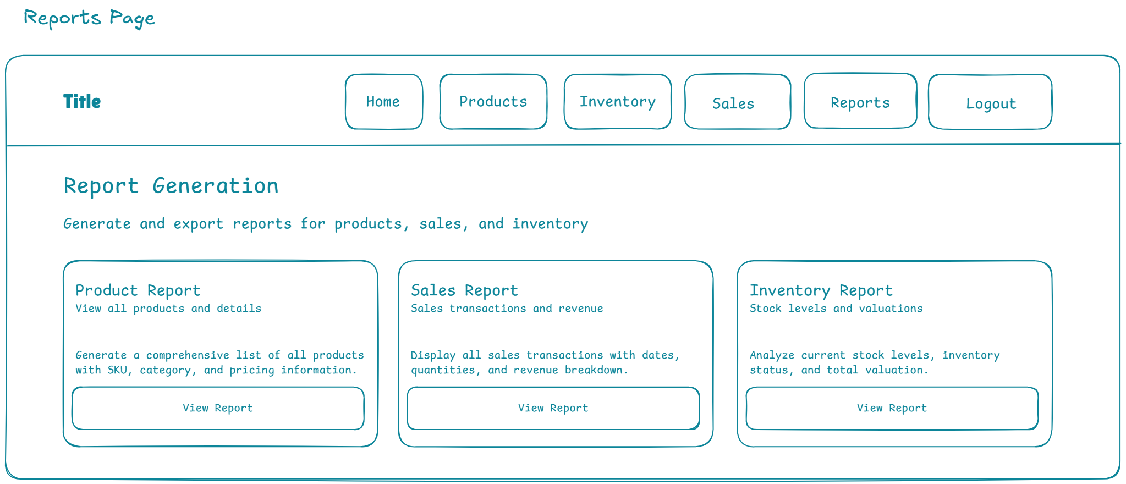
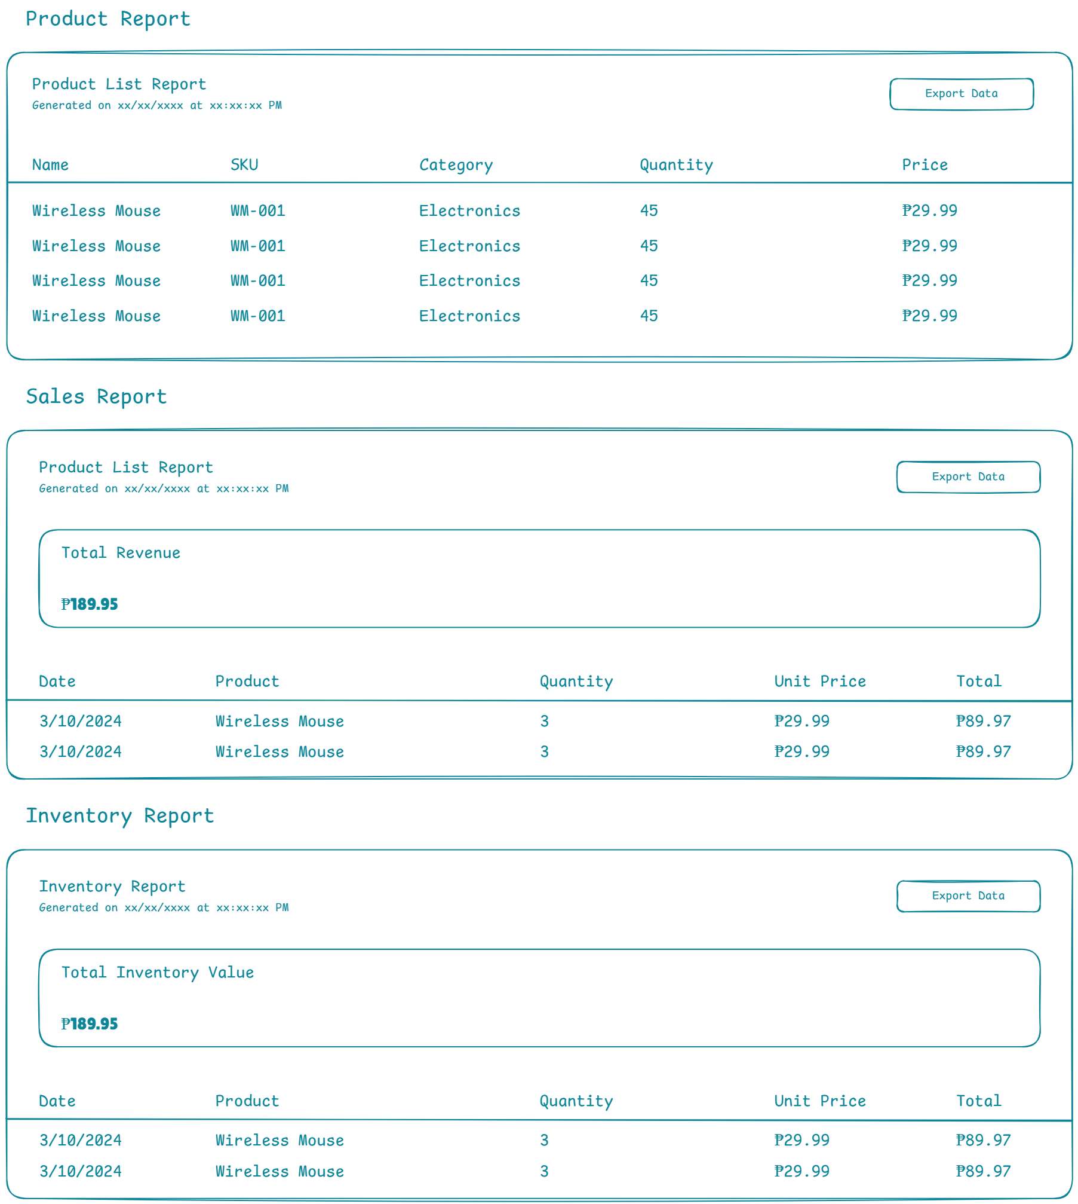

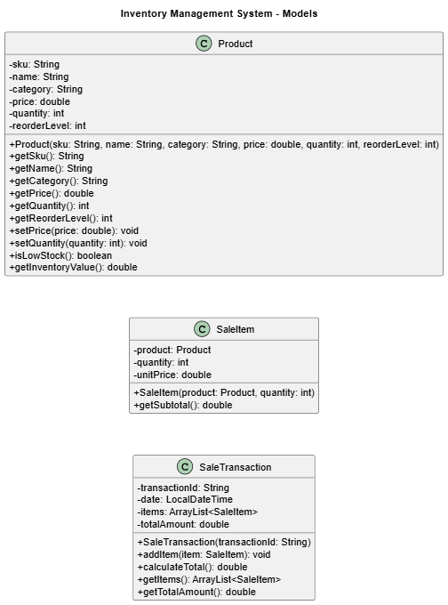
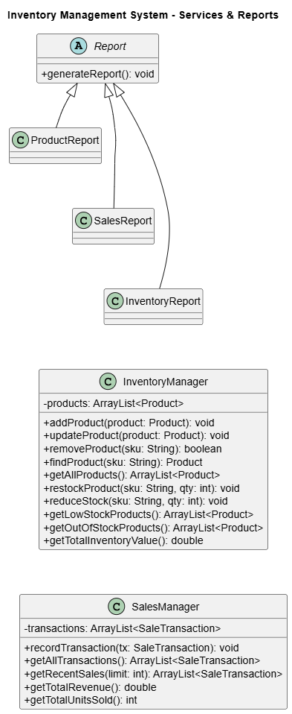
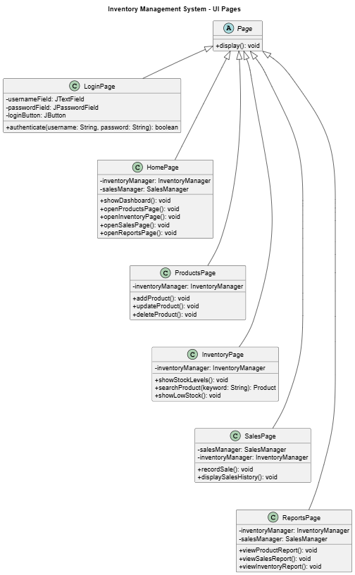

REFERENCES
Hashemi-Pour, C., Amsler, S., & O'Donnell, J. (2024). Inventory management definition. TechTarget
Lim, H. Q., Rahmat, A. R., & Suban Ani, S. (2025).
Pratama, A., & Hafsari, R.
https://al-kindipublishers.org/index.php/jbms/article/view/852?utm_source=chatgpt.com

