**Acknowledgement**

We wish to extend our heartfelt thanks to our teachers, parents and friends for their constant support throughout our project's completion. We would also like to express our sincere gratitude to our school for giving us the opportunity to work on our project on: Prison Management System.

**Overview of Python**

Python is a high-level, interpreted, interactive and object-oriented scripting language. Python’s simple, easy to learn syntax emphasizes readability. It supports modules and packages, which encourages program modularity and code reuse.

* High-Level Language: Python is a high-level programming language, which means it abstracts complex operations and provides a straightforward way to express ideas and algorithms. This makes it accessible to beginners and experts alike.
* Interpreted Language: Python is an interpreted language, meaning you don't need to compile your code before running it. This makes development and testing faster, as you can see the results of your code immediately.
* Versatility: Python is a versatile language suitable for a wide range of applications. It can be used for web development, data analysis, scientific computing, automation, scripting, and more. This versatility makes it a popular choice.
* Open Source: Python is an open-source language, which means it is freely available and can be modified and distributed by anyone. This open nature encourages collaboration and innovation.

**Overview of MySQL**

MySQL, the most popular Open Source SQL database management system, is developed, distributed, and supported by Oracle Corporation. It is known for organizing data into one or more data tables in which data types are related to each other. These relations help structure data, as SQL is a language that programmers use for creation, modification and extraction of data from a relational database. MySQL uses standalone clients that allow users to interact with MySQL, and also to use it with other programs for applications that need relational database capabilities. MySQL's reputation for reliability has led to its inclusion in the popular LAMP stack (Linux, Apache, MySQL, Python/Perl/PHP)

MySQL Connector module of Python is used to connect databases with the Python programs.

**Need for the Project**

Effective prison management is crucial for ensuring the safety of both inmates and prison staff. However, many prisons continue to struggle with outdated and inefficient manual processes, leading to security breaches, resource wastages, etc. The need for a comprehensive Prison Management System (PMS) is imperative to address the challenges faced by the correctional facilities.

The Prison Management System comprises of a secure login module which allows access only to authorized people.

It consists of systematic relational databases and tables to enable data management of prisoners and guards, tracking of finances, and the collection, modification and retrieval of relevant details.

This is better than manual record-keeping that lead to inaccuracies and inefficiencies in managing prisons

**Minimum Hardware and Software Requirements**

**HARDWARE:**

• CPU (Intel /AMD)

• 8 GB RAM

• 1 GB free disk space

**SOFTWARE:**

• Modern Operating System: Windows 10 or 11

• IDLE (Python 3.1164-bit)

• MySQL 8.0 CommandlineClient

**Detailed Explanation of the Project**

Our project is a Prison Management System called Hades which consists of three modules:

1. Cronus: It consists of the prisoners’ data
2. Horus: It manages the guards’ data and
3. Hermes: It handles the financial data of the prison.

The user is first required to login. The system checks if the username and password exist and opens the modules based on the user. For example: If the warden logs in, he/she is directed to cronus, if the chief_officer logs in he/she is directed to horus and if the finance_officer logs in he/she is directed to hermes. The user also has the option to change the password.

CRONUS

In Cronus, a menu is displayed which allows the warden to View, Add, Modify, Delete and Clear Prisoner Details. While adding prisoner details with fields such as: Name, Age, Gender, Crime, Sentence length, Cell Block where they are placed, if they are eligible for parole and Release Date; their unique Prisoner Number is randomly generated and is used as the primary key. The system also checks for the validity of the values entered. On exiting, the login menu reappears

HORUS

When the chief_officer logs into horus, a menu is displayed which allow the user to View, Add, Modify, Delete and Clear Guard Details. While adding guard details with fields such as: Name, Age, Gender, Salary, Cell Block to which they are assigned, Duty Start Time and Duty End Time; their unique Guard Number is randomly generated and is used as the primary key. The system also checks for the validity of the values entered. On exiting, the login menu reappears

HERMES

In Hermes, the finance_officer is displayed with options like:

1. View Transaction History which shows the Transaction No, Date when the transaction was made, Time, Description and the Funds
2. View Income, Expenditures and Balance which shows the Daily and Monthly Income, Expenditures which include salaries and expenses spent in utilities like water, food, electricity and healthcare, and the Balance of the Prison fund. It also displays the Prison’s revenue.
3. Modify Income allows the user to modify cell block rates.
4. Modify Expenditure allows the user to modify expenditures on the basis of utilities like salary, water, food, electricity and healthcare.
5. User can add or deduct funds by selecting respective options and describing the transaction along with amount.

On exiting, the login menu reappears.

The user can exit hades by selecting the exit option

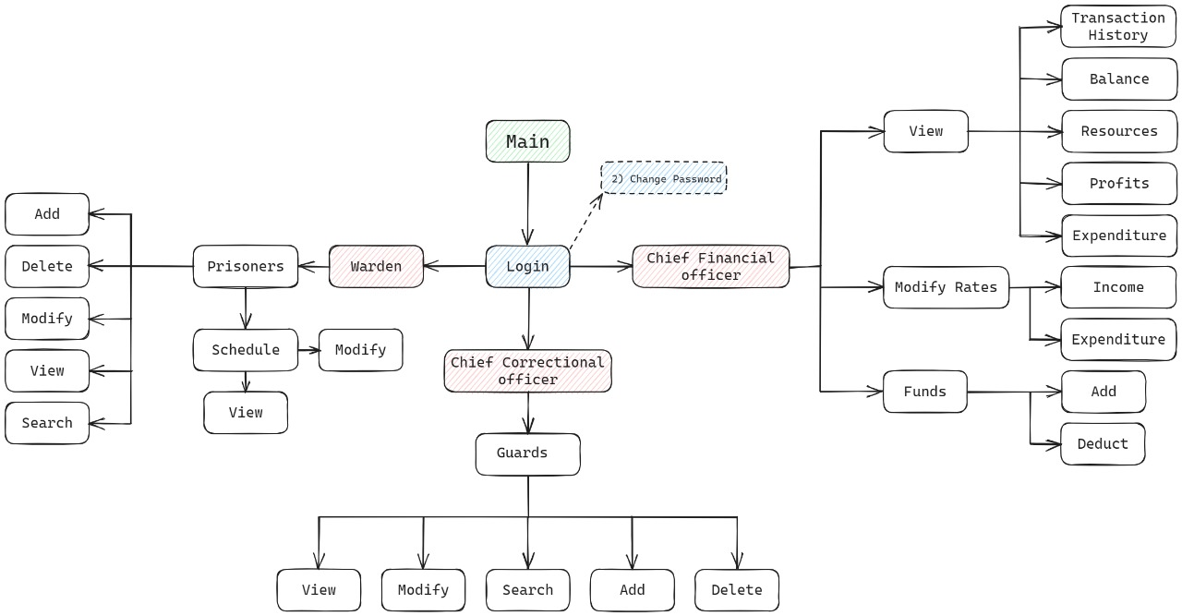

**Shortcomings**

1) New Sources of expenditures cannot be added

2) Sorting functionality isn't available

3) No defined list of crimes is present. So, user can input any crime for a prisoner record.

**Bibliography**

* Computer Science With PYTHON (Textbook for Class12-Sumita Arora)