**Suggestion: Rearrange the elementsto get get a more attractive page**

**Steps to reproduce:**

- Open the <https://www.ffl123.com/> page

- The displayed photos displayed in the horizontal menu are unnecessary

- The photos displayed in the horizontal menu should be removed

Screenshot:

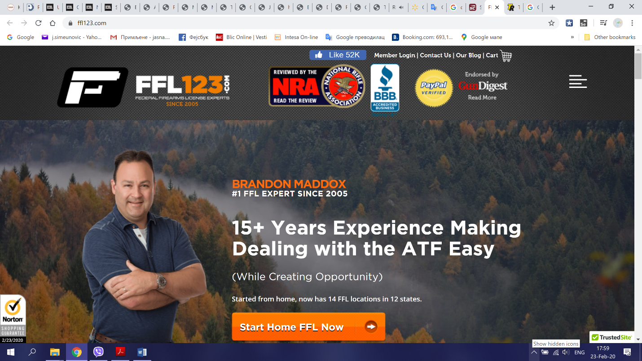

**Suggestion: Questions on the homepage should be transferred to FAQS page**

**Steps to reproduce:**

- Open the <https://www.ffl123.com/> page

- Scroll down the page to section Q

- Questions on the homepage should be removed from here in FAQS

Screenshot:

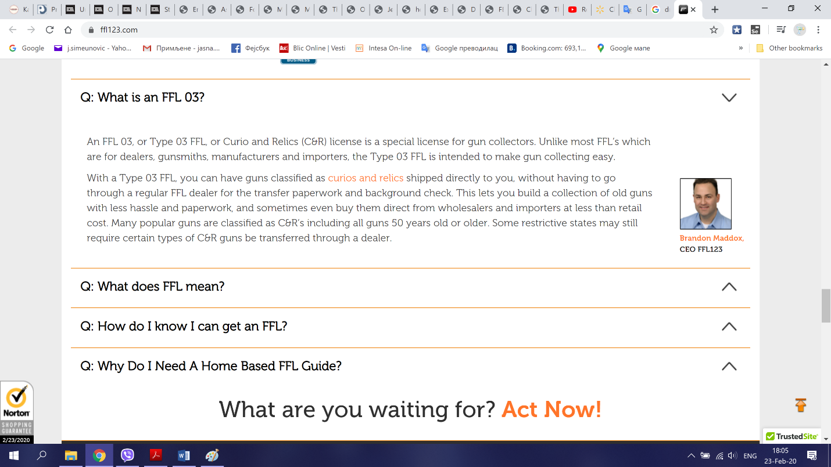

**Suggestion: The sales section should be removed from the page because it already exists on the pageSteps to reproduce:**

- Open the <https://www.ffl123.com/> page

- Scroll down the page to section sale

- Removed sale section

Screenshot:

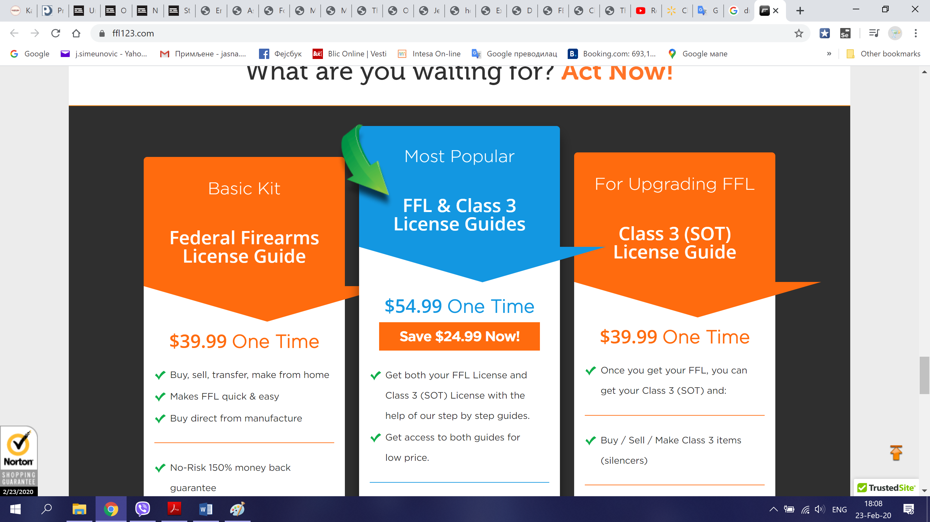

**Suggestion: The section whit logos and featured in should be removed from the page because it already exists on the page**

**Steps to reproduce:**

- Open the <https://www.ffl123.com/> page

- Scroll down the page to section logo and featured in

- Removed logo and featured in section

Screenshot:

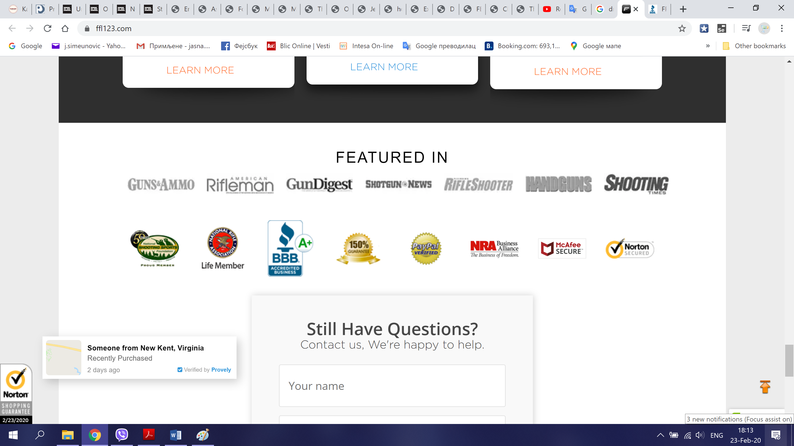

**Suggestion: The section TESTIMONIALS should be removed from the page because it already exists on the page**

**Steps to reproduce:**

- Open the <https://www.ffl123.com/> page

- Scroll down the page to section testimonials

- Removed testimonials section

Screenshot:

