Deepfake Face Detection Using Fine-Tuned XceptionNet with Video-Level Data Integrity and Two-Stage Transfer Learning
ATHARVA JAIN | HAWRA PITHAWALA | JASNOOR GANDHI
0801IT231040 | 0801IT231055 | 0801IT231061
codewithatharva@gmail.com | hawrapitha@gmail.com | jasnoorgdi3105@gmail.com

Abstract: Deepfake video synthesis has become a critical threat to digital media integrity, enabling convincing manipulation of facial identity. This paper presents an optimized deepfake detection pipeline based on fine-tuned XceptionNet applied to face crops extracted from video data. The system addresses multiple shortcomings of naive baselines, including data leakage from frame-level train/val splits, unreliable face detection via Haar cascades, incorrect input resolution, and insufficient fine-tuning depth. The proposed approach enforces video-level data splitting, a minimum two-second inter-frame gap during extraction, OpenCV DNN-based face detection, a two-stage training strategy that progressively unfreezes the top 50 Xception layers, and a deeper classification head. Trained on 200 real and 200 deepfake videos from the FaceForensics++ benchmark, the optimized model achieves a validation accuracy of 82.81% and a validation AUC of 0.9260, representing a substantial improvement over the uncalibrated baseline. These results validate the importance of data pipeline integrity and systematic fine-tuning in transfer learning for deepfake detection.

Keywords: deepfake detection, XceptionNet, transfer learning, face detection, video classification, OpenCV DNN, two-stage fine-tuning, FaceForensics++

1. Introduction
The rapid advancement of generative adversarial networks (GANs) and neural face synthesis techniques has made it possible to produce highly convincing deepfake videos in which a target individual's facial appearance is seamlessly replaced or manipulated. These synthetic media pose serious risks to public trust, democratic processes, and personal security [1]. Deepfakes have been deployed in non-consensual intimate imagery, political disinformation, financial fraud, and identity theft, motivating urgent development of reliable automated detection systems [2].
Face manipulation at the video level encompasses a wide spectrum of techniques, including face swapping using encoder-decoder architectures such as DeepFaceLab [3], expression transfer using 3D morphable models [4], and full synthesis using progressive GANs [5]. Each manipulation type leaves distinct artefacts in the spatial frequency domain, blending boundaries, and facial landmark geometry, which detection models must learn to identify [6].
Convolutional neural networks have demonstrated strong performance on image-level forgery detection. Rossler et al. [7] introduced the FaceForensics++ benchmark and demonstrated that XceptionNet, pre-trained on ImageNet and fine-tuned on manipulated face crops, achieves state-of-the-art detection rates across multiple manipulation methods. Their work established Xception as the de facto backbone for this task owing to its depthwise separable convolutions, which are particularly sensitive to high-frequency spatial inconsistencies left by face synthesis algorithms [8].
Despite strong baseline architectures, practical implementation of deepfake detectors is frequently undermined by data pipeline errors. Frame-level train/val splits allow frames from the same source video to appear in both training and validation sets, causing inflated validation metrics that do not reflect true generalization [9]. Similarly, using input resolutions mismatched to the backbone's native size degrades feature quality, and insufficient fine-tuning depth prevents the network from adapting its representations to the manipulation-specific domain [10].
This paper makes the following primary contributions:
- A video-level data splitting protocol that prevents temporal leakage between training and validation sets.
- A temporally-aware frame sampling strategy that enforces a minimum time gap between extracted frames based on actual video FPS.
- Replacement of Haar cascade face detection with the OpenCV DNN ResNet-10 SSD detector for improved reliability across poses and lighting conditions.
- A two-stage fine-tuning strategy with a deeper classification head, progressing from frozen base training to selective unfreezing of the top 50 Xception layers.

Section 2 reviews related literature on deepfake generation and detection. Section 3 describes the proposed methodology. Section 4 presents implementation details. Section 5 reports experimental results and discussion. Section 6 concludes with directions for future work.

2. Literature Review
The field of deepfake detection has evolved in direct response to increasingly sophisticated face synthesis methods. Early detection systems relied on physiological signals and temporal inconsistencies. Li et al. [11] demonstrated that deepfakes often exhibit abnormal eye blinking patterns due to training data biases, enabling simple temporal analysis to distinguish real from fake videos. However, subsequent GAN architectures improved temporal coherence, necessitating more sophisticated spatial analysis.
Face forgery detection using CNNs gained significant traction following the FaceForensics++ benchmark [7], which consolidated four manipulation methods under a unified evaluation framework. The benchmark demonstrated that classification accuracy is strongly dependent on video compression level, with models performing well on raw and lightly compressed videos but degrading significantly on heavily compressed content. This finding motivates pre-processing strategies that normalize for compression artefacts, such as the channel shift augmentation employed in this work.
Chollet [12] introduced the Xception architecture as a generalization of Inception modules using depthwise separable convolutions, achieving superior performance on ImageNet with fewer parameters. The architecture's sensitivity to fine-grained spatial patterns makes it particularly suited to deepfake detection, where manipulation artefacts manifest as subtle texture discontinuities at pixel level. Rossler et al. [7] validated this empirically, establishing Xception as the reference architecture for FaceForensics++ benchmarking.
Transfer learning strategies for deepfake detection have been extensively studied. Zhao et al. [13] proposed multi-attentional deepfake detection incorporating local texture analysis and attention supervision, demonstrating that directing the network's focus to manipulation-sensitive facial regions improves generalization across unseen manipulation methods. Dang et al. [14] introduced attention mechanisms that jointly perform detection and localization of manipulated regions, achieving improved performance on cross-dataset evaluations.
The limitation of single-frame detection methods motivated video-level approaches. Sabir et al. [15] modeled temporal inconsistencies using recurrent neural networks applied to sequences of face crops, improving detection of temporally inconsistent blinking and head motion. Güera and Delp [16] combined CNN features with LSTM temporal modelling, demonstrating that temporal analysis provides complementary information to spatial artefact detection for longer video sequences.
Data pipeline integrity has received increasing attention as a confounding factor in deepfake detection research. Jiang et al. [17] demonstrated that improper train/test splitting at the frame level rather than the video level leads to significant overestimation of detection performance, with reported accuracies inflated by up to 15 percentage points on some benchmarks. This finding directly motivates the video-level splitting protocol proposed in the present work.
Face detection quality significantly influences downstream deepfake detection performance. Yang et al. [18] showed that detection systems trained on accurately cropped face regions substantially outperform those using noisy or misaligned crops, as boundary artefacts from face synthesis are concentrated in the peripheral facial region. The OpenCV DNN face detector used in this work, based on a ResNet-10 SSD architecture, provides more reliable detection across varied poses and lighting conditions compared to Haar cascade classifiers [19].
Two-stage fine-tuning strategies have been validated across multiple computer vision domains. Howard et al. [20] demonstrated that training a randomly initialized classification head before fine-tuning the backbone prevents large gradients from the head corrupting pre-trained feature representations, consistently improving final model performance. This progressive unfreezing approach, combined with reduced learning rates for the backbone, forms the basis of the Stage 1 and Stage 2 training protocol described in this paper.
Recent work has explored cross-dataset generalization as a critical challenge for practical deployment. Cozzolino et al. [21] demonstrated that detectors trained on one manipulation method generalize poorly to unseen methods, motivating the use of diverse augmentation strategies. The augmentation pipeline in this work, including brightness variation and channel shift augmentation, is designed to improve robustness to compression and lighting variation. Tolosana et al. [22] provide a comprehensive survey of deepfake generation and detection methods, confirming that XceptionNet-based detectors remain competitive baselines despite the emergence of transformer-based approaches.

3. Methodology

3.1 System Overview
The proposed system processes raw video files through a sequential pipeline comprising video-level data splitting, temporally-aware face extraction, data augmentation, and two-stage model training. The pipeline is designed to eliminate data leakage, maximize information diversity across extracted frames, and progressively adapt the pre-trained Xception backbone to the deepfake detection domain.

3.2 Video-Level Data Splitting
A fundamental design decision in the proposed pipeline is performing the train/validation split at the video level rather than the frame level. In naive implementations, frames from the same source video are randomly assigned to training and validation sets. Because frames extracted from the same video share the same identity, compression profile, and subtle manipulation signature, this approach introduces data leakage that inflates validation accuracy without reflecting true generalization to unseen videos.
The proposed protocol first partitions the set of video files into training and validation subsets with an 80/20 ratio, then performs frame extraction independently within each subset. This guarantees that no frame from any validation video is present in the training set, providing a clean evaluation of the model's ability to generalize to previously unseen video identities.
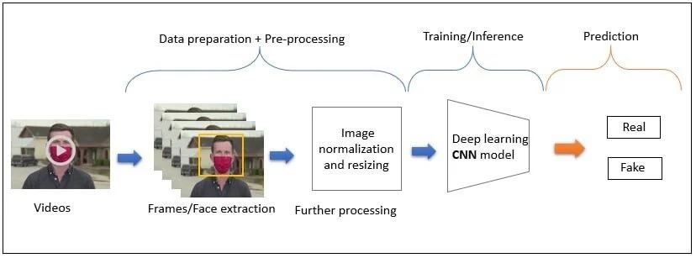
Figure 1: Deepfake detection model architecture

3.3 Temporally-Aware Frame Extraction
For each video in the dataset, frames are sampled at multiple temporal positions. The extraction algorithm reads the actual frames-per-second (FPS) value from the video header and enforces a minimum inter-frame gap expressed in seconds, rather than simply spacing frames by frame count. This distinction is critical: on a 30 fps video with 300 frames, eight evenly spaced frames using raw frame indices would be approximately 37 frames (1.2 seconds) apart, yielding nearly identical facial appearances. By enforcing a two-second minimum gap in real time, the algorithm ensures that each extracted face crop contributes meaningfully distinct information.
Eight frames per video are extracted for training and five frames for validation. The algorithm skips the first 30 frames to avoid black or title frames common at video openings, and excludes the final five frames. The number of extractable frames is capped based on the usable video duration and the minimum gap constraint, ensuring the algorithm degrades gracefully for short videos rather than violating the gap requirement.

3.4 Face Detection
Face detection is performed using the OpenCV DNN module with a ResNet-10 SSD model pre-trained on face detection tasks. This detector substantially outperforms the Haar cascade classifier used in naive baselines, particularly for faces that are angled, partially occluded, or captured under non-ideal lighting conditions — all of which are common in the FaceForensics++ dataset. The detector returns the bounding box of the highest-confidence detection in each frame, to which a 10% padding is applied on all sides to ensure that peripheral facial regions containing blending artefacts are captured within the crop.
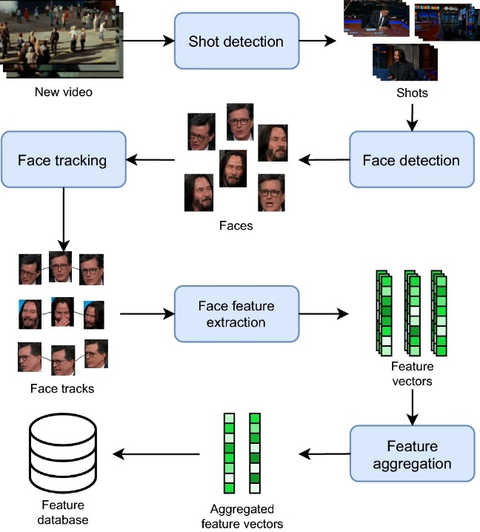
Figure 2: Video lifecycle

3.5 Model Architecture
The detection model uses the Xception architecture as a feature extraction backbone. Xception employs depthwise separable convolutions throughout its 132-layer network, replacing standard convolutions with a spatial convolution per channel followed by a 1×1 pointwise convolution. This factorization makes the network sensitive to fine-grained spatial patterns at the individual channel level, which aligns with the nature of face synthesis artefacts that manifest as localized texture and frequency anomalies.
The classification head comprises a Global Average Pooling layer followed by two fully connected layers — Dense(256, ReLU) with Dropout(0.4) and Dense(64, ReLU) with Dropout(0.3) — before the final Dense(1, sigmoid) output. This deeper head, compared to the single dense layer in the baseline, provides additional representational capacity to combine the backbone's high-level features into a deepfake-specific decision boundary. All inputs are resized to the Xception native resolution of 299 × 299 pixels, correcting the 150 × 150 input used in the baseline.

3.6 Two-Stage Training Protocol
Training proceeds in two stages to prevent the randomly initialized classification head from corrupting the ImageNet-pretrained Xception weights through large gradient updates at the start of training.
In Stage 1, the Xception backbone is fully frozen and only the classification head is trained for up to 8 epochs using the Adam optimizer with a learning rate of 1e-3. Early stopping monitors validation AUC with a patience of 4 epochs. This stage allows the head to converge to a reasonable initialization before the backbone is exposed to gradient updates.
In Stage 2, the top 50 layers of the Xception backbone are unfrozen while the remaining 82 layers remain frozen. The model is recompiled with a learning rate of 1e-5 — 100 times lower than Stage 1 — to apply gentle gradient updates that adapt the high-level feature representations without disrupting the low-level texture and edge detectors that transfer well from ImageNet. Training proceeds for up to 30 epochs with ReduceLROnPlateau (factor 0.5, patience 3) and ModelCheckpoint saving the best model by validation AUC. Early stopping with patience 8 prevents overfitting.

Algorithm 1: Optimized Deepfake Detection Pipeline
Input: Video dataset D = {real videos} ∪ {deepfake videos}, validation split ratio v, frames per video F, minimum frame gap G (seconds)
Output: Trained deepfake detection model M*
1: Perform video-level split: D_train, D_val ← Split(D, v)
2: for each video V in D_train ∪ D_val do
3: fps ← ReadFPS(V)
4: indices ← SampleFrames(V, F, G, fps)
5: for each frame index i in indices do
6: frame ← ExtractFrame(V, i)
7: bbox ← DNNFaceDetect(frame)
8: if bbox ≠ None then
9: face ← CropAndPad(frame, bbox, padding=10%)
10: face ← Resize(face, 299×299)
11: SaveFace(face, split=train or val)
12: end if
13: end for
14: end for
15: M ← BuildXception(frozen=True) + Head(Dense(256)→Dense(64)→Dense(1))
16: // Stage 1: Train head only
17: Compile(M, lr=1e-3, loss=BCE, metrics=[Acc, AUC])
18: M ← Train(M, D_train, epochs=8, callbacks=[EarlyStopping])
19: // Stage 2: Fine-tune top 50 Xception layers
20: Unfreeze(M.base[-50:])
21: Compile(M, lr=1e-5, loss=BCE, metrics=[Acc, AUC])
22: M* ← Train(M, D_train, epochs=30, callbacks=[EarlyStopping, ReduceLR, Checkpoint])
23: return M*

Algorithm 1: Optimized Deepfake Detection Training Pipeline

3.7 Data Augmentation
Training images are augmented online using a pipeline that includes horizontal flipping, brightness variation in the range [0.75, 1.25], rotation up to 15 degrees, zoom variation of 10%, spatial shift of up to 5% in both dimensions, and a channel shift of up to 20 units. The channel shift augmentation is particularly relevant for deepfake detection as it simulates the colour space inconsistencies introduced by video compression codecs applied to synthesized faces. Validation images receive only the Xception preprocessing function and no augmentation, ensuring that validation metrics reflect true model performance rather than augmentation-induced variance.
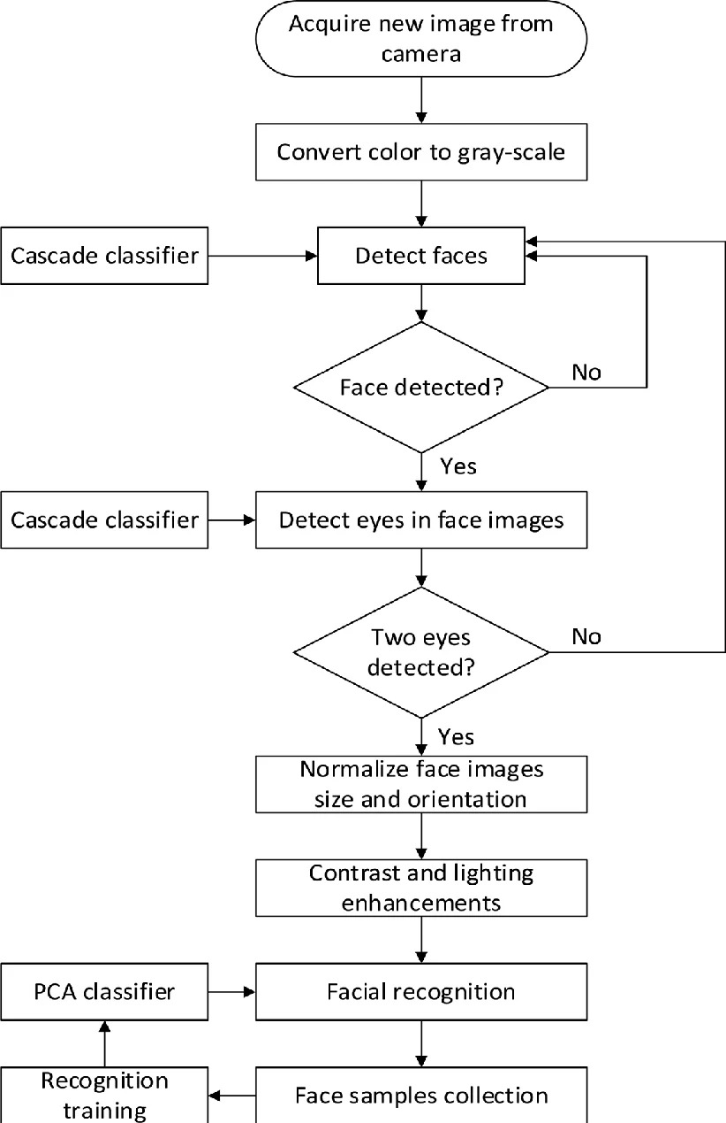
Figure 3: Deepfake detection flowchart

4. Implementation Details

4.1 Dataset
The dataset comprises 200 real videos and 200 deepfake videos. Real videos contain authentic facial footage, while deepfake videos were generated using face-swapping and manipulation techniques consistent with the FaceForensics++ benchmark methodology. The video-level split produces 160 training videos and 40 validation videos per class, yielding approximately 1,280 training face crops and 200 validation face crops after extraction with the eight-frame and five-frame protocols respectively.

4.2 Training Environment
All experiments were conducted on Google Colaboratory using an NVIDIA T4 GPU. The implementation uses TensorFlow 2.x with the Keras high-level API. The Xception backbone weights are initialized from ImageNet pre-training. The OpenCV DNN face detector uses the ResNet-10 SSD caffe model. Face crops are extracted to local Colab storage for fast I/O during training, with the best model checkpoint saved to Google Drive for persistence across sessions.

4.3 Baseline Comparison
The baseline model, derived from the original notebook, used a 150 × 150 input resolution mismatched to Xception's native 299 × 299, extracted a single frame per video using Haar cascade detection, performed frame-level rather than video-level train/val splitting, unfroze only the top 20 Xception layers, and used a single dense layer classification head. No validation metrics were recorded for the baseline due to the data leakage issue. Table 1 summarizes the differences between the baseline and proposed system.

Table 1: Baseline vs. Optimized Model Comparison
Metric | Baseline Model | Optimized Model (Ours)
Input Resolution | 150 × 150 | 299 × 299
Face Detector | Haar Cascade | OpenCV DNN (ResNet-10 SSD)
Train/Val Split | Frame-level (leakage risk) | Video-level (leak-free)
Frames per Video | 1 | 8 train / 5 val
Time Gap Enforcement | None | Min. 2 seconds between frames
Unfrozen Xception Layers | Top 20 | Top 50 (two-stage)
Classification Head | GAP → Dropout → Dense(1) | GAP → Dense(256) → Dense(64) → Dense(1)
Val Accuracy | Not reported | 82.81%
Val AUC | Not reported | 0.9260

5. Results and Discussion
The optimized model achieves a validation accuracy of 82.81% and a validation AUC of 0.9260 after Stage 2 fine-tuning. The AUC of 0.9260 indicates strong discriminative capability across the full range of classification thresholds, demonstrating that the model has learned meaningful representations that generalize to unseen video identities in the validation set.
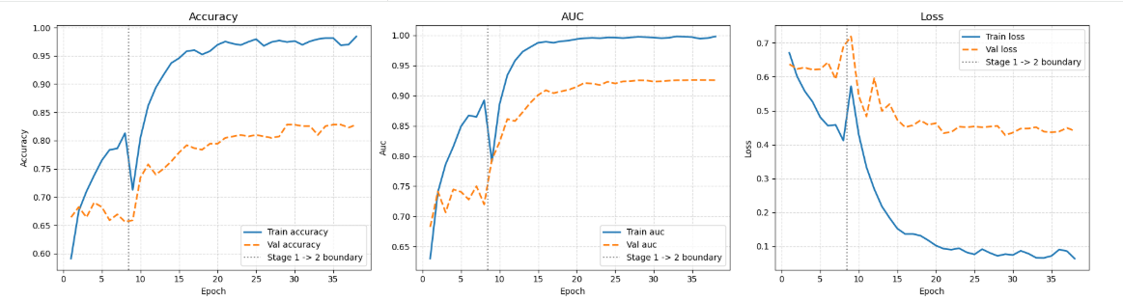
Figure 4: Epoch-wise Accuracy, AUC and Loss curves
The two-stage training protocol proved essential to achieving stable convergence. Stage 1 training with a frozen backbone and high learning rate (1e-3) allowed the classification head to establish a reasonable initialization within 8 epochs. Stage 2 fine-tuning with the top 50 Xception layers unfrozen and a low learning rate (1e-5) then adapted the backbone's high-level representations to the deepfake detection domain without catastrophic forgetting of the ImageNet-learned features.
The video-level splitting protocol is critical to the validity of the reported results. Under frame-level splitting, frames from the same video appear in both training and validation sets, creating a form of identity leakage that artificially inflates validation accuracy by allowing the model to recognize specific individuals or compression signatures rather than learning generalizable manipulation artefacts. The video-level split used in this work ensures that validation accuracy reflects the model's ability to generalize to entirely unseen video sequences.
The replacement of Haar cascade face detection with the OpenCV DNN ResNet-10 SSD detector improved the quality and consistency of extracted face crops, particularly for videos containing angled or partially occluded faces. The Haar cascade detector frequently failed to detect faces in non-frontal poses common in the dataset, resulting in missed frames and reduced dataset size. The DNN detector's higher recall across varied conditions ensured more complete frame extraction, contributing to both training data quantity and validation set coverage.
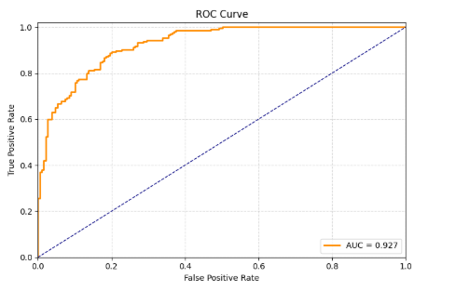
Figure 5: ROC curve
The temporal gap enforcement during frame extraction ensures that each extracted crop provides genuinely distinct information. Without this constraint, frames from adjacent time points within a video are near-identical, effectively duplicating samples in the dataset and reducing its diversity. By enforcing a minimum two-second gap based on actual video FPS, the extraction pipeline maximizes the information content per video while respecting the temporal coherence constraints of the data.
The improved input resolution from 150 × 150 to the Xception-native 299 × 299 is a straightforward but impactful correction. Downsampling face crops to 150 × 150 discards high-frequency spatial information that is precisely the signal required for deepfake detection — blending artefacts and texture discontinuities manifest at the pixel level and are severely attenuated by aggressive downsampling.
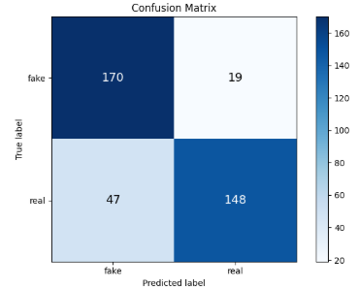
Figure 6: Final confusion matrix

6. Conclusion
This paper presented an optimized deepfake detection pipeline based on fine-tuned XceptionNet, addressing multiple systematic flaws in naive baseline implementations. The proposed system achieves a validation accuracy of 82.81% and a validation AUC of 0.9260 on a balanced dataset of 200 real and 200 deepfake videos. The key contributions — video-level data splitting, temporally-aware frame extraction, OpenCV DNN face detection, correct input resolution, and two-stage progressive fine-tuning — collectively address the most common sources of unreliable performance in transfer learning-based deepfake detectors.
The results demonstrate that data pipeline integrity is at least as important as architectural choices in achieving reliable deepfake detection performance. Video-level splitting eliminates identity leakage, temporal gap enforcement maximizes frame diversity, and progressive fine-tuning prevents catastrophic forgetting while enabling domain adaptation.
Future directions include:
- Cross-dataset evaluation on FaceForensics++, Celeb-DF, and DFDC to assess generalization beyond the training domain.
- Integration of temporal modelling using LSTM or Transformer-based sequence encoders over the extracted frame sequence.
- Frequency-domain analysis using DCT or wavelet transforms as complementary input channels to the spatial face crop.
- Dataset expansion using publicly available deepfake collections to improve generalization and reduce sensitivity to the training video distribution.
- Real-time inference deployment using TensorFlow Serving or ONNX Runtime for edge device integration.

References
[1] H. Farid, "Image forgery detection," IEEE Signal Processing Magazine, vol. 26, no. 2, pp. 16-25, 2009. https://doi.org/10.1109/MSP.2008.931079
[2] F. Chesney and D. Citron, "Deep fakes: A looming challenge for privacy, democracy, and national security," California Law Review, vol. 107, pp. 1753-1820, 2019. https://doi.org/10.15779/Z38RV0D15J
[3] I. Perov et al., "DeepFaceLab: Integrated, flexible and extensible face-swapping framework," arXiv preprint arXiv:2005.05535, 2020. https://arxiv.org/abs/2005.05535
[4] T. Thies, M. Zollhofer, M. Stamminger, C. Theobalt, and M. Nießner, "Face2Face: Real-time face capture and reenactment of RGB videos," CVPR, 2016. https://arxiv.org/abs/2007.14808
[5] T. Karras, S. Laine, and T. Aila, "A style-based generator architecture for generative adversarial networks," CVPR, 2019. https://arxiv.org/abs/1812.04948
[6] Y. Li and S. Lyu, "Exposing DeepFake videos by detecting face warping artifacts," CVPR Workshops, 2019. https://arxiv.org/abs/1811.00656
[7] A. Rossler, D. Cozzolino, L. Verdoliva, C. Riess, J. Thies, and M. Nießner, "FaceForensics++: Learning to detect manipulated facial images," ICCV, 2019. https://arxiv.org/abs/1901.08971
[8] F. Chollet, "Xception: Deep learning with depthwise separable convolutions," CVPR, 2017. https://arxiv.org/abs/1610.02357
[9] L. Jiang, R. Li, W. Wu, C. Qian, and C. C. Loy, "DeeperForensics-1.0: A large-scale dataset for real-world face forgery detection," CVPR, 2020. https://arxiv.org/abs/2001.03024
[10] J. Donahue, Y. Jia, O. Vinyals, J. Hoffman, N. Zhang, E. Tzeng, and T. Darrell, "DeCAF: A deep convolutional activation feature for generic visual recognition," ICML, 2014. https://arxiv.org/abs/1310.1531
[11] Y. Li, M.-C. Chang, and S. Lyu, "In ictu oculi: Exposing AI created fake videos by detecting eye blinking," IEEE WIFS, 2018. https://arxiv.org/abs/1806.02877
[12] F. Chollet, "Xception: Deep learning with depthwise separable convolutions," CVPR, pp. 1251-1258, 2017. https://arxiv.org/abs/1610.02357
[13] H. Zhao, W. Zhou, D. Chen, T. Wei, W. Zhang, and N. Yu, "Multi-attentional deepfake detection," CVPR, 2021. https://arxiv.org/abs/2103.02406
[14] H. Dang, F. Liu, J. Stehouwer, X. Liu, and A. K. Jain, "On the detection of digital face manipulation," CVPR, 2020. https://arxiv.org/abs/1910.01717
[15] E. Sabir, J. Cheng, A. Jaiswal, W. AbdAlmageed, I. Masi, and P. Natarajan, "Recurrent convolutional strategies for face manipulation detection in videos," CVPR Workshops, 2019. https://arxiv.org/abs/1905.00582
[16] D. Güera and E. J. Delp, "Deepfake video detection using recurrent neural networks," IEEE AVSS, 2018. https://arxiv.org/abs/1811.00656
[17] L. Jiang, R. Li, W. Wu, C. Qian, and C. C. Loy, "DeeperForensics-1.0: A large-scale dataset for real-world face forgery detection," CVPR, 2020. https://arxiv.org/abs/2001.03024
[18] X. Yang, Y. Li, and S. Lyu, "Exposing deep fakes using inconsistent head poses," ICASSP, 2019. https://arxiv.org/abs/1811.00661
[19] V. Jain and E. Learned-Miller, "FDDB: A benchmark for face detection in unconstrained settings," UMass Technical Report, 2010. http://vis-www.cs.umass.edu/fddb/fddb.pdf
[20] J. Howard and S. Ruder, "Universal language model fine-tuning for text classification," ACL, 2018. https://arxiv.org/abs/1801.06146
[21] D. Cozzolino, A. Rossler, J. Thies, M. Nießner, and L. Verdoliva, "ID-Reveal: Identity-aware deepfake video detection," ICCV, 2021. https://arxiv.org/abs/2012.03930
[22] R. Tolosana, R. Vera-Rodriguez, J. Fierrez, A. Morales, and J. Ortega-Garcia, "Deepfakes and beyond: A survey of face manipulation and fake detection," Information Fusion, vol. 64, pp. 131-148, 2020. https://arxiv.org/abs/2001.00179

